 | INTERNATIONAL TELECOMMUNICATION UNION  TELECOMMUNICATION  STANDARDIZATION SECTOR  STUDY PERIOD 2017-2020 |  |  | TSAG-TD1214
 |  |  |  | TSAG
 |  |  |  | Original: English
Question(s): |  |  | N/A | Online, 10-17 January 2022
TD
Source: |  |  | Director, TSB
Title: |  |  | Evaluation of Kaleidoscope 2021 papers with respect to relevance in ITU activities
Purpose: |  |  | Information
Contact: |  | Alessia Magliarditi  TSB/ITU |  |  | Tel: +41 22 730 5882  E-mail: kaleidoscope@itu.int

Keywords: | Kaleidoscope; academic papers;
Abstract: | This document provides an overview of the ITU Kaleidoscope academic conference 2021 (K-2021) that was held online from 6-10 December 2021. Attached to this TD is a document which presents keynote summaries, keynote papers, invited papers and accepted papers selected for presentation and publication, and identifies links to related activities in ITU-T and other ITU sectors.

Action required
TSAG, ITU-T study groups and focus groups are invited to review the papers relevant to their scope of work, and to take into consideration this input from the research community. Tailored TDs are also being submitted to the ITU-T study groups and focus groups. In addition, this report will be transmitted to RAG and TDAG.
Highlights of the conference
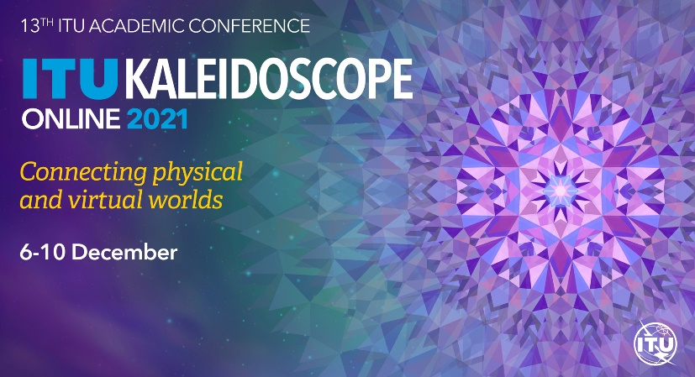
With the pace of digital transformation continuing to erode the barriers between physical and virtual worlds, this 13th edition of the ITU Kaleidoscope conferences, Connecting physical and virtual worlds, explored the development of persistent virtual realities and customized computer-generated environments, as well as new possibilities and associated challenges appearing on the horizon.
The conference programme featured four keynote speeches, an invited talk, two special sessions and four video demos, as well as coffee breaks hosting digitally enhanced art exhibitions and dance performances.
Keynotes looked ahead towards mobile-connected intelligence, sustainability, and spectrum management in the 6G era. They also explored key ethical questions for the transition to smart cities and considered how future communications tech could engage all five human senses.
Invited speakers shared research on a serverless approach for IoT, an ITU standardization perspective on quantum key distribution networks for trust in 5G and beyond, and a proposal to accelerate the adoption of virtual reality in medical training.
Two special sessions explored the cultural dimensions of digital transformation, with the first considering the reciprocal relationship emerging between digital technologies and cultural heritage, and the second looking 20 years ahead to forecast the future of art, culture, and technology.
Video demos showcased 5G and beyond-5G system simulations, eco-friendly tethered drones to monitor electromagnetic fields, standardization bolstering cyber defence in Africa, and ways to discover security vulnerabilities in critical infrastructure.
The winning papers of K-2021 are:

- FIRST best paper: "Towards a robust new radio compatible with XR" by Yuzhou Hu, Jiajun Xu​, Xiaoying Ma, Mengzhu Chen, Hong Tang and Jun Xu (State Key Laboratory of Mobile Network and Mobile Multimedia Technology, ZTE Corporation, China)
​
- SECOND best paper: "Collaborative 5G multi​access computing security: Threats, protection requirements and scenarios" by Gang Zhao, Feng Zhang, Le Yu, Hongyang Zhang, Qin Qiu and Sijia Xu (China Mobile, China)
​
- THIRD best paper (ex aequo): "Reinforcement learning for scheduling and MIMO beam selection using CAVIAR simulations" by João Paulo Tavares Borges, Ailton Pinto de Oliveira, Felipe Henrique Bastos e Bastos, Daniel Takashi Né do Nascimento Suzuki and Emerson Santos de Oliveira, Jr. (Universidade Federal do Pará, Brazil); Lucas Matni Bezerra (Universidade Estácio de Sá, Brazil); Cleverson Veloso Nahum (Universidade Federal do Pará, Brazil); Pedro dos ​Santos Batista (Ericsson Research, Sweden); Aldebaro Barreto da Rocha Klautau, Jr. (Universidade Federal do Para, Brazil)​
​​
- THIRD best paper (ex aequo): "Security vulnerability expressions: A technology for empowering novice practitioners around the world with security maturity capabilities​​" by Jacques Francoeur (Security Inclusion Now, USA)
Alongside the winners of the best paper awards, 18 entrants received Young Author Recognition Certificates.
The Best Video Demonstration of the Video Demonstration Track, as judged by the Steering Committee, was awarded to ​​Enabling cyber defence in Africa through standardization​, authored by Mwende Njiraini (DiploFoundation, Kenya) and Racky Seye (Ministry of Digital Economy and Telecommunications of Senegal, Senegal).
Programme, presentations, abstracts, and biographies are available online.
Full papers are reproduced in the Conference Proceedings​. All papers will be also available shortly on the IEEE Xplore Digital Library.
The best papers will be evaluated for potential publication in IEEE Communications Standards Magazine and other international journals.
Attached is a document presenting two keynote summaries, two keynote papers, two invited papers and 18 accepted papers, with links to the respective presentations, that have been selected by the Steering and Technical Programme Committees of Kaleidoscope 2021 and identifies links to related activities in ITU-T and other ITU sectors.
Upon request, the ITU Kaleidoscope Secretariat can establish contact between Study Groups/Focus Groups and authors, e.g. to arrange for a remote presentation of the findings of the paper during a Study Group/Focus Group meeting.
Nearly 130 delegates from 32 countries participated at the conference. The inhouse tool/platform, MyMeetings, was used and general information can be found on the event´s webpage.
The event was technically co-sponsored by the Institute of Electrical and Electronics Engineers (IEEE) and the IEEE Communications Society (IEEE ComSoc).
A 12-month, substantial preparatory process was required for this Kaleidoscope edition which involved the efforts and collaboration of
- dedicated Steering Committee members: Christoph Dosch (ITU-R Study Group 6 Vice-Chairman; ARD, Germany), Eva Ibarrola (University of the Basque Country, Spain), Kai Jakobs (RWTH Aachen University, Germany), Gyu Myoung Lee (Liverpool John Moores University, United Kingdom), Tiziana Margaria (University of Limerick, Ireland), Mitsuji Matsumoto (Professor Emeritus Waseda University, Japan), Roberto Minerva, (Télécom SudParis, France) and Mostafa Hashem Sherif (Consultant, USA);
- Technical Programme Committee​ (TPC) of 57 members, chaired by Mostafa Hashem Sherif. All members are internationally recognized ICT experts from academia, research institutes and the private sector, ensuring transparency through the double-blind peer-review process;
- partnering organizations which supported the promotion of the conference: Waseda University, the Institute of Image Electronics Engineers of Japan (IIEEJ), the Institute of Electronics, Information and Communication Engineers of Japan (IEICE) of Japan, the Chair of Communication and Distributed Systems at RWTH Aachen University, the European Academy for Standardization (EURAS), the University of the Basque Country, Liverpool John Moores University, Korea Advanced Institute of Science and Technology (KAIST), the University of Limerick, Confirm Smart Manufacturing, and Virtual Switzerland.

A detailed Final Report​ and the recordings of the conference are also available online.

_______________________

