 | INTERNATIONAL TELECOMMUNICATION UNION  TELECOMMUNICATION  STANDARDIZATION SECTOR  STUDY PERIOD 2017-2020 |  |  | TSAG-TD1321
 |  |  |  | TSAG
 |  |  |  | Original: English
Question(s): |  |  | N/A | E-meeting, 10-17 January 2022
TD
Source: |  |  | Rapporteur, TSAG RG-WM
Title: |  |  | Appendix to TSAG Part II report to WTSA regarding Resolution 1 Section 7
Purpose: |  |  | Information
Contact: |  | Steve Trowbridge  Nokia  USA |  |  | Tel: +1 303 809 7423  E-mail: steve.trowbridge@nokia.com

Keywords: | Resolution 1; Section 7;
Abstract: | Contains a proposed Appendix to the TSAG Part II report to WTSA to summarize the status of TSAG discussions concerning Resolution 1 Section 7.

Appendix xx
(to Part II of the TSAG Report to WTSA – document 24)

xx.1 Background
It is the consensus of TSAG that improvements are required to Resolution 1 Section 7. There are some internal inconsistencies in the clause itself: for example, the clause numbers cited in Figure 7.1a do not always match the number of the actual text clause corresponding to that process step. Some of the process steps are shown as occurring in a different chronological order in the figures as opposed to the order the steps are described in the text. There are some known differences between long-standing practice and the text (e.g., proposed new/revised Questions are approved if TSAG endorses without proposing changes without waiting for the next SG meeting, and questions proposed for the next study period at WTSA are posted as they come from the study groups, and not posted by TSAG after TSAG review). It is unclear under what circumstances and by what procedure, Member State consultation should be employed in the approval of new/revised Questions (e.g., before or after TSAG review).
Several options have been elaborated and discussed in TSAG (in the Rapporteur Group on Working Methods), in particular relating to the way in which Member State consultation might be used. No TSAG consensus has been reached on any specific option to use as the basis for improving Resolution 1 Section 7, or any specific text update. The status of TSAG discussions is provided to WTSA for information.

xx.2 Options for clarifying the options regarding the use of Member State consultation
Approval of new/revised Questions by Member State consultation (Ref Resolution 1 clause 7.2.3) is indicated in the case of failure to reach consensus in the SG. Clause 7.2 generally contains process steps that occur after TSAG review, and it is also shown in Figure 7.1a that this would occur after TSAG review. However, new/revised Questions are not even sent to TSAG for review unless the SG reaches consensus on a text to send to TSAG in the earlier step 7.1.6.
Four options have been discussed about how to reconcile this inconsistency (again, no consensus around whether any of these options or a variant of one of these options is the correct way forward):
- Option 1: Keeping the flow of the existing text, limit the application of Member State consultation to the narrow case where, after reaching consensus on a text to send to TSAG for review, the SG fails to reach consensus on text including TSAG recommended changes.
- Option 2: Add an explicit path to allow a SG to request TSAG review and advice in a non-consensus situation prior to initiating Member State consultation.
- Option 3: Defer all cases of proposed new/revised Questions that do not reach consensus to WTSA.
- Option 4: Re-purpose the Member State consultation as a final approval step for new and revised Questions with regulatory and policy implications, in particular, those which relate to tariff and accounting issues, and relevant numbering and addressing plans (“default TAP” Questions).
These four options are illustrated in the flowcharts in Figures xx-1 through xx-4 below. Note that these figures are drawn in the style of existing Figures 7.1a and 7.1b in Resolution 1. It was suggested that if a similar figure is to be included in the Resolution, it should be drawn using the ITU-T’s own Specification and Description Language (SDL) as described in ITU-T SG17 Recommendations Z.100-Z.109.

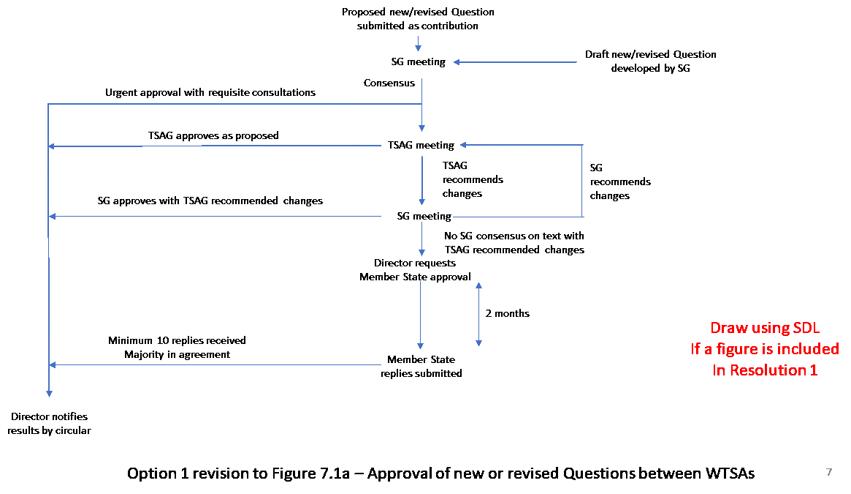

Figure xx-1 – Option 1 approval flow for new/revised Questions

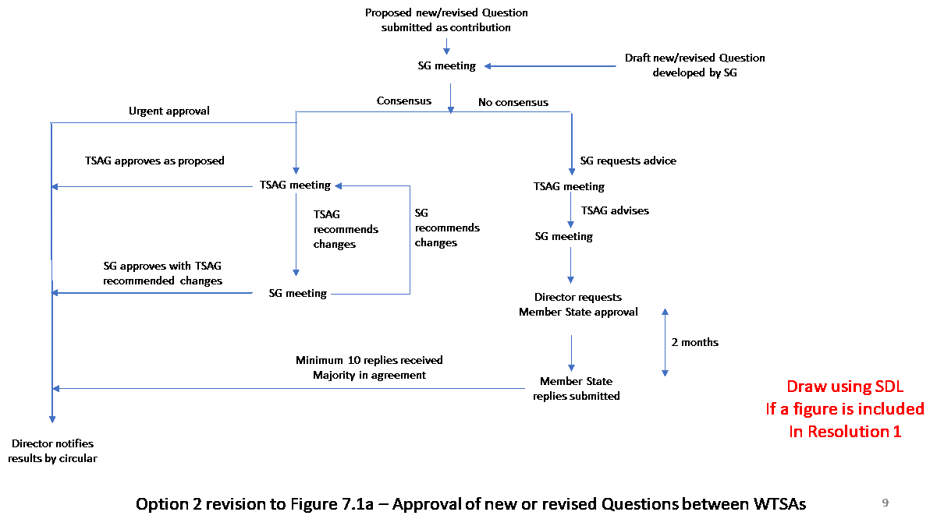
Figure xx-2 – Option 2 approval flow for new/revised Questions

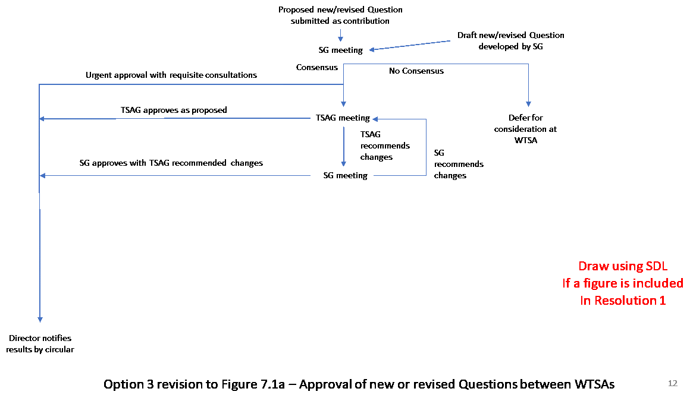

Figure xx-3 – Option 3 approval flow for new/revised Questions

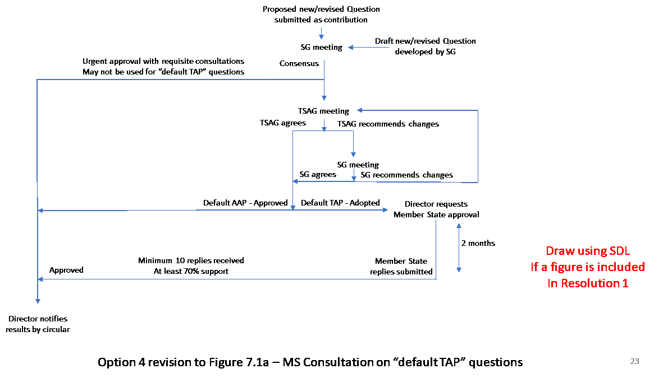
Figure xx-4 – Option 4 approval flow for new/revised Questions

xx.3 Possible Text Improvements to Resolution 1 Section 7
The following text was developed during the work of the TSAG Rapporteur Group on Working Methods. It has not had full review nor has it reached consensus. Square-bracketed text is shown that corresponds to the first three of the Options discussed in xx.2 above. No text has been produced corresponding to Option 4.

Development and approval of Questions

7 Development and approval of new or revised Questions by SGs and TSAG
7.1.1 Proposed new and revised Questions may be submitted as contributions to the SG meeting which will consider the new or revised Question(s).
7.1.2 Draft new or revised Questions may also be developed by a SG itself during a meeting.
7.1.3 Each proposed Question should be formulated in terms of specific task objective(s) and shall be accompanied by appropriate information as listed in Appendix I to this resolution with the aim of managing as efficiently as possible the scarce ITU resources and optimizing the use of resources. This information should clearly justify the reasons for proposing the Question and indicate the degree of urgency, while taking into account the relationship of the work of other SGs and standardization bodies.
7.1.4 Each SG shall consider the proposed new or revised Questions to determine:
i) the clear purpose of each proposed Question;
ii) the priority and urgency of new Recommendation(s) desired, or changes to existing Recommendations resulting from the study of the Questions;
iii) that there be as little overlap of work as possible between the proposed new or revised Questions both within the SG concerned and with Questions of other SGs and the work of other standardization organizations.

7.1.5 In addition, several Member States and Sector Members (normally at least four) shall commit themselves to support the work, e.g. by contributions, provision of rapporteurs or editors and/or hosting of meetings. The names of the supporting entities should be recorded in the meeting report, together with the type of support to which they are committing.
7.1.6 Agreement by a SG to submit proposed new or revised Questions for endorsement by TSAG is achieved by reaching consensus among the Member States and Sector Members present at the SG meeting when the proposed new or revised Question is discussed that the criteria in 7.1.4 and 7.1.5 have been satisfied.
7.1.7 TSAG is requested by liaison statement from the SGs to review and endorse proposed new or revised Questions, in order to allow it to consider the possible implications for the work of all ITU-T SGs or other groups (see 7.2.3).
[7.1.7bis If the support described in 7.1.5 is offered, but consensus of the SG to request approval of the new or revised Questions is not achieved, the SG may continue to consider the matter, or may request approval by a consultation of Member States after seeking the advice of TSAG (see 7.2.4).]
7.1.8 The opportunity for review of the Questions by TSAG prior to approval may be dispensed with only where urgent approval of the proposed Question by the SG without review by TSAG is justified in the opinion of the Director of TSB, after consulting the chairman of TSAG and the chairman of any other SGs where overlap or liaison problems could arise.
7.1.9 A SG may agree to commence work on a draft new or revised Question before its approval.
7.1.10 In order to allow for the specific characteristics of countries with economies in transition, developing countries4, and especially the least developed countries, TSB shall take account of the relevant provisions of WTSA Resolution 44 in responding to any request submitted by such countries through the Telecommunication Development Bureau (BDT), particularly with regard to matters related to training, information, examination of questions which are not covered by the ITU-D SGs, and technical assistance required for the examination of certain questions by the ITU-D SGs.

7.2 Approval of new or revised Questions between WTSAs
7.2.1 Between WTSAs, and after development of proposed new or revised Questions (see 7.1 above), the approval procedure for new or revised Questions is set out below.
[TBD based on selected option]
Figure 7.1a – Approval of new or revised Questions between WTSAs

7.2.2 Between WTSAs, TSAG shall review the work programme of ITU-T and recommend revisions as necessary.
7.2.3 TSAG shall review any new or revised Question proposed by a SG to determine whether it is in line with the mandate of the SG. TSAG may then endorse the text of any proposed new or revised Question or may recommend that it be modified. If TSAG recommends modifying the draft new or revised Question, the Question shall be returned to the relevant SG for reconsideration. TSAG shall note the text of any new or revised Question already approved (e.g., those approved by a SG (7.2.4) or by Member State consultation (7.2.5) since the last meeting of TSAG).
7.2.4 A SG may approve a Question where urgent approval of the proposed Question by the SG without review by TSAG is justified in the opinion of the Director of TSB, after consulting the chairman of TSAG and the chairman of any other SGs where overlap or liaison problems could arise (see 7.1.9). A SG may also approve a Question with modifications recommended by TSAG (see 7.2.3).
[7.2.5 Alternatively, if consensus of the SG to approve a new or revised Question with changes recommended by TSAG is not achieved, the SG may continue to consider the matter or request approval by consultation of the Member States.
a) The Director shall request Member States to notify the Director within two months whether they approve or do not approve the proposed new or revised Question.
b) A proposed Question is approved if:
– a simple majority of all the Member States responding are in agreement; and
– at least ten replies are received.
]
[7.2.5 A SG may seek the advice of TSAG concerning circumstances where consensus of the SG to request approval of a new or revised Question is not achieved (see 7.1.8). Pursuant to TSAG advice, the SG may continue to consider the matter or request approval by consultation of the Member States.
a) The Director shall request Member States to notify the Director within two months whether they approve or do not approve the proposed new or revised Question.
b) A proposed Question is approved if:
– a simple majority of all the Member States responding are in agreement; and
– at least ten replies are received.]
[7.2.5 Cases where approval of proposed new or revised Questions shall be deferred for consideration at a WTSA are:
a) Questions of an administrative nature concerning ITU-T as a whole;
b) where the SG concerned considers it desirable that WTSA itself should debate and resolve particularly difficult or delicate issues;
c) where attempts to achieve agreement within the SGs have failed due to non-technical issues such as differing views on policy.]
7.2.6 Any Question approved between WTSAs shall have the same status as Questions approved at a WTSA. The Director shall notify the results of questions approved by Circular.

7.3 Approval of Questions by WTSA
7.3.1 In later meetings of a study period, SGs should review and develop text of draft new and revised Questions for the continuation of their work into the next study period. Development of such questions follows the process described in 7.1.1 through 7.1.6. Draft questions are transmitted by liaison statement to TSAG, which should take them into account in discussions relating to study group structure, and to provide feedback to the SGs as appropriate.
[TBD based on selected option]
Figure 7.1b – Approval of new or revised Questions at WTSA
7.3.2 At least two months prior to WTSA, TSAG shall meet to consider, review and, where appropriate, recommend changes to Questions proposed by the SGs for WTSA's consideration, while ensuring that the Questions respond to the overall needs and priorities of the ITU-T work programme and are duly harmonized to:
i) avoid duplication of effort;
ii) provide a coherent basis for interaction between SGs;
iii) facilitate monitoring overall progress in the drafting of Recommendations and other ITU-T publications;
iv) facilitate cooperative efforts with other standardization organizations.
Any changes agreed by TSAG to the text of the Questions as proposed by the SGs is reflected in the TSAG report to WTSA in respect to study group structure.
7.3.3 At least 35 calendar days before WTSA, the Director shall inform the Member States and Sector Members of the list of proposed new and revised Questions, as agreed by each SG and any modifications agreed by TSAG.
7.3.4 A Question may be proposed as a contribution directly to a WTSA, which either approves the new or revised Question or invites the contributor to submit the proposed Question to the next meeting of the relevant SG(s) to allow time for its thorough examination.
7.3.5 The proposed Questions may be approved by WTSA in accordance with the General Rules of conferences, assemblies and meetings of the Union.

7.4 Deletion of Questions
SGs may decide in each individual case which of the following alternatives is the most appropriate for the deletion of a Question.

7.4.1 Deletion of a Question between WTSAs
7.4.1.1 At a SG meeting, it may be agreed by consensus among those present to delete a Question, e.g. either because work has been terminated or because no contributions have been received at that meeting and at the previous two SG meetings. Notification about this agreement, including an explanatory summary of the reasons for the deletion, shall be provided by a circular. If a simple majority of the Member States responding has no objection to the deletion within two months, the deletion comes into force. Otherwise the issue shall be referred back to the SG.
7.4.1.2 Those Member States which indicate disapproval are requested to provide their reasons and to indicate the possible changes that would facilitate further study of the Question.
7.4.1.3 Notification of the result shall be given in a circular, and TSAG shall be informed by the Director. In addition, the Director shall publish a list of deleted Questions whenever appropriate, but at least once by the middle of a study period.

7.4.2 Deletion of a Question by WTSA
Upon the decision of the SG, the chairman shall include in his or her report to WTSA the request to delete a Question. WTSA shall decide as appropriate.

_______________________

4 These include the least developed countries, small island developing states, landlocked developing countries and countries with economies in transition.

