Unión Internacional de Telecomunicaciones
Oficina de Normalización de las Telecomunicaciones
Ginebra, 1 de febrero de 2017

Ref.: | Revisión 1 de la  Circular TSB 3 | - A las Administraciones de los Estados Miembros de la Unión  - A los Miembros de Sector UIT-T;  - A los Asociados de la CE 12 del UIT-T;  - A las Instituciones Académicas de la UIT
Tel.:  Fax:  Correo-e: | +41 22 730 6828  +41 22 730 5853  tsbsg12@itu.int | Copia:  - A los Presidentes y Vicepresidentes de las Comisiones de Estudio del UIT-T;  - Al Director de la Oficina de Desarrollo de las Telecomunicaciones;  - Al Director de la Oficina de Radiocomunicaciones  - A los Copresidentes del Grupo de Expertos en calidad vídeo (VQEG)

Asunto: | Llamada de la Comisión de Estudio 12 y del VQEG a la participación en la Fase 2 de AVHD-AS/P.NATS: Modelo de opinión para calcular la calidad de vídeo de las aplicaciones de tipo flujo continuo adaptable
Acción: | Sírvase anunciar su intención definitiva y vinculante de participar en el desarrollo de la Fase 2 de AVHD-AS/P.NATS hasta el 17 de febrero de 2017 enviando un correo-e a la dirección tsbsg12@itu.int
Muy Señora mía/Muy Señor mío:
1 La Cuestión 14 de la Comisión de Estudio 12 del UIT-T (Calidad de funcionamiento, calidad de servicio y calidad percibida) tiene como objetivo acelerar la segunda fase de P.NAT, un modelo de opinión para calcular la calidad de vídeo de las aplicaciones de tipo flujo continuo adaptable.
2 Esta labor se llevará a cabo como proyecto conjunto entre la C14/12 del UIT-T y el Grupo de Expertos en calidad vídeo (VQEG), y se conocerá como Fase 2 de AVHD-AS/P.NATS.
3 En el Anexo 1 a la presente Circular se facilita el llamamiento a la participación en la Fase 2 de AVHD-AS/P.NATS.
4 Le quedaría agradecido si pudiera anunciar su intención definitiva y vinculante de participar en el desarrollo de la Fase 2 de AVHD-AS/P.NATS hasta el 17 de febrero de 2017 enviando un correo-e a la dirección tsbsg12@itu.int.
5 Toda solicitud de detalles o aclaraciones respecto de este llamamiento a la participación debe enviarse al Sr. Jörgen Gustafsson (jorgen.gustafsson@ericsson.com), el Sr. Alexander Raake (alexander.raake@tu-ilmenau.de), el Sr. Shahid Mahmood Satti (ss@opticom.de) y el Sr. Silvio Borer (Silvio.Borer@rohde-schwarz.com).
6 Deseo destacar la importancia de su participación en este tema de trabajo, ya que ayudaría a la Comisión de Estudio 12 del UIT-T y el VQEG en sus esfuerzos para hacer avanzar el trabajo en relación con la elaboración de modelos de calidad de vídeo para los sistemas de flujo continuo adaptable.
Atentamente,

Chaesub Lee
Director de la Oficina de
Normalización de las Telecomunicaciones

Anexo: 1

ANNEX 1
(to TSB Circular 3(Rev.1))
Call for participation on AVHD-AS/P.NATS Phase 2
Opinion model for estimating video quality of adaptive streaming services
Abstract
This Call for Participation is directed to all parties who are interested to contribute to AVHD-AS/P.NATS Phase 2 models for objective assessment of progressive download and adaptive streaming type video. Those parties are invited to announce their interest in contributing to AVHD-AS/P.NATS Phase 2 and spending further active development and analysis efforts into the project. Interested parties are expected to announce their final and binding intention to participate by 17 February 2017.
Background
The ITU-T P.1203 series of standards which target the parametric and bitstream based modelling of video quality have recently been consented to support progressive download and adaptive streaming types of HD video using H.264 video codec. The next step in Q14/12 model standardization is to broaden the scope of P.1203 for various video codecs and higher resolution, aiming at a more comprehensive model that can meet the requirements of modern day Ultra HD video streaming applications.
The ITU-T J.341/J.342 and J.343 series of standards were developed within VQEG targeting pure pixel-based and hybrid models to support video quality measurement for HDTV digital cable and IP-based video services, respectively. At present no standardized pixel-based and hybrid models are available for adaptive streaming applications. In addition, modern day streaming services involve a plethora of video codecs and streaming resolutions (up to and including Ultra-HD) for which these types of models need to be researched.
In an effort to measure video quality in a broad operational scope – ranging from head-end encoding optimization to in-network and client side quality monitoring – this project aims to develop different type of models using a common training/validation dataset to determine the potential of these model types in challenging measurement scenarios.
AVHD-AS/P.NATS Phase 2 work item
The AVHD-AS/P.NATS Phase 2 model will be developed using a dedicated training phase with a jointly developed set of training databases followed by cross-validation using a jointly developed set of validation databases.
The AVHD-AS/P.NATS Phase 2 work item is planned to have three tracks. Track 1 is a bitstream-based parametric video-only model, where the provided information is given in the same way as P.1203.1. As such, the first track is planned to result in an extension of P.1203.1 for a broader scope. In tracks 2 and 3, Recommendations are being developed which describe how the output of pure pixel-based and hybrid models can be used to obtain the quality of long (up to five minutes) videos in the context of adaptive streaming.

The building blocks of the AVHD-AS/P.NATS Phase 2 models are shown in Figure 1 below:
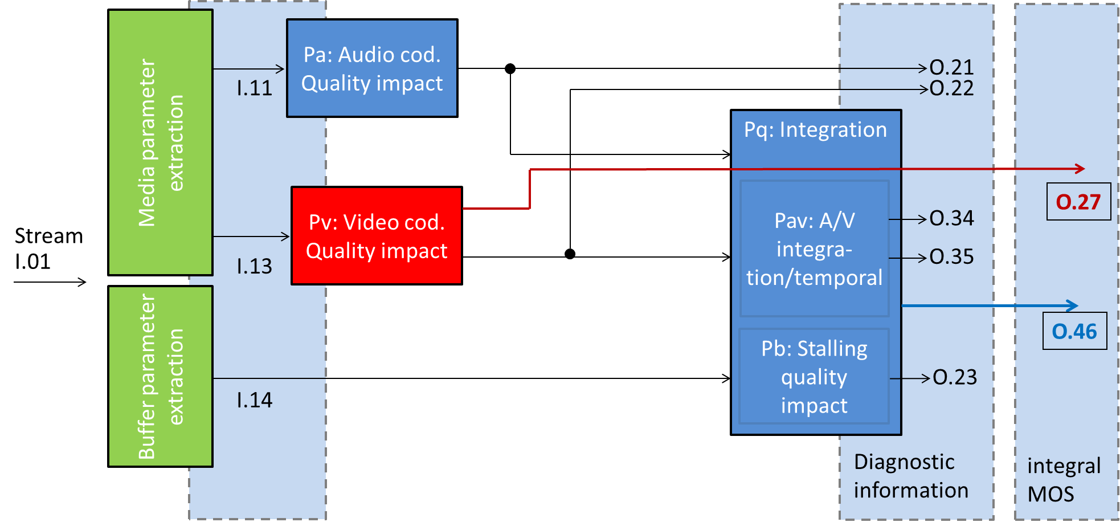

Figure 1 (a): Building blocks of the bitstream model (track1), only red shaded blocks will be developed, blue blocks are taken from P.1203 for characterization
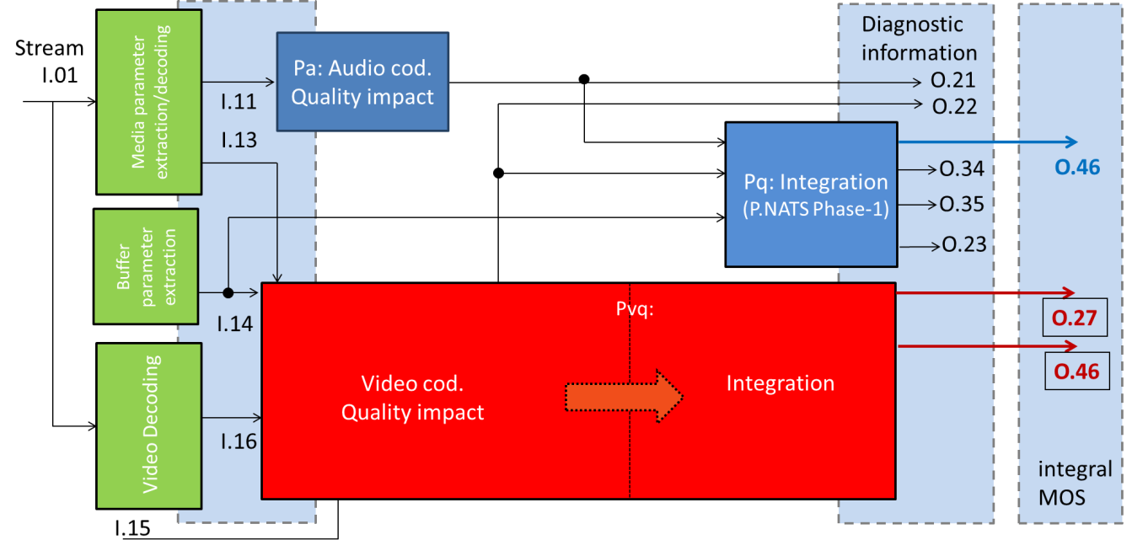
Figure 1 (b): Building blocks of the pixel-based (track2) and hybrid models (track3), only red shaded blocks will be developed, blue blocks are taken from P.1203 for characterization
The individual outputs can be summarized as follows:
- O.27: Final short-term video coding quality score
  - Single score for each short-length video, on 1-5 quality scale
  - Excludes aspects of temporal integration with initial- or re-buffering
- O.46: Final media session quality score
  - Single score for the session, on a 1-5 quality scale
  - Includes initial buffering and stalling and rate adaptivity aspects.
- O.22: Video coding quality per output sampling interval
  - Multiple segment scores provided per session and on a 1-5 quality scale
- O.21: Audio coding quality per output sampling interval
  - Multiple segment scores provided per session and on a 1-5 quality scale

- O.23: Perceptual buffering indication
  - Single score on a 1-5 quality scale for the session
- O.34: Audiovisual segment coding quality per output sampling interval
  - Multiple segment scores provided per session
- O.35: Final long-term audiovisual coding quality score
  - Single score for the session, on a 1-5 quality scale
  - Includes aspects of temporal integration with initial- or re-buffering

It is noted that the output nomenclature can be read as follows: The last number is incrementally specifying the index of the output, the first number specifies the level at which the information is obtained (the higher, the closer to the final media session quality score).
Requirements on parties
Interested parties are requested to announce their participation by 17 February 2017, and may then take part in continue creating a set of documents specifying the project layout and modus operandi. Note that many documents are already available and have been agreed by the proponents who provisionally have responded to the call for participation. New parties need to accept the decisions concerning the project already agreed by the parties already participating. The parties which take part in in the coming steps can then contribute to drafting the required documents, and take part in finally creating the new AVHD-AS/P.NATS Phase 2 Recommendation. This work will include producing four databases per proponent.
The announcement of participation in the mentioned project is divided into two steps:
- Interested parties had to announce their provisional intention to participate in the AVHD-AS/P.NATS Phase 2 development by 9 January 2017 to tsbsg12@itu.int. This deadline has passed and eleven companies have indicated provisionally their participation in this project.
- A binding commitment to participate in the AVHD-AS/P.NATS Phase 2 development has to be made by 17 February 2017 to the secretariat of ITU-T SG12 (tsbsg12@itu.int), and to the VQEG AVHD Co-Chairs (cs@opticom.de; Quan.Huynh-Thu@cisra.canon.com.au; mpinson@ntia.doc.gov). Note that parties not responding to the first provisional call are welcome to join the project by answering to this second call. The final commitment is based on a Requirement Specification and Terms of Reference for AVHD-AS/P.NATS Phase 2 that is considered as sufficient by Q14/12 and VQEG/AVHD for starting the development work, and which will be established jointly involving all declared participants according to this call for participation. It is noted that in case of later withdrawal, leaving parties have to grant usage of their already contributed test databases. These aspects will be, as it was done for example for the P.NAMS & P.NBAMS, POLQA and P.NATS development, legally handled outside ITU-T/VQEG using a respective agreement between the parties.

Draft overview time plan

Date (Tentative) | Result/activity completed
13 December 2016 | Call for indication of participation sent out  Stable ToR available  Draft requirement specification
9 January 2017 | Deadline for indication of participation
End of SG12 January meeting | Updates (if any) for requirement specification and ToR  Draft test specification available
17 February 2017 | Deadline response for binding call for participation
May 2017 | All details of test and processing chain set
August 2017 | Training databases submitted
November 2017 | Model submission

Communication
Participants are encouraged to respond to this call for participation as indicated above. Participants are also encouraged to subscribe to the e-mail reflector of AVHD-AS/P.NATS Phase 2 (pnats2avhd@lists.itu.int), to join the AVHD-AS/P.NATS Phase 2 conference calls announced on the email reflector, and to participate in the in-person project meetings. An ITU TIES or Guest account is required to subscribe. Participants can register for a Guest account at https://www.itu.int/net/iwm/public/frmUserRegistration.aspx and sign up for the e-mail reflector at https://www.itu.int/net4/iwm/?p0=0&p11=ITU&p12=ITU-SEP-ITU-T-SEP-Other%20Groups-SEP-pnats2avhd&p21=ITU&p22=ITU-SEP-ITU-T-SEP-Other%20Groups-SEP-pnats2avhd.
More information about Study Group 12 can be found at:
https://www.itu.int/en/ITU-T/studygroups/2017-2020/12/.
More information about VQEG can be found at http://www.its.bldrdoc.gov/vqeg/.

______________

