International telecommunication union
Telecommunication Standardization Bureau
 |  |  | Geneva, 22 March 2017
Ref: | TSB Circular 16  TSB Workshops/SP |  | To:  - To Administrations of Member States of the Union;  - To ITU-T Sector Members;  - To ITU-T Associates;  - To ITU Academia
Contact: | Stefano Polidori
Tel: | +41 22 730 5858
Fax: | +41 22 730 5853
E-mail: | tsbworkshops@itu.int |  | Copy:  - To the Chairman and Vice-Chairmen of ITU-T Study Groups;  - To the Director of the Telecommunication Development Bureau;  - To the Director of the Radiocommunication Bureau
Subject: | ITU Workshop on TV and content delivery on Integrated Broadband Cable Networks  Hangzhou, China, 26 May 2017
Dear Sir/Madam,
1 I would like to inform you that an ITU workshop on TV and content delivery on Integrated Broadband Cable Networks will take place in Hangzhou, China on 26 May 2017. The workshop is collocated with the Study Group 9 (Broadband cable and TV) meeting (24-31 May 2017), details of which are in TSB Collective Letter 1/9.
The workshop will open at 0930 hours. Participant registration will begin at 0830 hours at the venue entrance. Additional practical information about the meeting is set forth in Annex A.
2 Discussions will be held in English only.
3 Participation is open to any individual from a country that is a member of ITU who wishes to contribute to the work. The workshop especially targets cable operators, service providers, vendors, research institutions, academia, as well as international, regional and national SDOs, and other interested organizations. Participation at the workshop is free of charge.
4 The event aims to push the frontiers on content delivery for the integrated broadband cable telecommunication networks and provide an overview of recent cable technology trends and strategies.
The cable industry, including service providers and vendors, faces a rapidly evolving and highly competitive environment, which is mainly triggered by technological innovation and customer demand for high-definition and innovative television services that can captivate users by providing revolutionary experiences, such as virtual reality and augmented reality.
In this landscape, standards developing organizations (SDOs) are also required to move rapidly to keep up with these innovations and develop standards on new broadband and video technologies, which may eventually be adopted and deployed in products and services to meet customer demand.
5 The workshop aims to:
– share information on recent cable broadband and television technology trends;
– explore strategies to provide users with captivating viewing experiences;
– analyse current standardization activities and identify gaps;
– review key technical domains and identify priorities for future standardization;
– discuss how various standards bodies can work in concert to achieve these goals.
6 An exhibition will be organized during the workshop. Experts are invited to showcase recent research in the field of cable networks, which will interest and energize future standardization work. Exhibitors will be accepted on a first-come, first-serve basis, given the limited supply of exhibition space. Experts interested in exhibiting their work are requested to submit their application to exhibit before 15 April 2017. The application form can be found on the workshop webpage and in Annex C below, and should be submitted to the host at ouyangfeng@abs.ac.cn copying tsbsg9@itu.int.
7 A draft programme of the workshop will be made available from the workshop webpage. The workshop plans to cover the following topics:
a) Latest trends in cable television business and technologies.
b) Integrated services (TV, content and associated applications) delivery mechanisms and/or networks.
c) Innovative types of TV services, experiences and technologies, e.g., AR, VR, 3D, UHDTV (4k/8k), smart home, IoT).
d) Integrated smart terminals and/or related software.
e) Platforms for converged services for integrated broadband broadcast networks.
f) Planning, implementation and deployment of cable television systems, networks and services, particularly for developing countries.
8 Updated information relating to the workshop will be available on the event website at:
http://www.itu.int/en/ITU-T/Workshops-and-Seminars/201705/Pages/default.aspx.
10 To enable TSB and the host country to make the necessary arrangements concerning the organization of the workshop, I should be grateful if you would register via the online form http://itu.int/reg/tmisc/3000968 as soon as possible, but not later than 11 May 2017. Please note that pre-registration of participants for workshops is carried out exclusively online.
11 I would remind you that citizens of some countries are required to obtain a visa in order to enter and spend any time in China. The visa must be requested at least four (4) weeks before the date of beginning of the workshop and obtained from the office (embassy or consulate) representing China in your country or, if there is no such office in your country, from the one that is closest to the country of departure. Please see Annex B for an invitation letter and be aware that visa approval might cause delays so kindly make your visa request as soon as possible.
Yours faithfully,

Chaesub Lee
Director of the Telecommunication
Standardization Bureau
Annexes: 3
ANNEX A
PRACTICAL INFORMATION
(Please see an updated version of this practical information on the workshop webpage)

Meeting Venue
Zhejiang Hotel
Hotel Reservations: +86-571-87180808
Address: No. 278 Santaishan Road, Hangzhou, Zhejiang, China
http://www.zhejianghotel.com/en/reservation.html
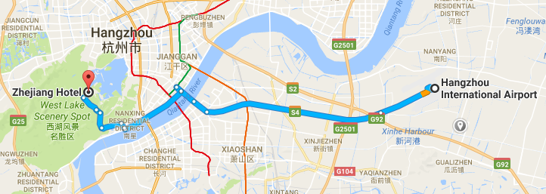

Transportation and site information
35 km to Xiao Shan International Airport; 10 km to the railway station; 20 km to the south railway station; 0 km to the West Lake.

Passports and Visas
All foreign visitors entering China must have a valid passport. Visitors from countries whose citizens require a visa should apply for a visa at a Chinese Embassy or consulate as early as possible and well in advance of travel.
For an invitation letter, please see Annex B.

Climate (end of May in Hangzhou)
Monthly average values for temperature and precipitation in Hangzhou are given in the table below:
 | May
Average max temperature | 25C / 77F
Average minimum temperature | 17C / 63F
Average precipitation | 157 mm

Hotels
In addition to the hotel venue, Zhejiang Hotel (see item 1 above), other close hotels are:
5.1 Hangzhou Sunday Sunny Resort
http://www.hzstsz-hotel.com
Hotel Reservations: +86-571-87975888
Address: No. 200 Santaishan Road, Hangzhou, Zhejiang, China
The distance from Hangzhou Sunday Sunny Resort to the meeting venue is approximately 0.5 km.
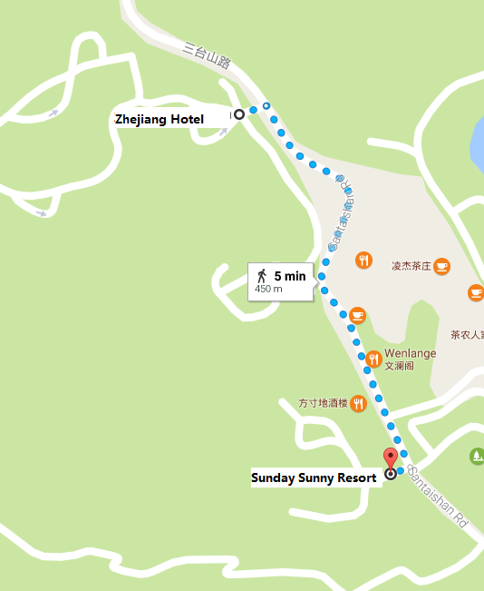

5.2 West Lake State Guest Hotel
http://www.xihusgh.com
Hotel Reservations: +86-571-87979889
Address: 18 Yanggongti Road, Hangzhou, Zhejiang, China
The distance from West Lake State Guest Hotel to the meeting venue is approximately 2 km.
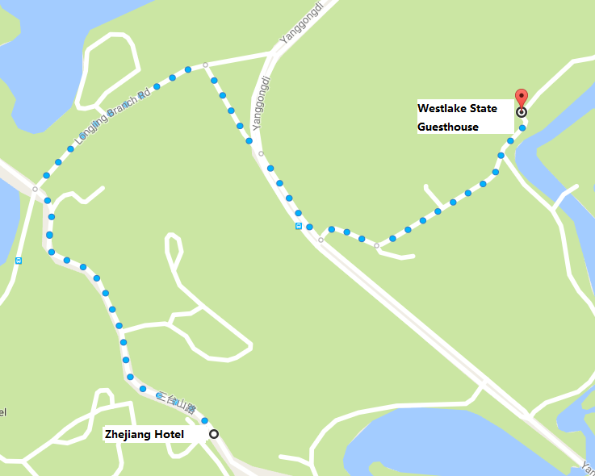

Internet access and wireless coverage at the venue
All meeting rooms will have a wireless network with access to the Internet. Every guest room offers high-speed Internet access free of charge. Internet access will be provided using the LAN technologies listed below:
Wireless via Wi-Fi: IEEE 802.11a/n on 5.2 GHz and 802.11g/n on 2.4 GHz.

Technical assistance
In case you have any technical problem at the venue (e.g., connecting to Internet, finding meeting rooms, etc.) please contact for help:
Mr Luo Xinqi: +86 13588774554 luoxq@wasu.com.

Electricity
The electricity in China is generally 220V, 50 Hz. Please make sure you have the proper adapter.
Chinese standard
Such sockets are common in China, Australia, New Zealand and many other countries.

Currency exchange
The currency in China is the RMB Yuan (￥), the exchange rate of US$ and RMB is around 6.878. Please check the currency exchange rate in the local bank system or use the following link as a reference: http://www.xe.com/

Additional information
10.1 Mobile phone: GSM and CDMA, WCDMA, TD-SCDMA, TD-LTE services provided by China Mobile, China Unicom and China Telecom.
10.2 Tipping: Tipping is not necessary.
10.3 Time zone: GMT+8:00.
10.4 Emergency number: In case of emergency, please dial 110.
10.5 Sightseeing: For more information see http://en.gotohz.com/

Contact person
Mr OUYANG Feng: +86 13511029034 (ouyangfeng@abs.ac.cn).

ANNEX B
INVITATION LETTER REQUEST FORM
All foreign visitors entering China must have a valid passport. Visitors from countries whose citizens require a visa should apply for a visa at a Chinese Embassy or Consulate as early as possible and well in advance of travel. You may need a letter of invitation from the Chinese host, which you will need to present to the Chinese Embassy/Consulate in your area in order to obtain your visa. The visa must be requested as soon as possible and at least one month before the start date of the meeting and obtained from the office (Embassy or Consulate) representing China in your country or, if there is no such office in your country, from the one that is closest to the country of departure. In order to obtain an invitation letter, please:
a) Complete the form below.
b) Provide an electronic copy of your passport (name, date of birth, nationality, passport number, expiration date of passport, etc., must be seen clearly).
c) Provide an electronic copy of any previous Chinese visas and records.
d) Send the information in a), b) and c) as email attachments to gebing@abs.ac.cn and ouyangfeng@abs.ac.cn; please mark as reference in the subject “Invitation letter request for ITU Workshop on TV and content delivery on Integrated Broadband Cable Networks
Hangzhou, China, 26 May 2017”.
(It is recommended to scan your passport so that it is discernible and can be used).
Company
Applicant Information |  |  |  | Mr Miss Ms Mrs
 |  |  |  | Date of birth :
 |  |  |  | Place of Issue:
 | Date of Issue: |  |  | Date of Expiry:
 | Marital Status:
 | If the country in which you will obtain your visa is different from your nationality, please indicate it here:
Address | Telephone Number:  Fax Number:  E-mail:
Note
Date of arrival in China |  |  | Date of departure from China
(Please do not forget to attach a copy of your passport photograph page before sending.)
In order to receive an invitation letter, your request should reach the host before 24 April 2017.
ANNEX C
EXHIBITORS’ APPLICATION FORM
ITU Workshop on TV and content delivery on Integrated Broadband Cable Networks
(Hangzhou, China, 26 May 2017)
Note: Please complete and return to ouyangfeng@abs.ac.cn (cc: tsbsg9@itu.int) by 15 April 2017 to reserve a booth. Considering the limited space and options, all participants should provide their own computers and storage, and please keep them to a minimum.

Company name | Contact person including contact details | E-mail address

Type of equip. to be displayed

Item(s) required | Description | Quantity
Tables
Chairs
Flat screens
Network switch
Power supply
Space required
Panels
Power consumption expected for equipment:
Dimension, weight of equipment
Additional notes
(if any)

________________________

