International telecommunication union
Telecommunication Standardization Bureau
 |  |  | Geneva, 26 May 2017
Ref: | TSB Circular 28  TSB Workshops/TK |  | To:  - To Administrations of Member States of the Union;  - To ITU-T Sector Members;  - To ITU-T Associates;  - To ITU Academia
Contact: | Tatiana Kurakova
Tel: | +41 22 730 5126
Fax: | +41 22 730 5853
E-mail: | tsbworkshops@itu.int |  | Copy:  - To the Chairman and Vice-Chairmen of ITU-T Study Groups;  - To the Director of the Telecommunication Development Bureau;  - To the Director of the Radiocommunication Bureau
Subject: | IMT-2020/5G Workshop and Demo Day  Geneva, Switzerland, 11 July 2017
Dear Sir/Madam,
1 I would like to inform you that IMT-2020/5G Workshop and Demo Day will take place at ITU headquarters, Geneva, on 11 July 2017. The Workshop will continue the practice of showcase of proofs of concepts and demonstrations of future 5G technologies.
The workshop will open at 0900 hours. Participant registration will begin at 0830 hours at the Montbrillant entrance. Detailed information concerning the meeting rooms will be displayed on screens at the entrances to ITU headquarters.
2 This workshop will be held in English only.
3 Participation is open to ITU Member States, Sector Members, Associates and Academic Institutions and to any individual from a country that is a member of ITU who wishes to contribute to the work. This includes individuals who are also members of international, regional and national organizations. Participation at the workshop is free of charge but no fellowships will be granted.
4 The workshop intends to offer a platform for all involved stakeholders and aims to:
• Give an overview of SG13 standardization work and future plan on IMT-2020 wireline as well as the work and plan of other ITU-T study groups on this topic;
• Present the achievements and current activities of the industry (operators, vendors) on IMT 2020;
• Discuss current technical issues and future plans of ITU-T members and other SDOs in relation with IMT-2020 infrastructures, applications and services;
• Demonstrate the IMT-2020 related prototype through a Demo show session of around two hours.
5 Information relating to the workshop, including the draft programme, will be available on the event website at the following address: www.itu.int/en/ITU-T/Workshops-and-Seminars/201707/Pages/default.aspx. This website will be regularly updated as new or modified information become available. Participants are requested to check periodically for new updates.
6 The workshop will be taking place concurrently with the SG11 and SG13 co-located rapporteur meetings in Geneva from 3 to 14 July 2017.
7 Wireless LAN facilities are available for use by delegates in the main ITU conference room areas. Detailed information is available on the ITU-T website (http://www.itu.int/ITU-T/edh/faqs-support.html).
8 A number of Geneva hotels offer preferential rates for delegates attending ITU meetings, and provide a card giving free access to Geneva’s public transport system. A list of participating hotels, and guidance on how to claim discounts, can be found at: http://itu.int/travel/.
9 To enable TSB to make the necessary arrangements concerning the organization of the workshop, I should be grateful if you would register via the online form http://itu.int/reg/tmisc/3000983 as soon as possible, but not later than 26 June 2017. Please note that pre-registration of participants for workshops is carried out exclusively online.
10 I would remind you that citizens of some countries are required to obtain a visa in order to enter and spend any time in Switzerland. The visa must be requested at least four (4) weeks before the date of beginning of the workshop and obtained from the office (embassy or consulate) representing Switzerland in your country or, if there is no such office in your country, from the one that is closest to the country of departure.
If problems are encountered by ITU Member States, Sector Members, Associates or Academic Institutions, and at the official request made by them to TSB, the Union can approach the competent Swiss authorities in order to facilitate delivery of the visa but only within the period mentioned of four weeks. Any such request should be made by official letter from the administration or entity you represent. This letter must specify the name and functions, date of birth, number, dates of issue and expiry of the passport of the individual(s) for whom the visa(s) is/are requested and be accompanied by a copy of the notification of confirmation of registration approved for the ITU-T workshop in question, and must be sent to TSB by fax (+41 22 730 5853) or e-mail (tsbreg@itu.int), bearing the words “visa request”. Please also note that ITU can assist only representatives of ITU Member States, ITU Sector Members, ITU Associates and ITU Academic Institutions.
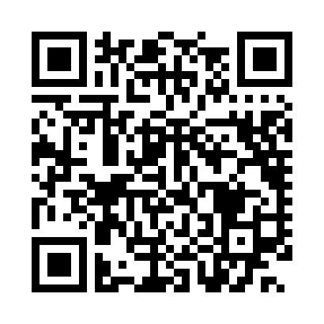
Latest meeting information
Yours faithfully,

Chaesub Lee
Director of the Telecommunication
Standardization Bureau

