|  |  |  |  |  |
| --- | --- | --- | --- | --- |
| The International Teleocmmunication Union - Connecting the World. | | **International telecommunication union**  **Telecommunication Standardization Bureau** | |  |
|  | | | Geneva, 29 August 2018 | |
| **Ref:** | **TSB Circular 110** | | **To:**  - Administrations of Member States of the Union;  - ITU-T Sector Members;  - ITU-T Associates;  - ITU Academia | |
| **Tel:** | +41 22 730 6805 | |
| **Fax:** | +41 22 730 5853 | |
| **E-mail:** | [tsbfgvm@itu.int](mailto:tsbfgvm@itu.int) | | **Copy to:**  - The Chairmen and Vice-Chairmen of ITU-T Study Groups;  - The Director of the Radiocommunication Bureau;  - The Director of the Telecommunication Development Bureau | |
| **Subject:** | **Creation of a new ITU-T Focus Group on Vehicular Multimedia (FG-VM) and its first meeting to be held in Ottawa, Ontario, Canada on 11 October 2018** | | | |

Dear Sir/Madam,

1 Further to the agreement by ITU-T Study Group 16 at its meeting in Ljubljana (9-20 July 2018), I am pleased to announce the establishment of the ITU-T Focus Group on Vehicular Multimedia (FG-VM), with Mr Jun Li (TIAA, People’s Republic of China) as chairman and Ms Gaëlle Martin‑Cocher (Blackberry, Canada) as vice-chairman.

2 The focus group will analyse and identify gaps in the vehicular multimedia standardization landscape and draft technical reports and specifications covering, among others, vehicular multimedia use cases, requirements, applications, interfaces, protocols, architectures and security.

3 Participation in FG-VM is free of charge and open to all, including governments, automotive and telecom/ICT industries and associations, academia and research institutions, non‑ITU Members and individuals. Anyone interested in updates and announcements related to this group is invited to subscribe to the FG-VM mailing list. Details on how to subscribe can be found on the FG-VM homepage: <https://itu.int/go/fgvm>.

4 The focus group’s lifetime is set for two years from the first meeting but is extensible if necessary by the decision of the parent group. It will operate under the procedures set out in [Recommendation ITU‑T A.7](http://www.itu.int/rec/T-REC-A.7) and within the agreed Terms of Reference reproduced in Annex 1.

5 The **first meeting of FG-VM** will be held at the BlackBerry/QNX Ottawa Office, Ontario, Canada, on 11 October 2018, kindly hosted by BlackBerry.

The **objectives** of the first meeting include:

– Discussion on Vehicular Multimedia: use cases, requirements, applications, interfaces, protocols, architectures, security, etc.;

– Appointment of FG-VM management, including additional vice-chairs;

– Agreement on the FG-VM working structure, including establishment of working groups (WGs) on specific topics and appointment of relevant WG Chairs;

– Agreement on a FG-VM roadmap of expected deliverables, identifying timeline, scopes and editors and assigning responsibilities to the various WGs;

– Agreement on FG-VM working methods, using as a base ITU-T A.7;

– Agreement on FG-VM future meeting plans, including frequency of meetings.

6 In line with the terms of reference set out in **Annex 1, written contributions are invited** for the first meeting of the Focus Group on Vehicular Multimedia to address the objectives highlighted above and especially to foster an initial development plan of deliverables.

7 Written contributions should be submitted to the secretariat ([tsbfgvm@itu.int](mailto:tsbfgvm@itu.int)) in electronic format using the [template](https://www.itu.int/en/ITU-T/focusgroups/vm/Documents/FG-VM-I-template.docx) available from the FG-VM homepage. **The deadline is 4 October 2018.**

8 The meeting will **start at 0930 hours** on the first day, and participant registration will begin at 0830 hours at ***BlackBerry/QNX, 1001 Farrar Road, Ottawa, Ontario Canada, K2K 0B3***. Practical meeting information is set out in **Annex 2**,and a visa support letter can be requested using the form in **Annex 3**. The meeting agenda will be available from the FG-VM homepage in advance of the meeting. The discussions will be held in English only, and will be supported by **remote participation**; details will be made available on the FG-VM homepage.

9 To enable the host to make the necessary logistics arrangements, participants are required to **pre-register online** via the FG-VM homepage as soon as possible, and **no later than   
4 October 2018**. Places are limited and registration will be handled on a **first-come, first-served basis**. Registration is required for remote participation as well as on-site participation.

10 Finally, please note that a workshop on ***"How communications will change vehicles and transport"***, jointly organized by SAE International and ITU, will be held from 8-9 October 2018, in Detroit, MI, United States. Interested participants are invited to relocate to Ottawa on 10 October 2018 for the kick-off of the FG-VM meeting on 11 October 2018. Participation in the workshop is also free of charge and open to all. More details about the workshop can be found at <http://itu.int/go/ITS-SAE/2018>.

**Key deadlines:**

|  |  |
| --- | --- |
| 11 September 2018 (soft deadline) | - Submit requests for visa support letters (see **Annex 3**) |
| 4 October 2018 | - Pre-registration (online via the [FG-VM homepage](https://www.itu.int/en/ITU-T/focusgroups/vm))  - Submit written contributions (by e-mail to [tsbfgvm@itu.int](mailto:tsbfgvm@itu.int)) |

I wish you a productive and enjoyable meeting.

|  |  |
| --- | --- |
| Yours faithfully,  *(signed)*  Chaesub Lee Director of the Telecommunication Standardization Bureau | Latest meeting information |

**Annexes: 3**

ANNEX 1  
  
Terms of Reference:  
ITU-T Focus Group on "VEHICULAR MULTIMEDIA" (FG-VM)

(Approved by ITU-T SG16 on 20 July 2018)

## 1. Rationale and Scope

With the convergence of different networks, the vehicle will change from a transport tool to an infotainment space and smart living platform. As ADAS (Advanced Driver Assistance System) and automatic driving technology is evolving, the vehicle will be the 3rd living and infotainment space besides home and office.

As for vehicular multimedia contents, satellite broadcasting and satellite communication (for example, mobile broadcasting satellite, low-orbit satellite constellation and high-orbit high-throughput communication satellite) will play an important role due to their advantages of wide coverage, low investment, fast transmission speed and high flexibility. The convergence of networks will provide low cost, wide coverage and good interactivity for vehicular multimedia solution.

Meanwhile, vehicular multimedia terminals are also evolving to support networks integration, contents integration, intelligent display, intelligent voice interaction, high-precision navigation and various applications as well as interconnection between in-vehicle devices and nomadic devices.

A Focus Group on Vehicular Multimedia (FG-VM) is established to identify the need for new vehicular multimedia standards based on space and terrestrial networks integration. The study will evaluate related software, hardware, and valued-added service to derive use cases. It focuses on vehicular multimedia services and infotainment applications, not aiming at changing existing transmission protocols and channels, such as terrestrial broadcasting, satellite broadcasting, and mobile cellular network. The FG-VM will also leverage the work done by ITU in its previous Focus Group on Driver’s Distraction [1], ITU-T SG16 Q27/16 and the ITU-T P.1100-P.1199 series [2] when relevant.

## 2. Objectives

The objectives of FG-VM is to conduct an analysis of vehicular multimedia in order to identify relevant gaps and issues in standardization activities related to this topic, to derive use cases, possible requirements and architectures. The group also serves as an open platform for experts representing ITU members and non-members to quickly move forward studies on technology, standard and application relevant to vehicular multimedia.

More precisely, the objectives include:

1) To study, gather information and develop a standards research orientation and standards research plan related to vehicular multimedia in the fields of intelligent voice interaction, interconnection between vehicular terminal and smart phone, connectivity for high precision navigation and various other applications;

2) To develop corresponding use cases and requirements of vehicular multimedia enabled by converged networks;

3) To study architectures, interfaces, protocols, data formats, interoperability, performance evaluation, security and protection of personal information for vehicular multimedia;

4) To produce a gap analysis of vehicular multimedia standardization in order to identify the relevant scope of possible future ITU-T Recommendations on these topics and develop a roadmap for vehicular multimedia;

5) To establish liaisons and relationships with other organizations which could contribute to the standardization activities for vehicular multimedia.

## 3. Structure

The FG-VM will establish working groups as needed.

## 4. Specific Tasks and Deliverables

– To provide terminology and taxonomy for VM;

– To gather information on initiatives pertaining to VM enabled by converged networks and to identify existing standards, best practises and challenges for the adoption of VM in the context of converged networks;

– To describe the VM ecosystem enabled by converged networks and the roles and activities of the different stakeholders of this ecosystem;

– To define possible requirements on VM;

– To draft technical reports for VM enabled by converged networks which may include architectures, interfaces, protocols and data formats;

– To send the final deliverables to ITU-T Study Group 16 at least four calendar weeks before the parent group’s next meeting in accordance with Recommendation ITU-T A.7;

– To analyse the standardization gaps related to VM and develop a future standardization roadmap, taking into consideration the activities currently undertaken by other ITU groups, various standards developing organizations (SDOs) and forums;

– To develop a list of SDOs, forums, consortia and other entities dealing with aspects of VM and liaise with the organizations that could contribute to the standardization activities on VM;

– To organise thematic workshops and forums on VM to bring together all stakeholders, and promote the FG-VM activities and encourage both ITU members and non-ITU members to join its work.

NOTE – The needs of persons with disabilities will be taken into account in undertaking the tasks above and preparation of deliverables. It is expected that using vehicular multimedia will improve the user experience and will increase driving safety for persons with disabilities.

## 5. Relationships

This Focus Group will work closely with SG16 through co-located meetings when possible. It will establish and maintain task-appropriate collaboration arrangements with other groups in ITU.

The FG-VM will collaborate with,

– ITU-T SG12 to leverage the P.1100-P.1199 series on communications involving vehicles and the outcomes of the Focus Group on Driver Distraction

– ITU-R SG4 and SG5 on connectivity for high precision navigation

– ITU-T SG17 on security and protection of personal information for vehicular multimedia

– ITU-T Q27/16 on vehicle gateway platform for telecommunication and ITS services and applications

Furthermore, the FG-VM will collaborate (as required) with other relevant groups and entities, in accordance with Recommendation ITU-T A.7. These include governments, non-governmental organizations (NGOs), policy makers, SDOs, industry forums and consortia, companies, academic institutions, research institutions and other relevant organizations.

## 6. Parent group

The parent group of the FG-VM is **ITU-T Study Group 16** "Multimedia coding, systems and applications".

## 7. Leadership

See clause 2.3 of Recommendation ITU-T A.7.

## 8. Participation

See clause 3 of Recommendation ITU-T A.7. A list of participants will be maintained for reference purposes and reported to the parent group.

It is important to mention that the participation in this Focus Group has to be based on contributions and active participations.

## 9. Administrative support

See clause 5 of Recommendation ITU-T A.7.

## 10. General financing

See clauses 4 and 10.2 of Recommendation ITU-T A.7.

## 11. Meetings

The Focus Group will conduct regular meetings. The frequency and locations of meetings will be determined by the Focus Group management. The overall meetings plan will be announced after the approval of the terms of reference. The Focus Group will use remote collaboration tools to the maximum extent, and collocation with existing SG16 meetings is encouraged.

The meeting dates will be announced by electronic means (e.g., e-mail and website, etc.) at least four weeks in advance.

## 12. Technical contributions

See clause 8 of Recommendation ITU-T A.7.

## 13. Working language

The working language is English.

## 14. Approval of deliverables

Approval of deliverables shall be taken by consensus.

## 15. Working guidelines

Working procedures shall follow the procedures of Rapporteur meetings. No additional working guidelines are defined.

## 16. Progress reports

See clause 11 of Recommendation ITU-T A.7.

## 17. Announcement of Focus Group formation

The formation of the Focus Group will be announced via TSB Circular to all ITU membership, via the ITU-T Newslog, press releases and other means, including communication with the other involved organizations.

## 18. Milestones and duration of the Focus Group

The Focus Group lifetime is set for two years from the first meeting but extensible if necessary by decision of the parent group. (see ITU-T A.7, clause 2.2).

## 19. Patent policy

See clause 9 of Recommendation ITU-T A.7.

## 20. References

[1] ITU-T Focus Group on Driver Distraction, <https://itu.int/en/ITU-T/focusgroups/distraction>

[2] ITU-T P.1100-P.1199 on Communications involving vehicles, <https://itu.int/rec/T-REC-P>

ANNEX 2  
  
Practical meeting information for participants

**WORKING METHODS AND FACILITIES**

**DOCUMENT SUBMISSION AND ACCESS:** The meeting will be run paperless. Written contributions to the focus group meeting are encouraged and should be submitted by e-mail to tsbfgvm@itu.int by **4 October 2018** at the latest using the document [template](https://staging.itu.int/en/ITU-T/focusgroups/vm/Documents/FG-VM-I-template.docx) available on the [FG-VM homepage.](https://www.itu.int/en/ITU-T/focusgroups/vm) Access to all input and output documents will be provided from the [collaboration site for FG‑VM](https://extranet.itu.int/sites/itu-t/focusgroups/vm/SitePages/Home.aspx) (a free [ITU user account](https://www.itu.int/en/ties-services/Pages/default.aspx) is required).

**WIRELESS LAN** facilities are available at the meeting venue.

**PRE-REGISTRATION**

**PRE-REGISTRATION:** Pre-registration for on-site or remote participation is to be done via the FG‑VM homepage **no later than 4 October 2018.**

**PRACTICAL INFORMATION**

## Meeting venue

BlackBerry/QNX Ottawa address:

1001 Farrar Road

Ottawa, Ontario

Canada, K2K 0B3

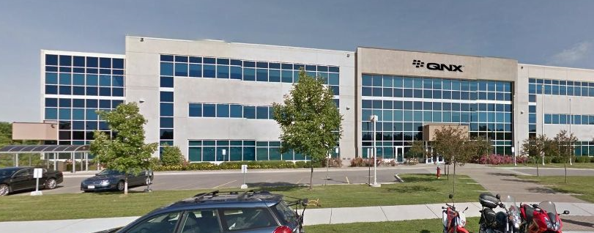

Please see below a map:

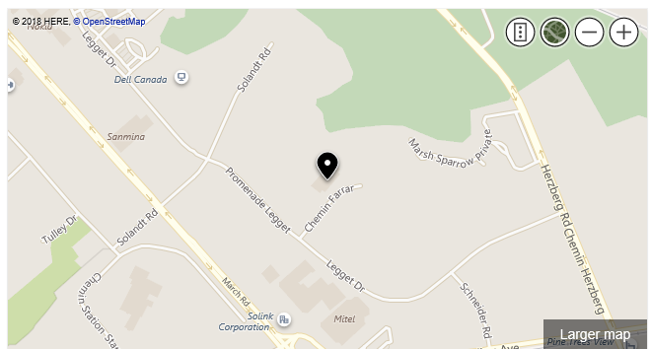

## Transportation and site information

The Ottawa Macdonald-Cartier International Airport (<https://yow.ca/en>) is 30 minutes from the meeting venue by car, depending on traffic.

Rental car agencies are available at the airport:  
<https://yow.ca/en/parking-transportation/car-rentals>

Taxis are also available:  
<https://yow.ca/en/parking-transportation/ground-transportation-options>

There is no direct public bus line from the airport to the meeting venue.

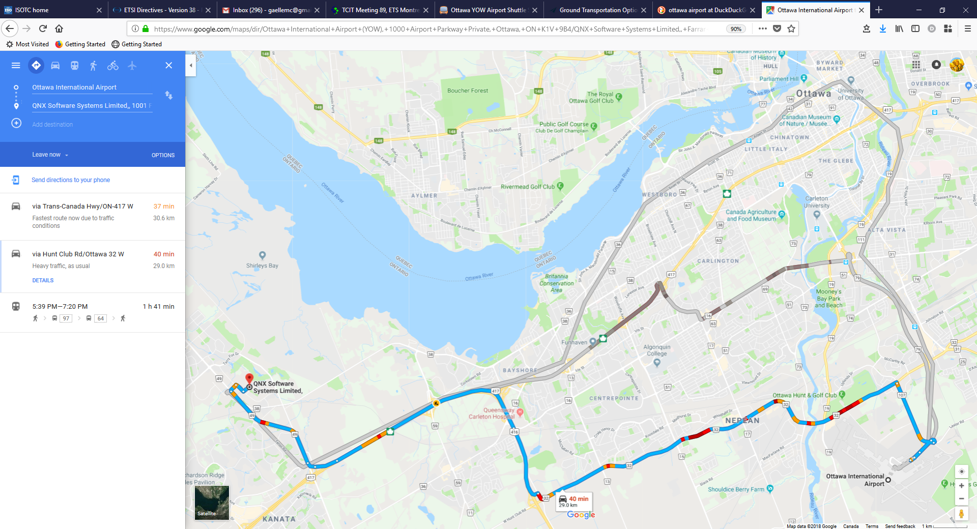

## Passports and visas

All foreign visitors entering Canada must have a valid passport. Visitors from countries whose citizens require a visa should apply for a visa at a Canadian Embassy or consulate at the earliest opportunity, and well in advance of travel.

See below for more information related to entry into Canada.

The entry requirements per country are available at this link:

<https://www.canada.ca/en/immigration-refugees-citizenship/services/visit-canada/entry-requirements-country.html#visarequired>

Visitors to Canada need an eTA or a visa.

– [Visa application](http://www.cic.gc.ca/english/information/applications/visa.asp)

– [eTA application](https://www.canada.ca/en/immigration-refugees-citizenship/services/visit-canada/eta.html)

For visitors from China, please click on the following [link](http://www.visitorstocanada.com/requirements-chinese-visiting-canada.html) for more information related to entry into Canada:  
<http://www.visitorstocanada.com/requirements-chinese-visiting-canada.html>

To request an invitation letter from the host for visa purposes, please use the form in **Annex 3**.

The focal point for visa support in Blackberry/QNX, Canada is:

Mrs Lisa Raad

E-mail: [lraad@blackberry.com](mailto:lraad@blackberry.com)

Tel: +1 289 261 4061

## Climate in early October in Ottawa, Canada

Monthly average values of the temperature and precipitation in Ottawa, Canada are given in the table below:

|  |  |
| --- | --- |
|  | **October** |
| Average max. temperature | 13°C or 55°F |
| Average min. temperature | 3°C or 37°F |
| Average precipitation | 74.7mm or 2.9” |

Please click on this [link](https://www.accuweather.com/en/ca/ottawa/k1y/october-weather/55487) for a long-range weather forecast during the month of October.

It is advisable to bring a jacket as the days may be warm and sunny, but the evening temperature will drop.

## Hotels

The closest hotel to the venue (walking distance) is the **Brookstreet Hotel**. <https://www.brookstreethotel.com/index.php>

Reservations: +1-888-826-2220

A preferential nightly rate can be obtained by mentioning BlackBerry at the time of booking.

Other hotels in the vicinity are:

**Homewood Suites** by Hilton Ottawa Kanata

[www.homewoodsuites3.hilton.com](http://www.homewoodsuites3.hilton.com)

Tel: +1-613-270-2050

# Holiday Inn & Suites

[www.hisottawa.ca](http://www.hisottawa.ca)

Tel: +1-613-271-3057

# Comfort Inn Ottawa West

[www.comfortinnkanata.com](http://www.comfortinnkanata.com)

Tel: +1-613-592-2200

# Fairfield Inn & Suites by Marriott

[www.marriott.com](http://www.marriott.com)

Tel: +1-613-599-7767

## Internet access and wireless coverage at the venue

Wireless Internet will be provided to you by the host. Access is granted via a logon and password.

## Technical assistance

In case you have any technical problems at the venue (e.g., connecting to the Internet, finding meeting rooms, etc.) please see the host on site.

## Electricity

The electricity in Canada is generally 120 V, 60 Hz. Please make sure you have the proper adapter and transformers as needed (see image below). Additional information can be found at: <http://www.walkabouttravelgear.com/c_can.htm>



## Useful information

*Currency exchange*

The currency in **Canada** is the **Canadian dollar (CAD)**; please check the currency exchange rate in the local bank system or use the following link as a reference: <http://www.xe.com/>

## Additional information

**10.1 Mobile phones:** Mobile phone service, or cellular, or cell phone service in Canada is the same as in the United States, but different from that in the rest of the world. There are two basic systems, CDMA and GSM (including AWS, UMTS, HSPA, LTE). GSM is used in most of the world but the North American system uses different frequencies.More information is available [here](https://www.tripadvisor.com/Travel-g153339-c163066/Canada:Mobile.Phones.In.Canada.html).

**10.2 Tipping:** Tipping is recommended, normally 15-20% of the bill.

**10.3 Time zone in October 2018:** UTC-4.

**10.4 Emergency number:** In case of emergency, dial 911.

**10.5 Sightseeing:**

Ottawa is the capital city of Canada with lots of to do and see. October is a gorgeous month to visit as the leaves should be changing into spectacular colours and the days are still warm and sunny.

* <https://www.ottawatourism.ca/see-and-do/tours-sightseeing/>
* <https://www.tripadvisor.ca/Attractions-g155004-Activities-Ottawa_Ontario.html>

## Contact person

Mrs Lisa Raad

E-mail: [lraad@blackberry.com](mailto:lraad@blackberry.com)

Tel: +1 289 261 4061

ANNEX 3  
INVITATION LETTER REQUEST FORM

All foreign visitors entering Canada must have a valid passport. Visitors from countries **whose citizens require a visa should, as soon as possible and** at least **one month** before the start date of the meeting, **apply for a visa** from the office (embassy or consulate) representing Canada in your country or, if there is no such office in your country, from the one that is closest to the country of departure. You may need a letter of invitation from the Canadian host, which you will need to present to the Canadian embassy/consulate in your area in order to obtain your visa. In order to obtain an invitation letter:

1. Please complete the form below.
2. An electronic copy of your passport must be provided with your name, date of birth, nationality, passport number, expiration date of passport, etc., clearly seen on the copy.
3. If you have been to Canada before, please provide an electronic copy of any previous Canadian visas and/or records.
4. Send the info in sections A, B and C as e-mail attachments to [**lraad@blackberry.com**](mailto:lraad@blackberry.com); please mark in the subject line ***“Invitation letter request for*** ***ITU‑T FG-VM meeting (11 October 2018)”***.

(Remember to scan your passport and email it to us so that it is discernible and can be used.)

|  |  |  |  |  |  |
| --- | --- | --- | --- | --- | --- |
| **Company** |  | | | | |
| **Applicant Information** |  | | | **❒Mr ❒Miss ❒Ms ❒Mrs** | |
|  | | | **Date of birth :** | |
|  | | | **Place of Issue:** | |
| **Date of Issue:** | | | **Date of Expiry:** | |
| **Marital Status:** | | |  | |
| **If the country in which you'll obtain your visa is different from your nationality, please indicate it here:** | | | | |
| **Address** | **Telephone Number:**  **Fax Number:**  **E-mail:** | | | | |
| **Note** |  | | | | |
| **Date of arrival in Canada** | |  | **Date of departure from Canada** | |  |

*(Please do not forget to attach a copy of your passport photograph page before sending.)*

***In order to receive an invitation letter, your information should be provided to the host before   
11 September 2018.***

***NOTE: The host will do its best to provide invitation letters that are requested late; however, it cannot guarantee that a visa will be received in time for the FG-VM meeting.***

__________________