国 际 电 信 联 盟
电信标准化局
 |  | 2020年1月21日，日内瓦
文号： | 电信标准化局第227号通函  FG-VM/SP | 致：  – 国际电联各成员国主管部门；  – ITU-T部门成员；  – ITU-T部门准成员；  – 国际电联学术成员
电话： | +41 22 730 5858
传真： | +41 22 730 5853
电子邮件： | tsbfgvm@itu.int | 抄送：  – ITU-T各研究组正副主席；  – 无线电通信局主任；  – 电信发展局主任
事由： | ITU-T车载多媒体焦点组（FG-VM）第八次会议  （2020年3月12-13日，新加坡）
尊敬的先生/女士：
我谨通知您，ITU-T车载多媒体焦点组（FG-VM）第八次会议将于2020年3月12-13日在新加坡召开，由德赛西威汽车电子新加坡公司盛情承办。
活动将在以下地点举办：
新加坡龙都酒店（Rendezvous Hotel）
9 Bras Basah Road, Singapore 189559
电话：+65 63360220

1 背景
焦点组将分析和确定车载多媒体网络标准化领域的差距，并起草技术报告和规范，其中包括车载多媒体使用案例、要求、应用、接口、协议、架构和安全性等。
ITU-T第16研究组在卢布尔雅那召开的会议（2018年7月9-20日）上设立了FG-VM。FG-VM的管理团队包括：
– FG-VM主席：李峻（中国车载信息服务产业应用联盟（TIAA））
– FG-VM副主席：Gaëlle Martin-Cocher（加拿大黑莓公司）
– FG-VM副主席：Kaname Tokita（日本本田公司）

FG-VM目前已召开七次会议：首次会议于2018年10月11日在加拿大渥太华召开，由黑莓公司承办；第二次会议于2019年1月23至25日在日本东京召开，由日本TTC承办；第三次会议于2019年3月18-19日在瑞士日内瓦召开，由国际电联承办；第四次会议于2019年5月16-17日通过电子方式召开；第五次会议于2019年7月11-12日在中国长春召开，由TIAA承办；第六次会议于2019年9月11-12日在匈牙利布达佩斯与国际电联世界电信展并行召开；第七次会议于2019年12月12-13日在瑞士日内瓦召开，由国际电联承办。
FG-VM的结构和领导班子如下：
第1工作组：车载多媒体的使用案例和要求
– 主席：Gaëlle Martin-Cocher女士（加拿大黑莓公司）
– 副主席：Kaname Tokita先生（日本本田公司）
– 副主席：鲁宇（中国长安汽车有限公司）
– 副主席：郭岩松（中国长城汽车有限公司）
第2工作组：车载多媒体的架构
– 主席：寇亚军（中国Global Fusion媒体技术与发展有限公司）。
– 副主席：Dimitri Konstantas（瑞士日内瓦大学）
– 副主席：李洁（中国电信）
第3工作组：车载多媒体的落实问题
– 主席：待定。

2 ITU-T车载多媒体焦点组（FG-VM）第八次会议
会议将于2020年3月12日9时30分开始并于2020年3月13日17时30分结束。与会者注册工作将自08时30分开始。
会议议程草案、会议文件及其他信息将在会议开始前在FG-VM主页上发布。
第八次会议的主要目标是推进关于“车载多媒体架构”的FG-VM第二份技术报告的制定。请参阅于2019年12月12-13日举办的FG-VM第七次会议的输出文件（FG-VM-O-035）。
FG-VM已成功发布关于“车载多媒体网络的使用案例和要求”的技术报告（FGVM-01R1）。
欢迎就进一步推进这份技术报告草案提交书面文稿。亦欢迎进一步推进FG-VM研究规划的文稿。
欲获取更多信息，请联系：tsbfgvm@itu.int。此外，更多信息将在FG-VM主页上提供。

3 注册和其他会务信息
为使东道主能够进行必要的会务安排，要求与会者尽快且不迟于2020年2月22日通过FG-VM主页进行在线预注册。远程参会和现场参会均需注册。
出席ITU-T车载多媒体焦点组（FG-VM）第八次会议，与会者可在国际电联网站上注册。
参与FG-VM工作不收取任何费用，来自政府、汽车和电信/ICT行业及协会、学术界和研究机构、非国际电联成员和个人等所有相关方均可参加。如对有关此焦点组的最新消息和公告感兴趣，请加入FG-VM电子邮件通讯录。有关如何加入的详细信息见FG-VM主页：https://itu.int/go/fgvm。分步说明见此处。

会议实用信息见附件1，签证协办函可使用附件2的表格申请。讨论将仅用英文进行，可远程参会；详细信息将在FG-VM主页上提供。

4 重要截止日期：
2020年2月12日  （建议截止日期） | – 提交签证协办函申请（见附件2）
2020年2月22日 | – 预注册（通过FG-VM主页在线进行）
2020年3月5日 | – 提交书面文稿（通过电子邮件发送至tsbfgvm@itu.int）
您与会顺利且富有成效！
顺致敬意！  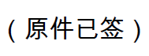  电信标准化局主任  李在摄 | 最新会议信息
附件：2件
ANNEX 1
Eight meeting of ITU-T FG-VM:
Singapore, 12-13 March 2020
Practical meeting information for participants
WORKING METHODS AND FACILITIES
DOCUMENT SUBMISSION AND ACCESS: The meeting will be run paperless. Written contributions to the Focus Group meeting are encouraged and should be submitted by e-mail to tsbfgvm@itu.int by 5 March 2020 at the latest using the document template available on the FG-VM homepage. Access to all input and output documents will be provided from the FG-VM collaboration site (free ITU account required).
WIRELESS LAN facilities are available at the meeting venue.
PRE-REGISTRATION
PRE-REGISTRATION: Pre-registration for on-site or remote participation is to be done via the FG-VM homepage preferably by 22 February 2020.
PRACTICAL INFORMATION

1. Meeting Venue
Rendezvous Hotel
9 Bras Basah Road, Singapore 189559
Tel: +65 63360220
Email: info.rhs@fareast.com.sg

Please see below a map:
https://www.google.com/maps/place/Rendezvous+Hotel+Singapore/@1.2984968,103.8479736,18z/data=!4m11!1m2!2m1!1sHotel+Rendezvous!3m7!1s0x31da19bca2ddeb3d:0x873e3e522ce5befa!5m2!4m1!1i2!8m2!3d1.2985226!4d103.849141

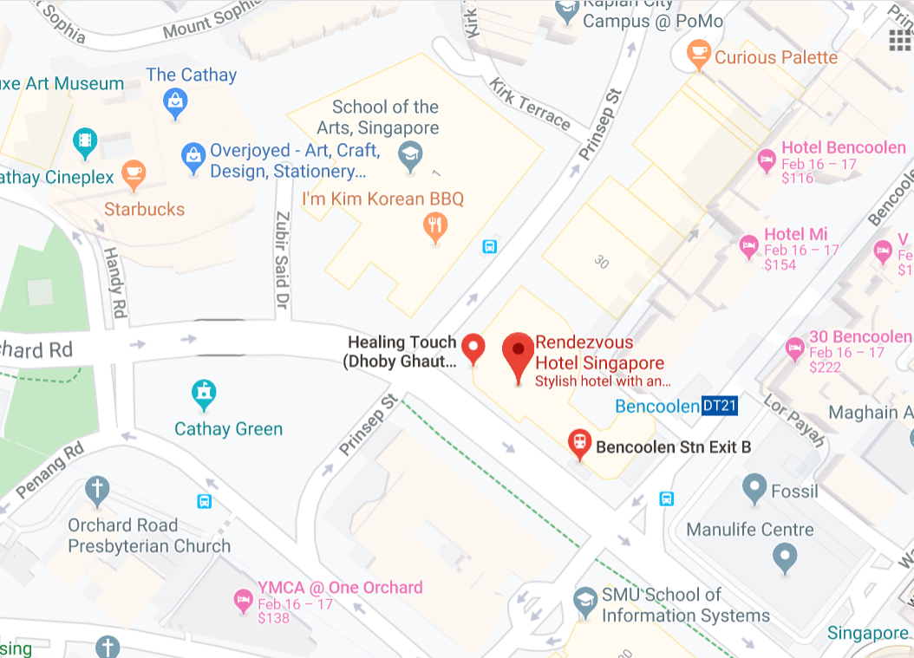

2. Transportation and site information
Changi International Airport is 25 minutes from the meeting venue by car, which will take you about approximately SGD 25. Grab may cost less depending on the peak hour time.
Public transport is available from Changi Airport to the meeting venue but it may take some time. (approximately around 52 minutes in bus). From Changi Airport there is a direct bus, (bus number 36) or you can take the Metro Train, therefore it is a personal choice to choose the best mode of transport depending on the availability of the time.
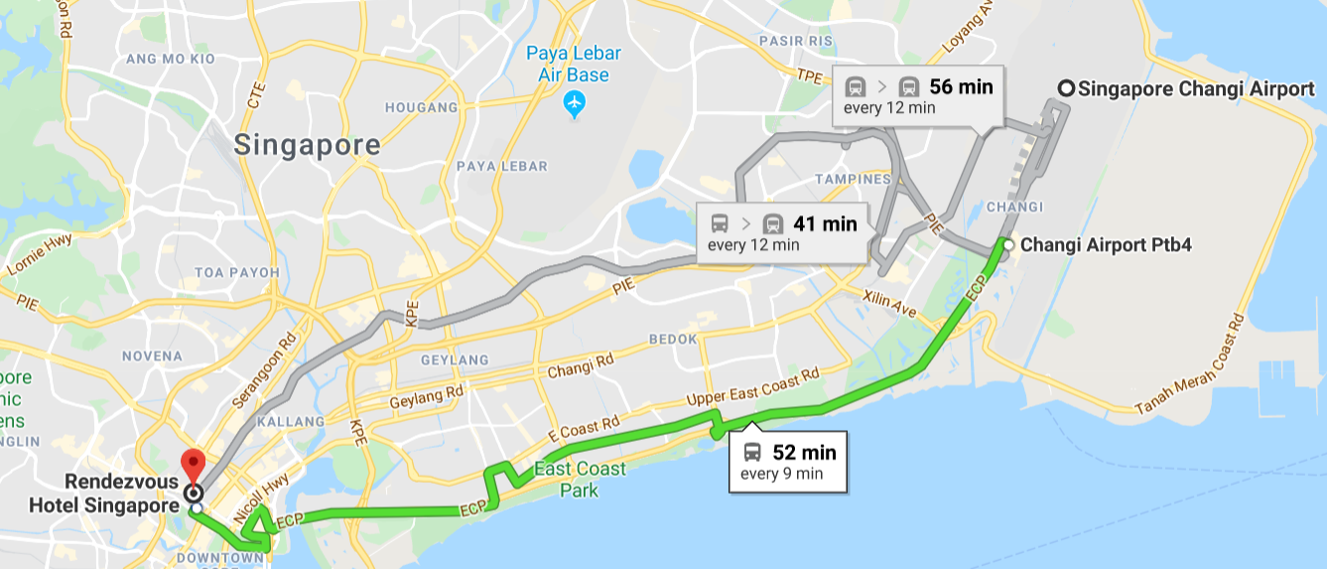

3. Passports and visas
All foreign visitors entering Singapore must have a valid passport. Visitors from countries whose citizens require a visa should at the earliest time and well in advance of travel apply for a visa at a Singapore Embassy or consulate.

See below for more information related to entry into Singapore:
https://www.ica.gov.sg/visitor/visitor_entryvisa

For requesting an invitation letter for visa purposes to the Host, please see Annex 2.

The focal point for visa support at Desay SV Automotive, Singapore is:
Name: Mr Krishna Prasath
E-mail: Prasath.Chandrashekar@desay-svautomotive.com
Tel: +65 83106485

4. Climate in March in Singapore
Monthly average values of the temperature and precipitation in Singapore, are given in the table below:
Weather in March in Singapore. The average temperature in Singapore in March is fairly hot at 25°C (76 °F). Afternoons can be very hot with average high temperatures reaching 32°C (90 °F). Overnight temperatures are generally somewhat warm with an average low of 20°C (68 °F).

 | March
Average maximum temperature | 32 degrees Celsius
Average minimum temperature | 25 degrees Celsius
Average precipitation | 171 mm

5. Hotels
Please make your hotel reservation by yourself. We suggest to book the hotel of the meeting venue.
Strand Hotel Singapore
25 Bencoolen Street, Singapore 189619
Tel: +65 63381866
Enquiries & RESERVATIONS
reservations@strandhotel.com.sg

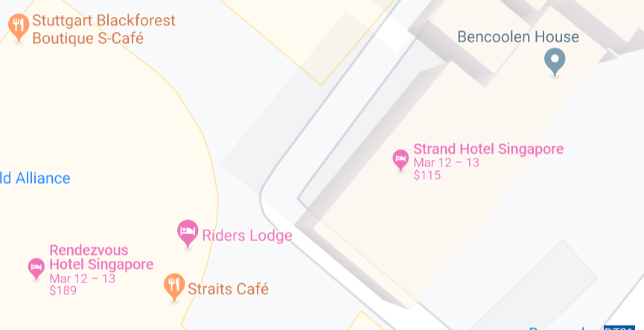

6. Internet access and wireless coverage at the venue
Wireless Internet will be provided to you by the hotel.

7. Technical assistance
In case you have any technical problem at the venue (e.g., connecting to Internet, finding meeting rooms, etc.) please see the host on site.

8. Electricity
The electricity in Singapore is generally 230V, 50 Hz. Please make sure you have the proper adapter.
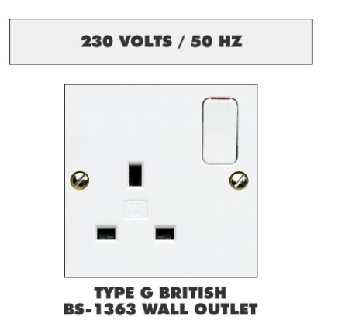Singapore Standard

9. Useful information

9.1 Time Zone: GMT+8:00.

9.2 Currency exchange
The currency in Singapore is the Singapore Dollars; please check the currency exchange rate in the local bank system or use the following link as a reference: http://www.xe.com/

9.3 Tipping: Tipping is not necessary.

10. Additional information

10.1 Mobile phone coverage: 3G, 4G services are provided by SingTel, StarHub and M1.

10.2 Emergency Numbers: In case of emergency, please dial 995.

10.3 Sightseeing:
https://www.timeout.com/singapore/attractions/the-best-singapore-attractions

11. Contact person
Name: Mr Krishna Prasath
E-mail: prasath.chandrashekar@desay-svautomotive.com
Tel: +65 83106485
ANNEX 2
Application form for visa support letter
All foreign visitors entering Singapore must have a valid passport. Visitors from countries whose citizens require a visa should at the earliest opportunity and well in advance of travel apply for a visa at a Singapore embassy or consulate. You may need a letter of invitation from the Singaporean host, which you will need to present to the Singaporean embassy/consulate in your area in order to obtain your visa. The visa must be requested as soon as possible and at least six weeks before the start date of the meeting and obtained from the office (embassy or consulate) representing Singapore in your country or, if there is no such office in your country, from the one that is closest to the country of departure. In order to obtain an invitation letter, please:
a) Fill out the form below.
b) Provide an electronic copy of your passport (name, date of birth, nationality, photo, passport number, expiration date of passport, etc., must be seen clearly).
c) Provide an electronic copy of previous Singaporean visa and records (if you have been to Singapore before).
d) Send the info in a), b) and c) as e-mail attachments to -Prasath.Chandrashekar@desay-svautomotive.com; please indicate as the subject “Application form for visa support letter for ITU-T FG-VM meeting (12-13 March 2020)”.
(Please do not forget to attach a copy of your passport photograph page before sending.)
In order to receive a support letter, your information should be provided to the host (Prasath.Chandrashekar@desay-svautomotive.com) before 12 February 2020.
Please inform the host clearly if you need the original visa support documents, or only the electronic and scanned documents would be sent to you.
NOTE – The Host will do its best to provide invitation letters that are requested after this date; however, we cannot guarantee that you will receive your visa in time for the FG-VM meeting.
Given name (first name)
Family name (last name)
Date of Birth (dd/mm/yyyy)
Gender (male/female)
Nationality
Valid passport number
Passport valid until (dd/mm/yyyy)
Country to submit your visa application
Postal address for your visa support documents to be shipped to | Address | (street)  (city)  (Province)
 | Postal Code
 | Country
 | Telephone number
The above address is: (please select one) |  | Office / home / other (specify: )
Occupation and job title
Name of company/organization
Company/organization address
Office telephone number |  | +
Fax number |  | +
Email address

