|  |  |  |  |
| --- | --- | --- | --- |
|  | INTERNATIONAL TELECOMMUNICATION UNION  **TELECOMMUNICATION STANDARDIZATION SECTOR**  STUDY PERIOD 2022-2024 | | SG9-TD404 |
| STUDY GROUP 9 |
| Original: English |
| **Question(s):** | | ALL/9 | Bogota, 14-23 November 2023 |
| **TD** | | | |
| **Source:** | | TSB | |
| **Title:** | | Logistics, visa and other practical information for SG9 meeting in Colombia | |
| **Contact:** | | TSB | Tel: +41 22 730 5858 Fax: +41 22 730 5853 Email [tsbsg9@itu.int](mailto:tsbsg9@itu.int) |

|  |  |
| --- | --- |
| **Abstract:** | This TD contains all the meeting facilities and useful information for the SG9 meeting in Bogota, Colombia. |

## Practical information on Bogotá, Colombia

1. **Meeting venue**

Hotel Habitel Select, Bogota, Colombia  
***Address：Av. El Dorado #100-89, Bogotá, Colombia***

*URL if available:* <https://www.habitelhotels.com/en/hotel-habitel-select-in-bogota/>

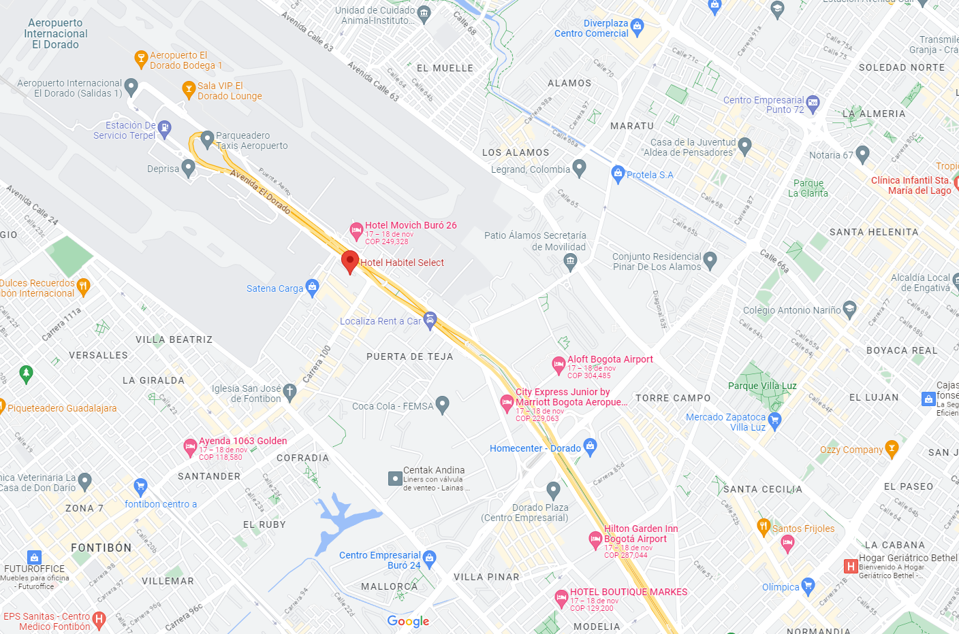

For the delegates who wish to book the same hotel as the venue (Hotel Habitel Select), when booking a room, please take the following steps:

* Go to the hotel homepage: <https://www.habitelhotels.com/en/hotel-habitel-select-in-bogota/>
* In [Online Reservation] field, select the check-in time, check-out time, number of rooms and occupancy. Then, click “check availability.”
* Choose the desired room and click "Book"
* Fill in the information in ["Guest info", "Payment method"] fields. Check “Complete Reservation” to submit. The booking is complete.

The venue is located 2,4 km from the El Dorado International Airport; 15,5 km to Bogota center; 9 km to the Gran Estacion Mall, 16,5 km to the 93 Park, which is a public park located in the north of Bogotá. It features a variety of dining and nightlife offer.

1. **Transportation and site information**

Once you arrive to the El Dorado Airport, you may reach the venue by:

* **If you choose a taxi,** the El Dorado Airport has an authorized taxi service through the company "Taxi Imperial", whose vehicles can pick up passengers at the airport, to ensure their safety and comfort. The taxi service can be found at gates 2, 3, 5 and 6 of Terminal 1 and at the Arrivals gate of Terminal 2**.**  Local Website:  <http://www.taxiimperial.com.co>.
* **If you decide to take the city’s public transport, "SITP"**, Once you arrive to El Dorado the airport, you can buy a card called "Tullave" in the gate 4 first floor, which is a rechargeable card to pay for public transportation and costs $ 7,000 Colombian pesos. Remember to charge the card with money, taking into account that each trip will cost an additional amount of $ 2,950 Colombian pesos; The (1) take the red bus called "k86" that will take you to the "Aeronautica Civil" (AC 26 - Kr 103) bus stop. (2) you can arrive at your destination by walking for 5 minutes.
* **In case you plan to rent a car**, the following instructions may be helpful: From the El Dorado Airport to the meeting venue, Hotel Habitel Select, the best route is to head east on 26th Street (Av El Dorado), up to “Carrera 100”. The hotel is located at the address number 100-89.

1. **Passports and Visas**

All foreign visitors entering Colombia must have a valid passport. Visitors from countries whose citizens require a visa should apply for a visa at a Colombian Embassy or Consulate as early as possible and well in advance of travel.

For requesting an invitation letter for visa purposes from the Colombian Administration, please see Annex A.

For more information related to entry into Colombia, see:

* Check if you need a visa:   
  <https://www.cancilleria.gov.co/tramites_servicios/visa/requisitos>
* General instructions for submitting a visa application :  
  <https://www.cancilleria.gov.co/tramites_servicios/visa/abece-visas>
* Online application:  
  <https://tramitesmre.cancilleria.gov.co/tramites/enlinea/solicitarVisa.xhtml>

The focal point for visa support in Colombia is:

**Ms. Johana Rodríguez**

[**johana.rodriguez@pubblica.com.co**](mailto:johana.rodriguez@pubblica.com.co)

**+57301 7715351**

1. **Climate (middle of November in Bogotá)**

Monthly Average temperature and precipitation in Bogota, Colombia are given in the table below:

|  |  |
| --- | --- |
|  | November |
| Average Maximum Temperature | 21°C |
| Average Minimum Temperature | 14°C |
| Average Precipitation | 92% |

1. **Hotels**

In addition to the hotel venue, Hotel Habitel Select (see item 1 above) other close hotels are:

* Hotel Movich Buró 26, Av. El Dorado #26 #102-20, Fontibón, Bogotá, Cundinamarca

<https://www.movichhotels.com/en/hotel-buro26-in-bogota/?utm_source=google&utm_medium=organic&utm_campaign=GoogleMyBusiness&partner=5652>

* Hotel Marriott Courtyard, Fontibón, Bogotá, Cundinamarca

<https://www.marriott.com/es/hotels/bogcy-courtyard-bogota-airport/overview/?gclid=CjwKCAjw38SoBhB6EiwA8EQVLg1BjG2C58m7QfCR1om3gRfF>

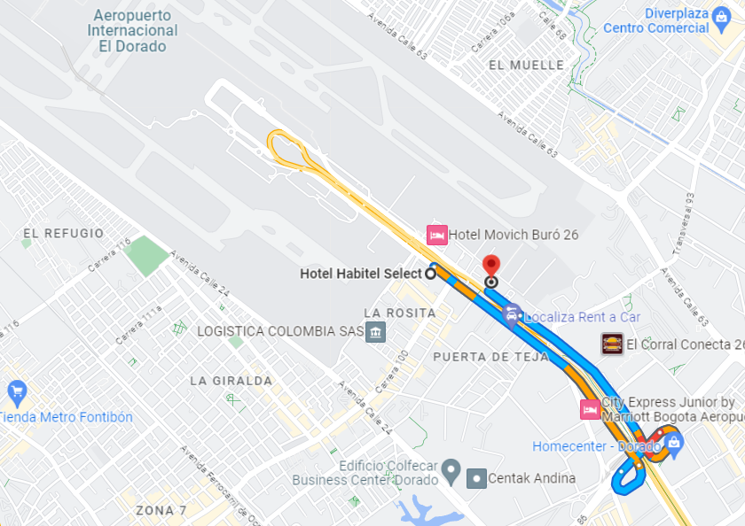

* City Express Plus by Marriott Bogota Aeropuerto

<https://www.marriott.com/en-us/hotels/bogpo-city-express-plus-bogota-aeropuerto/overview/?scid=f2ae0541-1279-4f24-b197-a979c79310b0>

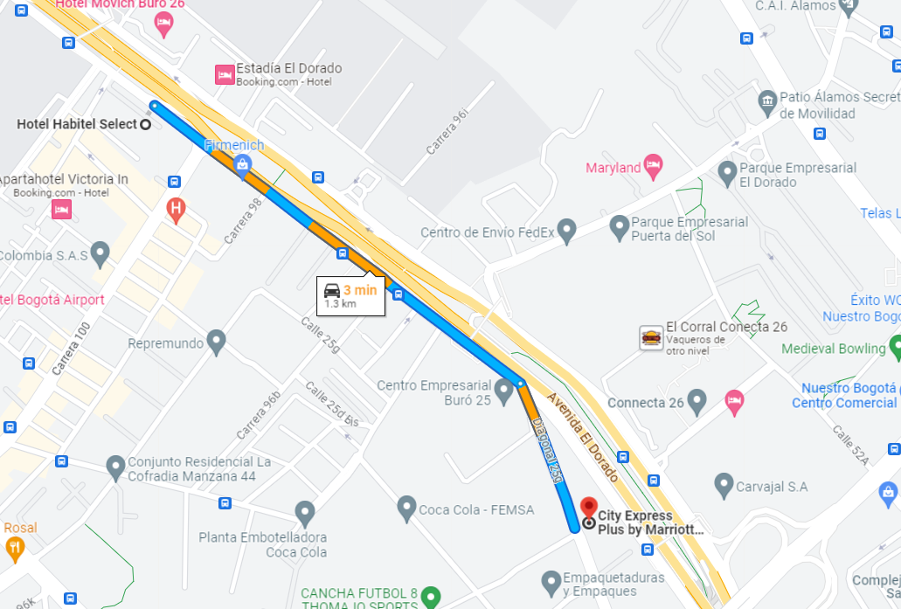

* Hotel Hilton Garden Inn, Bogotá

<https://www.hilton.com/es/hotels/bogatgi-hilton-garden-inn-bogota-airport/>

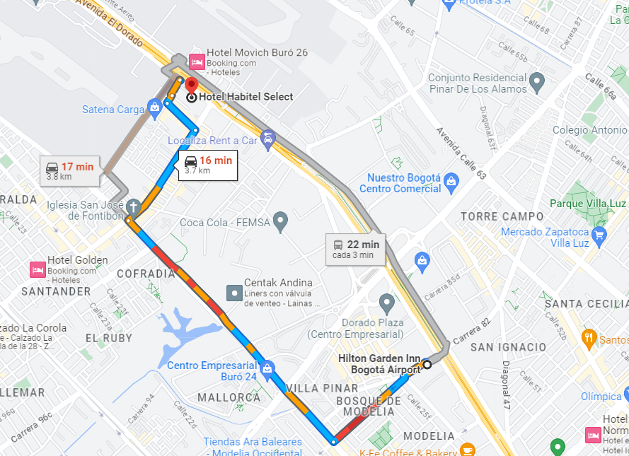

* Hotel Grand Hyatt, Bogotá

<https://www.hyatt.com/en-US/hotel/colombia/grand-hyatt-bogota/boggh?src=corp_lclb_gmb_seo_boggh>

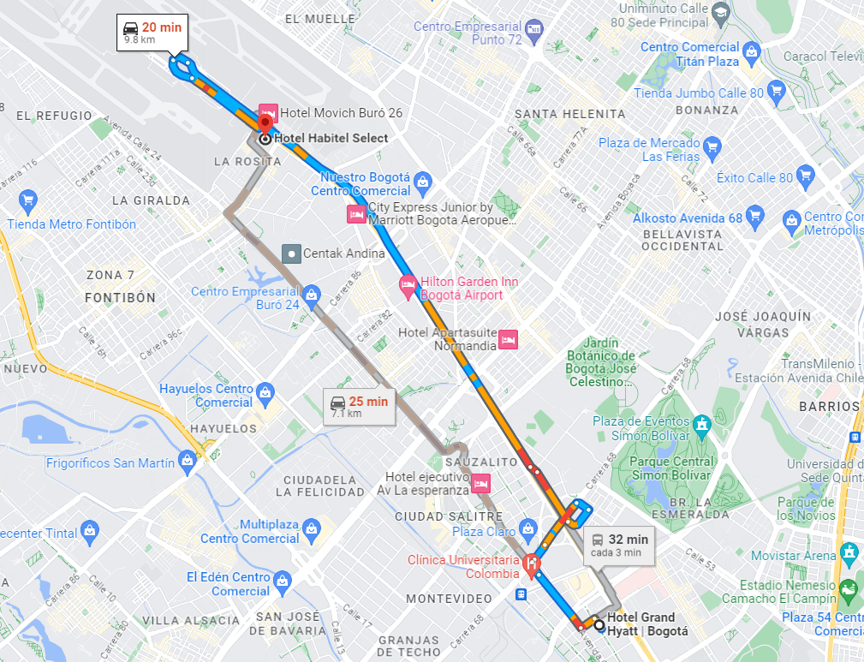

1. **Internet access and wireless coverage at the venue**

All meeting rooms will have a wireless network with access to the Internet. Every guest room offers high-speed Internet access free of charge. Internet access will be provided using the LAN technologies listed below:

**Wireless via Wi-Fi: IEEE 802.11a/n on 5.2 GHz and 802.11g/n on 2.4 GHz.**

1. **Technical assistance**

In case you have any technical problem at the venue (e.g., connecting to Internet, finding meeting rooms, etc.) please contact for help:

**Ms. Johana Rodríguez**

[**johana.rodriguez@pubblica.com.co**](mailto:johana.rodriguez@pubblica.com.co)

**+57301 7715351**

1. **Electricity**

The electricity in Colombia is generally 110V, 60HZ. Please make sure you have the proper adapter.

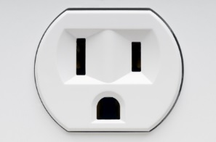

This socket is common in Colombia and many other countries.

1. **Currency exchange**

The currency in **Colombia** is the "**pesos colombianos"**; please check the currency exchange rate in the local bank system or use the following link as a reference: <http://www.xe.com/>.

1. **Additional information**

* **Mobile phones:** Cell (mobile) phone and mobile data coverage is excellent. Most unlocked cell phones will work with a local SIM card.
* **Tipping:** Tipping is recommended; normally it is 10% of the bill (voluntary).
* **Time Zone in November 2023**: UTC/GMT-5:00.
* **Emergency Number:** In case of emergency please dial 123.
* **Sightseeing:** <http://www.colombia.travel/es/a-donde-ir/andina/bogota>

1. **Contact persons**

* Mrs. Mariana Sarmiento: Mobile +57 320 8093858 ([mariana.sarmiento@crcom.gov.co](mailto:mariana.sarmiento@crcom.gov.co))
* Mrs. Johana Rodriguez: Mobile +57 301 7715351 ([johana.rodriguez@pubblica.com.co](mailto:johana.rodriguez@pubblica.com.co))

# ANNEX A

**INVITATION LETTER REQUEST FORM**

All foreign visitors entering Colombia must have a valid passport. Visitors from countries **whose citizens require a visa should, as soon as possible and** at least **one month** before the start date of the meeting, **apply for a visa** from the office (embassy or consulate) representing Colombia in your country or, if there is no such office in your country, from the one that is closest to the country of departure.

**Online application**: <https://tramitesmre.cancilleria.gov.co/tramites/enlinea/solicitarVisa.xhtml>

You may need a letter of invitation from the Colombian host, which you will need to present to the Colombian embassy/consulate in your area in order to obtain your visa.

To obtain an invitation letter:

1. Please complete the form below.
2. An electronic copy of your passport must be provided with your name, date of birth, nationality, passport number, expiration date of passport, etc., clearly seen on the copy. A proof of registration to the SG9 meeting may be requested by the Host.
3. If you have been to Colombia before, please provide an electronic copy of any previous Colombian visas and/or records.
4. Send the info in sections A, B and C as e-mail attachments to ([**mariana.sarmiento@crcom.gov.co**](mailto:mariana.sarmiento@crcom.gov.co)). Please mark in the subject***“Invitation letter request for*** ***ITU‑T SG9 meeting/Workshop 14-23 November 2023)”****.*

(Remember to scan your passport and e-mail it to us so that it is discernible and can be used.)

|  |  |  |  |  |  |
| --- | --- | --- | --- | --- | --- |
| **Company** |  | | | | |
| **Applicant Information** |  | | | **❒ Mr ❒ Miss ❒ Ms ❒ Mrs** | |
|  | | | **Date of birth :** | |
|  | | | **Place of Issue:** | |
| **Date of Issue:** | | | **Date of Expiry:** | |
| **Marital Status:** | | |  | |
| **If the country in which you'll obtain your visa is different from your nationality, please indicate it here:** | | | | |
| **Address** | **Telephone Number:**  **Fax Number:**  **E-mail:** | | | | |
| **Note** |  | | | | |
| **Date of arrival in Colombia** | |  | **Date of departure from Colombia** | |  |

*(Please do not forget to attach a copy of your passport photograph page before sending.)*

***In order to receive an invitation letter, your information should be provided to the host before 14 October 2023.***

***NOTE: The host will do its best to provide invitation letters that are requested late; however, it cannot guarantee that a visa will be received in time for the SG9 meeting.***

____________________