 |  |  | International telecommunication union  Telecommunication Standardization Bureau
 |  |  |  | Geneva, 30 October 2023
Ref: |  | Addendum 1 to  TSB Collective letter 3/15  SG15/HO |  | - To Administrations of Member States of  the Union;  - To ITU-T Sector Members;  - To ITU-T Associates of Study Group 15;  - To ITU Academia
Tel: |  | +41 22 730 6356
Fax: |  | +41 22 730 5853
E-mail: |  | tsbsg15@itu.int
Web: |  | http://itu.int/go/tsg15
Subject: |  | Meeting of Study Group 15; 20 November – 1 December 2023
Dear Sir/Madam,
The following Work Items under AAP received comments during the Last Call period of AAP-28, dated 16 May 2023:
− Recommendation ITU-T G.9940, High speed fibre-based in-premises transceivers - system architecture.
− Recommendation ITU-T G.9961, Unified high-speed wireline-based home networking transceivers - Data link layer specification.
The Work Items G.9940 and G.9961 were posted as SG15-TD191/PLEN and SG15-TD190/PLEN, respectively for approval at the meeting of Study Group 15 from 20 November to 1 December 2023.
Yours faithfully,  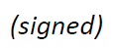  Seizo Onoe  Director of the Telecommunication  Standardization Bureau | 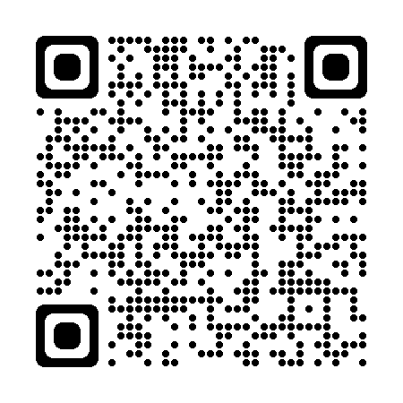 ITU-T SG15
 | Latest meeting information

