 | International telecommunication union  Telecommunication Standardization Bureau
 |  | Geneva, 6 June 2024
Ref: | Addendum 1 to  TSB Collective letter 4/15  SG15/HO | - To Administrations of Member States of  the Union;  - To ITU-T Sector Members;  - To ITU-T Associates of Study Group 15;  - To ITU Academia
Tel: | +41 22 730 6356
Fax: | +41 22 730 5853
E-mail: | tsbsg15@itu.int
Web: | http://itu.int/go/tsg15
Subject: | Meeting of Study Group 15; Montreal, Canada, 1-12 July 2024
Dear Sir/Madam,
The following Work Items under AAP received comments during the Last Call period of AAP-42, dated 16 December 2023:
− Recommendation ITU-T G.9930, Point-to-Point Fibre in the Premises
− Recommendation ITU-T G.9941, High speed fibre-based in-premises transceivers - physical layer specification
The following Work Item under AAP received comments during the Last Call period of AAP-44, dated 1 February 2024:
− Recommendation ITU-T G.9942, High speed fibre-based in-premises transceivers - data link layer
These Work Items G.9930, G.9941 and G.9942 were posted as SG15-TD346/PLEN, SG15-TD345/PLEN and SG15-TD342/PLEN, respectively for approval at the meeting of Study Group 15 from 1 to 12 July 2024.
Yours faithfully,  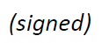  Seizo Onoe  Director of the Telecommunication  Standardization Bureau | 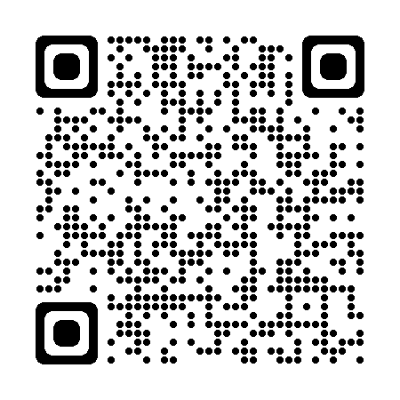 ITU-T SG15
 | Latest meeting information

