 |  | International telecommunication union  Telecommunication Standardization Bureau
 |  |  | Geneva, 24 November 2022
Ref: | Addendum 1 to  TSB Collective letter 1/SG17RG-ARB  SG17/XY |  | - To Administrations participating in SG17RG-ARB;  - To ITU-T Sector Members participating in SG17RG-ARB;  - To ITU-T Associates participating in SG17RG-ARB;  - To ITU Academia participating in SG17RG-ARB;  - To the ITU Regional Office for the Arab States, Cairo, Egypt
Tel: | +41 22 730 6206
Fax: | +41 22 730 5853
E-mail: | tsbsg17@itu.int
Web: | https://itu.int/en/ITU-T/regionalgroups/SG17-ARB
Subject: | Meeting of ITU-T Study Group 17 Regional Group for the Arab Region (SG17RG-ARB)  Manama, Bahrain, 5 December 2022
Dear Sir/Madam,
Further to TSB Collective letter 1/SG17RG-ARB dated 13 October 2022, and in consultation with the SG17RG-ARB Chairman and the host country, I regret to inform you that the meeting of ITU-T Study Group 17 Regional Group for the Arab Region (SG17RG-ARB) which was due to take place on 5 December 2022 in Manama, Bahrain has been postponed to a later date. The new dates and venue will be announced at a later stage.
Please consult the SG17RG-ARB web page as it will be updated when further information becomes available.
Yours faithfully,  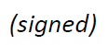  Chaesub Lee  Director of the Telecommunication  Standardization Bureau | 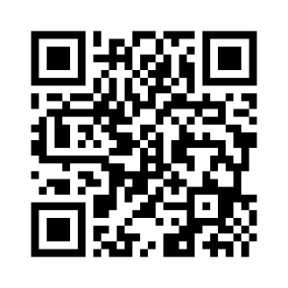 ITU-T SG17RG-ARB
 | Latest meeting information

