International telecommunication union
Telecommunication Standardization Bureau
 |  |  | Geneva, 11 September 2023
Ref: | Corrigendum 2 to  TSB Collective letter 3/20  SG20/CB |  | - To Administrations of Member States of the Union;  - To ITU-T Sector Members;  - To ITU-T Associates of Study Group 20;  - To ITU Academia
Tel: | +41 22 730 6301
Fax: | +41 22 730 5853
E-mail: | tsbsg20@itu.int
Web: | https://itu.int/go/tsg20
Subject: | Meeting of Study Group 20 and events; Arusha, 12-22 September 2023
Dear Sir/Madam,
We would like to inform you that the venue for the following events that will take place in Arusha, Tanzania, has changed. The events and meetings will now take place at Gran Meliá Arusha. The event and meeting dates remain the same:
- 12 September 2023 - ITU-T SG20 Newcomers’ session
- 12 September 2023 - 28th meeting of Joint Coordination Activity on Internet of Things and Smart Cities and Communities (JCA-IoT and SC&C)
- 12 September 2023 - Special Session of ITU Focus Group on metaverse (FG-MV)
- 13 September 2023 - 3rd ITU Forum on Cities and the metaverse: shaping a citiverse for all
- 13-22 September 2023 - Meeting of the ITU-T Study Group 20 “Internet of things (IoT) and smart cities and communities (SC&C)”
More information will be available on the ITU-T Study Group 20 homepage and events main landing page.
I wish you a productive and enjoyable meeting.
Yours faithfully,  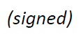  Seizo Onoe  Director of the Telecommunication  Standardization Bureau | 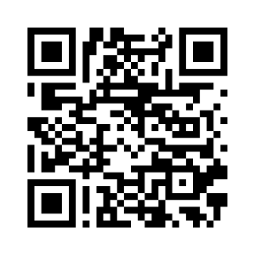 ITU-T SG20
 | Latest meeting information

