International telecommunication union
Telecommunication Standardization Bureau
 |  |  | Geneva, 21 April 2023
Ref: | Addendum 1 to  TSB Collective letter 1/SG20RG-AFR  SG20/CB |  | - To Administrations participating in SG20RG-AFR;  - To ITU-T Sector Members participating in SG20RG-AFR;  - To ITU-T Associates participating in SG20RG-AFR;  - To ITU Academia participating in SG20RG-AFR;  - To the ITU Regional Office for Africa
Tel: | +41 22 730 6301
Fax: | +41 22 730 5853
E-mail: | tsbsg20@itu.int
Web: | http://itu.int/go/sg20rgafr
Subject: | UPDATE: Meeting of Study Group 20 Regional Group for Africa (SG20RG-AFR);  Sharm El-Sheikh, Egypt, 8 June 2023
Dear Sir/Madam,
Please note that the timing of the meeting of ITU-T Study Group 20 Regional Group for Africa (SG20RG-AFR), which is planned to be held at the Tonino Lamborghini Convention Center, Sharm El-Sheikh, Egypt, on 8 June 2023, has been changed to 1445 to 1800 hours, EET.
The SG20RG-AFR meeting will be preceded by an Information session on ITU-T SG20 Regional Group for Africa that will take place from 1330 to 1430 hours, EET, at the same venue.
More information relating to the meeting will be posted on the SG20RG-AFR webpage at: http://itu.int/go/sg20rgafr.
I wish you a productive and enjoyable meeting.
Yours faithfully,  (Signed)  Seizo Onoe  Director of the Telecommunication  Standardization Bureau | 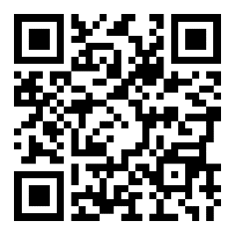 ITU-T SG20RG-AFR
 | Latest meeting information

