 | INTERNATIONAL TELECOMMUNICATION UNION  TELECOMMUNICATION  STANDARDIZATION SECTOR  STUDY PERIOD 2022-2024 |  |  | TSAG C075
 |  |  |  | TSAG
 |  |  |  | Original: English
Question(s): |  | N/A |  |  | Geneva, 22 - 26 January 2024
CONTRIBUTION
Source: |  | Japan
Title: |  | Proposals on the draft revised Recommendation ITU-T A.1 Clause 1.4.7.1
Contact: |  | Junichiro TOBE  MIC, Japan | E-mail: itu-t@ml.soumu.go.jp
Contact: |  | Yukiko TERAYAMA  MIC, Japan | E-mail: itu-t@ml.soumu.go.jp
Contact: |  | Kaoru KENYOSHI  NICT, Japan | E-mail: kaoru.kenyoshi@nict.go.jp
Contact: |  | Hideki YAMAMOTO  OKI, Japan | E-mail: yamamoto436@oki.com

Abstract: | This contribution proposals revisions on the draft revised Recommendation ITU-T A.1 Clause 1.4.7.1.
Introduction
TSAG-C28, TSAG-C44 and TSAG-C50 were submitted at TSAG (Geneva, 30 May -2 June 2023) and proposed improvement of the international nature of new work items. These contributions addressed the same topic on creation of a new work item and were discussed at TSAG RG-WM. The draft Recommendation ITU-T A.1 was revised and the updated version is included in RGWM-DOC8-R1. The ITU-T A.1-rev editor proposed the following texts for the article1.4.7.1.
The new work item shall be supported by Member States, Sector Members, Associates of the study group or Academia representing at least two different countries.
This article is still under discussions with yellow highlighted in the updated draft. This contribution aims to resolve the open issue in the article 1.4.7.1.
Discussion
Japan recognises that improvement of the international nature of new work items is very important to develop ITU-T Recommendations, which acts as defining elements for global telecommunication/ICT infrastructure, services and applications. Japan understands the rationales of proposals in three contributions at the previous TSAG on the modification of the article 1.4.7.1. We would like to support them principally.
For further consideration on this topic, Appendix of this contribution shows the result of analysis of the approved new work items at SG11 (Geneva, 10 - 20 October). In this meeting, fourteen new work items which were approved as shown in SG11-TD607/GEN. Nine new work items (64.3%) were supported by a single country and two new work items (14.3%) were supported by two countries. Three new work items (21.4%) were supported by more than three countries (See appendix). This analysis shows a similar tendency in SG13 in TSG13-TD189/PLEN (Geneva, 23 October - 3 November 2023). These data can be considered as reference information of the criteria for creation of a new work item.
Proposal
- Japan would like to support modifications of Clause 1.4.7.1 of Recommendation ITU-T A.1. By modifications of this article, it is expected to improve the international nature of new work item creation. We would propose that at least three different countries should support creation of a new work item as follows.
The new work item shall be supported by Member States, Sector Members, Associates of the study group or Academia representing at least three different countries.
21.4% of the approved new work items were supported by more than three countries in the last SG11. It is effective and affordable criteria by considering the analysis in Appendix of this contribution. Template of justification form attached in Annex A of Recommendation ITU-T A.1 needs to be updated accordingly.
- Japan won’t disturb the momentum of creating a new work item. We would like to confirm that any member can propose a new work item to Question/Rapporteur meetings by a single entity. If the member in these meetings reaches consensus on the new work item proposal with less than three supporting countries, Rapporteur may proceed and invite supporting countries at WP/SG. If it successfully gets supports by more than three countries, then WP/SG chair can ask approval on it.
- It is noted that some multi-national corporations have multiple memberships in multiple countries. Proposal supported by a company-A in country-A and the company-A in country-B, is this proposal supported by members in the different country? If it is happened in future, it needs to consider whether this case can conform with the new texts.

Appendix
New work items which were approved at SG11 (Geneva, 10 – 20 October 2023)
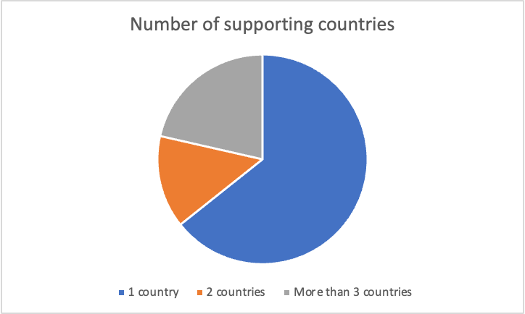

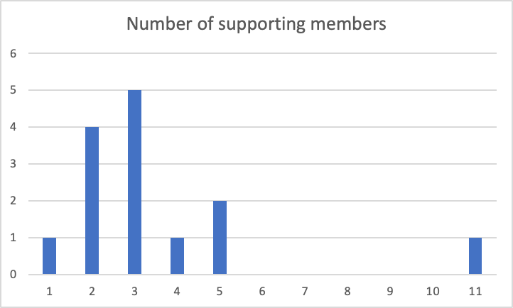
Horizontal axis: Number of supporting members
Vertical axis: Number of approved new work items

______________________

