 | INTERNATIONAL TELECOMMUNICATION UNION  TELECOMMUNICATION  STANDARDIZATION SECTOR  STUDY PERIOD 2022-2024 |  |  | TSAG C0076
 |  |  |  | TSAG
 |  |  |  | Original: English
Question(s): |  | N/A |  |  | Geneva, 22 - 26 January 2024
CONTRIBUTION
Source: |  | Japan
Title: |  | Proposals on the extension of FG-MV lifetime
Contact: |  | Hideki YAMAMOTO  OKI  Japan | Tel: +81-90-7342-2860  Email: yamamoto436[at]oki.com
Contact: |  | Hideo IMANAKA  NICT  Japan | Tel:  Fax:  Email: h.imanaka[at]nict.go.jp
Contact: |  | Rei ABE  MIC, Japan | Tel: +81-3-5253-5481  E-mail: icb-director-g[at]ml.soumu.go.jp

Abstract: | This contribution proposes to extend the FG-MV lifetime until March 2025.

1. Introduction
The ITU Focus Group on metaverse (FG-MV) started in March 2023 in Riyadh, Kingdom of Saudi Arabia, and would face the end of its lifetime in March 2024. FG-MV progressed very fast, for example, over 20 deliverables were published and three workshops were held around the world until December 2023 [TD400/GEN]. There remain still over 40 work items (WIs) which span wide variety of study areas, so it is necessary to continue studying them without slowing down. Furthermore, ITU-T Study Groups (SGs) might be difficult to continue studying the remaining WIs of FG-MV, because SGs would focus on the preparation of World Telecommunication Standards Assembly in 2024 (WTSA-24) and also the SG structure might be changed as the results of WTSA-24. In the world, metaverse is deployed more widely year and year, so ITU-T should continue studying metaverse pre-standardization study efficiently in order to develop ITU-T standards related to metaverse as quickly as possible.
In order to keep very fast activities on metaverse standardization and pre-standardization in ITU-T, this contribution proposes to extend the lifetime of FG-MV until March 2025.

2. Discussion
Japan submitted a contribution which proposed to extension FG-MV lifetime until March 2025 to the 4th FG-MV meeting (Geneva, 4-7 December 2023). In the discussion, lifetime extension was agreed. Regarding the extension period, there raised several opinions: some members supported with one year, and some members supported with three months which meant that all FG-MV deliverables would be sent to TSAG in July 2024. The majority of the participants agreed to extend the lifetime until the end of June 2024, in order to hand over the outcome deliverables of the FG-MV to TSAG as soon as possible and to deliver them to the appropriate SG for standardization studies. In response to these findings, FG-MV reported to TSAG recommending that TSAG consider extending it until June 2024.
Japan has two concerns:
- The report of the 4th FG-MV [LS-from-FGMV] proposes an extension FG-MV lifetime until the end of June 2024 (shown in yellow arrow in the figure below), but due to the WTSA in October 2024, SG might not be able to start metaverse standardization work until the next study period. The concern is that ITU-T will stop studying the standardization of the metaverse from July 2024 to the first quarter of 2025 (shown in red arrow in the figure below), which means delaying the standardization of the metaverse in ITU-T. Technologies of metaverse are advancing rapidly, so ITU-T might not be able to maintain its leading position due to a gap of more than six months in the study period.
Figure below shows the schedule of ITU-T meeting. Blue arrows show transferring FG-MV deliverables, which indicate that TSAG receives them from FG-MV and TSAG delivers them to relevant SGs.

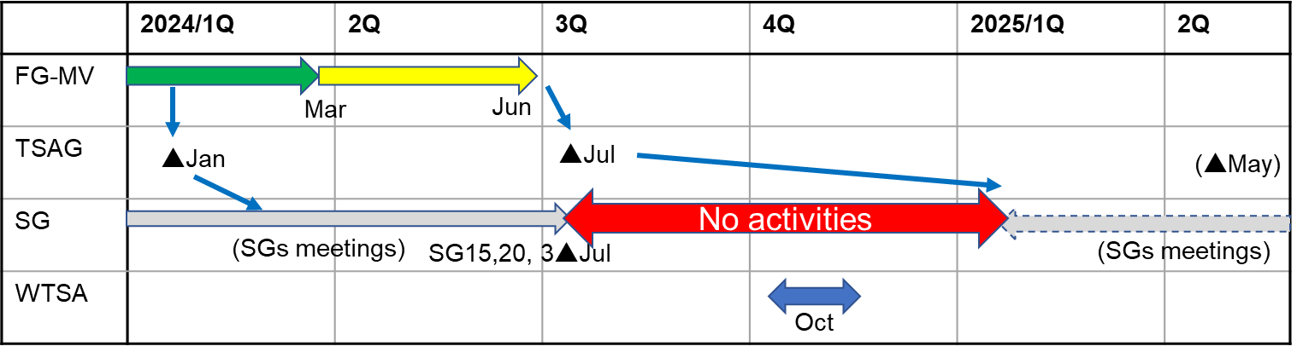
Figure: Schedule of ITU-T meetings

The duration between the last SG meeting in this study period and the first SG meeting in the next study period, which might have the 1st quarter of 2025, is more than half a year, as shown in red arrow. This means the deliverables, which were dispatched to the relevant SGs, could not be studied in SGs more than half year.

- Until the 4th FG-MV, 22 documents have been approved as FG-MV deliverables, but there are still more than 40 work items remaining, and there is a possibility that important work items might not be completed in June 2024.

- At least, current 22 deliverables should be studied for standardization work in the relevant SGs, after TSAG decides to deliver them to SGs.

3. Proposal
This contribution proposes to extend the FG-MV lifetime until March 2025, in order to avoid stopping metaverse standardization and pre-standardization work in ITU-T. For ITU-T to keep the lead role of metaverse standardization work in the world, this contribution suggests TSAG to decide the focal SG or candidates for the focal SGs for each approved deliverable and to dispatch it to the one SG or several SGs respectively.

Reference
[LS-from-FGMV] T22-TSAG-240122-TD-GEN-0400, LS on Results of the fourth meeting of the FG-MV (Ref.: FG-MV-O-187-R2).
______________________

