 | INTERNATIONAL TELECOMMUNICATION UNION  TELECOMMUNICATION  STANDARDIZATION SECTOR  STUDY PERIOD 2022-2024 |  | TSAG-TD201
 |  |  | TSAG
 |  |  | Original: English
Question(s): |  | N/A | Geneva, 30 May – 2 June 2023
TD
Source: |  | Chairman, ITU-T Study Group 9
Title: |  | ITU-T SG9 Lead Study Group report
Contact: |  | Satoshi Miyaji  KDDI Corporation  Japan | Tel: +81 80 5060 9134  E-mail: sa-miyaji@kddi.com

Abstract: | This document provides the report from SG9 on lead study group activities on integrated broadband cable networks and audiovisual content delivery over cable networks.

First SG9 physical meeting after COVID-19 pandemic (May 2023, Bangalore, India)
The first SG9 meeting in this study period (2022 – 2024) took place fully virtual in September 2022, it was covered by the previous Lead SG report from SG9 to TSAG (TSAG-TD32R1).
The second Study Group 9 meeting in this study period was held from 9 to 18 May 2023, in Bangalore, India, at the kind invitation of the Ministry of Communications, Government of India and co-hosted by Indian Institute of Science. The SG9 meeting was chaired by Mr Satoshi Miyaji (KDDI, Japan), assisted by Mr Stefano Polidori (TSB Counsellor). This was the first physical meeting of SG9 after the COVID-19 pandemic, and was addressed at the opening Plenary by dignitaries from the host, Professor Rajesh Sundaresan, Dean, Electrical, Electronics and Computer Sciences, Indian Institute of Science and Mr Avinash Agarwal, Deputy Director General, Telecommunication Engineering Centre, Ministry of Communications, Government of India (see Figure 1).
The meeting was attended by 69 participants from 18 countries (including remote participation), and the meeting considered 38 members Contributions. These numbers indicate that the SG9 momentum is maintained after the increased level of contributions and participation since the last study period, see Figure 2.

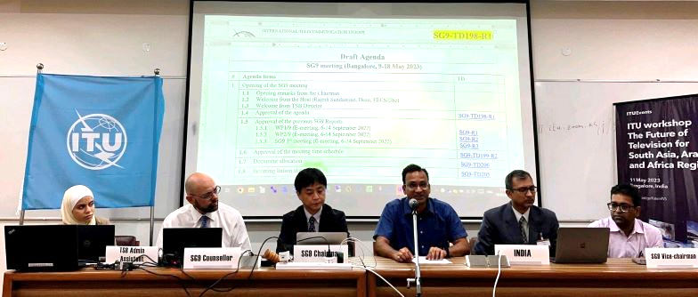
Figure 1: Opening remarks by the dignitaries from India at SG9 opening Plenary

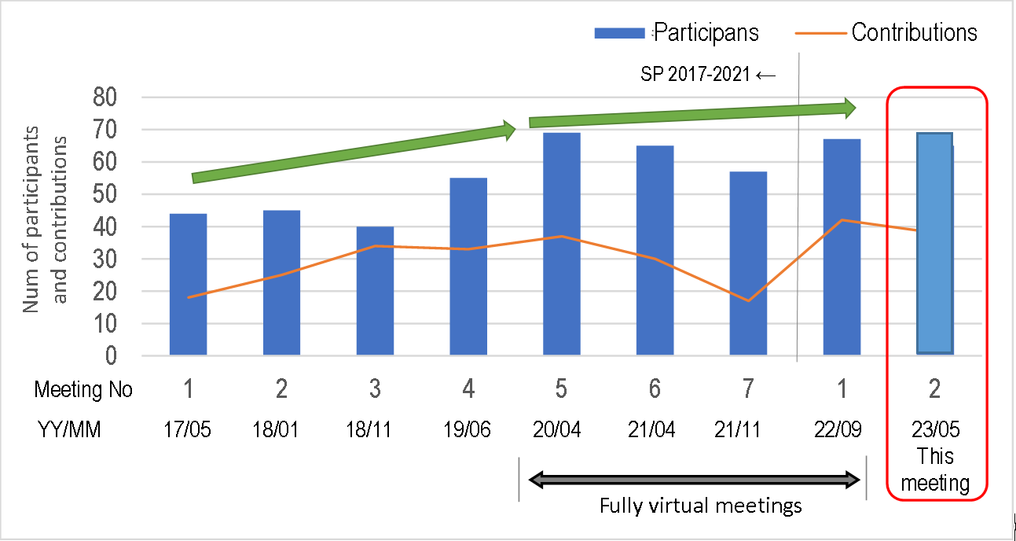
Figure 2: Number of participants and contributions

Co-located with SG9, ITU hosted a workshop on “The future of Television for South Asia, Arab and Africa regions” on 11 May 2023, organized by TSB jointly with BR and BDT, with participation of representatives from ITU-T SG9 and SG16, ITU-R SG6 and ITU-D Q2/1. Mr Seizo Onoe, the TSB Director, physically attended the workshop and provided a welcome address from the ITU, joined by the dignitaries from the hosts, Mr Premjit Lal, Deputy Director General, Department of Telecommunications, Ministry of Communications, Government of India and Professor Rajesh Sundaresan, Dean, Electrical, Electronics and Computer Sciences, Indian Institute of Science as well as Dr Satoshi Miyaji, SG9 Chairman (See Figure 4). The workshop was attended by more than 200 participants including approximately 140 physical attendees (see Figure 3).
The presentations given at the workshop are made available from the programme website at: https://www.itu.int/en/ITU-T/Workshops-and-Seminars/2023/0511/Pages/programme.aspx.
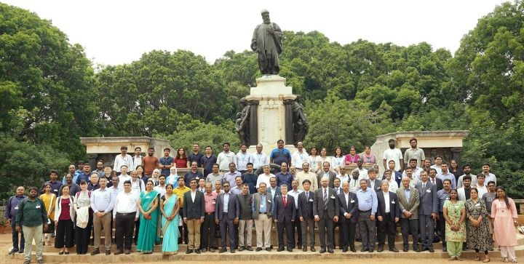
Figure 3: Group photo in front of the statue of Tata
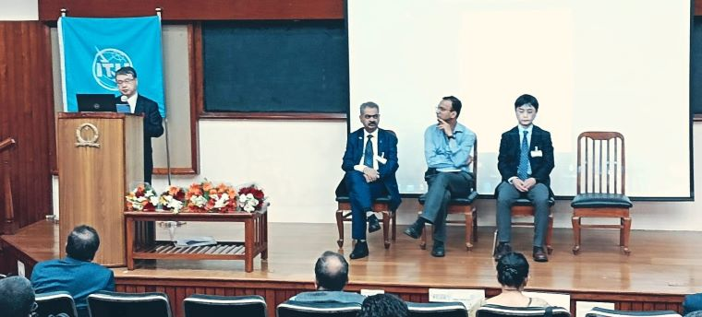
Figure 4: Opening address by TSB Director
In addition, a virtual meeting of the Intersector Rapporteur Group on Audiovisual Accessibility (IRG-AVA), contributed by ITU-T SG9 and SG16, as well as ITU-R SG6, was also organized during the SG9 meeting on 10 May and was attended by 21 participants. IRG-AVA serves as a collaborative platform to progress the ongoing draft Recommendations and technical documents in the three SGs concerned, and ITU-T SG9 contributes by discussing Question 11/9 “Accessibility to cable systems and services” related issues.
At this meeting, SG9 has agreed on a new appointment of WP2/9 vice-chair, Mr Yanbin (Evan) Sun, Huawei, China, to replace his colleague, Mr Eric Wang, who resigned from this position as found in SG9-TD200. SG9 also agreed on a new appointment of Rapporteurs and the list of liaison representatives as found in SG9-TD202 and SG9-TD203-R1, respectively.

2. Summary of activities

2.1 Overview
The SG9 meeting in Bangalore, May 2023, received thirty-eight (38) contributions, and a total of ten (10) draft Recommendations were finalized for AAP consent and two additional deliverables (one Supplement and one Technical Report) were agreed, as listed in the following tables.
Table 1: Draft Recommendations Consented (May 2023)
Question | AAP/TAP | Rec | Version | Title | Latest TD | A.5  just.
Q1/9  Q7/9 | AAP | ITU-T J.224 (Rev) | Rev | Fifth-generation transmission systems for interactive cable television services - IP cable modems | TD338 | TD368
Q1/9  Q7/9 | AAP | ITU-T J.225 (Rev) | Rev | Fourth-generation transmission systems for interactive cable television services - IP cable modems | TD339 | TD369
Q1/9  Q4/9 | AAP | ITU-T J.152 (ex J.cable-5G-req) | New | Requirements for cable television services to use 5G radio system | TD364-R1 | TD349
Q2/9 | AAP | ITU-T J.1036 (ex J.FSR-REQ) | New | Factual subscriber-base reporting and protected content delivery in conditional access system - Requirements | TD352 | N/A
Q6/9 | AAP | ITU-T J.299 (Rev) | Rev | Functional requirements for remote management of cable set-top box by auto configuration server | TD355 | TD348-R1
Q6/9 | AAP | ITU-T J.1612 (Rev.) | Rev | The Architecture for Smart Home Gateway | TD357 | TD378-R1
Q7/9 | AAP | ITU-T J.1112 (ex J.FSPEC-DVCS) | New | Functional Requirements for IP-based Digital Video Convergence Service | TD370 | N/A
Q8/9 | AAP | ITU-T J.1305  (ex J.mma-req) | New | Requirements of microservice architecture for audio-visual media in the converged media cloud | TD346 | N/A
Q8/9 | AAP | ITU-T J.1306  (ex J.mma-spec) | New | Specification of microservice architecture for audio-visual media in the converged media cloud | TD347-R1 | N/A
Q9/9 | AAP | ITU-T J.484 (ex J.cable-mabr) | New | Requirements of multicast adaptive bitrate (M-ABR) IP delivery | TD362 | N/A
Table 2: Draft Supplements and Technical Reports agreed (May 2023)
Q | Approval | Document | Title | Current TD
Q1, Q7 | Agreement | J Suppl. 10 (Rev) | Correspondence between CableLabs DOCSIS Specifications and ITU-T J-series Recommendations | TD340-R1
Q2 | Agreement | ITU-T Technical Report TR.FSR | Technical report on factual subscriber-base reporting and protected content delivery in Conditional Access System (CAS) | TD353

Also, a total of eleven (11) new work items were approved to initiate relevant studies.
Table 3: New work items approved (May 2023)
# | Q. | Acronym  (kind of publication) | Status | Title | TD | A.1 /A.13  Justification  template
1 | Q1/9  Q4/9 | J.cable-5G-arch (Recommendation) | New | System Architecture for cable television services to use 5G radio system | TD372 | ANNEX C  of TD321 (A.1)
2 | Q1/9  Q7/9 | J.Sup-HiNoC  (Supplement) | New | Comparison between third-generation HiNoC and second-generation HiNoC | TD375R1 | ANNEX D  of TD321 (A.13)
3 | Q1/9  Q7/9 | J.224 (Rev) (Recommendation) | Revised | Fifth-generation transmission systems for interactive cable television services - IP cable modems | TD338 | N/A
4 | Q1/9  Q7/9 | J.225 (Rev) (Recommendation) | Revised | Fourth-generation transmission systems for interactive cable television services - IP cable modems | TD339 | N/A
5 | Q1/9 Q7/9 | J.Sup10 (Rev)  (Supplement) | Revised | Correspondence between CableLabs DOCSIS Specifications and ITU-T J-series Recommendations | TD340-R1 | N/A
6 | Q2/9 | J.FSR-TEST  (Supplement) | New | Factual subscriber-base reporting and protected content delivery in Conditional Access System – Test Methods | TD354 | ANNEX C  of TD322 (A.13)
7 | Q5/9 | J.stvos-api  (Recommendation) | New | The application programming interface of smart TV operating system | TD383 | ANNEX C  of TD325 (A.1)
8 | Q6/9 | J.298 (Rev)  (Recommendation) | Rev | Requirements and technical specifications of a cable TV hybrid set-top box compatible with terrestrial and satellite TV transport | TD379 | ANNEX C  of TD326  (A.1)
9 | Q6/9 | J.299 (Rev.)  (Recommendation) | Rev | Functional requirements for remote management of cable set-top-box by auto configuration server | TD355 | N/A
10 | Q9/9 | J.cloud-holo  (Recommendation) | New | Requirements of E2E Network Platform for Cloud-based Holography Transmissions | TD363 | ANNEX C  of TD329 (A.1)
11 | Q10/9 | J.1 (Rev)  (Recommendation) | Rev | Terms, definitions and acronyms for television and sound transmission and integrated broadband cable networks | N/A | Annex C  of TD330 (A.1)
NOTE: In colour the work items that were immediately consent or agreed.
As of 18 May 2023, at the closure of this SG9 meeting, SG9 has a total of eighteen (18) work items for progressing as found in SG9-TD223.

2.2 Highlight related to Lead Study Group Roles
SG9 received a total of eleven (11) contributions from CableLabs Inc. proposing to update the DOCSIS-related, cable modem Recommendations: ITU-T J.224 (5th gen) and J.225 (4th gen), as well as the related supplement J.Suppl.10, which identifies the relationship between CableLabs DOCSIS and ITU-T J-series Recommendations to reflect the latest advancement of the cable modem technologies developed by CableLabs. SG9 appreciated the continuous collaboration between CableLabs and SG9.
Having held the SG9 meeting in India fostered a renewed interest from the host country that submitted ten (10) contributions, eight from the administration and two from the IISc, which either proposed to start new work items or helped to finalize existing work. This confirms that holding meetings in the regions is a good way to involve the participation of local experts.
SG9 also received two contributions from Japan Cable Laboratory to propose a new work item on “System Architecture for cable television services to use 5G radio system (J.cable-5G-arch)” and to split the previous work item (J.cable-5G) into two parts, i.e., a requirement part and a architecture part. The requirement part has been consented as J.1152 at this meeting, and the architecture part has been approved as a new work item J.cable-5G-arch for progressing. It was identified that one of the use cases described in J.cable-5G-arch will contribute to efficient cable television service expansion, particularly in developing countries.
With regard to J.suppl.11 “Guidelines for installing a digital television service for cable networks based on ITU-T Recommendations”, which is part of the ongoing efforts to support developing countries on their cable television deployment, SG9 continued liaison communication with ITU-D SG1 to collect additional use cases and also invited SG9 participants to propose relevant use cases in future meetings.
At the last SG9 meeting in September 2022, SG9 started the qualification process under the Recommendation ITU-T A.5 for Khronos. The TSB analysis of Khronos was not completed at the May meeting, therefore SG9 decided to postpone the discussion on the qualification of Khronos at its next meeting and decided to update the pre-published Recommendation ITU-T J.1205, so that it did not include normative references to Khronos specifications. TSB was advised to proceed this way for its publication. SG9 also confirmed that Recommendation J.1205 may be revised when the A.5 qualification process for Khronos will be completed in the future.

3. AOB
The Indian Institute of Science, the co-host of the SG9 meeting and the ITU workshop, has published a press release on 16 May 2023 as available at:
https://iisc.ac.in/events/india-hosts-meetings-to-advance-international-standards-for-tv-technology/. This was also covered by the several media, for instance, Business Standard, The Times of India, The Hindu, Deccan Herald, Gates Cambridge, etc., one example is shown below.
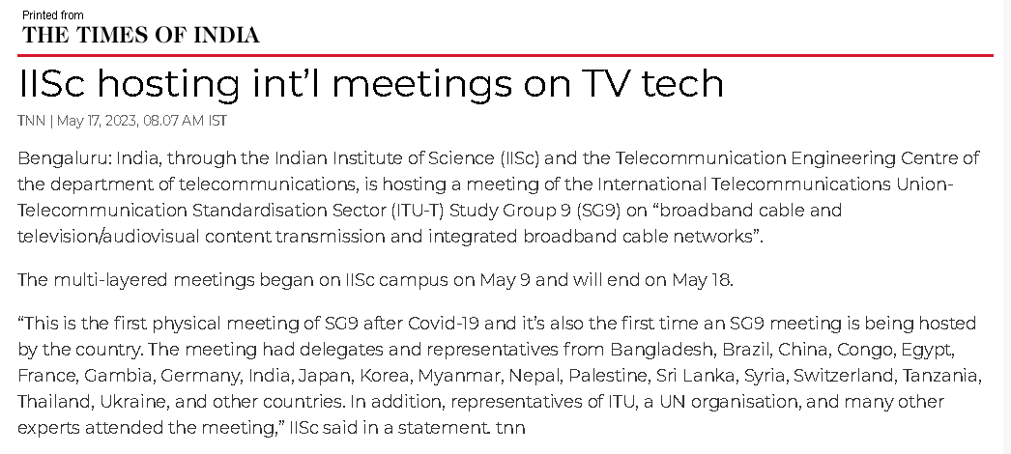
*IISc: Indian Institute of Science
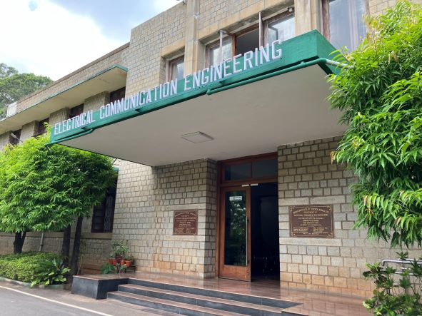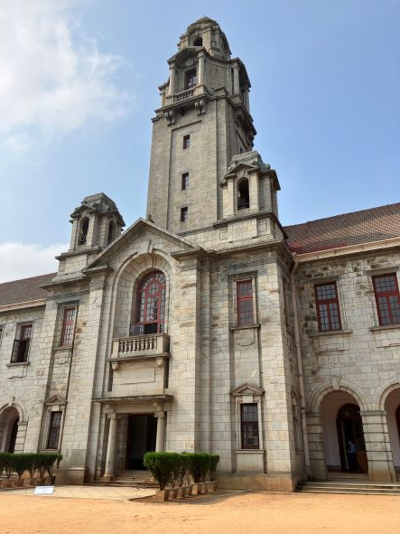
Venue of the SG9 meeting Venue of the workshop (IISc Faculty Hall)

Next SG9 meeting is currently scheduled to be held from 14 November to 23 November 2023, in Bogotá, Colombia at the kind invitation by the Colombian administration (TBC). More information will be provided on the SG9 website when available. A co-located workshop on “The future of Television for the Americas” may be organized in collaboration with ITU-R, ITU-D and ITU regional offices (TBC).
_______________________

