 | INTERNATIONAL TELECOMMUNICATION UNION  TELECOMMUNICATION  STANDARDIZATION SECTOR  STUDY PERIOD 2022-2024 |  |  |  | TSAG-TD227
 |  |  |  |  | TSAG
 |  |  |  |  | Original: English
Question(s): |  | N/A |  |  | Geneva, 30 May – 2 June 2023
TD
Source: |  | Director, TSB
Title: |  | ITU Journal on Future and Evolving Technologies – Publications and Webinars
Contact: |  |  | Alessia Magliarditi  TSB | Tel: +41 22 730 5882  E-mail: alessia.magliarditi@itu.int

Abstract: | The ITU Journal on Future and Evolving Technologies has published 148 papers since its launch in September 2020. Furthermore, new special issues are still calling for papers on 5G and beyond wireless systems, AI-driven security, AI for accessibility, metaverse, satellite constellations and space, for publication in 2023 and 2024. This document provides details on publications topics and contributors as well as on the new Webinar Series which will share insights from CTOs on industry ambitions for 5G, 6G, and associated innovations to boost network intelligence. The webinars highlight the growing synergy between academic researchers and industry players in developing and applying new technologies.

1 Introduction
The ITU Journal on Future and Evolving Technologies (ITU J-FET) was launched in September 2020 under the leadership of the Editor-in-Chief, Prof. Ian F. Akyildiz (Ken Byers Chair Professor Emeritus in Telecommunications at Georgia Tech, USA and Chief Executive Officer at Truva Inc.; h-index: 136; Citations: 140’000+). In two years and a half 148 papers have been published, authored by 659 researchers, 71% of which come from academia.
ITU Member States had adopted a new Resolution at the ITU Plenipotentiary Conference, which convened in Dubai, United Arab Emirates, from 29 October to 16 November 2018, to support the further development of the ITU Journal. Members resolved to establish collaborative efforts with the research community and to raise awareness of the ITU Journal worldwide (Resolution 207 (Dubai, 2018)).
ITU J-FET considers yet-to-be-published papers addressing fundamental and applied research. It shares new techniques and concepts, analyses and tutorials, and learnings from experiments and physical and simulated test beds. It also discusses the implications of the latest research results for policy and regulation, legal frameworks, the economy and society. Its interdisciplinary approach reflects ITU’s comprehensive field of interest and explores the convergence of ICT with other disciplines.
ITU J-FET is committed to the timely publication of very high quality, peer-reviewed, original papers. The Journal aims to promote accessibility of research to academics and industry researchers across the world. The publication is free of charge for both readers and authors, highlighting the true sense of the term "open access". The international Editorial Board is composed of experts (70% from academia) who are in the forefront of the telecommunications research world.
Achieving a significant impact factor is a goal for this Journal and will derive from the relevance of journal papers to the priorities of academia, industry and governments, leading the way to new frontiers in research.
The ITU Journal publishes original research online, welcoming papers at any time, on all topics within its scope (please visit the about ITU J-FET webpage for detailed information) and with the aim of building bridges between disciplines, connecting theory with application, and stimulating international dialogue on the future and evolution of the digital transformation.

2 Publication of the 1st issue of 2023
In March 2023, the ITU J-FET inaugurated the publication of Volum​e 4 (2023) which already includes Forewords from the new ITU Secretary-General and the new Director of the Telecommunication Standardization Bureau; two special issues described in the next sections of this document; and one regular paper on 6G non-terrestrial networks which analyses total path loss and usable bandwidth in three 6G aerial communication cases: Low Altitude Platform to High Altitude Platform (LAP-to-HAP); HAP-to-HAP; and HAP-to-Satellite (HAP-to-SAT) using GHz-to-THz broadband communications. A new set of special issues has been developed, with the calls for papers announced and publication anticipated for 2023 and 2024.
- Intelligent surfaces and their application towards wide-scale deployment
The first special issue of this year is on Intelligent surfaces and their applications towards wide-scale deployment​.
Published in March 2023, the issue contains ten academic research papers sharing insights on how networked metasurfaces – coating walls and doors, for example – could form part of smart, programmable wireless environments that could be orchestrated to optimize wireless propagation and the quality and privacy of user experiences.
The Editorial Board of this issue includes Christos Liaskos, University of Ioannina, Greece, as Leading Guest Editor; and the following Guest Editors: Andreas Pitsillides​, University of Cyprus, Cyprus & University of Johannesburg, South Africa; Tie Jun Cui, Southeast University, Nanjing, China; Marios Lestas, Frederick University, Cyprus; Evangelos Papapetrou, University of Ioannina, Greece; Stefan Schmid, University of Vienna, Austria; and Dimitrios Sounas​, Wayne State University, USA.
- Innovative network solutions for future services
Innovative network solutions for future services contains seven papers that explore networking innovations for scenarios such as the automation of industrial processes, highly targeted disaster-relief communications, and remote surgery, as well as future health wearables, self-driving vehicles, and the immersive experiences promised by the metaverse.
This issue was completed with the support of the Leading Guest Editors Ibrahim Habib​, City University of New York, USA, and Romeo Giuliano, Guglielmo Marconi University, Italy; and the Guest Editors Enjie Liu, University of Bedfordshire, United Kingdom, and Rui L. ​Aguiar​, Instituto de Telecomunicações, Portugal.

3 Series of special issues under preparation
The ITU Journal has announced a new series of special issues to be published in 2023 and paper submissions are currently welcome for some of them. These issues continue to look towards exploring the areas of future and intelligent technologies and with an emphasis on 5G and 6G wireless systems, as well as papers on ​​​​​​​AI-driven security, AI for accessibility, metaverse, satellite constellations and space.
More information on the Editorial Board, scope and topics​​, publication rights and copyright​, submission guidelines and templates​​, and review policy can be found online.

I. |  | The special issue on AI-driven security in 5G and beyond called for novel contributions dealing with security issues in networking technologies in the 5G and beyond era through utilization of AI tools.  This special issue will be published in June 2023.
II. | 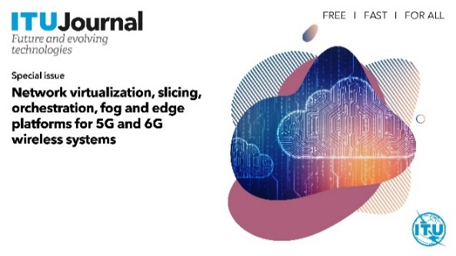 | In these highly virtualized and distributed environments that characterize the landscape of 5G and 6G networks, several challenges arise related to the management and orchestration of resources, which are the target of this special issue on Network virtualization, slicing, orchestration, fog and edge platforms for 5G and 6G wireless systems​.  Publication is foreseen for June 2023.
III. |  | The third edition of the special issue on AI/ML solutions in 5G and future networks is based on the research related to the third edition of the ITU AI/ML in 5G Challenge.  This issue is dedicated to the exploration of AI and ML in 5G and future networks as well as enabling technologies and tools in networks.  The publication is planned for September 2023.
IV. |  | The AI for accessibility special issue seeks contribution on the use of AI technology on developing or evaluating systems and services for people with different range of abilities. ​  Researchers are welcome to submit their work by 30 June 2023.
V. | 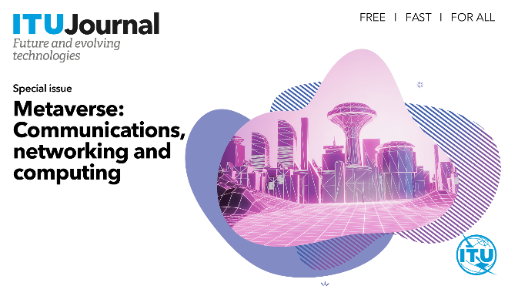 | The special issue on Metaverse: Communications, networking and computing​ aims to attract submissions of cutting-edge research from academia and industry, particularly those emphasizing theories, algorithms, techniques, prototypes, and applications for 6G communication, networking and computing technologies that can generate breakthroughs for Metaverse research.  Deadline for submissions is 30 June 2023.
VI. |  | This special issue seeks contributions that propose and evaluate intelligent techniques for networking and distributed systems, as well as encouraging a thorough discussion of the advantages and disadvantages of these solutions, addressing the trade-offs involved in their adoption.  Submissions to this issue on Intelligent technologies for future networking and distributed systems are welcome by 31 July 2023.
VII. | 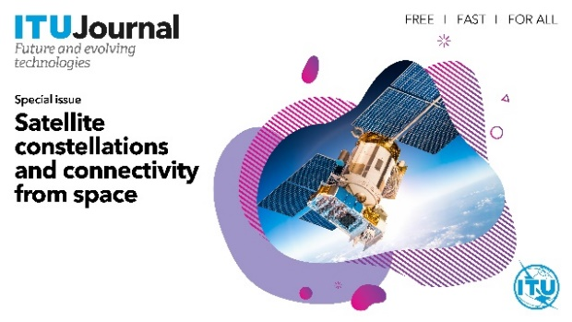 | The special issue on Satellite constellations and connectivity from space​ has just been announced and calls for submissions until 4 September 2023.  It invites contributions on the development of new adaptive and robust communications strategies (from physical to the application layer) to fully realize the potential offered by satellite constellations.
VIII. |  | The aim of this special issue is to examine various complementary aspects of cutting-edge trends and creative approaches in communications and networks research. The goal is to showcase selected driving technologies, methods, and principles that will support the development of the next generation of interconnected communication systems and facilitate their integration into smart society, industry, and economy.  Next Generation Computer Communications and Networks has just been launched and accepts submissions until 12 September 2023.

4 Past publications – regular and special issues
The ITU J-FET published its first issue (Volume 1 (2020), Issue 1) in December 2020 which included ten original research papers that highlight emerging technologies in the field of ICT.
In April 2021, the second regular issue of the ITU J-FET was published (Volume 2 (2021), Issue 1), with eight papers highlighting the areas of cryptocurrency, wireless sensor networks and spectrum allocation. Volume 2 (2021) was completed in December 2021 and includes a regular issue with eleven papers and a survey that provide an in-depth analysis of wireless networks and B5G communication systems; as well as special issues papers on AI and machine learning solutions in 5G and future networks (1st edition), Internet of Everything, Wireless communication systems in beyond 5G era, Terahertz communications, and Internet of Bio-Nano Things for health applications.
Volume 3 (2022), completed in December last year, contains a regular issue which
gathers ten papers on topics ranging from holographic communications, digital twins, and edge computing to the growing research challenges in wireless communications associated with extended reality that are receiving a high number of citations; as well as special issues papers on Towards vehicular networks in the 6G era, AI​​ and machine learning sol​utions​ in 5G and future networks (2nd edition), Emerging trends and applications in future communication networks, Integrated and autonomous network management and control for 6G time-critical applications​​, Future of networking beyond 2030​, and Digital continuum and next generation networks.

5 New series of Webinars

A new webinar series beginning on 6 June – presented as part of the ITU Journal on Future and Evolving Technologies – will share insights from Chief Technology Officers (CTOs) on industry ambitions for 5G, 6G, and associated innovations to boost network intelligence.
Academia and industry continually stimulate one another’s work as partners in research and development, as well as in sandbox initiatives to prove the market viability of new solutions. The upcoming series aims to highlight new opportunities to expand this collaboration.
Planned webinars will feature Erik Ekudden, CTO at Ericsson, and Nishant Batra, Chief Strategy and Technology Officer at Nokia, in addition to the three speakers listed below, as well as highly cited academics.
The ten webinars organized last year featured specialist, tech-focused master classes on several topics. Details are provided below and at the relevant webpages.
Each webinar also includes the “Wisdom Corner: Live Life Lessons” where participants have the chance to hear from the speakers about their impactful life lessons as well as their advice to young researchers in the field of ICTs.
All recordings can be watched at the ITU Journal Webinars Series playlist on Y​ou​Tube.

- Upcoming webinars
Naoki Tani, CTO at NTT DOCOMO, will present the mobile operator’s research and development to advance 5G and the prospects for 6G to drive new improvements to our quality of life. Register and join​.
Alex Jinsung Choi, Chairman of the O-RAN ALLIANCE, and Senior Vice President at Deutsche Telekom, will detail machine learning’s contribution to the intelligent control of 5G radio access networks (RANs) and how RAN automation and optimization could evolve for 6G. Register and join.
Alex Sinclair, CTO at GSMA, will guide a global tour of innovative 5G applications and benefits they can bring to business and society. The talk will also explore research challenges for 5G evolution and innovation towards 6G. Register and join.

- Past webinars
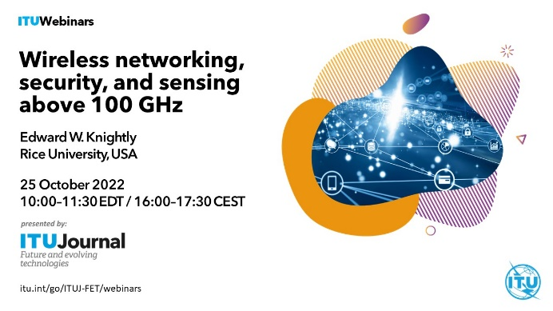

For more information on the ITU J-FET activities, please visit the ITU Journal webpage or contact the ITU Journal Team at journal@itu.int.
________________

