|  |  |  |  |  |
| --- | --- | --- | --- | --- |
| Title: ITU logo | INTERNATIONAL TELECOMMUNICATION UNION  **TELECOMMUNICATION STANDARDIZATION SECTOR**  STUDY PERIOD 2022-2024 | | | TSAG-TD274 |
| TSAG |
| **Original: English** |
| **Question(s):** | | N/A | | Geneva, 30 May - 2 June 2023 |
| **TD (Ref.:** [SG9-LS21](http://handle.itu.int/11.1002/ls/sp17-sg9-oLS-00021.docx)**)** | | | | |
| **Source:** | | ITU-T Study Group 9 | | |
| **Title:** | | LS/r on smart TV Operating System (SG16-LS23) [from ITU-T SG9] | | |
| **LIAISON STATEMENT** | | | | |
| **For action to:** | | | - | |
| **For information to:** | | | ITU-T SG16, TSAG | |
| **Approval:** | | | ITU-T Study Group 9 meeting (Bangalore,18 May 2023) | |
| **Deadline:** | | | N/A | |
| **Contact:** | | | Haifeng Yan Huawei P.R.China | Email: [yanhaifeng@hisilicon.com](mailto:yanhaifeng@hisilicon.com) |

This liaison statement answers [SG16-LS23](https://www.itu.int/ifa/t/2022/ls/sg16/sp17-sg16-oLS-00023.docx).

A new liaison statement has been received from SG9.

This liaison statement follows and the original file can be downloaded from the ITU ftp server at <http://handle.itu.int/11.1002/ls/sp17-sg9-oLS-00021.docx>.

|  |  |  |  |  |  |  |
| --- | --- | --- | --- | --- | --- | --- |
|  | INTERNATIONAL TELECOMMUNICATION UNION  **TELECOMMUNICATION STANDARDIZATION SECTOR**  STUDY PERIOD 2022-2024 | | | | | **SG9-LS21** |
| **STUDY GROUP 9** |
| **Original: English** |
| **Question(s):** | | 5/9 | | | | Bangalore, 9-18 May 2023 |
| **LS (Ref.:** [**SG9-TD382**](https://www.itu.int/md/T22-SG09-230509-TD-GEN-0382/en)**)** | | | | | | |
| **Source:** | | ITU-T Study Group 9 | | | | |
| **Title:** | | LS/r on smart TV Operating System (SG16-LS23) | | | | |
| **LIAISON STATEMENT** | | | | | | |
| **For action to:** | | | | - | | |
| **For information to:** | | | | ITU-T SG16, TSAG RG-WM | | |
| **Approval:** | | | | ITU-T Study Group 9 meeting (Bangalore, 18 May 2023) | | |
| **Deadline:** | | | | N/A | | |
| **Contact:** | | | Haifeng Yan Huawei P.R.China | | Email: [yanhaifeng@hisilicon.com](mailto:yanhaifeng@hisilicon.com) | |

|  |  |
| --- | --- |
| **Abstract:** | This liaison statement replies to the LS from ITU-T SG16 ([SG16-LS23](https://www.itu.int/ifa/t/2022/ls/sg16/sp17-sg16-oLS-00023.docx)) on smart TV Operating System. |

ITU-T SG9 thanks ITU-T SG16 for the liaison (your [SG16-LS23](https://www.itu.int/ifa/t/2022/ls/sg16/sp17-sg16-oLS-00023.docx)) to clarify the issues discussed on TVOS-related work items.

During ITU-T SG9 meeting, Bangalore, 9-18 May 2023, we discussed your concerns in relation to the information displayed in the ITU-T website pages where the Recommendation details are listed.

We noted that in each website there is a way to get the scope and the title of the Recommendation, and we hope to clarify in this liaison statement that there is no confusion on the scope of the SG9 Recommendations. We discussed this also with a representative from Brazil who mentioned that he was also a member of SG16 and that he agreed with SG9 views that there is no confusion on the scope of the SG9 Recommendations in SG9 pages. He would report his views to SG16 colleagues.

We listed the relevant ITU-T websites below, see from next page:

1. <https://www.itu.int/ITU-T/recommendations/rec.aspx?id=14871>

The summary of the Recommendation is shown on the top.

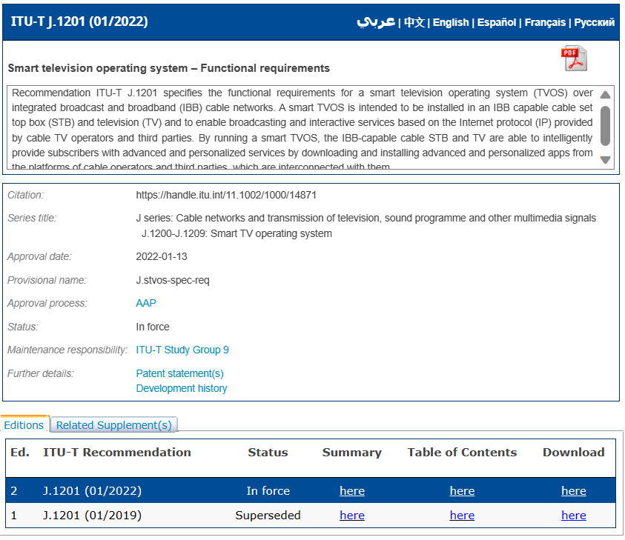

1. <https://www.itu.int/rec/T-REC-J.1201-202201-I>

The link of summary is shown on the right top.

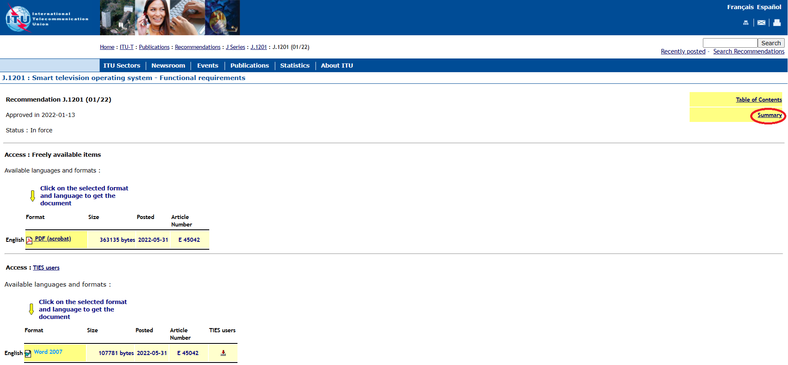

We also searched the TVOS Recommendation in other known research engines for standards and we found the following:

1. <https://standards.globalspec.com/std/14517330/J.1201>

The scope of Recommendation is shown on the top.

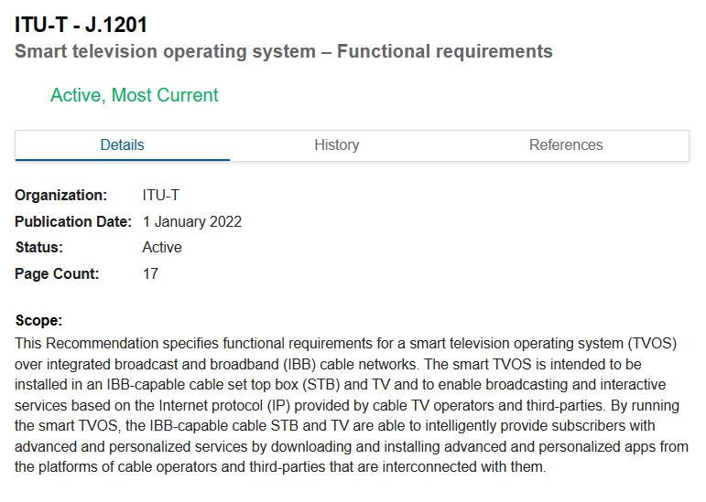

We noted that most of the webpages related to TVOS Recommendations (both within ITU and outside ITU) clearly show either the summary or the scope of the Recommendation without the need to download the whole Recommendation to find it out.

We firmly believe that the content of a Recommendation (and in general any standard) cannot be fully understood by its title only. That is the reason why the scope clause is added within the text of the standards, so downloading the Recommendation (/standard) full text seems an obvious action from any expert who come across an interesting document. So, any delegate who would come across any ITU-T Recommendation would need to look for the scope to fully understand its applicability (either on the webpage or on the Recommendation text).

We think that the scope of our TVOS Recommendations is quite evident by the summary of the Recommendations, which is well evident from the ITU-T webpages. So, we would like to keep the titles of TVOS Recommendations as they are and believe that the information displayed in the current webpage of TVOS Recommendations is sufficient.

Again, we hope for your understanding, and please be assured that ITU-T SG9 wishes to continue collaborating with ITU-T SG16 and TSAG RG-WM on these topics.

____________________