|  |  |  |  |  |  |  |
| --- | --- | --- | --- | --- | --- | --- |
|  | INTERNATIONAL TELECOMMUNICATION UNION  **TELECOMMUNICATION STANDARDIZATION SECTOR**  STUDY PERIOD 2022-2024 | | | | | TSAG-TD405 |
| TSAG |
| Original: English |
| **Question(s):** | | N/A | | | | Geneva, 22-26 January 2024 |
| **TD** | | | | | | |
| **Source:** | | Director, TSB | | | | |
| **Title:** | | Kaleidoscope 2024 | | | | |
| **Purpose:** | | | | Information | | |
| **Contact:** | | | Alessia Magliarditi TSB/ITU | | Tel: +41 22 730 5882 E-mail: [kaleidoscope@itu.int](mailto:kaleidoscope@itu.int) | |

|  |  |
| --- | --- |
| **Keywords:** | Kaleidoscope; academic papers; artificial intelligence, cloud computing, digital transformation, extended reality, green communications, human-oriented technologies, Internet of Things, machine learning, metaverse, mobile and wireless communications, regulation and standardization, security and privacy in cyberspace, technological innovation, UN agenda for sustainable development; |
| **Abstract:** | This document provides an overview of the next ITU Kaleidoscope academic conference 2024 (K-2024) that will take place from 21 to 23 October 2024, in New Delhi, India, in parallel with the World Telecommunication Standardization Assembly 2024 (WTSA-24). Attached to this TD is the full Call for Papers. |

Action required

TSAG, ITU-T Study Groups (SGs) and Focus Groups (FGs) are invited to promote the 15th ITU Kaleidoscope academic conference and disseminate its Call for Papers widely among relevant academic and industry R&D communities. The aim is to increase the synergies between Kaleidoscope and ITU-T SGs and FGs, by encouraging submission of papers that could contribute to the work of the Union, especially considering that Kaleidoscope 2024 will take place in parallel with WTSA-24.

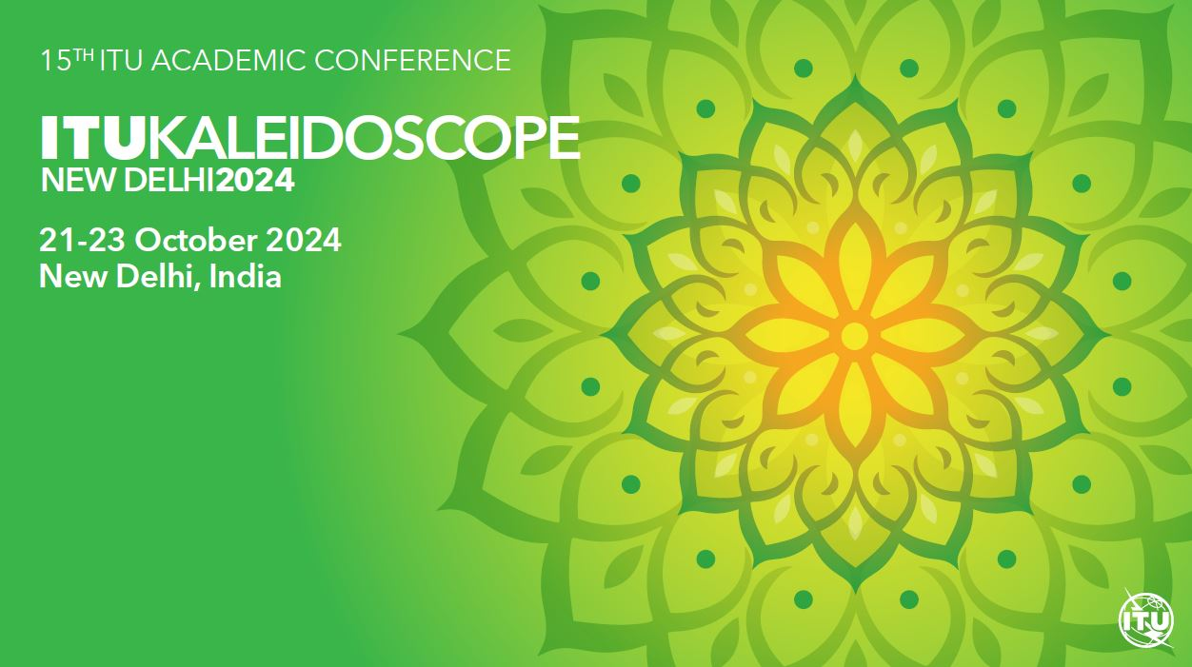Introduction

[Kaleidoscope](http://itu-kaleidoscope.org/) is the ITU flagship event for academia which brings together a wide range of views from universities, industry and research institutions.

The aim of Kaleidoscope is to foster collaboration and discussion on emerging trends in technologies for a digital and sustainable transformation that can benefit humanity.

The 15th edition of this series of peer-reviewed academic conferences will take place in New Delhi, India, from 21 to 23 October 2024, in parallel with WTSA-24, at the kind invitation of India’s Administration.

As stated in PP-22 Rev. Res. 169 on “Admission of academia to participate in the work of the Union”, Kaleidoscope is organized “on a rotational basis, to the greatest extent possible”. The aim is to maximize inclusivity, thereby facilitating hosting opportunities for regions worldwide. This approach ensures that each part of the globe has the chance to both host and derive benefits from the conference, fostering connections and empowering academia within their respective countries. In this regard, we strongly encourage local participation in the conference from Indian universities and research institutions, as well as industry R&D, and startups. A special session focusing on youth and standardization will also be organized.

Theme and other info

*Kaleidoscope 2024: Innovation and digital transformation for a sustainable world* calls for original, academic papers exploring technological innovation and digital transformation's implications for policy, regulation, legal and ethical frameworks, the economy, and society. Emphasis is placed on how international ICT standards contribute to achieving the UN Sustainable Development Goals.

Kaleidoscope targets specialists in the fields of ICT, standardization, and socio-economic development, including researchers, academics, students, engineers, policymakers, regulators, and innovators.

The accepted papers, selected through a doble-blind peer-review process, that will be presented at the conference will be published in the Conference Proceedings and, prior approval of IEEE technical co-sponsorship, will also be submitted for publication in the IEEE *Xplore* Digital Library.

A prize fund will be shared among the authors of the three best papers, as judged by the Steering and Technical Programme Committees. Young authors of up to 30 years of age who will present an accepted paper will receive a​ Young Author Recognition certificate.

Additional information, including the calls for video demonstrations and local universities exhibit, will be available shortly at the conference [webpage](https://www.itu.int/en/ITU-T/academia/kaleidoscope/2024/Pages/default.aspx).

The full **Call for Papers** is available in the Annex to this document for promotional purposes.

*ITU Kaleidoscope 2024*

***Innovation and digital transformation for a sustainable world***The 15th ITU Kaleidoscope academic conference

New Delhi, India, 21-23 October 2024

Call for Papers

*Kaleidoscope 2024: Innovation and digital transformation for a sustainable world* is the fifteenth in a series of peer-reviewed academic conferences organized by ITU to bring together a wide range of views from universities, industry and research institutions. The aim of Kaleidoscope is to foster collaboration and discussion on emerging trends in technologies for a digital and sustainable transformation that can benefit humanity.

**Preamble**

The United Nations (UN) 2030 Agenda for sustainable development, which includes the 17 Sustainable Development Goals ([SDGs](https://sustainabledevelopment.un.org/sdgs)), recognizes that “*the spread of information and communication technology and global interconnectedness has great potential to accelerate human progress, to bridge the digital divide and to develop knowledge societies, as does scientific and technological innovation across areas as diverse as medicine and energy*”.

The UN Secretary-General’s vision on the future of global cooperation puts forward an upgraded UN that can offer more relevant, system-wide, multilateral and multi-stakeholder solutions to better respond to humanity’s most pressing challenges, focusing significantly on innovation and digital transformation.

Sustainable digital transformation and universal connectivity are ITU’s main goals, as indicated in the Union’s Strategic Plan, which put forward a clear vision for “*an information society, empowered by the interconnected world, where telecommunication/information and communication technologies (ICTs) enable and accelerate social, economic and environmentally sustainable growth and development for everyone*”.

**Theme**

The theme of the fifteenth edition of the ITU Kaleidoscope academic conference captures the ongoing global efforts to harness the power of technology for positive and sustainable change.

The landscape of innovation and digital transformation is evolving at an unprecedented pace, influencing every aspect of our lives, and profoundly impacting global development. As we strive to achieve the SDGs and address pressing societal and environmental concerns, the role of ICTs becomes pivotal.

The conference invites contributions that delve into cutting-edge research, transformative technologies, and innovative practices that underpin the digital revolution with a focus on sustainability and standardization. From the fundamental restructuring of network infrastructures to the applications shaping sustainable development, and the enabling technologies driving these advancements, we seek to explore the multidimensional facets of innovation and digital transformation.

**Objective**

The fifteenth Kaleidoscope conference calls for original, academic papers exploring technological innovation and digital transformation's implications for policy, regulation, legal and ethical frameworks, the economy, and society. **Emphasis is placed on how international ICT standards contribute to achieving the UN SDGs.**

**Audience**

Kaleidoscope 2024 targets specialists in the fields of ICT and socio-economic development, including researchers, academics, students, engineers, policymakers, regulators, and innovators.

**Date and venue**

21-23 October 2024, in conjunction with the World Telecommunication Standardization Assembly 2024 (WTSA-24, 15-24 October - <https://www.itu.int/wtsa/2024/>).

**Submission of papers**

Submission of full, original papers should be within eight pages, including a summary and references, using the template available on the event website. All papers will go through a double-blind peer-review process. Submission must be made electronically; see <http://itu.int/go/K-2024> for more details on online submission (EDAS). Paper proposals will be evaluated according to content, originality, clarity, relevance to the conference’s theme and, in particular, **significance to future standards**.

**Deadlines**

Submission of full paper proposals: ***29 April 2024***

Notification of paper acceptance: ***12 July 2024***

Submission of camera-ready accepted papers: ***2 August 2024***

**Publication and presentation**

Accepted and presented papers will be published in the Conference Proceedings.

**Awards**

A prize fund totaling CHF 6,000 will be shared among the authors of the three best papers, as judged by the Steering and Technical Programme Committees. In addition, young authors of up to 30 years of age presenting accepted papers will receive Young Author Recognition certificates.

**Keywords**

Artificial intelligence, cloud computing, digital transformation, extended reality, green communications, human-oriented technologies, Internet of Things, machine learning, metaverse, mobile and wireless communications, regulation and standardization, security and privacy in cyberspace, technological innovation, UN agenda for sustainable development

**Suggested (non-exclusive) list of topics**

|  |  |
| --- | --- |
| **Track 1:**  **Technology, next-generation network architectures** | * Future mobile and wireless communication networks and network infrastructures (5G and beyond) * Energy-efficient cloud computing and sustainability * Cyber-physical systems for environmental monitoring and management * System architectures for extended reality (XR), metaverse, and immersive live experience (ILE) * Security, privacy, and trust in decentralized and distributed systems * Edge computing and fog computing for real-time applications * Machine learning and AI-driven optimization in sustainable solutions: Quality of Service (QoS), Quality of Experience (QoE) and performance * Network resilience in disaster relief and recovery systems * Quantum communication for secure and resilient networks * Optical and wireless communication convergence system * Long-distance and ultra-high-speed transmission network systems (terabit, exabit) * Efficient communication and design in IoT and sensor networks * Circular economy approaches in ICT waste management |
| **Track 2:**  **Applications and services for sustainable development** | * AI-driven personalized e-services for health and well-being * IoT applications for water quality monitoring and sanitation * Sustainable energy services * Smart transportation and urban mobility applications * Data analytics for monitoring and assessing development goals * Robotics and drones for eco-friendly applications * Technology for aging in place and ambient assistive living * Sustainable smart cities and communities * Provision of adequate security and privacy services |
| **Track 3:**  **Enabling technologies** | * Data processing, management and analytics * Interoperability in decentralized and distributed systems * Next-generation human-computer interaction * Location-based services and spatial registration technologies * Semantic computing and communications * Service chaining, orchestration and federation * Technology convergence: computing network convergence, IT/OT (operational technology) convergence, etc. * Modeling and simulation for digital twins and digital humans * Emerging AI techniques and algorithms including Generative AI * Edge intelligence with on device AI * Blockchain/Distributed Ledger Technologies with incentive and consensus mechanisms * Technologies for quality and sustainable online education * Alternate technology options for rural connectivity * Integration of existing mechanisms to provide for security and privacy |
| **Track 4:**  **Social, economic, environmental and policy aspects for sustainable development** | * Standards and regulations for sustainable development and sustainable ICT solutions * ICT strategies for sustainable development * Regulatory mechanisms under the convergence paradigm * Environmental implications of cloud computing services * Accessibility and usability in technology solutions * Engineering education for sustainable development * Modeling of the role of technology in society * Intellectual property rights in the digital era * Conformance and interoperability for global technology adoption * Regulation to enforce adequate security and privacy mechanisms * Generating a sustainable echo-system for the Startups |

**Steering Committee**

​Christoph Dosch, ITU-R Study Group 6 Vice-Chairman; ARD​, Germany

Debkumar Chakrabarti, Ministry of Communications, India

Eva Ibarrola, University of the Basque Country, Spain

Kai Jakobs, RWTH Aachen University, Germany

Gyu Myoung Lee, Liverpool John Moores University, United Kingdom

Tiziana Margaria, University of Limerick, Ireland​

Mitsuji Matsumoto, Waseda University Emeritus Professor, Japan

Roberto Minerva, Télécom SudParis, France

Vishnu Ram OV, Independent Consultant, India

Mostafa Hashem Sherif, Consultant, United States

Atul Sinha, Ministry of Communications, India

**Technical Programme Committee**

Mostafa Hashem Sherif, Consultant, United States

The Technical Programme Committee is composed of international subject-matter experts. Details will be available shortly at

<http://itu.int/en/ITU-T/academia/kaleidoscope/2024/Pages/progcom.aspx>.

**Additional information**

For additional information, please visit the conference website: <http://itu.int/go/K-2024>.

Inquiries should be addressed to Alessia Magliarditi at [kaleidoscope@itu.int](mailto:kaleidoscope@itu.int)

_______________