 | INTERNATIONAL TELECOMMUNICATION UNION  TELECOMMUNICATION  STANDARDIZATION SECTOR  STUDY PERIOD 2022-2024 |  |  |  | TSAG-TD406
 |  |  |  |  | TSAG
 |  |  |  |  | Original: English
Question(s): |  | N/A |  |  | Geneva, 22-26 January 2024
TD
Source: |  | Director, TSB
Title: |  | ITU Journal on Future and Evolving Technologies – Publications and Webinars
Contact: |  |  | Alessia Magliarditi  TSB | Tel: +41 22 730 5882  E-mail: alessia.magliarditi@itu.int

Abstract: | The ITU Journal on Future and Evolving Technologies has published 179 papers since its launch in September 2020. In 2023 the Journal’s quarterly publication included 50 papers on a variety of topics relevant to the ITU’s work. Three special issues are currently under preparation for publication in 2024, and two new special issues are still calling for papers on AI and machine learning solutions in 5G and future networks, and Geospatial AI to advance the United Nations Sustainable Development Goals​. This document provides details on all 2023 publications as well as on the Webinar Series which share insights from CTOs and leading academic minds. The webinars highlight the growing synergy between academic researchers and industry players in developing and applying new technologies.

1 Introduction
The ITU Journal on Future and Evolving Technologies (ITU J-FET) was launched in September 2020 under the leadership of the Editor-in-Chief, Prof. Ian F. Akyildiz (Ken Byers Chair Professor Emeritus in Telecommunications at Georgia Tech, USA and Chief Executive Officer at Truva Inc.; h-index: 137; Citations: 145’000+). In about three years, 179 papers have been published, authored mainly by academics.
ITU Member States had adopted a new Resolution at the ITU Plenipotentiary Conference, which convened in Dubai, United Arab Emirates, from 29 October to 16 November 2018, to support the further development of the ITU Journal. Members resolved to establish collaborative efforts with the research community and to raise awareness of the ITU Journal worldwide (Resolution 207 (Dubai, 2018)).
ITU J-FET considers yet-to-be-published papers addressing fundamental and applied research. It shares new techniques and concepts, analyses and tutorials, and learnings from experiments and physical and simulated test beds. It also discusses the implications of the latest research results for policy and regulation, legal frameworks, the economy and society. Its interdisciplinary approach reflects ITU’s comprehensive field of interest and explores the convergence of ICT with other disciplines.
ITU J-FET is committed to the timely publication of very high quality, peer-reviewed, original papers. The Journal aims to promote accessibility of research to academics and industry researchers across the world. The publication is free of charge for both readers and authors, highlighting the true sense of the term "open access". The international Editorial Board is composed of experts (70% from academia) who are in the forefront of the telecommunications research world.
Achieving a significant impact factor is a goal for this Journal and will derive from the relevance of journal papers to the priorities of academia, industry and governments, leading the way to new frontiers in research.
The ITU Journal publishes original research online, welcoming papers at any time, on all topics within its scope (please visit the about ITU J-FET webpage for detailed information) and with the aim of building bridges between disciplines, connecting theory with application, and stimulating international dialogue on the future and evolution of the digital transformation.

2 2023 Quarterly publication
The 2023 quarterly publication of the ITU Journal is included in Volum​e 4, which is composed of 42 papers selected from 7 special issues and 8 regular papers, available for free download at the ITU Journal Digital Library.
- March issue
In March, a regular paper on GHz‑to‑THz Broadband Communications for 6G Non‑Terrestrial Networks and selected papers from the following special issues were published:


The first special issue of 2023 is on Intelligent surfaces and their applications towards wide-scale deployment​. Published in March 2023, the issue contains ten academic research papers sharing insights on how networked metasurfaces could form part of smart, programmable wireless environments that could be orchestrated to optimize wireless propagation and the quality and privacy of user experiences.


Innovative network solutions for future services contains seven papers that explore networking innovations for scenarios such as the automation of industrial processes, highly targeted disaster-relief communications, and remote surgery, as well as future health wearables, self-driving vehicles, and the immersive experiences promised by the metaverse.

- June issue
June publication includes two regular papers on Towards autonomous open radio access networks and Reflection loss‑based roadway water depth measurement for driver safety, and selected papers from the following special issues:

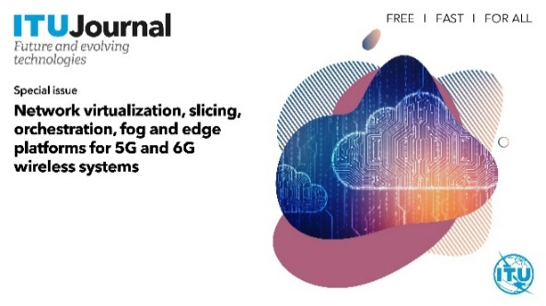
In these highly virtualized and distributed environments that characterize the landscape of 5G and 6G networks, several challenges arise related to the management and orchestration of resources, which are the target of this special issue on Network virtualization, slicing, orchestration, fog and edge platforms for 5G and 6G wireless systems featuring five research papers.

The special issue on AI-driven security in 5G and beyond features a survey on AI‑driven container security approaches for 5G and beyond, and a research paper on a Kubernetes dataset for misuse detection.

- September issue
This publication includes three regular papers on 360° View on Zero-Touch (Zero-Touch) Networks, Channel estimation and PAPR reduction in OFDM based on dual layers-superimposed training, and FuzDeMa: A portable fuzzy-based decision-making tool for reliable communication in wireless underground sensor networks, and selected papers from the following special issue:

The third special issue on AI/ML solutions in 5G and future networks is based on the research related to the third edition of the ITU AI/ML in 5G Challenge.
This issue is dedicated to the exploration of AI and ML in 5G and future networks as well as enabling technologies and tools in networks, and contains seven research papers.

- December issue
This publication highlights innovations to power the metaverse and artificial intelligence for accessibility and also features research on vehicle-to-everything communications, edge computing, and low-earth orbit satellite networking.
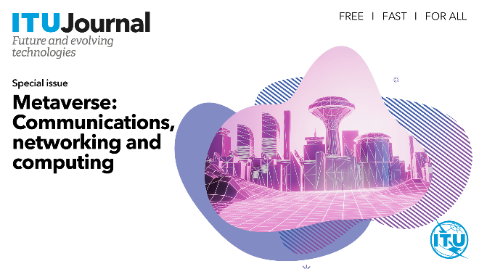
The special issue on Metaverse: Communications, networking and computing​ features seven cutting-edge research papers from academia and industry, emphasizing innovations to power the metaverse. The issue analyses the maturity of existing virtual worlds, the state of the art in multisensory media aimed at engaging all five human senses, point cloud videos for holographic-type communication, and the networking innovations necessary to envisioned metaverse applications.

The AI for accessibility special issue features research on digital inclusion. It explores assistive devices and applications leveraging AI and computer vision, the merits of gamifying the learning of sign language, the accessibility of educational websites, and presents a sound indication device that alerts users to specific sounds and the value gained from machine learning performing tasks locally on the device rather than relying on cloud-based services. ​

3 New series of special issues under preparation
The ITU Journal has announced a new series of special issues to be published in 2024 and paper submissions are currently welcome for some of them. These issues continue to look towards exploring the areas of AI and machine learning, future and intelligent technologies and with an emphasis on 5G and 6G wireless systems, as well as on next generation computer communications and networks, satellite constellations and space, and Geospatial Artificial Intelligence.
More information on the Editorial Board, scope and topics​​, publication rights and copyright​, submission guidelines and templates​​, and review policy can be found online.

I. |  | The aim of this special issue is to examine various complementary aspects of cutting-edge trends and creative approaches in communications and networks research. The goal is to showcase selected driving technologies, methods, and principles that will support the development of the next generation of interconnected communication systems and facilitate their integration into smart society, industry, and economy. Next Generation Computer Communications and Networks will be published in March 2024.
II. | 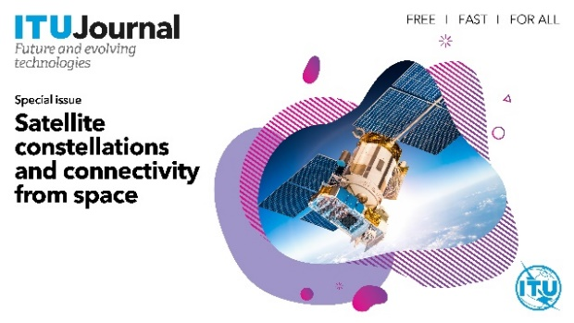 | The special issue on Satellite constellations and connectivity from space​ will be published in June 2024.  It invited contributions on the development of new adaptive and robust communications strategies, from physical to the application layer, to fully realize the potential offered by satellite constellations.
III. |  | This special issue will feature contributions that propose and evaluate intelligent techniques for networking and distributed systems, as well as encouraging a thorough discussion of the advantages and disadvantages of these solutions, addressing the trade-offs involved in their adoption.  Research papers on Intelligent technologies for future networking and distributed systems will be published in September 2024.
IV. |  | Following the successful publication of the three past editions, the 4th edition has been launched recently and accepts submissions until 31 January 2024. The invitation targets hosts and participants of the ITU AI/ML Challenge. Contributions based on novel research with clearly explained and strongly aligned topics in the challenge are also welcome. This dedicated edition aims to explore the impact of AI and ML in 5G/6G and future networks, along with the enabling technologies and tools within network infrastructures.
V. |  | In 2022 ITU launched the GeoAI Discovery webinar series and the GeoAI Challenge. Now in its second year this challenge stands as a beacon, motivating intellects globally to collaboratively tackle geospatial problems by leveraging the progress of AI/ML, with the ultimate vision of furthering the UN SDGs.  Building on the ongoing discussions on GeoAI in the ITU Discovery track and the achievements of the GeoAI Challenge's second edition, this special issue aspires to spotlight and amplify the groundbreaking approaches and insights from the challenge. GeoAI Challenge participants and experts from the broad GeoAI community are invited, by 1 March 2024, to share their novel solutions, techniques, and visions.

4 2023 Webinar Series

The 2023 webinar series – presented as part of the ITU Journal on Future and Evolving Technologies – shared insights from leading minds in academia and Chief Technology Officers (CTOs) on industry ambitions for 5G, 6G, and associated innovations to boost network intelligence.
Academia and industry continually stimulate one another’s work as partners in research and development, as well as in sandbox initiatives to prove the market viability of new solutions. The 2023 series aimed to highlight new opportunities to expand this collaboration.
Each webinar also includes the “Wisdom Corner: Live Life Lessons” where participants have the chance to hear from the speakers about their impactful life lessons as well as their advice to young researchers in the field of ICTs.
All recordings can be watched at the ITU Journal Webinars Series playlist on Y​ou​Tube. Details are provided below and at the relevant webpages.

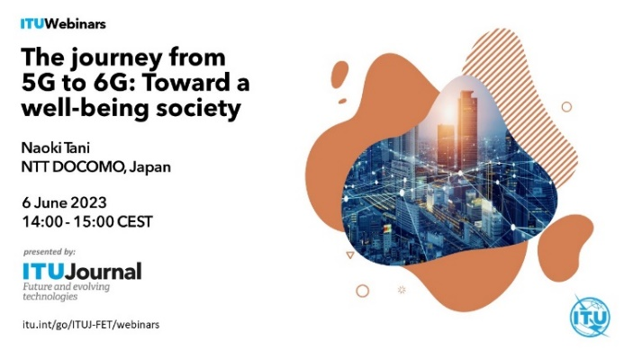 |   The journey from 5G to 6G: Toward a well-being society​ was presented by Naoki Tani, CTO at NTT DOCOMO. The speaker introduced the mobile operator’s research and development to advance 5G and the prospects for 6G to drive new improvements to our quality of life.
 |   Alex Jinsung Choi, Chairman of the O-RAN ALLIANCE, and Senior Vice President at Deutsche Telekom, talked about AI, machine learning RAN intelligent controller for 6G. He detailed machine learning’s contribution to the intelligent control of 5G radio access networks (RANs) and how RAN automation and optimization could evolve for 6G.
 |   Transformation in the 5G era was in focus at the webinar featuring Alex Sinclair, CTO at GSMA, who guided a global tour of innovative 5G applications and benefits they can bring to business and society. The talk also explored research challenges for 5G evolution and innovation towards 6G.
 |   Disrupting NextG was the theme of the talk delivered by Prof. Andrea J. Goldsmith from Princeton University, USA.  As 5G takes to the airwaves, we now turn our imagination to the next generation of wireless technology. This webinar described what the wireless future might look like along with some of the innovations and breakthroughs required to realize this vision.
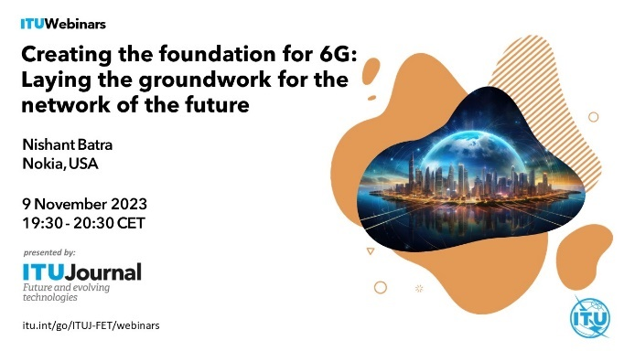 |   Nishant Batra, ​CTO at Nokia​, USA, ​presented many of the key technologies Nokia and its partners are envisioning for future 6G systems. These technologies include network-as-a-sensor, which will introduce new spatial and contextual awareness capabilities, and the AI-native air interface, which will give radios the ability to learn. More info can be found online.
 |   Wang Xiaoyun, Chief Scientist and Deputy Chief Engineer of China Mobile Communications Corporation, presented China Mobile’s efforts towards the construction of a future-centric network that seamlessly melds "connectivity, computing power, and capability", striving for universal connectivity, omnipresent computing resources, and comprehensive capabilities.​ More info is online.
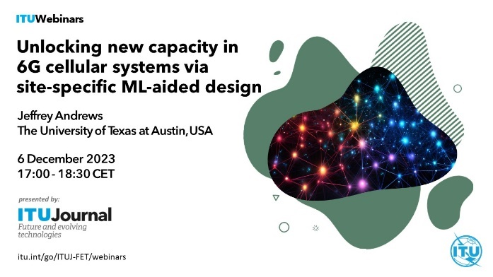 |   6G cellular networks will be extremely complex systems that must meet many requirements in a variety of environments and use cases. Prof. Jeffrey Andrews​, The University of Texas at Austin, USA described some of recent discoveries and technologies based on deep learning (DL) that demonstrate a large potential impact in 6G future development.​​ More info can be found online.

For more information on the ITU J-FET activities, please visit the ITU Journal webpage or contact the ITU Journal Team at journal@itu.int.
________________

