 | INTERNATIONAL TELECOMMUNICATION UNION  TELECOMMUNICATION STANDARDIZATION SECTOR  STUDY PERIOD 2022-2024 |  |  | TSAG-TD430
 |  |  |  | TSAG
 |  |  |  | Original: English
Question(s): |  | N/A |  | Geneva, 22-26 January 2024
TD
(Ref.: SG15-LS109)
Source: |  | ITU-T Study Group 15
Title: |  | ITU-T SG15 EWM Liaison Report [from ITU-T SG15]
LIAISON STATEMENT
For action to: |  |  | -
For information to: |  |  | TSAG
Approval: |  |  | ITU-T SG15 meeting (Geneva, 1 December 2023)
Deadline: |  |  | -
Contact: |  |  | Paul DOOLAN  ITU-T SG15 EWM Rapporteur | Tel: +1 972 357 5822  E-mail: pdoolan@infinera.com

A new liaison statement has been received from SG15.
This liaison statement follows and the original file can be downloaded from the ITU ftp server at http://handle.itu.int/11.1002/ls/sp17-sg15-oLS-00109.docx.

 | INTERNATIONAL TELECOMMUNICATION UNION  TELECOMMUNICATION  STANDARDIZATION SECTOR  STUDY PERIOD 2022-2024 |  |  |  | SG15-LS109
 |  |  |  |  | STUDY GROUP 15
 |  |  |  |  | Original: English
Question(s): |  | All/15 |  |  | Geneva, 20 November – 1 December 2023
Ref.: SG15-TD291/PLEN
Source: |  | ITU-T Study Group 15
Title: |  | ITU-T SG15 EWM Liaison Report
LIAISON STATEMENT
For action to:
For information to: |  |  |  | TSAG
Approval: |  |  |  | ITU-T SG15 meeting (Geneva, 1 December 2023)
Deadline: |  |  |  | -
Contact: |  |  | Paul DOOLAN  ITU-T SG15 EWM Rapporteur |  |  | Tel: +1 972 357 5822  E-mail: pdoolan@infinera.com

Abstract: | This is the report of the SG15 EWM coordination team for presentation at the SG15 closing plenary and transmittal to TSAG as an informational liaison.

The SG15 EWM team would like to inform you about the feedback received regarding EWM in SG15.

 | INTERNATIONAL TELECOMMUNICATION UNION  TELECOMMUNICATION  STANDARDIZATION SECTOR  STUDY PERIOD 2022-2024 |  |  | SG15-TD291/PLEN
 |  |  |  | STUDY GROUP 15
 |  |  |  | Original: English
Question(s): |  | All/15 | Geneva, 20 November - 1 December, 2023
TD
Source: |  | EWM Rapporteur
Title: |  | Report on Electronic Working Methods
Contact: |  | Tony ZENG  WP1 EWM Coordinator |  | Tel: +86 136 8957 6518  E-mail: tony.zengyan@huawei.com
Contact: |  | Paul DOOLAN  WP2 EWM Coordinator |  | Tel: +1 972 357 5822  E-mail: pdoolan@infinera.com
Contact: |  | Yuanbin Zhang  WP3 EWM Coordinator |  | Tel: +86 186 1160 6950  E-mail: zhang.yuanbin@zte.com.cn

Abstract: | This is the report of the SG15 EWM coordination team for presentation at the SG15 closing plenary.

- SG15 EWM coordinators
The opening plenary meeting of the 2022 – 2024 study period appointed the individuals below as SG15 EWM coordinators for the working parties indicated:
WP1: | Tony Zeng | tony.zengyan@huawei.com
WP2: | Paul Doolan | pdoolan@infinera.com
WP3: | Yuanbin Zhang | zhang.yuanbin@zte.com.cn

The EWM coordination team nominated Mr Paul Doolan as EWM Rapporteur.
The EWM team solicits input via email and through in person discussion with the coordinators.
- Meeting Facilities
Rooms for this meeting were allocated in both the ITU buildings and in CICG. There were no problems reported with connectivity or audio visual systems in either venue. TSB support staff provided our interface to the CICG technical staff; this was much appreciated by those responsible for running meetings.
Our concerns about facilities like a second monitor, a remote participation computer, microphones, power sockets, etc in CICG reported in TD103/PLEN and TD182/PLEN have all been accommodated, in our opinion, i.e. from the EWM perspective, CICG is an entirely adequate facility in which to host a SG15 meeting.

- Coordination with TSB ICT staff
Once again we appreciate being able to meet face to face with TSB staff. Their expertise and knowledge helps us understand delegates issues more completely and they are able to provide guidance on how we can appropriately respond to some of them.
The support received during the plenary from ITU/CICG staff for audio/visual, MyMeetings and other issues from Ilia Londo and Gent Bajrami of TSB, was again exemplary and we extend to them our thanks.
- FTP Issues particular to this meeting
We have reported previously on issues with FTP to the IFA site, those fall into two categories only one of which ITU and/or its support staff can help with.
Corporate prohibition on the use of FTP
Some members of ITU-T do not allow their employees to use FTP, some allow their employees to use FTP but only for download. Clearly the ITU-T has no responsibility or jurisdiction in such corporate policy matters.
Corporate requirements on FTP server configuration
Some members of ITU-T only allow their employees to use FTP servers that support specific security protocols. During this meeting the TSB support staff have confirmed with their colleagues that the FTP server is now configured to support TLS 1.2. TLS 1.2 enables secured connections and it can be changed easily on the Filezilla client which is widely used in SG15:
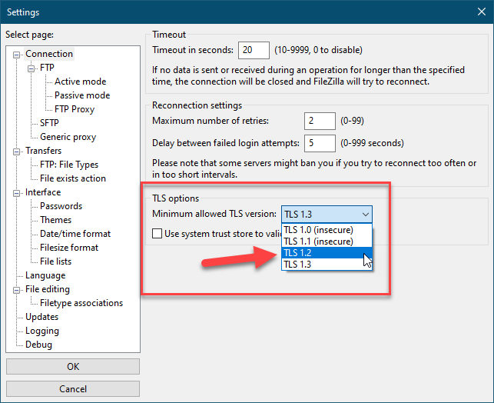
Use of email to distribute official meeting documents
The corporate restriction on using FTP resulted in one of our questions circulating documents that would normally have been posted on the IFA via email to the question’s mailing list for a short period during the meeting. This is not a normal practice in SG15, indeed here we regard it as having been an ‘emergency’ measure. TSB have kindly agreed that in future emergencies of this sort documents may be sent to them and they will upload them to the FTP site.

- Proposed Annex in Rec A.1 on EWM
We were made aware of the existence of a draft working text: https://extranet.itu.int/meetings/ITU-T/T22-TSAGRGM/RGWM-231121/DOCs/T22-TSAGRGM-RGWM-231121-DOC-0002.docx from TSAG RG-WM and contains a new normative Annex (Annex B) on EWM.
We were asked to consider the SG15 perspective on three specific aspects of that proposed Annex:
- Banning document distribution on email
- Forcing use of FTP for SG meetings
- Forcing use of Sharepoint for rapporteur meetings

Consultation with colleagues revealed:
- Unanimous willingness to accept a ban on official document distribution on email.
  - This comes as no surprise since it is not something we do (normally) anyway.
- The trenchant observation that we already use FTP during SG meetings in combination with the TSB supported posting of documents to the SG15 Meeting documents page and repository. FTP should not (indeed cannot) replace those.
- Recognition of the irony that such a mandate should be being considered in the same week as the FTP issues detailed in 4 above manifested themselves.
Unanimous opposition to forcing the use of Sharepoint for RGMs. The sentiment was actually wider than mere opposition to use of Sharepoint; the choice of which of the available tools to use should be left to the management of the SG, WP and Questions. Our SG and WP management leave the choice of which tools to use to the Questions and the Rapporteurs who guide them since they likely know best what works best for them.
- Collaboration tools
Following on from the Annex B matters above we remark that Sharepoint is used – although we do not know to precisely what extent – in Q3, Q4/15. In TD103/PLEN we reported on a tutorial Mr Van Der Putten gave on Q4’s experience. There have been no requests to repeat that and, we are not aware of any significant interest in expanding its use to other questions.
In TD103/PLEN we also mentioned MyWorkspace. That platform was significantly enhanced for WTSA and TSB ICT staff briefly showed us some of its features. A tool to allow collaborative document processing already exists, there is some interest to evaluate that and TSB’s assistance in exposing it to more of the community would be beneficial.
- DDP Contribution submission
The issues noted in TD103/PLEN and TD182/PLEN with respect to DDP problems were brought to our attention again at this meeting. TSB ICT staff have, in this meeting, contacted the DDP maintainers who have offered to meet with us. That meeting will occur virtually after the SG15 plenary.
- Better guidance for newcomers
New delegates continue to join SG15. We have received suggestions that amount to “there should be some introductory guidance” but this from a person whose questions do not attend the plenary until the second week. There is a newcomer presentation on the first day of the plenary which touches on EWM matters. There are three obvious solutions: attend the whole plenary; have questions need to be present for only part of the period attend at the start; repeat the newcomers meeting at the start of both weeks.
During the newcomers meeting in the first week of this plenary a new delegate asked if a video could be made to help newcomers, while not exactly an EWM matter if such a video were to be made it should include some guidance on EWM methods in SG15.
We have also received input that compares our EWM facilities with those available in IEEE plenaries. Further investigation of that may be a topic in future SG15 EWM reports.
- Liaison to TSAG
The liaison attached as Appendix I is to report to TSAG on EWM in SG15.
- Conclusion
The EWM coordinators thank those members of SG15 who took time to provide us input during this meeting. Please note that we also accept input in the period between plenary meetings.

___________________

