|  |  |  |  |
| --- | --- | --- | --- |
|  | INTERNATIONAL TELECOMMUNICATION UNION  **TELECOMMUNICATION STANDARDIZATION SECTOR**  STUDY PERIOD 2022-2024 | | TSAG-TD535 |
| TSAG |
| Original: English |
| **Question(s):** | | N/A | Geneva, 29 July - 2 August, 2024 |
| **TD** | | | |
| **Source:** | | Chair, ITU-T SG9 | |
| **Title:** | | ITU-T SG9 Lead Study Group report | |
| **Contact:** | | Satoshi Miyaji KDDI Corporation Japan | Tel: +81 80 5060 9134 E-mail: [sa-miyaji@kddi.com](mailto:sa-miyaji@kddi.com) |
| **Contact:** | | Mr Stefano Polidori TSB; Counsellor SG9 | E-mail: [stefano.polidori@itu.int](mailto:stefano.polidori@itu.int) |

|  |  |
| --- | --- |
| **Abstract:** | This document provides the report of ITU-T SG9 on Lead Study Group activities on integrated broadband cable networks and audiovisual content delivery over cable networks. |

Contents

1. Introduction 1

2. Preparation for WTSA-24 3

3. Actions agreed to foster membership involvement in specific activities of SG9 3

4. Next Study Group 9 meeting 4

5. Next workshop on the Future of TV -series 4

# Introduction

The fourth Study Group 9 (Broadband cable and TV) meeting in the study period 2022 – 2024 was held fully virtual, from 9 to 17 May 2024. The SG9 meeting was chaired by Mr Satoshi Miyaji (KDDI, Japan), who was assisted by Mr Stefano Polidori (TSB Counsellor). The meeting was organized at 10h00 – 16h00 CEST to coordinate the time zones of all regions as much as possible, and was attended by 56 participants from 15 countries. All sessions were held using MyMeetings remote participation tool.

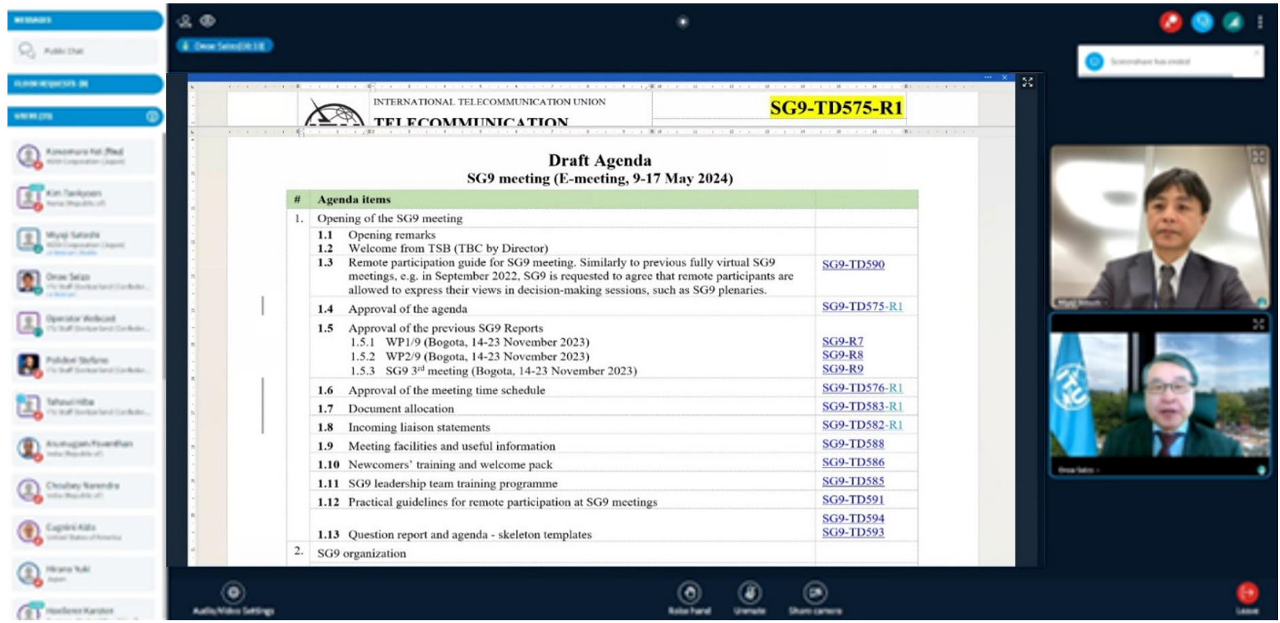

Figure 1: SG9 opening plenary

During the SG9 meeting in May 2024, a total of five (5) draft Recommendations (4 new, 1 revised) were finalized and agreed for AAP Consent.

| Question | Rec | Version | Title | Final TD | A.5  just. |
| --- | --- | --- | --- | --- | --- |
| Q1/9, Q4/9 | J.153 (ex [J.cable-5G-arch](http://www.itu.int/itu-t/workprog/wp_item.aspx?isn=18894)) | New | System architecture for cable television services to use IMT-2020 radio systems | [TD728](https://www.itu.int/md/T22-SG09-240509-TD-GEN-0728/en) | [TD730](http://www.itu.int/md/T22-SG09-231114-TD-GEN-0730) |
| Q3/9 | [J.1630 (ex J.pcnp-char)](http://www.itu.int/itu-t/workprog/wp_item.aspx?isn=17753) | New | End to End Network Characteristics Requirement for Video Services over integrated broadband cable network | [TD747R1](https://www.itu.int/md/T22-SG09-240509-TD-GEN-0747/en) | [TD748R1](https://www.itu.int/md/T22-SG09-240509-TD-GEN-0748/en) |
| Q6/9 | [J.298-rev](http://www.itu.int/itu-t/workprog/wp_item.aspx?isn=18899) | Rev. | Requirements and technical specifications of a cable TV hybrid set-top box compatible with terrestrial and satellite TV transport | [TD690](https://www.itu.int/md/T22-SG09-240509-TD-GEN-0690/en) | [TD719](http://www.itu.int/md/T22-SG09-231114-TD-GEN-0719) |
| Q6/9 | J.1291 (ex [J.STB-AV](https://www.itu.int/ITU-T/workprog/wp_item.aspx?isn=19222)) | New | Requirements and functional specification of Audio and Video interface on cable set-top box | [TD736](https://www.itu.int/md/T22-SG09-240509-TD-GEN-0736/en)R2 | N/A |
| Q9/9 | J.1311 (ex [J.cloud-game-req](http://www.itu.int/itu-t/workprog/wp_item.aspx?isn=17758)) | New | Technical Requirements for Cloud Gaming Service Platforms | [TD706R2](https://www.itu.int/md/T22-SG09-240509-TD-GEN-0706/en) | N/A |

In addition, the following four (4) Corrigenda were agreed for AAP Consent. These Corrigenda are intended to improve the content related to terms and definitions of these in-force Recommendations in accordance with the liaison communications for harmonization with SCV/CCV on terminology definitions.

|  |  |  |  |  |  |
| --- | --- | --- | --- | --- | --- |
| **Question** | **Rec** | **Version** | **Title** | **Final TD** | **A.5  just.** |
| Q1/9, Q7/9 | J.198.2 (Cor.1) | Corr | Physical layer specification for third-generation HiNoC | [TD721](https://www.itu.int/md/T22-SG09-240509-TD-GEN-0721/en) | N/A |
| Q2/9, Q10/9 | J.1036 (Cor.1) | Corr | Factual subscriber-base reporting and protected content delivery in conditional access system – Requirements | [TD734](https://www.itu.int/md/T22-SG09-240509-TD-GEN-0734/en) | N/A |
| Q8/9, Q10/9 | J.1305 (Cor.1) | Corr | Requirements for microservices architecture for audiovisual media in the converged media cloud | [TD732](https://www.itu.int/md/T22-SG09-240509-TD-GEN-0732/en) | N/A |
| Q8/9, Q10/9 | J.1306 (Cor.1) | Corr | Specification of microservices architecture for audiovisual media in the converged media cloud | [TD733](https://www.itu.int/md/T22-SG09-240509-TD-GEN-0733/en) | N/A |

Additionally, the following Technical Report was agreed for publication by SG9 at this meeting.

| Q | Approval | Document | Title | Final TD |
| --- | --- | --- | --- | --- |
| Q1/9 | Agreement | [J.TR.WiFiTV](http://www.itu.int/itu-t/workprog/wp_item.aspx?isn=18510) | Secondary distribution of digital television and audiovisual content to portable devices using the wireless local area network | [SG9-TD739R1](https://www.itu.int/md/T22-SG09-240509-TD-GEN-0739/en) |

At this meeting, SG9 agreed to start eleven (11) new work items, and SG9 has now totally nineteen (19) ongoing work items.

# Preparation for WTSA-24

Following to our WTSA-24 preparation work started at the last SG9 meeting held in Bogotá, in November 2023, SG9 organized a couple of interim special sessions on “SG9 restructuring in view of WTSA-24” online, the first on 27 and 28 February and the second on 18 and 24 April. The objectives of these sessions focused on progressing on the updated mandate of SG9 (Res.2 portion) as well as updated Question texts.

In accordance with the results of the TSAG meeting in January 2024, SG9 was made aware that WTSA-24 may decide to consolidate SG9 and SG16 into one Study Group (SGC). However, SG9 continued the work to prepare the updated mandate as well as the updated list of Question texts which were used as baseline to the proposal prepared by the joint management team of SG9 and SG16, submitted to TSAG, for the WTSA Resolution 2 element related to a consolidated SG9 and SG16 ("SGC") being proposed to WTSA-24

The preparation work continued during the May meeting, and three special sessions on SG9 restructuring were held to finalise the updated SG9 mandate and Question texts for the next study period. The group agreed to submit them as Part 2 of WTSA-24 report as contained in TSAG-TD592 [***Ref. WTSA-24 Doc 8***].

In addition, the main achievements of each SG9 Question during 2022-2024 study period were also discussed at the special session. Inputs collected by the various Rapporteurs were compiled and summarised and eventually included in part 1 of WTSA-24 report [***Ref. WTSA-24 Doc 7***].

In addition, the joint management team of SG9 and SG16 (JMT9&16) held various meetings to discuss and prepare a proposal for TSAG review on the consolidation of SG9 and SG16. For details, please see the relevant “report of the JMT9&16 on the consolidation of SG9 and SG16 for the next Study Period” available in [TSAG-TD598](https://www.itu.int/md/meetingdoc.asp?lang=en&parent=T22-TSAG-240729-TD-GEN-0598).

# Actions agreed to foster membership involvement in specific activities of SG9

To accelerate our work items, the following action items were raised at this meeting.

***Action 1:*** *TSB is requested to advise Q4/9 on possible actions (e.g. circular letter, workshops, etc.) to promote work of Q4/9 to other experts concerned in developing countries to submit contribution on use cases of hybrid cable network*.

***Action 2:*** *SG9 members are requested to submit actual use cases of cable IPTV services in respective countries to be included in Appendix III of J.cable rf-to-ip (SG9-TD735).*

TSB was requested to investigate a possible Circular letter from TSB Director to foster feedback on the two actions above mainly from developing countries (action 1) and both developing and developed countries (action 2).

Note: The TSB Circular was drafted and issued and is now available as CIR-219.

# Next Study Group 9 meeting

Next ITU-T SG9 meeting, which is the last one in this Study Period, is planned to be held from 2 to 10 September 2024 in Tokyo, Japan, hosted by Japanese Government, Ministry of Internal Affairs and Communications (MIC). A half-day workshop to be jointly organized with SG16 is now being planned on 6 September 2024. Details on the workshop will be provided on the SG9 and SG16 website soon. A session of the Intersector Rapporteur Group on Audiovisual Accessibility (IRG-AVA) is also being planned in co-location.

# Next workshop on the Future of TV -series

ITU-T SG9 continues its involvement in the ITU Workshop on “The Future of Television” which will see its next edition dedicated to “Europe”, which will take place in Geneva, Switzerland, on 7 November 2024 from 0900 to 1800 hours (CET).

The aim of the workshop is to discuss the future of television for Europe with relevant stakeholders, covering regulatory and policy frameworks, emerging and convergent ICT Infrastructures and services, as well as user interfaces and human factors issues. It will also provide an opportunity to discuss TV-related regional and international standardization and to share best practices and case studies on TV implementations over various media as well as new TV services. This event continues the successful ITU-series of thematic workshops exploring the Future of TV in the various regions of the world and is jointly organized by the three Sectors of the ITU namely: the Radiocommunication Bureau (BR), the Telecommunication Standardization Bureau (TSB), and the Telecommunication Development Bureau (BDT) with the assistance of the ITU Regional Office for Europe.

This time the workshop is co-located with the [ITU-R Study Group 6 and its Working Parties meetings](https://www.itu.int/en/ITU-T/studygroups/2017-2020/09/Pages/default.aspx), which are scheduled from 4-15 November 2024 (Circular Letter [6/LCCE/114](https://www.itu.int/md/meetingdoc.asp?lang=en&parent=R00-SG06-CIR-0114) and Administrative Circular [CACE/1108](https://www.itu.int/md/R00-CACE-CIR-1108/en)), and contributes to the workflow of several ITU Study Groups, namely:

* ITU-R [SG 6](https://www.itu.int/en/ITU-R/study-groups/rsg6/Pages/default.aspx): Broadcasting service
* ITU-T [SG9](https://www.itu.int/en/ITU-T/studygroups/2022-2024/09/Pages/default.aspx): Broadband cable and TV
* ITU-T [SG16](https://www.itu.int/en/ITU-T/studygroups/2022-2024/16/Pages/default.aspx): Multimedia and digital technologies
* ITU-D [SG1 Question 2/1](https://www.itu.int/en/ITU-D/Study-Groups/2022-2025/Pages/reference/SG1/questions/Question-2-1.aspx): Strategies, policies, regulations and methods of migration to and adoption of digital technologies for broadcasting, including to provide new services for various environments

For more information see:

<https://www.itu.int/en/ITU-R/seminars/Future-of-tv-europe/Pages/default.aspx>

_______________________