|  |  |  |  |  |
| --- | --- | --- | --- | --- |
|  | INTERNATIONAL TELECOMMUNICATION UNION  **TELECOMMUNICATION STANDARDIZATION SECTOR**  STUDY PERIOD 2022-2024 | | | TSAG-TD665 |
| TSAG |
| Original: English |
| **Question(s):** | | RG-SOP | | Geneva, 29 July – 2 August 2024 |
| **TD** | | | | |
| **Source:** | | TSB | | |
| **Title:** | | RG-SOP: Schedule of meetings in relation to TSAG inputs for the elaboration of the draft Strategic Plan, 2028-2031 | | |
| **Contact:** | | Hugues DEPOISIER Counsellor, TSAG RG-SOP ITU/SG/FRMD | E-mail: [hugues.depoisier@itu.int](mailto:hugues.depoisier@itu.int) | |
| **Contact:** | | Kaoru MIZUNO Counsellor, TSAG RG-SOP ITU/TSB | E-mail: [kaoru.mizuno@itu.int](mailto:kaoru.mizuno@itu.int) | |

|  |  |
| --- | --- |
| **Abstract:** | This TD contains the schedule of meetings including planned CWG-SFP until PP-26 and possible TSAG’s actions in relation to TSAG inputs for the elaboration of the draft Strategic Plan for 2028-2031 to be considered by TSAG RG-SOP. |

**Action**: TSAG RG-SOP is invited to take note of this document.

At the interim e-meeting of the Rapporteur Group “Strategic Operational Plan” (RG-SOP) held on 18 June 2024, it was suggested RG-SOP to discuss and to provide inputs through TSAG to the Council Working Group on Strategic and Financial Plan (CWG-SFP) for the elaboration of the draft Strategicand Financial Plan for 2028 - 2031. To this end, it was requested to provide related information including the timeline until PP-26 in order for TSAG to consider submitting its inputs to CWG-SFP. This document provides information on the schedule of related meetings including CWG-SFP communicated by the General Secretariat, as well as possible actions to be taken by TSAG. This document also includes the timeline in relation to the development of the ITU Operational Plans to be approved by the Council.

**Table 1: Timeline and TSAG’s actions**

|  |  |  |  |
| --- | --- | --- | --- |
| Meeting | Confirmed and planned dates | Actions in relation to | |
| Strategic Plan | Operational Plan |
| TSAG 2024 | 29 July - 2 August 2024 | TSAG to develop/approve the first LS to the CWG-SFP on TSAG inputs on the Strategic Plan 2028-2031 Submission Deadline : 26 September 2024 | TSAG is invited to review ITU-T Operational Plan for 2025-2028 and to provide guidance as deemed appropriate. TSAG is invited to note the ITU Operational Plan 2025-2028 (already approved by Council 2024) |
| CWG-SFP | 10 - 11 October 2024 | 1st input from TSAG to CWG-SFP |  |
| WTSA-24 | 15 - 24 October 2024 | Possible meetings of the TSAG RG-SOP during WTSA to consider strategic and operational planning further | Possible meetings of the TSAG RG-SOP during WTSA to consider strategic and operational planning further |
| Cluster of CWGs & EGs | 10-21 February 2025 | 2nd input from TSAG to CWG-SFP |  |
| TSAG 2025 | 31 March - 4 April (tentative) | TSAG to submit further inputs to the CWG-SFP (September 2025 meeting) | TSAG is invited to review ITU-T Operational Plan for 2026-2029 and to provide guidance as deemed appropriate. TSAG to provide inputs to Council on the ITU Operational Plan 2026-2029 |
| Council 2025 | 1 - 11 July 2025 |  | Council to approve ITU Operational Plan 2026-2029 |
| Cluster of CWGs & EGs | 8 - 19 September 2025 | 3rd input from TSAG to CWG-SFP |  |
| Cluster of CWGs & EGs | 12 - 23 January 2026 | Final input from TSAG to CWG-SFP |  |
| TSAG 2026 | TBC |  | TSAG is invited to review ITU-T Operational Plan for 2027-2030 and to provide guidance as deemed appropriate. TSAG to provide inputs to Council on the ITU Operational Plan 2027-2030 |
| Council 2026 | 28 April - 8 May 2026 |  | Council to approve ITU Operational Plan 2027-2030 |
| Council 2026 final meeting | 7 November 2026 |  |  |
| PP-26 | 9 - 27 November 2026 | PP-26 to approve the ITU Strategic Plan 2028-2031 |  |

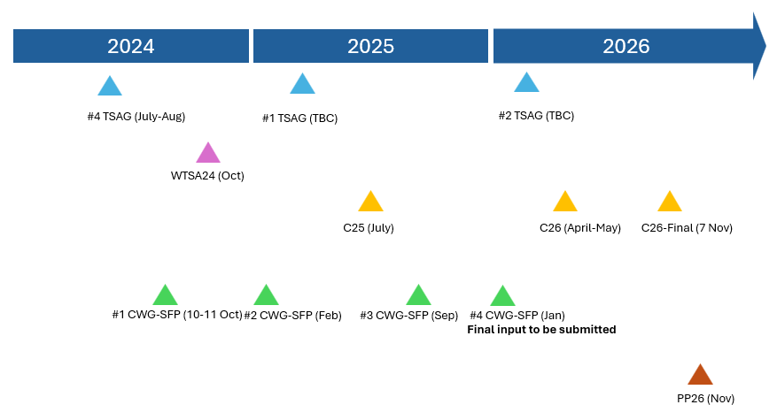**Figure 1: Timeline of meetings**

_______________________