 | INTERNATIONAL TELECOMMUNICATION UNION  TELECOMMUNICATION  STANDARDIZATION SECTOR  STUDY PERIOD 2022-2024 |  |  |  | TSAG-TD571R1
 |  |  |  |  | TSAG
 |  |  |  |  | Original: English
Question(s): |  |  | RG-WM |  | Geneva, 29 July – 2 August 2024
TD
Source: |  |  | Rapporteur, TSAG Rapporteur group on working methods
Title: |  |  | Draft new Recommendation ITU-T A.RA "Appointment and operations of registration authorities"
Contact: |  | Olivier Dubuisson  Orange  France |  | E-mail: olivier.dubuisson@orange.com
Contact: |  | Mr Stefano Polidori  TSB; Secretary RG-WM |  | E-mail: stefano.polidori@itu.int

Abstract: | This is the latest draft of new Recommendation ITU-T A.RA, based on discussions at the 21 Feb 2024 and 26 Apr 2024 rapporteur group meetings. It also includes new proposals for discussion that were received via contribution on 2 July 2024 at RG-WM rapporteur meeting.
Action: TSAG is invited to continue discussing this document.

History:
In 2012, a TSAG correspondence group on the synchronized appointment of a registration authority by ITU-T and JTC 1 agreed to recommend to TSAG that it develops a supplement to the ITU-T A-series Recommendations entitled "Guidelines on the appointment and operation of registration authorities."
Excerpt of the report of the correspondence group on the synchronized appointment of a registration authority by ITU-T and ISO/IEC JTC 1 (TSAG-TD391 [2009-2012]):
No rules are defined for the mutual agreement of an RA (associated with a common or twin text) by an ITU-T study group and the collaborating JTC 1 sub-committee. While this has not posed problem for many years, in two recent cases (joint work between ITU-T SG 16 and ISO/IEC JTC 1/SC 31; joint work between ITU-T SG 17 and ISO/IEC JTC 1/SC 6) this absence resulted in difficulty to establish the coordination. This generated a lot of discussions and concerns between the involved groups, and the result was not satisfactory for the ITU-T study group.
The first draft of this document (developed in 2012 as TSAG-TD393 [2009-2012]) was based on ISO/IEC JTC 1 Standing Document 16 which has been withdrawn in the meantime but Annex H of the ISO/IEC Directives contains similar material (ISO and ISO/IEC JTC 1 have had quite detailed guidelines on the appointment and operations of registration authorities for many years).
This document also includes:
- contribution DOC6 (230223) from the UK to the 23 Feb 2023 interim meeting of RG-WM;
- contribution C47 from the UK to the 30 May – 2 June 2023 meeting of TSAG;
- ideas from the ISO/IEC Directives, Annex H;
- answer from SG11 (TD364) and from SG2 (TD392) to the liaison statement from TSAG;
- contribution C73 from China Telecom to the 22-26 January 2024 meeting of TSAG;
- liaison statement from SG2 (TD565);
- contribution DOC4 (240702) from China Telecom and CAICT, MIIT (China) to the 2 July 2024 interim meeting of RG-WM.
DRAFT Recommendation ITU-T A.RA
Appointment and operations of registration authorities

Summary
This Recommendation provides a methodology to aid ITU-T study groups in developing Recommendations with a registration function and in selecting a registration authority to provide this function.
Keywords
Identification, register, registration authority.

DRAFT Recommendation ITU-T A.RA
Appointment and operations of registration authorities

1 Scope
Interoperability between information systems in the field of telecommunications/ICT sometimes requires specific identifiers to be assigned by a competent body designated as a registration authority.
Study groups developing Recommendations shall make every attempt to avoid the necessity for registration and registration authorities in particular. Where this is not possible, the use of existing registration processes (e.g., use of [b-ISO 3166-1] for country codes) is preferred to creating a new process.
This Recommendation concerns study groups which develop a draft Recommendation with a registration function, and which need to select a registration authority that provides this function.
This Recommendation does not apply when TSB is the registration authority for a particular Recommendation. It does not apply either when a Recommendation is the registration authority itself (i.e., when the list of identifiers is assigned in the given Recommendation).
In case of joint work with ISO/IEC JTC 1, clause II.5 of [b-ITU-T A.23] gives guidance on the synchronized appointment of a registration authority by both an ITU-T study group and an ISO/IEC JTC 1 sub-committee.

2 References
The following ITU-T Recommendations and other references contain provisions which, through reference in this text, constitute provisions of this Recommendation. At the time of publication, the editions indicated were valid. All Recommendations and other references are subject to revision; users of this Recommendation are therefore encouraged to investigate the possibility of applying the most recent edition of the Recommendations and other references listed below. A list of the currently valid ITU-T Recommendations is regularly published. The reference to a document within this Recommendation does not give it, as a stand-alone document, the status of a Recommendation.
[WTSA Res. 1] WTSA Resolution 1 (Rev. Geneva, 2022), Rules of procedure of the ITU Telecommunication Standardization Sector.

3 Definitions

3.1 Terms defined elsewhere
3.1.1 identifier [b-ITU-T Y.3076]: An identifier is a series of digits, characters and symbols or any other form of data used to identify subscriber(s), user(s), network element(s), function(s), network entity(ies) providing services/applications, or other entities.
3.1.2 object (of interest) [b-ITU-T X.660]: Anything in some world, generally the world of telecommunications and information processing or some part thereof, a) which is identifiable (can be named); and b) which may be registered.

3.2 Terms defined in this Recommendation
This Recommendation defines the following terms:
3.2.1 applicant: An entity (organization, individual, etc.) which requests the assignment of an identifier for an object (of interest) from a registration authority.
3.2.2 candidate registration authority: An entity (government entity, private organization, general partnerships, unincorporated association, sole proprietorship[, individual]) which answers to a call for offers to become a registration authority.
3.2.3 register: A set of files containing the identifiers assigned by a registration authority and the information associated with the object (of interest).
3.2.4 registration: Assignment of a unique identifier to an object (of interest) in a way that makes the assignment available to interested parties.
3.2.5 registration authority: Entity entitled and trusted to perform the registration service as described in an ITU-T Recommendation, and to maintain a register of assigned identifiers.
3.2.6 registration authority Recommendation: ITU-T Recommendation containing the definition of the classes of objects (of interest) requiring registration and specifying the procedures for a registration authority to follow.

4 Abbreviations and acronyms
TAP Traditional approval process

5 Conventions
None.

6 Chronology for the selection and appointment of a registration authority
6.1 A study group shall identify that a registration authority is required as soon as its work is sufficiently mature to make this decision, whether this is during the creation of a new Recommendation or the revision of an existing Recommendation involving changes in its implementation. TSB shall be informed at an early stage, to permit any necessary negotiations in advance of the determination of the registration authority Recommendation (see clause 6.3) and to ensure that the methodology specified in the following clauses is applied (see also Figure 1).
NOTE – It is also recommended to share the draft registration authority Recommendation as soon as possible with Study Group 2 as the lead study group on numbering, naming, addressing and identification.
6.2 For every instance of registration involving a registration authority, a study group shall develop a registration authority Recommendation that defines the classes of objects (of interest) to be registered and the procedure according to which the registration authority shall work, as well as its duties and obligations (see clause 7).
6.3 After the study group has checked that the content of the registration authority Recommendation is consistent with clause 7, the registration authority Recommendation shall be considered for TAP determination (see 8.1.1 of [WTSA Res. 1]).
6.4 The study group can then apply the process in clause 8 to issue a call for offers, select a candidate registration authority and appoint it.
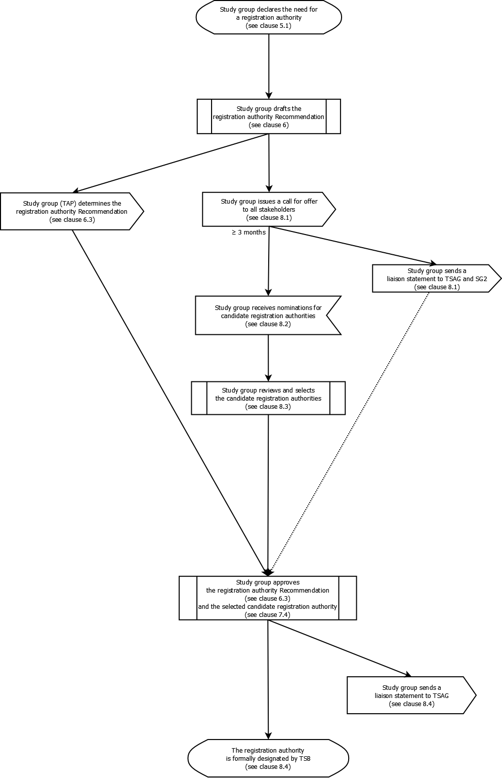
Figure 1 – Chronology for the selection and appointment of a registration authority

7 Content of a registration authority Recommendation
7.1 A registration authority Recommendation includes:
- a description of the identification scheme, the syntax of identifiers used and, if applicable, the conditions and the process to re-use or reclaim identifiers (see clause 7.3);
- criteria for applicants for registration (organization meeting specific criteria in relation with the classes of objects (of interest) to be assigned, etc.);
- information to be included on application (see clause 7.4) including (when applicable) the technical definition of the object (of interest) to be registered;
- if applicable, requirements for confidentiality of portions of the information;
- steps involved in review and response to applications including the process by which the definition of the object (of interest) is validated (possibly by consulting with the study group in charge of the registration authority Recommendation) and maximum time intervals between steps;
- assignment process for identifiers such that assigned identifiers are unique within the register and the same identifier is not assigned to another object (of interest);
- criteria for rejection of applications (see clause 7.7), including an appeals process (see clause 11);
- procedures for maintenance of a register (see clause 7.8), including review of successful applicants on a periodic basis;
- if applicable, procedures for publication of the register (see clause 7.6).
7.2 A registration authority Recommendation:
- shall not include the name of the registration authority;
Note – The name and contact information of the registration authority for a given Recommendation can be found on the web site of the study group in charge of that Recommendation. Instead, a link to the web site is provided as a note or a footnote.
- shall not include contractual or other legal aspects;
- shall not include the types of fees and amounts;
- shall not include a copy or an adaptation of the selection process in clause 8.
7.3 Wherever possible, the identification scheme should be open-ended to accommodate future registration requirements. In selecting the identification scheme, the following should be considered:
- the reservation of space for special assignments;
- the syntax (e.g., numeric, alphabetic, alphanumeric, etc.) from which the identifiers are assigned;
- the length of the identifier;
- the matching criteria to be used for determination of duplicate entries.
Depending on the volume of registrations anticipated, and technical and other considerations, reuse of identifiers may be necessary. The registration authority Recommendation shall state if:
- an identifier can never be re-used; or
- an identifier can be re-used after a specific time period to identify another object (of interest).
To be available for re-use, previously assigned identifiers may either be given up voluntarily or be reclaimed by the registration authority. In both cases, the conditions and the process are described in the registration authority Recommendation.
7.4 The contents of forms for registration application, request for update, notification of assignment or update, and rejection of application shall include:
- name of applicant;
- postal/email address, telephone/facsimile number of applicant;
- if the applicant is an organization, the name, title, postal/email address, telephone/facsimile number of a contact person within the organization.
Depending on the type of form, additional information to be included are:
- authorization to release specific data (registration application);
- any justification required for the assignment (registration application);
- where required by the registration authority Recommendation, a technical definition of the object (of interest) to be registered (registration application);
- data to be updated, old and new values (request for update);
- reasons for action taken (notification of assignment or update; rejection of application).
The registration authority Recommendation may define additional information relevant to the class of objects (of interest) to be registered.
7.5 After the assignment has been made, the identifier and associated information are included in the register, and the registration authority informs the applicant of the assignment in a timely manner (within the maximum response time specified in the registration authority Recommendation) using the information in clause 7.4.
7.6 The register shall contain:
- the assigned identifier;
- name of initial applicant;
- address of initial applicant;
- date of original assignment;
- date of last transfer of assignment, if allowed (updatable);
- name of current owner (updatable);
- postal/email address of current owner (updatable);
- if the owner is an organization, the name, title, postal/email address, telephone/facsimile number of a contact person within the organization (updatable);
- date of last update (updatable);
- where required by the registration authority Recommendation, a technical definition of the object (of interest).
The registration authority Recommendation may define additional register information relevant to the class of objects (of interest) to be registered.
7.7 The criteria for rejection of applications include the following as well as any additional criteria deemed necessary:
- ineligibility of the applicant (see clause 7.1 b);
- the absence of proper fee;
- incomplete or incomprehensible information in application;
- the justification for inclusion in the register (as defined in the registration authority Recommendation) is not adequate;
- the object (of interest) to be registered does not conform to the registration authority Recommendation.
7.8 The requirements that the registration authority shall follow for maintenance of the register include:
- mechanisms for maintaining the integrity of the register including adequate backup (such as off premises storage) and records retention requirements. In addition, there shall be provision for the owner of an identifier to provide updated information;
- mechanisms for maintaining confidentiality of data elements where such confidentiality is required.

8 Selection and appointment of organizations to fulfill registration authority functions
8.1 The selection process needs to be open and transparent. It begins with a call for offers made by the study group to all stakeholders (in particular, members of the study group). The call for offers shall mention the criteria listed in Annex A and the deadline for responses (normally 12 calendar days before the study group [or working party] meeting which will select a candidate registration authority). It shall be published as a TD of the study group and recorded in the meeting report. It shall be issued once the registration authority Recommendation has been determined for TAP consultation (see clause 6.3) and at least three months before the plenary meeting which will select a candidate registration authority. It is also sent as a liaison statement to TSAG and Study Group 2 for information.
NOTE – It is recognized that study groups may have difficulties identifying organizations willing to assume a registration authority function and it may be necessary to approach particular organizations which may be able to fulfill the function. Such a process shall be done with full transparency through liaison statements (published as TDs).
8.2 Responses to the call for offers are received no later than the given deadline and published as a TD of the study group. Each response shall include a statement stipulating that the candidate registration authority is willing to assume the responsibility and to commit to the requirements of this Recommendation. If applicable (see clause 9), the response also describes the fee structure.
8.3 Once the deadline for receiving responses (in writing) to the call for offers is reached, they are reviewed by the study group. In consultation with the ITU Member State where each candidate registration authority is based and, if necessary, with the ITU legal adviser, the study group ensures that the candidate registration authority is a legal entity. This means that the entity has [been formed under the laws of a particular jurisdiction | legal status in a country] and that it is therefore subject to governance related rules. This requirement promotes a higher level of assurance regarding the accountability and credibility of the entity selected to be the registration authority.
8.4 The study group produces a report that includes an evaluation of each response against the criteria in Annex A and the recommended candidate registration authority. The report is published as a TD and presented [for approval] at a plenary meeting. It is then sent as a liaison statement to TSAG for information, and the study group submits the name and any relevant information about the organization to the Director of TSB for formal designation.
8.5 When a registration authority Recommendation is revised, the study group reviews and decides whether the existing registration authority should continue or if a selection process should be launched to select additional candidate registration authorities (see also clause 12).

9 Charging of fees for registration authority services
9.1 Registration authorities may charge fees for the services they provide subject to authorization by the study group. The level of such fees should be set on a cost-recovery basis. The proposed fee structure is included in the answer of each candidate registration authority and considered by the study group in its decision to authorize the charging of fees.
9.2 The registration service undertaken by a registration authority under the provisions of a registration authority Recommendation requires no financial contribution from the ITU.

10 Oversight and accountability of registration authorities
10.1 Study groups have the main responsibility for the oversight of the non-commercial aspects of registration authorities. They maintain ongoing communication and remain informed of the activities of the registration authority relative to its function in relation to registration authority Recommendations. Study groups require registration authorities to provide annual activity reports which are published as a TD (see clause 12 if a registration authority fails to provide such a report).
10.2 Registration authorities are required to indicate clearly in their operations that they have been designated by an ITU-T study group.

11 Dispute resolution
11.1 Although instances of disputes between registration authorities and applicants are rare, it is expected that the registration authority will make reasonable efforts to resolve the dispute. The registration authority Recommendation addresses any specific requirements for this informal process.
11.2 Additionally, to resolve the dispute, the registration authority Recommendation defines a formal appeal process for use when the informal efforts to resolve the dispute fail. The study group in charge of the registration authority Recommendation participates in any formal appeal process.

12 Termination of a registration authority
12.1 When the study group decides to replace a registration authority (in particular because the registration authority does not fulfill all the criteria of Annex A anymore), it notifies the current registration authority (and informs TSAG) and clause 8 is applied in the selection of a replacement registration authority.
12.2 When a designated registration authority decides to cease its operation, clause 8 is applied in the selection of a replacement registration authority. In the meantime, the study group should exercise particular oversight to ensure that the registration service is maintained during the transition period and that the register of assigned objects (of interest) is transferred to the new registration authority.
12.3 When a registration authority Recommendation is withdrawn, the study group notifies the current registration authority (and informs TSAG).
Annex A
Criteria to select a registration authority
(This annex forms an integral part of this Recommendation.)

The following criteria shall be checked by the study group when evaluating each candidate registration authority response to the call for offers (see clause 8.4).
A.1 Proof (e.g., statutes) that it is a legal entity, i.e., an organization formed under the laws of a jurisdiction and that it is, therefore, subject to governance-related rules.
A.2 Statement stipulating that the candidate registration authority is willing to assume the responsibility, to follow the requirements specified in the registration authority Recommendation and to provide an annual activity report to the study group (see clause 10.1).
A.3 Documentation of the candidate registration authority’s experience in the field of registration services.
A.4 Confirmation that the candidate registration authority is technically and financially able to carry out, at an international level, the registration service described in the registration authority Recommendation.
NOTE – Examples of proofs are: financial plan for funding the expected volume of registrations, list of employees or third parties and their applicable background and skills, description of the physical facilities available to accomplish the work, demonstrated financial capacity to meet liability exposure for performing the services.
A.5 Confirmation of whether the candidate registration authority will charge fees and, if it charges fees, confirmation that any such fees will be on a cost recovery basis.
A.6 Confirmation of fulfilment of specific criteria, if any, specified in the registration authority Recommendation (see clause 7.1 b).
Bibliography

[b-ISO 3166-1] ISO 3166-1:2020, Codes for the representation of names of countries and their subdivisions – Part 1: Country code.
[b-ITU-T A.23] Recommendation ITU-T A.23 (2000), Collaboration with ISO and IEC on information technology, Amendment 1 (01/2022) on best practices.
[b-ITU-T X.660] Recommendation ITU-T X.660 (2011) | ISO/IEC 8824-1:2011, Information technology –Procedures for the operation of object identifier registration authorities: General procedures and top arcs of the international object identifier tree.
[b-ITU-T Y.3076] Recommendation ITU-T Y.3076 (2020), Architecture of ICN-enabled edge network in IMT-2020.
_______________________

