Standardization Sector
ITU Focus Group Technical Report
(10/2023)
ITU Focus Group on metaverse
Metaverse: an analysis of definitions

Working Group 1: General
ITUPublications | International Telecommunication Union
Technical Report ITU FGMV-02
Metaverse: an analysis of definitions
Summary
This Technical Report ITU FGMV-02 contains a detailed gap analysis in literature of "metaverse" definitions with an explained terminology. This Technical Report studied and analysed approximately 150 existing definitions of metaverse from various sources.
Keywords
Metaverse (MV), definitions, gap analysis, terminology, virtual worlds, augmented reality, mixed reality, virtual reality.
Note
This Technical Report is an informative ITU-T publication. Mandatory provisions such as those found in ITU-T Recommendations lie outside the scope of this Technical Report, which should only be referenced bibliographically in ITU-T Recommendations.
Change log
This document contains Version 1.0 of the ITU Technical Report on "Metaverse: an analysis of definitions" approved at the third meeting of the ITU Focus Group on metaverse (FG-MV), held on 3-5 October 2023 in Geneva, Switzerland.
Acknowledgements
This Technical Report was prepared by Leonidas Anthopoulos (University of Thessaly, Greece).
Additional information and materials relating to this report can be found at: https://www.itu.int/go/fgmv. If you would like to provide any additional information, please contact Cristina Bueti at tsbfgmv@itu.int.

Editor: | Leonidas Anthopoulos  University of Thessaly  Greece | E-mail: lanthopo@uth.gr

© ITU 2024
Some rights reserved. This publication is available under the Creative Commons Attribution-Non Commercial-Share Alike 3.0 IGO licence (CC BY-NC-SA 3.0 IGO; https://creativecommons.org/licenses/by-nc-sa/3.0/igo).
For any uses of this publication that are not included in this licence, please seek permission from ITU by contacting TSBmail@itu.int.

Table of contents
Page
1 Scope 1
2 References 1
3 Definitions 1
3.1 Terms defined elsewhere 1
3.2 Terms defined in this Technical Report 1
4 Abbreviations and acronyms 1
5 Conventions 2
6 Introduction 2
7 Goals and motivation for a comprehensive definition 2
7.1 Goals 2
7.2 Lack of standardized terminologies 3
8 Observations from literature 3
9 Definitions and analysis 12
9.1 Sources of information 12
9.2 Methodology 12
9.3 Approach 13
10 Results 25
10.1 Keyword analysis from definitions 25
10.2 Keyword grouping 29
10.3 Important terms to be included in a standardized definition 29
11 Recommended definition 29
11.1 Criteria for definition 29
11.2 Specification Properties 30
12 Conclusions 30
Annex 1 – Definitions of metaverse 31
Bibliography 50

Technical Report ITU FGMV-02
Metaverse: an analysis of definitions

1 Scope
This Technical Report analyses the major aspects of metaverse definitions from: (i) the perspective of academics, (ii) the business initiative approach, and (iii) the international organization collaborations, with the final aim of establishing a concrete definition for metaverse that can be used worldwide. This would also provide a basis for understanding the most common features of metaverse.

2 References
None.

3 Definitions

3.1 Terms defined elsewhere
None.

3.2 Terms defined in this Technical Report
None.

4 Abbreviations and acronyms
This Technical Report uses the following abbreviations and acronyms:
3D Three dimensional
AI Artificial Intelligence
AR Augmented reality
DLT Decentralized Ledger Technologies
FG-MV Focus Group on Metaverse
ICT Information and Communication Technology
ITU International Telecommunication Union
MMORPG Massively Multiplayer Online Role-Playing Game
MR Mixed Reality
PII Personally Identifiable Information
SDO Standards Development Organization
ToR Terms of Reference
TSAG Telecommunication Standardization Advisory Group
VR Virtual Reality
VW Virtual World
WG Working Group
XR Extended Reality

5 Conventions
None.

6 Introduction
The Focus Group on metaverse1 (FG-MV) was established by the Telecommunication Standardization Advisory Group (TSAG) on 16 December 2022. The FG-MV has been assigned the task of analysing the technical requirements of the metaverse to identify fundamental enabling technologies in areas from multimedia and network optimization to digital currencies, Internet of things, digital twins and environmental sustainability.
FG-MV has established nine working groups (WGs):
• Working Group (WG) 1 – General
• Working Group (WG) 2 – Applications & Services
• Working Group (WG) 3 – Architecture & Infrastructure
• Working Group (WG) 4 – Virtual/Real World Integration
• Working Group (WG) 5 – Interoperability
• Working Group (WG) 6 – Security, Data & Personally identifiable information (PII) Protection
• Working Group (WG) 7 – Economic, regulatory & competition aspects
• Working Group (WG) 8 – Sustainability, Accessibility & Inclusion
• Working Group (WG) 9 – Collaboration
One of the key deliverables for WG1 in the Focus Group on Metaverse is to develop a standardized definition for metaverse: "What definitions and attributes describe metaverse?". To help address the above question, FG-MV has developed this detailed Technical Report on Metaverse: An Analysis of Definitions. Using this Technical Report as a basis, the Focus Group will be able to fulfil its mandate to develop deliverables related to working definitions and terminology, use cases and requirements.

7 Goals and motivation for a comprehensive definition

7.1 Goals
Metaverse is a compound word that is formed by the words "meta" (meaning "beyond") and "verse" (short for "universe"), and literally means a universe beyond the real world. The term is used widely and refers to the three-dimensional virtual world in which the real and the unreal coexist. The metaverse is, therefore, a network of virtual worlds. In these worlds, people will be able to perform several tasks, ranging from work to entertainment, either alone or with colleagues and friends. In the future, people are expected to be able to simultaneously live multiple, different lives in different universes, beyond the real world, in the world of the metaverse. The metaverse, then, seems to be much more than a virtual world, and plays a catalytic role in people's lives. The effects they will have on people and real society will be significant and this is why further scientific research is needed on this topic.

7.2 Lack of standardized terminologies
Although the term metaverse was first coined in 1992, the world of the metaverse, to this day, remains unexplored. The reason may be the fact that the metaverse is still a theory. It is an idea whose implementation is still in the initial stages. Being uncharted territory, the world of the metaverse needs to be explored today, more than ever. The interest of big vendors indicates that the realization of this idea is very close. The metaverse will soon become an integral part of people's daily lives as it is an environment that people enter to work, play, and interact with other people. Moreover, it has been characterized by many scientists as the Internet of the future, essentially constituting the evolution of web 2.0.
Although there is abundant literature available on smart cities, there is no standardized, commonly accepted set of terminologies that would help to describe metaverse aptly. Various definitions and features of metaverse must be analysed before setting a standardized definition that is expected to provide a good basis for the FG-MV to define metaverse, including main features of metaverse, virtual worlds, virtual/mixed/augmented reality (VR/MR/AR), and the relative terminology.

8 Observations from literature
Corresponding scientific literature grows fast and the publications that could be located in late March 2023 were as follows:
Table 1 – Literature findings (March 2023)
Source | Keyword "Metaverse" | Keywords "Metaverse" AND "Definition" | Publication period
ScienceDirect | 729 | 325 | 1994-2023
Web of Science | 774 | 28 | 1995-2023
Scopus | 1664 | 53 | 1995-2023
The bibliometric analysis of the combination of keywords "Metaverse" AND "Definition" returns the following information:
1. Definitions have started being provided since 2010 (see Table 2).
2. Fifty-seven works discuss the subject of metaverse definition, coming from 52 sources and 186 scholars (see Table 2).
3. Terms/keywords that relate with metaverse definition concern the following topics (see Figures 3 and 4):
a. Virtual/ mixed/ augmented reality
b. Virtual worlds
c. Opportunities
d. Applied domains (i.e., education)
e. System
4. Trends in metaverse concern the following subjects (see Figure 5):
a. Augmented reality and digital twinning are basic themes.
b. Blockchain, economics, augmented and virtual worlds are motor themes.
c. Non-place places, avatars and autonomous vehicles are niche themes.
d. Interoperability, privacy, and user experience are emerging themes.
5. Major schools of thought appear on (see Figure 6).
Table 2 – bibliometric analysis summary
Description |  | Results
MAIN INFORMATION ABOUT DATA
 | Timespan | 2010:2023
 | Sources (Journals, Books, etc.) | 52
 | Documents | 57
 | Annual Growth Rate % | 23.16
 | Document Average Age | 1.17
 | Average citations per doc | 6.772
 | Average citations per year per doc | 3.431
 | References | 1672
DOCUMENT TYPES
 | article | 33
 | article; early access | 3
 | book chapter | 2
 | conference paper | 13
 | editorial | 1
 | review | 5
DOCUMENT CONTENTS
 | Keywords Plus (ID) | 230
 | Author's Keywords (DE) | 258
AUTHORS
 | Authors | 186
 | Author Appearances | 202
 | Authors of single-authored docs | 11
AUTHORS COLLABORATION
 | Single-authored docs | 13
 | Documents per Author | 0.306
 | Co-Authors per Doc | 3.54
 | International co-authorships % | 8.772

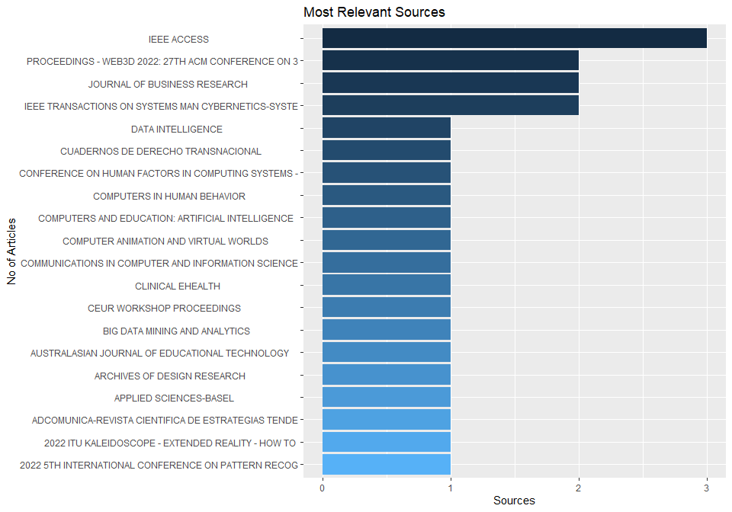
Figure 1 – Major sources
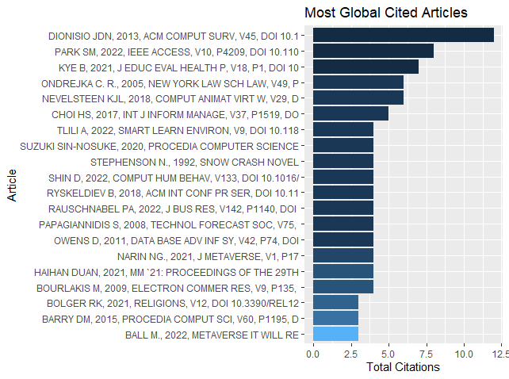
Figure 2 – Most-cited articles
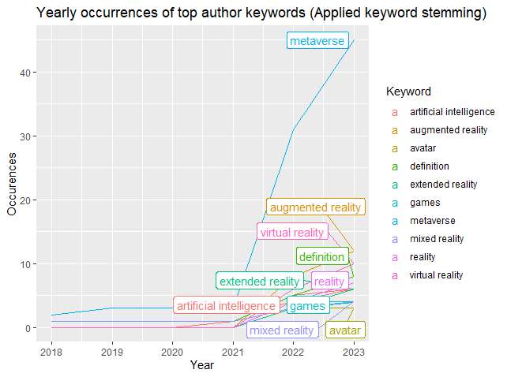
Figure 3 – Top author keywords
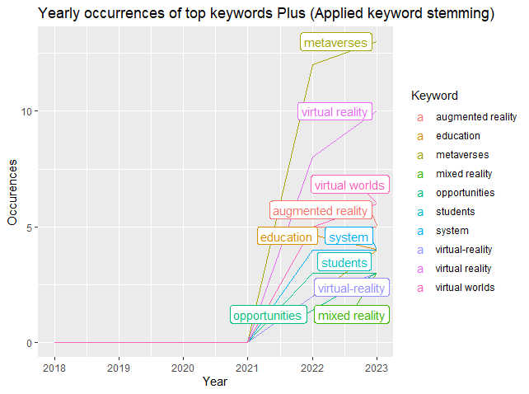
Figure 4 – Top author keywords (applied keyword stemming)
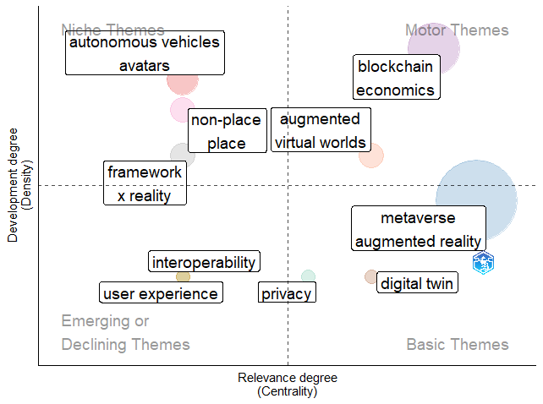
Figure 5 – Trends in metaverse definitions
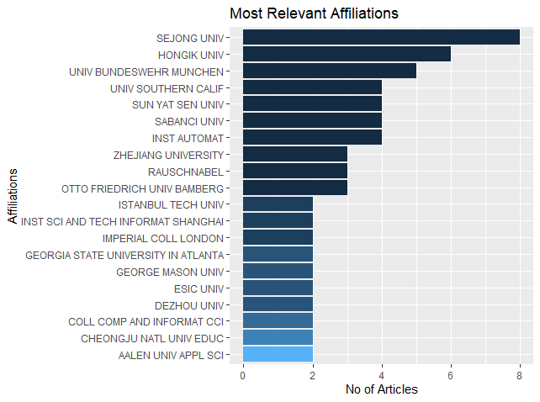
Figure 6 – Major schools of thought
The bibliometric analysis of the combination of keywords "Metaverse" returns the following information:
1. The subject started appearing in 1995 (see Table 3).
2. The 1 732 works discuss the subject of metaverse, coming from 936 sources and 3 692 scholars (see Table 2).
3. Terms/keywords that relate with metaverse concern the following topics (see Figures 9 and 10):
a. Technologies (AI, blockchain, digital twin)
b. Virtual/ mixed/ augmented reality
c. Virtual worlds
d. Applied domains (i.e., training/e-learning)
4. Top Schools of thought appear on (Figure 11).
Table 3 – Bibliometric analysis summary (Metaverse in general)
Description |  | Results
MAIN INFORMATION ABOUT DATA
 | Timespan | 1995:2023
 | Sources (Journals, Books, etc) | 936
 | Documents | 1 732
 | Annual Growth Rate % | 20.11
 | Document Average Age | 1.96
 | Average citations per doc | 3.008
 | Average citations per year per doc | 1.163
 | References | 20 195
DOCUMENT TYPES
 | art exhibit review | 1
 | article | 744
 | article article | 3
 | article book chapter | 1
 | article; early access | 66
 | article; proceedings paper | 1
 | book | 6
 | book chapter | 45
 | book review | 3
 | conference paper | 549
 | conference paper article | 1
 | conference paper conference paper | 1
 | conference review | 64
 | correction; early access | 1
 | editorial | 32
 | editorial material | 63
 | editorial material; early access | 6
 | erratum | 5
 | letter | 22
 | letter conference paper | 1
 | letter; early access | 4
 | meeting abstract | 5
 | news item | 3
 | note | 6
 | review | 94
 | review book chapter | 1
 | review; early access | 3
 | short survey | 1
DOCUMENT CONTENTS
 | Keywords Plus (ID) | 5 892
 | Author's Keywords (DE) | 4 327
AUTHORS
 | Authors | 3 692
 | Author Appearances | 5 793
 | Authors of single-authored docs | 322
AUTHORS COLLABORATION
 | Single-authored docs | 448
 | Documents per Author | 0.469
 | Co-Authors per Doc | 3.34
 | International co-authorships % | 8.256

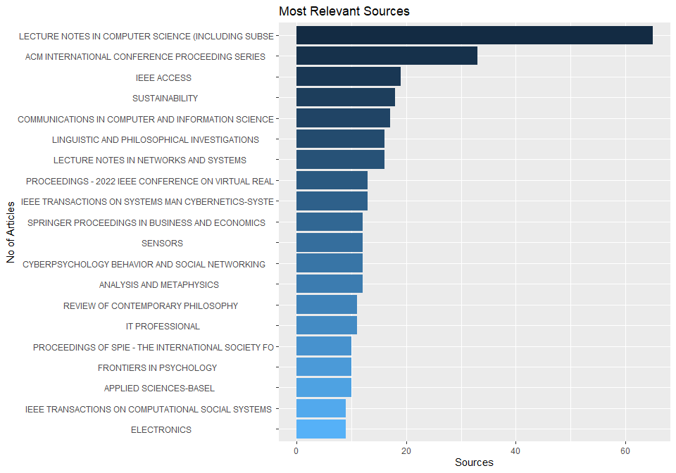
Figure 7 – Major sources (Metaverse in general)
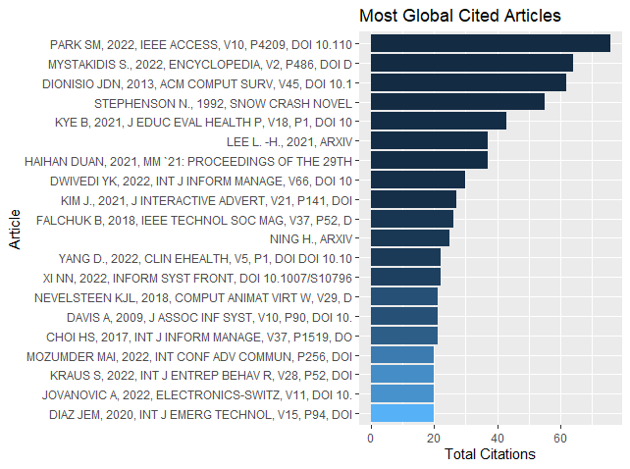
Figure 8 – Most-cited articles (Metaverse in general)
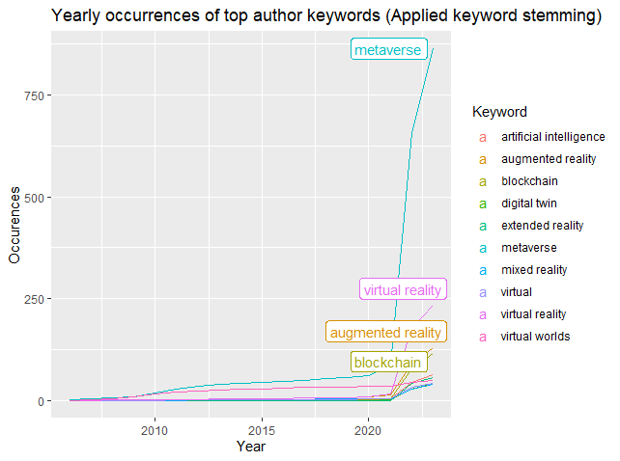
Figure 9 – Keywords (Metaverse in general)
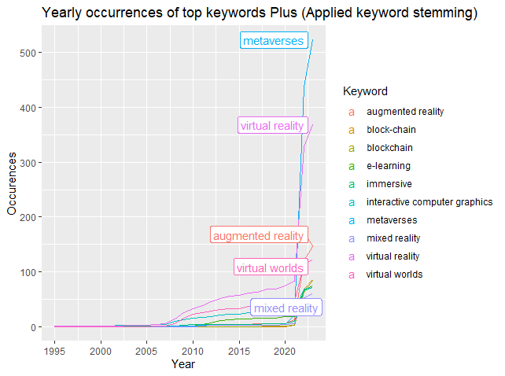
Figure 10 – Keywords, after stemming (Metaverse in general)
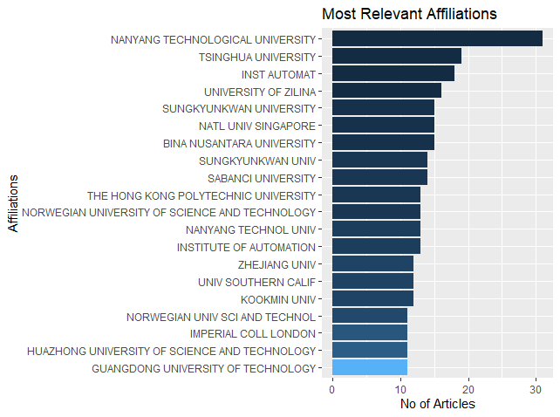
Figure 11 – Major schools of thought (Metaverse in general)

9 Definitions and analysis

9.1 Sources of information
This Technical Report was based on the context of top cited articles that were collected from the above bibliometric analysis. Moreover, several reports were collected from the Internet. These articles were reviewed and analysed to help consolidate a wide range of perspectives which ensures that the definition of smart sustainable cities proposed by the FG-MV includes all major aspects. These definitions were obtained from a variety of sources including:
• Academia and research communities.
• Government initiatives including EU.
• International organizations (e.g., United Nations, ITU).
• Corporate/company profiles.
• User centric definitions (from leading market research firms).
• Trade associations.
• Standardization Bodies (SDOs).
A complete list of over all the definitions found in the open literature is stated in Annex 1.

9.2 Methodology
Moreover, there is a lack of conceptual clarity in the identified definitions and in this regard, the approach from [b-Vial] was followed to document corresponding challenges, according to conceptual definition rules [b-Wacker]: use of primitive and derived terms; uniqueness; unambiguous and clear terminology; consistency with the field; narrowness; new hypothesis avoidance; statistical testing of the terms.

9.3 Approach
Table 4 – Collected definitions
Source | Definitions | Keywords | Conceptual clarity challenge(s)
[b-Park] | Metaverse is a compound word of transcendence meta and universe and refers to a three-dimensional virtual world where avatars engage in political, economic, social, and cultural activities | Virtual world,  avatar | Conflation between the concept and its impacts
[b-XRSI] | A network of interconnected virtual worlds with the following key characteristics: Presence, Persistence, Immersion and Interoperability. Metaverse is the next iteration of the Internet enabled by several converging technologies such as extended reality (XR), artificial intelligence (AI), decentralized ledger technologies (DLTs), neuro-technologies, optics, bio-sensing technologies, improved computer graphics, hardware, and network capabilities. | Presence,  Persistence,  immersion  XR, AI, DLT. | Comparative definition  (Next iteration of the Internet)
[b-EU Council] | A contraction of the Greek word "meta", meaning beyond, and the word "universe".  An immersive and constant virtual three dimensional (3D world where people interact through an avatar to enjoy entertainment, make purchases and carry out transactions with cryptoassets, or work without leaving their seat | Immersive,  virtual world,  avatar. | Conflation between the concept and its impacts
[b-Ministry of Science and ICT] | A digital new continent with infinite potential and anyone can achieve their dreams by playing as the main character. In particular, it will be a space of opportunity for young people to challenge more and grow bigger to leap into a wider world | Digital world | Unclear term  Conflation between the concept and its impacts
[b-Ministry of Economy] | A digital world | Digital world | Unclear term
[b-Metaverse.EU] | "Metaverse" is a "suitcase word". It carries many different meanings. This bundling simplifies the nascent concept and allows it to adapt to different contexts: virtual office, visiting a library, projecting furniture with augmented reality, or creating a digital twin of a factory. | Adaptive,  Augmented. | Unclear term  Conflation between the concept and its impacts
[b-Ministry of Internal affairs and Communications] | A metaverse is a virtual digital space that allows users to communicate with each other and can be accessed through telecommunication networks. | Virtual digital space | Conflation between the concept and its impacts
Some more definitions are collected in Table 5.
Table 5 – Collected definitions from top-cited bibliometric articles
 | Source | Definitions | Keywords | Conceptual clarity challenge(s)
1. | [b-Dionisio] | Metaverse is a portmanteau of the prefix "meta" (meaning "beyond") and the suffix "verse" (shorthand for "universe"). Thus, it literally means a universe beyond the physical world. More specifically this "universe beyond" refers to a computer-generated world, distinguishing it from metaphysical or spiritual conceptions of domains beyond the physical realm. | Computer-generated world | Comparative definition
2. | [b-Frey] | A massive infrastructure of inter-linked virtual worlds accessible via a common user interface (browser) and incorporating both 2D and 3D in an Immersive Internet. | Inter-linked, virtual worlds, 2D, 3D, immersive. | Unclear term
3. | [b-Dionisio] | The Metaverse refers to a fully immersive, three-dimensional digital environment in contrast to the more inclusive concept of cyberspace that reflects the totality of shared online space across all dimensions of representation. | Immersive, three-dimensional, digital environment, representation. | Comparative definition
4. | [b-Smart] | The Metaverse involves both "simulation technologies that create physically persistent virtual spaces such as virtual and mirror worlds" and "technologies that virtually-enhance physical reality such as augmented reality". | Simulation technologies, virtual worlds, mirror worlds, augmented reality. | Conflation between the concept and its impacts
5. | [b-Park] | Metaverse is a compound word of transcendence meta and universe and refers to a three-dimensional virtual world where avatars engage in political, economic, social, and cultural activities. It is widely used in the sense of a virtual world based on daily life where both the real and the unreal coexist. (https://en.wikipedia.org/wiki/Metaverse) | Three-dimensional, virtual world, avatars, real – unreal. | Conflation between the concept and its impacts
6. | [b-Park] | Metaverse is a virtual world to predict the future by reflecting the characteristics of reality realistically. | Virtual world, reflecting reality. | Conflation between the concept and its impacts
7. | [b-Kye] | The metaverse refers to a virtual reality existing beyond reality. It is a compound word of "meta", meaning transcendence and virtuality, and "universe", meaning world and universe. This term refers to the digitized earth as a new world expressed through digital media such as smartphones and the Internet. | Virtual reality, digitized earth, digital media. | Comparative definition
8. | [b-Go] | "A 3D-based virtual reality in which daily activities and economic life are conducted through avatars representing the real themselves." | 3D-based, virtual reality, avatars. | Conflation between the concept and its impacts
9. | [b-Lee] | "Metaverse means a world in which virtual and reality interact and co evolve, and social, economic, and cultural activities are carried out in it to create value." | Virtual and reality interaction, value. | Conflation between the concept and its impacts
10. | [b-Kye] | Metaverse is a complex of virtual reality technologies. Socially, it is a space where members of the digital native generation leave traces in their daily life and economic life with their various appearances (personas, avatars) in the 3D-based Internet world. | Virtual reality technologies, appearances, 3D-based Internet world. | Comparative definition  Unclear term  Conflation between the concept and its impacts  Lack of parsimony
11. | [b-Kim] | The metaverse is a compound of the words "meta" (which is an abstract concept) and "universe" and means a space created by the convergence of virtual and augmented reality. | Virtual reality, augmented reality. | Comparative definition  Unclear term  Lack of parsimony
12. | [b-Tlili] | Metaverse is a combination of the prefix "meta" which implies transcending with the word "universe" which describes a parallel or virtual environment linked to the physical world. | Parallel or virtual environment. | Unclear term  Conflation between the concept and its impacts  Lack of parsimony
13. | [b-Knox] | Metaverse "is not simply a platform developed by one company, implying the usual constraints of monopolization, but rather a new plane of existence, not just void of control by any single corporation, but also free of incursions by any state entity or government." | New plane of existence, free of incursions. | Comparative definition  Unclear term  Conflation between the concept and its impacts  Lack of parsimony
14. | [b-Tlili] | Metaverse is a continuity of the physical world in the virtual world to create an ecosystem that merges both worlds (physical and virtual). | Continuity, ecosystem. | Unclear term  Conflation between the concept and its impacts
15. | [b-Suzuki] | Metaverse is the three-dimensional world where avatars are active on behalf of users in the real world. | Three-dimensional, avatars. | Conflation between the concept and its impacts
16. | [b-Ryskeldiev] | A persistent and constantly updated collection of mixed reality spaces mapped to different geospatial locations. | Persistent, constantly, mixed reality spaces. | Unclear term
17. | [b-Hollensen] | Metaverse is a current immersive XR where people can work, play, socialize, and experience virtually. | Current, immersive, XR, virtually. | Comparative definition  Conflation between the concept and its impacts
18. | [b-Shin] | Metaverse is a result of a combination of a socially constructed and materially enabled artifact. | Socially constructed, materially enabled, artifact. | Comparative definition  Unclear term
19. | [b-Gartner] | A collective virtual shared place, designed by combining virtually enhanced physical and digital reality. | Virtual, shared place. | Comparative definition  Unclear term
20. | [b-Kim] | A current XR as metaverse is designed as an extension of the real world. | Extension, real world. | Comparative definition  Unclear term
21. | [b-Hollensen] | A kind of virtual reality that provides users with experiences to become part of extended worlds. | Virtual reality, extended worlds. | Comparative definition  Unclear term
22. | [b-Narin] | A concept used to describe 3D (three-dimensional), VWs (virtual worlds) in which people interact with each other and their environment without the physical limitations of the real world. | 3D, virtual worlds, interaction, without the physical limitations. | Comparative definition  Conflation between the concept and its impacts  Lack of parsimony
23. | [b-Duan] | A combination of "meta" (meaning beyond) and the stem "verse" from "universe", denoting the next-generation Internet in which the users, as avatars, can interact with each other and software applications in a three dimensional (3D) virtual space. | Next-generation Internet, avatars, interaction, software applications, 3D, virtual space. | Comparative definition  Conflation between the concept and its impacts  Lack of parsimony
24. | [b-Duan] | An evolving virtual world with unlimited scalability and interoperability. | Virtual world, scalability, interoperability. | Comparative definition  Unclear term  Conflation between the concept and its impacts
25. | [b-Duan] | An interactive multimedia community relying on massive numbers of online users. | Interactive, multimedia community, users. | Comparative definition  Unclear term
26. | [b-Stephenson] | A follow-on to the Internet, a three-dimensional space where one's avatar is a stand-in for one's actions in a simulated world. | Three-dimensional, avatar, simulated world. | Comparative definition  Conflation between the concept and its impacts
27. | [b-Smart] | A three-dimensional transparent space or sphere that will encompass the entire Earth. | Three-dimensional, transparent. | Unclear term  Conflation between the concept and its impacts
28. | [b-Davis] | A metaverse is a three-dimensional virtual world (VW) where people interact with each other and their environment, using the metaphor of the real world but without its physical limitations. | Three-dimensional, virtual world, interaction, without physical limitations. | Conflation between the concept and its impacts  Lack of parsimony
29. | [b-Ball] | A massively scaled and interoperable network of real time rendered 3D virtual worlds that can be experienced synchronously and persistently by an effectively unlimited number of users with an individual sense of presence, and with continuity of data, such as identity, history, entitlements, objects, communications, and payments. | Interoperable, network, 3D, virtual worlds, users, presence, continuity of data. | Conflation between the concept and its impacts  Lack of parsimony
30. | [b-Mystakidis] | The metaverse is the post-reality universe, a perpetual and persistent multiuser environment merging physical reality with digital virtuality. It is based on the convergence of technologies that enable multisensory interactions with virtual environments, digital objects and people such as virtual reality (VR) and augmented reality (AR). Hence, the metaverse is an interconnected web of social, networked immersive environments in persistent multiuser platforms. It enables seamless embodied user communication in real-time and dynamic interactions with digital artifacts. | Post-reality universe, multiuser environment, multisensory interactions, digital objects, virtual reality, augmented reality, immersive, multiuser platforms, communication, digital artifacts. | Comparative definition  Conflation between the concept and its impacts  Lack of parsimony
31. | [b-Mystakidis] | A post-reality universe, a perpetual and persistent multiuser environment merging physical reality with digital virtuality. | Post-reality universe, perpetual, persistent, multiuser environment | Unclear term
32. | [b-Papagiannidis] | Metaverses are not isolated artificial spaces, but vibrant, highly interactive and quickly evolving places that can reach the real world in numerous direct and indirect ways. | Highly interactive, quickly evolving. | Comparative definition  Unclear term  Conflation between the concept and its impacts
33. | [b-Bourlakis] | Metaverses are virtual worlds extending our physical universe by adding new dimensions and domains for economic, social and leisure activities. | Virtual worlds, extending physical universe. | Comparative definition  Unclear term  Conflation between the concept and its impacts
34. | From [b-Park]:
35. | [b-Stephenson] | A world where humans as avatars interact with each other and with software agents in a three-dimensional space that reflects the real world. | Avatars, interaction, software agents, three-dimensional. | Unclear term
36. | [b-Schroeder] | A resident virtual world where the geography and physical characteristics of the real world are modelled in a networked digital space where the user is represented as an avatar. | Resident virtual world, networked digital space, avatar. | Comparative definition  Unclear term  Conflation between the concept and its impacts
37. | [b-Jaynes] | An immersive environment using a universal and shared digital media network that removes the barriers of time and space by deceiving users' visual senses. | Immersive, digital media network, visual senses. | Unclear term  Conflation between the concept and its impacts
38. | [b-Ondrejka] | The technical challenges of making something close to the complexity and realism depicted in Snow Crash. |  | Comparative definition  Unclear term
39. | [b-Kemp] | Access online systems as exclusive clients and interact with content and other residents. | Online systems, interaction. | Unclear term  Conflation between the concept and its impacts
40. | [b-Goertzel] | An increasingly intelligent world where AGIs are integrated into interacting human social networks. | Intelligent world, interacting social networks. | Comparative definition  Unclear term
41. | [b-Collins] | From business to entertainment, an interactive network with continuous, immersive 3D virtual environments accessible. | Interactive network, continuous, immersive, 3D, virtual environments. | Unclear term
42. | [b-Wright] | Extensive 3D network virtual world that can support many people at the same time for social interaction. | 3D, virtual world, interaction. | Comparative definition  Unclear term  Conflation between the concept and its impacts
43. | [b-Schlemmer] | Extension of the parallel space of the physical world within the virtual Internet space into cyberspace. | Parallel space, cyberspace. | Comparative definition  Unclear term
44. | [b-Schaf] | A world of enhancing the feeling of being in a classroom rather than being an incorporeal observer in a 2D virtual environment. | Virtual world | Comparative definition  Unclear term  Conflation between the concept and its impacts
45. | [b-Prisco] | A complete video-realistic medium based on virtual reality allows immersive interaction between participants. | Virtual reality, immersive interaction, participants. | Comparative definition  Unclear term  Conflation between the concept and its impacts
46. | [b-Rymaszewski] | An environment where you can create your personality, quickly visit different places, explore expansive buildings, and shop your way. | Create personality, visit places, explore, shop. | Unclear term  Conflation between the concept and its impacts
47. | [b-Messinger] | A virtual world where thousands of people can interact simultaneously within the same simulated 3D space. | Virtual world, simultaneously interact, simulated, 3D space. | Comparative definition  Conflation between the concept and its impacts
48. | [b-Hazan] | A place where users log in all the time to interact with others in play, commerce, creativity, and exploration. | Users, interact, play, commerce, creativity, exploration. | Conflation between the concept and its impacts
49. | [b-Papagiannidis] | A continuous, continuous world designed to give users control over almost every aspect of the world by creating the objects they want. | Continuous world, users, control, creation. | Unclear term  Conflation between the concept and its impacts
50. | [b-Forte] | A virtual place where an individual's cyber community can share social interactions without the constrains of the physical world. | Virtual place, share, social interactions, no physical constrains. | Unclear term  Conflation between the concept and its impacts
51. | [b-Cunningham] | A compound word of meta and universe, meaning beyond, a temporal-spatial aspect where the real world and the virtual world are mixed. | Mix of real and virtual world. | Unclear term  Conflation between the concept and its impacts
52. | [b-Owens] | An immersive three-dimensional virtual world in which people interact with each other and their environment, using real-world metaphors but without physical limitations. | Immersive, three-dimensional, virtual world, interaction, without physical limitations. | Conflation between the concept and its impacts
53. | [b-Toneis] | A world that reconstructs the meaning of the living world with the experience. | Reconstruction of living world, experience. | Comparative definition  Unclear term
54. | [b-Guo] | A computer simulation that allows avatars to interconnect and communicate in relatively life-like environments. | Computer simulation, avatars, interconnect, communicate. | Comparative definition  Unclear term
55. | [b-Connolly] | Continuous online 3D world | Continuous, online, 3D world. | Unclear term
56. | [b-Resmini] | One of the variants of the Matrix movie with some good swordsmanship or some zero-gravity kung-fu. |  | Comparative definition  Unclear term
57. | [b- Müller] | A world like electronic memory and the Internet as a virtual reality where users log in every day. | Virtual reality, users. | Comparative definition  Unclear term  Conflation between the concept and its impacts
58. | [b-Xanthopoulou] | A three-dimensional extension of the traditional electronic space that typically hosts massively multiplayer online role-playing games (MMORPGs). | Three-dimensional, electronic space, MMORPGs. | Comparative definition  Conflation between the concept and its impacts
59. | [b-Cameron] | Utopian and dystopian futures, where people live more in virtual worlds than in reality. | Futures, virtual worlds. | Unclear term  Conflation between the concept and its impacts
60. | [b-Hughes] | An asynchronous environment that users connect to and an avatar-connected world that is a proxy for a digitally represented human being. | Asynchronous, users, avatar-connected world. | Unclear term  Conflation between the concept and its impacts
61. | [b-Kim] | A collective online space created by combining some physical reality enhanced by a 3D virtual world and a physically permanent virtual space. | Online space, 3D virtual world, physically, permanent, virtual space. | Comparative definition
62. | [b-Kanematsu] | A 3D virtual space where the avatar is activated on behalf of the user. | 3D, virtual space, avatar. | Unclear term  Conflation between the concept and its impacts
63. | [b-Kipper] | Cyberspace where everyone is interconnected, similar to the Internet accessed through a medium called virtual reality. | Cyberspace, interconnection, virtual reality. | Comparative definition  Unclear term  Conflation between the concept and its impacts
64. | [b-Kim] | The virtual world which connects physical devices (e.g., biosensors). | Virtual world, physical devices. | Unclear term
65. | [b-Preda] | Collective online shared space. | Collective, online, shared space. | Unclear term
66. | [b-Luse] | Virtual world technology that allows you to live your virtual life online. | Virtual world technology, virtual life, online. | Unclear term  Conflation between the concept and its impacts
67. | [b-Dionisio] | An integrated network of 3D virtual worlds in an independent virtual world or an attractive alternative realm for human sociocultural interaction. | Integrated network, 3D, independent virtual world, interaction. | Comparative definition  Unclear term  Conflation between the concept and its impacts
68. | [b-Ko] | An online virtual community that allows the use of simulations and objects to interact with other users through avatars. | Online, virtual community, simulations, interaction, avatars. | Comparative definition  Conflation between the concept and its impacts
69. | [b-Dascalu] | New environments and visualizations where physical and digital objects co-exist and interact in real-time. | Visualizations, coexistence of physical and digital objects, interaction, real-time. | Comparative definition  Unclear term  Conflation between the concept and its impacts
70. | [b-González] | Instantiation of a 3D virtual space where people interact with each other via avatars and clients. | 3D, virtual space, interaction, avatars. | Unclear term  Conflation between the concept and its impacts
71. | [b-Amorim] | An immersive environment that can simulate real-world features (e.g., sound and gravity). | Immersive, simulation. | Comparative definition  Unclear term
72. | [b-Yoon] | An immersive world of information where anything you can imagine today is connected to the Internet and intensely stimulates the senses. | Immersive, world of information, stimulation of senses. | Comparative definition  Unclear term
73. | [b-Moldoveanu] | Open 3D platform, consisting in a collection of customized 3D world. | 3D platform, customized, 3D world | Comparative definition  Unclear term
74. | [b-Kwanya] | Online shared space created by the convergence. | Online, shared space. | Comparative definition  Unclear term
75. | [b-Barry] | A virtual 3D world where the avatar does everything for you. | Virtual, 3D world, avatar. | Comparative definition  Unclear term
76. | [b-Rehm] | Virtually augmented physical reality and physically persistent virtual space. | Virtually, augmented, physical reality, persistent, virtual space. | Comparative definition  Unclear term
77. | [b-Chen] | Immersive environments that reflect the real world and are co-created by residents using their imaginations. | Immersive, reflection of the real world, co-created. | Comparative definition  Unclear term  Conflation between the concept and its impacts
78. | [b-Zackery] | A world that can exist in different temporally, politically, and culturally different forms through human-machine interactions enables the game's agents to solve present problems, redefine the past, and invent the future. | Human-machine interactions. | Comparative definition  Unclear term  Conflation between the concept and its impacts  Lack of parsimony  Circularity of Term
79. | [b-Choi] | A space created by the fusion of virtual reality and augmented reality as a compound word of abstract concepts meta and universe. | Fusion, virtual reality, augmented reality. | Comparative definition  Unclear term
80. | [b-Kanematsu] | Created world with four different factors: realism, ubiquity, interoperability, and extensibility. | Realism, ubiquity, interoperability, extensibility. | Unclear term
81. | [b-Nevelsteen] | An interactive human-computer mediated simulation of an artificial environment as a permanent, synthetic, 3D, non-game-centric space that separates games and social spaces. | Interactive, human-computer mediated simulation, artificial environment, permanent, synthetic, 3D, non-game-centric. | Comparative definition  Unclear term  Conflation between the concept and its impacts
82. | [b-Huggett] | A world where virtual worlds combine immersive VR with physical actors, objects, interfaces, and networks in a future form of the Internet; A social virtual world that parallels and replaces the real world. | Social virtual world, immersive VR, physical actors, objects, interfaces, networks. | Comparative definition  Unclear term  Conflation between the concept and its impacts  Lack of parsimony
83. | [b-De Decker] | The conceptual environment in which users of networked computers interact. | Users, networked computers, interaction. | Unclear term  Conflation between the concept and its impacts
84. | [b-Siyaev] | Stunning mixed reality digital space inside the physical world, interacting in millions of 3D virtual experiences. | Mixed reality, digital space, interaction, 3D virtual experiences. | Unclear term
85. | [b-Dowling] | A next-generation virtual world built on blockchain. | Virtual world, blockchain. | Comparative definition  Unclear term
86. | [b-Duan] | The world that the users, as avatars, can interact with each other and software applications in a 3D virtual space. | Avatars, interaction, software applications, 3D, virtual space. | Unclear term  Conflation between the concept and its impacts

10 Results

10.1 Keyword analysis from definitions
All the definitions (presented in Section 4 and the ones listed in Annex 1) were analysed to identify the top keywords and characteristics of metaverse. Some words such as "metaverse" are implicit and mentioned in almost every description, and hence these words have not been captured explicitly as a separate keyword.
A total of 50 keywords were identified which appeared to have multiple references across all the studied definitions and suggest key terms that accompany the definition of the metaverse. There were a total of 726 instances within the examined documents (1.732). These are represented in Figures 12 and 13.
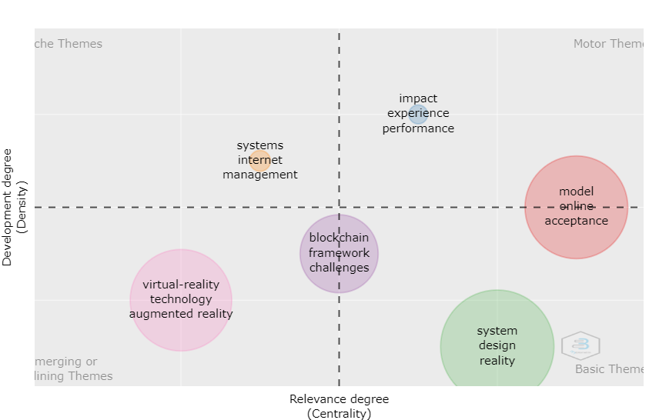
Figure 12 – Keywords extracted from the WoS dataset
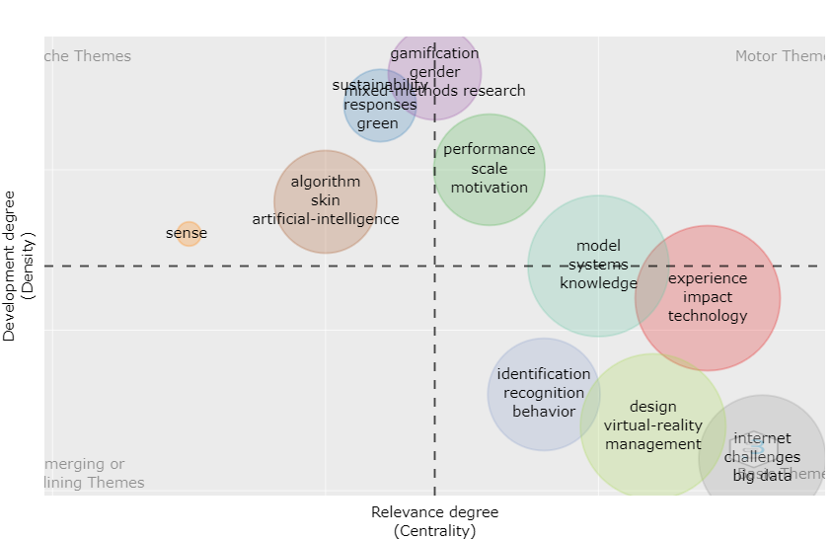
Figure 13 – Keywords extracted from the Scopus dataset
The keywords are captured and presented in Table 6 to reflect the relative contribution/number of times that these keywords were repeated across all the 100+ definitions. The table reflects a quantitative analysis of different keywords and the number of occurrences that these keywords had from the documents studied (as detailed in Annex 1). The keywords are grouped in categories that are explained in Table 7. Different colours are used only for visualization purposes, to depict these groups.
Table 6 – List of keywords, occurrences and relative percentage
Keyword | Total occurrences | % Occurrence
Systems/System | 41 | 5.8%
Model/Unified Model | 36 | 5.1%
Virtual Worlds/Worlds | 22 | 3.1%
Framework | 13 | 1.8%
Environments | 10 | 1.4%
Networks | 9 | 1.3%
Communication | 8 | 1.1%
Scale | 6 | 0.8%
Architecture | 3 | 0.4%
Classification | 3 | 0.4%
Composite | 3 | 0.4%
Determinants | 3 | 0.4%
Channel | 2 | 0.3%
Complexity | 2 | 0.3%
Virtual Reality/Reality | 59 | 8.3%
Technology/Technologies | 43 | 6.1%
Augmented Reality | 21 | 3.0%
Blockchain | 20 | 2.8%
Internet | 18 | 2.5%
Online | 16 | 2.3%
Big data | 14 | 2.0%
Information | 10 | 1.4%
Artificial Intelligence | 8 | 1.1%
Digital Twin | 6 | 0.8%
Simulation | 5 | 0.7%
Social media | 5 | 0.7%
Algorithm | 4 | 0.6%
Parallel Intelligence | 3 | 0.4%
Platform | 3 | 0.4%
Sense | 2 | 0.3%
Triboelectric nanogenerator | 2 | 0.3%
Wave | 2 | 0.3%
Challenges/Future | 24 | 3.4%
Acceptance/Technology Acceptance | 12 | 1.7%
Opportunities/Values | 10 | 1.4%
Experience | 9 | 1.3%
Impact | 9 | 1.3%
Adoption | 8 | 1.1%
Students/Student | 8 | 1.1%
Intention | 6 | 0.8%
Engagement | 5 | 0.7%
Life | 5 | 0.7%
Self | 5 | 0.7%
Behaviour | 4 | 0.6%
Benefits | 4 | 0.6%
Evolution | 4 | 0.6%
Skin | 4 | 0.6%
Dynamics | 3 | 0.4%
Emotion | 3 | 0.4%
Motivation | 3 | 0.4%
Pressure | 3 | 0.4%
Responses | 3 | 0.4%
Competition | 2 | 0.3%
Gender | 2 | 0.3%
Older-adults | 2 | 0.3%
Trust | 2 | 0.3%
Education/School | 13 | 1.8%
Care | 6 | 0.8%
Gamification/Games | 5 | 0.7%
Identification | 5 | 0.7%
Recognition | 5 | 0.7%
Science | 5 | 0.7%
E-commerce | 4 | 0.6%
Industry | 4 | 0.6%
Knowledge | 4 | 0.6%
Service | 4 | 0.6%
Video | 4 | 0.6%
Activity Recognition | 3 | 0.4%
Covid-19 | 3 | 0.4%
Disease | 3 | 0.4%
Simulation | 3 | 0.4%
Chemistry | 2 | 0.3%
Decision making | 2 | 0.3%
Mixed-methods research | 2 | 0.3%
Sustainability | 4 | 0.6%
Reconstruction | 3 | 0.4%
Climate | 2 | 0.3%
Consumption | 2 | 0.3%
Green | 2 | 0.3%
Temperature | 2 | 0.3%
Security | 8 | 1.1%
Context | 4 | 0.6%
Navigation | 3 | 0.4%
Search | 2 | 0.3%
Design | 15 | 2.1%
Performance | 11 | 1.5%
Management | 7 | 1.0%
Resource-allocation | 5 | 0.7%
Efficiency | 3 | 0.4%
Implementation | 3 | 0.4%
Innovation | 3 | 0.4%
Optimization | 3 | 0.4%
Quality | 3 | 0.4%
Estimation | 2 | 0.3%
Risk | 2 | 0.3%
Validation | 2 | 0.3%

10.2 Keyword grouping
The above key terms are classified in Table 7 in logical groups according to their context and to the classification that was performed through bibliometric analysis. Different colours are used to depict and associate each category with the corresponding key terms included in Table 6.
Table 7 – Logical groupings
Category | % Occurrence
Conceptualizing & architecture | 22.7
Technology | 33.9
People & Society | 19.7
Business and Services | 10.8
Environment | 2.1
Application Features | 2.4
Implementation, Governance & Management | 8.3

10.3 Important terms to be included in a standardized definition
Based on all the analysis performed above, using the key categories and principle keyword indicators, the following 24 key terms should be included in a standardized definition for metaverse.
• System  • Model  • Virtual Worlds  • Unified  • Reality (AR/VR/XR)  • Immersive  • Internet  • Blockchain | • Big data  • Information  • Digital  • Challenges  • Acceptance  • Opportunities/Values  • Experience  • Interactions | • Services  • Industry  • Values/Opportunities  • Sustainability  • Ecosystem  • Design  • Management  • Performance

11 Recommended definition

11.1 Criteria for definition
Based on the previously presented analysis of over 150 definitions of metaverse, it was found that the following criteria best define metaverse:
Key categories or groups
• Conceptualizing & architecture
• Technology
• People & Society
• Business and Services
• Environment
• Application Features
• Implementation, Governance & Management
Key terms to be included
A set of 24 key terms were identified as essential to be included in the standardized definition for metaverse. This list is provided in a separate document that is developed within the FG-MV WG1, under the Terminology and Definitions Task Group.

11.2 Specification properties
Based on the above findings, some considerations related to "metaverse" are described below, including the fact that that it can be considered as an Internet-based ecosystem of virtual worlds that utilizes emerging information and communication technology (ICT) (i.e., different types of reality systems, for example, virtual, augmented, extended, mixed, AI, blockchain) in a manner that:
1. Generates new types of digital experiences for the users (e.g., purchases, visits, entertainment, participation in shows).
2. Offers a new digital space where people can perform their digital transactions (e.g., social, monetary, entertainment, gaming, education) with other people (human-to-human) or with digital agents (human-to-machine).
3. Simplifies and enhances the efficiency of digital transactions with the availability of new types of human-computer-interaction environments.
4. Enables new digital product development and new digital service delivery for the organizations (public and private).
5. Generates new value opportunities (monetary, social and public) for the organizations that utilize it.
6. Establishes new types of social connections between individuals and organizations.

12 Conclusions
This Technical Report provides an insight into what is meant by metaverse and the underlying key terms.
• This Technical Report studies and analyses approximately 150 existing definitions of metaverse from various sources to determine a common theme identifying metaverse.
• In addition, this Technical Report identifies key terms and categories which should be considered for metaverse.
• A list of 98 key terms were analysed, and 24 were identified to be included in a standardized definition.
• Although this Technical Report is based on scientific and secondary data sources, it can be extremely useful for understanding the concept of metaverse.

Annex 1
Definitions of metaverse
*Details of references are provided in bibliography.
 | Category | Definitions/Features | Key concept/ Keywords | Source
1. | Corporate | An integrated immersive ecosystem where the barriers between the virtual and real worlds are seamless to users, allowing the use of avatars and holograms to work, interact and socialise via simulated shared experiences.  The metaverse is the next evolution in social connection and the successor to the mobile Internet.  Like the Internet, the metaverse will help you connect with people when you aren't physically in the same place and get us even closer to that feeling of being together in person. | social connection and the successor to the mobile Internet, holograms | [b-Meta]
2. | Corporate | The term "metaverse" is attached to a variety of applications and digital environments related to education, health care, entertainment and social interactions, accessible via both new technologies such as augmented reality (AR)/virtual reality (VR) headsets and older ones like desktop-based system | augmented reality (AR)/virtual reality (VR) headsets | [b-Economist]
3. | Academic | The metaverse thus allows its users to have an immersive experience in a virtual environment, in which they can interact with each other, conduct business and forge social connections through their virtual "avatars" | immersive experience, avatars | [b-Purdy]
4. | Academic | The metaverse is an interconnected web of ubiquitous virtual worlds partly overlapping with and enhancing the physical world. These virtual worlds enable users represented by avatars to connect and interact with each other, to experience and consume user-generated content in an immersive, scalable, synchronous and persistent environment | ubiquitous virtual worlds, avatars, immersive, scalable, synchronous and persistent environment | [b-Weinberger]
5. | Corporate | The next platform will be even more immersive – an embodied Internet where you are in the experience, not just looking at it. We call this the metaverse, and it will touch every product we build.  The defining quality of the metaverse will be a feeling of presence – like you are right there with another person or in another place. Feeling truly present with another person is the ultimate dream of social technology. That is why we are focused on building this.  In the metaverse, you'll be able to do almost anything you can imagine – get together with friends and family, work, learn, play, shop, create – as well as completely new experiences that do not really fit how we think about computers or phones today. | immersive – an embodied Internet, feeling of presence | [b-Zuckerberg]
6. | Academic | Commonly, the metaverse is regarded as a fully immersive, hyperspatio-temporal, and self-sustaining virtual shared space blending the ternary physical, human, and digital worlds. | immersive, hyperspatio-temporal, self-sustaining virtual shared space | [b-Wang]
7. | Academic | It provides an immersive experience based on augmented reality technology, generates a mirror image of the real world based on digital twin technology. Characteristics of the Metaverse are identified: 1) multitechnology convergence; 2) sociality; and 3) hyperspatio-temporality. | augmented reality technology, digital twin | [b-Ning]
8. | Academic | The metaverse is an interconnected web of ubiquitous virtual worlds partly overlapping with and enhancing the physical world. These virtual worlds enable users who are represented by avatars to connect and interact with each other, and to experience and consume user-generated content in an immersive, scalable, synchronous, and persistent environment. An economic system provides incentives for contributing to the metaverse. | immersive, scalable, synchronous, and persistent environment | [b-Weinberger]
9. | Media | Metaverse, a term first coined in science fiction: is a combination of the prefix "meta", meaning beyond, and "universe".  It refers to shared virtual worlds where land, buildings, avatars and even names can be bought and sold, often using cryptocurrency. In these environments, people can wander around with friends, visit buildings, buy goods and services, and attend events. | cryptocurrency, shared virtual worlds | [b-Roh]
10. | Academic | Metaverse seamlessly integrates the real world with the virtual world and allows avatars to carry out rich activities including creation, display, entertainment, social networking, and trading. Thus, it is promising to build an exciting digital world and to transform a better physical world through the exploration of the metaverse. | virtual world | [b-Yang]
11. | Academic | The economy is the fundamental component of the metaverse. The metaverse economic system is composed of four parts: digital creation, digital asset, digital market, and digital currency, whose exploitation will lead to the transformation of the conventional economy.  • Digital Creation is the foundation of the metaverse.  • Digital Asset has the hidden property, which is the precondition of trade.  • Digital Market is the fundamental place in which avatars can trade to have income like in the physical world.  • Digital Currency is the media in metaverse with which the avatars can finish the trade and exchange. While in the metaverse, fiat currency cannot satisfy the demands of the development of the metaverse due to the high cost of the legal currency system. | digital creation, digital asset, digital market, and digital currency | [b-Yang]
12. | Academic | The metaverse has been recognized as being the next generation of social connection. It refers to a created world, in which people can "live" under the rules defined by the creator. | next generation of social connection | [b-Farjami]
13. | Academic | A metaverse could be fully or partially virtual; for example, it could be a fully virtual world like a virtual reality (VR) system, or a partially virtual world like the use of augmented realty (AR) in real-world contexts | VR, virtual | [b-Avila]
14. | Academic | Shared online space that incorporates 3D graphics, either on-screen or in virtual reality. | Shared online space, 3D | [b-Sparkes]
15. | Academic | Metaverse is a new type of Internet application and social form that integrates a variety of new technologies. It has the characteristics of multi-technology, sociality, and hyper spatio-temporality. | Internet application and social form, multi-technology, sociality, hyper spatio-temporality | [b-Ning]
16. | Academic | The metaverse will not take place inside one or more locked virtual worlds but rather will permeate every aspect of everyday life, seamlessly blending digital and physical realities and dissolving perceptions of the traditional dichotomy between purportedly real (i.e., physical) and false (i.e., synthetic) experiences. Accordingly, the metaverse is an ecosystem of interconnected, shared digital and physical environments that can be experienced synchronously, persistently, and interoperably, and in which physical and technology-enhanced realities are seamlessly combined. | ecosystem of interconnected, shared digital and physical environments | [b-Golf-Papez]
17. | Academic | In the metaverse, physical and digital worlds converge to form a new, fundamentally enhanced experience of reality. In this new reality, value is predicated on developing synthetic customer experiences (SCx) – that is, natural or physical customer experiences (PCx) extended through technology so as to enhance customers' cognitive, emotional, behavioral, sensorial, and social responses. | cognitive, emotional, behavioral, sensorial, and social responses | [b-Golf-Papez]
18. | Internet | Metaverse is a compound word of transcendence meta and universe and refers to a three-dimensional virtual world  where avatars engage in political, economic, social, and  cultural activities. It is widely used in the sense of a virtual  world based on daily life where both the real and the unreal coexist. | virtual world | [b-Wikipedia]
19. | Academic | Metaverse can be divided life-logging, mirror world, augmented reality, and the virtual world according to whether the implemented space is reality oriented or virtual-centred, and whether the implemented information is external environment information-centred and individual-centred. | reality oriented, virtual-centred, information-centred, individual-centred | [b-Lee]
20. | Corporate | The metaverse is a collection of immersive, collaborative, and interactive environments that span digital and physical worlds and enable us to create, exchange, socialize and learn. | immersive, collaborative, interactive | [b-Johnson]
21. | Academic | 1. A metaverse is a combination of virtual worlds and augmented real worlds. They are not closed systems but linked with each other and with reality.  2. A metaverse is a social medium in which people can interact, communicate, collaborate, but also trade and own property.  3. A metaverse is persistent and long-lasting but can also include temporally limited sessions.  4. A metaverse is an integrated system that entails and utilizes XR- and other technologies. This requires utilized components to be as open and interoperable as possible, ideally using open standards.  5. In addition to getting immersed in virtual worlds (VR) and augmented real worlds (AR/MR), capturing the state of the user and the real environment are key actions for metaverse applications.  6. Metaverse participation is multi-modal and can be accomplished with varying intensities and representations, such as embodiment through avatars. Participants can seamlessly change the form and intensity of their participation.  7. A metaverse is tightly coupled with reality. Information, actions, and interactions can be exchanged between both worlds, real and digital, and can influence each other. Using digital twins allows for cooperative interactions with things in the real and virtual world. | virtual worlds and augmented real worlds, social medium, integrated system, VR/MR, avatars, digital twin, real and virtual worlds. | [b-Buchholz]
22. | Media | 1. A virtual world: this is, in my opinion, the most important characteristic of a metaverse. You could explore it using a computer, gaming console, mobile, wearable technology or other device, experiencing 3D graphics and sound along the way. The idea is that this makes you feel more present in the metaverse, and presumably less present in the everyday world (where your body stubbornly remains).  2. Virtual reality. You need a virtual reality headset for this. The idea here is that you become immersed in the virtual world, so you feel even more present – at least until you bump into something that remains in the everyday world, like the coffee table.  3. Other people. The metaverse is social. There are lots of other people there, represented as avatars. Some of these avatars might be bots, virtual agents and manifestations of artificial intelligence. You can hang out with the other people or even do things together. The social aspect is likely to be central in Facebook's metaverse given its history as a social network.  4. Persistence. This means the virtual world is available whenever you want to visit it. You can change it by adding new virtual buildings or other objects and importantly, the changes remain in place next time you visit. You might be able to take up residence and own a bit of it. The metaverse will rely on your user-generated content – your digital creations and personal stories – in the same way social media does today.  5. Connection to the real world. In some visions of the metaverse, the virtual stuff in the virtual world actually represents real stuff in the real world. For example, you might fly a virtual drone in the metaverse to steer an actual drone in the real world. People talk about the real and virtual as being "digital twins". | virtual reality, persistence, connection | [b-Benford]
23. | Media | The metaverse is a network of always-on virtual environments in which many people can interact with one another and digital objects while operating virtual representations – or avatars – of themselves. Think of a combination of immersive virtual reality, a massively multiplayer online role-playing game and the web.  There are three key aspects of the metaverse: presence, interoperability and standardization.  • Presence is the feeling of actually being in a virtual space, with virtual others.  • Interoperability means being able to seamlessly travel between virtual spaces with the same virtual assets, such as avatars and digital items.  • Standardization is what enables interoperability of platforms and services across the metaverse. | always-on virtual environments, avatars, immersive virtual reality, presence, interoperability, standardization | [b-Ratan]
24. | Academic | The term metaverse is sometimes used in conjunction with the term web3, as well as technologies such as blockchain or distributed ledger.  The metaverse is considered as an open combined system that is linked with the reality. This requires digital identities for both, the objects in the reality as well as the metaverse, as well as means for the transfer and exchange of assets between different metaverse worlds.  The metaverse as a social medium for trading and owning properties requires a notary and clearinghouse that can be easily realized by appropriate smart contract. | Web3, digital identity, blockchain, social medium | [b-Buchholz]
25. | Corporate | The metaverse is an all-digital layer of reality that floats above, around, and throughout the features of the real world – or, in some definitions, is entirely separate from it. | All digital layer | [b-Sullivan]
26. | Corporate | Qualcomm views the metaverse as an ever-present spatial Internet complete with personalized digital experiences that spans the physical and virtual worlds, where everything and everyone can communicate and interact seamlessly. People will access the metaverse through any computing device – smartphone, PC, AR/VR device, etc. – as a portal to a virtual presence that mirrors aspects of real life. In the metaverse, unlimited users and businesses can explore, create, socialize, and participate in a wide variety of communities, daily experiences and economic activities in 2D and 3D. | Special Internet, unlimited users, 3D | [b-Swart]
27. | Corporate | The metaverse is almost like The Truman Show. Only, instead of walking into a television set, you walk into the Internet and explore any number of different realities. It is the tech moguls' dream of re-coding the DNA of society. But will we feel more connected? Or lonelier than we are today? | Different realities, Internet | [b-Sullivan]
28. | Corporate | We imagine the metaverse as reality made better, a world infused with magic, stories, and functionality at the intersection of the digital and physical worlds. Through it, we think there is the potential to make people and society better by nudging us to get out, exercise, and rediscover the physical world around us. | magic, stories, functionality | [b- Sullivan]
29. | Corporate | The metaverse is a set of virtual, three dimensional spaces where you can share immersive experiences with other people even when you can't be together. It will be inherently social; you will be able to hang out with friends, collaborate with colleagues, learn, shop and create – among other things. The metaverse isn't just VR! Those spaces will connect to AR glasses and to 2D spaces like Instagram. And most importantly, there will be a real sense of continuity where the things you buy are always available to you. Today, much of what you buy on the Internet is inside a single app, website, or game. You might buy a custom skin for your gaming avatar, but you cannot take it with you when you move to a new space. In the future, you will be able to buy goods and services and have them available to you in the metaverse more broadly – and for creators, this can open up new ways to build a meaningful business. | virtual three dimensional spaces, sense of continuity | [b-Meta]
30. | Industry association | The metaverse will be an infinite realm that blankets both the physical and virtual worlds. At its core will be a self-contained economy that allows individuals and businesses to create, own or invest in a range of activities and experiences. Like the Internet, it will not be just one thing but several layers of different technologies, products and languages. | infinite realm, different technologies, products and languages | [b-Consumer Technology Association]
31. | Corporate | The vision of bridging physical and digital realities is about inhabiting an interface, where the metaverse is the spatial version of the Internet Ideally, the metaverse is highly customizable and as separate or integrated into our physical realities as necessary – and desired. Therefore, the metaverse experience can be altered from the individual's point of view and shaped or curated by any number of agents – whether human or A.I. In that sense, the metaverse does not have an objective look beyond its backend. In essence, the metaverse, together with our physical locations, forms a spatial continuum. The very materials of the metaverse are mathematics and imagination, so we should expect buildings or garments made here to function in new, more ambitious, and inspired ways than their counterparts in the physical world. After all, there is more than one way to skin a city when the only limitation is the computational cost per second. | spatial version of the Internet, maths and imagination, | [b-Global Architecture And Design Firm CallisonRTKL]
32. | Academic | • The metaverse has the potential to extend the physical world using extended, augmented, and virtual reality technologies.  • Interactive virtual environments and immersive games are considered as antecedents of the metaverse.  • The transformative impact of the metaverse as well as societal effects relating to social interaction factors from widespread adoption.  • Sectors potentially impacted by the metaverse include marketing, education, tourism, and health care. | extended, augmented, virtual reality technologies, interactive virtual environments, immersive. | [b-Dwidedi]
33. | Academic | The metaverse as a virtual reality (VR) space that utilizes Internet and augmented reality (AR) via avatars and software agents. | VR, utilize Internet, avatars, software agents | [b-Joshua]
34. | Media | The metaverse has been described as a new iteration of the Internet that utilizes VR headsets, blockchain technology and avatars within a new integration of the physical and virtual worlds. | a new iteration of the Internet, VR, blockchain, avatars, integration of the physical and virtual worlds | [b-The Verge]
35. | Academic | The metaverse has been recognized as being the next generation of social connection. It refers to a created world, in which people can "live" under the rules defined by the creator | virtual reality; augmented reality | [b-Hwang]
36. | Academic | The collective, virtual and shared space created by the convergence of virtually enhanced physical reality and physically persistent virtual space, including the sum of all virtual worlds, augmented reality and the Internet. | collective, virtual, shared space, augmented reality | [b-Zhang]
37. | Media | Where communities and economies span physical and virtual realities, converging in a shared online space | shared online space, physical and virtual realities | [b-Kamin]
38. | Academic | There are three features of the metaverse that make it quite different from conventional VR or AR: "shared," "persistent," and "de-centralized." Moreover, artificial intelligence (AI) is a required technology to enable the world of the metaverse to work following the rules defined by the creator. | shared, persistent, decentralized | [b-Hwang]
39. | Think Tank | • A combination of physical and digital worlds – embodying a unified digital presence into physical and virtual lives.  • Fully formed, high-fidelity 3D worlds that embrace mixed reality via AR/VR  • Always on, persistent, and real time.  • Unlimited immersive and social interaction that can occur at any scale.  • A seamless digital economy delivering creation and marketplace opportunity.  • An advanced workspace with new forms of collaboration, productivity and communications. | unified digital presence, high fidelity 3D, AR/VR, persistent and real time, immersive and social interaction, digital economy, workspace, collaboration, productivity, communication | [b-Enders Analysis]
40. | Think tank | The metaverse industry covers a vast spectrum of new evolving technologies, including blockchain, 5G and AI. This industry does not only rely on only Virtual and Augmented Reality. Decentralization from blockchain,  Connectivity from 5G, and rapid development from Artificial Intelligence are just a few of the components of this fast-evolving industry. | blockchain, VR, AR, 5G, AI | [b-Metaverse insider]
41. | Corporate | It is a gaming platform, a virtual retail destination, a training tool, an advertising channel, a digital classroom, a new gateway to digital experiences. The metaverse seems to be whatever people's imaginations dream it to be. | gaming platform, virtual retail destination, training tool, advertising channel, digital classroom | [b-McKinsey]
42. | Media | It is partly a dream for the future of the Internet. | future of the Internet | [b-The Verge]
43. | Corporate | The metaverse is an expansive network of persistent, real-time rendered 3D worlds and simulations that support continuity of identity, objects, history, payments, and entitlements, and can be experienced synchronously by an effectively unlimited number of users, each with an individual sense of presence. | expansive network, persistent, real time, 3D, identity, objects, payments, entitlements, individual sense of presence | [b-Ball]
44. | Corporate | A seamless convergence of our physical and digital lives, creating a unified, virtual community where we can work, play, relax, transact and socialize. | unified, virtual community, transact, socialize | [b-J.P. Morgan]
45. | Government | The metaverse as a fundamental shift in our world, due to technology becoming more advanced and ubiquitous. The key component is that the shift is powered by technology and is significant and universal, having a strong influence across disciplines, cultures or other barriers. The notion of a "critical mass" of technologies ‘coming together' to form the metaverse is also common.  (1) The generalized and significant shift across norms, disciplines, cultures or other barriers creates new opportunities.  (2) Persistent, cohesive, shared experiences give the sense of a new "world".  (3) Can be immersive and interactive, but users also can interact with it in a limited capacity. In other words, the metaverse is flexibly immersive. | advanced, ubiquitous, critical mass, coming together, persistent, cohesive, shared experience, immersive and interactive | [b-European Parliamentary Research Service]
46. | Government | The metaverse is the product of a technology-driven shift with generalized impact through persistent and adaptable digital experiences.  Closed metaverse: A generalised, impactful, persistent and adaptable system touching upon all aspects of life would be the very meaning of success for some of today's more impactful entities. This is the definition of a closed metaverse, one that benefits a collection of large entities or a single large entity, at the expense of societal good.  Open metaverse: While an outright techno-feudal closed metaverse is unlikely as long as established institutions and regulations continue to exist, proponents of an open metaverse argue that by utilising open standards, an interoperable and accessible metaverse can benefit everyone. Central to enabling such an open metaverse are technologies such as blockchain, as well as the concept of Web 3.0, or an evolution of the Internet where information and benefits are more decentralised. | technology-driven shift, persistent, adaptable, decentralized, close metaverse, open metaverse | [b-European Parliamentary Research Service]
47. | Government | The main technology factors of metaverse are as follows.  • Hardware. This includes networking, processing speed both on servers and on edge devices, volatile (random access memory (RAM)) and non-volatile (solid state drive (SSD)) memory capacity and speed, specialized processing devices (in particular graphics processing unit (GPUs)), visualization devices (screens, AR and virtual reality (VR) headsets, combo solutions), and location devices (Global Positioning System (GPS), accelerometers).  • Software. This includes computer vision in its various guises (analysis of the non-animated and human interaction context), language recognition (speech and written), language composition, as well as several other applications of artificial intelligence (AI) and machine learning. It also includes general advances in the realistic rendering of 3D objects and various blockchain-related patterns, in particular public key infrastructure.  • Data. This often-underestimated part of the technical infrastructure relates to data from the real world, in particular maps and other location data.  • Integration. This includes combinations of the above, e.g. using advances in hardware and software to understand the context of an image captured and being able to augment it, both in real time; new and standardised ways to interact with metaverse objects using technology primitives from the blockchain space, in particular, their PKI-driven application programming interface (API) structures. | hardware, software, data, integration | [b-European Parliamentary Research Service]
48. | Government | 1. Photorealism, i.e. the degree to which the metaverse world resembles the physical world and is sufficiently indistinguishable from it, to the casual observer;  2. Immersiveness, i.e. the degree to which users can (or must) embed themselves inside the world to use it, for example by wearing a VR headset;  3. Persistence, i.e. the degree to which the interaction experience "follows" users in their daily lives in an always-on fashion;  4. Data ownership, i.e. the degree to which users own the assets they possess in the virtual world (e.g., avatars, objects, land) and can take them off the metaverse to be used in other virtual worlds;  5. Openness, i.e. the degree to which the virtual world is open to developers to create new spaces, experiences, objects and applications;  6. Censorship resistance, i.e. the degree to which users can be prohibited from accessing the virtual world, restricted in their experiences or expelled from the metaverse, by a centralised authority who "owns" and controls the world. | photorealism, immersiveness, persistence, data ownership, openness, censorship resistance | [b-European Parliamentary Research Service]
49. | Corporate | The metaverse is not 3D or 2D, or even necessarily graphical; it is about the inexorable dematerialization of physical space, distance, and objects. The metaverse is the moment in time where our digital life is worth more to us than our physical life. | inexorable dematerialization of physical space, distance, objects | [b-Radoff]
50. | Academic | The metaverse is likely to be the default interaction model for the Internet in the coming decades. | default interaction model for the Internet | [b-UNIC]
51. | Think tank | 1. Immersivity. The development of new augmented reality/mixed reality (AR/MR) technologies that effectively overcome current technical obstacles would be a strong accelerator of new usages in the coming years. In the same way that smartphones made the digital economy shift from computers to mobiles, we believe that user-acceptable AR/MR glasses would drive a similar shift from screen to metaverse.  2. Interoperability. Interoperability is essential to provide a true seamless experience to users and to allow them to share resources, irrespective of their access platform. However, due to diverging interests between vendors, users, and other players in the value chain, there is no guarantee that this will be achieved.  3. Abundance. In the physical world, scarcity drives the value of assets in a market economy. In the traditional digital economy, since a digital file can be duplicated at no cost, scarcity was reintroduced artificially through systems such as digital rights management. In a virtual world with blockchain and non-fungible tokens (NFTs), a new economic paradigm of "abundance" may appear, implying a more fundamental value shift from physical assets to experience and, perhaps, status. The extent to which this will happen, and its implications for business, are uncertain. | immersivity, interoperability, abundance | [b-Little]
52. | Think tank | The metaverse is the concept of an immersive, interactive virtual world. It would be accessed by people using new digital technologies like virtual reality (VR) headsets and sensors.  When people enter the metaverse, they would be able to interact with each other in different ways and take part in entertainment, social, professional and other experiences." | immersive, interactive, virtual, VR | [b-Global Counsel]
53. | Corporate | An evolution of the Internet that enables a user to move beyond browsing to inhabiting and participating in a persistent shared digital experience that spans the spectrum of immersion. | persistent, shared, immersion | [b-Accenture]
54. | Think tank | The metaverse will be an evolved version of the Internet, one that is a social an immersive real-time blend of our physical and digital lives.  The main characteristics of metaverse definition:  • Immersive: our digital and physical lives will be blended seamlessly.  • Interoperable: virtual assets, data and identities will be usable across individual experiences.  • Persistent: the metaverse will exist regardless of a time and a place. It cannot be turned off and is readily available in real time.  • Infinite: there are no fixed boundaries-only those that are created purposefully.  • Social: we will be able to socialize, work, transact, play and create, with few limitations.  • Economical: cryptocurrency and blockchain ownership paradigms will enable true virtual economies across metaverse experiences.  • Decentralized: the metaverse will be more open and decentralized (web3-enabled) than today's Internet platform. | immersive, interoperable, persistent, infinite, social, economical, decentralized | [b-Heider]
55. | Corporate | While there is no agreed upon definition of the metaverse, one way to think about it is as an expansive network of digital spaces, including immersive 3D experiences in augmented, virtual, and mixed reality, that are interconnected and interoperable so you can easily move between them, and in which you can create and explore with other people who aren't in the same physical space as you. | expansive network, digital space, 3D, augmented, virtual, mixed reality | [b-Meta]
56. | Industry association | The metaverse isn't a single firm or organization's product or space, or even all of them together – it is the way they are connected. | connected | [b-Herrman]
57. | Think tank | In addition to collaboration and technological advances on a massive scale, the metaverse is going to require elevated user experience, sophisticated telecoms infrastructure, and human-machine interfaces. Some of these components are already well advanced, while others still need to be created and developed. Augmented reality (AR),13 virtual reality (VR),14 mixed reality (MR), extended reality (XR), blockchain, and non-fungible tokens (NFTs or "tokens") are fledgling technologies of today that are expected to be the backbone of the metaverse or of social and economic activity within the metaverse. | collaboration, sophisticated telecoms infrastructure, human-machine interface, AR, VR, XR, blockchain, NFTs, tokens | [b-Christensen]
58. | Internet | The Internet is considered as an imaginary area without limits where you can meet people in virtual reality (= images and sounds, produced by a computer, that seem to represent a real place or situation):  The metaverse is a virtual world where humans, as avatars, interact with each other in a three-dimensional space that mimics reality. | virtual reality, avatars, 3D | [b-Cambridge Dictionary]
59. | Industry association | Interoperability is the bedrock of the metaverse, to enable multiple disruptive technologies to work together, to build bridges between applications to scale beyond a series of disconnected silos, and to evolve a platform that is open and inclusive for all. | interoperability, platform, inclusive, open | [b-Metaverse Standards Forum]
60. | Internet | Metaverse generally refers to the concept of a highly immersive virtual world where people gather to socialize, play and work. | highly immersive, virtual | [b-Merriam-Webster]
61. | Industry | The metaverse is a digital reality that combines aspects of social media, online gaming, augmented reality (AR), virtual reality (VR) and cryptocurrencies to allow users to interact virtually. Augmented reality overlays visual elements, sound, and other sensory input onto real-world settings to enhance the user experience. In contrast, virtual reality is entirely virtual and enhances fictional realities. | digital reality, social media, online gaming, AR, VR, cryptocurrencies | [b-Investopedia]
62. | Academic | Metaverse, proposed network of immersive online worlds experienced typically through virtual reality or augmented reality in which users would interact with each other and purchase goods and services, some of which would exist only in the online world. Builders of metaverse technology consider it to be the next step in the evolution of the Internet after early 21st century developments such as smartphone applications and social media. | network, immersive, VR, AR | [b-Gregersen]

Bibliography

[b-Amorim] | Amorim, T., Tapparo, L., Marranghello, N., Silva, A.C.R., & Pereira, A.S. (2014). A multiple intelligences theory-based 3D virtual lab environment for digital systems teaching. Proc. Comput. Sci., vol. 29, pp. 1413-1422.
[b-Avila] | Avila, S. (2017). Implementing augmented reality in academic libraries. Public Services Quarterly, 13 (3), pp. 190-199
[b-Ball] | Ball, M. (2021). Framework for the Metaverse, The Metaverse Primer, Web, Last accessed 16 August 2023 https://www.matthewball.vc/all/forwardtothemetaverseprimer
[b-Ball2] | Ball, M. (2022). THE METAVERSE And How It Will Revolutionize Everything. Liveright Publishing Corporation.
[b-Ball] | Barry, D.M., Ogawa, N., Dharmawansa, A., Kanematsu, H., Fukumura, Y., Shirai, T., Yajima, K., & Kobayashi, T. (2015). Evaluation for students' learning manner using eye blinking system in metaverse, Proc. Comput. Sci., vol. 60, pp. 1195-1204.
[b-Benford] | Benford, S. (2021). Metaverse: Five Things to Know – and what it Could Mean for You; The Conversation
[b-Bourlakis] | Bourlakis, M., Papagiannidis, S., & Li, F. (2009). Retail spatial evolution: paving the way from traditional to metaverse retailing. Electronic Commerce Research (9), pp. 135-148. doi: 10.1007/s10660-009-9030-8
[b-Buchholz ] | Buchholz, F., Oppermann, L., & Prinz, W. (2022). There's more than one metaverse, i-com, vol. 21, no. 3, pp. 313-324. https://doi.org/10.1515/icom-2022-0034
[b-Metaverse Standards Forum] | Building an Open Metaverse, Metaverse Standards Forum, Web, Last accessed 17 August 2023  https://metaverse-standards.org/
[b-Meta] | Building the Metaverse Responsibly. Meta. (2021).
[b-Cameron] | Cameron, A. (2012). Splendid isolation: Philosopher's islands' and the reimagination of space. Geoforum, vol. 43, no. 4, pp. 741-749.
[b-Chen] | Chen, J.C. (2016). The crossroads of English language learners, task-based instruction, and 3D multi-user virtual learning in second life. Comput. Educ., vol. 102, pp. 152-171.
[b-Choi] | Choi, H.S., & Kim, S.H. (2017). A content service deployment plan for metaverse museum exhibitions - Centering on the combination of beacons and HMDs. Int. J. Inf. Manage., vol. 37, no. 1, pp. 1519-1527.
[b-Christensen] | Christensen, L., & Robinson, A. (2022). The Potential Global Economic Impact of the Metaverse, The Analysis Group, The Potential Global Economic Impact of the Metaverse (analysisgroup.com)
[b-Collins] | Collins, C. (2008). Looking to the future: Higher education in the Metaverse, Educause Rev., vol. 43, no. 5, pp. 51-63.
[b-Connolly] | Connolly, T.M., Stansfield, M., & Hainey, T. (2011). An alternate reality game for language learning: ARGuing for multilingual motivation. Comput. Educ., vol. 57, no. 1, pp. 1389-1415.
[b-EU Council] | Council of the European Union. (2022). Metaverse – Virtual World, Real Challenges. Available at: https://www.consilium.europa.eu/media/54987/metaverse-paper-9-march-2022.pdf
[b-Cunningham] | Cunningham, T.C. (2010). Marching toward the metaverse; strategic communication through the new media. Army Command Gen. Staff Coll Fort Leavenworth KS School Adv. Mil. Stud., VA, USA, Tech. Rep. ADA522953.
[b-Dascalu] | Dascalu, M.I., Moldoveanu, A., & Shudayfat, E.A. (2014). Mixed reality to support new learning paradigms. Proc. 18th Int. Conf. Syst. Theory, Control Comput. (ICSTCC), pp. 692-697.
[b-Davis] | Davis, A., Murphy, J., Owens, D., Khazanchi, D., & Zigurs, I. (2009). Avatars, people, and virtual worlds: Foundations for research in metaverses. Journal of the Association for Information Systems, 10(2), pp. 1-29.
[b-De Decker] | De Decker, P., & Peterson, S. (2020). Beyond virtual or physical environments: Building a research metaverse a white paper for NDRIO's Canadian digital research needs assessment. Digit. Res. Alliance Canada, Toronto, ON, Canada, Tech. Rep.
[b-Dionisio] | Dionisio, J.N., Burns III, W.G., & Gilbert, R. (2013). 3D Virtual Worlds and the Metaverse: Current Status and Future Possibilities. ACM Computing Surveys, 45. doi: http://dx.doi.org/10.1145/2480741.2480751
[b-Dowling] | Dowling, M. (2021). Fertile LAND: Pricing non-fungible tokens. Finance Res. Lett., Art. no. 102096.
[b-Duan] | Duan, H., Li, J., Fan, S., Lin, Z., Wu, X., & Cai, W. (2021). Metaverse for Social Good: A University Campus Prototype. Proceedings of the 29th ACM International Conference on Multimedia (MM '21). Retrieved from https://doi.org/10.1145/3474085.347923
[b-Dwivedi] | Dwivedi, Y.K., Hughes, L., Baabdullah, A.M., Ribeiro-Navarrete, S., Giannakis, M., Al-Debei, M.M., Dennehy, D., Metri, B., Buhalis, D., Cheung, C.M.K., Conboy, K., Doyle, R., Dubey, R., Dutot, V., Felix, R., Goyal, D.P., Gustafsson, A., Hinsch, C., Jebabli, I., Janssen, M.F.W.H.A., Kim, Y.G., Kim, J., Koos, S., Kreps, D., Kshetri, N., Kumar, V., Ooi, K.B., Papagiannidis, S., Pappas, I.O., Polyviou, A., Park, S.M., Pandey, N., Queiroz, M.M., Raman, R., Rauschnabel, P.A., Shirish, A., Sigala, M., Spanaki, K., Tan, G. W.-H., Tiwari, M.K., & Viglia, G., Wamba, S.F. (2022). Metaverse beyond the hype: multidisciplinary perspectives on emerging challenges, opportunities, and agenda for research, practice and policy. Int. J. Inf. Manag. 2022, 66, 102542. https://doi.org/10.1016/j.ijinfomgt.2022.102542
[b-Farjami] | Farjami, S., Taguchi, R., Nakahira, K.T., Nunez Rattia, R., Fukumura, Y., & Kanematsu, H. (2011). Multilingual problem based learning in metaverse, International conference on knowledge-based and intelligent information and engineering systems, Springer, Berlin, Heidelberg, pp. 499-509.
[b-Folger] | Folger, J., Brown, J., & Velasquez, V. (2022). What Does Metaverse Mean and How Does This Virtual World Work? Investopedia. Web, Last accessed 17 August 2023.
[b-Investopedia] | Forte, M., Lercari, N., Galeazzi, F., & Borra, D. (2010). Metaverse communities and archaeology: The case of Teramo. Proc. EuroMed, pp. 79-84.
[b-Frey] | Frey, D., Royan, J., Piegay, R., Kermarrec, A.M., Anceaume, E., & Le Fessant, F. (2008). Solipsis: A Decentralized Architecture for Virtual Environments. 1st International Workshop on Massively Multiuser Virtual Environments, pp. 29-33.
[b-Gartner] | Gartner. (2022). Predicts 2022: 4 technology bets for building the digital future. Gartner Report.
[b-Global Architecture And Design Firm CallisonRTKL] | Sullivan, M. (2021). What the Metaverse will (and won’t) Be, According to 28 Experts. Fast Company, vol. 26. Available at: http://web.archive.org/web/20220127184057/https://www.fastcompany.com/90678442/what-is-the-metaverse.
[b-Go] | Go, SY, Jeong, H.G., Kim, J.I., & Sin, Y.T. (2021). Concept and developmental direction of metaverse. Korea Inf Process Soc Rev [Internet]. Available from: http://www.koreascience.kr/article/ JAKO202122450520317.pdf
[b-Goertzel] | Goertzel, B. (2007). Human-level artificial general intelligence and the possibility of a technological singularity: A reaction to Ray Kurzweil's the singularity is near, and McDermott's critique of Kurzweil. Artif. Intell., vol. 171, no. 18, pp. 1161-1173.
[b-Golf-Papez] | Golf-Papez, M., Heller, J., Hilken, T., Chylinski, M., De Ruyter, K., Keeling, D., & Mahr, D. (2022). Embracing falsity through the metaverse: The case of synthetic customer experiences, Business Horizons, Volume 65, Issue 6, Pages 739-749, ISSN 0007-6813.
[b-González] | González, M.A., Santos, B.S.N., Vargas, A.R., Martín-Gutiérrez, J., & Orihuela, A.R. (2013). Virtual worlds. Opportunities and challenges in the 21st century. Proc. Comput. Sci., vol. 25, pp. 330-337.
[b-Accenture] | Government Enters the Metaverse. (2022). Accenture, Federal Technology Vision 2022: Government Enters the Metaverse (accenture.com)
[b-Gregersen] | Gregersen, E. (2023). Metaverse. Encyclopedia Britannica, Web, Last accessed 17 August 2023
[b-Guo] | Guo, J., Angelina, C., & Rolf, W.T. (2011). Virtual wealth protection through virtual money exchange. Electron. Commerce Res. Appl., vol. 10, no. 3, pp. 313-330.
[b-Hazan] | Hazan, S. (2010). Musing the metaverse. Heritage in the Digital Era. Brentwood, Esse, U.K.: Multi-Science Publishing.
[b-Heider] | Heider, C. and Valentin, P. (2023) Unlocking the Metaverse. Accessed, Sept. 2023 from https://www.simon-kucher.com/en/insights/unlocking-metaverse
[b-Herrman] | Herrman, J., & Browning, K. (2021). Are We in the Metaverse Yet? The New York Times. Available at: https://www.nytimes.com/2021/07/10/style/metaverse-virtual-worlds.html/
[b-Hollensen] | Hollensen, S., Kotler, P., & Opresnik, M.O. (2022). Metaverse the new marketing universe. Journal of Business Strategy. https://doi.org/10.1108/JBS-01-2022-0014
[b-Huggett] | Huggett, J. (2020). Virtually real or really virtual: Towards a heritage metaverse. Stud. Digit. Heritage, vol. 4, no. 1, pp. 1-15.
[b-Hughes] | Hughes, I. (2012). Virtual worlds, augmented reality, blended reality. Comput. Netw., vol. 56, no. 18, pp. 3879-3885.
[b-Hwang] | Hwang, G.-J., & Chien, S.-Y. (2022). Definition, roles, and potential research issues of the metaverse in education: An artificial intelligence perspective, Computers and Education: Artificial Intelligence, Volume 3, 100082, ISSN 2666-920X, https://doi.org/10.1016/j.caeai.2022.100082
[b-Jaynes] | Jaynes, C., Seales, W.B., Calvert, K., Fei, Z., & Griffioen, J. (2003). The metaverse: A networked collection of inexpensive, self-configuring, immersive environments. Proc. Workshop Virtual Environ. (EGVE), pp. 115-124.
[b-Johnson] | Johnson, C., Crawford, D., Naik, N., & Verma, N. (2023). Taking the Hyperbole Out of the Metaverse, https://www.bain.com/insights/taking-the-hyperbole-out-of-the-metaverse-tech-report-2023/
[b-Joshua] | Joshua, J. (2017). Information Bodies: Computational Anxiety in Neal Stephenson's Snow Crash. Interdisciplinary Literary Studies, 19 (1), pp. 17-47
[b-Kamin] | Kamin, D. (2021). Investors snap up metaverse real estate in a virtual land boom, The New York Times, https://www.nytimes.com/2021/11/30/business/metaverse-real-estate.html
[b-Kanematsu] | Kanematsu, H., Kobayashi, T., Ogawa, N., Barry, D.M., Fukumura, Y., & Nagai, H. (2013). Eco car project for Japan students as a virtual PBL class. Proc. Comput. Sci., vol. 22, pp. 828-835.
[b-Kanematsu2] | Kanematsu, H., Ogawa, N., Shimizu, A., Shirai, T., Kawaguchi, M., Kobayashi, T., Nakahira, K.T., & Barry, D.M. (2017). Skype discussion for PBL between two laboratories and students biological/psychological responses. Proc. Comput. Sci., vol. 112, pp. 1730-1736.
[b-Kemp] | Kemp, J., & Livingstone, D. (2006). Putting a second life `metaverse' skin on learning management systems. Proc. 2nd Life Educ. Workshop Second Life Community Conv., San Francisco, CA, USA, vol. 20, pp. 22-47.
[b-Kim] | Kim, C., Lee, S.G., & Kang, M. (2012). I became an attractive person in the virtual world: Users' identification with virtual communities and avatars. Comput. Hum. Behav., vol. 28, no. 5, pp. 1663-1669.
[b-Kim2] | Kim, J. (2021). Advertising in the metaverse. Journal of Interactive Advertising, 21(3), 141–144. https://doi.org/10.1080/15252019.2021.2001273
[b-Kim3] | Kim, Sung-hee. (2014). Trend on technologies of smart space and Metaverse exhibition guide. Electron. Telecommun. Trends 2014, 70–73.
[b-Kim4] | Kim, S.K., Joo, Y.S., Shin, M., Han, S., & Han, J.J. (2013). Virtual world control system using sensed information and adaptation engine. Signal Process., Image Commun., vol. 28, no. 2, pp. 87-96.
[b-Kipper] | Kipper, G., & Joseph, R. (2012). Augmented Reality: An Emerging Technologies Guide to AR. Amsterdam, The Netherlands: Elsevier.
[b-Knox] | Knox, J. (2022). The metaverse, or the serious business of tech frontiers. Postdigital Science and Education, 4, 207-215.  https://doi.org/10.1007/s42438-022-00300-9
[b-Ko] | Ko, E., & Jang, J. (2014). The virtual device managing module of the metaverse assisted living support system. Proc. Int. Conf. Modeling, Simulation Vis. Methods (MSV) Steering Committee World Congr. Comput., Eng. Appl. Comput. (WorldComp), pp. 125-126.
[b-Kwanya] | Kwanya, T., Christine, S., & Peter, U. (2014). Library 3.0: Intelligent Libraries and Apomediation. Amsterdam, The Netherlands: Elsevier.
[b-Kye] | Kye, B., Han, N., Kim, E., Park, Y., & Jo, S. (2021). Educational applications of metaverse: possibilities and limitations. Journal of Educational Evaluation for Health Professions. Retrieved from
[b-Lee] | Lee, S. (2021). Log in Metaverse: revolution of human×space×time (IS-115) [Internet]. Seongnam: Software Policy & Research Institute. Available from: https://spri.kr/posts/view/23165?code=issue_reports
[b-Lee2] | Lee, S.G., Trimi, S., Byun, W.K., & Kang, M. (2011). Innovation and imitation effects in Metaverse service adoption, Service Bus., vol. 5, no. 2, pp. 155-172.
[b-Little] | Meige, A., Papadopoulos, M., Abascal, J., De Filippi, P., & Babinet, S. (2022). Metaverse beyond fantasy. Available at: https://www.adlittle.com/en/insights/report/metaverse-beyond-fantasy.
[b-Luse] | Luse, A., Mennecke, B., & Triplett, J. (2013). The changing nature of user attitudes toward virtual world technology: A longitudinal study. Comput. Hum. Behav., vol. 29, no. 3, pp. 1122-1132.
[b-The Verge] | Mark in the Metaverse. (2021). The Verge. Accessed on 23.04.2022.
[b-Messinger] | Messinger, P.R., Stroulia, E., Lyons, K., Bone, M., Niu, R.H., Smirnov, K., & Perelgut, S. (2009). Virtual worlds-Past, present, and future: New directions in social computing. Decis. Support Syst., vol. 47, no. 3, pp. 204-228.
[b-Messinger] | Metaverse beyond fantasy. (2022). Arthur D. Little,
[b-Cambridge Dictionary] | Metaverse, Cambridge Dictionary, Web, Last accessed 17 August 2023. https://dictionary.cambridge.org/dictionary/english/metaverse
[b-Metaverse.EU] | Grady, P. and Vona, G. : EU Strategy on Virtual Worlds and Web 4.0. Available at https://metaverseeu.substack.com/p/document-eu-communication-on-virtual?r=lqxm0&utm_campaign=post&utm_medium=web&triedRedirect=true
[b-Metaverse Insider] | Metaverse Market Report. (2022). Metaverse Insider,
[b-European Parliamentary Research Service] | Metaverse: Opportunities, risks and policy implications. (2022). European Parliamentary Research Service, Available at:  https://www.europarl.europa.eu/RegData/etudes/BRIE/2022/733557/EPRS_BRI%282022%29733557_EN.pdf
[b-Ministry of Economy] | Abigael, N. (2022). UAE Ministry of Economy to set up shop in the metaverse. Available at: https://www.arabianbusiness.com/industries/technology/uae-ministry-of-economy-to-set-up-shop-in-the-metaverse.
[b-Ministry of Internal affairs and Communications] | ABE, IKUBO & KATAYAMA. (2023). The Japanese Government’s Approach to legal issues in Metaverse. Available at: https://www.aiklaw.co.jp/en/whatsnewip/2023/08/18/4269/.
[b-Ministry of Science and ICT] | Hyeong-woo, K. (2022). Korea aims to become 5th-largest metaverse market by 2026. Available at: https://www.koreaherald.com/view.php?ud=20220120000709.
[b-Wikipedia] | .Metaverse Wiki. Web, Available [viewed 2023-08-14] at:  https://en.wikipedia.org/wiki/Metaverse
[b-Moldoveanu &Moldoveanu] | Moldoveanu, A., Gradinaru, A., Ferche, O.M., & Stefan, L. (2014). The 3D UPB mixed reality campus: Challenges of mixing the real and the virtual. Proc. 18th Int. Conf. Syst. Theory, Control Comput. (ICSTCC), pp. 538-543.
[b-Müller] | Müller, F. (2012). Remembering in the metaverse: Preservation, evaluation, and perception. Ph.D. dissertation, Dept. Mathematik Informatik, Univ. Basel, Basel, Switzerland.
[b-Mystakidi] | Mystakidis, S. (2022). Metaverse. Encyclopedia (2), pp. 486-497.
[b-Narin] | Narin, N. (2021). A Content Analysis of the Metaverse Articles. Journal of Metaverse, 1(1), pp. 17-24.
[b-Nevelsteen] | Nevelsteen, K.J.L. (2018). Virtual world, defined from a technological perspective and applied to video games, mixed reality, and the metaverse. Comput. Animation Virtual Worlds, vol. 29, no. 1, p. e1752.
[b-UNIC] | NFTs And The Metaverse, the Open Metaverse Initiative of the University of Nicosia (UNIC), Web, Last accessed 16 August 2023 Free MOOC on NFTs and the Metaverse – University of Nicosia.
[b-Ning] | Ning, H., Wang, H., Lin, Y., Wang, W., Dhelim, S., Farha, F., Ding, J., & Daneshmand, M. A. (2021). Survey on Metaverse: The State-of-the-art, Technologies, Applications, and Challenges. IEEE Internet of Things Journal, vol. 10, no. 16, pp. 14671-14688, doi: 10.1109/JIOT.2023.3278329
[b-Ondrejka] | Ondrejka, C. (2004). Escaping the gilded cage: User created content and building the metaverse. NYL Sch. L. Rev., vol. 49, p. 81.
[b-J.P. Morgan] | Opportunities in the metaverse - How businesses can explore the metaverse and navigate the hype vs. reality. (2022). J.P. Morgan, Opportunities in the metaverse (jpmorgan.com)
[b-Owens] | Owens, D., Mitchell, A., Khazanchi, D., & Zigurs, I. (2011). An empirical investigation of virtual world projects and metaverse technology capabilities. ACM SIGMIS Database, Database Adv. Inf. Syst., vol. 42, no. 1, pp. 74-101.
[b-Papagiannidis] | Papagiannidis, S., & Bourlakis, M. (2010). Staging the new retail drama: At a metaverse near you! J. Virtual Worlds Res., vol. 2, no. 5, pp. 425-446.
[b-Papagiannidis2] | Papagiannidis, S., Bourlakis, M., & Li, F. (2008). Making real money in virtual worlds: MMORPGs and emerging business opportunities, challenges and ethical implications in metaverses. Technological Forecasting & Social Change (75), pp. 610–622. doi: 10.1016/j.techfore.2007.04.007
[b-Park] | Park, S.-M., & Kim, Y.-G. (2022). A Metaverse: Taxonomy, Components, Applications, and Open Challenges. IEEE Access (10), pp. 4209-4251. doi: 10.1109/ACCESS.2021.3140175
[b-Preda] | Preda, M., Morán, F., & Timmerer, C. (2013). Introduction to the special issue on MPEG-V. Signal Process., Image Commun., vol. 28, no. 2, pp. 85-86.
[b-Prisco] | Prisco, G. (2009). A virtual world space agency. Futures, vol. 41, no. 8, pp. 569-571.
[b-Purdy] | Purdy, M. (2022). Harvard Business Review, Web, Available [viewed 2023-08-14]
[b-Radoff] | Radoff, J. (2021). The Metaverse Value-Chain, Web, Available [viewed 2023-08-16] at: https://medium.com/building-the-metaverse/the-metaverse-value-chain-afcf9e09e3a7
[b-Ratan] | Ratan, R., & Lei, Y. (2021). What is the metaverse? 2 media and information experts explain. The Conversation, 2021. Available at:  https://theconversation.com/what-is-the-metaverse-2-media-and-information-experts-explain-165731
[b-Global Counsel] | Regulating the metaverse. (2022). Global Counsel
[b-Rehm] | Rehm, S.V., Goel, L., & Crespi, M. (2015). The metaverse as mediator between technology, trends, and the digital transformation of society and business. J. Virtual Worlds Res., vol. 8, no. 2, pp. 1-8.
[b-Resmini] | Resmini, A., & Luca, R. (2011). Pervasive Information Architecture: Designing Cross-Channel User Experiences. vol. 4. Amsterdam, The Netherlands: Elsevier.
[b-Roh] | Roh, J. (2021). Factbox: What is the 'metaverse' and how does it work? Web, Last accessed by 14 August.
[b-Rymaszewski] | Rymaszewski, M., Au, W.J., Wallace, M., Winters, C., Ondrejka, C., & Batstone Cunningham, B. (2007). Second Life: The Official Guide. Hoboken, NJ, USA.
[b-Ryskeldiev] | Ryskeldiev, B., Ochiai, Y., Cohen, M., & Herder, J. (2018). Distributed Metaverse: Creating Decentralized Blockchain-based Model for Peer-to-peer Sharing of Virtual Spaces for Mixed Reality Applications. AH2018: The 9th Augmented Human International Conference. Retrieved from https://doi.org/10.1145/3174910.3174952
[b-Schaf] | Schaf, F.M., Müller, D., Bruns, F.W., Pereira, C.E., & Erbe, H.-H. (2009). Collaborative learning and engineering workspaces. Annu. Rev. Control, vol. 33, no. 2, pp. 246-252.
[b-Schlemmer] | Schlemmer, E., Trein, T. D., & Cristoffer, O. (2009). The metaverse: Telepresence in 3D avatar-driven digital-virtual worlds. Tic. Revista d' innovaci? Educativa, vol. 2, pp. 26-32.
[b-Schroeder] | Schroeder, R., Huxor, A., & Andy, S. (2001). Activeworlds: Geography and social interaction in virtual reality. Futures, vol. 33, no. 7, pp. 569-587.
[b-Shin] | Shin, D. (2022). The actualization of meta affordances: Conceptualizing affordance actualization in the metaverse games. Computers in Human Behavior, 133, https://doi.org/10.1016/j.chb.2022.107292
[b-Siyaev&Jo] | Siyaev, A., & Jo, G.S. (2021). Towards aircraft maintenance metaverse using speech interactions with virtual objects in mixed reality. Sensors, vol. 21, no. 6, p. 2066.
[b-Smart] | Smart, J., Cascio, J., & Paffendorf, J. (2008). Metaverse Roadmap: Pathways to the 3D Web. A Cross-Industry Public Foresight Project.
[b-Sparkes] | Sparkes, M. (2021). What is a metaverse and why is everyone talking about it? New Scientist, Available at:  https://www.newscientist.com/article/2286778-what-is-a-metaverse-and-why-is-everyone-talking-about-it/
[b-Stephenson] | Stephenson, N. (1992). Snowcrash. London, U.K.: ROC, 1992.
[b-Sullivan] | Sullivan, M. (2021). What the Metaverse will (and won't) Be, According to 28 Experts; Fast Company, vol. 26, 2021. Web, Available [viewed 2023-08-14] at: http://web.archive.org/web/20220127184057/https://www.fastcompany.com/90678442/what-is-the-metaverse
[b-Suzuki] | Suzuki, S.-n., Kanematsu, H., Barry, D. M., Ogawa, N., Yajima, K., Nakahira, K. T., Yoshitake, M. (2020). Virtual Experiments in Metaverse and their Applications to Collaborative Projects: The framework and its significance. Procedia Computer Science (176), 2125–2132. doi: 10.1016/j.procs.2020.09.249
[b-Swart] | Swart, H. QUALCOMM, Web, Available [viewed 2023-08-15] at: http://web.archive.org/web/20220127080339mp_/https://www.qualcomm.com/
[b-The Economist] | The Economist (2023). Toward a successful metaverse: the case for measuring enabling factors. Available [viewed 2023-08-14] at: https://impact.economist.com/perspectives/sites/default/files/download/economist_impact_toward_a_successful_metaverse_final_28_june_2023_1.pdf
[b-Tlili] | Tlili, A., Huang, R., Shehata, B., Liu, D., Zhao, J., Metwally, A., Burgos, D. (2022). Is Metaverse in education a blessing or a curse: a combined content and bibliometric analysis. Smart Learning Environments. Retrieved from https://doi.org/10.1186/s40561-022-00205-x
[b-Tonéis] | Tonéis, C.N. (2011). Puzzles as a creative form of play in metaverse. J. Virtual Worlds Res., vol. 4, no. 1.
[b-Mckinsey] | Value creation in the metaverse- The real business of the virtual world. (2021). Mckinsey. Value-creation-in-the-metaverse.pdf (mckinsey.com)
[b-Vial] | Vial, G. (2019). Understanding digital transformation: A review and a research agenda. Journal of Strategic Information Systems, 28, pp. 118-144.
[b-Wacker] | Wacker, J.G. (2004). A theory of formal conceptual definitions: developing theory-building measurement instruments. Journal of Operations Management, 22 (6), 629-650.
[b-Wang] | Wang, Y., Su, Z., Zhang, N., Liu, D., Xing, R., Luan, T.H., & Shen, X. (2022). A Survey on Metaverse: Fundamentals, Security, and Privacy, arXiv:2203.02662. https://doi.org/10.1109/COMST.2022.3202047
[b-Weinberger] | Weinberger, M. (2022). What Is Metaverse? – A Definition Based on Qualitative Meta-Synthesis. Future Internet, 14, 310. https://doi.org/10.3390/fi14110310
[b-Enders Analysis] | Welcome to the Metaverse. (2022). Enders Analysis, Welcome to the metaverse: A toolkit for the next 24 months [2022-097] (ctfassets.net)
[b-Merriam-Webster] | What is the 'metaverse'? A real word for a virtual world, Merriam-Webster, 30 October 2021. Web, Available [viewed 2023-08-17] at:  https://www.merriam-webster.com/wordplay/meaning-of-metaverse
[b-The Verge] | What is the metaverse, and do I have to care? (2021). The Verge,
[b-Meta] | What is the metaverse? Meta, Web, Available [viewed 2023-08-14] at: https://about.meta.com/what-is-the-metaverse/
[b-Wright] | Wright, M., Ekeus, H., Coyne, R., Stewart, J., Travlou, P., & Williams, R. (2008). Augmented duality: Overlapping a metaverse with the real world. Proc. Int. Conf. Adv. Comput. Entertainment Technol. (ACE), pp. 263-266.
[b-XRSI] | WRSI. (n.d.). The Metaverse. Available at: https://xrsi.org/definition/the-metaverse.
[b-Xanthopoulou & Papagiannidis] | Xanthopoulou, D., & Papagiannidis, S. (2012). Play online, work better? Examining the spillover of active learning and transformational leadership. Technol. Forecasting Social Change, vol. 79, no. 7, pp. 1328-1339.
[b-Yang] | Yang, Q., Zhao, Y., Huang, H., Xiong, Z., Kang J., & Zheng, Z. (2022). Fusing Blockchain and AI With Metaverse: A Survey, IEEE Open Journal of the Computer Society, vol. 3, pp. 122-136,  doi: 10.1109/OJCS.2022.3188249
[b-Yoon] | Yoon, K., Kim, S.K., Han, J.J., Han, S., & Preda, M. (2015). MPEG-V: Bridging the Virtual and Real World. New York, NY, USA: Academic.
[b-Zackery] | Zackery, A., Shariatpanahi, P., Zolfagharzadeh, M.M., & Pourezzat, A.A. (2016). Toward a simulated replica of futures: Classification and possible trajectories of simulation in futures studies. Futures, vol. 81, pp. 40-53.
[b-Zhang&Hayashi] | Zhang, J., & Hayashi, Y. (2023). Chapter 36 – Policy recommendations and future challenges. In Zhang and Hayashi (Eds), World Conference on Transport Research Society, Transportation Amid Pandemics, Pages 453-460, ElSevier. https://doi.org/10.1016/B978-0-323-99770-6.00011-9
[b-Zuckerberg] | Zuckerberg, M. (2021). Founder's Letter. Available [viewed 2023-08-14] at:  https://about.fb.com/news/2021/10/founders-letter/

_____________

1 https://www.itu.int/go/fgmv

