|  |  |  |
| --- | --- | --- |
|  | | Standardization Sector |
| **ITU Focus Group Technical Report** | |
| **(12/2023)** | |
|  | ITU Focus Group on metaverse | |
|  | **Principles for building concepts and definitions related to metaverse**  *Working Group 1: General* | |

|  |  |
| --- | --- |
| **ITUPublications** | **International Telecommunication Union** |

Technical Report ITU FGMV-21

Principles for building concepts and definitions related to metaverse

Summary

This Technical Report establishes the principles for building terms, concepts and definitions related to metaverse as the foundation for developing a technical specification of vocabulary for metaverse.

Keywords

Concepts, definitions, metaverse, principles.

Note

This Technical Report is an informative ITU-T publication. Mandatory provisions, such as those found in ITU‑T Recommendations, are outside the scope of this publication. This publication should only be referenced bibliographically in ITU-T Recommendations.

Change Log

This document contains Version 1.0 of the ITU Technical Report on "*Principles for building concepts and definitions related to metaverse*" approved at the 4th meeting of the ITU Focus Group on metaverse (ITU FG-MV), held on 4-7 December 2023 in Geneva, Switzerland.

Acknowledgements

This Technical Report was researched and written by Xiaomi An (Renmin University of China, China), Rui Wang (Renmin University of China, China), Jie Huang (Renmin University of China, China) and Leonidas Anthopoulos (University of Thessaly, Greece) as a contribution to the ITU Focus Group on metaverse (FG-MV). The development of this document was coordinated by Leonidas Anthopoulos (University of Thessaly, Greece), as FG-MV Working Group 1 Chair, Radia Funna (Build n Blaze, LLC), as FG-MV Working Group 1 Acting Chair, and by Xiaomi An (Renmin University of China, China) as Chair of Task Group on terminology & definitions.

Special thanks to Hideo Imanaka (NICT, Japan) for their helpful reviews and contributions.

Additional information and materials relating to this report can be found at: <https://www.itu.int/go/fgmv>. If you would like to provide any additional information, please contact Cristina Bueti at [tsbfgmv@itu.int](mailto:tsbfgmv@itu.int).

|  |  |  |
| --- | --- | --- |
| **Editor & Task Group Chair:** | Xiaomi An Renmin University of China  China | Tel.: +86 13521644930 E-mail: [anxiaomi@ruc.edu.cn](mailto:anxiaomi@ruc.edu.cn) |
| **Editor:** | Rui Wang Renmin University of China  China | Tel.: +86 13060085251 E-mail: [wangrui1998@ruc.edu.cn](mailto:wangrui1998@ruc.edu.cn) |
| **Editor:** | Jie Huang Renmin University of China  China | Tel.: +86 18110077873  E-mail: [huangjie2018@ruc.edu.cn](mailto:huangjie2018@ruc.edu.cn) |
| **Editor &  WG1 Chair:** | Leonidas ANTHOPOULOS University of Thessaly Greece | E-mail: [lanthopo@uth.gr](mailto:lanthopo@uth.gr) |
| **WG1 Acting Chair:** | Radia Funna Build n Blaze, LLC. | E-mail: [rfunna@buildnblaze.com](mailto:rfunna@buildnblaze.com) |

© ITU 2024

**FGMV-06 (2023-10)**

ii

Some rights reserved.This publication is available under the Creative Commons Attribution Non-Commercial Share Alike 3.0 IGO licence (CC BY-NC-SA 3.0 IGO; [https://creativecommons.org/licenses/by-nc-sa/3.0/igo](https://eur03.safelinks.protection.outlook.com/?url=https%3A%2F%2Fcreativecommons.org%2Flicenses%2Fby-nc-sa%2F3.0%2Figo&data=05%7C02%7CChristelle.Gachet%40itu.int%7C0fe5406e5055456a0b5a08dc7bce06f3%7C23e464d704e64b87913c24bd89219fd3%7C0%7C0%7C638521372006151524%7CUnknown%7CTWFpbGZsb3d8eyJWIjoiMC4wLjAwMDAiLCJQIjoiV2luMzIiLCJBTiI6Ik1haWwiLCJXVCI6Mn0%3D%7C0%7C%7C%7C&sdata=HtXL1m3ekhVn82amVYFS35Ip8LaaB74uwbUtbEu0fKM%3D&reserved=0)).

For any uses of this publication that are not included in this licence, please seek permission from ITU by contacting [TSBmail@itu.int](mailto:TSBmail@itu.int).

**Table of Contents**

Page

1 Introduction 1

2 References 1

3 Definitions 1

3.1 Terms defined elsewhere 1

3.2 Terms defined in this Technical Report 2

4 Abbreviations and acronyms 2

5 Conventions 2

6 Principles 2

6.1 Systemic relationship between the principles 2

6.2 Principles for building terms and concepts related to metaverse 3

6.3 Principles for building definitions related to metaverse 3

6.4 Principles for creating new terms and definitions related to metaverse 3

7 Conclusion 3

Bibliography 4

Technical Report ITU FG-MV-21

Principles for building concepts and definitions related to metaverse

# 1 Scope

This Technical Report provides principles for building terms, concepts and definitions related to metaverse.

# 2 References

None.

# 3 Definitions

## 3.1 Terms defined elsewhere

This Technical Report uses the following terms defined elsewhere:

### 3.1.1 characteristic [b-ISO 1087]: Abstraction of a property.

EXAMPLE: 'Having a cable for connecting with a computer' as a characteristic of the concept 'cord mouse'.

Note — Characteristics are used for describing concepts.

**3.1.2 concept** [b-ISO 1087]: Unit of knowledge created by a unique combination of characteristics.

Note 1 — Concepts are not necessarily bound to natural languages. They are, however, influenced by the social or cultural background which often leads to different categorizations.

Note 2 — This refers to the concept of 'concept' as used and designated by the "termconcept" in terminology work. It is a very different concept from that designated by other domains such as industrial automation or marketing.

**3.1.3 definition** [b**-**ISO 1087]: Representation of a concept by an expression that describes it and differentiates it from related concepts.

**3.1.4 object** [b-ISO 1087]: Anything perceivable or conceivable.

Note 1 to entry: Objects can be material (e.g., 'engine', 'sheet of paper', 'diamond'), immaterial (e.g., 'conversion ratio', 'project plan') or imagined (e.g., 'unicorn', 'scientific hypothesis').

**3.1.5 property** [b-ISO 1087]:Feature of an object.

EXAMPLE 1: 'Being made of wood' as a property of a given 'table'.

EXAMPLE 2: 'Belonging to person A' as a property of a given 'pet'.

EXAMPLE 3: 'Having been formulated by Einstein' as a property of the equation 'E = mc2'.

EXAMPLE 4: 'Being compassionate' as a property of a given 'person'.

EXAMPLE 5: 'Having a given cable' as a property of a given 'computer mouse'.

NOTE — One or more objects can have the same property.

### 3.1.6 term [b-ISO 1087]: Designation that represents a general concept by linguistic means.

EXAMPLE: "laser printer", "planet", "pacemaker", "chemical compound", "¾ time", "Influenza A virus", "oil painting".

NOTE· — Terms may be partly or wholly verbal.

**3.1.7** **vocabulary** [b-ISO 1087]: Terminological dictionary that contains designations and definitions from one or more domains or subjects.

NOTE· — The vocabulary may be monolingual, bilingual, or multilingual.

## 3.2 Terms defined in this Technical Report

None.

# 4 Abbreviations and acronyms

None.

# 5 Conventions

None.

# 6 Principles

## 6.1 Systemic relationship between the principles

Principles for building concepts and definitions related to metaverse should be defined and followed, to include general considerations and specific considerations. General considerations are embodied in principles for building terms and concepts related to metaverse (details can be found in clause 6.2); while specific considerations are embodied in principles for building definitions related to metaverse (details in clause 6.3). These are both embodied in principles for creating new terms and definitions related to metaverse (details in clause 6.4).

The systemic relationship between the principles from general considerations about terms and concepts building related to metaverse to specific considerations about how to give a definition and create a new term with reference to the standards best practice of terminology work is shown in Figure 1. The practical work adheres to the following steps according to Figure 1:

1) Identify terms related to metaverse based on the principles of building terms and concepts related to it, with reference to [b-ISO 704].

2) After determining the terms, based on the principles of building definitions related to metaverse, metaverse related terms are defined, with reference to [b‑ITU‑T Editing Guidelines] and [b-ITU-T FG-DPM TR D0.2].

3) If a new definition is needed, create it according to the principles of creating new terms and definitions related to metaverse, with reference to [b-ITU-T Editing Guidelines], [b‑ITU‑T FG‑DPM TR D0.2] and [b-ISO/TC 46/SC 11 N 1916].

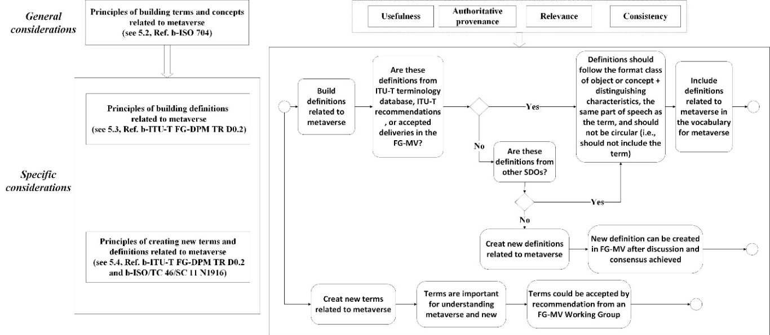

Figure 1 – Systemic relationship between the principles

## 6.2 Principles for building terms and concepts related to metaverse

1) Usefulness: All terms and concepts should be used by the Focus Group on metaverse (FG‑MV) working groups (WGs), task groups (TGs) and deliverables.

2) Authoritative provenance: Terms are adopted from clause 3 of FG-MV deliverables or recommended by FG-MV WGs or TGs.

3) Relevance: Each concept is related to the metaverse.

4) Consistency: FG-MV deliverables are preferred for the concept of terms. When multiple definitions of the same term appear in FG-MV deliverables, a consensus of "one term, one definition" should be reached in vocabulary for metaverse. Ensure that the concepts in FG‑MV deliverables are finally consistent with the concepts proposed by the vocabulary for metaverse.

## 6.3 Principles for building definitions related to metaverse

1) Definitions from the ITU-T terminology database or ITU-T recommendations or definitions from accepted deliverables in the FG-MV will take priority if they are appropriate and applicable. If more appropriate definitions exist from other Standards Developing Organizations (SDOs), they may be considered for discussion.

2) If there is no definition from ITU-T, then definitions from other SDOs will be the second priority for consideration.

3) Definitions should follow the format class of object or concept + distinguishing characteristics, the same part of speech as the term, and should not be circular (i.e., should not include the term).

## 6.4 Principles for creating new terms and definitions related to metaverse

1) If no definition exists, or if existing definitions are not appropriate to the metaverse, then a new definition can be created in FG-MV after discussion and consensus.

2) Even if a term appears only once in FG-MV deliverables, if it is important for understanding metaverse and is new, it may be accepted by recommendation from an FG-MV WG.

# 7 Conclusion

Although this Technical Report focuses on principles for building terms and concepts within the FG-MV, these principles may also be applied in similar environments outside it.

Bibliography

[b-ITU-T Editing Guidelines] Recommendation ITU-T (2023), *Author's guide for drafting ITU-T Recommendations.*   
<https://www.itu.int/oth/T0A0F000004/en>

[b-ITU-T FG-DPM TR D0.2] ITU-T FG-DPM TR D0.2 (2019), *Data processing and management for IoT and smart cities and communities: methodology for data processing and management.*  
<http://handle.itu.int/11.1002/pub/813b0844-en>

[b-ISO 704] ISO 704:2022, *Terminology work — Principles and methods*.

[b-ISO 1087] ISO 1087:2019, *Terminology work and terminology science — Vocabulary.*

[b-ISO/TC 46/SC 11 N 1916] ISO/TC 46/SC 11 N 1916 (2020), *Terminology consistency guidance for convenors and project leaders*.

______________