Standardization Sector
ITU Focus Group Technical Report
(07/2023)
ITU Focus Group on metaverse
Exploring the metaverse: opportunities and challenges
Working Group 1: General
ITUPublications | International Telecommunication Union

ITU FG-MV Technical Report D.WG1-01
Exploring the metaverse: opportunities and challenges
Summary
This Technical Report explores the opportunities and challenges, and clarifies the role of international standards and the potential for the metaverse in the achievement of the United Nations Sustainable Development Goals.
Keywords
Digital transformation, interoperability, metaverse.
Note
This Technical Report is an informative ITU-T publication. Mandatory provisions such as those found in ITU-T Recommendations lie outside the scope of this Technical Report, which should only be referenced bibliographically in ITU-T Recommendations.
Change log
This edition contains Version 1.0 approved at the second meeting of the ITU Focus Group on metaverse (ITU-T FG-MV), held 2023-07-04/06 in Shanghai, China.
Acknowledgements
This Technical Report was researched and written by Leonidas Anthopoulos (University of Thessaly, Greece) as a contribution to the ITU Focus Group on metaverse (ITU-T FG-MV).
Special thanks to Xiaomi An (Renmin University of China, China), Younghwan Choi (Electronics and Telecommunications Research Institute (ETRI), Korea (Rep. of)), Radia Funna (Build n Blaze), Hideo Imanaka (National Institute of Information and Communications Technology (NICT), Japan), Hlekiwe Kachali (UNICEF), Ryotaro Matsuoka (Ministry of Internal Affairs and Communications, Japan), Pilar Orero (Universitat Autònoma de Barcelona (UAB), Spain), Sophia Papathanasopoulou (Ministry of Digital Governance, Greece), Andrey Perez (Agência Nacional de Telecomunicações (ANATEL), Brazil) and Junichiro Tobe (Ministry of Internal Affairs and Communications, Japan), for their helpful reviews and contributions.
Additional information and materials relating to this report can be found at: https://www.itu.int/go/fgmv. If you would like to provide any additional information, please contact Cristina Bueti at tsbfgmv@itu.int.

Editor: | Leonidas Anthopoulos  University of Thessaly  Greece | E-mail: lanthopo@uth.gr

© ITU 2024
Some rights reserved. This publication is available under the Creative Commons Attribution-Non Commercial-Share Alike 3.0 IGO licence (CC BY-NC-SA 3.0 IGO; https://creativecommons.org/licenses/by-nc-sa/3.0/igo). For any uses of this publication that are not included in this licence, please seek permission from ITU by contacting TSBmail@itu.int.
Table of Contents
Page
1 Scope 1
2 References 1
3 Definitions 1
3.1 Terms defined elsewhere 1
3.2 Terms defined in this Technical Report 1
4 Abbreviations and acronyms 2
5 Conventions 2
6 Background 2
6.1 A brief history of the metaverse 2
6.2 A metaverse or multiverse (metaverses) 3
6.3 Market value 4
6.4 Development stages of the metaverse 5
7 Challenges 6
8 Opportunities 7
8.1 Digitalized lifestyle for inhabitants in the metaverse 8
8.2 Industrial metaverse for vertical industries 9
8.3 Accelerating digital transformation for cities and communities through the metaverse 11
9 The key elements of the metaverse 16
9.1 Underlying technologies 16
9.2 Regulations and economic competitions 18
10 The role of international standards 18
11 Metaverse for SDGs 20
12 Conclusion 21
Bibliography 22

ITU FG-MV Technical Report
Exploring the metaverse: opportunities and challenges

1 Scope
This Technical Report explores the background, including the history, of the metaverse, the ecosystem and its development stages, challenges and opportunities. It also examines the role of international standards and how the metaverse can accelerate the achievement of the sustainable development goals (SDGs). It aims to explore the role of the metaverse in accelerating digital transformation and achieving the SDGs. This Technical Report includes a set of examples showing how the metaverse has been, or could be, used in transforming different sectors. It also explores the role of international standards in ensuring a safe, inclusive and interoperable metaverse.

2 References
None.

3 Definitions

3.1 Terms defined elsewhere
This Technical Report uses the following terms defined elsewhere:
3.1.1 artificial intelligence
3.1.1.1 artificial intelligence (AI) [b-ITU-T M.3080]: Computerized system that uses cognition to understand information and solve problems.
3.1.1.2 artificial intelligence [b-ISO/IEC 2382]: Interdisciplinary field, usually regarded as a branch of computer science, dealing with models and systems for the performance of functions generally associated with human intelligence, such as reasoning and learning.
3.1.2 augmented reality (AR) [b-ITU-T P.1320]: An environment containing both real and virtual sensory components. The augmented reality continuum runs from virtual content that is clearly overlaid on a real environment (assisted reality) to virtual content that is seamlessly integrated and interacts with a real environment (mixed reality).
3.1.3 digital twin [b-ITU-T Y.4600]: A digital representation of an object of interest.
3.1.4 Internet of things (IoT) [b-ITU-T Y.4000]: A global infrastructure for the information society, enabling advanced services by interconnecting (physical and virtual) things based on existing and evolving interoperable information and communication technologies.
3.1.5 interoperability [b-ITU-T Y.101]: The ability of two or more systems or applications to exchange information and to mutually use the information that has been exchanged.
3.1.6 mixed reality (MR) [b-ITU-T P.1320]: An environment containing both real and virtual components that are seamlessly integrated and interact with each other in a natural way (one end of the augmented reality continuum).
3.1.7 virtual reality (VR) [b-ITU-T P.1320]: An environment that is fully generated by digital means. To qualify as virtual reality, the virtual environment should differ from the local environment.

3.2 Terms defined in this Technical Report
None.

4 Abbreviations and acronyms
This Technical Report uses the following abbreviations and acronyms:
3D three-Dimensional
AI Artificial Intelligence
AR Augmented Reality
ICT Information and Communication Technology
IoT Internet of Things
MR Mixed Reality
NFT Non-Fungible Token
SDG Sustainable Development Goal
SDO Standards Development Organization
VR Virtual Reality

5 Conventions
None.

6 Background
The concept and characteristics of the metaverse have been discussed widely since its initial appearance. Many attempts to define the metaverse have been made but there is no internationally agreed-upon definition, although we should bear in mind that the metaverse is still in its initial stage of development.
Industries and governments have already started experimenting with metaverse projects; however, many technological and regulatory challenges still need to be addressed. It is difficult to predict where the metaverse will go in the future. However, there is a growing consensus that the metaverse has the potential to be a major paradigm shift in how we interact with technology and with one another.

6.1 A brief history of the metaverse
The metaverse is a compound word comprising "meta" and "universe". [b-Stephenson] first used the term in the science fiction novel Snow crash, in which, the metaverse is described as a parallel virtual world that people could enter through an avatar representing the digital identity of a human's physical self.
Since then, the idea of the metaverse has been discussed for several decades, but with the development of digital technologies such as the Internet of things (IoT), digital twin, augmented reality (AR), virtual reality (VR), artificial intelligence (AI) and blockchain, the metaverse has moved from science fiction to research and is now in application. Table 1 shows a rough timeline of the key milestones in the development of the metaverse.
Table 1 – A timeline of the development of the metaverse
Year | Milestones
1992 | [b-Stephenson] coins the term "metaverse" in his novel, Snow crash. | Science fiction
1998 | Introduction of B-money, which was intended to be an anonymous, distributed electronic cash system. | Underlying technology
2002 | The concept of digital twin was first introduced and was envisioned for use to improve the design, operation and maintenance of complex systems. | Underlying technology
2003 | Linden Lab launched Second Life, an online virtual world that allows users to create their own avatars and interact with others | Game
2006 | Roblox, an online game platform, was launched. Players can customize their avatars, buy and sell virtual items, and interact with others. | Game
2009 | Blockchain technology was first introduced as the underlying technology for the cryptocurrency Bitcoin. | Underlying technology
2011 | Publication of [b-Cline], the futuristic novel Ready player one | Science fiction
2014 | Facebook acquires Oculus VR, a company that develops VR headsets. | Underlying technology
2015 | Decentraland, a virtual world platform built on blockchain technology, was launched. | Game
2016 | The concept of decentralized autonomous organization emerged. It is a type of organization running through smart contracts. | Underlying technology
2018 | [b-Cline] is adapted into a film, which popularizes the concept of the metaverse. | Science fiction
2020 | The COVID-19 pandemic accelerates interest in virtual events and remote work, leading to increased investment in the metaverse. | Industry interest
 | NVIDIA launches Omniverse, a platform for industrial metaverse applications. | Industry interest
2021 | Major tech companies announce plans to invest in and develop metaverse technologies.  Facebook rebrands its parent company as Meta.  Microsoft also launches Mesh as a metaverse platform service. | Industry interest
 | Seoul releases its 5 year metaverse plan.  Barbados announces its plan for a metaverse embassy. | Government
2022 | Dubai launches its metaverse strategy.  European Commission's plans on thriving in the metaverse.  Shanghai's action plan on metaverse.  Tuvalu plans to replicate itself in the metaverse. | Government
 | NVIDIA collaborates with Siemens to enable the industrial metaverse. | Industry
2023 | Several UN agencies delve into research and pilot projects of the metaverse.  ITU establishes a new Focus Group on metaverse. | United Nations
 | …

6.2 A metaverse or multiverse (metaverses)
One view is that there will be a universal digital platform, while another, the multiverse (metaverses), assumes that several available metaverse platforms interact simultaneously. As shown in Figure 1, metaverse and multiverse refer to virtual universes with close connections to and interactions with the real world, with the support of a set of digital technologies and information and communication technologies (ICTs), including AI, IoT, digital twin and blockchain. A metaverse can be considered as a collective space or a unified platform, while the multiverse (metaverses) has several integrated digital platforms and ecosystems that interact.
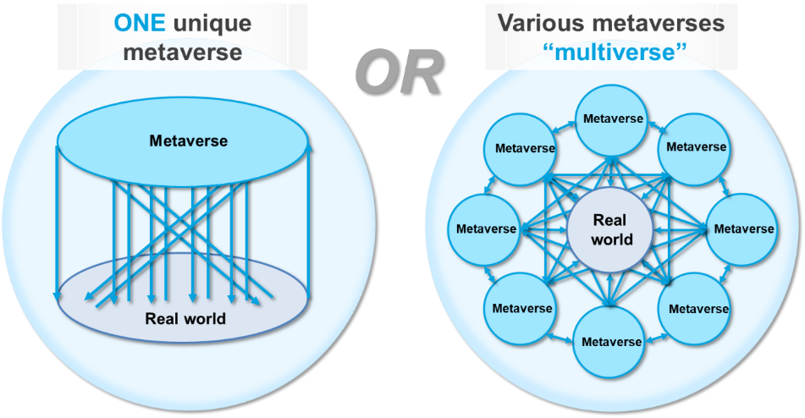
Figure 1 – Metaverse vs. multiverse
It is predicted that instead of one single metaverse, hundreds of often interconnected metaverses, such as those devoted to Industry 4.0 or entertainment, can be expected. In this sense, metaverses will act as a collective space, with interoperability as a key feature.

6.3 Market value
It is predicted that the metaverse market will grow in the upcoming years. Various sources have predicted that the metaverse will generate more than USD 1 trillion in annual revenue [b-Morgan]. According to [b-Zion Market Research], the metaverse industry is expected to grow at a compound annual growth rate of 39.5% from 2022 to 2028. [b-Kanterman] suggests that the total market value of the metaverse as the world's "next big technology platform" could reach USD 800 billion by 2024. [b-Statista] forecasts the metaverse market in 2030 in three scenarios: conservative (USD 1.91 trillion); moderate (USD 3.17 trillion); and optimistic (USD 4.44 trillion).
According to [b-McKinsey], 59% of consumers are excited about transitioning their everyday activities to the metaverse. [b-Gartner] predicts that 25% of people will spend at least 1 h per day in a metaverse in 2026. Considering the potential market opportunity and consumer interests, it appears clear that the metaverse is no longer science fiction but can become a game changer in the worldwide economy.
In addition, the development of the metaverse will not simply be led by large technology players. There is enough room for everyone driving innovation to create real value in this space. The metaverse is a complex system that involves a wide range of stakeholders. Companies and organizations from all spheres come together to build an ecosystem where people and businesses can interact, work, socialize, entertain and transact. The metaverse ecosystem is a complex, rapidly emerging market yet to be comprehensively mapped. It is constantly evolving and expanding. Figure 2 provides a non-exhaustive illustration of the current metaverse market [b-Newzoo]. Numerous companies will continue to appear and grow the metaverse ecosystem incrementally, creating real value for enterprises and consumers.
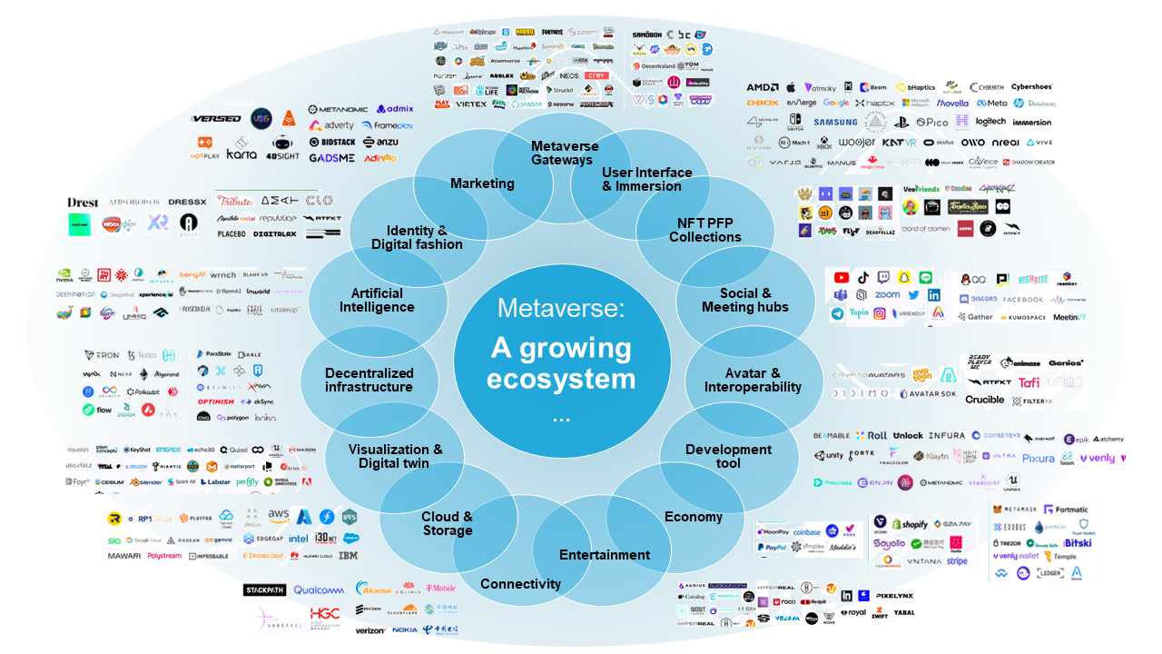
Figure 2 – Metaverse ecosystem diagram [b-Newzoo]

6.4 Development stages of the metaverse
The evolution of metaverse can be divided into stages: emerging, advanced and mature (as shown in Figure 3). The emerging stage sees progress in fundamental technologies, which provide network and computing capabilities, and enable the basic operation of single-industry applications. The metaverse is likely to stay in the emerging stage for some time. It has already been adopted in the entertainment industry, e.g., in games, virtual concerts and virtual museums. Work, education and social events could also encompass scenarios in this stage. The advanced stage focuses on connection of data, as well as cross-platform integration to deepen cross-industry scenarios. With further development in the technologies, along with the support of standards, regulations and laws, the metaverse is expected to enter the mature stage and be massively adopted in various sectors.
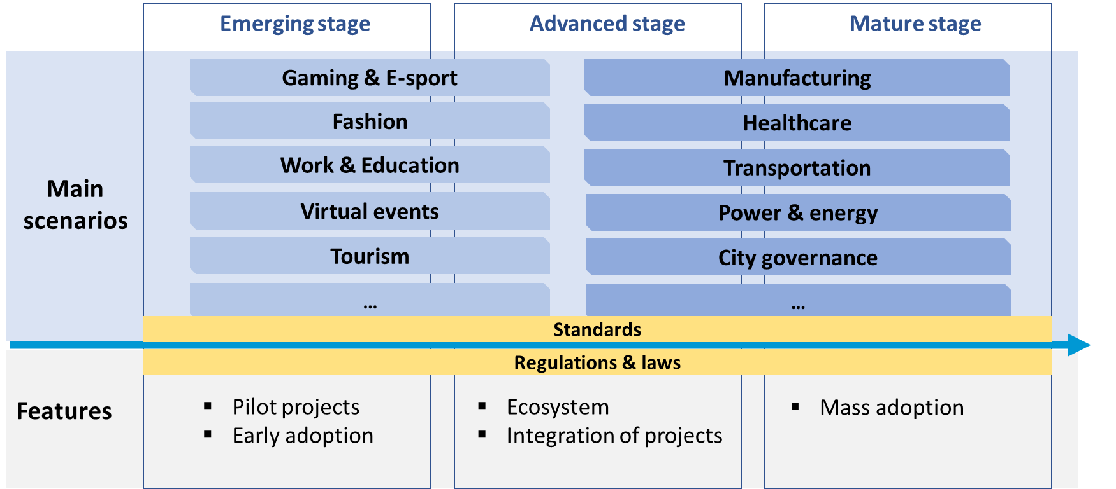
Figure 3 – Development stages of the metaverse

7 Challenges
Although there have been significant advancements in the metaverse, it is also facing various challenges. As of now, the metaverse is a grey area with the potential to be beneficial or harmful to those who engage in it. Given that the technology is still in its early stages and rapidly evolving, this creates new challenges. Figure 4 illustrates the challenges encountered in the metaverse, from interoperability and digital identity to sustainability and regulations.
Interoperability. The lack of interoperability and uniformity between the various metaverse platforms is a significant challenge – a unifying framework and protocol are needed to facilitate user movement between metaverses and devices.
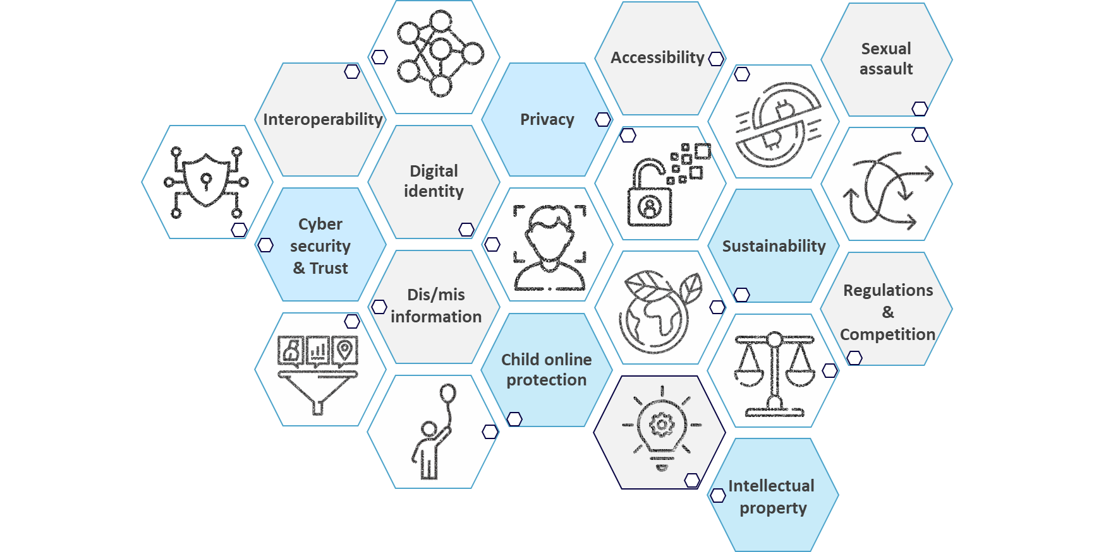
Figure 4 – Challenges facing the metaverse
Regulation. While the metaverse is a space that brings users together, it can also make them vulnerable if proper legislation and regulations are not established.
Competition. For the metaverse to flourish it needs to be built on a foundation that enables market competition of ideas and avoids dominance by a few companies.
Digital identity. In the metaverse, there are questions around how individual users can prove who they are. Aside from having issues related to ethics, there are challenges concerning identity authentication or verification.
Dis/misinformation. The metaverse ushers in a new set of challenges related to distributing false or malicious information. Unless regulated, the metaverse could become a dangerous tool of persuasion, promoting the spread of hate, harassment, and polarization.
Privacy. The metaverse poses a significant threat to privacy since every action, such as how you breathe, walk, think, move or stare, is captured. Data collection in the metaverse is involuntary and continuous, rendering consent almost impossible and raising privacy concerns. It is, therefore, critical, during this nascent phase, that the level of acceptable consent is determined and standardized based on various needs and considering the diverse range of participants (including child users), so that it is baked into implementation.
Accessibility. The metaverse can pose further complexities for many people, in particular the aged, those who are deaf or blind, or have limited vision. In addition, individuals with motor and dexterity impairments may have difficulty navigating the metaverse. Language and culture may also become barriers to metaverse access. Finally, those who have no access to the Internet are also at risk of exclusion from the metaverse; this could be for geographical or social reasons. All these are considered vulnerable groups; they are a very large section of the population and measures for their inclusion need to be addressed at the onset of any development. Interoperability with the equipment required for these groups to access the metaverse should also be taken into consideration by default since it can lead to a new digital divide.
Sustainability. Even though the metaverse is virtual, it impacts the environment. The metaverse draws far more electricity than previous online technologies; it will also increase data centre activity and corresponding carbon emissions. It is also important to note that continuous technology development can create an influx of e-waste.
Child online protection and other social challenges. There is concern that the metaverse will exacerbate the problems associated with social media. For instance, virtual environments create loneliness, and participants can be exposed to harmful content. The metaverse also poses a potential risk for children, including cyberbullying and a lack of privacy.
Sexual assault: Incidents of sexual assault have already been reported on metaverse platforms. There is a serious need for tech companies involved in developing the metaverse applications to address issues of sexual assault by introducing forms of moderation and systems to restrict this behaviour.
Intellectual property: The metaverse has the potential to create new forms of intellectual property such as virtual goods, digital assets, non-fungible tokens (NFTs), and experiences. It is important to ensure that these new forms of intellectual property are protected, and that their owners can profit from them.

8 Opportunities
With challenges comes opportunity, and while the metaverse is still being defined, literally and figuratively, there is the potential that it could unleash the next wave of digital transformation. As already seen, the metaverse has the opportunity to impact almost every sector and could drive a very different world over the next 10 years.
Recently, the metaverse has been used to develop new ICTs and digital technologies in customer-oriented and industrial scenarios. Additionally, cities and countries have been launching metaverse policies and pilot projects. As the technology continues to develop, more innovative and transformative applications of the metaverse are expected to appear.
Clauses 8.1 to 8.3 explore how the metaverse can be implemented in three key scenarios (see Figure 5): digitalized lifestyle for inhabitants; industrial metaverse for industries; and digital transformation for cities and communities.
Scenarios | Digitalized lifestyle  for  inhabitants | 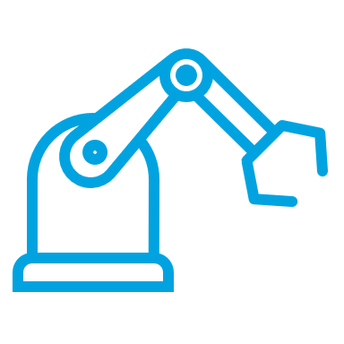  Industrial metaverse  for  industries | Digital transformation  for  cities and communities
Figure 5 – Three key scenarios of the metaverse

8.1 Digitalized lifestyle for inhabitants in the metaverse
A digitalized lifestyle scenario can be referred to as a virtual environment in which people can be present in digital spaces with the support of AR, VR, digital twin and other technologies. Specific scenarios include work, games, shopping, online learning, events and fitness activities.

8.1.1 Work
Remote work was adopted around the world during the COVID-19 pandemic. In terms of the job market, the percentage of workers working from home has increased rapidly, according to a survey from Enterprise Technology Research [b-Chavez-Dreyfuss]. By 2025, [b-Castrillon] estimates that 70% of the workforce will be working remotely for at least 5 days a month. On the one hand, remote workers are more efficient than previous expectations. On the other, people miss face-to-face collaboration, body language, etc. The metaverse can offer a virtual space to meet, collaborate and present in a more immersive way.
Example: Microsoft launch of Mesh
Microsoft launched Mesh for Microsoft Teams in 2021, which combined with its traditional products and services to support the future of work, collaborating virtually, training together anywhere, gaining remote expertise and designing together in three dimensional (3D) space.
As an example of practical application, Accenture, a global professional services company, has been on-boarding new employees via the virtual platform supported by Microsoft Mesh, One Accenture Park. In addition, thousands of Accenture staff have attended events in a virtual digital twin of its recently opened office.

8.1.2 Games or social interactions
The metaverse can offer a virtual space to meet, collaborate and present in a more immersive way. The concept of the metaverse was adopted in the games industry decades ago. Several gaming companies have been moving towards the metaverse, such as Epic Games, Roblox, Axie Infinity, Decentraland, Sandbox, Illuvium, Chain of Alliance, My Neighbor Alice, Krystopia and Alien Worlds. Digital technologies have significantly influenced social activities in recent years. With the advancement of AR, VR, cloud computing and other digital technologies, more immersive and interactive experiences can be realized in the metaverse.
Example: Santa Monica adoption of a metaverse project using a social app
Santa Monica is a beachfront city in western Los Angeles County, California, USA. The city is partnering with [b-FlickPlay], a social metaverse platform, to launch a play-to-earn metaverse mobile app, which will combine social media with gamification.
The mobile app will use VR and AR to build a digital layer of reality across restaurants, parks and businesses. Citizens can unlock collectibles and rewards to redeem for actual physical items at retail locations in the city.

8.1.3 Retail or fashion
AI, AR, digital twin and other metaverse technologies could offer an opportunity for new business models to enrich consumer experience and leverage virtual fashion. Many companies are setting up stores in the metaverse, such as Adidas, Burberry, Gucci, Tommy Hilfiger, Nike and Samsung. Nike has collaborated with [b-Roblox] to launch a virtual world called Niketown. Gucci has established its Gucci Garden in the Roblox gaming metaverse, which attracted 19 million visitors. The metaverse allows for 360° views through online showrooms and avatars of models and consumers. In addition, the metaverse has been used in digital collection with the support of NFTs, which provide a unique digital identifier that cannot be copied.
Example: Metaverse Fashion Week
The Metaverse Fashion Week was held on a [b-Decentraland], a decentralized virtual reality platform. The second Metaverse Fashion Week ran in March 2023 with the participation of luxury brands, household names, digital native designers and more than 10 000 visitors.
The Metaverse Fashion Week aimed to allow creators and designers to: broaden the scope of their creativity; offer opportunities for more audiences to access the brands; provide inclusive and personalized experiences for audiences; and allow visitors to try on clothes in a digital form.

8.1.4 Education
The metaverse can bring positive changes to education from several perspectives, e.g., immersive interactive experience, visualization and simulation of abstract theories, lower learning costs and risks, unrestricted time and space (such as the recreation of historical events), and personalization and engagement. According to a [b-PWC] survey, VR learners were four times faster to train than in the classroom. With the application of VR and other digital technologies, there will be a revolution in the education sector to change ways of teaching and learning and promote equality in educational resources for citizens in developed and less developed countries. Technology companies are working on the application of the metaverse in the area of education.
Example: Stanford University's Virtual People course
[b-Stanford] University's Virtual People course allows students to be fully immersed in VR environments. The Virtual People course was launched in 2003, and has been taught since, entirely in VR, owing to the advances in VR technology.
The course provides opportunities for students' avatars to experience and build applications from therapeutic medicine to sports training. The course examines the role of the metaverse in areas such as engineering, behavioural science and communication.

8.1.5 Events
Virtual concerts and events will be another application of the metaverse. The immersive and extensible nature of the metaverse offers unlimited space for ideas to hold an event. The metaverse also allows audiences to further engage and interact with each other and players in the events.
Example: SK Telecom staged free virtual concerts on its ifland metaverse platform
[b-SK Telecom] held the metaverse music festival on its ifland metaverse platform in 2022. It made use of hundreds of cameras filming from all angles to generate naturally moving 3D models in virtual reality. The festival featured several singers and an avatar group. Attendee avatars were allowed to float in the air around the hall.
SK Telecom is merging the metaverse technology with K-pop content aimed at generation Z. The company is also building cooperation with other telecommunication operators in this domain.

8.2 Industrial metaverse for vertical industries
The second scenario can be broadly called the industrial metaverse. According to a survey [b-Nokia], 50% of enterprises believe that the industrial metaverse will be a "real game changer". The metaverse arguably offers the greatest potential to sectors such as manufacturing, banking, healthcare, and transportation.

8.2.1 Manufacturing
The industrial metaverse can be applied to the manufacturing industry through an interplay among the technology of IoT, AI, digital twin, etc. The metaverse can be implemented in factories in the process of research and development, manufacturing, and operation and maintenance.
The industrial metaverse can enhance the interaction and collaboration between designers and stakeholders in the value chain at the research and development stage. The digital twin of the manufacturing process could support factories in monitoring and optimizing production and testing processes in real time. It can also improve security and work together without the barriers of distance. In terms of operation and maintenance, problems and risks can be captured and fixed before they arise with the support of metaverse technologies. It also offers a valuable tool for training and testing.
Example: Mercedes-Benz assembles Next Generation factories with the metaverse
Mercedes-Benz has announced that it is using the NVIDIA Omniverse platform to further digitalize its production process [b-Shapiro].
With Omniverse, Mercedes-Benz planners can access the digital twin of the factory to review and optimize the plant and synchronize plant locations anywhere in the world. The metaverse technologies can help this automaker reduce waste, decrease energy consumption and continuously enhance quality.

8.2.2 Tourism
Digital technologies have been implemented in the tourism industry for decades. With the onset of the COVID-19 pandemic, digital services were expanded in the tourism sector and virtual tourism advanced during the lockdown. A smart tourist destination is one that is innovative, consolidated on cutting-edge technological infrastructure, which guarantees the sustainable development of the tourist territory. It promotes accessibility for all and facilitates interaction and integration of the visitor with the environment, so increasing the quality of their experience in the destination and improving the quality of life of the residents [b-U4SSC]. The metaverse will further accelerate digital transformation to smart tourist destinations.
Example: Yabu opening of a Virtual Yabu in the metaverse
The Japanese city of [b-Yabu] opened its Metaverse Virtual Yabu in June 2022. The local government worked with an entertainment company in Japan, Yoshimoto Kogyo One, to build the virtual space. It recreated the city's tourism resources in the metaverse and plans to hold events that connect the virtual space and the real world in the future.
According to the Yabu Government website, Virtual Yabu allows users to see the remains of Akenobe Mine and enjoy the mining game. It also provides virtual experiences of other sightseeing spots. Users can access the metaverse with or without VR devices.

8.2.3 Banking
Most banking transactions have been moving online in recent decades. The metaverse offers an opportunity for banks to provide a more engaging experience, and differentiated products and services for customers. In addition, as one of the key technologies in the metaverse, blockchain also impacts the financial industry with new age transactions and lending.
Banks are already launching projects in the metaverse, e.g., KB Kookmin Bank in the Republic of Korea is building the KB Metaverse VR branch testbed where customers can access bank services in the metaverse via VR devices [b-Zelealem]. Another example is Shinhan Bank, which is working with Korea Telecom (KT) in a wide range of digital services. KT plans to integrate Shinhan's financial infrastructure into its metaverse platform and is exploring the possibility of integrating commercial real estate services [b-Wood].
Example: JPMorgan opening of a bank branch in the metaverse
JPMorgan opened a "lounge" in Decentraland in 2022, and thus became the first bank to establish a presence in the metaverse. The lounge shows the bank's blockchain accomplishments and videos of e-commerce and financial technology forum.
The company's ambitions are not limited to a virtual bank branch. According to its report on Opportunities in the metaverse, the virtual real estate market could start seeing banking services much like the services in the banks in the physical world, including credit, mortgages and rental agreements [b-Morgan].

8.2.4 Healthcare
On the health care metaverse, according to [b-Brown], 81% of healthcare executives surveyed worldwide say that they think the metaverse will impact their organizations positively.
Metaverse can be used to train healthcare professionals, including practising surgery on virtual patients and making training more accessible to students in remote areas. Telemedicine will be another key application for health care in the metaverse. According to [b-Marr], more than 90% of healthcare facilities can provide patients with remote consultations after 2020, and the metaverse will open new possibilities for remote consultations and treatments.
Moreover, those frontier technologies of the metaverse could allow professionals to peek inside patients' bodies to detect, diagnose and treat them. Furthermore, medical professionals could explore and determine the best possible procedure in the 3D virtual environment and use that information to improve the treatment.
Example: MeTAI ecosystem
A research paper published in Nature Machine Intelligence proposed a metaverse of 'medical technology and AI' (MeTAI), which can facilitate the AI-based medical practice, especially medical imaging-guided diagnosis and therapy: virtual comparative scanning (to find the best imaging technology in a specific situation); raw data sharing (to allow controlled open access to tomographic raw data); augmented regulatory science (to extend virtual clinical trials in terms of scope and duration); "metaversed" medical intervention (to perform medical intervention aided by metaverse) [b-Wang].

8.2.5 Transportation
The industrial metaverse can be implemented in the transportation area from two perspectives: providing an immersive metaverse experience to drivers and passengers, and providing transportation system operation and management platforms. The metaverse can enable a more intelligent, efficient and sustainable transportation network by leveraging digital twins of physical infrastructure and AI automation. Although the future of transportation in the metaverse is unclear, industries have already started to launch pilot metaverse projects, from vehicle manufacturing to transportation management.
Example: MTR enters the metaverse
Hong Kong's MTR Corporation announced its partnership with the Sandbox and became the first transport operator to enter the metaverse [b-MTR]. The MTR plans to build a virtual railway space such as a railway station and railway museum in the metaverse, and provide immersive experiences through gamification. The company has bought land in the Sandbox metaverse to build a virtual station as a replica of the physical railway station. The MTR aims to enhance the interaction with the community and seize opportunities that would be added to the real world.

8.3 Accelerating digital transformation for cities and communities through the metaverse
The third metaverse scenario is focused on cities and communities. By 2050, 70% of the world's population is expected to live in urban settlements. At the same time, cities account for between 60% and 80% of energy consumption and generate as much as 70% of human-induced greenhouse gas emissions [b-UN-Habitat]. The COVID-19 pandemic has accelerated the rise of virtual services and communities. The growth of digital experiences and the real-time virtual environment have laid the groundwork for the metaverse.
According to the UN Deputy Secretary-General's remarks at the High-level Meeting of the General Assembly on the Implementation of the New Urban Agenda, cities are engines of growth, innovation, culture and knowledge. Cities are generally where productive firms and key institutions are located and where innovative technologies and applications are developed and initially adopted, e.g., mobile Internet. Cities could provide an ideal platform for implementing these technologies to support the vision and development of the metaverse.
The metaverse could provide opportunities to improve urban design, increase citizen participation, improve operational efficiency, optimize energy consumption and enhance the capability of disaster and emergency management. It might even make changes to the forms of governance.
The metaverse will improve urban efficiency and generate new value to cities in the physical world. In addition, it will also enrich the physical experiences of citizens and create new virtual experiences.
Although the metaverse is still in its early stage, several cities have already identified the importance of this trend. Indeed, the metaverse has been pioneered in cities around the world. The metaverse has been mentioned in city development plans several times. Some cities have even launched metaverse plans to stay one step ahead and are prepared to enter the upcoming metaverse era. These plans and implementations of the metaverse will raise confidence for cities to move towards the metaverse.

8.3.1 The Republic of Korea aims to create its metaverse ecosystem
According to the Ministry of Science and Information and Communications Technology of the Republic of Korea, the country will spend at least USD 186.7 million to create its metaverse ecosystem, with the potential to create 1.5 million job opportunities [b-Chittum]. To support the development of the metaverse, the country also plans to produce more than 40 000 professionals specialized in this area. The government set four goals: activating the ecosystem for metaverse platforms; nurturing professionals; fostering companies; and establishing a safe environment for metaverse users.
The Republic of Korea emphasizes the following applications: arts; culture; education; K-pop; and tourism. It plans to establish a metaverse academy and organize metaverse development competitions to build a creative culture and encourage the participation of citizens and companies. The government will launch a new metaverse hub to provide space and facilities to support start-ups and provide financial support via a metaverse fund.
Additionally, the Electronics and Telecommunications Research Institute (ETRI), together with the Korea Information and Communication Technology Association, will start developing an ICT convergence standard framework for the metaverse [b-Kim].
Despite this support for technological development, the government plans to draft a set of ethical principles, and will create a pan-governmental body to review and revise related laws and regulations. The Korea Information Society Development Institute report, [b-KISDI], identified 10 principles for the future-oriented regulations of platforms in the metaverse era such as approaching all platforms on a case-by-case basis and joining the global efforts to harmonize regulations.
Seoul is the capital city of the Republic of Korea. In November 2021, the city launched a 5 year plan to build Metaverse Seoul [b-SMG]. Seoul aims to become the first city to enter the metaverse (see Figure 6). The plan involves seven areas: economy; education; tourism; communication; city; administration; and infrastructure. This 5 year basic plan has three stages as follows.
• Introduction stage in 2022: Establish the platform and introduce services, including those for the economy, education, tourism, public services, urban management, and conferences, complete the creation of the platform and showcase it to the public.
• Expansion stage in 2023 and 2024: Establish an online general civil service office. Once the virtual service office is completed, citizens may meet avatars of public officials, resolve their civil complaints and benefit from consultancy services without physically being present at the City Hall. Also, Seoul's famous tourist attractions will be created virtually on the platform as a "special zone for a virtual tour." Destroyed historical sites such as Donuimun will be reanimated in the virtual space.
• Settlement stage in 2025 and 2026: Further enhance the civil service and tourist services.
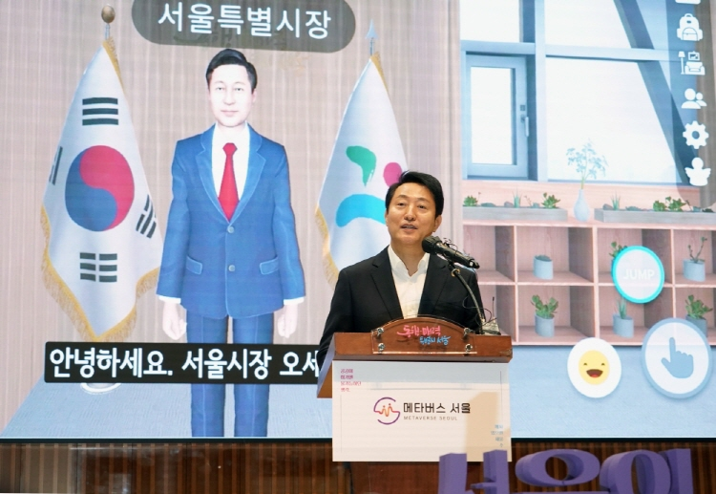
Figure 6 – Metaverse Seoul: Virtual municipal world

8.3.2 Dubai aims to become a global hub for the metaverse community
Dubai launched its metaverse strategy in July 2023, aiming to turn Dubai into one of the world's top metaverse economies, as well as a global hub for the metaverse community. The metaverse is expected to add USD 4 billion to annual GDP and 40 000 jobs to the country's workforce by 2030 [b-DFF].
The city plans to foster metaverse innovation and economic contribution, cultivate metaverse talent through education and training, develop metaverse use cases and applications in the Dubai Government, and adopt, scale and globally advocate for safe platforms. The metaverse strategy will focus on four key sectors, namely tourism, education, government services, and retail and real estate.
In addition to the strategic plan, some metaverse projects have been adopted in public service. For example, the Ministry of Health and Prevention launched a metaverse Customer Happiness Service Centre where citizens can request information, submit documents, pay fees, etc.
Dubai's strategy is also supported by governance and regulations to resolve concerns on issues such as security and privacy, to name but two. Dubai's Virtual Asset Regulatory Authority, which has been established recently, aims to empower investors and increase awareness about virtual asset services and products, and encourage innovation to promote real opportunity. It is a significant step towards regulating the expansive global virtual assets in the metaverse.

8.3.3 Chinese cities release policy documents promoting metaverse development
China has also noticed the opportunities in the metaverse. The China Mobile Communications Association created the Metaverse Industry Committee in December 2021, during the World Artificial Intelligence Conference, which took place in Shanghai. A metaverse experience hall was shown at the 2022 China International Fair for Trade in Services. In addition, several cities have released their action plans and other policy documents on the metaverse.
Shanghai is one of the biggest cities in China. The Shanghai City Department has released its 5 year development plan in electronic information manufacturing industry, which includes encouraging metaverse use in public services, business offices, etc.
[b-Cheng] mentions "encouraging the application of the metaverse in areas such as public services, business offices, social entertainment, industrial manufacturing, production safety and electronic games". It will promote the development of related metaverse technologies and businesses.
In July 2022, the Shanghai City Government released another policy paper on Shanghai's "Metaverse" New track action plan (2022–2025) [b-SMPG]. It aims to build the metaverse industry to CNY 350 billion by the end of 2025, and promote the city's digital transformation through building more than 50 pilot metaverse applications and more than 100 leading products and services. The strategy focuses on developing the technical infrastructure, cultivating metaverse applications and scenarios and building an innovative ecosystem. Key scenarios include new business, education, culture and tourism, entertainment, manufacturing, health, work and city governance.
The Fengxian district, a new suburban district in Shanghai, has become the first to launch a metaverse city hall. This project is a collaboration with a digital entertainment company based in Shanghai that aims to provide digital services to citizens in the future.

8.3.4 Barbados plans to launch the first metaverse embassy
Barbados is an island country in the Lesser Antilles of the West Indies, in the Caribbean region of the Americas. It plans to legally declare digital real estate sovereign land by establishing a metaverse embassy.
The Barbadian Ministry of Foreign Affairs and Foreign Trade signed an agreement with Decentraland, which provides a fully digital world, to establish this metaverse embassy. With the release of the embassy, Barbados will become the first country in the world to recognize digital sovereign land. As mentioned by His Excellency Mr Gabriel Abed, Ambassador of Barbados to the United Arab Emirates, establishing embassies in the metaverse could support more diplomatic missions for Barbados to achieve diplomatic parity and could save costs compared to the establishment of a physical embassy [b-Wyss].
The metaverse embassy for Barbados could empower developing countries to: gain diplomatic representation without vast budgets and infrastructure; create immersive virtual experiences for diplomats, investors and habitants; expand the reach of diplomacy to promote culture, tourism and investment to the world; and manage multiple diplomatic missions with non-resident ambassadors.

8.3.5 Europe's plan to thrive in the metaverse: People, technologies and infrastructure
The European Commission recognized that not one but many metaverses are being built and fosters the metaverse from three perspectives, people, technologies and infrastructure [b-EC]. It aims to build the metaverse centred on Europe's values and rules through developing standards, increasing interoperability and maximizing impact of different stakeholders.
To master the metaverse technologies, Europe is building an ecosystem based on existing capabilities in emerging technologies. The Virtual and Augmented Reality Industrial Coalition was launched in 2022, bringing together stakeholders from key metaverse technologies. In addition, construction of a more resilient connectivity infrastructure is expected to shape the metaverse.
A briefing [b-EP] analyses the policy issues on competition, data protection, liabilities, financial transactions, cybersecurity, health, and accessibility and inclusiveness.
In addition, a European Commission initiative, Global Gateway, has been launched to boost smart, clean and secure links in digital, energy and transport, and strengthen health, education and research systems worldwide [b-EC-GG]. The metaverse is being used to enhance the immersive experience.

8.3.6 The Pacific nation of Tuvalu is planning to upload itself to the metaverse
The world is undergoing severe climate change and urgent action is needed to address this. According to the Intergovernmental Panel on Climate Change [b-IPCC], there is high confidence that beyond 2040, and depending on the level of global warming, climate change will lead to numerous irreversible risks to natural and human systems. Cities, inhabitants and infrastructures will be put at high risk with further global warming. Climate change mitigation and environmental protection involve policymakers, government, civil society and the private sector.
The first step would be to raise awareness of this urgent issue. The metaverse, which makes a digital replica of the real world, with the support of a set of digital technologies and ICTs, can provide a platform to simulate and test city responses to any future climate change scenarios. In addition, cutting-edge frontier technologies such as AI, digital twin or robotics can contribute to mitigation. Metaverse, as an aggregate of these emerging technologies, could be used to analyse and simulate the impacts of climate change and test a set of action plans to combat climate change.
Responding to the existential threat of rising sea levels, Tuvalu launched Tuvalu's Future Now Project, a new initiative by the Ministry of Justice, Communication and Foreign Affairs, in 2021 [b-Tuvalu]. The country is planning to create a version of itself in the metaverse. It will create a digital twin of the country in the metaverse to preserve its nature and culture. The project aims to raise awareness of climate change. See Figure 7.
The metaverse presents a wide range of examples across different industries, and the potential for even more innovative applications is vast as the technology continues to develop.
Figure 7 – Tuvalu's foreign minister unveils plans to turn the country into a metaverse

8.3.7 Japan is preparing for the spread of metaverse in cities and communities
The potential market for metaverse is considered large, and one study predicts that its global value will reach USD 678.8 billion in 2030, about 17 times the 2021 level. Some potential problems that are not yet apparent could arise when there are many more users.
In August 2022, the Japanese Ministry of Internal Affairs and Communications (MIC) established the Study Group on the Utilization of Metaverse towards Web3 Era in order to examine use cases of metaverse and to identify such potential problems. The draft report, "Study Group on the Utilization of Metaverse towards Web3 Era,” compiled in June 2023, addresses the challenges of promoting metaverses in cities and communities, and proposes solutions [b-MIC]. In the future, the MIC plans to take the necessary measures to promote safe and secure metaverse based on the published report.
In May 2020, KDDI Corporation, Shibuya Mirai Design Corporation, and Shibuya Ward Tourism Association Corporation unveiled the Shibuya Ward Certified Virtual Shibuya, a reproduction of Shibuya, one of Tōkyō's most famous wards, on the Metaverse (see Figure 8). Taking advantage of this experience, the Virtual City Consortium established the virtual city guideline in April 2022, which is a private-sector guideline for urban-linked metaverse and guidelines for building metaverse [b-KDDI]. The following five items are discussed, and the results will be included in the virtual city guideline for the development of communication among users using avatars, user-centric search activities, and economic activities in cooperation with existing cities when constructing city-linked metaverse:
• activation of the creator economy;
• user generated contents copyright;
• avatar protection;
• avatar portrait rights and publicity rights;
• virtual properties.
Figure 8 – Shibuya Ward certified virtual Shibuya

9 The key elements of the metaverse
It is clear that in addition to the technical infrastructure, the metaverse also includes a range of social and economic structures. To facilitate a healthy development of the metaverse, underlying technologies, and regulatory and economic implications are both important.

9.1 Underlying technologies
Different models have been proposed by different organizations and individuals to organize the metaverse components, differing on emphasis and granularity. Examples are the metaverse ecosystem of [b-Deloitte], the five layers of the value creation model in [b-WEF], the seven layer model of [b-Radoff], and 10 layer model of [b-McKinsey]. Five core building elements, infrastructure, human augmentation, digital identity, economic enablers and ecosystem, have been introduced in ITU and the UNWTO Executive Briefing on metaverse [b-EBMV]. See Figure 9.
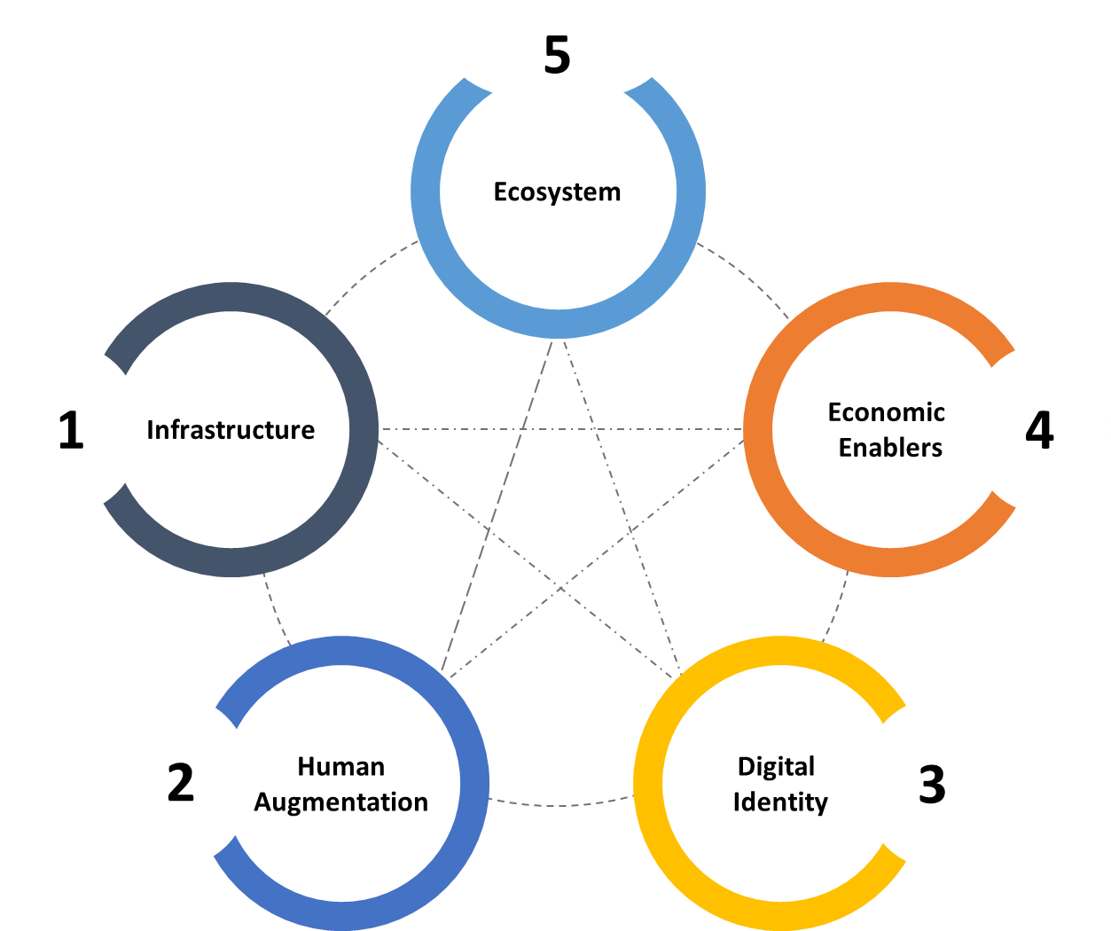
Figure 9 – Five elements model of the metaverse
Based on connectivity and computing infrastructure, users can access the metaverse and explore the virtual and physical worlds seamlessly with the support of human interfaces and various software and hardware platforms. Enabled by digital identity and decentralized finance technologies, the metaverse can provide various immersive experiences, creating profound impacts on the economy and on society by gradually fostering a new digital ecosystem. The five building elements of the metaverse consist of the following concepts and technologies.
• Infrastructure: networks and connectivity, computing power, graphic processing units, storage capacity, sensing or perception, cloud or edge infrastructure, semiconductor (chips or processors).
• Human augmentation:
– mobile devices: headsets (VR), smart glasses (AR), other wearables, haptics, holographic, brain-machine interface;
– creation platform: interaction platform, content moderation platform, 3D design or modelling, game engines, AI or machine learning services, creator tools, search/visual search;
– asset: 3D interoperable assets, asset market.
• Digital identity: avatar, agent, multiuser and multitasking, social graphs, rating, social curation, security, privacy.
• Economic enablers: decentralized, blockchain, cryptocurrency, NFT, commerce, advertising, payment, transactions.
• Ecosystem: entertainment, shopping, education, games, e-sports, industrial applications, regulation, governance, ethics.

9.2 Regulations and economic competitions
As the metaverse continues to evolve and expand, there are increasing calls for regulation to ensure that its development and operation is safe, secure and ethical. However, regulating the metaverse is complex as it involves a wide range of stakeholders, including governments, industry players and users.
One of the main challenges is that the metaverse could be operated across multiple platforms and countries in a decentralized manner. However, most traditional regulatory frameworks are based on geographic boundaries and centralized authority, which may not be suitable for the metaverse. Another key area of concern for regulation is the issue of safety and privacy. As the metaverse involves large-scale data collection and processing, it is important to set regulation to ensure the safety, privacy and well-being of users. In addition, regulations on diversity and inclusivity are important to avoid the potential for the metaverse to exacerbate existing social and economic inequalities.
With the huge market opportunities, the metaverse is expected to become a major part of the digital economy in the future. One of the primary drivers of the metaverse economy is the creation and sale of virtual goods and services. These could include virtual real estate, digital assets, as well as digital experiences. Digital currency is also an important element in the metaverse. Many existing virtual platforms already have their own currencies, which can be used to purchase goods and services within the platform. The economy in the metaverse is likely to be complex and dynamic. Furthermore, its economy can interact with the real-world economy and affect the lives and livelihoods of people around the world. Regulations on consumer protection, anti-monopoly measures, intellectual property rights, digital currencies, taxation and other aspects will be needed to shape healthy and sustainably economic competitions in the metaverse.
Overall, regulating the metaverse will require a collaborative and multi-stakeholder approach that balances innovation and growth with the need for consideration of safety, security, ethics, sustainability, accessibility and equity.

10 The role of international standards
Interoperability will be essential to provide a seamless and immersive experience between metaverses. Several large technology companies have undertaken actions to create toolsets to design, build and operate their versions of the metaverse with some open standards. Still, it is difficult to relinquish their sense of proprietary ownership. As a result, widely recognized and freely accessible standards will be more effective for interacting and cooperating across different multiverses. By creating a set of standards for these multiverses, it will promote a faster and more secure environment for the sharing of content and data. It will stipulate the effective functioning of the metaverse, guaranteeing interoperability between different virtual worlds to provide a seamless user experience.
A new ITU-T Focus Group on metaverse (FG-MV) was established in December 2022 to work towards international technical standards for the metaverse, laying the groundwork for technical standards that can help create underlying technologies and business ecosystems (Table 2). The establishment of the Focus Group was supported by 193 ITU Member States and more than 900 companies, universities, research institutes, as well as international and regional organizations.
Table 2 – ITU-T Focus Group on metaverse
The Focus Group on the metaverse was established as an ITU-T Telecommunication Standardization Advisory Group (TSAG) in December 2022.
FG-MV provides an international collaboration platform for dialogue and aims to develop a roadmap for setting technical standards to make metaverse services and applications interoperable, enable a high-quality user experience, ensure security and protect personal data.
The FG-MV analyses the technical requirements of the metaverse in order to identify fundamental enabling technologies in areas from multimedia and network optimization to digital currencies, the Internet of things, digital twins and environmental sustainability.
To facilitate the discussion and collaboration, eight working groups have been established under the focus group as follows.
• Task Group – Collaboration
• Working Group 1 – General
• Working Group 2 – Applications and services
• Working Group 3 – Architecture and infrastructure
• Working Group 4 – Virtual/real world integration
• Working Group 5 – Interoperability
• Working Group 6 – Security, Data and personally identifiable information (PII) protection
• Working Group 7 – Economic, regulatory and competition aspects
• Working Group 8 – Sustainability, accessibility and inclusion
The focus group coordinates with governments, industry and academia, and collaborates with other standards development organizations (SDOs), as well the UN family, to establish an agreed foundation for open, inclusive and interoperable metaverse standards, which will ensure that the metaverse contributes to sustainable digital transformation for the benefit of all users.
Although the metaverse is still evolving, there are already some other organizations and initiatives working on developing standards and guidelines for the metaverse. Examples follow.
• The World Economic Forum (WEF) has launched an initiative to define and build the metaverse to develop and share actionable strategies for the creation and governance of the metaverse.
• The Metaverse Standards Forum has been established to provide a venue for cooperation between organizations and companies to foster the development of interoperability standards for an open and inclusive metaverse.
• SDOs: The Institute of Electrical and Electronics Engineers (IEEE) has established the Metaverse Standards Committee (CTS/MSC), Computer Society SAB SC Metaverse SG (MSG), etc. The International Organization for Standardization (ISO) and International Electrotechnical Commission (IEC) have also worked in this area, e.g., in the Joint Standardization Evaluation Group (JSEG) on the metaverse. The World Wide Web Consortium (W3C) has established an (Open) Metaverse Interoperability (OMI) Community Group.
The standardization landscape of the metaverse is still emerging, and will be important for stakeholders to work together to develop open, transparent, and interoperable standards that enable the growth and development of the metaverse.

11 Metaverse for SDGs
Digital inequality is clearly evident between urban and rural communities, among different socioeconomic groups, across less economically developed countries compared to their more economically developed counterparts, and between individuals with varying levels of education, disability and age. There is a critical need to ensure that the metaverse is developed in a way that builds an accessible, safe and secure space for all, leaving no one behind.
The metaverse has the potential to provide greater access and inclusivity across social boundaries. It is crucial to be mindful of the potential for widening the digital divide.
The 17 SDGs have been determined by the member states of the United Nations to find solutions to the challenges that concern humanity. The SDGs are fundamental, affecting our planet and society; cities, organizations and industry have been increasing awareness and driving change by employing various technologies. While the metaverse is still in its infancy, there is already potential to advance the SDGs. See Figure 10.
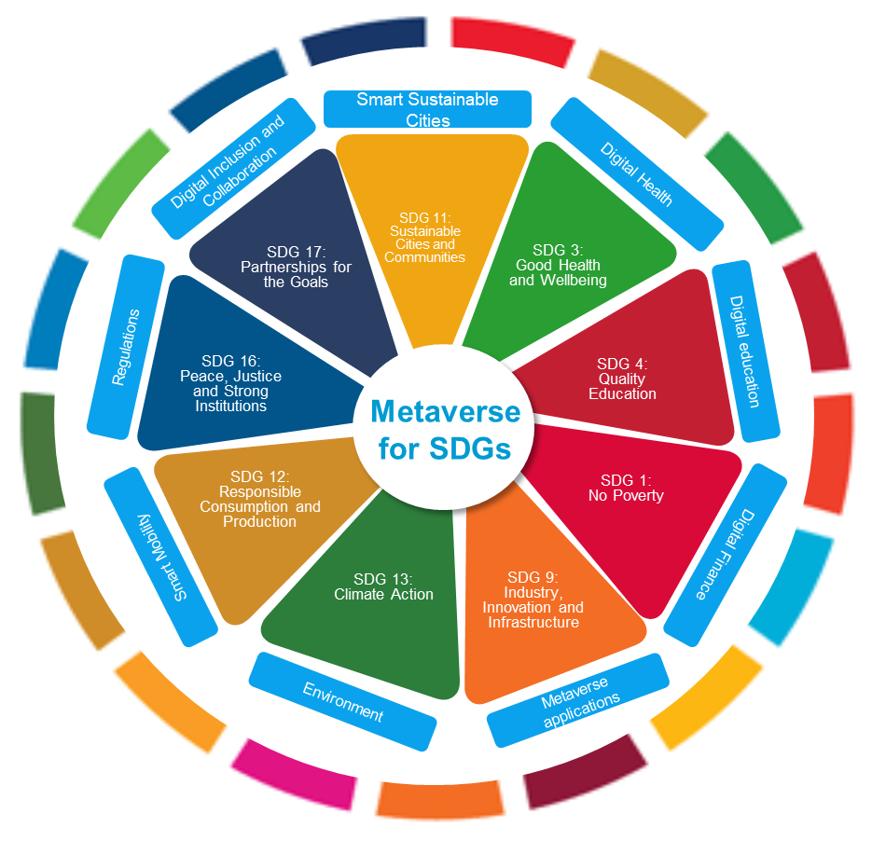
Figure 10 – Metaverse for SDGs
The metaverse could be harnessed effectively to transform and enhance education, improve the livelihood of inhabitants and generate income, provide access to public and private services, strengthen global cooperation and community building, boost citizen engagement, and enable new cooperative and collaboration models. Examples follow.
• SDG 1: No poverty. The metaverse can provide new opportunities for income generation and economic empowerment. It can also support skills development and entrepreneurship, enabling individuals to access new markets and increase their income.
• SDG 3: Good health and well-being. The metaverse can play a significant role in achieving this goal by enabling people to access health and wellness services, including virtual therapy and telemedicine. It can also facilitate access to health education and raise awareness about health-related issues. Additionally, it can provide a platform for research and development of new technologies and treatments to improve health outcomes.
• SDG 4: Quality education. The metaverse can support access to education and lifelong learning opportunities, particularly for people who are unable to attend in-person classes due to financial, geographic or other barriers. It can also promote greater inclusivity and diversity by providing a virtual space for people from different backgrounds to connect and collaborate.
• SDG 9: Industry, innovation and infrastructure. The metaverse can serve as a platform for innovation and experimentation. It has the potential to promote sustainable industrialization, foster innovation, and build resilient infrastructure.
• SDG 11: Sustainable cities and communities. The metaverse can contribute to sustainable urban planning and infrastructure by providing a platform for city planners and architects to test and refine their designs in a virtual environment before implementing them in the real world. This can lead to more efficient and environmentally friendly buildings and infrastructure.
• SDG 13: Climate action. The metaverse can provide a platform for sustainable virtual events and activities, reducing the need for physical travel and minimizing carbon emissions. It can also support education and awareness-raising campaigns on climate change and its impacts, promoting behaviour change towards more sustainable lifestyles.
• SDG 17: Partnership for the goals. The metaverse can contribute to achieving this goal by providing a platform for collaboration and knowledge sharing among diverse stakeholders. Additionally, it can facilitate cross-border communication and cooperation, supporting the implementation of sustainable development initiatives and the sharing of best practices.

12 Conclusion
While there is increasing interest in the development of the metaverse, it is important to acknowledge that the unfolding and ultimate shape of the metaverse remain uncertain at the time of publication. As with any new technology, the development of the metaverse raises important questions and considerations that will need to be addressed. It is important to continue to explore its potential and engage in dialogues and studies of the metaverse. ITU-T has entered the exploration phase of the metaverse and will continue to collaborate with various stakeholders to build the metaverse for the benefit of all and accelerate achievement of the SDGs.

Bibliography

[b-ITU-T M.3080] Recommendation ITU-T M.3080 (2021), Framework of artificial intelligence enhanced telecom operation and management (AITOM).
[b-ITU-T P.1320] Recommendation ITU-T P.1320 (2022), Quality of experience assessment of extended reality meetings.
[b-ITU-T Y.101] Recommendation ITU-T Y.101 (2000), Global information infrastructure terminology: Terms and definitions.
[b-ITU-T Y.4000] Recommendation ITU-T Y.4000/Y.2060 (2012), Overview of the Internet of things.
[b-ITU-T Y.4600] Recommendation ITU-T Y.4600 (2022), Requirements and capabilities of a digital twin system for smart cities.
[b-Brown] Brown, S. (2022). Want to improve healthcare access, experience and outcomes? Step into the metaverse. Dublin: Accenture.
[b-Castrillon] Castrillon, C. (2020). This is the future of remote work in 2021. Jersey City, NJ: Forbes. Available [viewed 2023-07-15] at: https://www.forbes.com/sites/carolinecastrillon/2021/12/27/this-is-the-future-of-remote-work-in-2021/?sh=4de622541e1d
[b-Chavez-Dreyfuss] Chavez-Dreyfuss, G. (2020). Permanently remote workers seen doubling in 2021 due to pandemic productivity: Survey. London: Reuters. Available [viewed 2023-07-15] at: https://www.reuters.com/article/us-health-coronavirus-technology-idCAKBN2772P0
[b-Cheng] Cheng, E. (2021). Shanghai doubles down on the metaverse by including it in a development plan. Englewood Cliffs, NJ: CNBC. Available [viewed 2023-07-17] at: https://www.cnbc.com/2021/12/31/shanghai-releases-five-year-plans-for-metaverse-development.html#:~:text=Shanghai%20doubles%20down%20on%20the%20metaverse%20by%20including%20it%20in%20a%20development%20plan,-Published%20Fri%2C%20Dec&text=A%20Shanghai%20city%20department%20released,business%20offices%20and%20other%20areas.
[b-Chittum] Chittum, M. (2022). South Korea to pour $187m into 'world-class metaverse ecosystem'. New York, NY: Blockworks. Available [viewed 2023-07-14] at: https://blockworks.co/news/south-korea-to-pour-187m-into-world-class-metaverse-ecosystem
[b-Cline] Cline, E. (2011). Ready player one. New York, NY: Broadway Paperbacks. 374 pp.
[b-Decentraland] Decentraland (2023). Metaverse Fashion Week, March 28-31. Beijing: Decentraland. Available [viewed 2023-07-15] at: https://events.decentraland.org/event/?id=0e430773-6315-40b6-9bcf-df0a9642d793
[b-DFF] DFF (2022). Dubai Metaverse Assembly – Assembly outcomes report. Dubai: PWC and Dubai Future Foundation. Available [viewed 2023-07-17] at: https://www.dubaifuture.ae/wp-content/uploads/2022/12/TheMetaverseAssembly-OutcomesReport-WP-English.pdf
[b-Deloitte] Deloitte (2022). Welcome to the metaverse. London: Deloitte. 40 pp. Available [viewed 2023-07-17] at: https://www2.deloitte.com/content/dam/Deloitte/ca/Documents/technology-media-telecommunications/ca-industry-tmt-welcome-to-the-metaverse-en.pdf
[b-EBMV] ITU, UNWTO (2023). Executive briefing on the metaverse. Geneva: International Telecommunication Union. 26 pp. Available [viewed 2023-07-17] at: https://www.itu.int/en/publications/Documents/tsb/2023-Executive-briefing-on-the-metaverse/index.html#p=1
[b-EC] EC (2022). People, technologies & infrastructure – Europe's plan to thrive in the metaverse I Blog of Commissioner Thierry Breton. Brussels: European Commission. 2 pp. Available [viewed 2023-07-17] at: https://ec.europa.eu/commission/presscorner/detail/en/STATEMENT_22_5525
[b-EC-GG] European Commission (2021). Global Gateway: Up to €300 billion for the European Union's strategy to boost sustainable links around the world. Brussels: European Commission. 3 pp. Available [viewed 2023-07-14] at: https://ec.europa.eu/commission/presscorner/detail/en/ip_21_6433
[b-EP] Car, P., Madiega ,T.A., Niestadt, M. (2022). Metaverse: Opportunities, risks and policy implications. European Parliament. 12 pp. Available [viewed 2023-07-17] at: https://www.europarl.europa.eu/thinktank/en/document/EPRS_BRI(2022)733557
[b-FlickPlay] Flickplay (2021). Downtown Santa Monica District gets fully immersed in AR with Flickplay. Flickplay. Available [viewed 2023-07-15] at: https://www.flickplay.co/post/grow-your-blog-community
[b-Gartner] Wiles, J. (2022). What is a metaverse? And should you be buying in? Stamford, CT: Gartner. Available [viewed 2023-07-14] at: https://www.gartner.com/en/articles/what-is-a-metaverse
[b-IPCC] IPCC (2022). Climate change 2022: Impacts, adaptation and vulnerability, IPCC sixth assessment report. Geneva: Intergovernmental Panel on Climate Change. Available [viewed 2023-07-17] at: https://www.ipcc.ch/report/ar6/wg2/
[b-ISO/IEC 2382] International Standard ISO/IEC 2382:2015, Information technology – Vocabulary.
[b-Kanterman] Kanterman, M., Naidu, N. (2022). Metaverse may be $800 billion market, next tech platform. New York, NY: Bloomberg Finance. Available [viewed 2023-07-14] at: https://www.bloomberg.com/professional/blog/metaverse-may-be-800-billion-market-next-tech-platform/
[b-KDDI] Asian News (2022). https://asianews.network/rules-for-metaverse-conduct-being-developed/. Available [viewed 2023-07-24] at: https://asianews.network/rules-for-metaverse-conduct-being-developed/
[b-Kim] Kim, Y.-J. (2022). ETRI to develop 'metaverse' standard guidelines in earnest '. Kurdo. Available [viewed 2023-07-17] at: www.kurdo.org/2022/04/28/etri-to-develop-metaverse-standard-guidelines-in-earnest/
[b-KISDI] KISDI (2021). KISDI publishes the 'Regulation of digital platforms in the age of the metaverse'. Chungcheongbuk-do: Korea Information Society Development Institute. Available [viewed 2023-07-17] at: https://www.kisdi.re.kr/eng/bbs/view.do?key=m2102103236440&bbsSn=113639
[b-Marr] Marr, B. (2022). The amazing possibilities of healthcare in the metaverse '. Jersey City, NJ: Forbes. Available [viewed 2023-07-16] at: https://www.forbes.com/sites/bernardmarr/2022/02/23/the-amazing-possibilities-of-healthcare-in-the-metaverse/?sh=2fb1215e9e5c
[b-McKinsey] Elmasry, T., Hazan, E., Khan, H., Kelly, G., Srivastava, S., Yee, L., Zemmel, R.W., editors (2022). Value creation in the metaverse: The real business of the virtual world. New York, NY: McKinsey. 77 pp. Available [viewed 2023-07-14] at: https://www.mckinsey.com/~/media/mckinsey/business%20functions/marketing%20and%20sales/our%20insights/value%20creation%20in%20the%20metaverse/Value-creation-in-the-metaverse.pdf
[b-MIC] MIC (2023). The Interim Report of the Study Group on the Utilization of Metaverse Towards Web3 Era (in Japanese). MIC. Available [viewed 2023-07-24] at: https://www.soumu.go.jp/main_content/000860618.pdf
[b-Morgan] Moy, C., Gadgil, A. (2022). Opportunities in the metaverse: How businesses can explore the metaverse and navigate the hype vs. reality. New York, NY: JPMorgan Chase. 17 pp. Available [viewed 2023-07-14] at: https://www.jpmorgan.com/content/dam/jpm/treasury-services/documents/opportunities-in-the-metaverse.pdf
[b-MTR] MTR (2022). MTR enters the Web3 era in partnership with Sandbox. MTR. Available [viewed 2023-07-24] at: https://www.mtr.com.hk/archive/corporate/en/press_release/JPR-2022-4-21-E.pdf
[b-Newzoo] Newzoo. 2022. Metaverse ecosystem diagram 2022. Amsterdam: Newzoo. Available [viewed 2023-07-14] at: https://newzoo.com/resources/blog/metaverse-ecosystem-infographic-2022
[b-Nokia] Nokia. 2022. 'Ready, set...metaverse!'.
[b-PWC] PWC (2017–23). What does virtual reality and the metaverse mean for training? London: PWC. Available [viewed 2023-07-15] at: https://www.pwc.com/us/en/tech-effect/emerging-tech/virtual-reality-study.html
[b-Radoff] Radoff, J. (2021). The metaverse value-chain. In: Building the Metaverse. San Francisco, CA: Medium. Available [viewed 2023-07-17] at: https://medium.com/building-the-metaverse/the-metaverse-value-chain-afcf9e09e3a7
[b-Roblox] Nike (2023). Nikeland. San Mateo, CA: Roblox. Available [viewed 2023-07-15] at: https://www.roblox.com/games/7462526249/NIKELAND-NEW
[b-Shapiro] Shapiro, D. (2023). Manufactured in the metaverse: Mercedes-Benz assembles next-gen factories with NVIDIA Omniverse; Premium automaker implements digital-first approach to production.Santa Clara, CA: NVIDIA. Available [viewed 2023-07-16] at: https://blogs.nvidia.com/blog/2023/01/03/mercedes-benz-next-gen-factories-omniverse/#:~:text=Manufactured%20in%20the%20Metaverse%3A%20Mercedes,digital%2Dfirst%20approach%20to%20production.&amp;text=Building%20state%2Dof%2Dthe%2D,of%2Dthe%20art%20planning%20system.
[b-SK Telecom] SK Telecom (2021). SKT Unveils New Metaverse Platform 'Ifland'. SK Telecom. Available [viewed 2023-07-24] at: https://www.sktelecom.com/en/press/press_detail.do?idx=1513
[b-SMG] Seoul Metropolitan Government (2021). Seoul to provide public services through its own metaverse platform. Seoul: Seoul Metropolitan Government. Available [viewed 2023-07-17] at: https://english.seoul.go.kr/seoul-to-provide-public-services-through-its-own-metaverse-platform/
[b-SMPG] Shanghai Municipal People's Government. 2022. 'Shanghai cultivates "Metaverse" New track action plan (2022-2025)'. Available [viewed 2023-07-24] at: https://www.shanghai.gov.cn/202214bgtwj/20220720/90aa73b046464b9c8799ef2339026d7d.html
[b-Stanford] Stanford University (2021). Stanford course allows students to learn about virtual reality while fully immersed in VR environments. Stanford University. Available [viewed 2023-07-24] at: https://news.stanford.edu/2021/11/05/new-class-among-first-taught-entirely-virtual-reality/
[b-Statista] Armstrong, M. (2023). Metaverse: The land of opportunity? New York, NY: Statista. Available [viewed 2023-07-14] at: https://www.statista.com/chart/29239/forecast-total-addressable-metaverse-market/
[b-Stephenson] Stephenson, N. (1992). Snow crash. New York, NY: Bantam Books. 440 pp.
[b-Tuvalu] Government of Tuvalu (2021). Future Now Project. Government of Tuvalu. Available [viewed 2023-07-24] at: https://dfa.gov.tv/index.php/future-now-project/
[b-U4SSC] United for Smart Sustainable Cities (2022). Smart tourism: A path to more secure and resilient destinations. Geneva: International Telecommunication Union. 74 pp. Available [viewed 2023-07-14] from: https://www.itu.int/hub/publication/t-tut-smartcity-2022-07/
[b-UN-Habitat] UN-Habitat (2019). The strategic plan 2020-2023. Nairobi: United Nations Human Settlements Programme. 83 pp. Available [viewed 2023-07-17] at: https://unhabitat.org/sites/default/files/documents/2019-09/strategic_plan_2020-2023.pdf
[b-Wang] Wang, G., Badal, A., Jia, X. Maltz, J.S., Mueller, K., Myers, K.J., Niu, C., Vannier, M., Yan, P., Yu, Z., Zeng, R. (2022).Development of metaverse for intelligent healthcare. Nat Mach Intell 4, 922–9.
[b-WEF] World Economic Forum, Accenture (2023). Demystifying the consumer metaverse. Cologny: World Economic Forum. 52 pp. Available [viewed 2023-07-17] at: https://www3.weforum.org/docs/WEF_Demystifying_the_Consumer_Metaverse.pdf
[b-Wood] Nick Wood (2022). KT Corp prepares Shinhan Bank for life in the metaverse. Telecoms. Available [viewed 2023-07-24] at: https://telecoms.com/512983/kt-corp-prepares-shinhan-bank-for-life-in-the-metaverse/
[b-Wyss] Wyss, J. (2021). Barbados is opening a diplomatic embassy in the metaverse. New York, NY: Bloomberg. Available [viewed 2023-07-17] from: https://www.bloomberg.com/news/articles/2021-12-14/barbados-tries-digital-diplomacy-with-planned-metaverse-embassy#xj4y7vzkg
[b-Yabu] Yabu (2022). Metaverse "Virtual Yabu" opened. Yabu. Available [viewed 2023-07-24] at: https://www.city.yabu.hyogo.jp/soshiki/kikakusomu/kikaku/metaverse/9581.html
[b-Zelealem] Fasika Zelealem (2021). South Korea's KB Bank enters metaverse space. Yahoo finance. Available [viewed 2023-07-24] at: https://finance.yahoo.com/news/south-korea-kb-bank-enters-121438920.html
[b-Zion Market Research] Zion Market Research (2022). Metaverse market to exhibit double-digit growth with CAGR of 39.5% over 2022–2028. Pune: Zion Market Research. Available [viewed 2023-07-14] at: https://www.zionmarketresearch.com/news/metaverse-market#:~:text=Over%202022-2028-,Metaverse%20Market%20To%20Exhibit%20Double-Digit%20Growth%20With,of%2039.5%25%20Over%202022-2028&text=According%20to%20Zion%20Market%20Research,US%24%20400.5%20billion%20in%202028.

_______________

