 |  | International Telecommunication Union
 |  | ITU-T | Technical Report
 |  | TELECOMMUNICATION  STANDARDIZATION SECTOR  OF ITU |  | (16 January 2020)
 | FG-NET2030 – Focus Group on Technologies for Network 2030
FG-NET2030-Sub-G1
Representative use cases and key network requirements for Network 2030

Summary
Towards the year of 2030 and beyond, many novel applications are expected to emerge as other applications mature, leading to increasingly intertwined human and machine communications. The new applications usually trigger new services and introduce challenging requirements that demand continuous evolution of networking technologies. Thus, the inherent capabilities of interconnected networks and the running principles therein need to be enhanced, or even replaced, due to these evolving requirements.
To help identify core network requirements and shape the future networks' design paradigm, this Technical Report summarizes some representative use cases for Network 2030 that have been well selected through group discussions within Sub-Group 1 of the ITU-T Focus Group on Network 2030 (FG NET-2030).
Specifically, this Technical Report presents in Part I the following seven use cases: holographic type communications (HTC); tactile Internet for remote operations (TIRO); intelligent operation network (ION); network and computing convergence (NCC); digital twin (DT); space-terrestrial integrated network (STIN); industrial IoT (IIoT) with cloudification. Their corresponding key network requirements are also stated.
In Part II, five overarching abstract requirement dimensions are proposed and scored relatively in order to compare the requirements of each use case. Through a clustering methodology these dimensions are also presented graphically. Based on this, the most prominent requirements of each case can easily be extracted, and their accumulated statistics are further shown to provide future network designers with a high-level perspective of the diverse dimensions foreseen as requirements of future use cases.
Finally, it is important to note that additional use cases and further details on the presented use cases can be found in the global set of contributions submitted to the ITU-T FG NET-2030 and are accessible in the SharePoint repository.

Keywords
Network 2030, network requirements, use cases.

Focal points

Bin Da  Huawei Technologies Co, Ltd,  Beijing, China | Tel: +86 10 82882144  Email: dabin@huawei.com
Marco Carugi  Huawei Technologies, European Research Center | Tel: +33 6 64047454  Email: marco.carugi@gmail.com

NOTE
This is an informative ITU-T publication. Mandatory provisions, such as those found in ITU-T Recommendations, are outside the scope of this publication. This publication should only be referenced bibliographically in ITU-T Recommendations.

© ITU 2020
All rights reserved. No part of this publication may be reproduced, by any means whatsoever, without the prior written permission of ITU.

Table of Contents

Page
Part I Representative use cases with key network requirements 3
I.1 Holographic type communications (HTC) 3
I.1.1 Use case description 3
I.1.2 Key network requirements 4
I.2 Tactile Internet for remote operations (TIRO) 4
I.2.1 Use case description 4
I.2.2 Key network requirements 5
I.3 Intelligent operation network (ION) 6
I.3.1 Use case description 6
I.3.2 Key network requirements 7
I.4 Network and computing convergence (NCC) 8
I.4.1 Use case description 8
I.4.2 Key network requirements 9
I.5 Digital twins (DT) 9
I.5.1 Use case description 9
I.5.2 Key network requirements 10
I.6 Space-terrestrial integrated network (STIN) 11
I.6.1 Use case description 11
I.6.2 Key network requirements 12
I.7 Industrial IoT (IIoT) with cloudification 12
I.7.1 Use case description 12
I.7.2 Key network requirements 13
Part II Use case requirement scoring and analysis 14
II.1 Graphic representations of the network requirements 14
II.2 Rationale for consideration of the five abstract requirement dimensions 16
II.3 Detailed analysis of the individual use cases 17
References 20

Figures and Table
Figure 1 – Comparison of human visual perception with 2D and 3D effects 3
Figure 2 – Types of 3D data transmission in HTC 3
Figure 3 – Two typical use cases for tactile Internet 5
Figure 4 – Automated and intelligent closed-loop control 7
Figure 5 – Edge cloud coordination based on network and computing convergence 8
Figure 6 – Example reference framework of a digital twin city 10
Figure 7 – Example of LEO satellites and terrestrial Internet integration 11
Figure 8 – Requirements of IIoT with cloudification 13
Figure 9 – Relative network requirement scores for the seven representative use cases – ball diameter graph representation 14
Figure 10 – Relative network requirement scores for the seven representative use cases – reverse spider graph representation 15
Figure 11 – Accumulated dimensional scores for the seven representative use cases 16

Table 1 – Abstract dimensions with relevant network requirements 14

TR-FG-NET2030
Representative use cases and key network requirements for Network 2030
Scope of this Technical Report
This Technical Report comprises two parts.
In Part I, seven representative use cases with their key network requirements are presented:
– Holographic type communications (HTC)
– Tactile Internet for remote operations (TIRO)
– Intelligent operation network (ION)
– Network and computing convergence (NCC)
– Digital twin (DT)
– Space-terrestrial integrated network (STIN)
– Industrial IoT (IIoT) with cloudification
Then, in Part II, five overarching abstract requirement dimensions are proposed and scored relatively in order to compare the requirements of each use case, graphically. The rationale for consideration of these abstract dimensions is stated in detail, as well as an analysis of each use case from the abstract dimension perspective.
Acronyms
AI Artificial Intelligence
AR Augmented Reality
BGP Border Gateway Protocol
CAPEX Capital Expenditure
CGH Computer-Generated Holograms
DT Digital Twin
DTC Digital Twin City
HMD Head-Mounted Display
HSI Human System Interface
HTC Holographic Type Communications
ION Intelligent Operation Network
IIoT Industrial IoT
IoT Internet of Things
IT Information Technology
LEO Low Earth Orbit
ML Machine Learning
NCC Network and Computing Convergence
OPEX Operational Expenditure
OT Operational Technology
PLC Programmable Logic Controllers
RIR Regional Internet Registries
STIN Space-Terrestrial Integrated Network
TIRO Tactile Internet for Remote Operations
VR Virtual Reality

Part I Representative use cases with key network requirements

I.1 Holographic type communications (HTC)

I.1.1 Use case description
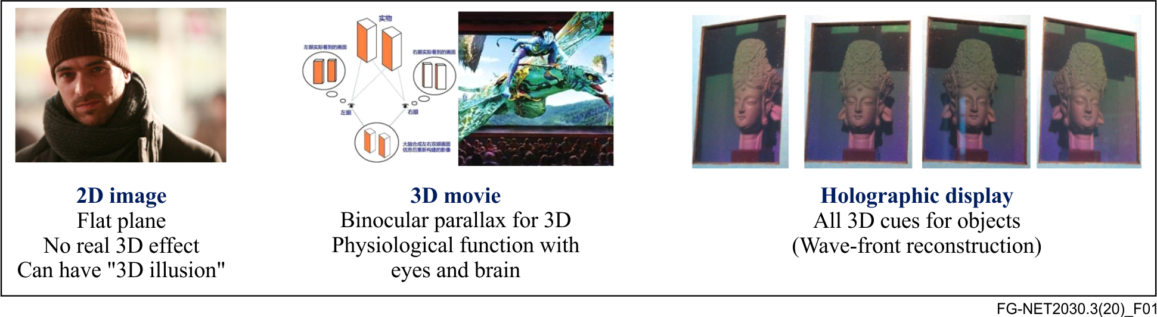
Figure 1 – Comparison of human visual perception with 2D and 3D effects
(Image sources from left to right: Paris (2008 film); Avatar (2009 film); Holographic photo in ISDH2012).
Figure 1 illustrates a simple comparison of the human perception of the visual effects for 2D images, traditional 3D movies using binocular parallax, and true holograms, respectively. It can be observed that the holographic display should satisfy all visual cues for the human observation of any 3D object, to appear as natural as possible [1]. In theory, holography is a method of producing a three-dimensional image of a physical object by recording, on a photographic plate or film. The pattern of interference is formed by a split laser beam and then illuminated either with a laser or with ordinary light by diffraction. Besides, such optical holograms can record the wavelength (colour) and intensity (amplitude) of light waves, as well as the phase of light waves (perception of depth). However, holography's technological foundation and ecosystem are presently not mature enough. In the next decade, the motivation of enabling fully immersive experience will lead to the adoption of lenslet light-field 3D through the naked-eye or indeed through augmented reality (AR) and virtual reality (VR) via head-mounted display (HMD) devices [2].
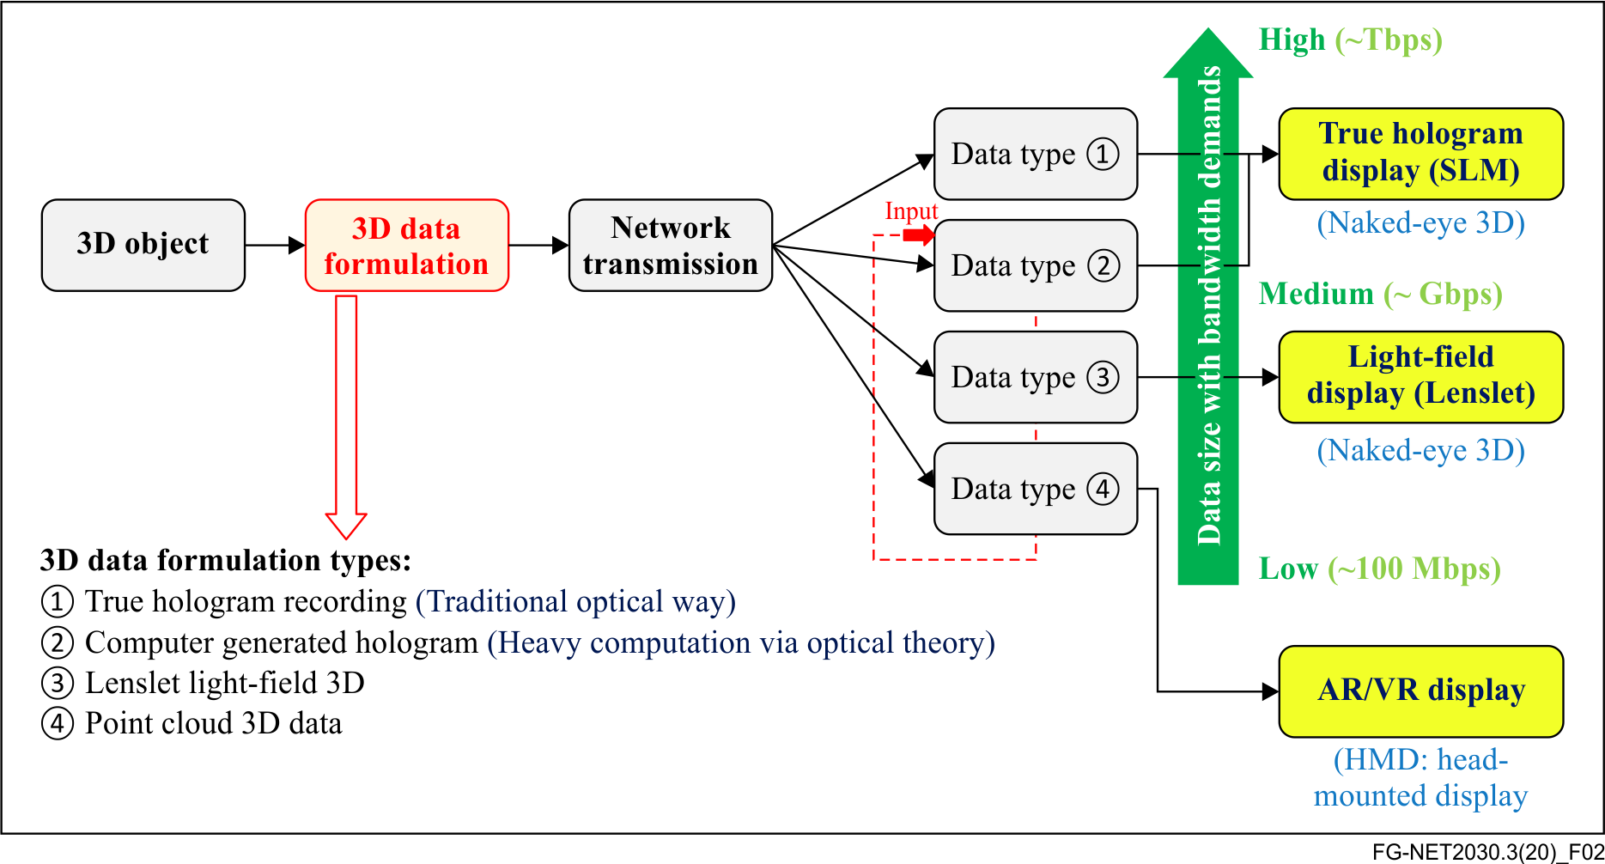
Figure 2 – Types of 3D data transmission in HTC
Holographic type communications (HTC) are expected to digitally deliver 3D images from one or multiple sources to one or multiple destination nodes in an interactive manner. It is foreseen that fully immersive 3D imaging will impose great challenges on future networks.
Figure 2 analyses four 3D data types that can be potentially transmitted for end-to-end HTC applications. True holograms will need extremely large data for recording and reconstruction, as will computer-generated holograms (CGH), where traditional holograms are digitized. Both potentially demand bandwidth up to Tbps level [3] for transmission. The lenslet light-field 3D uses many parallel views for observing 3D objects, and thus typically requires high bandwidth for data transmission, usually at the Gbps level. As demonstrated in holoportation scenarios [2], the AR/VR-based display with high definition resolution usually needs bandwidth at tens of Mbps level, while extreme AR/VR with much higher resolution demands bandwidth at Gbps level. Furthermore, point cloud 3D data, popularly used nowadays for 3D imaging, can serve as the input data of 3D models for a variety of 3D displaying methods such as CGH.
In addition to the bandwidth requirements, other network challenges for HTC are highlighted in the clause I.1.2.

I.1.2 Key network requirements
– Bandwidth: Based on the specific data formats used for different 3D holographic applications, for either perception by the naked-eye or HMD-assisted display, HTC bandwidth requirements could vary from tens of Mbps for entry-level point cloud transmission, to Gbps for highly immersive AR/VR and light-field 3D scenarios, and may further reach Tbps level for true hologram transmission at normal human-size [4] and [5].
– Latency: Ultra-low latency is crucial for truly immersive scenarios to alleviate simulator sickness, especially when HMDs are involved. Furthermore, applications involving real-time communications impose stringent latency requirements on the transmitted media streams. Additionally, the ability to adjust the quality of fields of view in the image array based on user interactivity depends on the network's ability to rapidly adjust streams with pre-defined response limit [6]. In the near future, HTC might also be further integrated with haptic sense data transmission [7], which confirms the latency requirement at sub-ms level (see also TIRO case in clause I.2).
– Synchronization: In order to support multi-party holographic communications or multi-master and single-slave control [8], multiple transmission paths or data streams with diverse geo-locations are expected to be synchronized appropriately with limited arrival time differences, usually at the level of ms time interval.
– Security: For many future applications, such as hologram-based remote surgical control, complete security should be guaranteed.
– Reliability: In HTC cases, reliability is also essential, especially when critical operations are accompanied.
– Computation: Hologram-based displays will often require high computational power to synthesize, render, or reconstruct 3D images before being visualised (for example CGH). Hence, edge computing close to the 3D data receiving endpoints and terminals is a key requirement for HTC.

I.2 Tactile Internet for remote operations (TIRO)

I.2.1 Use case description
The tactile Internet envisions the real-time control of remote infrastructure, creating a plethora of opportunities and opening new areas of applications within sectors such as Industry 4.0 or tele-medicine. Immersive video streaming applications, such as the aforementioned HTC 3D image streaming, will enable real-time and immersive interaction between a human operator and remote machinery.
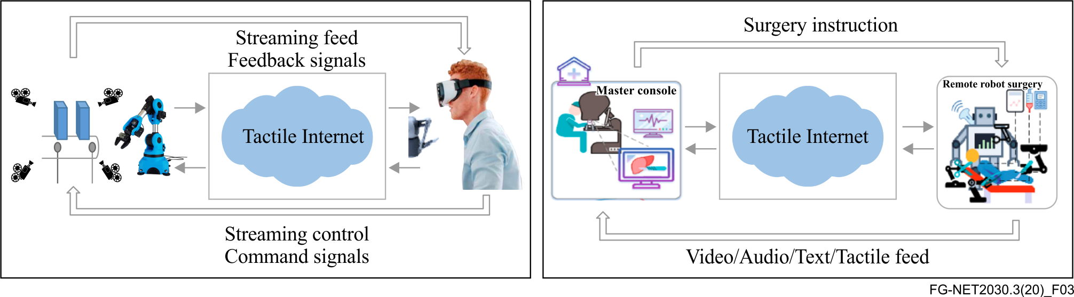
Figure 3 – Two typical use cases for tactile Internet
Two typical use cases for tactile Internet are illustrated in Figure 3. The first use case is remote industrial management that involves real-time monitoring and control of industrial infrastructure operations. Tactile sensors aid a remote human operator to control the machinery by means of kinaesthetic feedback. A crucial component of such operation between an operator and a machine is the real-time visual monitoring of the remote infrastructure, accompanied by haptic control. This can be provided by immersive audio-visual feeds, such as VR video streaming or other HTC-based streaming methods, together with haptic sensing data synchronization.
The second use case is remote robotic surgery. At the human system interface (HSI), a master console is installed, where the surgeon gets a real-time audio-visual feed of the patient and operating room, as well as feeds from additional data inputs, such as diagnostics and haptic senses. The visual feed is again provided by an HTC-type streaming technology, depending on whether the surgeon is wearing a head mounted device or interacting with a hologram. The surgeon then operates the haptic devices at the HSI and performs the surgical actions based on the real-time visual feed and the haptic information transmitted to the robot. Haptic feedback from the patient side must also be sent back to the surgeon.
Generally, these two use cases require the network to have very low (near zero) end-to-end network latency for real-time interaction, along with guaranteed high bandwidth to support the visual feed. They also necessitate strict synchronization between the various feeds to allow interactive control.

I.2.2 Key network requirements
– Bandwidth: Bandwidth is especially important in the case of remote monitoring as the increase in complexity of the visual feed (from a traditional 2D image, to 360° video, up to holograms) means that the bandwidth requirements grow drastically. For instance, bandwidths up to 5 Gbps might be required for VR feeds, increasing up to 1 Tbps for large sized holograms.
– Latency: Latency is most crucial for high precision applications such as those described in the above use cases (latency is expected to be ultra-low). The maximum delay that goes unnoticed by the human eye is about 5 ms. Moreover, for the operation to be smooth and immersive, the new paradigm even demands end-to-end latency at sub-ms level for instantaneous haptic feedback in tactile cases [9] and [10].
– Synchronization: The human brain has different reaction times to different sensory inputs, for example tactile (1 ms), visual (10 ms) and audio (100 ms) [10]. Thus, in tactile cases, the real-time feedback from hybrid sensory inputs, which possibly arise from different locations, must be strictly synchronized. Even in the presence of ultra-low latency, synchronization is important and needs to be significantly shorter than delay. Additionally, reaction time differences may necessitate differentiation, when allocating networking resources. The same application may even involve multiple streams, each with their own delay requirements.
– Security: During remote operations, data transmission security should be guaranteed, without being compromised, especially for critical tactile cases associated with human lives and high-value machinery.
– Reliability: In such critical applications, loss of information means loss of reliability of the system. Hence, data loss should be as minimal as possible (for example, robust signalling could be enabled for higher reliability). In addition, reliable (re-)transmission schemes should also operate within tolerable delays.
– Prioritization: The network should be capable of prioritizing streams based on their immediate relevance and criticality. Since visual feeds involve multiple views and angles for immersive media, the relevance of such different streams should be considered, with those of higher importance to the operator task at hand having a higher priority.

I.3 Intelligent operation network (ION)

I.3.1 Use case description
As networks become increasingly flexible and the complexity of network functions grows, the introduction of intelligent operation capabilities in future networks can be foreseen to be of great importance in order to efficiently provide a variety of intelligent services and applications.
In the scenario where we are monitoring a network for impairment (or potential impairment) for example, it is common that multiple sensors will be measuring numerous parameters and the key performance indicator is 'network health'. These sensors tend to measure independently of one another and are not always working together in a system wide manner. Thus, a comprehensive unified, multi-level, and deeply correlated analysis of measurements is needed to accurately pinpoint root causes of alarms and instantly invoke automatic recovery mechanisms.
In this use case, intelligent technologies such as artificial intelligence (AI) will play a key role in feature and pattern recognition [11]. It is envisaged that such technologies and models would be trained based upon historical data as well as learning (for example using neural network techniques) from live network operations and other statistics, to establish a human-brain like cognition to locate network malfunctions and faults accurately.
A fully automated and intelligent closed-loop control for ION-type applications could be achieved by a framework. As an example, Figure 4 illustrates one such framework with a four-core functional module implementation, including data measurement, data collection, intelligent control centre (i.e., centralized intelligent network-brain), and intelligent intervention capabilities.
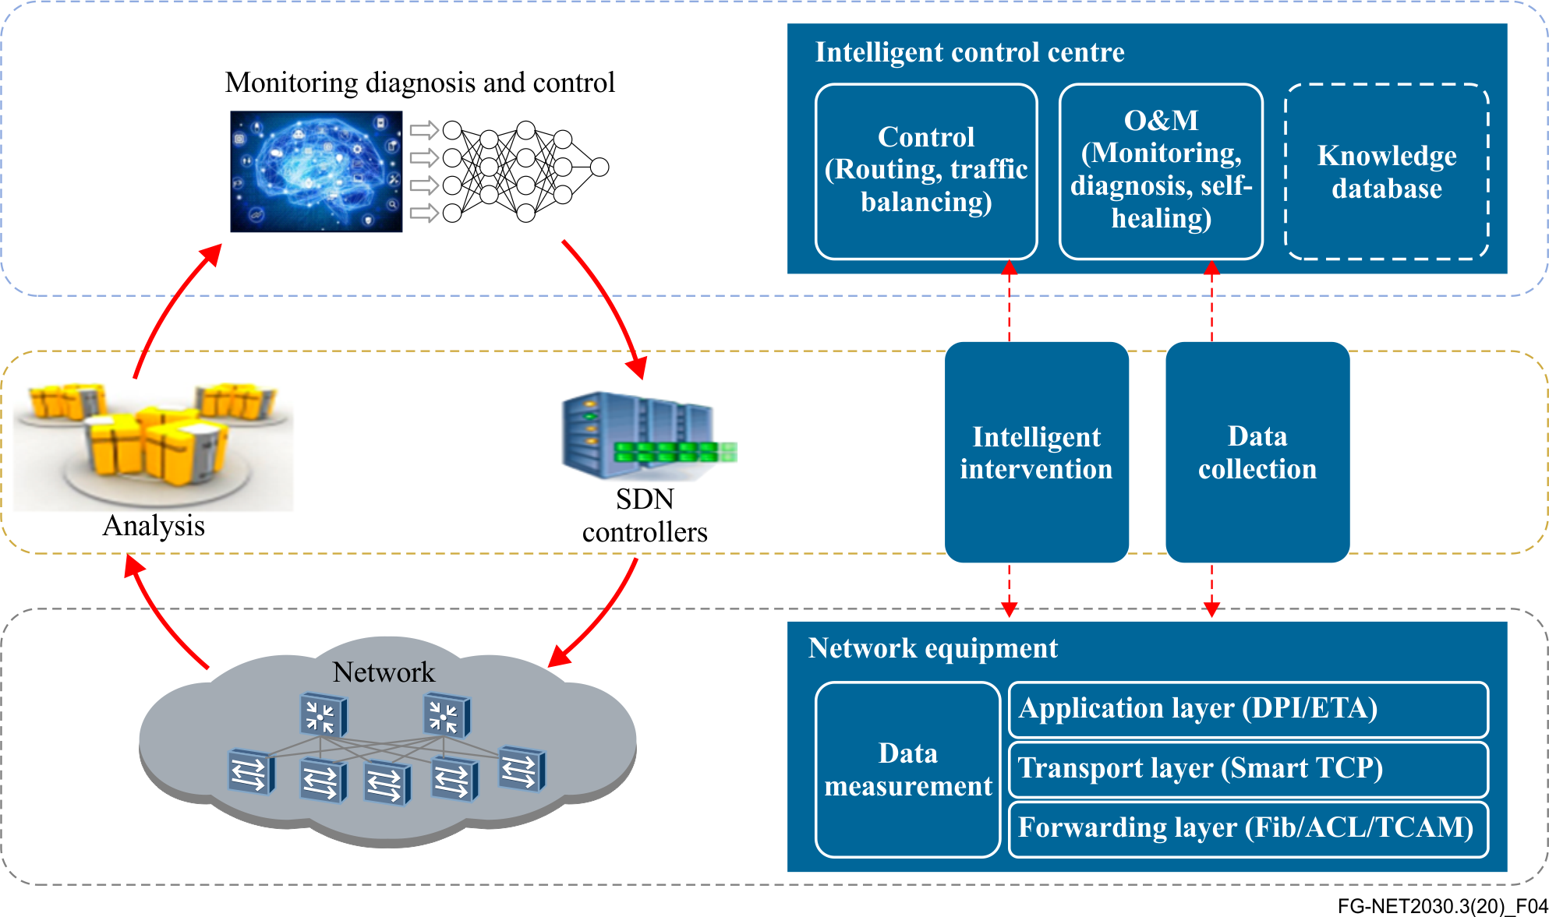
Figure 4 – Automated and intelligent closed-loop control

I.3.2 Key network requirements
– Low latency intelligent closed-loop control: This capability in future networks enables the advanced intelligent operations described previously. The network requires instantaneous collection of network statistics with low latency (in many situations, at ms or sub-ms level [12]), in order to perform real-time analysis with the assistance of DT-tailored algorithms. If analysis determines that there is a network impairment or an issue with optimization, intelligent management commands are dispatched immediately to enable network recovery or adjustment.
– Low latency event driven response with data prioritization: The network will need to report network monitoring information to the intelligent control functionalities from diverse discrete events (e.g., path changes, queue congestion, link breakage, etc.) to implement any intelligent remedial or optimizing actions. Such information should be given a higher priority, as a need for extremely low latency is expected, at millisecond level, to support ION applications.
– High-bandwidth instantaneous data collection for network status: To truly realise ION-powered networks and the required AI, training models will also require intelligent ways to transmit, store and compute the data required by ION-type applications. This implies that potential sub-functions related to, for example, network availability, utilization, throughput, congestion states (links, routers/switches), transfer paths for traffic, etc., should also considered.
– Programmability and softwarization: ION requires the network to have the capabilities of programmability and softwarization. The network should provide, on demand, programmable and customized data with relevant virtualized functions. Intelligent control functionalities can then (in closed-loop control) react with agility and at an even pace. In addition, the reported data should be well screened and structured to facilitate analysis by higher layer applications.

I.4 Network and computing convergence (NCC)

I.4.1 Use case description
Networking technologies have been developed and deployed over decades to meet the fundamental and ever-increasing requirements of connecting more and more things, people and services. The recent advent of cloud computing and network functions virtualization has resulted in the emergence of network cloudification. Furthermore, with the proliferation of edge computing, computing resources inside a network now extend from a centralized cloud to the network edge, providing almost ubiquitous computing power. However, the computing capability of a single network edge site is normally limited and cannot be flexibly expanded. Therefore, as shown in Figure 5, future networks may require multiple distributed network edge sites to interconnect and collaborate with each other. Orchestration capabilities that are computing aware may need to be supported.
On the other hand, from the perspective of current Internet applications, a serverless oriented micro-service model tends to gradually replace traditional client/server models. Based on new micro-service architectures, together with the availability of ubiquitous computing and storage capabilities throughout the network, individual network edge sites and nodes can become resource providers. As a result, diverse applications can dynamically schedule computing tasks to corresponding computing nodes at different locations according to specific service requirements, real-time network status, and real-time computing resource availability [13]. For example, when a client requests low-latency services, the network is enabled to dispatch the request to a nearest light-loaded edge site in order to obtain low-latency responses. If, however, a client requests computation-intensive services, the corresponding tasks may be scheduled to a distant cloud or edge site with high computing power instead.
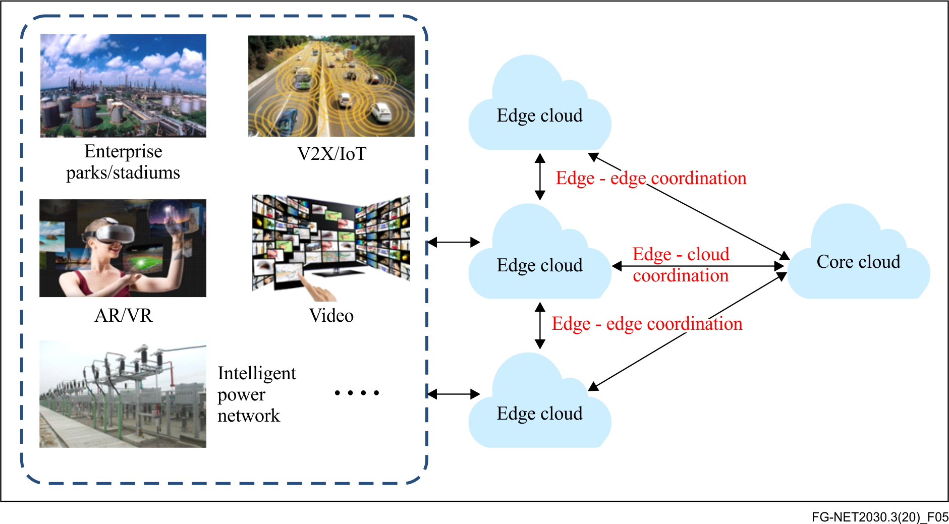
Figure 5 – Edge cloud coordination based on network and computing convergence
Emerging edge applications (for example, AR rendering, autonomous driving and HTC) are characterized by high mobility and other time-varying features. They may require one or more data centres to provide computing resources simultaneously in a coordinated way. In order to support intelligent load-balancing among multiple edge sites, future networks need to support computing-aware network capabilities, with unified management, control and operation in order to guarantee differentiated service experience with much higher granularity than in current networks.

I.4.2 Key network requirements
– Computing awareness: As networks and computing converge, future networks should support controllable in-time computing power allocation, including modelling, measuring, sensing, advertising and operation of computing power, with prescribed time limitations.
– Joint network and computing resource scheduling: Future networks should also support joint network and computing resource scheduling. There are two possible ways of performing such scheduling, either in centralized or distributed manners. These two methods can be appropriately utilized to serve as the foundation for agile allocation of computing power based upon diverse services' needs, real-time networking requirements and computing power distribution status.
– Network protocol programmability: The resources in future networks should be flexibly configurable, which means that network protocol fields with embedded features be highly programmable, for enhanced realization of NCC applications (e.g., the hybrid coordination of distinct services when there are limited resources). This capability should further satisfy other requirements, such as security, privacy, and deterministic delay, while programmability also needs a balanced consideration between protocol overhead and network efficiency. Thus, well-designed mechanisms for network protocol programmability in NCC should be devised.
– Flexible addressing: Based on ubiquitous computing resources, every network node can become a resource provider. Flexible addressing capability is thus needed in order to optimally address computing sites and to avoid wasting network resources.
– Distributed and intelligent network management for verticals: Taking advantage of ubiquitous computing resources, future networks should support intelligent management capability for every element in the network, enabling autonomic management, self-evolution and self-growth to meet the demand of vertical applications without manual intervention.
– Multiple access capability: To cope with the diversity of access modalities from various future computing services, it is expected that future networks support multi-access capability tailored for computing-aware services or (virtual and physical) endpoints. Such capability should be enabled on a large geographic scale with uniform quality of experience and service.
– Fast routing and re-routing: Future networks should support fast routing and re-routing of service traffic flows and computing tasks to the nearest or most available edge site, for real-time processing, under diverse conditions including user mobility, server load variations and other network constraints.

I.5 Digital twins (DT)

I.5.1 Use case description
A digital twin (DT) is usually defined as a real-time representation of a physical entity in the digital world. DTs will add value to traditional analytical approaches by improving situational awareness, and further enable better responses for physical asset optimization and predictive maintenance. Facilitated by vastly deployed DTs, the digital world and the physical world will also have the potential to be fully intertwined, contributing to formulate a new norm of DT-enabled cyber-physical world in the near future.
Digital twins can be applied to various scenarios with physical objects, including cars, buildings, factories, cities, environment, as well as processes and people. Among these scenarios, a digital twin city (DTC) is a case that exhibits typical features of the use of DTs [14]. To be more specific, a city is a complex system, composed of people, things, processes, and many events: through the adoption of DT relevant technologies, all the city facilities can be mapped to their DT counterparts, such as streets, communities, schools, hospitals, water supply systems, power systems, and even crowd activities and events. This allows city operators to model guideline strategies with potential tactics to deal with issues in the city before they occur. Figure 6 shows an example of a smart city system reference framework based on the DT paradigm, which interconnects the physical city with the virtualized city in the cyber world.
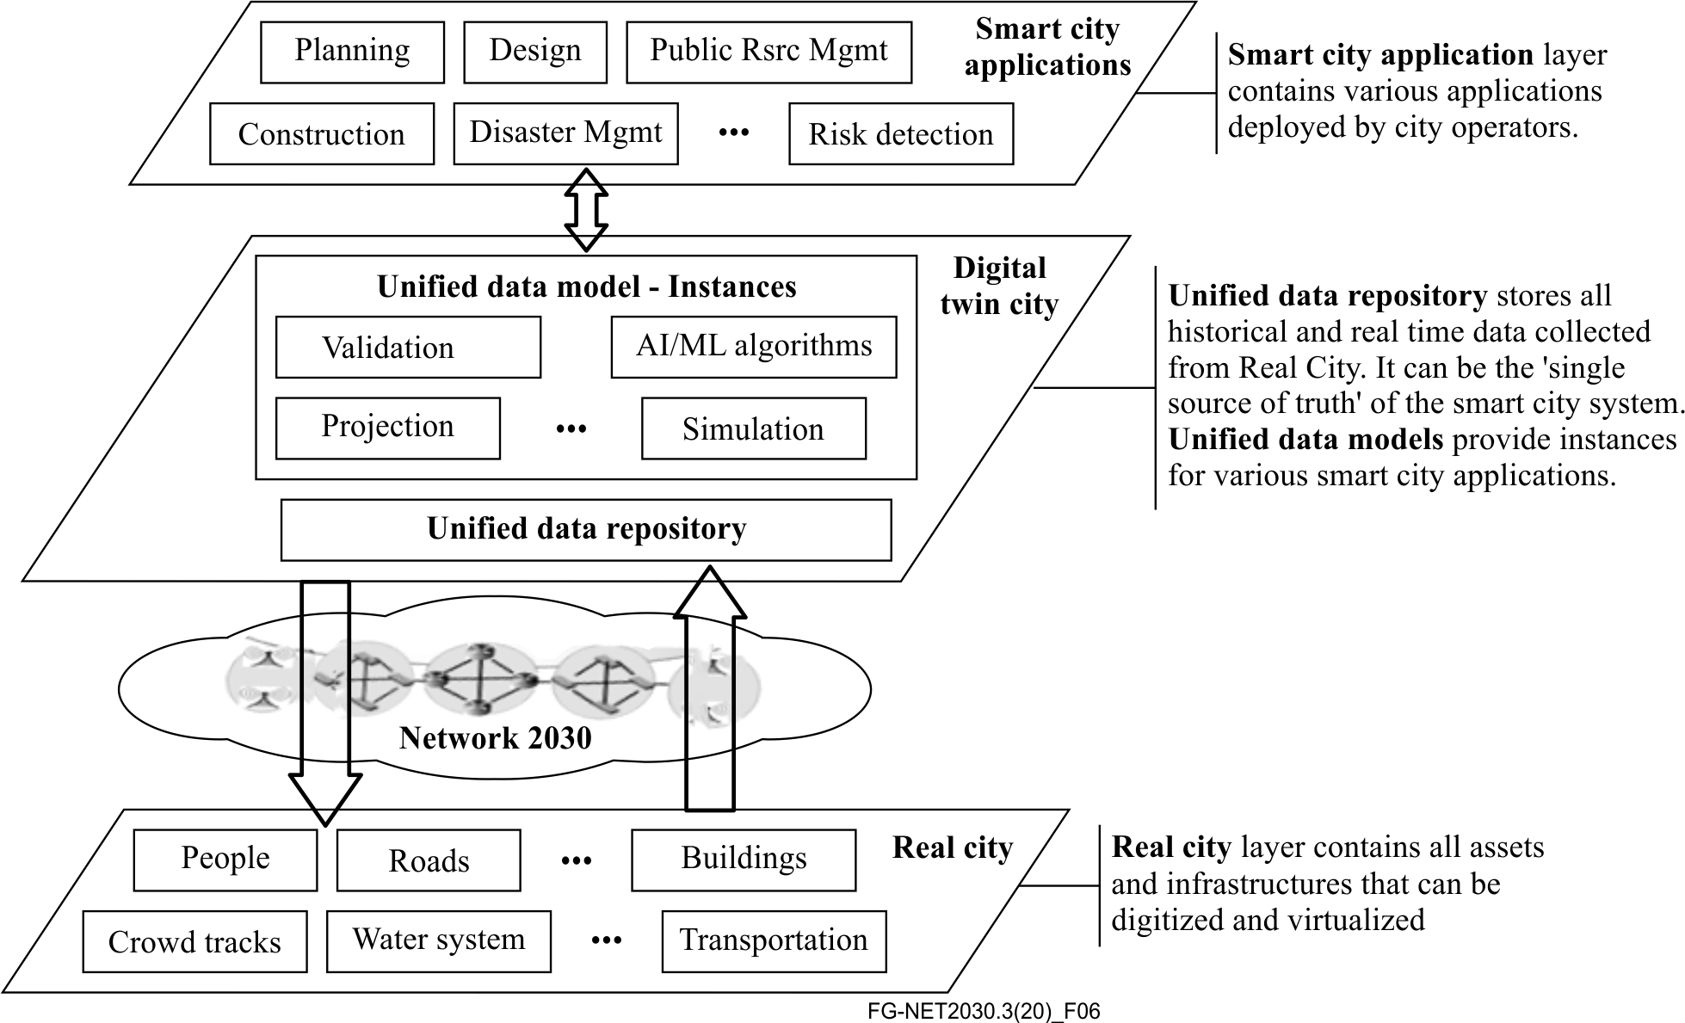
Figure 6 – Example reference framework of a digital twin city

I.5.2 Key network requirements
– Bandwidth: Virtualized objects in a DTC may generate extremely large amounts of data (it should be noted that, once the virtual model is mapped, subsequent changes may imply reduced amounts of data). In some cases, the sensory data exchanged between digitized objects or between physical and virtual objects, is quite small, however, in other cases, such as when AR/VR is used to visualize a large-size digital twin entity (e.g., buildings, factories, etc.) for data exchange, high bandwidth is required, similar to HTC. Furthermore, in the case of applying sensory entities for alarming, it demands a guaranteed bandwidth for instant low-volume data transmission with relatively high priority. Therefore, highly diversified bandwidth on-demand is a key network requirement for DTC.
– Latency: Empowered by DT technologies, city operators need to have timely responses for regular resource management, as well as mission critical applications such as emergency management. Data exchange between a DTC and a real city, needs to be as fast as possible, down to ms level in the case of critical services, hence requiring extremely low-latency data transmission [14].
– Mobility: In a DTC, some entities (e.g. buildings, water system) are static, whilst others (e.g., citizens, cars, subways) have high mobility or group mobility. Thus, the network needs to flexibly support mobility on-demand and virtualized entity transition in the DT world.
– Elasticity: In a DTC, different DTs may request different network resources to meet the requirements from different city applications. Moreover, some digital objects may request network resources only for temporary tasks. Thus, the network should be highly elastic to enable flexible resource scheduling.
– Security and privacy: Since most of the data in a DTC will be associated with citizens or public facilities in the real world, the information exchanges in the digital world must be secure enough to avoid attacks and must be well protected to maintain data privacy . Thus, new security frameworks (i.e., intrinsic security, binding with digital objects) and novel privacy protection mechanisms should emerge in order to achieve end-to-end security and privacy in an integrated cyber-physical world. Note that, a network serving a DTC could be a private network, logically or physically separated from the public network, for example in a factory of the future.
– Artificial intelligence (AI) for DTC operations: AI will play an increasingly important role in DTCs, as adoption of AI technologies to efficiently process large-scale heterogeneous data in emerging DT platforms grows. As examples, AI can be deployed to easily detect network attacks and quickly apply recovery strategies, as well as for achieving increased reliability through intelligent operations with full network automation in the DTC.

I.6 Space-terrestrial integrated network (STIN)

I.6.1 Use case description
This use case outlines a scenario of a future seamlessly integrated space and terrestrial Internet framework. In this example, the aim is to leverage inter-connected low earth orbit (LEO) satellites and other non-terrestrial networking nodes and platforms to build a parallel Internet network that can peer with its terrestrial counterpart. With such an integrated framework, the envisaged key benefits include: (i) ubiquitous Internet access at a global scale, including rural areas like oceans, deserts, as well as moving platforms such as ships and planes; (ii) enriched Internet paths that could lead to better data delivery performance compared to those over the terrestrial Internet determined by border gateway protocol (BGP) configurations across domains; (iii) ubiquitous edge caching and computing services provided by lightweight, on-board computing and storage resources on LEO satellites.
Compared to today's satellite network infrastructures, one essential aspect is that future mobile devices (e.g. smart phones, tablets, etc.) are able to directly communicate with the locally accessible LEO satellite, but without necessarily relying on traditional ground station infrastructures that are constrained by geographical distributions. Figure 7 provides a high-level illustration of the use case for space-terrestrial integrated network (STIN) [15].
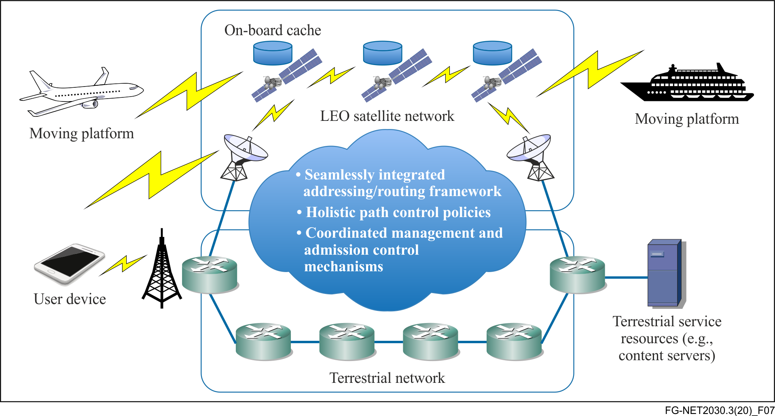
Figure 7 – Example of LEO satellites and terrestrial Internet integration

I.6.2 Key network requirements
– Flexible addressing and routing: Nowadays, allocation of IP prefixes is typically done through major Regional Internet Registries (RIRs) according to specific geographical locations. Consider the IP addressing issue on potentially thousands of LEO satellites with their constellations, the interoperations with the terrestrial Internet infrastructure will incur new challenges, as the IP addresses in space will dynamically interconnect to different domains (autonomous systems) on the ground with different IP prefixes. The new feature of allowing mobile devices to directly connect to local satellites also requires a cost-efficient addressing scheme for mobile devices to communicate with local satellites without necessary address translation operations. The IP addressing strategy will also have direct implications to the routing mechanism both within the LEO satellite network and across the network boundaries between it and the terrestrial network infrastructure. The mobility characteristic of LEO satellite network is that the movement of the satellites are dynamic but predictable. The vast majority of network links connecting them are statically configured, while a small number of links can be established and torn down on the fly when two satellites on different orbits meet/depart from each other. Thus, an integrated routing mechanism is highly demanded, with the consideration of unique features in STIN.
– Bandwidth capacity at the satellite side: Compared to the high-capacity fibre optical links that constitute the traditional Internet infrastructure backbone as well as cutting edge access networks, the links connecting LEO satellites in the space and terrestrial Internet infrastructure may become a significant bottleneck in terms of bandwidth capacity. In this scenario, the requirement is to increase the capacity in space, including peering links between satellites and also between satellites and ground stations or user devices in order to match the terrestrial capacity for future STIN-based applications.
– Admission control by satellites: In contrast to the traditional scenario where ground stations can be responsible for admission control on the traffic intended to be delivered through space Internet, allowing mobile devices to directly access satellite networks will need to lift the admission control function to individual satellites which will directly interface with these mobile devices. In this challenge, it is essential for each satellite (as the access point) to have the necessary knowledge about the traffic load in the space network in order to make admission control decisions.
– Edge computing and storage: The realisation of edge computing and storage capabilities will incur challenges, in particular the hardware requirements, on the LEO satellite side. For instance, the complexity of data/content processing at each satellite will be constrained by power or battery capabilities. Lightweight edge computing tasks are still possible, which can be enabled under such constraints. Edge content caching is another application scenario that can be supported by the LEO satellite network for improving user experience, thanks to reduced content access latency from the local cache in space. Similar to the edge computing scenario, content caching will be constrained by the data storage capacity that can be carried by each satellite [15].

I.7 Industrial IoT (IIoT) with cloudification

I.7.1 Use case description
Industrial networks enabled by the Internet of things (IIoT) are fundamentally different from information technology (IT) networks in terms of performance and reliability requirements. They go beyond connecting back offices to factory floors, moving towards integration from device level all the way through to enterprise business systems, resulting in the automatic operation and control of industrial processes without significant human intervention. These networks therefore need to deliver superior performance and mandate a real-time, secure, and reliable factory-wide connectivity, as well as inter-factory connectivity at large scales in the future.
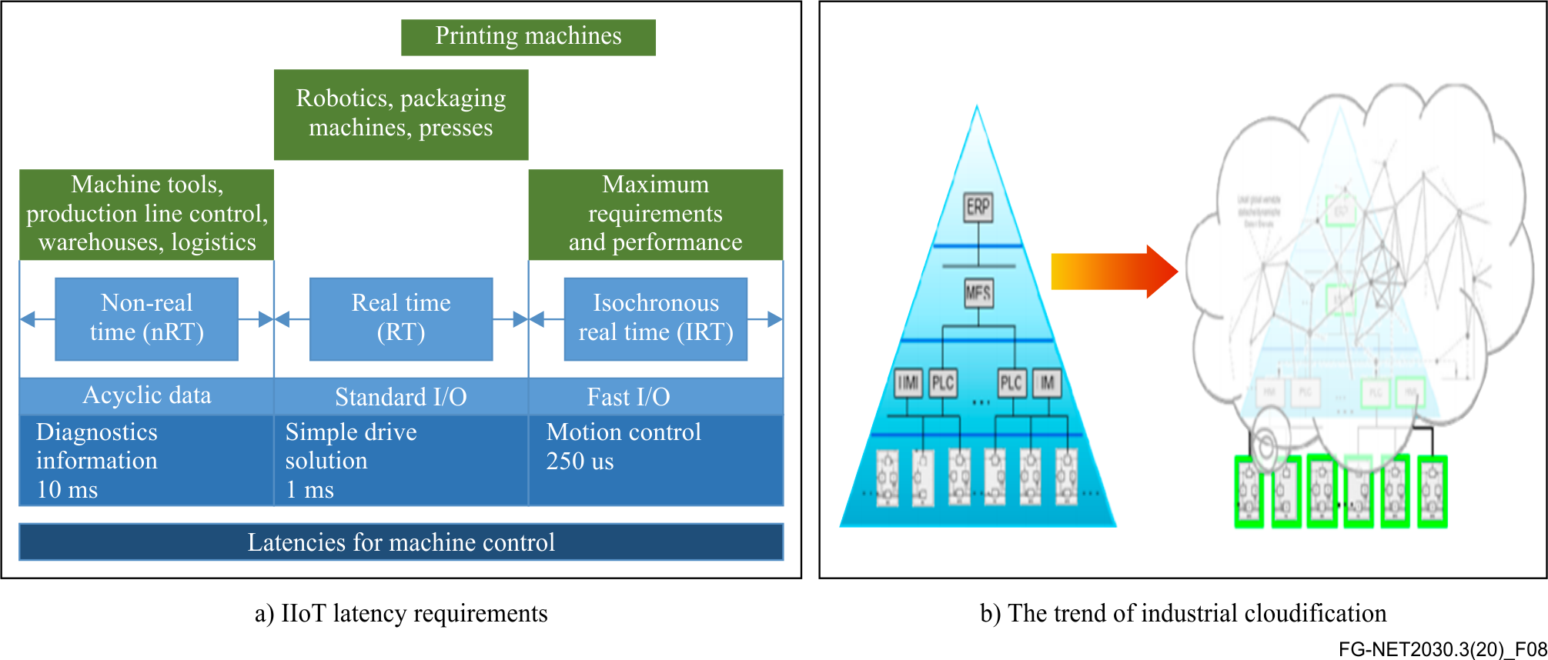
Figure 8 – Requirements of IIoT with cloudification
Factory automation and machine control applications typically demand low end-to-end latency ranging (from sub-ms to 10 ms), and small jitter (at 1µs level), to meet the critical closed loop control requirements, as shown in Figure 8. Additionally, many machine control applications are multi-axis applications requiring time synchronization to manage the complex position relationships between axes. Moreover, in some observed instances, a service availability of 99.999999% is demanded by some industrial networks [16] and [17], as any break or suspension in the production line may lead to million-dollar losses. For similar reasons, the security requirements of such systems are also extremely important.
At the same time, as part of the fourth industrial revolution, or Industry 4.0, operational technologies (OTs) and IT are converging. Control functions traditionally carried out by customized hardware platforms, such as programmable logic controllers (PLC), have been slowly virtualized and moved onto the edge or into the cloud in order to reduce the capital expenditure (CAPEX) and the operational expenditure (OPEX) of the system, and to provide increased system flexibility and capability to handle and analyse 'big data'. This industrial cloudification places even higher requirements on underlying networks, as the same latency, jitter, security and reliability requirements need to be implemented at larger scales.

I.7.2 Key network requirements
– Latency: IIoT systems contain many control sub-systems that run at cycle times ranging from sub-ms to 10 ms [16] and [17]. In such systems, end-to-end control requires in-time signalling delay at the same cycle time level, without malfunctions. These low latency requirements of IIoT applications are increasingly relevant not only to internal system communications, but also becoming essential for the interconnection of remote systems.
– Synchronization: It is a fundamental requirement for multiple-axis applications to have time synchronization in order to permit cooperation between various devices, sometimes remotely.
– Small and bounded jitter: In order to recover the clock signal and reach precise time synchronization, the machine control, especially the motion control sub-system, requires very small jitter at sub-microsecond level, and such small jitter is expected to have bounded limits under some critical situations.
– Security and reliability: IIoT systems demand high reliability and high security to avoid any potential risk of interrupting production. Specifically, the service availability requirement typically ranges from 99.9999% to 99.999999% for IIoT applications [17].
– Large-scale deterministic networking capability: Due to upcoming wide deployment of industrial cloudification, the aforementioned network requirements should be supported by large-scale deterministic networks in the near future.

Part II Use case requirement scoring and analysis

II.1 Graphic representations of the network requirements
The seven representative use cases described in this Technical Report have been further evaluated according to five abstract network requirement dimensions, widely discussed in [18], namely: Bandwidth, Time, Security, Artificial Intelligence (AI), and ManyNets. The relative scores for these five dimensions, ranging from 1 to 10, are shown in Figures 9 and 10 using two different graphic representations. (Note that all the scores are given according to the relative importance of a specific network requirement: 1 to 3 are for relatively LOW requirement; 4 to 6 are for MEDIUM requirement; 7 to 9 are for relatively HIGH requirement; and 10 means EXTREMELY demanding requirement).
The five dimensions identified in this Technical Report have been abstracted from more than twenty relevant network requirements considered within Sub-Group 1 of FG NET-2030, as shown in Table 1.
Table 1 – Abstract dimensions with relevant network requirements
Abstracted dimensions | Relevant network requirements
Bandwidth | Bandwidth; capacity; QoE; QoS; flexibility; and adaptable transport
Time | Latency; synchronisation; jitter; accuracy; scheduling; coordination; and geolocation accuracy
Security | Security; privacy; reliability; trustworthiness; resilience; traceability; and lawful intercept
AI | Data computation; storage; modelling; collection and analytics; autonomy; and programmability
ManyNets | Addressing; mobility; network interface; and heterogeneous network convergence
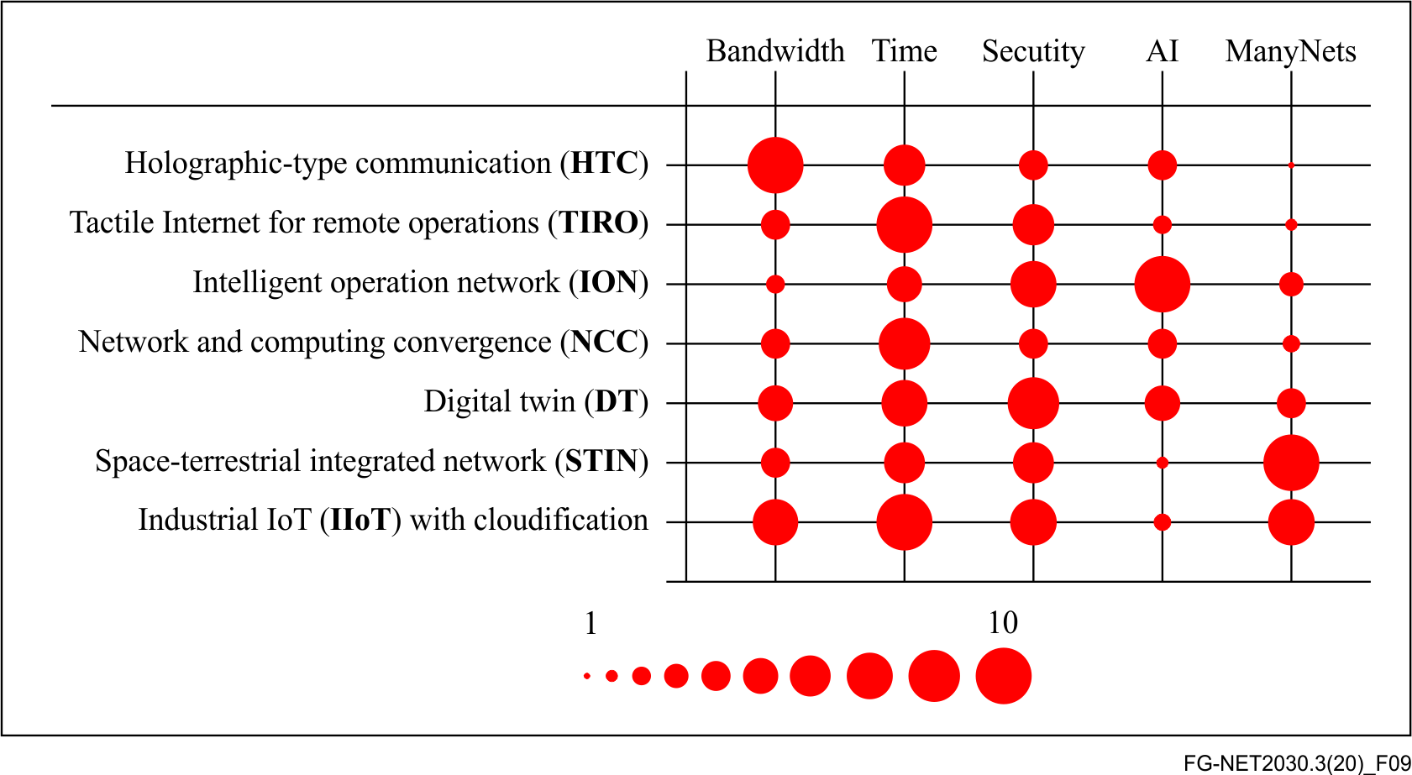
Figure 9 – Relative network requirement scores for the seven representative use cases – ball diameter graph representation
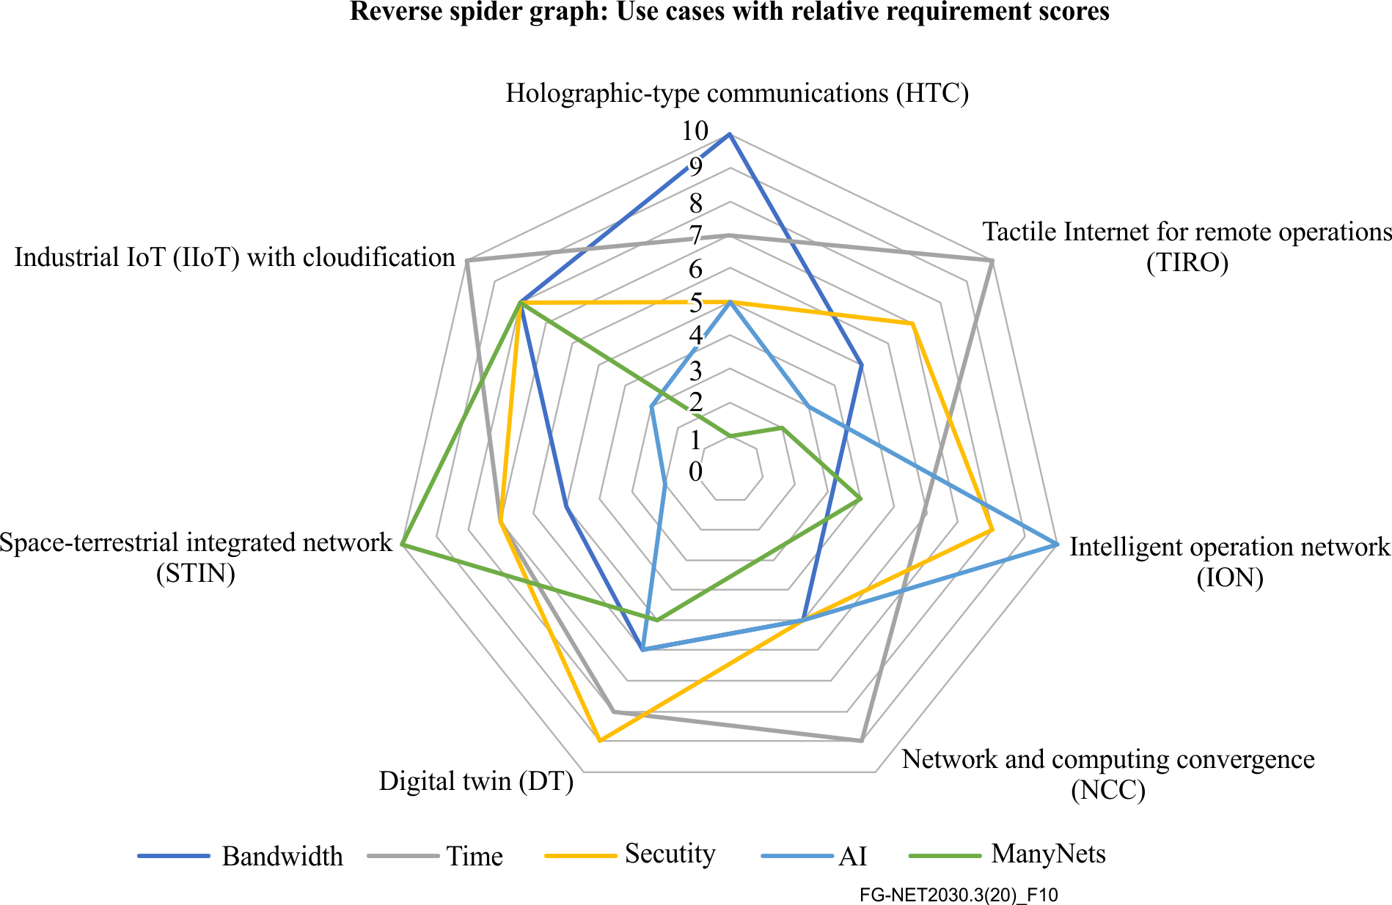
Figure 10 – Relative network requirement scores for the seven representative use cases – reverse spider graph representation
Both Figure 9 and Figure 10 show the relative significance of each network requirement dimension for a given use case. In Figure 9, the relative importance of network requirements can be easily compared, horizontally for different dimensions of one particular case, or vertically for a specific dimension across multiple use cases. On the other hand, Figure 10 shows the most prominent dimensions for all use cases. The rationale behind the five abstract requirement dimensions and a detailed analysis of the individual use cases are elaborated in clause II.2 and II.3, respectively.
Additionally, Figure 11 collectively presents the relative importance of each of the five network requirement dimensions by presenting the accumulated scores of each dimension across use cases. From this, the following observations can be derived:
– The Time dimension is of the highest importance across all use cases. This pinpoints that deterministic timing, bounded jittering, time-sensitive synchronization should be a primary consideration in future network protocols and architecture designs for Network 2030;
– The Security dimension is the second-most prominent one, highlighting that new applications and services will trigger new security requirements, and that, generally, security and privacy issues are always of high priority and even more in future networks which will be highly softwarised;
– The Bandwidth dimension is highly customized for specific vertical applications: the demand can be extremely high for AR/VR/HTC-style applications, or just of medium level for large-scale monitoring services via IoT sensors;
– The Artificial Intelligence (AI) dimension is becoming more and more important: AI is not only applicable to improve networking operations through network status analysis, but also can be widely deployed to enable future intelligent applications and services;
– Lastly, the ManyNets dimension targets the seamless coexistence of heterogeneous networks and is essentially motivated by the integration of terrestrial networks with spatial and marine networks for entire global connectivity coverage. Furthermore, it can also address the integration of vertical industries with the telecommunication networks, as well as more novel network paradigms that will emerge due to the era of network convergence.
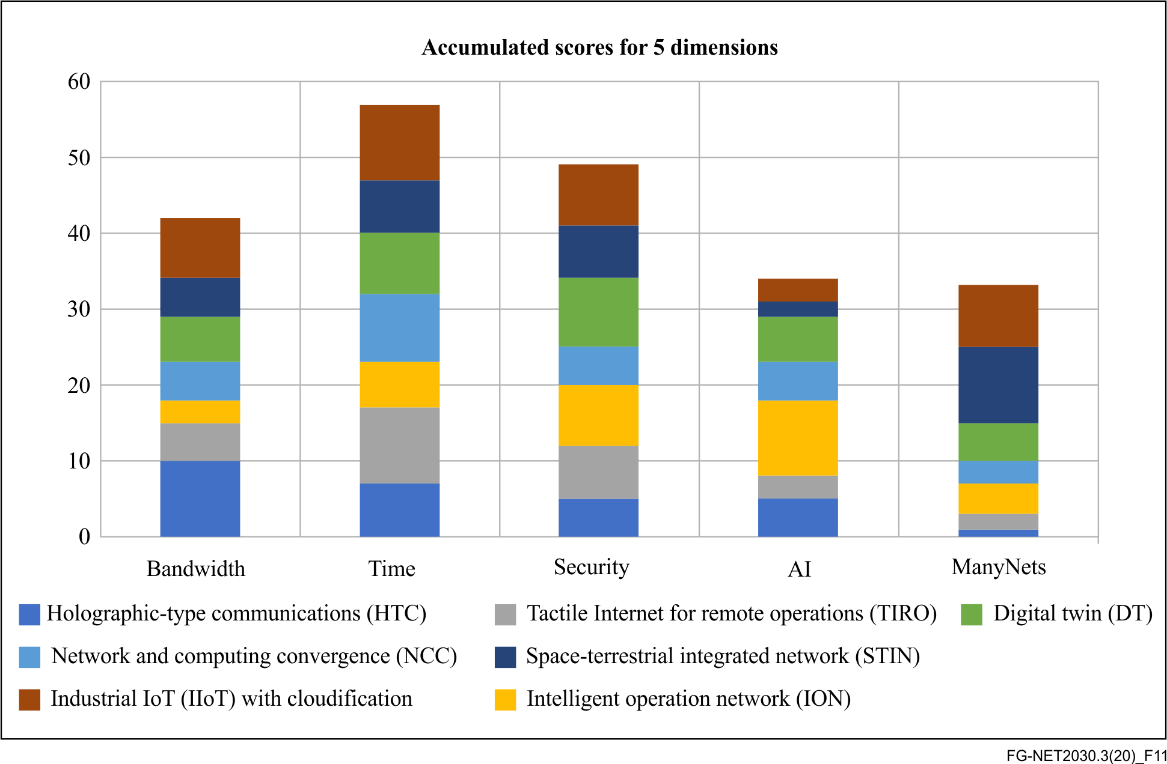
Figure 11 – Accumulated dimensional scores for the seven representative use cases

II.2 Rationale for consideration of the five abstract requirement dimensions
The representative use cases identified for Network 2030 each have their own requirements in terms of specific network capabilities. In order to plan the deployment of a specific service, it is important to understand its requirements at a high level as well as its impact upon the different dimensions. In simple terms, the views of all stakeholders, from network operators all the way through to end users, have to be considered; for example, bandwidth might be key to an end user's application flow, but an operator will be considering aggregated bandwidth and requirements of applications simultaneously using the network for multiple purposes.
In this context, each dimension adopted in Figure 9 and Figure 10 has been abstracted after considering and consolidating different (but related) factors, as explained below through examples:
– The Bandwidth dimension uses higher scores of 1-10 range to show high bandwidth requirements. The score is obviously very high for 3D multi-media related applications such as HTC. However, in some cases, it should also be considered that flexible 'bandwidth on demand' type of situations may arise, such as in the ION use case. In addition, Industry 4.0 relevant operations (IIoT use case) may require asymmetric flows of high bandwidth in one direction (upstream to controller) and low bandwidth in the other direction (e.g. downstream command to robots).
– The Time dimension expresses the notion of latency tolerance, based upon a lower tolerance receiving a higher score. The time dimension may refer to data transmission latency, sensitivity to jitter and timing accuracy, or even synchronized arrival intervals. Since mobility is a requirement of most of these use cases, finding the accuracy of geo-location in real-time may also be partially regarded as a characteristic factor of the time dimension.
– The Security dimension encompasses integrity, privacy protection, trustworthiness, resilience, lawful interception and traceability, with a high score indicating stringent requirements. The interpretation of this dimension includes consideration of the requirements and priorities of all stakeholders. The default score for security has been assumed to be relatively high (i.e., 5 or above in our scoring system) as all identified use cases need a secure end-to-end communication infrastructure. Furthermore, crossing regulatory boundaries or working with multi-domain networks may be required: a high score for security in these use case scenarios means that interconnectivity between different networks preserves user's identity and data integrity.
– The Artificial Intelligence (AI) dimension increases in relevance and practical impact upon applications almost on a daily basis. Across the use cases identified, the primary consideration is the application of AI and machine learning (ML) techniques that can be implemented in networks, for purposes such as network optimisation, predictive analytics, improved capacity and congestion planning, traffic pattern prediction, anomaly detection dynamic resource allocation, resilience enhancement, and so forth. It is believed that AI will play an important role in future networks, and high scores are used to indicate high importance.
– The ManyNets dimension represents the heterogeneity score of the networks, so that network capabilities are normalized. A particular user should be offered the same network capabilities and receive the same network experience through any type and number of networks it attaches to or transits through. A low score suggests that quite homogeneous networks predominate in the use case, like closed factory sites, local-scale IP-based delivery, whereas a high score implies relevant usage of public networks in combination with quite heterogeneous access or transit network technologies.

II.3 Detailed analysis of the individual use cases
The scores for each use case have been based upon agreed estimates and the relative importance of each dimension in a use case has been benchmarked against the other use cases. For example, in the security dimension, a score of five has been chosen to denote standard security requirements. Where either reduced or above normal levels of security are deemed important or critical, when compared to the other use cases, the score has been adjusted accordingly with qualitative best guess scores applied, after group consent.
In each use case, the most demanding, single flow application, has been the driving consideration when comparing the relevance of each dimension. So, in the HTC use case, it is envisaged that these applications require much higher bandwidth than the baseline bandwidth requirement for other use cases, and with the potential for bandwidth requirements to be extremely large when true hologram-based digital teleportation is fulfilled, the score of this dimension is high.
– Holographic type communications (HTC)
The key network requirement for HTC is bandwidth. A single HTC flow is expected to consume from hundreds of megabytes to multi-gigabytes of bandwidth, or even higher for full size, true holograms. Thus, a small number of such live sessions will have a large impact on an operator's overall network capacity. In addition, time is also of relatively high importance for this use case, although not as much as in other cases such as IIoT. It is expected that AI or ML algorithms for image sampling or recognition will play a role in managing the bandwidth demands of the future (for example, through the enhancement of the current media formats). Security, as in all other use cases, needs careful consideration. The security requirements may vary slightly depending upon the specific application. The ManyNets dimension is not critical to HTC.
– Tactile Internet for remote operations (TIRO)
The TIRO use case addresses applications which are first and foremost reliant and sensitive to the time dimension, and therefore, a corresponding extreme score has been assigned. The average score in bandwidth is on the other hand expected, as requirements will depend upon specific applications and the required degree of sensing and feedback in each communication. Almost all industrial verticals benefit from the feedback of remote operations or from remote entities, hence network operators may wish to plan for a high number of active tactile flows. An average score in security is expected, this score being high for critical tactile applications associated with human lives and high-value machinery. Both ManyNets and AI dimensions are not critical to TIRO-style applications.
– Intelligent operation network (ION)
Networks are expected to become more autonomous, self-healing, self-managing and self-configuring, and therefore relying heavily on AI enabled operations. Although ION may require a large amount of real-time telemetry data (which is generally in the control plane), it is by no means comparable to HTC's high volume data: thus, this use case carries a lower bandwidth score, and relatively equivalent score for time. The security of such networks is proven to be of a high importance (and therefore a high score is prescribed) at the infrastructure level. An operator may need to manage heterogeneous network domains for new service capabilities, therefore a reasonable dependency on ManyNets is anticipated.
– Network and computing convergence (NCC)
The most prominent feature of the NCC use case is the ability to promptly schedule network resources (networking capability and computing power), whenever demanded in the network: this implies a high score for the time dimension. From the perspective of network operations, the NCC use case is expected to have fair requirements in terms of bandwidth, security and AI. The ManyNets requirement focuses on connecting a variety of networks that may merely adopt NCC-compliant mechanisms, hence its score is relatively low.
– Digital twins (DT)
– DTs are digital replicas of physical objects, and the core technology for automatic cyber-physical integration. DTs and relevant network enablers are heading towards a variety of applications, which are reflected by above average scores of bandwidth and time dimensions. Securing DT-based operations and identity, assuring trustworthiness and that the data in transit is not compromised, are of utmost importance since DT-based applications and tools will be a key technology for critical infrastructure. Considering that application level intelligence needs to be distinguished from network level intelligence (as the AI capabilities that will support DT operations are not network related), a medium score for AI is associated with this use case. Fair requirements are also expected in terms of ManyNets.
– Space-terrestrial integrated network (STIN)
– The particular value that STIN provides is to enable low latency applications and provide connectivity to under-served geographical areas. Satellite networks may be placed as access, edge or backhaul networks in ManyNets, therefore, opening several new opportunities for network infrastructure design. The time and security dimensions are rated high, while average bandwidth capabilities are required and AI is expected to play only a marginal role in service specific path selection, planning or re-computation.
– Industrial IoT (IIoT) with cloudification
IIoT is at the heart of Industry 4.0. The types of devices involved range from cameras to tiny sensors. Some IIoT devices will beam large amounts of multi-media data, while a large set of sensors will cover all aspects of a factory floor. Recently, the core parts of a PLC tend to be fully cloudified facilitating the application of IIoT at large scales. Basically, other than AI's limited usage (a low score is attributed due to the separation of application level intelligence from the network), the IIoT use case has pervasive high demands across all other requirement dimensions.
Conclusion
Part I of this Technical Report describes seven representative use cases for Network 2030 with their key network requirements, and part II summarizes these network requirements with their relative importance according to five abstract dimensions. The relative scores were also evaluated for each use case and illustrated in a graphic manner.
Collectively, and within the limits of this restricted exercise, it is believed that these representative use cases may provide a potential vision of new applications and services in the era of Network 2030. For additional and more detailed use cases, participation in ITU-T FG Network 2030 meetings and activities, and contribution to its final outputs, are warmly invited.
Further study
– Further elaboration on security aspects
– Generalization of the space-terrestrial integrated network (STIN) use case (not restricted to LEO satellites)
– Quantitative projections for some requirements

References

[1] A Survey on Holography: <http://drrajivdesaimd.com/2017/09/17/hologram>.
[2] Holoportation, Microsoft Research, <https://www.microsoft.com/en-us/research/project/holoportation-3>.
[3] Network 2030: Market Drivers and Prospects, Richard Li, FG NET-2030 Chairman, 1st Network 2030 Plenary Meeting in New York, Oct. 2018. <https://www.itu.int/en/ITU-T/Workshops-and-Seminars/201810/Pages/Programme.aspx>.
[4] 3D Holographic Display and Its Data Transmission Requirement, 2011. <https://ieeexplore.ieee.org/abstract/document/6122872>.
[5] Holographic image transmission using blue LED visible light communications, 2016 <http://www.apsipa.org/proceedings_2016/HTML/paper2016/234.pdf>.
[6] Toward Truly Immersive Holographic-Type Communication: Challenges and Solutions, IEEE Communications Magazine, Jan. 2020.
[7] HaptoClone: <http://www.hapis.k.u-tokyo.ac.jp/?portfolio=haptoclone&lang=en>.
[8] A Systematic Review of Multilateral Teleoperation Systems, Mahya Shahbazi, Seyed Farokh Atashzar, Rajni V. Patel, IEEE Transactions on Haptics, May 2018.
[9] Ultrareliable and Low-Latency Communication Techniques for Tactile Internet Services, 2019: <https://arxiv.org/pdf/1907.04474.pdf>.
[10] The Tactile Internet ITU-T Technology Watch Report August 2014. <https://www.itu.int/dms_pub/itu-t/opb/gen/T-GEN-TWATCH-2014-1-PDF-E.pdf>.
[11] Mazin Gilbert, Artificial Intelligence for Autonomous Networks (Book, CRC Press, 2018).
[12] RFC8678, Deterministic Networking Use Cases, https://tools.ietf.org/html/rfc8578 .
[13] China Mobile Edge Computing Technical White Paper, 2019: <http://cmri.chinamobile.com/wp-content/uploads/2019/02/China-Mobile-Edge-Computing-Technical-White-Paper.pdf>.
[14] Digital Twin Technologies and Smart Cities, 2020: <https://link.springer.com/content/pdf/10.1007/978-3-030-18732-3.pdf>.
[15] The Space-Terrestrial Integrated Network (STIN): An Overview, Haipeng Yao, Luyao Wang, Xiaodong Wang, Zhou Lu, and Yunjie Liu, IEEE Communications Magazine, 2018.
[16] Industrial Networking Enabling IIoT Communication, 2018: <https://www.iiconsortium.org/pdf/Industrial_Networking_Enabling_IIoT_Communication_2018_08_29.pdf>.
[17] Private 5G Mobile Networks for Industrial IoT, 2019: <https://www.qualcomm.com/media/documents/files/private-5g-networks-for-industrial-iot.pdf>.
[18] FG Network 2030 Sub-Group 1's interim activities: <https://extranet.itu.int/sites/itu-t/focusgroups/net-2030/SitePages/Sub-Group%201.aspx>.

Main contributors
– Part I:
• HTC case: Xinzhu Sang (BUPT, China), Bin Da (Huawei, China)
• TIRO case: Maria Torres Vega (Ghent University, Belgium), Filip De Turck (Ghent University, Belgium), Bin Da (Huawei, China); Alexander Clemm (Futurewei, USA)
• ION case: Yuan Zhang (China Telecom, China); Yunpeng Xie (China Telecom, China)
• NCC case: Huijuan Yao (China Mobile, China); Yunpeng Xie (China Telecom, China); Yuexia Fu (China Mobile, China); Dirk Trossen (InterDigital Europe, UK)
• DT case: Cheng Zhou (China Mobile, China)
• STIN case: Ning Wang (University of Surrey, UK)
• IIoT case: Nampuraja Enose (Infosys, Germany); David Zhe Lou (Huawei, Germany)
– Part II: Kiran Makhijani (Futurewei, USA); Sundeep Bhandari (NPL, UK); Xavier Priem (University of Bristol, UK); Bin Da (Huawei, China); Marco Carugi (Huawei, Europe)
– Overall editing and coordination: Bin Da (Huawei, China); Marco Carugi (Huawei, Europe); Sundeep Bhandari (NPL, UK)

__________________

Sub-Group 1’s SharePoint page: https://extranet.itu.int/sites/itu-t/focusgroups/net-2030/SitePages/Sub-Group%201.aspx

