 |  | International Telecommunication Union
 |  | ITU-T | FG-SSC
 |  | TELECOMMUNICATION  STANDARDIZATION SECTOR  OF ITU |  | (03/2015)
 | ITU-T Focus Group on Smart Sustainable Cities
 | Cybersecurity, data protection and cyber resilience in smart sustainable cities
 | Focus Group Technical Report

FOREWORD
The International Telecommunication Union (ITU) is the United Nations specialized agency in the field of telecommunications, information and communication technologies (ICTs). The ITU Telecommunication Standardization Sector (ITU-T) is a permanent organ of ITU. ITU-T is responsible for studying technical, operating, and tariff questions and issuing Recommendations on them with a view to standardizing telecommunications on a worldwide basis.
The procedures for establishment of focus groups are defined in Recommendation ITU-T A.7. ITU-T Study Group 5 set up the ITU-T Focus Group on Smart Sustainable Cities (FG-SSC) at its meeting in February 2013. ITU-T Study Group 5 is the parent group of FG-SSC.
Deliverables of focus groups can take the form of technical reports, specifications, etc., and aim to provide material for consideration by the parent group in its standardization activities. Deliverables of focus groups are not ITU-T Recommendations.

SERIES OF FG-SSC TECHNICAL REPORTS/SPECIFICATIONS
Technical Report on "Smart sustainable cities: a guide for city leaders"
Technical Report on "Master plan for smart sustainable cities"
Technical Report on "An overview of smart sustainable cities and the role of information and communication technologies"
Technical Report on "Smart sustainable cities: an analysis of definitions"
Technical Report on "Smart water management in cities"
Technical Report on "Electromagnetic field (EMF) considerations in smart sustainable cities"
Technical Specifications on "Overview of key performance indicators in smart sustainable cities"
Technical Report on "Information and communication technologies for climate change adaptation in cities"
Technical Report on "Cybersecurity, data protection and cyber resilience in smart sustainable cities"
Technical Report on "Integrated management for smart sustainable cities"
Technical Report on "Key performance indicators definitions for smart sustainable cities"
Technical Specifications on "Key performance indicators related to the use of information and communication technology in smart sustainable cities"
Technical Specifications on "Key performance indicators related to the sustainability impacts of information and communication technology in smart sustainable cities"
Technical Report on "Standardization roadmap for smart sustainable cities"
Technical Report on "Setting the stage for stakeholders’ engagement in smart sustainable cities"
Technical Report on "Overview of smart sustainable cities infrastructure"
Technical Specifications on "Setting the framework for an ICT architecture of a smart sustainable city"
Technical Specifications on "Multi-service infrastructure for smart sustainable cities in new-development areas"
Technical Report on "Intelligent sustainable buildings for smart sustainable cities"
Technical Report on "Anonymization infrastructure and open data in smart sustainable cities"
Technical Report on "Standardization activities for smart sustainable cities"

© ITU 2015
All rights reserved. No part of this publication may be reproduced, by any means whatsoever, without the prior written permission of ITU.

Cybersecurity, data protection and cyber resilience in smart sustainable cities

About this Technical Report
This Technical Report has been prepared as a contribution to the International Telecommunication Union's (ITU) Focus Group on Smart Sustainable Cities – Working Group 2 (WG2).
Acknowledgements
This Technical Report was prepared by Giampiero Nanni (Symantec), in collaboration with Ziqin Sang (Fiberhome Technologies Group). The authors wish to acknowledge the guidance and support from all the members of the ITU-T FG-SSC Management Team, and especially Paolo Gemma (Huawei), Angelica V. Ospina (University of Manchester), Michael Mulquin (IS Communications Ltd), Sian John (Symantec), Wei Qin (Fiberhome Technologies Group) who have provided constructive comments towards the successful completion of this Technical Report.
Additional information and materials relating to this Technical Report can be found at: www.itu.int/itu-t/climatechange. If you would like to provide any additional information, please contact Cristina Bueti at tsbsg5@itu.int.

Cybersecurity, data protection and cyber resilience
in smart sustainable cities
Table of Contents
Page

1 Introduction 1
1.1 Scope 1
2 Key definitions 2
3 ICT implications in smart sustainable cities 3
4 Architecture of SSC 4
5 SSC services, potential cyberthreats and protective measures 6
6 SSC components and their vulnerabilities 11
7 Security architecture of SSC 14
8 Cybersecurity and a SSC governance framework 15
9 Recommendations to ensure SSC service continuity 16
10 Conclusions 19
Abbreviations 20
Bibliography 22

Cybersecurity, data protection and cyber resilience
in smart sustainable cities
Overview
Smart and sustainable city deployments will be carried out by a diverse ecosystem of providers in innovative domains, involving state-of-the-art technology, including critical and complex information and communication technology (ICT) implementations.
These deployments can address different components and city systems, like intelligent transportation, connected health care, public safety and security, emergency services, smart grid and smart metering, intelligent buildings, etc.
Increasing ICT complexity, hyper-connectivity, namely through “Internet of Things” (IoT) environments, as well as the generation of significant amounts of data, will also mean increasing vulnerability, both to malicious attacks and unintentional incidents. By conceiving interconnected urban systems with cybersecurity and data protection in mind, city administrators will be able to ensure service continuity, safety and well-being for citizens and businesses alike.
This Technical Report details these cybersecurity and data protection considerations in smart and sustainable city developments. It will explore the requirements and challenges of creating a secure, reliable and resilient smart and sustainable city. It will also consider how administrations and the overall city ecosystems will need to provide innovative, resilient “smart” solutions that leverage digital information while protecting against malicious violations, unintentional damage and natural disasters.

Executive Summary
Smart sustainable cities (SSC) are highly dependent on information and communication technologies (ICTs), including Internet of Things (IoT), radio frequency identification (RFID), and machine-to-machine (M2M). The advanced underlying infrastructure not only resolves the need for hyper-connectivity for smart sustainable city components and services, but also introduces higher levels of complexity and higher volumes of data. Increased system complexity opens new doors and opportunities for malicious cyberattacks and data loss in the case of serious incidents, including natural disasters. The linkages that exist between the higher levels of complexity, connectivity and data volumes that characterize SSC, which together lead to exacerbated levels of vulnerability to security threats, can be summarized as follows:
Hyper complexity + hyper connectivity + hyper data volumes = hyper vulnerability
Given the increasing interconnectedness of smart sustainable city environments, security incidents can prove highly penalizing for the systems they affect, for the city services they control, and ultimately for the citizens and end users of the services.
A very compelling need for SSC is therefore to guarantee the protection of the relevant ICT systems and the various technologies involved, as well as the data used to govern the systems and the services.
Cybersecurity, information protection and system resilience constitute political and governance issues at the forefront of new developments in this field. As they closely relate to both governance and policy, they require the attention of public administrators and decision-makers, especially given the potential effects of malicious attacks and disasters on critical ICT systems and infrastructure, including citizens' deprivation of essential services, from transportation to utilities (e.g. smart grid, water management), health care, emergency services, and public safety, among others.
With appropriate processes in place, multi-stakeholder collaboration and good governance, technology can provide tangible solutions to issues related to cybersecurity, information protection and system resilience.
Within this context, this Technical Report provides a detailed account of the potential cyber-vulnerabilities of SSC, and a set of recommendations to ensure the protection and resilience of the services offered to the citizens.
This Technical Report is structured around nine sections.
Section 1 provides the introductory background and scope. Section 2 provides working definitions for the notions that are at the core of this Technical Report, namely "resilience", "cybersecurity" and "data protection". Section 3 describes the main implications of ICT use in the contexts of SSC. It explores the IoT, the rising technology at the base of the SCC paradigm, as well as other ICTs that introduce new potential threats to the integrity and security of the systems involved. Section 4 provides a general overview of the technical architecture of SSC in order to contextualize the analysis and to illustrate the complex security challenges faced by SSC strategists and implementers.
Based on this context, section 5 describes a number of examples of SSC services and security threats, providing the reader with a series of practical recommendations aimed at countering potential cyber-vulnerabilities in those areas. Section 6 expands the technical architecture concepts by analysing the different technologies components and their vulnerabilities. Section 7 details the analysis by presenting the technical cybersecurity architecture of SSC.
Section 8 highlights the need for a SSC governance framework that provides, among others, the leadership required for the design and effective adoption of cybersecurity and resilience approaches in smart sustainable cities.
Building on this analysis, section 9 guides the reader through a series of key recommendations on how to effectively maintain service continuity despite the occurrence of different types of incidents, with varying levels of impact.
This Technical Report concludes by advocating cybersecurity and cyber resilience as vital ingredients of SSC, and as part of the collaborative efforts between SSC stakeholders aimed at ensuring service continuity, reliability, citizen privacy, and ultimately the achievement of SSC goals.
1 Introduction
For the first time in history, more than 50% of the world's population live in cities.
The projected rates of urban growth will bring benefits and challenges. Demographic and social ecosystems will need to evolve, economies will be under increased pressure, the environment will be challenged, city governance will have to adapt, digital and social inclusion needs will grow, and health care and education provision will demand new approaches, among others.
In order to address these challenges, cities need to become, and in many cases are already becoming, 'smart', by ensuring a more rational approach to the way services are operated and delivered, and by aiming at a better and more sustainable quality of life for city inhabitants.
ITU-T Focus Group on Smart Sustainable Cities (FG-SSC) defines a smart sustainable city as "an innovative city that uses information and communication technologies (ICTs) and other means to improve quality of life, efficiency of urban operation and services, and competitiveness, while ensuring that it meets the needs of present and future generations with respect to economic, social and environmental aspects".
As ICTs are a key enabler of SSC, the systems involved can profit from the ability to be highly interconnected through various technologies. For example, a broad variety of applications will be introduced based on the Internet (e.g. e-government, e-commerce, e-money, online banking), while IoT will be adopted in applications such as intelligent transportation, connected health care, public safety and security, emergency services, smart grid and smart metering and intelligent buildings, among others.
In order to guarantee service continuity and integrity, the ICT systems that oversee and control smart and sustainable cities need to consider, from the initial stages of inception and design, measures to ensure cybersecurity, robustness, reliability, privacy, information integrity, and crucially, resilience.
1.1 Scope
This Technical Report explores the requirements and challenges involved in creating a secure, reliable and resilient smart sustainable city. It considers how administrations and the overall city ecosystem will need to provide innovative, resilient "smart" solutions that leverage digital information while protecting against malicious violations, unintentional damage and natural disasters.

The content of this Technical Report is aimed at an audience of SSC stakeholders, including city officials and administrators, among others, described in the Technical Report on SSC Stakeholders.
When required, reference is made to other Technical Reports that have been prepared as part of the mandate of ITU-T Focus Group on Smart Sustainable Cities.
2 Key definitions
The notions of "resilience", "cybersecurity" and "data protection" are gaining increasing momentum, and are becoming extremely pertinent in a smart sustainable city context as they relate to the risks posed to service continuity by threats from the cyberspace. While available literature in this field offers a wide range of definitions for these terms, which often vary according to the area or the sector of implementation, the following constitute the working definitions that will be used for the purposes of this Technical Report:
a. Resilience
ITU-T Study Group 17 (SG17) defines resilience as the "Ability to recover from security compromises or attacks."
The FG-SSC has noted the ITU-T Study Group 17 Recommendations related to Cybersecurity Information Exchange (CYBEX), X.1500-Series. (ITU-T X.1500-Series Recommendations). Complementing this focus, a recent ITU report on 'Resilient Pathways' defines resilience as "The ability of a system or a sector to withstand, recover, adapt, and potentially transform in the face of stressors such as those caused by climate change impacts".
This Technical Report suggests that the resilience of ICT systems is linked to a series of attributes, which can be linked to security as follows:
- Robustness and ability to maintain performance and to continue operating, even under a cyber-attack or other incident (e.g. natural disaster).
- Redundancy of system components that allow the system to resume operations, within a defined delay of time, in case of abrupt interruption, total or partial.
- Flexibility and adaptability to new circumstances, including the systems' ability to prepare for future threats by adjusting/rectifying issues that allowed the incident to occur, or that took place during an incident.
Achieving resilience and cyber resilience in a SSC context will ensure service continuity to its citizens.
b. Cybersecurity
This concept refers to the discipline of ensuring that ICT systems are protected from attacks and incidents, whether malicious or accidental, threatening the integrity of data, their availability or confidentiality, including attempts to illegally "exfiltrate" sensitive data or information out of the boundaries of an organization.
This applies to the network and server environments, as well as to the endpoints (i.e. the individual terminals), in-house or mobile. Cybersecurity includes software tools, processes and people as key components of a successful implementation of the discipline.
c. Data protection
This notion refers to the tools and processes used to store data relevant to a certain ICT system or environment, as well as recover lost data in case of an incident – be it fraudulent, accidental or caused by a natural disaster.
One critical element about data is the concept of data ownership, which refers to who is in charge of data, who can authorize or deny access to certain data, and is responsible for its accuracy and integrity, in particular personally identifiable information (PII) . This aspect is expanded in the FG-SSC Technical Report on “Anonymization infrastructure and open data for smart sustainable cities”.
These definitions provide the basis for the analysis presented in subsequent sections of this Technical Report. As the analysis will demonstrate, their consideration and effective integration as part of SSC strategies is crucial to ensure the continuity of service provision in situations of shocks or stress, but equally important, to ensure high standards of quality, trust and reliability on ICT infrastructures and services, all required for SSC to succeed.
3 ICT implications in smart sustainable cities
The underlying nature of smart sustainable cities involves systems and objects interconnected through various technologies.
The IoT is a key element of SSC developments and refers to devices with embedded technology (e.g. sensors), and/or with Internet protocol (IP) addresses, able to be reached and exchange information, for example, in an intelligent transportation system.
The amount of data generated by these technologies can reach a considerable size. Big data will need to be appropriately and centrally stored, managed, analysed, and protected. The city operation's centre will supervise the interaction between systems and will have to ensure continuity, integrity and resilience.
With time, the interconnected and interdependent services of smart cities will evolve under a centralized governance dashboard of specialized stakeholders, responsible for setting policies and processes, managing ICT assets, services and protocols, and ultimately administering the services for constituents. ICT control and management capabilities will be crucial in order to guarantee an efficient, secure and resilient governance and delivery.
Strategic information technology (IT) trends like virtualization, cloud and mobile, are cornerstones of operational effectiveness and efficiency.
At the same time, business-critical IT applications are increasingly running on virtualized servers, while cloud services are expanding into core exploration and production processes.
As an increasing number of experiences suggest, mobile technologies improve the collaboration of users and the connectivity of smart devices across widely distributed infrastructure assets.
The European Network and Information Security Agency (ENISA) indicates that "processes" are seen as the most important pillar to secure critical infrastructures and industrial control systems (ICSs) – much more important than technology and people. Therefore, focusing solely on IT data centres and operation control centres is not enough. As the supply chain and technical infrastructure domains become highly complex, a comprehensive end-to-end approach is necessary. Each part of the industry value chain needs to be analysed, assessed and secured – but not in an isolated way.
Governance, Risk and Compliance (GRC) is a key discipline for public sector organizations. GRC is to be fulfilled through policies and processes, enabled by ad hoc IT suites conceived to ensure that IT departments monitor their environment against the evolving regulation scenarios, and involves taking appropriate action to stay compliant and mitigate risks.
SSC security officers should consider the following measures as part of their GRC framework, and as part of their overall SSC security strategy:
- Embedding security with data to achieve confidentiality, integrity and authentication.
- Managing smart endpoints and embedded systems, as SSC will need to manage an increasing number of smart devices and secure data, identity and services across the entire supply chain, to avoid these devices being compromised and opening an additional threat vector.
- Protecting data explosion, including real-time information, which involves a sound management approach to storing, protecting, backing-up, archiving and retrieving data whenever needed.
4 Architecture of SSC
In order to provide a general background of the complex architecture that characterizes SSC, this section provides an overview of a sample configuration of SSC infrastructure. Gaining awareness of the complex, multi-layered architecture of SSC's infrastructure constitutes an important step towards the design of a comprehensive, system-wide cybersecurity strategy.
The architecture of SSC is divided into a sensing layer, a communication layer, a data layer and an application layer (Figure 4-1 from bottom to top), and is overseen by the SSC security system. Each of these components is explained in detail in the FG-SSC Technical Report on “Overview of smart sustainable cities infrastructure”.
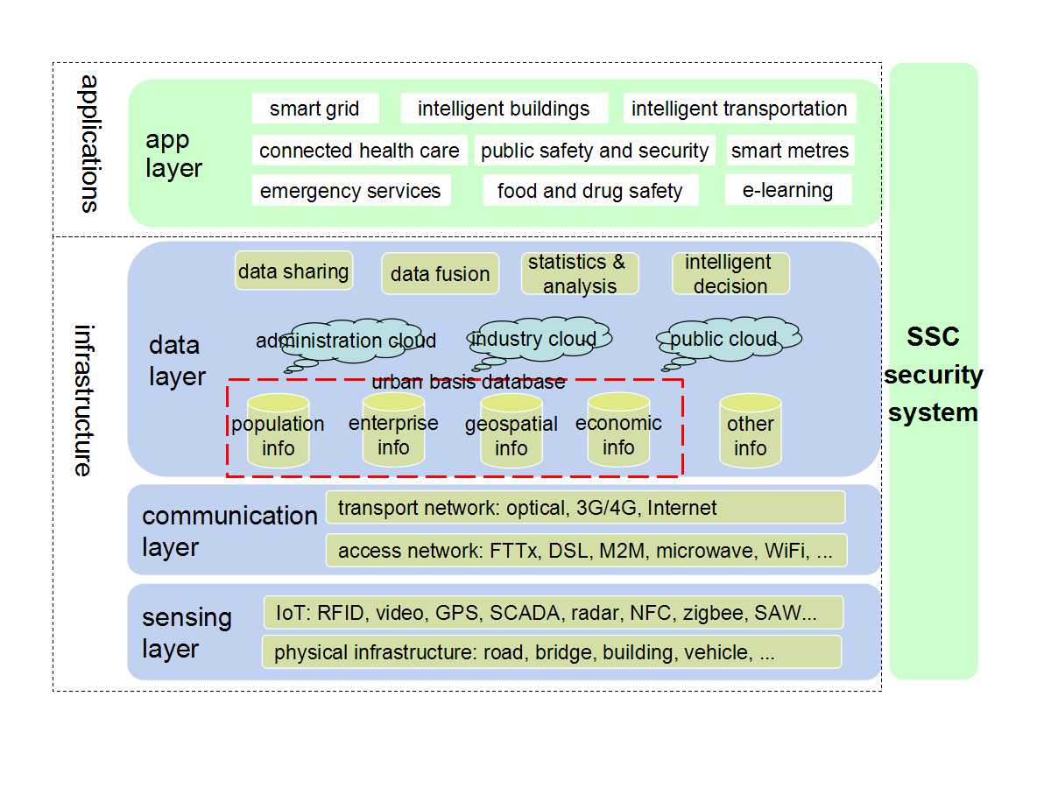
Source: FG-SSC deliverable, Technical Report on overview of smart sustainable cities infrastructure. Ibid.
Figure 4-1 – Architecture of a smart sustainable city
While a more in-depth explanation of the architectural components of SSC's infrastructure is beyond the scope of this Technical Report, a general overview of each of the layers is provided in Box 4-1.

Box 4-1. Layers of the SSC architecture
- The sensing layer is the basic requirement for SSC to achieve its "smart" component. It provides the superior 'environment-detecting' ability and intelligence for monitoring and controlling the infrastructure, the environment, the buildings and the security within the city. It uses radio frequency identification (RFID) devices, sensors, supervisory control and data acquisition (SCADA) and other Internet of things technologies, providing ubiquitous and omnipotent information services and applications for individuals and society.
- The communication layer is the “infobahn” or the backbone of SSC. The communication network should consist of large-capacity, high-bandwidth, highly reliable optical, pervasive networks, to relay and transport the city's intelligence. At the same time, the citizens can access the network "anytime, anywhere, on-demand", and can enjoy broadband services such as interactive personality television (IPTV), high-definition television (HDTV), and high-definition video calls.
- Data is a vital and strategic resource of smart and sustainable cities. The data layer makes the city "smarter": its main purpose is to ensure that fragmented data is shared by the functions of data association, data mining, and data activation. The data layer contains data centre from industries, departments, enterprises, as well as the municipal dynamic data centre and data warehouse, among others, established for the realization of data sharing and data activation.
- The application layer includes the various applications that manage the SSC's systems. This level exploits the previous layers and operates using their services.

Source: ITU-T FG-SSC (2014)
5 SSC services, potential cyberthreats and protective measures
As the overview provided in the previous section suggests, the infrastructural architecture of SSC can be vulnerable to a number of threats given its complexity, cross-level nature, and extent. According to the Internet security threat report (2014) by Symantec, targeted attacks have increased by 91% in 2013, with a wide variety of attackers and motivations, and increasingly sophisticated techniques.
The dramatic increase in cyberattacks can be explained by the fact that more and more motivations can effectively and efficiently be served through the Internet. Perpetrators are attracted and can succeed, because cyberattacks are less detectable than physical actions, they do not physically expose the attackers, can be extremely inexpensive, can be launched by a geographically remote location, the attribution is extremely difficult, and even if someone is identified, the prosecution is even more problematic due to the lack of definitive international legislation and uncertain jurisdiction.
Hackers' motivations can range from a criminal intent aimed at financial gain, through to industrial espionage, cyber sabotage, cyber warfare, and political activism, among others. Any of these can be conceived, take place, and have damaging repercussions in SSC.
Numerous episodes of city-infrastructure sabotage have been recorded in recent times, suggesting that ICT vulnerabilities can jeopardize the safe delivery of services to citizens, and/or their continuity.
Vulnerabilities can involve data "in transit" (i.e. being transmitted between devices) or "at rest" (i.e. while stored). Malicious attackers will assess the vulnerability of the different systems and engineer the most effective and damaging approach according to their objectives.
The following are examples of SSC services that are vulnerable to the above-mentioned threats:
• Smart grid, intelligent buildings and other critical infrastructure
It is generally estimated that cities are responsible for between 60% and 80% of the world's energy use. Therefore, optimizing energy delivery and consumption is vital.
Smart grid technology aims to tailor the generation and supply of energy to user consumption, thus increasing efficiency, reducing costs and environmental impact. In particular, consumer “smart metres” and sensors, equipped with IP addresses, can communicate information about energy utilization patterns to the supplier, while allowing end-user control. This can help manage real-time demand, and even provide advice to consumers about their use habits.
Buildings, both residential and commercial, provide an important opportunity to optimize energy consumption and enhance the well-being of residents and workers. Intelligent buildings, particularly office environments, are able to leverage smart grid technologies to influence energy supply and consumption by controlling lighting, climate control and IT. They can even provide electric plug-in stations for employees to recharge their cars while at work.
Smart grids and related infrastructure need protection from attacks that could cause severe stoppages to cities, community sites, industrial sites and essential services.
Attackers exploiting vulnerabilities in SCADA systems, based on traditional software platforms, can lead to intrusions with the potential to disrupt data exchange between utility control centres and end users, and severely compromise the delivery of energy services. Whitelisting techniques, used to ensure that only specified system applications and processes are active at any one time, are particularly effective against zero-day vulnerabilities and attacks in SCADA environments. Zero-day vulnerabilities are still unknown on the day of the attack, hence vulnerabilities against which no vendor has released a patch.
Intruders can also install malware designed to obtain sensitive information, to control the networks that operate the service and cause a denial-of-service situation. This can be countered through intrusion prevention techniques, coupled with robust policies in areas such as network usage, browser patches, e-mail usage, as well as users' awareness of the issue and their education and preparedness on the subject.
At the end-user level, smart metres may simply be hacked and compromised for fraudulent purposes: to alter proof of consumption or to 'steal' energy from other users, while preventing the provider from detecting service flaws.

Recommendations
- Public key infrastructure (PKI) or managed PKI can be used to avoid the fraudulent manipulation of smart metres in large scale and advanced metering infrastructures (AMIs), thus securing data integrity, revenue streams and service continuity.
- The smart grid can be secured at the communication layer by implementing PKI directly into metres, enabling identification, verification, validation and authentication of connected metres for network access. PKIs are ideal for large-scale security deployments requiring a high level of security with minimal impact on performance. In a PKI environment, it is essential that private keys and certificates be guarded by a reliable management solution that protects against ever-evolving data threats.

The European Union (EU) has engaged in a number of initiatives in the critical infrastructure protection (CIP) space.
The Project CRISALIS (CRitical Infrastructure Security AnaLysIS) was launched in June 2012. Its goal is to provide new methodologies to secure critical infrastructure environments from targeted attacks, deliver new tools to detect intrusions, and develop new techniques to analyse successful intrusions.
• Intelligent transportation
Keeping the city moving is critical. Transportation strategies have an impact on public safety, the environment, energy, emergency response services, the ability to do business, and on the delivery of other critical services, as well as the overall maintenance of the quality of life of citizens.
Real-time traffic flow information, coupled with telecommunications, global positioning systems (GPSs), machine-to-machine (M2M) communication, wireless fidelity (Wi-Fi) and RFID technologies, as well as data analytics and prediction techniques, can be used to enhance private and public travel. Sensors can collect information about traffic conditions at critical city spots and send this information, via wireless communication, to centralized control systems. This data can then influence decision-making or even operate processes like traffic light synchronization.
Optimizing transportation models requires a high degree of complexity from the ICT infrastructure and its components to avoid disruptions. These can be the result of malicious intent or simply well- meaning insiders' actions. For example, traffic management could be impaired by hacking into the navigation system that directs a bus driver into the city through a wrong route, due to false information about traffic volume.
Recommendations
- The data transmitted from devices may be subject to spoofing. Unencrypted traffic data may be subject to attackers injecting false traffic reports into satellite navigation devices, as proven by cybersecurity experts.
- Vulnerabilities can also put information at risk due to unintentional actions, mistakes, carelessness or inadequate processes.
• Connected health care
Health care delivery can benefit from a connected approach, with electronic patient records available to all medical services. This will enable public health professionals and clinicians to collaboratively access information in a secure way, at any time, from anywhere and from any mobile device.
In many cases, telemedicine solutions connected through broadband, wireless or satellite, can prove vital in situations where the infrastructure or specific contingencies do not allow for the physical presence of a specialist, in cases such as natural disasters or remote geographical locations.
An ageing population needs traditional care, as well as assisted living and health monitoring services to enable independence at home. This can be achieved through the utilization of sensors and devices connected to health operators through broadband, wireless and data analytics, and crucially, the deployment of privacy, identification and security systems.
In the case of a road accident, a malicious intrusion that compromises communication between first respondents and operational centres could prevent its accurate localization and the efficient dispatch of emergency units. Equally, during such incidents, emergency services might need to operate using medical data for injured patients by accessing a central location, and they should operate on the basis of reliability and integrity of the information.

Recommendations
- In this context, back-up, cybersecurity and authentication solutions can ensure that health care systems offer reliability and integrity, as well as patient privacy.
• Public safety and security
Above all, cities need to be safe. Public safety and security has become paramount for city administrations, whether protecting them against crime, natural disasters, accidents or terrorism.
From conventional street violence to complex financial offences, identity thefts or data breaches, the crime scenario is extremely dynamic and can only be tackled by increasingly sophisticated technologies and processes.
Telesurveillance systems are becoming pervasive in urban settings and, coupled with real-time communication capabilities, can help emergency services intervene promptly in incidents.
In the immediate aftermath of a serious accident or catastrophic event, reliability and security become key factors. The ability to share information between agencies, to operate sophisticated telesurveillance systems, to guarantee connectivity to incident response teams and first responders, to gather and analyse heterogeneous intelligence and data about incidents in real time, allow municipalities and emergency services to increase safety conditions for citizens, businesses, assets and infrastructure.
Recommendations
- It is critical that telesurveillance systems maintain their integrity and availability and that emergency services can rely on wireless or M2M communication to obtain directions and instructions from operational control centres.
- When information is transferred and managed over unsecured lines between different operators (both internal and external) and with heterogeneous systems, data encryption is required. By leveraging strong two-factor authentication and one-time password entry, only trusted personnel can gain access to critical data and control systems. Digital certificates can also be used for authentication, signing and encryption.

• Wireless communications and hotspots
Both large and small municipalities offer free wireless hotspots in addition to those provided by airports, hotels, and shops. As this trend continues to grow, more and more citizens will be exposed to potential vulnerabilities, in particular the younger population who are at risk of being lured into unsafe websites and chat rooms.
Designing and building encryption solutions into devices ensures that they can only communicate with the required control centre, and that communications can be authenticated.
Public WiFi connections (both free and paid) are increasingly common, but security for such connections may be lacking or is insufficient. WiFi connections can be provided in coffee shops, hotels, airports, parks and even in some streets. The host buys a wireless access point, connects that device to the Internet, and broadcasts its signal within a public place. Anyone with a wireless card within range of the host's access point can access its network and use the Internet. In order to make it quick and easy to use their hotspots, some hosts disable much of the security built into their wireless devices. This is a notable trade-off. Without encryption, your plain text data passes unprotected through the air, where it can be intercepted by cybercrooks.
Recommendations
- Attention should be paid to the surrounding area when accessing hotspots, in order to verify that nobody is able to read one's laptop screen. A privacy screen can be used for extra security.
- The network configuration should be changed in order to manually select each wireless network that the system joins.
- File sharing should be turned off while at a hotspot. Highly sensitive or personal data should be stored elsewhere, and when using instant messaging or e-mail, nothing should be sent that one would not want made public.
- There exist products that enable users to become “invisible” on the network by creating a virtual private network (VPN). These products encrypt the username, password and other confidential information that users may have entered online, allowing the users to control what they share online, no matter where they connect to the Internet. Internet banking, stock trading or other sensitive online financial transactions should be avoided while using a public hotspot.
- Security software should be kept current and active.
These Internet hotspots can be a virtual playground for beginning hackers or a potential gold mine for sophisticated veteran cybercriminals, as illustrated in Box 5-1.

Box 5-1. How do cybercriminals exploit WiFi hotspots?
Packet sniffers are programs that allow the interception of wireless transmissions via data packets. If the packets are unencrypted, someone with a packet sniffer can see information like personal communications, financial transactions and account passwords as plain text.
Wi-phishing, or The evil twin, is a process in which a cybercriminal pre-empts the hotspot's wireless signal with one of his own, spoofs the legitimate network name, and replaces the sign-up page with one that looks like the real thing. As a result, credit card and other personal information can be supplied to the spoofer, rather than the hotspot provider.
Firesheep is a free add-on application created for the Firefox browser that wraps a friendly interface around a hacker's tool, allowing cybercriminals to “side jack” or intercept login credentials for a site or service that does not require a secure socket layer (SSL) (a security feature that provides encryption).
It is critical that free Wi-Fi hotspots in SSC, whether provided by private entities like shops or by the city administration itself, are secured.
6 SSC components and their vulnerabilities
• Network infrastructure
The network infrastructure of SSC should ensure the safety and reliability of communication, including various network forms (e.g. cellular network, Internet, satellite network, government and enterprise intranets, among others). The vulnerabilities of these networks will be inherited by the network infrastructure of SSC and possibly amplified, given the additional complexity of the SSC architecture.
Vulnerabilities of the network infrastructure in SSC may be present in the following areas:
– There is wide variety of devices involved in a SSC network. A peak of network accesses in a short time might lead to network congestion, a situation favourable to potential attackers. In these cases, authentication and key generation mechanisms can produce further network resource consumption.
– Internet or next-generation Internet will be the core carrier of network infrastructure of SSC. Denial of service (DoS) and distributed denial of service (DDoS) attacks across the Internet still exist, hence the need to adopt more robust preventive measures and disaster recovery mechanisms, also taking into account the heterogeneity of technical equipment and their protection capabilities.
– The heterogeneity of the network architectures will produce additional vulnerabilities, particularly in network authentication.
– The separation of sensor networks and communication networks will create new security risks. Theft, tampering, counterfeiting information, can disrupt the communication between different types of the network.
• Cloud computing facilities
Due to the high concentration of users and information resources, the security consequences of cloud delivery are much higher than traditional delivery models. The security issues faced by cloud computing technology are as follows:
– Data concentration security issues
Cloud computing systems will affect the storage, processing and transmission of user data. If the privacy information is lost or stolen, the user could be seriously impacted. Cloud computing has introduced new types of security challenges, such as how to ensure the security of cloud service management and access control mechanisms inside the security provider, how to implement effective security audits, security monitoring for data manipulation, as well as how to avoid the potential risk of multi-user coexistence in a cloud computing environment.
– Data availability in the cloud
User data and business applications are hosted in the cloud computing system. Therefore, business processes are dependent on the service provider's general reliability, in terms of service continuity, service level agreement (SLA) and security policies, as well as user data protection and recovery in case of an incident.
• Internet of Things
IoT describes the capability of devices, provided with embedded sensors, to be connected via an IP address to the Internet, and exchange data with a remote system.
These capabilities can be exploited in SSC environments in the various disciplines identified so far, thus providing the ability to remotely control the components of the different systems.
With this ability come additional vulnerabilities: on one hand, in the shape of new doors for malicious attacks, and on the other, in terms of the significant amount of data generated while exchanging information or data that will need to be managed, stored and restored in case of an incident. Hence, this constitutes an additional area of potential concern in managing SSCs.
• Sensor network security
Sensor information should be transmitted outside through one or more sensing nodes, called gateway nodes. Thus, the security of sensor network security should be considered.
Sensor nodes are deployed in unattended situations, for example, when node resources are severely limited it is difficult to adopt sophisticated security mechanisms, or when the node processing capacity is weak. Due to these features, the sensor nodes can pose security issues such as intermittent connection, vulnerability to capture, or false data being sent. In these cases, the traditional security mechanisms cannot be applied.
In these circumstances, the risks are as follows:
a) If the sensor network gateway node is controlled by the attacker, it may lead to the loss of security in the sensor network, with subsequent uncontrolled access to the existing information through the gateway.
b) If the ordinary sensor node is still controlled, but the key is leaked, the attacker could be able to gain control of the node in order to transmit some erroneous data.
c) If the ordinary sensor node is controlled, but not the key, then the attacker can discriminate node functions, such as testing temperature, humidity, among others.
• Bottlenecks of radio frequency identification (RFID) security
The characteristics of RFID include non-contact operation, long distance identification, and reading without visible light, among others. Due to its nature, RFID technology involves privacy risks. For example, information may be illegally collected and the location illegally tracked. Furthermore, RFID authentication should also be considered as part of the security strategies.
• Data
– Embedding security with data to achieve confidentiality, integrity and authentication
SSC will need to manage a significant number of smart devices and associated data, together with identity and services across the entire supply chain. Thus, it will be important to secure smart endpoints and embedded systems in order to ensure these devices to avoid exposing to additional threat vectors and risk.
Protecting data explosion, including real-time information, involves a sound management approach to storing, protecting, and backing-up, as well as archiving and retrieving data whenever needed.
– Data confidentiality issues
SSC systems can access, use and exchange sensitive personal information, which, if disclosed, could cause great harm to individuals. Typically, health care systems will include detailed medical history and other sensitive information closely related to the patient's life.
Similarly, information on critical infrastructure like smart grids is highly sensitive, and if compromised or in the wrong hands, could endanger national security and economic interests.
Identity theft, counterfeiting and forgery are other instances of data-related threats that could aim at different sorts of fraud, e.g. card cloning or licence plate counterfeit.
– Data availability issues
A vast number of RFID and other IoT devices in SSC will involve potential issues with the traditional authentication systems. The massive presence of strict certification requirements can cause a severe impact on system efficiency, for example, when cross-domain access is needed, involving authentication systems.
7 Security architecture of SSC
An information security system provides a security guard for a smart sustainable city both in terms of technology and management aspects. A sample architecture is presented in Figure 7-1, and includes the following main components:
- information security infrastructure;
- information security mechanism:
– information security management system;
– information security technical protection;
– information security operation and maintenance system;
- security of applications (top section of Figure 7-1).
The information security infrastructure can include several centres, such as the security management centre, the key management centre and the identity management centre.
A comprehensive security strategy should address the security risk at each of these layers (i.e. sensing layer, communication layer, data layer and application layer), in order to ensure a system-wide, all-encompassing protection for SSC from the multiple threats that can affect the optimal operation of its services.
This protection mechanism should also cover the various applications implemented in SSC (e.g. medical, traffic, travel).
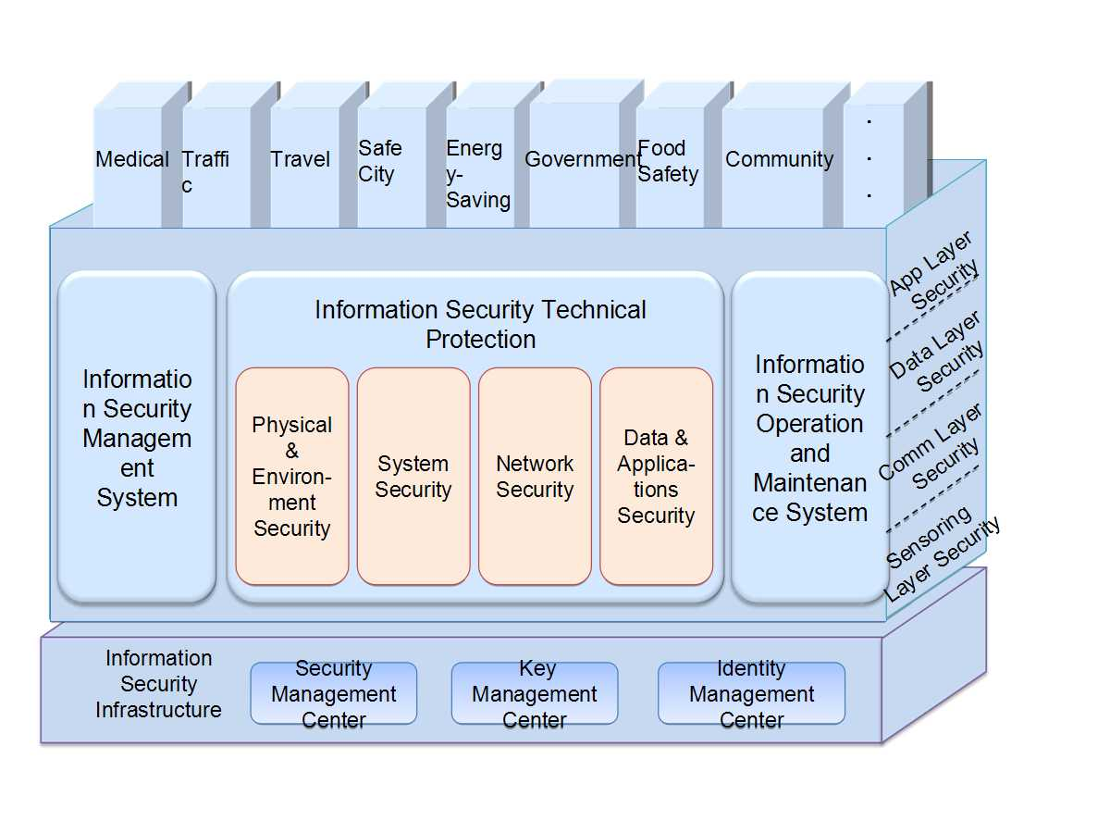
Source: FG-SSC deliverable, Technical Report on overview of smart sustainable cities infrastructure. Ibid.
Figure 7-1 – Architecture of an information security system for SSC
• SSC information security infrastructure
The information security infrastructure constitutes the technical foundation of the entire system, and as such, it provides a large number of security functions. The tasks of the information security infrastructure centres include disaster recovery, emergency monitoring, key management, security management, security evaluation and identity management (Figure 7-2).
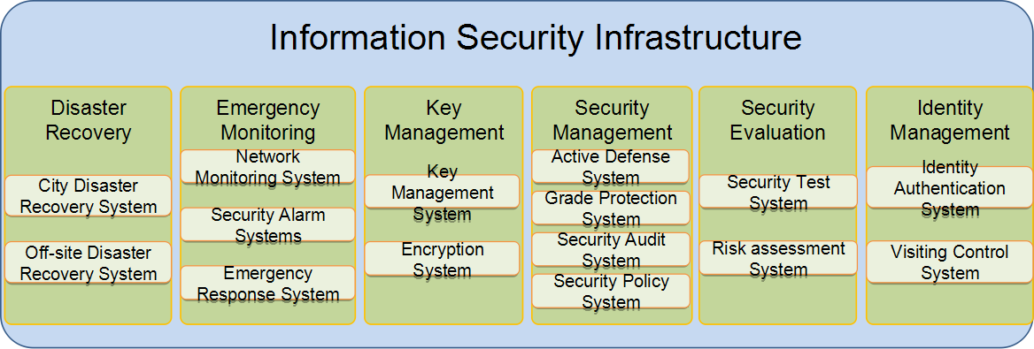
Source: FG-SSC deliverable, Technical Report on overview of smart sustainable cities infrastructure. Ibid.
Figure 7-2 – Information security infrastructure of SSC
• SSC information security technical protection
The core protection mechanism for SSC functions through a comprehensive security system that should be established in four directions, namely physical and environmental security, system security, network security, and data and application security on a technical level.
– Physical and environment security contains several aspects of environment security, equipment security, as well as disaster recovery and prevention.
– System security includes three main aspects: anti-virus technology, host security reinforcement, and operating system security.
– Network security involves gateway anti-virus, firewall, and intrusion detection.
– Data and applications security includes database encryption and database backup technologies, among others.
• SSC security of applications
Within SSC environment, the security of various applications should be based on the information security mechanism that relies not only on technical protection security, but also on security management, security operation and maintenance aspects.
8 Cybersecurity and a SSC governance framework
Traditional mechanisms to organize and coordinate efforts among city stakeholders may prove insufficient to achieve the goals of smart sustainable cities, and ultimately ensure a better quality of life to city dwellers, businesses and visitors facing the effects of increasing threats.
The need for interoperability of different smart systems and data sets generates the need for a unified approach to governance, to ICTs, and in particular, to cybersecurity and data protection mechanisms.
SSC stakeholders are faced by the need to ensure that the ICT approach and the related cyber-protection mechanisms are interwoven with the overall development strategy of the city. Chief Information Officers (CIOs) are becoming increasingly involved in devising these strategies, in collaboration with policy and decision-makers.
Each stakeholder, including system administrators, will have to consider the wider implications of security incidents, regardless of their nature. This involves considering how the recovering process could impact upon other components of the cities' services and operations.
Similarly, any subsequent adjustment aimed at addressing new system vulnerabilities will have to take into account the implications of those measures on any related system, both in terms of interoperability and cybersecurity.
A centralized governance body for SSC could utilize a central virtual dashboard, comprising the ICT operational centre, to run the services provided by SSC and provide ongoing assessment and timely response to varying incidents and needs. With the reliability of SSC services at stake, absolute continuity, reliability and safety must be guaranteed.
Any threat to the security of the system and its information can be detected, analysed and dealt with using threat intelligence services. The deployed ICT should be able to obtain reliable threat and vulnerability intelligence, and consequently dynamically adjust its security stance. In the case of incidents, these need to be promptly and effectively managed by specialist operators and incident management tools in order to ensure that services return to their normal operational status, and to minimize the disturbance caused to users.
Ultimately, modern cities compete with each other to attract businesses, talent, skills and taxpayers. As a result, administrations are increasingly valuing the role of innovation, technology, marketing and communication practices. In turn, private sector companies are attracted into cities by the ease of doing business – in terms of cost efficiency, infrastructure (e.g. office space, broadband, telecommunications, as well as utilities such as energy, water and transportation), and general quality of life for their staff (e.g. residential, health care and educational systems).
The adoption of effective governance structures as part of SSC strategies is closely linked to the effectiveness of cybersecurity measures. It is vital to ensure adequate preparedness and operational efficiency, as well as to take advantage of opportunities, address emerging needs, and overcome the security challenges faced by smart sustainable cities. Further information on SSC governance can be found in the FG-SSC Technical Report on “Engaging stakeholders for smart sustainable cities”.
9 Recommendations to ensure SSC service continuity
Smart sustainable cities should prioritize providers who offer solutions and methodologies for security, backup, data loss prevention, archiving and disaster recovery, and who are able to protect and manage heterogeneous environments resulting from legacy systems and newer deployments, including open source, managed mobile devices, and virtualized systems.
• Protecting information proactively
SSC contexts increasingly involve big data considerations, and subsequently the need to centralize and manage the vast amount of information that is continuously generated and used. Taking an information-centric approach, embedding security within data and taking a content-aware approach to protecting information, is vital for identifying ownership of: (a) the location of sensitive information, and (b) who has access to it. Classifying data and utilizing encryption helps to secure sensitive information and to restrict access to unauthorized individuals.
• Authenticating users
Strong authentication enables organizations to protect public assets by verifying the true identity of a smart device, system or application. This prevents individuals from accidentally disclosing credentials to an attack site, and from attaching unauthorized devices to the infrastructure.
• Leveraging threat intelligence
In order to understand the major attack trends, city officials and CIOs can count on an established observatory, like the Global Intelligence Network, to provide one of the most extensive and accurate vendor-neutral analyses of trends on malware, security threats and vulnerabilities from security research centres around the world. The same information is also used to compile the annual Internet Security Threat Report, which contains vital information about current and emerging threats and vulnerabilities.
• Balancing traditional versus cloud delivery
Within a SSC environment, all the smart services mentioned so far in the analysis can be delivered through a traditional client-server approach, but also through a cloud computing model, both private and hybrid, in order to leverage “as-a-service” capabilities and efficiencies.
These models require a secure virtualized environment where data can be safely guarded and processed with appropriate service level agreements (SLAs) in order to guarantee the provision of essential services to citizens. Authentication and encryption policies and techniques can help ensure the integrity of the cloud environment and its safe operation in the virtual space. Availability and disaster recovery solutions should guarantee compliance with SLAs, as well as resilience for critical city services.
• Managing security services and Computer Emergency Response Teams (CERTs)
SSC should also consider outsourcing security services to providers who can leverage extensive, global expertise in the field of cybersecurity to minimize security-related disruptions and data loss. The ICT leadership can then be relieved from this particular complex and time-consuming aspect and focus on the functional duties of running the city's ICT.
SSC should also rely on their national CERTs to align with national coordination on cyber incidents and security, and thus benefit from the international visibility this type of coordinated efforts provide.
• Protecting infrastructure
Securing endpoints, messaging and web environments, defending critical internal servers and implementing the backup and recovery of data, should be among the key priorities of SSC strategists. Organizations also need visibility and security intelligence to respond to threats rapidly.
• 24x7 availability of the critical infrastructure
Ensuring resilience in case of an incident can be achieved through the adoption of solid backup and recovery software or appliances, as well as adequate policies, processes and tools.
• Developing an information management strategy
This should include an information retention plan and policies. Organizations need to refrain from using backup for archiving and legal retention, and should instead implement deduplication mechanisms to free up resources, adopt a full-featured archive system, and deploy data loss prevention technologies.
• Access control at the boundary of network
Access control at the boundary can isolate attacks away from internal networks. Different boundaries can be implemented, with different policies enforced.
A firewall that consists of access rule, verification tools, packet filtering and application gateway, can greatly improve the security of an internal network. Since only selected protocols can pass through the firewall, the network environment has become more secure. Firewall can prevent well-known unsafe protocols, making it impossible for external attackers to use these vulnerabilities to attack the internal network. The firewall should be able to reject all of the above types of attack packets, and immediately alert the administrator.
In the firewall-centered security environment, all security measures (e.g. passwords, encryption, authentication and auditing, among others) can be configured on the firewall. This approach is more cost-effective than a decentralized network security mode.

If all network accesses go through the firewall, this can record and make a log of these visits, and also provide statistical data of network usage. When suspicious actions occur, the firewall can then generate the appropriate alarm, and provide detailed information about the incident for threat analysis purposes.
• Protecting intrusion dynamically
Intrusion detection is another important dynamic security technology, which can collect and analyze information from a number of key points of computer network and system, and find out whether there is any suspicious behaviour, sign of an attack or policy violation. There are three types of intrusion detection systems (IDSs):
(a) network-based IDS;
(b) host-based IDS;
(c) integrated IDS.
• Preventing DDoS attacks
There are different mechanisms that can enhance the ability to withstand DDoS through increasing the cost of attack. These include the use of high-performance network equipment, the guarantee of sufficient network bandwidth, the upgrade of the host server hardware, the use of static pages whenever possible, the enhancement of the operating system transmission control protocol (TCP)/IP stack, and the installation of specialized anti-DDoS firewall.
• Network security audit
A network security audit carries out compliance management by fine-grained auditing the network operating behaviour of the business environment. Through recording, analyzing, and reporting the network behaviour of system and authorized users, the network security audit can function as a mechanism for planning and preventing, concurrently monitoring, as well as reporting and tracking the source after the incidents take place. Consequently, network security audits can strengthen the internal and external networks behavioural regulation.
• Child online protection in SSC
As the analysis conducted thus far has demonstrated, the design of a comprehensive cybersecurity strategy for SSC should take into account multiple sources of vulnerabilities, as well as existing and emerging threats. Children are among the most vulnerable users of online services. As identified by the ITU-T Joint Coordination Activity on Child Online Protection (ITU-T JCA-COP):
"Child online protection covers a number of issues, and is being addressed at national, regional and international levels, across a myriad of environments, including social and legal. At the international level, and within the ITU, the Council Working Group on Child Online Protection has received much information on national activities, and has developed guidelines, and the Joint Coordination Activity on Child Online Protection has identified many technical activities that are contributing to the safety of children on line at a global level."(ITU-T JCA-COP)
Further details about child online protection can be found in the reports produced by the ITU-T JCA-COP, at http://www.itu.int/en/ITU-T/jca/COP/Pages/default.aspx.
10 Conclusions
Smart sustainable cities are emerging around the globe, with numerous examples of initiatives fostered by local, national and transnational governments and various institutions.
Consequently, local administrators and policy makers will be increasingly driven to make their cities more competitive in order to attract businesses, talent and taxpayers, as well as to comply with sustainable policies, including greenhouse gas emission targets and carbon footprint guidelines.
SSC deployments will involve multifaceted developments carried out by a diverse ecosystem of providers in innovative domains, as well as the adoption of state-of-the-art technologies characterized by critical and complex ICT implementations.
However, the rise in ICT complexity has also translated into increasing levels of vulnerability, both to malicious attacks and to unintentional incidents.
The analysis conducted in this Technical Report has explored how leadership and governance are key drivers, as well as essential conditions to ensure cyber resilience and service resilience within smart sustainable cities.
Protecting both the systems and the data with rigorous policies, up-to-date technology and techniques, will prove vital in ensuring the continuity and the resilience of all the services involved in the SSC architecture.
Only by conceiving interconnected urban systems with security and information protection in mind, SSC administrators will be able to ensure the safety and the well-being for citizens and businesses alike.
Security threats and defensive strategies are now an integral part of the discussion in the policy making boardrooms, as much as they are in the private sector. Public administrators know that any serious incident or breach could result in devastating outcomes in terms of financial, data, credibility and reputation loss. Thus, city planners and administrators should take proactive steps to ensure systems' security and data protection from the early stages of the SSC's inception and planning process. This constitutes a crucial step towards building resilient, smart sustainable cities for the twenty-first century.

Abbreviations
This Technical Report uses the following abbreviations:
3G Third Generation mobile networks
4G Fourth Generation mobile networks
AMI Advanced Metering Infrastructure
CERT Computer Emergency Response Teams
CIO Chief Information Officer
CIP Critical Infrastructure Protection
CRISALIS CRitical Infrastructure Security AnaLysIS
DoS Denial of Service
DDoS Distributed Denial of Service
DSL Digital Subscriber Line
EC European Commission
ENISA European Network and Information Security Agency
EU European Union
FFTx Fibre to the x (B – Building, Business; H – Home; C – Cabinet, Curb)
GPS Global Positioning System
GRC Governance, Risk and Compliance
HDTV High-Definition Television
ICS Industrial Control System
ICT Information and Communication Technology
IDS Intrusion Detection System
IoT Internet of Things
IP Internet Protocol
IPTV Interactive Personality Television
IT Information Technology
M2M Machine-to-Machine
NFC Near Field Communication
PII Personally Identifiable Information
PKI Public Key Infrastructure
RFID Radio Frequency Identification
SAW Surface Acoustic Wave
SCADA Supervisory Control and Data Acquisition
SG Study Group
SLA Service Level Agreement
SSC Smart Sustainable Cities
SSL Secure Socket Layer
TCP Transmission Control Protocol
UNFPA United Nations Population Fund
VPN Virtual Private Network
WEF World Economic Forum
WiFi Wireless Fidelity

Bibliography
FG-SSC deliverable, Technical Report on anonymization infrastructure and open data for smart sustainable cities. Available at http://www.itu.int/en/ITU-T/focusgroups/ssc/Pages/default.aspx
FG-SSC deliverable, Technical Report on engaging stakeholders for smart sustainable cities. Available at: http://www.itu.int/en/ITU-T/focusgroups/ssc/Pages/default.aspx
FG-SSC deliverable, Technical Report on overview of smart sustainable cities infrastructure. Available at http://www.itu.int/en/ITU-T/focusgroups/ssc/Pages/default.aspx
Ospina, A.V., Bueti, C., Dickerson, K., and Faulkner, D. (2013), Resilient Pathways: The Adaptation of the ICT Sector to Climate Change, International Telecommunication Union (ITU), Geneva, Switzerland. Available at: http://www.itu.int/en/ITU-T/climatechange/Documents/Publications/Resilient_Pathways-E.PDF
Recommendations ITU-T X.1500 series (2011-2015). Available at: http://www.itu.int/ITU-T/recommendations/index.aspx?ser=X
Symantec (2014), Internet security threat report 2014 – Volume 19. Available at: http://www.symantec.com/content/en/us/enterprise/other_resources/b-istr_main_report_v19_21291018.en-us.pdf
UNFPA (2007), State of the World Population 2007: Unleashing the Potential of Urban Growth, United Nations Population Fund (UNFPA). Available at: http://www.unfpa.org/swp/2007/english/introduction.html

UNFPA (2007), State of the World Population 2007: Unleashing the Potential of Urban Growth, United Nations Population Fund (UNFPA). Available at: http://www.unfpa.org/swp/2007/english/introduction.html.
The Technical Reports are available on the website of the ITU-T Focus Group on Smart Sustainable Cities at: http://www.itu.int/en/ITU-T/focusgroups/ssc/Pages/default.aspx.
For example, the U.S Department of Homeland Security refers to resilience as "The ability to prepare for and adapt to changing conditions, and withstand and recover rapidly from disruptions. Resilience includes the ability to withstand and recover from deliberate attacks, accidents, or naturally occurring threats or incidents". The Information Security Forum defines cyber-resilience as "The organisation's capability to withstand negative impacts due to known, predictable, unknown, unpredictable, uncertain and unexpected threats from activities in cyberspace", while the World Economic Forum (WEF) refers to it as "The ability of systems and organisations to withstand cyber-events, measured by the combination of mean time to failure and mean time to recovery".
Ospina, A.V., Bueti, C., Dickerson, K., and Faulkner, D. (2013), Resilient Pathways: The Adaptation of the ICT Sector to Climate Change, International Telecommunication Union (ITU), Geneva, Switzerland. Available at; http://www.itu.int/en/ITU-T/climatechange/Documents/Publications/Resilient_Pathways-E.PDF.
FG-SSC deliverable, Technical Report on anonymization infrastructure and open data for smart sustainable cities. Available at http://www.itu.int/en/ITU-T/focusgroups/ssc/Pages/default.aspx.
Examples are available in the FG-SSC deliverable, Technical Report on overview of smart sustainable cities infrastructure. Available at http://www.itu.int/en/ITU-T/focusgroups/ssc/Pages/default.aspx.
FG-SSC deliverable, Technical Report on overview of smart sustainable cities infrastructure. Ibid.
Symantec (2014), Internet security threat report 2014 – Volume 19. Available at: http://www.symantec.com/content/en/us/enterprise/other_resources/b-istr_main_report_v19_21291018.en-us.pdf
FG-SSC deliverable, Technical Report on engaging stakeholders for smart sustainable cities. Available at: http://www.itu.int/en/ITU-T/focusgroups/ssc/Pages/default.aspx ______________

