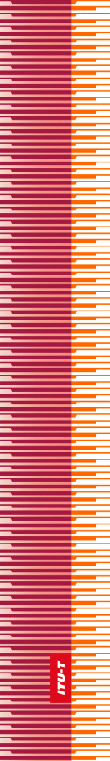 |  | International Telecommunication Union
 |  | ITU-T
TELECOMMUNICATION
STANDARDIZATION SECTOR
OF ITU
WORLD TELECOMMUNICATION STANDARDIZATION ASSEMBLY
Hammamet, 25 October – 3 November 2016

 | Resolution 85 – Strengthening and diversifying the resources of the ITU Telecommunication Standardization Sector

FOREWORD
The International Telecommunication Union (ITU) is the United Nations specialized agency in the field of telecommunications, information and communication technologies (ICTs). The ITU Telecommunication Standardization Sector (ITU-T) is a permanent organ of ITU. ITU-T is responsible for studying technical, operating and tariff questions and issuing Recommendations on them with a view to standardizing telecommunications on a worldwide basis.
The World Telecommunication Standardization Assembly (WTSA), which meets every four years, establishes the topics for study by the ITU-T study groups which, in turn, produce Recommendations on these topics.
The approval of ITU-T Recommendations is covered by the procedure laid down in WTSA Resolution 1.
In some areas of information technology which fall within ITU-T's purview, the necessary standards are prepared on a collaborative basis with ISO and IEC.

© ITU 2016
All rights reserved. No part of this publication may be reproduced, by any means whatsoever, without the prior written permission of ITU.

resolution 85 (Hammamet, 2016)
Strengthening and diversifying the resources of the
ITU Telecommunication Standardization Sector
(Hammamet, 2016)
The World Telecommunication Standardization Assembly (Hammamet, 2016),
considering
a) Article 28 of the ITU Constitution and Article 33 of the ITU Convention, pertaining to the finances of the Union;
b) Resolution 158 (Rev. Busan, 2014) of the Plenipotentiary Conference, instructing the Secretary-General to study possible new measures to generate additional revenue for the Union;
c) Resolution 34 (Rev. Dubai, 2012) of the World Telecommunication Standardization Assembly, on voluntary contributions;
d) Resolution 44 (Rev. Hammamet, 2016) of this assembly, on bridging the standardization gap between developed and developing countries1, which describes the sources from which funds will be raised for the purpose of bridging the standardization gap,
noting
a) the deliberations of the 2016 session of the ITU Council, on international numbering resources (INRs) and the identification of other possible sources of revenue for the ITU Telecommunication Standardization Sector (ITU-T), in the course of which the secretariat indicated that it would be difficult to present a balanced budget for 2018-2019 unless new sources of revenue are identified;
b) the recommendation of the 2016 session of the Council that a study be presented to its 2017 session, identifying all possible sources of revenue for the Union without restriction to INR,
observing
a) that, while the work and activities of ITU-T are continually increasing, the resources allocated to the Sector may be insufficient to cover fully all the work, activities and studies it carries out;
b) that Union revenues, which rely upon the contributions of Member States and Sector Members, have been in continuous decline;
c) that ITU-T revenues must be increased by increasing and diversifying revenue sources,
resolves to instruct the Director of the Telecommunication Standardization Bureau
to participate in the study referred to in noting b) above, for possible new measures to generate additional revenue for ITU-T, including revenues that may be obtained from INR and conformance and interoperability testing.

1 These include the least developed countries, small island developing states, landlocked developing countries and countries with economies in transition.

