Standardization Sector
ITU-T Technical Report
(03/2023)
DSTR-IoT-DLT-Accounting
Accounting and billing aspects in Internet of Things (IoT) ecosystem and integrated approach using Distributed Ledger Technology (DLT)
ITUPublications | International Telecommunication Union


Technical Report ITU-T DSTR-IoT-DLT-Accounting
Accounting and billing aspects in Internet of Things (IoT) ecosystem and integrated approach using Distributed Ledger Technology (DLT)
Summary
The purpose of this Technical Report is to study the various accounting, billing and related challenges in the Internet of things (IoT) ecosystem and to analyse the usage of distributed ledger technology (DLT) to provide an integrated approach to the management of IoT. In addition, it presents various principles and models on this subject and records the best practices followed by Member States.
This Technical Report discusses the various challenges faced in the accounting, billing and related areas in the IoT ecosystem. The exponential growth of digital interactions and the increasing use of IoT devices to collect and transmit data has created the need for modern billing systems that are well-integrated with businesses and capable of accommodating complex business models and pricing structures.
The challenges in accounting and billing in the IoT ecosystem include long and complex value chains, fragmented business and financial architecture, limited support from traditional billing solutions, auditing provisions, compliance to accounting standards, reconciliation and settlements across platforms, and transparency in pricing models. The success of the IoT ecosystem depends on how the financials are managed and how accounting and billing aspects play a critical role in capturing every strand of transactions accurately, efficiently, and without errors.
This Technical Report intends to study these challenges in the accounting, billing, and related areas of the IoT ecosystem, exploring the principles and models on the subject, and analysing the usage of DLT as an integrated approach to IoT management.

Keywords
Accounting, billing, DLT, IoT.
Note
This is an informative ITU-T publication. Mandatory provisions, such as those found in ITU-T Recommendations, are outside the scope of this publication. This publication should only be referenced bibliographically in ITU-T Recommendations.
Change Log
This document contains Version 1 of the ITU-T Technical Report on "Accounting and billing aspects in Internet of Things (IoT) ecosystem and integrated approach using Distributed Ledger Technology (DLT)" approved at the ITU-T Study Group 3 meeting held in Geneva, 1-10 March 2023.

Editor: | MC Sathish Kumar  Ministry of Communication  India | Tel: +91 9444044400  Fax: n/a  Email: mc.sathish@gov.in
© ITU 2023
All rights reserved. No part of this publication may be reproduced, by any means whatsoever, without the prior written permission of ITU.

Table of Contents
Page
1 Scope 1
2 References 1
3 Definitions 1
3.1 Terms defined elsewhere 1
3.2 Terms defined in this Technical Report 1
4 Abbreviations and acronyms 1
5 Introduction 2
6 Scope of the Technical Report 2
6.1 Overview of Internet of things 2
7 Accounting, billing and related challenges in IoT ecosystem 3
7.1 Business and billing models of IoT 5
8 Principles of accounting in IoT 6
9 Integrated approach to IoT using DLT 7
9.1 Enabling IoT with DLT 7
10 Concluding remarks 9
Bibliography 10

Technical Report ITU-T DSTR-IoT-DLT-Accounting
Accounting and billing aspects in Internet of Things (IoT) ecosystem and integrated approach using Distributed Ledger Technology (DLT)

1 Scope
This Technical Report intends to study the various accounting, billing and related challenges in the Internet of things (IoT) ecosystem. It attempts to explore various principles and models on this subject and records the best practices followed by Member States. This Technical Report also analyses the usage of distributed ledger technology (DLT) to provide an integrated approach to the management of IoT.

2 References
None.

3 Definitions

3.1 Terms defined elsewhere
This Technical Report uses the following terms defined elsewhere:
3.1.1 Internet of Things (IoT) [b-ITU-T Y.4000]: A global infrastructure for the information society, enabling advanced services by interconnecting (physical and virtual) things based on existing and evolving interoperable information and communication technologies.
NOTE 1 – Through the exploitation of identification, data capture, processing and communication capabilities, the IoT makes full use of things to offer services to all kinds of applications, whilst ensuring that security and privacy requirements are fulfilled.
NOTE 2 – From a broader perspective, the IoT can be perceived as a vision with technological and societal implications.
3.1.2 distributed ledger technology (DLT) [b-ITU-T X.1400]: Technology that enables the operation and use of distributed ledgers.

3.2 Terms defined in this Technical Report
This Technical Report does not define any particular terms.

4 Abbreviations and acronyms
This Technical Report uses the following abbreviations and acronyms:
AI Artificial Intelligence
AoT Accounting of Things
B2B Business-to-Business
B2B2C Business-to-Business-to-Consumer
CSP Communications Services Provider
DLT Distributed Ledger Technology
ICT Information and Communication Technology
IoT Internet of Things
ITS Intelligent Transport Systems
M2M Machine to Machine
MNO Mobile Network Operators
QoS Quality of Service
SIM Subscriber Identity Module

5 Introduction
The exponential growth in the access to Internet combined with the advent of various futuristic technologies such as 5G, artificial intelligence (AI), Big Data, Cloud and Edge computing, etc. have created a universe of digital interactions. The delivery of services across all sectors are now dependent on information and communication technology (ICT) applications. We are in an age of connected living where it is not just about connecting humans using communications technologies as in an earlier era, it is now connecting the entire physical world with the cyber world.
IoT devices collect and transmit data and are intended to enhance our lives by creating efficiencies and seamless experiences like never before. It is estimated there will be over 26 billion IoT devices by 2020 – a huge jump from the 8.4 billion just a few years ago. It is estimated that the financial impact will be up to $11 trillion globally by 2025.
Accounting and billing have traditionally been specialty areas with standalone management systems. However, modern billing systems need to be well integrated with all aspects of the businesses they serve in order to capitalize on the IoT. These systems also require the capability to accommodate increasingly complex business models and pricing structures.

6 Scope of the Technical Report
The accounting system forms a strong base for any kind of IoT application. This Technical Report intends to study the various accounting, billing and related challenges in the IoT ecosystem. It attempts to explore various principles and models on this subject and records the best practices followed by Member States.
Also, it analyses the usage of DLT to provide an integrated approach to the management of IoT.

6.1 Overview of Internet of things
The IoT can be described as a multitude of connections between various computing devices connected to the Internet. A new kind of connectivity between devices, systems, and services appeared, bringing in a phenomenon much broader than any previous technologies [b-ITU-T-UnleashingIoT].
Figure 1 shows how the IoT added the dimension "Any THING communication" to the information and communication technologies (ICTs) which already provided "any TIME" and "any PLACE" communication.
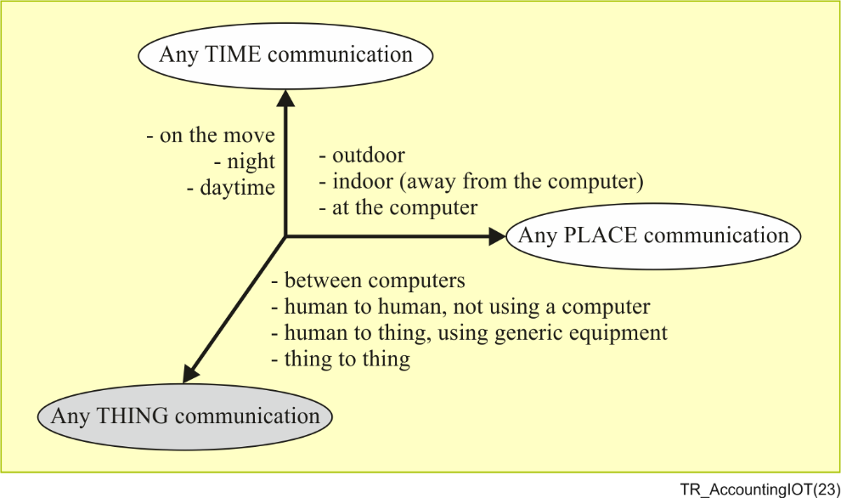
Source: [b-ITU-T Y.4000]
Figure 1 – The new communication dimension added by IoT
IoT can be useful in many different vertical industries including: automotive, retail and payment, logistics and transportation, consumer electronics, healthcare, industrial and smart business, security and surveillance, energy and utilities, smart cities and smart homes.

7 Accounting, billing and related challenges in IoT ecosystem
The supply chain of a typical IoT application will involve numerous players and the chain is quite long as well as complex. The following players can be identified in the IoT ecosystem:
– Mobile network operator (MNO);
– IoT provider;
– Application provider;
– Device provider;
– Third party partner;
– Customer/reseller;
– End user; and
– Regulator.
It can be seen that there are variety of players in the IoT space and they are interrelated with each other. The numbers of relations and settlements between those entities provide a vast canvas of permutations and combinations. In some cases, it could be a very simple selling process, while in others, it can be an extremely complex revenue chain, depending on the provided services and the relations between the involved parties [b-telecomscomarch].
Some of the challenges for accounting and billing in an IoT ecosystem can be:
1) Long, complex value chains of an IoT ecosystem;
2) Fragmented business and financial architecture of IoT;
3) Traditional billing solutions may not support the pricing agility demands of IoT;
4) Auditing provisions;
5) Compliance to accounting standards e.g., revenue recognition;
6) Reconciliation and settlements across platforms; and
7) Transparency in pricing models.
The most crucial factor in the whole IoT ecosystem, is that billing has to support all relations, levels of charging and processes for the end-to-end billing chain. The whole financial area is quite large and can be described as a multi-levelled, multi-tenant, multi-device environment where billing has to take into account the subscriber identity module (SIM) and device lifecycle as well as customer/reseller and end user lifecycle with different states and transitions between them. Billing support for SIMs, devices and even applications will involve different rules in terms of payments (one time, usage, recurring), source of data, QoS policies and many more while support for partnerships has to gather unlimited numbers of organizations, agreements and settlements [b-telecomscomarch].
IoT has changed the way of thinking about billing processes, adding a significant number of new business models and cases. In the past, just a few different kinds of relations had to be handled by billing tools, today the service and player diversity makes these kinds of relations rise into hundreds. The billing system should create a kind of a "cloud" over the whole environment as shown in Figure 2.
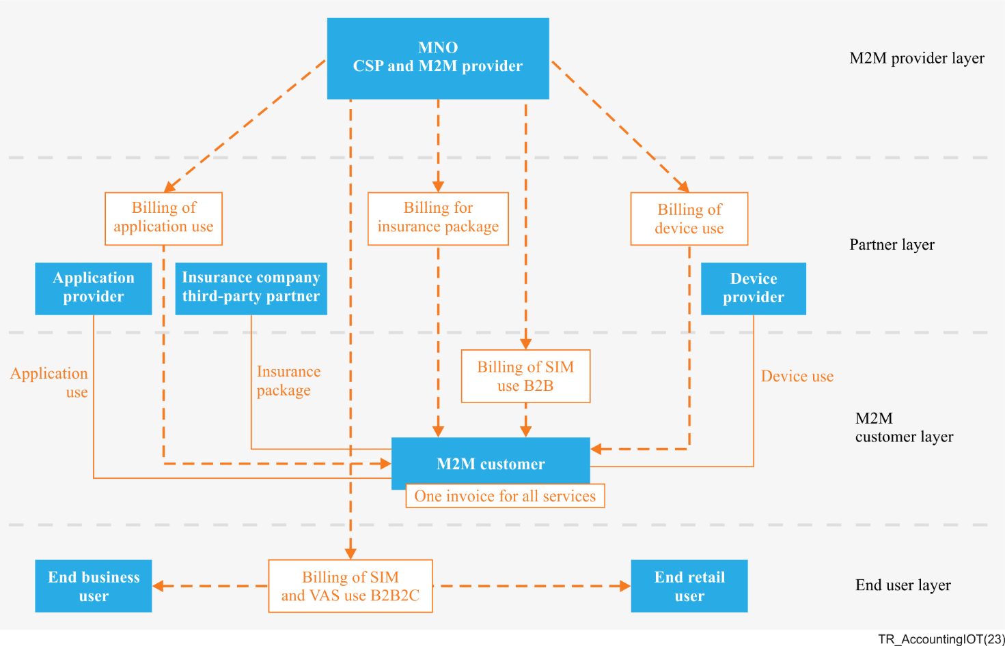
Figure 2 – Accounting and billing in the IoT ecosystem
Source: [b-telecomscomarch]
It is not just about the relations but more so about the big volume of data, not to mention plethora of different policies and pricing plans, rules, and catalogues. In the IoT world, new services, prices, relations have to be introduced smoothly and rapidly.
The success of any system will depend on how the financials are managed and how relevant supporting structures are constructed to ensure that every strand of the transactions are captured in an accurate manner without undue delay and errors. This is where the accounting and billing aspects play a critical role. In traditional systems, the accounting functionality is mostly seen from a regulatory compliance perspective and as a back-end verification tool. However, in scenarios like IoT, the entire ecosystem works on the guarantee of accurate capture of data, seamless transactions, and trust in settlements.

7.1 Business and billing models of IoT
IoT is composed of four layers as well as management capabilities and security capabilities which are associated with the four layers.
The four layers, shown in Figure 3, are as follows:
1) application layer;
2) service support and application support layer;
3) network layer; and
4) device layer.
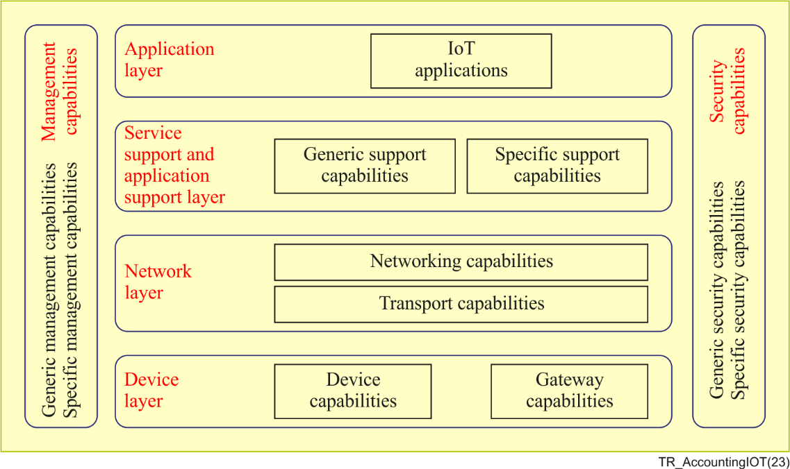
Source: [b-ITU-T Y.4000]
Figure 3 – IoT layers and associated management and security capabilities
The IoT ecosystem players may have a variety of relationships in real deployments. The motivations for this variety of relationships are based on different possible business models. Only some IoT business models are examined here from the perspective of telecom service and network operators. From this perspective, five business models are described in Table 1.
Table 1 – Business models
Model | Features
Model 1 | In model 1, player A operates the device, network, platform and applications and serves the application customer directly.  In general, telecom operators and some vertically integrated businesses (such as smart grid and intelligent transport systems (ITS) businesses) act as player A in model 1.
Model 2 | In model 2, player A operates the device, network, and platform, and player B operates the application and serves the application customers.  In general, telecom operators act as player A, other service providers as player B in model 2.
Model 3 | In model 3, player A operates the network and platform, player B operates the device and applications and serves the application customers.  In general, telecom operators act as player A and other service providers act as player B.
Model 4 | In model 4, player A only operates the network and player B operates the device and platform, providing applications to the application customers.  In general, telecom operators act as player A, other service providers and vertically integrated businesses act as player B in model 4.
Model 5 | In model 5, player A only operates the network, player B operates the platform, and player C operates devices and provides applications to the application customers.  In general, telecom operators act as player A, other service providers act as player B, and vertically integrated businesses act as player C in model 5.
There can be various types of innovative pricing models in IoT scenario, which is also dependent upon the business models as discussed above:
– Value-based pay-per-use model is based on how devices are being used;
– Criteria-based flat rate – the CSP receives a fixed monthly or annual fee from the end user;
– Consumer device models are based on the data package size;
– Enterprise device model is pricing based on application type; and
– Tailored pricing is based on a case-by-case situation.

8 Principles of accounting in IoT
The enormous opportunities provided by IoT also comes with many challenges. IoT applications powered by 5G, artificial intelligence (AI), Big Data, etc., create a disruption to the existing mechanisms. Hence, there is a need to re-assess and re-tune the existing controlling mechanisms, especially the accounting and billing mechanism, in order to cope with the complexities of transactions in the IoT ecosystem.
The current billing systems are equipped to cater to the traditional services, but they need to be upgraded to tackle the enormous transaction capabilities of IoT. This may warrant establishment of new-age billing and accounting systems or create a hybrid system by integrating traditional systems with futuristic technologies.
The accounting and billing system acts as the backbone of any application. The framework in which these systems are placed must follow some standard principles to ensure the integrity and robustness of all applications. There are accounting standards which are followed to ensure the standardization of accounting systems across horizontals and verticals. With the onset of disruptive technologies like IoT, extreme care has to be taken to ensure that vital accounting principles are embedded in the algorithms of these applications.
Some of the principles which are to be adhered to include:
1) Revenue assurance;
2) Transparent billing;
3) Auditing provisions;
4) Data security and privacy;
5) Tax compliance;
6) Revenue recognition;
7) Consistency principle;
8) Economic entity principle; and
9) Disclosure principle.
The universe of IoT will be enabled at many levels and will consist of huge numbers of complex chains of transactions. The above principles will help to create a framework which will ensure Accounting of Things (AoT) for IoT.

9 Integrated approach to IoT using DLT
A distributed ledger is a type of ledger that is shared, replicated, and synchronized in a distributed and decentralized manner. Blockchain with assistive technologies such as distributed ledger, smart contracts and consensus mechanisms creates an immutable, auditable, and secured trail of value transactions without any dependence of intermediaries.
"Unlike the Internet alone, blockchains are distributed, not centralized; open, not hidden; inclusive, not exclusive; immutable, not alterable; and secure. Blockchain gives us unprecedented capabilities to create and trade value in society." – World Economic Forum (2017)
The key characteristics of DLT systems are:
– Append only – An append only ledger is used to provide full transactional history. Unlike traditional databases, transactions and values in a DLT are not overwritten.
– Immutable – Distributed ledgers are cryptographically secure and immutable, ensuring that the data contained within the ledger has not been tampered with, and that the data within the ledger is attestable.
– Shared – The ledger is shared amongst multiple nodes. Some nodes contain the full state of the ledger while other nodes do not necessarily contain the full state of the ledger. This provides transparency and optimal efficiency across the node participants in the DLT network.
– Distributed – The distributed nature of DLT allows for the scaling of nodes in a DLT network. By increasing the number of nodes, the ability for a bad actor to impact the consensus protocol used by the DLT is reduced thus, making it more resilient to attacks by bad actors.

9.1 Enabling IoT with DLT
DLT can act as the foundation layer for the IoT ecosystems connecting them with the various other layers by injecting trust into the system. The IoT platforms are at many times extremely fragmented leading to the "working in silos" scenario. This limits the potential of IoT applications. With the increasing adoption of IoT in various domains such as consumer business, manufacturing (Industry 4.0), etc., the interaction of various IoT ecosystems may have to be integrated to bring in operational as well as economic efficiencies.
In the ecosystem of IoT applications, the concept of digital twins can create enormous benefits for related businesses and product modelling. Digital twins are the virtual copies of the physical objects which exactly replicate the physical state of the entity in the virtual world by visualizing relevant underlying data. The potential of using digital twins is restricted by the fragmentation of the IoT ecosystem.
A well-designed DLT system can act as a unifier in plugging the weaknesses of the fragmented IoT ecosystems by creating an underlying transactional platform connecting various IoT ecosystems.
Figure 4 illustrates how the DLT platform can create a common base layer for various IoT ecosystems. This enables them to create a User Interaction model between multiple vertical layers of IoT ecosystem through a mutually agreed DLT platform. The concept of digital twins can be tokenized and equipped with smart contract capabilities. This provides an integrated approach to handle the IoT applications using DLT which increases efficiencies without any intermediaries, enables trust among stakeholders, security through encryption, tamper-proof database and complete traceability. In this way, DLT can serve as the backbone for the IoT ecosystem by providing an integrated solution to the businesses to create an efficient user-friendly IoT models for multi-stakeholders interactions [b-deloitteIoTBlockchain].
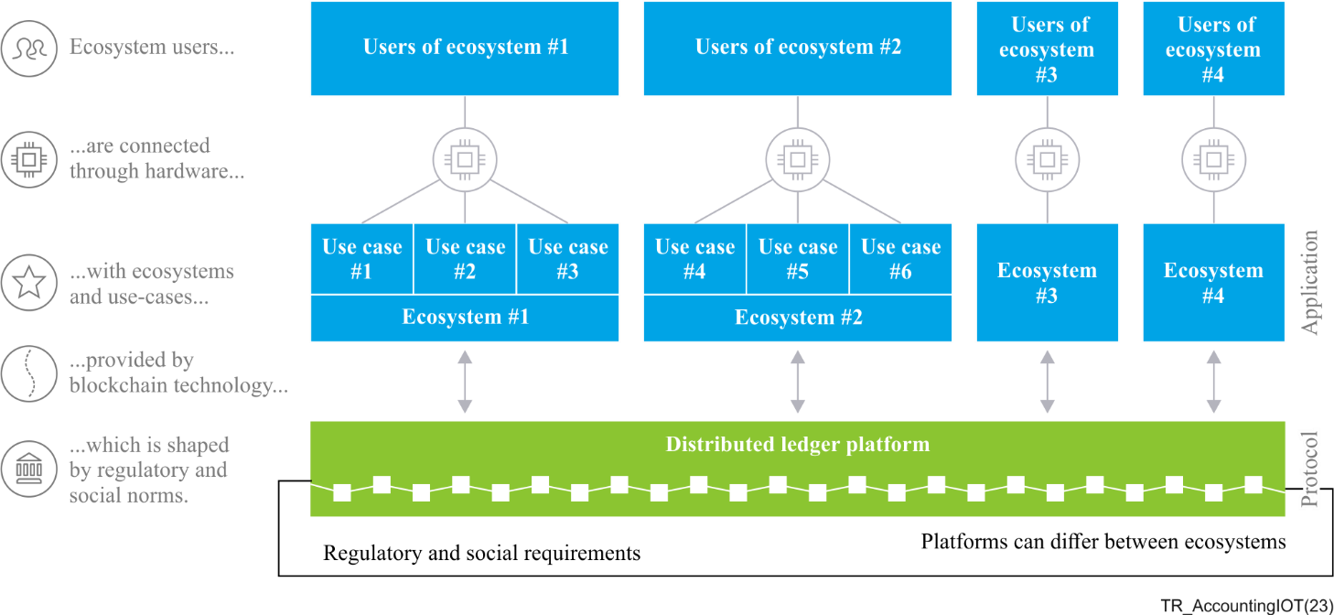
Source: [b-deloitteIoTBlockchain]
Figure 4 – DLT platform as underlying transactional platform connecting IoT ecosystems
The accounting and billing aspects in IoT ecosystems may have to be handled from an integrated point of view rather than a stand-alone approach. The blockchain technology with its embedded features as noted above can act as a solid platform to record the huge number of complex transactions in an IoT application. The DLT can map all kinds of players and their various interactions on a shared fabric with features such as trust and transparency.
When combined with IoT devices, DLT can create a more efficient, transparent, and secure system for accounting and billing. For example, IoT sensors can automatically collect and transmit data on energy consumption to a DLT platform, allowing for real-time tracking and billing of energy usage. The decentralized and tamper-proof nature of DLT ensures that all transactions are recorded accurately and cannot be altered, providing a secure and reliable source of information for auditing and regulatory purposes. Additionally, DLT can enable instant and automated billing and payment processes, reducing the need for manual intervention and increasing the speed and accuracy of financial transactions. Overall, the integration of DLT and IoT may have the potential to transform the accounting and billing domain by providing a more efficient, secure, and transparent system for financial transactions.
One specific use case of DLT technology with IoT in accounting and billing is in the field of smart energy meters. Smart energy meters equipped with IoT sensors can measure energy consumption in real-time and transmit this data to a DLT platform. The DLT platform can then securely store this information, providing a tamper-proof record of energy consumption. This information can then be used for billing purposes, as well as for regulatory reporting and auditing. The use of DLT ensures that all transactions are recorded accurately and cannot be altered, providing a secure and reliable source of information. Additionally, by automating the billing process, DLT and IoT can reduce the potential for human error and increase the speed and efficiency of financial transactions. Overall, this use case demonstrates how DLT and IoT can work together to transform the accounting and billing processes in the energy sector.

10 Concluding remarks
In conclusion, the exponential growth in the access to Internet and advancements in technologies such as 5G, AI, Big Data, Cloud and Edge computing have led to a universe of digital interactions and a dependency on ICT applications. The IoT has transformed our way of living by collecting and transmitting data to enhance lives through efficiencies and seamless experiences.
This Technical Report highlights challenges related to accounting and billing, particularly in the IoT ecosystem. It gives an analysis of the usage of DLT to provide an integrated approach to the management of IoT. The Technical Report also sets out the vital accounting principles that must be embedded in the algorithms of IoT applications in order to create a framework for accounting of things (AoT). DLT helps to take an integrated approach to accountability and billing. There are various challenges in the IoT ecosystem in the domain of accounting, billing and related processes. IoT systems can have long and complex value chains spanning across fragmented business and financial architectures. Such complex systems may lack support for pricing agility demands and compliance to accounting standards. The success of any IoT system will depend on the effective management of accounting aspects, which are critical for ensuring accurate transactions without undue delay and errors.
The accounting and billing aspects in IoT ecosystems may have to be handled from an integrated point of view rather than a stand-alone approach. Blockchain technology with its embedded features as noted above can act as a solid platform to record the huge number of complex transactions in an IoT application.

Bibliography

[b-ITU-T X.1400] Recommendation ITU-T X.1400 (2020), Terms and definitions for distributed ledger technology.
[b-ITU-T Y.4000] Recommendation ITU-T Y.4000/Y.2060 (2012), Overview of the Internet of things.
[b-ITU-T-UnleashingIoT] ITU-T Smart cities & communities (2016), Unleashing the potential of Internet of Things.
[b-deloitteIoTBlockchain] Deloitte Blockchain Institute (2018), IoT powered by Blockchain.
[b-telecomscomarch] telecoms.comarch.com; The new role of billing systems in the Internet of Things.

_______________

