|  |  |  |  |  |
| --- | --- | --- | --- | --- |
|  | | **International Telecommunication Union** | | |
|  | |  | | |
| **ITU-T** | **Technical Report** | |
| TELECOMMUNICATION STANDARDIZATION SECTOR OF ITU | | (15 February 2017) |
|  |  | | | |
|  | **QTR-CICT Survey report on counterfeit ICT devices in Africa region** | | | |
|  |  | | | |

Summary

This technical report contains a survey on Counterfeit ICT Devices in Africa which was aimed at gathering information on challenges, use cases and efforts in place to address the problem of counterfeit ICT devices and collect information from Member States in the Africa to progress the on-going study on Counterfeit ICT devices, in ITU-T Study Group 11 and ITU- D Study Groups. The report explored the perspectives of Africa on counterfeit ICT devices and provides background information on the national initiatives to combat ICT counterfeit devices.

Keywords

Counterfeiting, ICT devices

Change Log

This document contains Version 1 of the ITU-T Technical Report: “Survey report on counterfeit ICT devices in Africa region” approved at the ITU-T Study Group 11 meeting held in Geneva, 15 February 2017.

|  |  |  |
| --- | --- | --- |
| **Editor:** | Isaac Boateng | Tel: +233 302 763434/776621 Fax: +233 302 763449 Email: [isaac.boateng@nca.org.gh](mailto:isaac.boateng@nca.org.gh) |

Table of Contents

[ACKNOWLEDGEMENT 4](#_Toc476292896)

[CHAPTER ONE 7](#_Toc476292897)

[BACKGROUND OF THE STUDY 7](#_Toc476292898)

[1. INTRODUCTION 7](#_Toc476292899)

[1.1 OVERVIEW OF COUNTERFEIT ICT DEVICES 7](#_Toc476292900)

[1.2 IMPACTS OF COUNTERFEIT ICT DEVICES 7](#_Toc476292901)

[1.3 OBJECTIVES OF THE SURVEY 8](#_Toc476292902)

[CHAPTER TWO 9](#_Toc476292903)

[2. METHODOLOGY 9](#_Toc476292904)

[2.1 Design of the Study 9](#_Toc476292905)

[2.2 Population and Sample Size 9](#_Toc476292906)

[2.3 Data type and data collection 9](#_Toc476292907)

[2.4 Data Analysis and Findings 9](#_Toc476292908)

[2.5 Conclusions and Recommendations 9](#_Toc476292909)

[CHAPTER 3 10](#_Toc476292910)

[3. DATA ANALYSIS 10](#_Toc476292911)

[3.1 COMMON PERCEPTIONS OF COUNTERFEIT ICT DEVICES 10](#_Toc476292912)

[3.1.1 The Perceived Understanding of a Counterfeit ICT Device 10](#_Toc476292913)

[3.1.2 Member States’ Definition of Counterfeit ICT Device 10](#_Toc476292914)

[3.1.3 Known Counterfeit ICT Device among Member States 11](#_Toc476292915)

[3.1.4 Patronage of Counterfeit ICT Device among Member States 11](#_Toc476292916)

[3.2 POLICIES, LAWS AND REGULATIONS INCLUDING CONFORMITY ASSESSMENT LAWS 12](#_Toc476292917)

[3.2.1 Policies, Laws & Regulations on Counterfeit ICT Devices 12](#_Toc476292918)

[3.2.2 Effectiveness of Laws and Regulatory Frameworks 12](#_Toc476292919)

[3.2.3 National Bodies to Fight Against Counterfeit ICT Devices 13](#_Toc476292920)

[3.3 Conformity Assessment Laws and Regulations 14](#_Toc476292921)

[3.4 IMPACT ASSESSMENT 15](#_Toc476292922)

[3.4.1 Negative effects of counterfeit ICT devices 15](#_Toc476292923)

[3.4.2 Perceived positive effects of counterfeit ICT devices 16](#_Toc476292924)

[3.5 EXISTING MEASURES AND TECHNIQUES TO COMBAT COUNTERFEIT ICT DEVICES 17](#_Toc476292925)

[3.5.1 Awareness creation and Sensitization 17](#_Toc476292926)

[3.5.2 Perceived level of Awareness Creation and Sensitization 17](#_Toc476292927)

[3.5.3 Need and Extent of Public Education 17](#_Toc476292928)

[3.6 TECHNICAL MEASURES 19](#_Toc476292929)

[3.6.1 Verification of ICT Device Authentication 19](#_Toc476292930)

[3.6.2 Measures in Place to Verify the Authenticity of Devices 19](#_Toc476292931)

[3.6.3 Conformity Assessment Process to Check Market Entry 20](#_Toc476292932)

[3.6.4 Testing Laboratory 20](#_Toc476292933)

[3.6.5 Conformity Assessment to Combat Counterfeit ICT Devices 21](#_Toc476292934)

[3.7 ITU INVOLVEMENT AND THE CREATION OF REGIONAL GROUP 21](#_Toc476292935)

[CHAPTER 4 24](#_Toc476292936)

[4. FINDINGS 24](#_Toc476292937)

[CHAPTER 5 26](#_Toc476292938)

[5. CONCLUSIONS & RECOMMENDATIONS 26](#_Toc476292939)

[5.1 CONCLUSIONS 26](#_Toc476292940)

[5.2 RECOMMENDATIONS 26](#_Toc476292941)

[REFERENCES 28](#_Toc476292942)

[ANNEX 1: TABLES 29](#_Toc476292943)

[APPENDIX 1: QUESTIONNAIRE 34](#_Toc476292944)

[APPENDIX 2: RAW DATA FILE 56](#_Toc476292945)

# ACKNOWLEDGEMENT

***The following people are acknowledged for their contributions to this report.***

**GHANA**

* Clement Oppong-Afriyie
* Priscilla Akosua Darkowa Archer
* Kofi Ntim Yeboah-Kordieh

**ITU HEADQUARTERS**

* Bilel Jamoussi
* Stefano Polidori
* Riccardo Passerini

**ITU REGIONAL OFFICE FOR AFRICA**

* Andrew Rugege
* Chali Tumelo

**ABBREVIATIONS**

2G Second Generation Wireless Telephony

3G Third Generation Wireless Telephony

4G Fourth Generation Wireless Telephony

C&I Conformity and Interoperability

CSPro Census and Survey Processing System

EMI Electromagnetic Immunity

ICT Information and Communications Technology

ITU International Telecommunication Union

ITU-D SG1&2 International Telecommunication Union – Development Sector Study Group 1&2

ITU-TR ITU – Technical Report

ITU-T SG11 International Telecommunication Union – Telecommunication Standardization Sector Study Group 11

QoS Quality of Service

RF Radio Frequency

SPSS Statistical Package for Social Sciences

TRIPS Trade-Related aspects of Intellectual Property Rights

WTO World Trade Organization

**ABSTRACT**

The survey on Counterfeit ICT Devices in Africa was aimed at gathering information on challenges, use cases and efforts in place to address the problem of counterfeit ICT devices and collect information from Member States in the region to progress the on-going study on Counterfeit ICT devices, in ITU-T Study Group 11 and ITU- D Study Groups.

The survey explored the perspectives of Africa on counterfeit ICT devices. It also provides background information on the national initiatives to combat ICT counterfeit devices. The report of the survey is organized into five thematic blocks, as a result of responses obtained from the survey. These themes are:

* Common perceptions of counterfeit ICT devices
* Available Laws, Regulations and Enforcement
* Impact Assessment on counterfeit ICT devices
* Existing measures and techniques to combat counterfeit ICT devices
* ITU involvement and a possible creation of a regional group of ITU-T SG11

***Conclusions from the findings showed among others that:***

* Counterfeit ICT devices are commonly understood to mean “fake and substandard”.
* ICT devices perceived to have been counterfeited are mobile phones, tablets and personal computers.
* Affordability and availability are the major reasons for the larger market and higher patronage of counterfeit ICT devices in the Africa Region.
* ITU’s involvement in addressing the problem of counterfeit ICT devices through its standardisation work is essential.
* Conformity Assessment Schemes can be used one of the tools to combat counterfeit ICT devices.
* Member States recommend the establishment of an ITU-T SG11 Regional Group for Africa. They would support and participate in such group’s activities.

It is therefore concluded from these findings that establishing ITU-T SG11 Regional Group for Africa to provide the regional views and influence ICT standards developments activities, particularly on counterfeit ICT devices, Conformance and Interoperability Testing and other related topics aimed at bridging the ICT digital divide is of essence. This report also recommends improved public sensitization and awareness creation on the negative impacts of counterfeit ICT devices as well as the development of regulatory frameworks to combat counterfeit ICT devices. The report should be used to progress the work currently on-going in ITU-T SG11 Question 8 and Question 11 as well as ITU-D SG 1 & SG 2.

# CHAPTER ONE

# BACKGROUND OF THE STUDY

# INTRODUCTION

Globally, there is a common perception about the influx of counterfeit ICT devices in both developed and developing countries. The Africa Region is not an exception. The challenges posed by this menace to the present ICT age can be devastating – economically, socially, and environmentally. The lack of official study report in African region to trigger ITU’s technical studies and possibly develop Recommendations that could influence decisions and policy directions, leading to solutions to combat counterfeit ICT devices was of interest in commissioning this survey.

During an ITU-T SG11 meeting held on 22 – 29 April, 2015, it was recognised that counterfeit ICT devices pose a lot of challenges in developing countries, particularly the Africa Region. Due to the absence or less available factual findings, SG11 endorsed a proposal to conduct a survey in Africa Region with the aim of gathering empirical information on the nature of the challenges, use cases and efforts in place to address such challenges posed by counterfeit ICT devices. This survey therefore, explored the perspectives of Member States from the Africa Region on the subject of counterfeit ICT devices. The survey was based on questionnaires sent to some selected twenty (20) African countries in the sub-region for which fourteen (14) Member States responded.

## OVERVIEW OF COUNTERFEIT ICT DEVICES

The WTO's Agreement on Trade-Related Aspects of Intellectual Property Rights (the TRIPS Agreement, 1994) defines counterfeit trademark goods as "any goods, including packaging, bearing without authorization a trademark which is identical to the trademark validly registered in respect of such goods, or which cannot be distinguished in its essential aspects from such a trademark, and which thereby infringes the rights of the owner of the trademark in question under the law of the country of importation" (footnote 14 to Article 51). The term "counterfeit" is therefore used in the TRIPS Agreement only in the trademark area. It refers to infringing goods which are defined more precisely than ordinary trademark infringements on the basis that the trademark is identical to or essentially indistinguishable from the original. This text does not touch on the intention behind the use of the counterfeit trademark. It defines a counterfeit product in terms of the closeness of the mark used to a registered product and applies to cases where the goods are the same as for which the trademark is registered. In practice, such infringing goods would typically include cases where a mark is slavishly copied, deliberately to give the impression of identifying a genuine product [1].

## IMPACTS OF COUNTERFEIT ICT DEVICES

Counterfeit products are not usually tested nor approved according to any regulatory requirements that may be applicable. The use of counterfeit products can be extremely dangerous. For example, there are reports of deaths due to the explosion of counterfeit batteries, cases of electrocution and fires caused by chargers, and documented instances of these devices containing high levels of hazardous substances such as lead and cadmium. Counterfeit equipment impact several sectors including manufacturers, operators, consumers and governments through loss of revenues, erosion of brand value, loss of goodwill, network disruptions, poor quality of service (QoS) delivery and risks to public health [2]. Each of these sectors needs to respond quickly and uniquely to address the challenges in order to successfully reduce counterfeiting.

Manufacturers of original devices invest huge sums of money in producing quality devices, only for these devices to get to the market and compete with the counterfeit devices. Manufacturers of counterfeit ICT devices do not pay royalties to the owners of patents and copy rights, denying such owners of their expected returns that triggered the investment. Counterfeit mobile devices pose QoS delivery issues. Studies conducted in India and Brazil have shown that such mobile devices failed standard call attempts, high call drop rates and handover failure [3]. Because counterfeit ICT devices are cheaper, consumers prefer to buy them at the expense of the original devices that are relatively expensive. This directly impacts on the manufacturers’ supply chain of genuine devices. In the mobile phone industry counterfeiters have taken advantage of the strong growth and have circumvented the International Mobile Equipment Identity (IMEI) thus shipping thousands of phones with duplicate IMEI through the unapproved national routes [4].

It is also reported that counterfeit equipment have high levels of hazardous substances like lead and cadmium. They are not subjected to extensive testing (i.e. health and safety, electromagnetic compatibility, low voltage) compared to genuine devices and are not normally type approved hence posing a very high safety risk to consumers. Those devices are normally sold without warranty and this denies the consumers the right to have their devices replaced in case they are faulty which is usually the case, thus counterfeit devices have shorter life span and therefore become expensive to the consumer in the long run.

Governments also lose huge sums of money from taxes because of the activities of counterfeiters in the sense that these products gain entry into the market through informal routes and therefore dealers of these devices do not pay duties and taxes. Government has to spend resources needed for other productive sectors to combat these illegal activities. Because counterfeit devices have shorter life span, they also create electronic waste and thus causing environmental and disposal problems to central governments and local authorities.

It is worth noting that whiles some countries, in the Europe, Asia and the US have implemented systems to combat counterfeit ICT devices to protect their markets, very less is known in the Africa Region. Ukraine in 2009 for instance implemented Automatic Information System for Mobile Terminal Registration (AISMTR) to protect her national market from imports of counterfeit mobile phones [5]. There are other negative impacts of counterfeit ICT devices such as cyber-security related threats, facilitating drug trade, terrorism, jeopardizing consumer privacy, impairing safety of digital transactions etc. [3].

## OBJECTIVES OF THE SURVEY

The objectives of the survey were:

1. To gather information on challenges, use cases and efforts in place to address the problem of counterfeit ICT in Africa.

1. To consider a possible creation of a regional group of ITU-T SG11 in Africa to provide regional views on combating counterfeit ICT devices and C&I testing issues towards Bridging the ICT Standardization Gap between developed and developing countries.

1. To enhance awareness on the impacts of counterfeit ICT devices in the region.

1. To recommend best practices, including regulatory frameworks (in countries where there are none) as well as technical means to combat counterfeit ICT devices.
2. To identify and recommend possible initiatives the ITU could take towards the fight against counterfeit ICT devices.

# CHAPTER TWO

# METHODOLOGY

This section outlines the methodology used in obtaining the relevant data for analysis, conclusion and recommendations.

## Design of the Study

The study employed both quantitative and qualitative techniques to enable the respondents express their views to aid the researcher with detailed data for analysis.

## Population and Sample Size

The survey was conducted on African countries that are members of the ITU. Twenty (20) countries were randomly selected, out of which fourteen (14) Member States namely; Benin, Guinea, Uganda, Zambia, Sudan, Nigeria, Ghana, Kenya, Mozambique, Zimbabwe, Gambia, Ethiopia, Burundi and Tunisia responded. Respondents were mainly Regulators and Ministries, in charge of ICT.

## Data type and data collection

Primary data was collected for the study with the administration of questionnaires to the respondents. The distribution of the questionnaires was possible with the aid of ITU Head Quarters in Geneva through its Africa Regional Office in Addis Ababa whilst respondents’ responses were received via the Internet. The respondents to the questionnaires were mostly Officers from ICT Regulatory Authorities and Ministries in charge of Telecommunications/ICT.

## Data Analysis and Findings

SPSS and CSPro, both statistical data management software were used to collate, process and analyze the data received. The results of this analytical process have been presented using relevant statistical formats such as tables, charts and percentages. The qualitative responses obtained were used to throw more light on the statistical findings.

## Conclusions and Recommendations

Conclusions have been formed out of the findings per the results of the data analysis. Based on these, recommendations have been made to this report.

# CHAPTER 3

# DATA ANALYSIS

This section presents the results of data obtained from the survey. The section is organized into five thematic blocks in perspectives of the study objectives. These include:

* Common perceptions of counterfeit ICT devices
* Available Laws, Regulations and Enforcement
* Impact Assessment on counterfeit ICT devices
* Existing measures and techniques to combat counterfeit ICT devices
* ITU involvement and possible creation of a Regional Group of ITU-T SG11

## COMMON PERCEPTIONS OF COUNTERFEIT ICT DEVICES

### The Perceived Understanding of a Counterfeit ICT Device

There are common perceptions over the definition and understanding of counterfeit ICT devices in the Africa Region. The survey explored such perceptions with respect to whether a counterfeit ICT device also means either of the following: substandard device, fake device, unregistered device or un-authorized device. Fifty percent (50%) of the respondents indicated their understanding of a “counterfeit ICT device” to mean a “fake device”. The figure below presents the results.

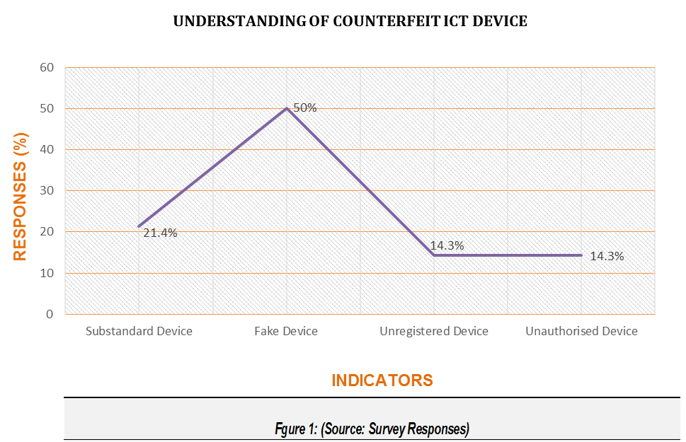

### Member States’ Definition of Counterfeit ICT Device

When respondents were asked to indicate whether their countries have a specific definition for counterfeit ICT Device, only three countries representing 21% were in the affirmative. However, 79% of the remainder representing 11 countries had no definitions. The respondents who responded that there were definitions in their countries did not state what the definitions were however.

|  |  |  |  |
| --- | --- | --- | --- |
| **COUNTRY SPECIFIC DEFINITION OF A COUNTERFEIT ICT DEVICE** | | | |
| RESPONSES | NO OF RESPONSES | (%) RESPONSES | CUMULATIVE PERCENTAGE (%) |
| Yes | 3 | 21.4 | 21.4 |
| No | 11 | 78.6 | 100 |
| Total | 14 | 100 | 0 |
| ***Table 1: Source: Survey responses*** | | | |

### Known Counterfeit ICT Device among Member States

Responses to identify specific types of ICT devices known to have been counterfeited indicated that in general, mobile (2G, 3G & 4G enabled) phones and tablets were the most known counterfeited ICT devices in Africa. The chart below depicts the responses obtained. It could be observed from the chart that 2G, 3G/4G enabled mobile phones (also known as smart phones) as well as tablets were known to be the most counterfeited ICT device commonly found in the markets. The results of this analysis could be found on *figure 2* below.

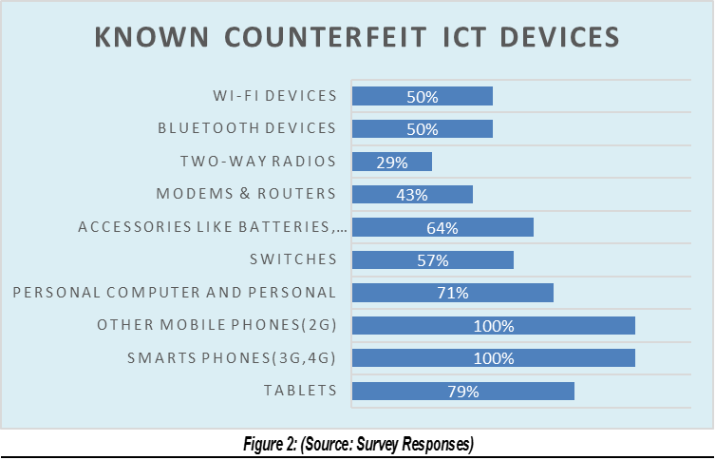

### Patronage of Counterfeit ICT Device among Member States

Responses as to why patronages of counterfeit ICT devices are perceived to be on the upsurge revealed that there are “availability” of such devices in the market. Also “affordability” followed as the next influencing factor. Thus, people patronize the counterfeit ICT devices because they are available and affordable in the market. Figure 3 below presents the summary of such analysis.

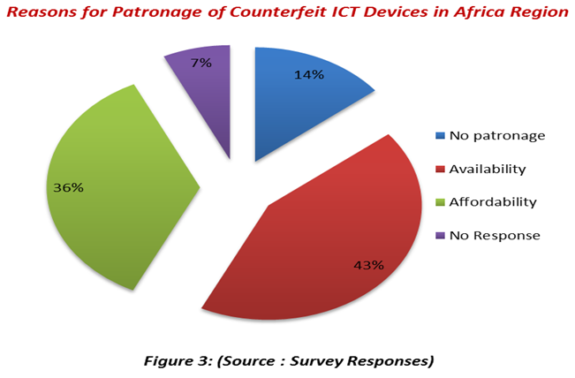

## POLICIES, LAWS AND REGULATIONS INCLUDING CONFORMITY ASSESSMENT LAWS

### Policies, Laws & Regulations on Counterfeit ICT Devices

Table 2 below presents the responses on countries that have national policies, laws and regulations for manufacturing, importation, distribution and usage of ICT devices, which are aimed at combating counterfeit ICT devices. The results indicate a 100% in the affirmative. In Kenya, handling of stolen mobile devices is a crime under “Section 322 of the Penal Code” while Substandard communication devices are prohibited under “Section 9 of the Standards Act, CAP 496”.

|  |  |  |  |
| --- | --- | --- | --- |
| ***Laws and Regulations for Combating Counterfeit ICT Devices*** | | | |
| Responses | No. of Respondents | Percentage (%) | Cumulative Percentage |
| Yes | 14 | 100.0 | 100.0 |
| No | 0 | 0 | 0 |
| Total | 14 | 100 | 100 |
| ***Table 2: (Source: Survey Responses)*** | | | |

### Effectiveness of Laws and Regulatory Frameworks

On the assessment of the effectiveness of those existing laws based on a scale of 1 to 5 with 5 being highly effective and 1 being not effective, 50% of the respondents indicated that their national laws and regulations were effective, 21% of them indicated that their national laws and regulations were highly effective. It was however interesting to also know that 14% of the respondents acknowledged low effectiveness of their national laws with the same percentage being neutral. The analyses of these responses are contained in table 3 hereunder.

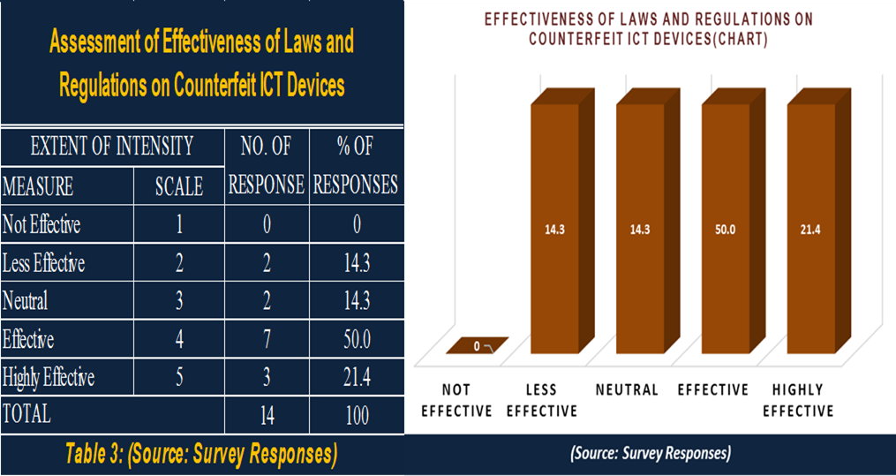

### National Bodies to Fight Against Counterfeit ICT Devices

Table 4 shows responses to whether there were national bodies to fight against counterfeit ICT devices. The results indicate a 100% in the affirmative. That is, all the respondents answered yes – *that there were anti-counterfeiting bodies in place*. The responses also indicated that in most of these countries, the fight against counterfeit in general is made up of stakeholders from Copyright Authorities, Anti-Counterfeit Agencies, National Standards Authorities, Police Service, Revenue Authorities and ICT/Telecom Regulators.

|  |  |  |  |
| --- | --- | --- | --- |
| ***National Bodies to Fight Against Counterfeit ICT Devices*** | | | |
| Responses | No Of Responses | %of Responses | Cumulative % |
| Yes | 14 | 100.0 | 100.0 |
| No | 0 | 0 | 0 |
| ***Table 4: (Source: Survey Responses)*** | | | |

On the assessment of the effectiveness of such national bodies to fight against counterfeit ICT devices based on a scale of 1 to 5 with 5 being highly effective and 1 being not effective, 36% of the respondents indicated that their national bodies were effective in the fight against counterfeit ICT devices whilst 14% indicated that their bodies were not effective. Figure 4 presents these findings.

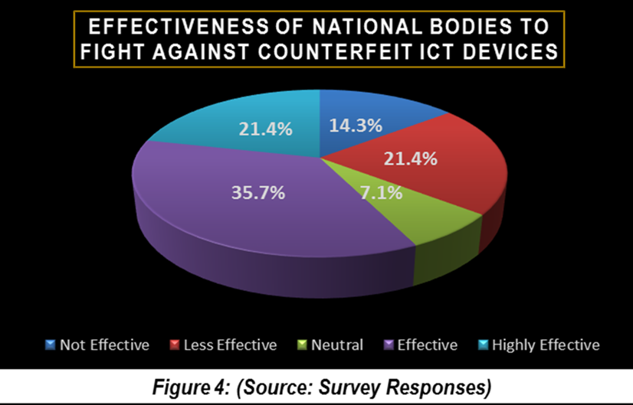

## Conformity Assessment Laws and Regulations

On this issue, 79% of the respondents said that there were laws and regulatory framework that established requirements for ICT devices and services to be legally imported and supplied in the market place whilst 21% of respondents, representing 3 Member States have no such laws and regulations. Figure 5 below shows this assessment while Table 5 presents a list of countries and their relevant laws, regulations and guidelines.

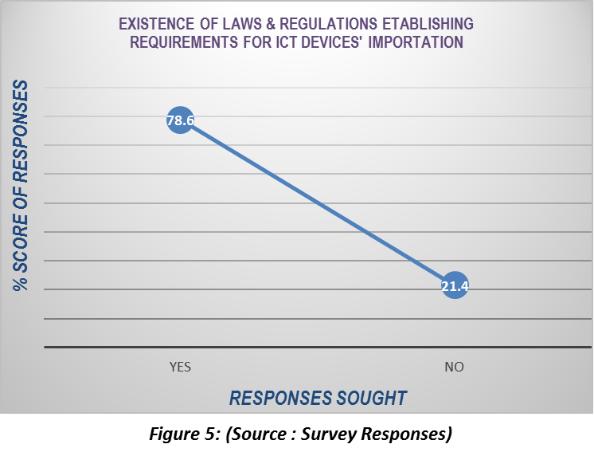

**Table 5: Examples of Existing Conformity Assessment Laws/Regulations/Guidelines in Member States**

|  |  |
| --- | --- |
| COUNTRY | EXISTING LAW/REGULATIONS/GUIDELINES |
| Uganda | Minimum Specifications for STBs And IDTVs, Minimum Standards for Telecom Devices Type Approval Guidelines |
| Gambia | Type approval regulation approved |
| Nigeria | NCC Act, 2003; Type Approval Regulations; Type Approval Guidelines |
| Mozambique | Type approval regulation approved in 2009 |
| Ethiopia | Standards for short Range devices, Technical Specifications for 2G and 3GTerminals  Technical Specifications for corded and cordless Telephones and PABX systems |
| Ghana | Electronic Communications Act, 2008 (Act 775), Electronic Communication Regulations, (LI 1991 of 2011), Type Approval Guidelines, Technical Specifications for 2G and 3G terminals including other short range devices, Minimum Specification for STBs and IDTvs |
| Kenya | Kenya Information and Communications (Import, Type Approval and Distribution of Communications Equipment) Regulations, 2010. |
| Sudan | MRA with Accredited test labs |
|  |  |
| *(Source: Survey Responses)* | |

## IMPACT ASSESSMENT

This section considered both the negative and positive impacts (if any) of counterfeit ICT devices. The data obtained is presented as per the analysis below.

### Negative effects of counterfeit ICT devices

Responses on the negative effects of counterfeit ICT devices showed “infringement on property and copy rights or trademark” and “threat to the public health and safety” as the two effects that adversely impact the use of counterfeit ICT devices, recording 23% each. Figure 6 depicts the analysis of responses obtained.

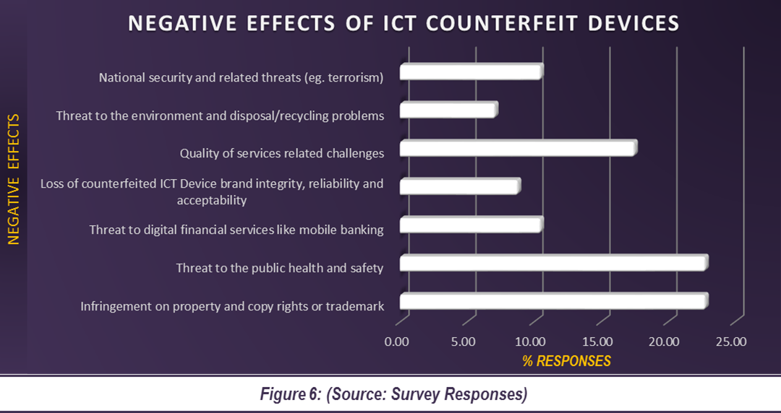

### Perceived positive effects of counterfeit ICT devices

Responses that were sought to identify whether there is/are any positive effect(s) on counterfeit ICT devices recorded as high as 57% for “affordability” and 29% for “increased universal access to ICT and internet”. Figure 7 is a depiction of the responses obtained. The Reason accounting for this were though, not sought for, it may include the uptake of social media by the youth in the region hence encouraging counterfeiters to invest in such affordable ICT devices.

**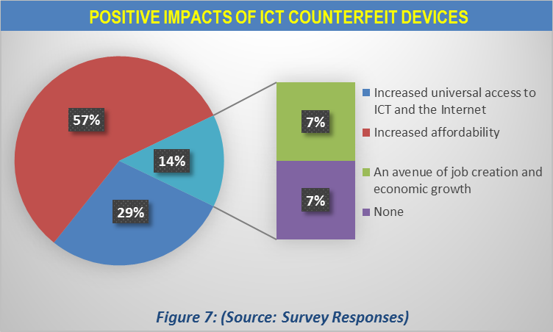**

## EXISTING MEASURES AND TECHNIQUES TO COMBAT COUNTERFEIT ICT DEVICES

This section considers existing measures and techniques that Member States have deployed aimed at combating counterfeit ICT devices in their countries. The researcher’s questionnaires explored the feedback of this issue from the perspective of public awareness creation, technical measures such as testing and device authentication.

### Awareness creation and Sensitization

On this, 71% representing 10 respondents said their countries have public awareness and sensitization programs on counterfeit whilst 29% representing 4 Member States indicated in the negative. Table 6 presents respondents’ views.

### Perceived level of Awareness Creation and Sensitization

On the assessment of the perceived public awareness and sensitization against counterfeit ICT devices based on a scale of 1 to 5 with 5 being very high level of awareness and 1 being very low level of awareness, 36% of Member States responded that their level of public awareness and sensitization against counterfeit ICT devices were very high whilst 7% indicated that there were very low public awareness and sensitization programmes. However, as depicted on Figure 8 below, there was “NO RESPONSES” from 29% of the responding countries.

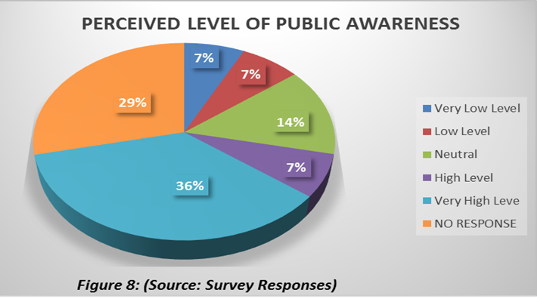

### Need and Extent of Public Education

All of the Member States embraced the need for public education on counterfeit ICT devices as evidenced in the yes/no responses shown below in Table 7.

|  |  |  |  |
| --- | --- | --- | --- |
| **NEED FOR PUBLIC EDUCATION ON**  **COUNTERFEIT ICT DEVICES** | | | |
| Responses | No. of Responses | % of Responses |
| Yes | 14 | 100 |
| No | 0 | 0 |
| TOTAL | 14 | 100 |
| ***Table 7: (Source: Survey Responses)*** | | | |

The extents of such needs for public education were also assessed and 57% of the respondents recommended that there should be highly intensive public education on counterfeit ICT devices in the region as could be seen in Figure 9 hereunder.

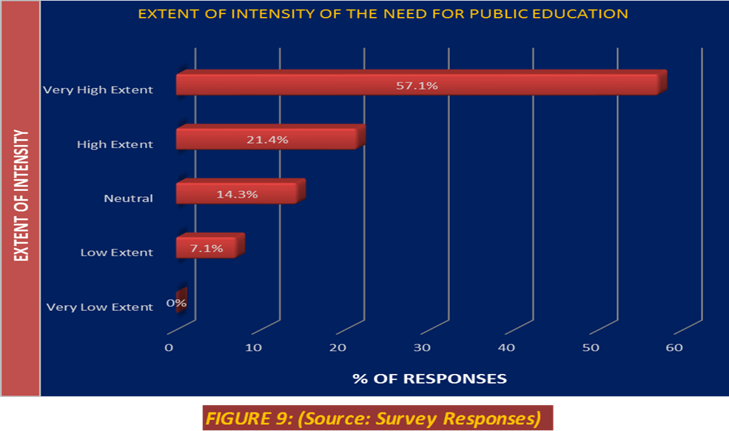

On the issue of ICT anti-counterfeiting fora, which has the potential to support the awareness creation, educate the masses, and act as platforms to help implement policies and laws to check the proliferation of counterfeit ICT devices within the region, 43% of the respondents indicated that they had such fora in place in their countries. However, the remaining 57% without such fora is not encouraging requiring serious attention.

For countries where there are such fora, only two of such respondents could state such forum. For example, in Nigeria, there is no permanent forum but occasionally stakeholders are brought together for the purpose while in Kenya the forum is normally initiated by the Regulator with the involvement of the operators, suppliers and government agencies.



## TECHNICAL MEASURES

### Verification of ICT Device Authentication

On the verification of device authenticity, 64% representing 9 respondents said their countries have no procedures to authenticate ICT devices whilst 36% representing 5 Member States indicated in the affirmative. The data found is analyzed in Table 9 below.



### Measures in Place to Verify the Authenticity of Devices

Responses to identify measures in the place to verify the authenticity of ICT devices showed that “Testing” and “Market Surveillance Activities “were the dominant verification mechanisms used to determine the authenticity of ICT devices. This is represented by figure 10 below with percentage figures of 29% and 22% respectively.

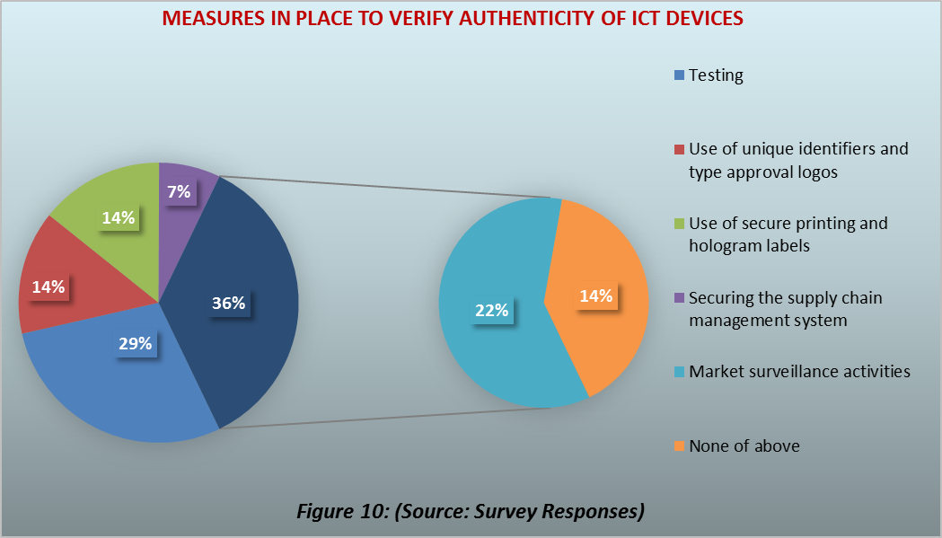

### Conformity Assessment Process to Check Market Entry

The conformity assessment schemes adopted to check market entry of ICT devices were also explored and responses received showed that “Testing & Certification” followed by “Type Approvals” with both assessment schemes receiving 38% and 29% responses respectively are the most widely used. Figure 11 below depicts the analysis of responses obtained.

**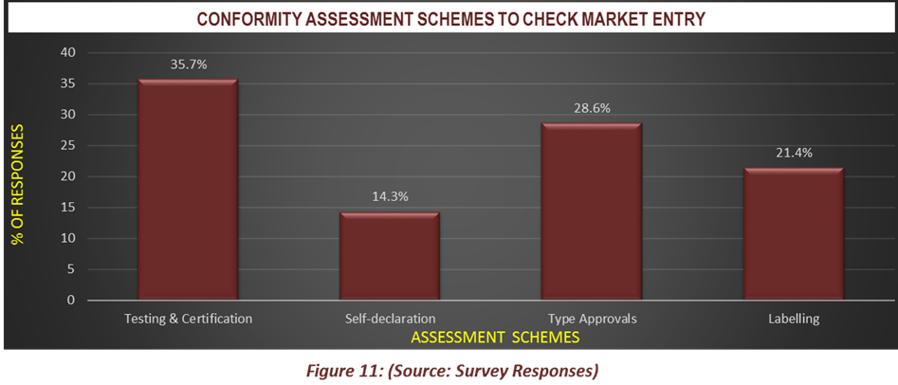**

### Testing Laboratory

On the Testing Labs, 79% representing 11 respondents said their countries have no such ICT Testing Labs whilst 21% representing 3 Member States responded in the affirmative. All the 3 countries affirmed that their labs were capable of performing device authentication. Response from Sudan indicates that the country performs RF Parameter and EMI Testing (Emission) whereas Nigeria indicated a light testing scope on Mobile Phones. This analysis is presented on Table 10.



### Conformity Assessment to Combat Counterfeit ICT Devices

This section looks at the issues of whether or not conformity assessment schemes can be used to combat counterfeit ICT devices. In all, 79% of the respondents said “yes” whilst 21% responded in the negative. This is contained in Table 11(a) below.

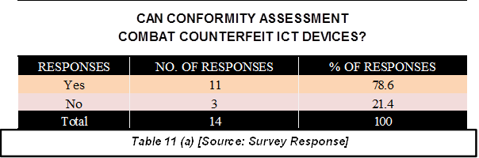

## ITU INVOLVEMENT AND THE CREATION OF REGIONAL GROUP

A question was posed as to the possibility of creating an ITU-T SG11 **Regional Group** for Africa to address and provide the ITU with regional views on ITU-T SG11 studies, including Combating Counterfeiting of ICT devices as well as Conformity and Interoperability testing. The responses showed that there is the need to create such a group. This can be seen from the Table 11(b) below with 100% “yes” responses from all the 14 Member States.

**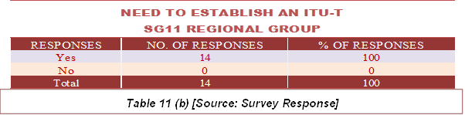**

In addition, 86% of the respondents indicated that they would participate in the group (see Table 14) whilst 79% as in Table 13, also answered “yes” to submitting a joint contribution to the meeting of ITU-T SG11 (June/July 2016) for the creation of such a regional group.

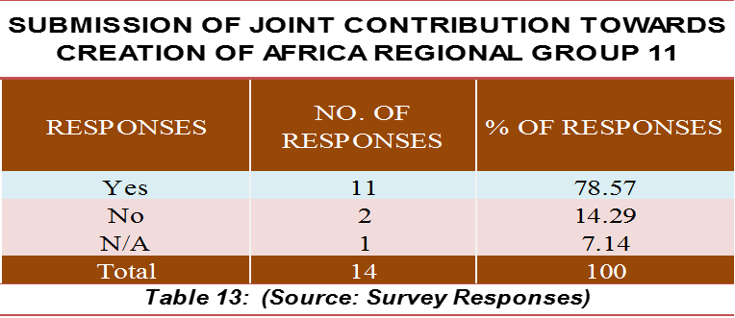



On ITU’s involvement in addressing the problem of counterfeit ICT devices through standardization work, as many as 93% (see Table 12) responded “yes” to the question.



On initiatives that the ITU, could take in the area of ICT counterfeiting, it observed that the initiatives presented on Figure 12 are all relevant to be considered by ITU.

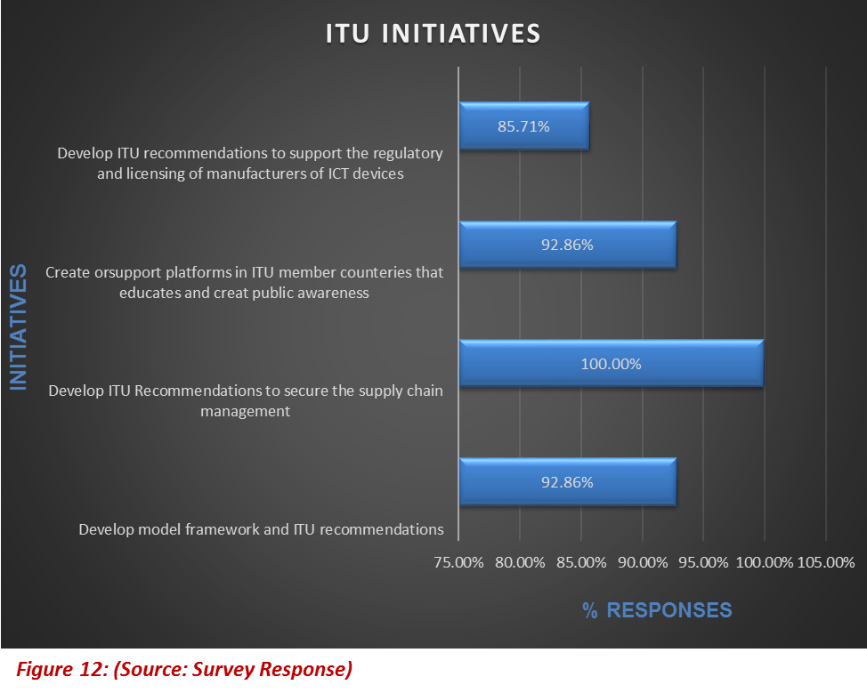

# CHAPTER 4

# FINDINGS

This section presents the findings from the data analysis in Chapter 3 above which was presented using relevant statistical tables, charts and percentages. The findings are outlined below.

1. Though, there are no Member States specific definitions for counterfeit ICT devices, the terms “Fake” and “Sub-standard” are understood to mean “Counterfeit”. From figure 1, it can be seen that while 50% of the respondents understand counterfeit to mean “Fake”, 21% also said counterfeit is the same as “Sub-standard”. Findings in Table 1 show that 79% representing 11 Member States had no specific definitions for counterfeit ICT devices. The 3 countries that responded in affirmative to have such definitions failed to state such definitions.
2. Mobile phones are perceived to be the most counterfeited ICT devices in the region. This is true with all categories of mobile phone devices namely; *2G, 3G, 4G and tablets*. Personal computers also rank high in the perception on counterfeit ICT devices.
3. Counterfeit mobile phones are easily patronized because of their affordability and availability in the markets.
4. There are existing and effective laws, regulations and national anti-counterfeiting forums in place to combat ICT devices in the Africa markets. But it was interesting to note that 28% - (14% + 14%) - respondents were not convinced on the level effectiveness of their national laws to combat ICT counterfeit.
5. Though Member States responded positively to existence of public awareness and sensitization programs on counterfeit ICT devices, it was interesting to know that all of the Member States also recommended for a highly intensive public education programmes to be in place.
6. On ICT anti-counterfeiting forums, which have the potential to support the awareness creation and act as platforms to help implement policies and laws to check the proliferation of counterfeit ICT devices within the region, it is worth noting that 57% of respondents without such forums is not encouraging and requires serious attention.
7. Member States have Laws and Regulatory Frameworks that establish the requirements for ICT devices to be legally imported and supplied in the market place. In addition, “Testing” and “Market Surveillance activities” dominate verification mechanisms for the authenticity of ICT devices. Both mechanisms recorded only 50% of total responses, indicating that much more have to be done in the region.
8. “Testing and Certification” and “Type Approvals” are the dominant assessment schemes adopted to check market entry of ICT devices in the region.
9. Majority of Member States in the region have no “ICT testing laboratory”. This represents 79% (11 countries).
10. Majority of Member States in the region confirmed that conformity assessment schemes can be used to combat counterfeit ICT devices”. This represents 79% (11 countries).
11. All of the Member States are in favor of creating an ITU-T SG11 Regional Group for Africa with over 79% indicating that they would support submitting a join contribution to the meeting of ITU-T SG11 (June/July 2016) for such a group to be established and would participate in the group activities.
12. Majority of Member States are in favor of the need for ITU’s involvement in addressing the problem of counterfeit ICT devices through its standardization work.
13. The following four initiatives were recommended as relevant to be considered by ITU:

* Develop model framework and ITU Recommendations
* Develop ITU Recommendations to secure the supply chain management
* Create or support platforms in ITU member countries that educates and create public awareness
* Develop ITU recommendations to support the regulatory and licensing of manufacturers of ICT devices.

# CHAPTER 5

# CONCLUSIONS & RECOMMENDATIONS

## CONCLUSIONS

Based on the findings presented in chapter four, the following conclusions have been arrived at.

1. Counterfeit ICT devices are considered “fake and substandard” as per the understanding of the respondents in the Africa Region.
2. ITU’s involvement in addressing the problem of counterfeit ICT devices through its standardization work is essential.
3. ICT Devices perceived to have been counterfeited are mobile phones and personal computers. The reasons causing this situation were not identified however. In the researcher’s view, it is believed that the advent of social media and its acceptability by majority of the African youth could be among the key reasons for counterfeit mobile phones and personal computers. Also smart phones, tablets and personal computers are the most portable ICT devices used for modern data communications. As such there are high demands for them and counterfeiters have taken advantage of the demand.
4. Counterfeit mobile phones are easily patronised because of their affordability and availability in the markets. It is the view of the researcher that in this modern day, people cannot move without access to communication services. Therefore, once people can easily get access to counterfeit phones, due to their affordability, they would acquire and use them irrespective of the negative effects on health, safety and the environment.
5. The existence of policies, laws, regulations and national anti-counterfeiting fora show the preparedness of Member States to fight against the influx of counterfeit ICT devices.
6. Much public awareness could be explored with the use of national ICT anti-counterfeiting fora.
7. Member States have Laws and Regulatory Frameworks for “Testing” and “Market Surveillance activities” before and after ICT devices are imported and supplied. This is evident in the application of “Type Approvals” procedures and other assessment schemes.
8. Majority of Member States in the region have no “ICT testing laboratory”. This requires an investment in the areas of ICT testing laboratories.
9. Conformity assessment schemes can be used to combat counterfeit ICT devices.
10. Member States recommend the establishment of an ITU-T SG11 Regional Group for Africa and would support and participate in such group activities.

## RECOMMENDATIONS

1. Since most of the Member States in the Africa Region have no definitions for counterfeit ICT devices, it is recommended for the ITU to adopt the definition in the TRIPS agreement or develop its own standard definition for counterfeit ICT devices to help the industry and avoid the seaming confusion.
2. Manufacturers of genuine products should take into account in their production, the financial constraint in developing countries particularly those in the Africa Region. They could produce authentic devices that are “affordable”, ensuring their “availability” to aid combating ICT devices.
3. There should be effective implementation of laws and regulations including effective awareness creation and sensitization to make counterfeit ICT equipment production, distribution and usage not attractive. Also national anti-counterfeiting forums to support the awareness creation and act as platforms to help implement policies and laws to check the proliferation of counterfeit ICT devices within the region should also be encouraged.
4. Much more need to be done on Market Surveillance activities and Type Approvals in the region. For example, there should be constant validation of ICT devices at the ports of entry before they are allowed in the market place. The Ukrainian solution could be a very good approach to deter/check those devices that come through the unapproved routes. This will require a well-coordinated and committed effort among stakeholders like customs, police, regulators, standard and IPR authorities
5. ICT equipment testing laboratory is required in this region to authenticate devices and give assurance to the general public. The ITU and other donor partners in this case should help by supporting Member States to establish same. This should be Government, or private sector led initiatives, at least for the benefit of the citizenry.
6. There is the need for ITU-T SG11 regional group for Africa to be established to provide the regional views to influence ICT standards development, particularly on the subject of counterfeit ICT devices, Conformance, Interoperability testing and other related topics.
7. There should be sub-regional or regionally harmonized ICT standards to facilitate regional trade. In this way, countries that have testing laboratories could have mutual recognition arrangements (MRA) at least, to enable those without labs benefit from the few established ones in the region. This could reduce the immediate huge cost of investing in building test labs while considering long term plans to expand existing facilities.
8. The initiatives contained in the conclusion are recommended as relevant for ITU’s consideration.

# REFERENCES

[1] WTO – TRIPS Definition on Counterfeit Devices” as cited in ITU Technical Report on Counterfeit ICT Devices, December 2015.

[2] Summary of Discussions at ITU’s Event on “Combating Counterfeit and Substandard ICT Devices’," in *ITU WORKSHOP ON COUNTERFEIT ICT DEVICES*, GENEVA, 2014, p. 1.

[3] MMF Counterfeit Phones EN,” [Online]. Available: http://spotafakephone.com/docs/eng/MMF\_CounterfeitPhones\_EN.pdf.

[4] Framework for Combating the Importation, Supply and Use of Counterfeit / Substandard Terminals in The EACO Member States," EACO, Kigali.

[5] Ukraine’s 2009 Automatic Information System for Mobile Terminal Registration (AISMTR) as cited in ITU Technical Report Counterfeit ICT Devices.”

# ANNEX 1: TABLES

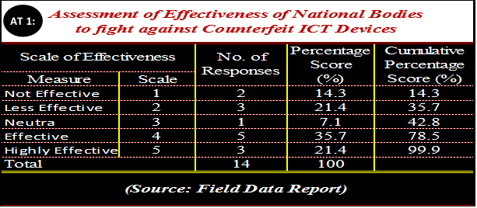

**AT 2:**



**AT 3**

**AT 4**

AT 5

AT 6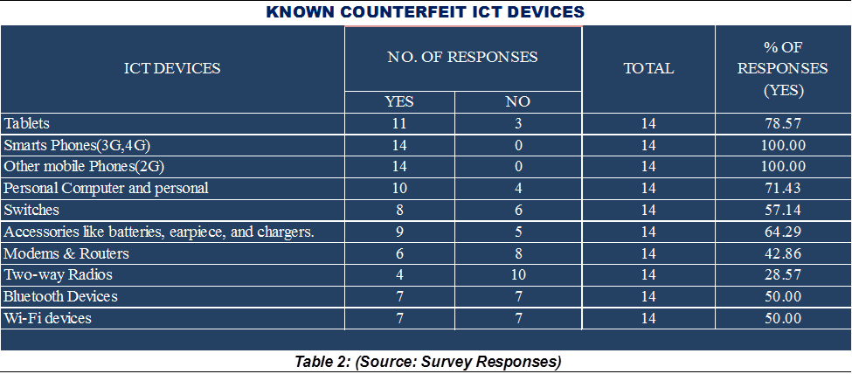

AT 7

**AT 8**



**AT 9**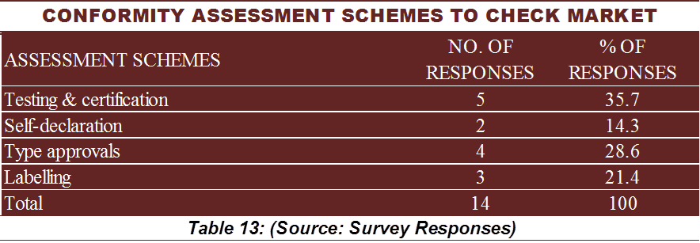

**AT 10**

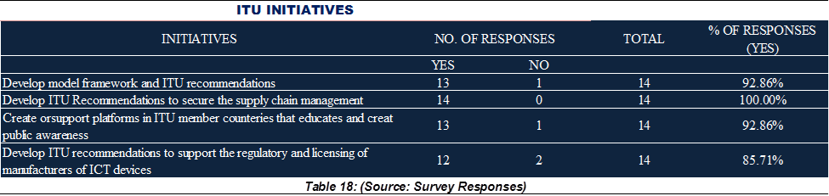

# APPENDIX 1: QUESTIONNAIRE

|  |  |  |
| --- | --- | --- |
| itu_logo | **International telecommunication union** |  |

**QUESTIONNAIRE:**

**ITU SURVEY ON COUNTERFEIT ICT DEVICES IN AFRICA REGION**

***PART 1: TO BE COMPLETED BY ICT MINISTRIES/REGULATORY AUTHORITIES***

***PART 2: TO BE COMPLETED BY OPERATORS & DEALERS IN ICT DEVICES***

***PART 3: TO BE COMPLETED BY CONSUMER GROUPS***

***PLEASE SUBMIT YOUR REPLY BY 15 MARCH 2016 TO:***

***Isaac BOATENG, vice-chairman ITU-T SG11 ( [isaac.boateng@nca.org.gh](mailto:isaac.boateng@nca.org.gh) ;*** [***tsbsg11@itu.int***](mailto:tsbsg11@itu.int)***)***

***[December, 2015]***

***PART 1: [TO BE COMPLETED BY ICT MINISTRIES/REGULATORY AUTHORITIES]***

FORM TO BE FILLED IN BY THE FOCAL POINT

It is my consent to complete the following questionnaires with the assurance that the information provided herein shall be treated confidentially and will be solely used for the purpose of this survey.

COUNTRY: \_\_\_\_\_\_\_\_\_\_\_\_\_\_\_\_\_\_\_\_\_\_\_\_\_\_\_\_\_\_\_\_\_\_\_\_\_\_\_\_\_\_\_\_\_\_\_\_\_\_\_\_\_\_\_\_\_\_\_\_\_\_\_\_\_\_\_\_\_\_\_\_\_\_\_\_\_\_\_\_

Name of Respondent: \_\_\_\_\_\_\_\_\_\_\_\_\_\_\_\_\_\_\_\_\_\_\_\_\_\_\_\_\_\_\_\_\_\_\_\_\_\_\_\_\_\_\_\_\_\_\_\_\_\_\_\_\_\_\_\_\_\_\_\_\_\_\_\_\_\_\_\_\_\_\_\_

Your job title: \_\_\_\_\_\_\_\_\_\_\_\_\_\_\_\_\_\_\_\_\_\_\_\_\_\_\_\_\_\_\_\_\_\_\_\_\_\_\_\_\_\_\_\_\_\_\_\_\_\_\_\_\_\_\_\_\_\_\_\_\_\_\_\_\_\_\_\_\_\_\_\_\_\_\_\_\_\_\_\_

Name of Organisation: \_\_\_\_\_\_\_\_\_\_\_\_\_\_\_\_\_\_\_\_\_\_\_\_\_\_\_\_\_\_\_\_\_\_\_\_\_\_\_\_\_\_\_\_\_\_\_\_\_\_\_\_\_\_\_\_\_\_\_\_\_\_\_\_\_\_\_\_\_\_\_\_

Which of the following ICT class does your organisation belong to?

ICT Regulatory Agency



Ministry in charge of ICT



EMAIL ADDRESS:\_\_\_\_\_\_\_\_\_\_\_\_\_\_\_\_\_\_\_\_\_\_\_\_\_\_\_\_\_\_\_\_\_\_\_\_\_\_\_\_\_\_\_\_\_\_\_\_\_\_\_\_\_\_\_\_\_\_\_\_\_\_\_\_\_\_\_\_\_\_

Tel: \_\_\_\_\_\_\_\_\_\_\_\_\_\_\_\_\_\_\_\_\_\_\_\_\_\_\_\_\_\_\_\_\_\_\_\_\_\_\_\_\_\_\_\_\_\_

***Please tick (√) your response in the box preceding or following it, where applicable.***

**GENERAL ISSUES ON ICT AND COUNTERFEIT DEVICES**

1. (a) What is your understanding of a ***counterfeit*** *ICT* device? *(Please tick(√) all that applies).*

Sub-standard device.



Fake device.



Unregistered device.



Unauthorised device.



Others, *please specify*: \_\_\_\_\_\_\_\_\_\_\_\_\_\_\_\_\_\_\_\_\_\_\_\_\_\_\_\_\_\_\_\_\_\_\_\_\_\_\_\_\_\_\_\_\_\_\_\_\_\_\_\_\_\_\_\_\_\_\_



1. (b) Is there a definition of ***counterfeit*** *ICT* device in your country and if so where is this definition contained?

Yes.



No.



*If yes, please specify*:\_\_\_\_\_\_\_\_\_\_\_\_\_\_\_\_\_\_\_\_\_\_\_\_\_\_\_\_\_\_\_\_\_\_\_\_\_\_\_\_\_\_\_\_\_\_\_\_\_\_\_\_\_\_\_\_\_\_\_\_\_\_

1. Are you aware of any counterfeit ICT device in your country?

Yes.



No.



1. Which of the following ICT devices do you know have been counterfeited? *Please tick (√) all that applies in the table below*.

|  |  |
| --- | --- |
| Tablets |  |
| Smart phones (3G, 4G) |  |
| Other mobile phones (2G) |  |
| Personal computers and Note Books |  |
| Switches |  |
| Accessories like batteries, earpiece, and chargers. |  |
| Modems and Routers |  |
| Two-way radios |  |
| Bluetooth devices |  |
| Wi-Fi devices |  |
| Others *(please specify below):* | |
|  | |
|  | |

1. Do you believe that there is patronage of counterfeit ICT devices in your country? If so, in your view, what is the motive for the patronage? Please tick all that applies

There is not patronage in my country



Availability



Affordability



Multi-functionality



Others, *please specify*: \_\_\_\_\_\_\_\_\_\_\_\_\_\_\_\_\_\_\_\_\_\_\_\_\_\_\_\_\_\_\_\_\_\_\_\_\_\_\_\_\_\_\_\_\_\_\_\_\_\_\_\_\_\_\_\_\_\_\_\_\_\_\_\_\_\_\_



1. What have been the ***negative*** effects of counterfeit ICT devices in your country? *Please tick (√) all that applies in the table below.*

|  |  |
| --- | --- |
| Infringement on property and copy rights or trademarks. |  |
| Threat to public health and safety. |  |
| Threat to digital financial services like mobile banking. |  |
| Loss of the counterfeited ICT brand integrity, reliability and acceptability. |  |
| Quality of service related challenges |  |
| Threat to the environment and disposal/recycling problems |  |
| National security related threats (e.g. terrorism) |  |
| Other socio-economic effects., *please specify:*   \_\_\_\_\_\_\_\_\_\_\_\_\_\_\_\_\_\_\_\_\_\_\_\_\_\_\_\_\_\_\_\_\_\_\_\_\_\_\_\_\_\_\_\_\_\_\_\_\_\_\_\_\_\_\_\_\_\_\_\_\_\_\_\_\_\_\_\_\_\_\_\_\_\_\_\_\_\_\_\_\_  \_\_\_\_\_\_\_\_\_\_\_\_\_\_\_\_\_\_\_\_\_\_\_\_\_\_\_\_\_\_\_\_\_\_\_\_\_\_\_\_\_\_\_\_\_\_\_\_\_\_\_\_\_\_\_\_\_\_\_\_\_\_\_\_\_\_\_\_\_\_\_\_\_\_\_\_\_\_\_\_\_\_\_ | |

1. (a) Do you have any public awareness programme on counterfeit ICT devices in your country?

Yes.



No.



***[Please skip question 6(b) if you answered No to question 6(a) above]***

6. (b) If ***Yes*** to question 6(a), what do you perceive to be the level of public awareness?   
(*Please indicate a number on a scale of* 1 *to* 5*, with 5 being Very high and* 1 *being very low).*



1. (a) Do you consider there is a need for public education on the importation, distribution and usage of counterfeit ICT devices and the problems they pose in your country?

Yes.



No.



***[Please skip question 7(b) if you answered No to question 7(a) above]***

7. (b) To what extent do you consider the need for such public education described in 7(a) above?

*(Please indicate your rating* by *circling a number on a scale of* 1 *to* 5*, with 5 being highly intensive and* 1 *being not intensive).*



1. Do you perceive any ***positive*** impact of counterfeiting ICT devices and accessories, if so which? (*Please tick (√) all that applies).*

Increased universal access to ICT and the Internet



Increased affordability



An avenue of job creation and economic growth



None



Others, (please specify) \_\_\_\_\_\_\_\_\_\_\_\_\_\_\_\_\_\_\_\_\_\_\_\_\_\_\_\_\_\_\_\_\_\_\_\_\_\_\_\_\_\_\_\_\_\_\_\_\_\_\_\_\_\_\_\_\_\_\_\_\_\_\_



1. Are there any ICT ***anti-counterfeit forums*** in your country?

Yes.



No.



If yes, please list them \_\_\_\_\_\_\_\_\_\_\_\_\_\_\_\_\_\_\_\_\_\_\_\_\_\_\_\_\_\_\_\_\_\_\_\_\_\_\_\_\_\_\_\_\_\_\_\_\_\_\_\_\_\_\_\_\_\_\_\_\_\_\_\_

\_\_\_\_\_\_\_\_\_\_\_\_\_\_\_\_\_\_\_\_\_\_\_\_\_\_\_\_\_\_\_\_\_\_\_\_\_\_\_\_\_\_\_\_\_\_\_\_\_\_\_\_\_\_\_\_\_\_\_\_\_\_\_\_\_\_\_\_\_\_\_\_\_\_\_\_\_\_\_\_\_\_\_\_\_\_\_\_

1. (a) Is there any national body in your country to fight against the proliferation of the counterfeit ICT

devices?

Yes.



No.



If yes, please specify which:\_\_\_\_\_\_\_\_\_\_\_\_\_\_\_\_\_\_\_\_\_\_\_\_\_\_\_\_\_\_\_\_\_\_\_\_\_\_\_\_\_\_\_\_\_\_\_\_\_\_\_\_\_\_\_\_\_\_\_

10. (b) If yes, how effective is this national body? (*Please indicate a number on a scale of* 1 *to* 5*, with 5 being highly effective and* 1 *being highly ineffective to indicate your rating on 10(a) above.)*



1. Are there national policies and laws or statutory enactments on the manufacturing, importation, distribution and usage of ICT devices in your country?

Yes.



No.



*If Yes, please list the main ones:.\_\_\_\_\_\_\_\_\_\_\_\_\_\_\_\_\_\_\_\_\_\_\_\_\_\_\_\_\_\_\_\_\_\_\_\_\_\_\_\_\_\_\_\_\_\_\_\_\_\_\_\_\_\_\_\_\_\_\_\_\_\_\_\_\_\_\_\_\_\_*

*\_\_\_\_\_\_\_\_\_\_\_\_\_\_\_\_\_\_\_\_\_\_\_\_\_\_\_\_\_\_\_\_\_\_\_\_\_\_\_\_\_\_\_\_\_\_\_\_\_\_\_\_\_\_\_\_\_\_\_\_\_\_\_\_\_\_\_\_\_\_\_\_\_\_\_\_\_\_\_\_\_\_\_\_\_\_\_\_\_\_\_\_\_\_\_\_\_\_\_\_\_\_\_\_\_\_\_\_\_\_\_\_\_\_\_\_\_\_\_\_\_\_\_\_\_\_\_\_\_\_\_\_\_\_\_\_\_\_\_\_\_\_\_\_\_\_\_\_\_\_\_\_\_\_\_\_\_\_\_\_\_\_\_\_\_\_\_\_\_\_\_\_\_\_\_\_\_\_\_\_\_\_\_\_\_\_\_\_\_\_\_\_\_\_\_\_\_\_\_\_\_\_\_\_\_\_\_\_\_\_\_\_\_\_\_\_*

1. If yes to question 11 above, how effective are these laws and statutory enactments in combating counterfeit ICT devices in your country? *(Please indicate a number on a scale of* 1 *to* 5*, with 5 being highly effective and* 1 *being not effective).*



1. (a) Is there any legal framework and regulation which protects the intellectual property rights of manufacturers and authorised dealers of ICT devices in your country?

Yes.



No.



If Yes, which one(s)? \_\_\_\_\_\_\_\_\_\_\_\_\_\_\_\_\_\_\_\_\_\_\_\_\_\_\_\_\_\_\_\_\_\_\_\_\_\_\_\_\_\_\_\_\_\_\_\_\_\_\_\_\_\_\_\_\_\_\_\_\_\_\_\_\_\_\_\_\_\_\_\_\_\_\_\_\_\_\_\_\_\_\_\_ \_\_\_\_\_\_\_\_\_\_\_\_\_\_\_\_\_\_\_\_\_\_\_\_\_\_\_\_\_\_\_\_\_\_\_\_\_\_\_\_\_\_\_\_\_\_\_\_\_\_\_\_\_\_\_\_\_\_\_\_\_\_\_\_\_\_\_\_\_\_\_\_\_\_\_\_\_\_\_\_\_\_\_\_

13. (b) If yes, what measures have been put in place to enforce the framework and regulation? Please specify below:

i. \_\_\_\_\_\_\_\_\_\_\_\_\_\_\_\_\_\_\_\_\_\_\_\_\_\_\_\_\_\_\_\_\_\_\_\_\_\_\_\_\_\_\_\_\_\_\_\_\_\_\_\_\_\_\_\_\_\_\_\_\_\_\_\_\_\_\_\_\_\_\_\_\_\_\_\_\_\_\_\_\_\_\_\_\_\_\_\_

ii. \_\_\_\_\_\_\_\_\_\_\_\_\_\_\_\_\_\_\_\_\_\_\_\_\_\_\_\_\_\_\_\_\_\_\_\_\_\_\_\_\_\_\_\_\_\_\_\_\_\_\_\_\_\_\_\_\_\_\_\_\_\_\_\_\_\_\_\_\_\_\_\_\_\_\_\_\_\_\_\_\_\_\_\_\_\_\_

iii. \_\_\_\_\_\_\_\_\_\_\_\_\_\_\_\_\_\_\_\_\_\_\_\_\_\_\_\_\_\_\_\_\_\_\_\_\_\_\_\_\_\_\_\_\_\_\_\_\_\_\_\_\_\_\_\_\_\_\_\_\_\_\_\_\_\_\_\_\_\_\_\_\_\_\_\_\_\_\_\_\_\_\_\_\_\_\_

1. (a) Is the authenticity of ICT devices verified in your country?

Yes.



No.



14 (b) If ***Yes***, what measures are in place to verify? (*Please tick (√) all that applies)*

|  |  |
| --- | --- |
| Testing |  |
| Use of unique identifiers and type approval logos |  |
| Use of secure printing and hologram labels |  |
| Securing the supply chain management systems |  |
| Market surveillance activities |  |
| Databases and blocking |  |
| Others please specify\_\_\_\_\_\_\_\_\_\_\_\_\_\_\_\_\_\_\_\_\_\_\_\_\_\_\_\_\_\_\_\_\_\_\_  \_\_\_\_\_\_\_\_\_\_\_\_\_\_\_\_\_\_\_\_\_\_\_\_\_\_\_\_\_\_\_\_\_\_\_\_\_\_\_\_\_\_\_\_\_\_\_\_\_\_\_\_\_\_\_\_\_\_\_  \_\_\_\_\_\_\_\_\_\_\_\_\_\_\_\_\_\_\_\_\_\_\_\_\_\_\_\_\_\_\_\_\_\_\_\_\_\_\_\_\_\_\_\_\_\_\_\_\_\_\_\_\_\_\_\_\_\_\_ |  |

1. (a) Do you have information about legally sold ICT Devices (Smartphones, 2G Phones)?

Yes.



No.



15 (b) If yes, please provide the following time series of value of sales (in USD) and/or units sold:

|  |  |  |  |  |  |  |  |  |  |  |  |  |  |  |
| --- | --- | --- | --- | --- | --- | --- | --- | --- | --- | --- | --- | --- | --- | --- |
| Item sold | 2008 | | 2009 | | 2010 | | 2011 | | 2012 | | 2013 | | 2014 | |
| USD | Units | USD | Units | USD | Units | USD | Units | USD | Units | USD | Units | USD | Units |
| Total Smartphones (all brands) |  |  |  |  |  |  |  |  |  |  |  |  |  |  |
| Older phones (2G all brands) |  |  |  |  |  |  |  |  |  |  |  |  |  |  |

**CONFORMITY AND INTEROPERABILITY**

1. (a) Is there any legal and regulatory framework which establishes technical requirements for ICT devices and services to be legally imported and supplied in the marketplace?

Yes.



No.



16. (b) If yes, Please specify below:

i. \_\_\_\_\_\_\_\_\_\_\_\_\_\_\_\_\_\_\_\_\_\_\_\_\_\_\_\_\_\_\_\_\_\_\_\_\_\_\_\_\_\_\_\_\_\_\_\_\_\_\_\_\_\_\_\_\_\_\_\_\_\_\_\_\_\_\_\_\_\_\_\_\_\_\_\_\_\_\_\_\_\_\_\_\_\_\_\_

ii. \_\_\_\_\_\_\_\_\_\_\_\_\_\_\_\_\_\_\_\_\_\_\_\_\_\_\_\_\_\_\_\_\_\_\_\_\_\_\_\_\_\_\_\_\_\_\_\_\_\_\_\_\_\_\_\_\_\_\_\_\_\_\_\_\_\_\_\_\_\_\_\_\_\_\_\_\_\_\_\_\_\_\_\_\_\_\_

iii. \_\_\_\_\_\_\_\_\_\_\_\_\_\_\_\_\_\_\_\_\_\_\_\_\_\_\_\_\_\_\_\_\_\_\_\_\_\_\_\_\_\_\_\_\_\_\_\_\_\_\_\_\_\_\_\_\_\_\_\_\_\_\_\_\_\_\_\_\_\_\_\_\_\_\_\_\_\_\_\_\_\_\_\_\_\_\_

1. Which of these Conformity Assessment Schemes is/are adopted for ICT devices’ market entry in your country? *Please tick (√) all that applies in the table below.*

|  |  |
| --- | --- |
| Testing & Certification |  |
| Self-declaration |  |
| Type approvals |  |
| Labelling |  |
| Use of proxies such as ISO/IEC, FCC, etc. |  |

1. (a) Do you have any ICT testing laboratory in your country?

Yes.



No.



18. (b) If yes to 18 (a), please specify the scope of testing.

i. \_\_\_\_\_\_\_\_\_\_\_\_\_\_\_\_\_\_\_\_\_\_\_\_\_\_\_\_\_\_\_\_\_\_\_\_\_\_\_\_\_\_\_\_\_\_\_\_\_\_\_\_\_\_\_\_\_\_\_\_\_\_\_\_\_\_\_\_\_\_\_\_\_\_\_\_\_\_\_\_\_\_\_\_\_\_\_\_\_\_\_\_\_\_\_\_\_\_\_\_\_

ii. \_\_\_\_\_\_\_\_\_\_\_\_\_\_\_\_\_\_\_\_\_\_\_\_\_\_\_\_\_\_\_\_\_\_\_\_\_\_\_\_\_\_\_\_\_\_\_\_\_\_\_\_\_\_\_\_\_\_\_\_\_\_\_\_\_\_\_\_\_\_\_\_\_\_\_\_\_\_\_\_\_\_\_\_\_\_\_\_\_\_\_\_\_\_\_\_\_\_\_\_

iii. \_\_\_\_\_\_\_\_\_\_\_\_\_\_\_\_\_\_\_\_\_\_\_\_\_\_\_\_\_\_\_\_\_\_\_\_\_\_\_\_\_\_\_\_\_\_\_\_\_\_\_\_\_\_\_\_\_\_\_\_\_\_\_\_\_\_\_\_\_\_\_\_\_\_\_\_\_\_\_\_\_\_\_\_\_\_\_\_\_\_\_\_\_\_\_\_\_\_\_

1. Is the testing laboratory and process capable of device authentication?

Yes.



No.



1. Do you think Conformity Assessment Schemes can be used to combat counterfeit ICT devices?

Yes.



No.



**ADDRSSING COUNTERFEIT ICT DEVICE PROBLEM REGIONALLY**

1. (a) Do you think there is a need to establish an ITU-T SG11 **Regional Group** for Africa to address and provide the ITU with regional views on ITU-T SG11 studies, including Combating Counterfeiting of ICT devices and addressing Conformity and Interoperability issues?

Yes.



No.



21 (b) Would you participate in the work of such a group?

Yes.



No.



21 (c) Would you be interested in submitting a joint contribution from African ITU Members to the meeting of ITU-T SG11 (June/July 2016) to request the establishment of such a Regional group

Yes.



No.



**ADDRSSING COUNTERFEIT ICT DEVICE PROBLEM GLOBALLY**

1. Is your Country a signatory to any intellectual property right and ICT anti-counterfeit international convention?

Yes.



No.



1. Do you think ITU may help in addressing the problem of counterfeit ICT devices through standardization in ITU-T?

Yes.



No.



1. What initiatives the ITU, as a UN body, could take a lead in the area of ICT counterfeiting? Please check what applies:

Develop model framework and ITU Recommendations to combating ICT counterfeiting



Develop ITU Recommendations to secure the supply chain management (from manufacturing, importation, distribution and marketing).



Create or support platforms in ITU member countries that educate and create public awareness of the influx of counterfeit ICT devices and the dangers they pose.



Develop ITU Recommendations to support the regulation and licensing of manufacturers of ICT devices.



Others please specify…\_\_\_\_\_\_\_\_\_\_\_\_\_\_\_\_\_\_\_\_\_\_\_\_\_\_\_\_\_\_\_\_\_\_\_\_\_\_\_\_\_\_\_\_\_\_\_\_\_\_\_\_\_\_\_\_\_\_\_\_\_\_\_\_\_\_\_\_\_\_\_\_\_\_



***PART 2: [TO BE COMPLETED BY OPERATORS & DEALERS IN ICT DEVICES]***

FORM TO BE FILLED IN BY THE FOCAL POINT

It is my consent to complete the following questionnaires with the assurance that the information provided herein shall be treated confidentially and will be solely used for the purpose of this survey.

COUNTRY: \_\_\_\_\_\_\_\_\_\_\_\_\_\_\_\_\_\_\_\_\_\_\_\_\_\_\_\_\_\_\_\_\_\_\_\_\_\_\_\_\_\_\_\_\_\_\_\_\_\_\_\_\_\_\_\_\_\_\_\_\_\_\_\_\_\_\_\_\_\_\_\_\_\_\_\_\_\_\_\_

Name of Respondent: \_\_\_\_\_\_\_\_\_\_\_\_\_\_\_\_\_\_\_\_\_\_\_\_\_\_\_\_\_\_\_\_\_\_\_\_\_\_\_\_\_\_\_\_\_\_\_\_\_\_\_\_\_\_\_\_\_\_\_\_\_\_\_\_\_\_\_\_\_\_\_\_\_\_\_\_\_\_

Your job title: \_\_\_\_\_\_\_\_\_\_\_\_\_\_\_\_\_\_\_\_\_\_\_\_\_\_\_\_\_\_\_\_\_\_\_\_\_\_\_\_\_\_\_\_\_\_\_\_\_\_\_\_\_\_\_\_\_\_\_\_\_\_\_\_\_\_\_\_\_\_\_\_\_\_\_\_\_\_\_\_

Name of Company/Organisation:\_\_\_\_\_\_\_\_\_\_\_\_\_\_\_\_\_\_\_\_\_\_\_\_\_\_\_\_\_\_\_\_\_\_\_\_\_\_\_\_\_\_\_\_\_\_\_\_\_\_\_\_\_\_\_\_\_\_\_\_\_

Which of the following ICT class does your organisation belong to?

ICT Operating/Recognised Operating Agency



ICT Device Dealer/Distributor



EMAIL ADDRESS\_\_\_\_\_\_\_\_\_\_\_\_\_\_\_\_\_\_\_\_\_\_\_\_\_\_\_\_\_\_\_\_\_\_\_\_\_\_\_\_\_\_\_\_\_\_\_\_\_\_\_\_\_\_\_\_\_\_\_\_\_\_\_\_\_\_\_\_\_\_\_

Tel: \_\_\_\_\_\_\_\_\_\_\_\_\_\_\_\_\_\_\_\_\_\_\_\_\_\_\_\_\_\_\_\_\_\_\_\_\_\_\_\_\_\_\_\_\_\_

***Please tick (√) your response in the box preceding or following it, where applicable.***

**GENERAL ISSUES ON ICT COUNTERFEIT DEVICES**

1. What is your understanding of a ***counterfeit***device? *(Please tick (√) all that applies).*

Sub-standard device.



Fake device.



Unregistered device.



Unauthorised device.



Others, *please specify*: \_\_\_\_\_\_\_\_\_\_\_\_\_\_\_\_\_\_\_\_\_\_\_\_\_\_\_\_\_\_\_\_\_\_\_\_\_\_\_\_\_\_\_\_\_\_\_\_\_\_\_\_\_\_\_\_\_\_\_\_\_\_\_\_\_\_\_\_\_\_\_\_\_\_\_\_\_\_\_\_



1. Are you aware of any counterfeit ICT device in your country?

Yes.



No.



1. Which of the following ICT devices do you know or perceive to have been counterfeited?   
   *(Please tick (√) all that applies in the table below).*

|  |  |
| --- | --- |
| Tablets |  |
| Smart phones (3G, 4G) |  |
| Other mobile Phones (2G) |  |
| Personal computers and Note Books |  |
| Switches |  |
| Accessories like batteries, earpiece, and chargers. |  |
| Modems and Routers |  |
| Two-way radios |  |
| Bluetooth devices |  |
| Wi-Fi devices |  |
| Others *(please specify below:* | |

1. Do you believe that there is patronage of counterfeit ICT devices in your country? If so, in your view, what is the motive for the patronage? *(Please tick (√) all that applies)*

There is no patronage



Availability



Affordability



Multi-functionality



Others, *please specify*:\_\_\_\_\_\_\_\_\_\_\_\_\_\_\_\_\_\_\_\_\_\_\_\_\_\_\_\_\_\_\_\_\_\_\_\_\_\_\_\_\_\_\_\_\_\_\_\_\_\_\_\_\_\_\_\_\_\_\_\_\_\_\_



1. What have been the ***negative*** effects of counterfeit ICT devices in your country?   
   *(Please tick (√) all that applies in the table below).*

|  |  |
| --- | --- |
| Infringement on property and copy rights or trademarks. |  |
| Threat to public health and safety. |  |
| Threat to digital financial services like mobile banking. |  |
| Loss of the counterfeited ICT brand integrity, reliability and acceptability. |  |
| Quality of service related challenges |  |
| Threat to the environment and disposal/recycling problems |  |
| National security related threats (e.g. terrorism) |  |
| Other socio-economic effects, *please specify:*  *\_\_\_\_\_\_\_\_\_\_\_\_\_\_\_\_\_\_\_\_\_\_\_\_\_\_\_\_\_\_\_\_\_\_\_\_\_\_\_\_\_\_\_\_\_\_\_\_\_\_\_\_\_\_\_\_\_\_\_\_\_\_\_\_\_\_\_\_\_\_\_\_\_\_\_\_\_\_\_\_\_\_\_\_\_\_\_\_\_\_*  *\_\_\_\_\_\_\_\_\_\_\_\_\_\_\_\_\_\_\_\_\_\_\_\_\_\_\_\_\_\_\_\_\_\_\_\_\_\_\_\_\_\_\_\_\_\_\_\_\_\_\_\_\_\_\_\_\_\_\_\_\_\_\_\_\_\_\_\_\_\_\_\_\_\_\_\_\_\_\_\_\_\_\_\_\_\_\_\_\_\_* | |

1. (a) Do you have any public awareness programme on counterfeit ICT devices in your

country?

Yes.



No.



***[Please skip question 6(b) if you answered No to question 6(a) above]***

6. (b) If ***Yes*** to question 6(a), what do you perceive to be the level of public awareness on counterfeiting in your country?   
(*Please indicate a number on a scale of* 1 *to* 5*, with 5 being Very high and* 1 *being very low).*



1. (a) Do you consider there is ***need for better public education*** on the effects of counterfeit ICT devices and the problems they pose

Yes.



No.



***[Please skip question 7(b) if you answered No to question 7(a) above]***

7. (b) To what extent do you consider there is the need for such public education described in 7(a) above?

*(Please indicate your rating* by *indicating a number on a scale of* 1 *to* 5*, with 5 being highly intensive and* 1 *being not intensive).*



1. Do you perceive any ***positive*** impact of counterfeiting ICT devices and accessories, if so which? (*Please tick (√) all that applies).*

Increased universal access to ICT and the Internet



Increased affordability



An avenue of job creation and economic growth



None



Others, (please specify) \_\_\_\_\_\_\_\_\_\_\_\_\_\_\_\_\_\_\_\_\_\_\_\_\_\_\_\_\_\_\_\_\_\_\_\_\_\_\_\_\_\_\_\_\_\_\_\_



1. Is there any ICT ***anti-counterfeit forum*** in your country?

Yes.



No.



1. (a) Is there any national body in your country to fight against the proliferation of the counterfeit ICT devices?

Yes.



No.



10. (b) How effective is this national body?   
*(Please indicate a number on a scale of 1 to 5, with 5 being highly effective and 1 being highly ineffective)*



1. (a) Are you aware of national policies and laws or statutory enactments on the manufacturing, importations, distribution and usage of ICT devices in your country?

Yes.



No.



11. (b) If yes to question 11 (a) above, in your opinion how effective are these laws and statutory enactments in combating counterfeit ICT devices in your country? *(Please indicate a number on a scale of* 1 *to* 5*, with 5 being highly effective and* 1 *being not effective)*



1. (a) Are you aware of any legal framework and regulation which protects the intellectual property rights of manufacturers and authorised dealers of ICT devices in your country?

Yes.



No.



12. (b) If yes, what measures have been put in place to enforce the framework and regulation? Please specify below:

i. \_\_\_\_\_\_\_\_\_\_\_\_\_\_\_\_\_\_\_\_\_\_\_\_\_\_\_\_\_\_\_\_\_\_\_\_\_\_\_\_\_\_\_\_\_\_\_\_\_\_\_\_\_\_\_\_\_\_\_\_\_\_\_\_\_\_\_\_\_\_\_\_\_\_\_\_\_\_\_\_\_\_\_\_\_\_\_\_\_\_\_\_\_\_

ii. \_\_\_\_\_\_\_\_\_\_\_\_\_\_\_\_\_\_\_\_\_\_\_\_\_\_\_\_\_\_\_\_\_\_\_\_\_\_\_\_\_\_\_\_\_\_\_\_\_\_\_\_\_\_\_\_\_\_\_\_\_\_\_\_\_\_\_\_\_\_\_\_\_\_\_\_\_\_\_\_\_\_\_\_\_\_\_\_\_\_\_\_\_

iii. \_\_\_\_\_\_\_\_\_\_\_\_\_\_\_\_\_\_\_\_\_\_\_\_\_\_\_\_\_\_\_\_\_\_\_\_\_\_\_\_\_\_\_\_\_\_\_\_\_\_\_\_\_\_\_\_\_\_\_\_\_\_\_\_\_\_\_\_\_\_\_\_\_\_\_\_\_\_\_\_\_\_\_\_\_\_\_\_\_\_\_\_\_

1. (a) Does your company verify the authenticity of ICT devices?

Yes.



No.



1. (b) If yes to 13 (a) above, what measures are in place to verify? (*Please tick (√) all that applies)*

|  |  |
| --- | --- |
| Testing |  |
| Use of unique identifiers and type approval logos |  |
| Use of secure printing and hologram labels |  |
| Securing the supply chain management systems |  |
| Market surveillance activities |  |
| Databases and blocking |  |
| Other please specify…\_\_\_\_\_\_\_\_\_\_\_\_\_\_\_\_\_\_\_\_\_\_\_\_\_\_\_\_\_\_\_\_\_\_\_\_\_\_\_\_\_\_\_\_\_\_\_\_\_\_\_\_\_\_\_\_\_ \_\_\_\_\_\_\_\_\_\_\_\_\_\_\_\_\_\_\_\_\_\_\_\_\_\_\_\_\_\_\_\_\_\_\_\_\_\_\_\_\_\_\_\_\_\_\_\_\_\_\_\_\_\_\_\_\_\_\_\_\_\_\_\_\_\_\_\_\_\_\_\_\_\_\_\_\_\_\_\_\_\_\_\_\_\_\_\_\_\_\_\_\_\_\_\_\_\_\_\_\_\_\_\_\_\_\_\_\_\_\_\_\_\_\_\_\_\_\_\_\_\_\_\_\_\_\_\_\_\_\_\_\_\_\_\_\_\_\_\_\_\_\_\_\_\_\_\_\_\_\_\_\_\_\_\_\_\_\_\_\_\_\_\_\_\_\_\_\_\_\_\_\_\_\_\_\_\_\_\_\_\_\_\_\_\_\_\_\_\_\_\_\_\_\_\_\_\_\_\_\_\_\_\_\_\_\_\_\_\_\_\_\_\_\_\_\_\_\_\_\_\_\_\_\_\_\_\_\_\_\_\_\_\_\_\_\_\_\_\_\_\_ |  |

1. (a) Do you have information about legally sold ICT Devices (Smartphones, 2G Phones)?

Yes.



No.



14 (b) If yes, please provide the following time series of value of sales (in USD) and/or units sold:

|  |  |  |  |  |  |  |  |  |  |  |  |  |  |  |
| --- | --- | --- | --- | --- | --- | --- | --- | --- | --- | --- | --- | --- | --- | --- |
| Item sold | 2008 | | 2009 | | 2010 | | 2011 | | 2012 | | 2013 | | 2014 | |
| USD | Units | USD | Units | USD | Units | USD | Units | USD | Units | USD | Units | USD | Units |
| Total Smartphones (all brands) |  |  |  |  |  |  |  |  |  |  |  |  |  |  |
| Older phones (2G all brands) |  |  |  |  |  |  |  |  |  |  |  |  |  |  |

**CONFORMITY AND INTEROPERABILITY**

1. (a) Are you aware of any legal and regulatory framework which establishes technical requirements for ICT devices and services to be legally imported and supplied in the marketplace?

Yes.



No.



15. (b) If yes to 15 (a), please specify below:

i. \_\_\_\_\_\_\_\_\_\_\_\_\_\_\_\_\_\_\_\_\_\_\_\_\_\_\_\_\_\_\_\_\_\_\_\_\_\_\_\_\_\_\_\_\_\_\_\_\_\_\_\_\_\_\_\_\_\_\_\_\_\_\_\_\_\_\_\_\_\_\_\_\_\_\_\_\_\_\_\_\_\_\_\_\_\_\_\_\_

ii. \_\_\_\_\_\_\_\_\_\_\_\_\_\_\_\_\_\_\_\_\_\_\_\_\_\_\_\_\_\_\_\_\_\_\_\_\_\_\_\_\_\_\_\_\_\_\_\_\_\_\_\_\_\_\_\_\_\_\_\_\_\_\_\_\_\_\_\_\_\_\_\_\_\_\_\_\_\_\_\_\_\_\_\_\_\_\_\_\_

iii. \_\_\_\_\_\_\_\_\_\_\_\_\_\_\_\_\_\_\_\_\_\_\_\_\_\_\_\_\_\_\_\_\_\_\_\_\_\_\_\_\_\_\_\_\_\_\_\_\_\_\_\_\_\_\_\_\_\_\_\_\_\_\_\_\_\_\_\_\_\_\_\_\_\_\_\_\_\_\_\_\_\_\_\_\_\_\_\_\_

1. Which of these Conformity Assessment Schemes is/are adopted for ICT devices’ market entry in your country? *(Please tick (√) all that applies in the table below.)*

|  |  |
| --- | --- |
| Certification |  |
| Self-declaration |  |
| Type approvals |  |
| Labelling |  |
| Use of proxies such as ISO/IEC, FCC, etc. |  |

1. (a) Are you aware of any ICT Testing laboratory in your country?

Yes.



No.



17. (b) If yes, please specify the scope of testing below.

i. \_\_\_\_\_\_\_\_\_\_\_\_\_\_\_\_\_\_\_\_\_\_\_\_\_\_\_\_\_\_\_\_\_\_\_\_\_\_\_\_\_\_\_\_\_\_\_\_\_\_\_\_\_\_\_\_\_\_\_\_\_\_\_\_\_\_\_\_\_\_\_\_\_\_\_\_\_\_\_\_\_\_\_\_\_\_\_

ii. \_\_\_\_\_\_\_\_\_\_\_\_\_\_\_\_\_\_\_\_\_\_\_\_\_\_\_\_\_\_\_\_\_\_\_\_\_\_\_\_\_\_\_\_\_\_\_\_\_\_\_\_\_\_\_\_\_\_\_\_\_\_\_\_\_\_\_\_\_\_\_\_\_\_\_\_\_\_\_\_\_\_\_\_\_\_\_

iii. \_\_\_\_\_\_\_\_\_\_\_\_\_\_\_\_\_\_\_\_\_\_\_\_\_\_\_\_\_\_\_\_\_\_\_\_\_\_\_\_\_\_\_\_\_\_\_\_\_\_\_\_\_\_\_\_\_\_\_\_\_\_\_\_\_\_\_\_\_\_\_\_\_\_\_\_\_\_\_\_\_\_\_\_\_\_\_

1. Is the testing laboratory and process capable of device authentication?

Yes.



No.



1. Do you think Conformity Assessment Schemes can be used to combat counterfeit ICT devices?

Yes.



No.



1. Do you recommend the creation of a ITU regional group of SG11 in Africa to address and provide regional views on ICT Counterfeiting?

Yes.



No.



1. Do you think the ITU may help in addressing the problem of counterfeit ICT devices through Standardization?

Yes.



No.



1. What initiative the ITU, as UN body, could take a lead in the area of ICT counterfeiting? Please check what applies:

Develop framework and ITU Recommendations to combating ICT counterfeiting



Develop ITU Recommendations to secure the supply chain management (from manufacturing, importation, distribution and marketing).



Create or support platforms in ITU member countries that educate and create public awareness of the influx of counterfeit ICT devices and the dangers they pose.



Develop ITU Recommendations to support the regulation and licensing of manufacturers of ICT devices.



Others please specify…\_\_\_\_\_\_\_\_\_\_\_\_\_\_\_\_\_\_\_\_\_\_\_\_\_\_\_\_\_\_\_\_\_\_\_\_\_\_\_\_\_\_\_\_\_\_\_\_\_\_\_\_\_\_\_\_\_\_\_\_\_\_\_\_\_\_\_



***PART 3: [TO BE COMPLETED BY CONSUMER GROUPS]***

FORM TO BE FILLED IN BY THE FOCAL POINT

It is my consent to complete the following questionnaires with the assurance that the information provided herein shall be treated confidentially and will be solely used for the purpose of this survey.

COUNTRY: \_\_\_\_\_\_\_\_\_\_\_\_\_\_\_\_\_\_\_\_\_\_\_\_\_\_\_\_\_\_\_\_\_\_\_\_\_\_\_\_\_\_\_\_\_\_\_\_\_\_\_\_\_\_\_\_\_\_\_\_\_\_\_\_\_\_\_\_\_\_\_\_\_\_\_\_\_\_\_\_

Name of Respondent: \_\_\_\_\_\_\_\_\_\_\_\_\_\_\_\_\_\_\_\_\_\_\_\_\_\_\_\_\_\_\_\_\_\_\_\_\_\_\_\_\_\_\_\_\_\_\_\_\_\_\_\_\_\_\_\_\_\_\_\_\_\_\_\_\_\_\_\_\_\_\_\_\_

Your job title: \_\_\_\_\_\_\_\_\_\_\_\_\_\_\_\_\_\_\_\_\_\_\_\_\_\_\_\_\_\_\_\_\_\_\_\_\_\_\_\_\_\_\_\_\_\_\_\_\_\_\_\_\_\_\_\_\_\_\_\_\_\_\_\_\_\_\_\_\_\_\_\_\_\_\_\_\_\_\_\_

Name of Consumer Organisation:\_\_\_\_\_\_\_\_\_\_\_\_\_\_\_\_\_\_\_\_\_\_\_\_\_\_\_\_\_\_\_\_\_\_\_\_

EMAIL ADDRESS\_\_\_\_\_\_\_\_\_\_\_\_\_\_\_\_\_\_\_\_\_\_\_\_\_\_\_\_\_\_\_\_\_\_\_\_\_\_\_\_\_\_\_\_\_\_\_\_\_\_\_\_\_\_\_\_\_\_\_\_\_\_\_\_\_\_\_\_\_\_\_

Tel: \_\_\_\_\_\_\_\_\_\_\_\_\_\_\_\_\_\_\_\_\_\_\_\_\_\_\_\_\_\_\_\_\_\_\_\_\_\_\_\_\_\_\_\_\_\_

***Please tick (√) your response in the box preceding or following it, where applicable.***

**GENERAL ISSUES ON COUNTERFEIT ICT DEVICES**

1. (a) Is your organisation a consumer group for users of ICT devices in your country?

Yes.



No.



1. (b) If ***Yes,*** which group(s) of users belong to your organisation?

Corporate consumers



Household consumers



Both



Other; *please specify*: \_\_\_\_\_\_\_\_\_\_\_\_\_\_\_\_\_\_\_\_\_\_\_\_\_\_\_\_\_\_\_\_\_\_\_\_\_\_\_\_\_\_\_\_\_\_\_\_\_\_\_\_\_\_\_\_\_\_\_\_\_\_\_



1. What is your understanding of a ***counterfeit*** *ICT* device? *(Please tick (√) all that applies).*

Sub-standard device.



Fake device.



Unregistered device.



Unauthorised device.



Others, please\_\_\_\_\_\_\_\_\_\_\_\_\_\_\_\_\_\_\_\_\_\_\_\_\_\_\_\_\_\_\_\_\_\_\_\_\_\_\_\_\_\_\_\_\_\_\_\_\_\_\_\_\_\_\_\_\_\_\_\_\_\_\_\_\_\_\_\_\_\_\_\_



1. Are you aware of any counterfeit ICT device in your country?

Yes.



No.



1. (a) Are methods to identify counterfeit ICT devices publically known to the consumer group you represent?

Yes.



No.



4. (b) If yes to question 4 (a) above, what are the methods known to you and other consumers?

Checking of device description/specifications on manufacturer's website.



Checking device authentication and certification from websites of national ICT authorities.



Checking the device unique identifier.



Buying from authorised dealers.



Other please specify



1. Which of the following ICT devices do you know or perceive to have been counterfeited?   
   *(Please tick (√) all that applies in the table below.)*

|  |  |
| --- | --- |
| Tablets |  |
| Smart phones (3G, 4G) |  |
| Other mobile Phones (2G) |  |
| Personal computers and Note Books |  |
| Switches |  |
| Accessories like batteries, earpiece, and chargers. |  |
| Modems and Routers |  |
| Two-way radios |  |
| Bluetooth devices |  |
| Wi-Fi devices |  |
| Others *(please specify below:* |  |
|  | |
|  | |
|  | |

1. Do you believe that there is patronage of counterfeit ICT devices in your country? If so, in your view, what is the motive for the patronage? *(Please tick (√) all that applies)*

There is no patronage



Availability



Affordability



Multi-functionality



Others, please specify: \_\_\_\_\_\_\_\_\_\_\_\_\_\_\_\_\_\_\_\_\_\_\_\_\_\_\_\_\_\_\_\_\_\_\_\_\_\_\_\_\_\_\_\_\_ \_\_\_\_\_\_\_\_\_\_\_\_\_\_\_



1. What have been the ***negative*** effects of counterfeit ICT devices in your country?   
   *(Please tick (√) all that applies in the table below.)*

|  |  |
| --- | --- |
| Infringement on property and copy rights or trademarks. |  |
| Threat to public health and safety. |  |
| Threat to digital financial services like mobile banking. |  |
| Loss of the counterfeited ICT brand integrity, reliability and acceptability. |  |
| Quality of service related challenges |  |
| Threat to the environment and disposal/recycling problems |  |
| National security related threats (e.g. terrorism) |  |
| Other socio-economic effects, *please specify below:* |  |

1. (a) Do you have any public awareness programmes on counterfeit ICT devices in your country?

Yes.



No.



***[Please skip question 8(b) if you answered No to question 8(a) above]***

8. (b) If **Yes** to question 8(a), what do you perceive to be the level public awareness in your country?   
(*Please indicate a number on a scale of* 1 *to* 5*, with 5 being Very high and* 1 *being very low).*



1. (a) Do you consider there is need for better public education by Authorities in your country on the effects of counterfeit ICT devices and the problems they pose?

Yes.



No.



***[Please skip question 9(b) if you answered No to question 8(a) above]***

9. (b) To what extent do you consider there is the need for such public education described in 9(a) above?

*(Please indicate your rating by indicating a number on a scale of 1 to 5, with 5 being highly intensive and 1 being not intensive).*



1. Is there any ICT ***anti-counterfeit forum*** in your country?

Yes.



No.



1. (a) Is there any national body in your country to fight against the proliferation of the counterfeit ICT

devices?

Yes.



No.



11. (b) How effective is this national body?

*(Please indicate a number on a scale of 1 to 5, with 5 being highly effective and 1 being highly ineffective)*



1. Do you perceive any ***positive*** impact of counterfeiting ICT devices and accessories, if so which? (*Please tick (√) all that applies).*

Increased universal access to ICT and the Internet



Increased affordability



An avenue of job creation and economic growth



None



Others, (please specify\_\_\_\_\_\_\_\_\_\_\_\_\_\_\_\_\_\_\_\_\_\_\_\_\_\_\_\_\_\_\_\_\_\_\_\_\_\_\_\_\_\_\_\_\_\_\_\_\_\_\_\_\_\_\_\_\_\_\_\_\_\_\_\_\_\_\_\_\_\_\_\_\_\_\_\_\_\_\_\_\_\_\_\_\_\_



1. Are you aware of national policies and laws or statutory enactments on the manufacturing, importations, distribution and usage of ICT devices in your country?

Yes.



No.



1. *If* ***Yes*** *to question 13 above,* in your opinion how effective are these laws and statutory enactments in combating counterfeit ICT devices in your country?

*(Please indicate a number on a scale of* 1 *to* 5*, with 5 being highly effective and* 1 *being highly ineffective).*



1. (a) Are you aware of any legal framework and regulation which protects the intellectual property rights of manufacturers and authorised dealers of ICT devices in your country?

Yes.



No.



15. (b) If yes, what measures have been put in place to enforce the framework and regulation? Please specify below:

i. \_\_\_\_\_\_\_\_\_\_\_\_\_\_\_\_\_\_\_\_\_\_\_\_\_\_\_\_\_\_\_\_\_\_\_\_\_\_\_\_\_\_\_\_\_\_\_\_\_\_\_\_\_\_\_\_\_\_\_\_\_\_\_\_\_\_\_\_\_\_\_\_\_\_\_\_\_\_\_\_\_\_\_\_\_\_\_\_\_\_\_\_\_\_\_\_\_\_\_\_\_\_\_\_\_

ii. \_\_\_\_\_\_\_\_\_\_\_\_\_\_\_\_\_\_\_\_\_\_\_\_\_\_\_\_\_\_\_\_\_\_\_\_\_\_\_\_\_\_\_\_\_\_\_\_\_\_\_\_\_\_\_\_\_\_\_\_\_\_\_\_\_\_\_\_\_\_\_\_\_\_\_\_\_\_\_\_\_\_\_\_\_\_\_\_\_\_\_\_\_\_\_\_\_\_\_\_\_\_\_\_

iii. \_\_\_\_\_\_\_\_\_\_\_\_\_\_\_\_\_\_\_\_\_\_\_\_\_\_\_\_\_\_\_\_\_\_\_\_\_\_\_\_\_\_\_\_\_\_\_\_\_\_\_\_\_\_\_\_\_\_\_\_\_\_\_\_\_\_\_\_\_\_\_\_\_\_\_\_\_\_\_\_\_\_\_\_\_\_\_\_\_\_\_\_\_\_\_\_\_\_

1. Do you and your members verify the authenticity of ICT devices in your country before purchase or usage?

Yes.



No.



1. (a) Are the members of the consumer group you represent informed of the dangers posed by counterfeit ICT devices?

Yes.



No.



17. (b) If Yes to questions 17 (a), how informed are they?

*(Please indicate a number on a scale of* 1 *to* 5*, with 5 being highly informed and* 1 *being not informed).*



1. Do you recommend the creation of a ITU regional group of SG11 in Africa to address and provide regional views on ICT Counterfeiting?

Yes.



No.



1. Do you think the ITU may help in addressing the problem of counterfeit ICT devices through Standardization?

Yes.



No.



1. What initiative the ITU, as UN body, could take a lead in the area of ICT counterfeiting? Please check what applies:

Develop framework and ITU Recommendations to combating ICT counterfeiting



Develop ITU Recommendations to secure the supply chain management (from manufacturing, importation, distribution and marketing).



Create or support platforms in ITU member countries that educate and create public awareness of the influx of counterfeit ICT devices and the dangers they pose.



Develop ITU Recommendations to support the regulation and licensing of manufacturers of ICT devices.



Others please specify\_\_\_\_\_\_\_\_\_\_\_\_\_\_\_\_\_\_\_\_\_\_\_\_\_\_\_\_\_\_\_\_\_\_\_\_\_\_\_\_\_\_\_\_\_\_\_\_\_\_\_\_\_\_\_\_\_\_\_\_\_



# APPENDIX 2: RAW DATA FILE

The raw data which forms the responses from the fourteen (14) ITU Member States is contained in [TD 1199 (GEN/11)](https://www.itu.int/md/T13-SG11-160627-TD-GEN-1199/en).