|  |  |  |  |  |
| --- | --- | --- | --- | --- |
|  | | **International Telecommunication Union** | | |
|  | |  | | |
| **ITU-T** | **Technical Report** | |
| TELECOMMUNICATION STANDARDIZATION SECTOR OF ITU | | (05/2019) |
|  |  | | | |
|  | **DSTR-DFSSNDL**  **Digital financial services – Impact of social networks on digital liquidity** | | | |

Summary

Social networks enable users to chat, share photos and perform similar social activities. As social networks mature, they continually add commercial services such as person-to-person (P2P) payments, shopping at physical stores and 'conversational commerce' via chat applications.

Social networks have become enormously popular and are themselves bigger than the largest e-commerce companies in the world. Importantly, social networks have determined multiple ways to monetize their user base, including advertising, digital content and transaction fees. Revenue growth has been impressive: for example, Facebook's revenue has grown from $2 billion to $18 billion in just five years.

At this point in time, however, this social networking and commercial revolution has largely skipped the bottom of the pyramid (BoP). In general, while social networks are present in most developing countries and view the BoP as a big opportunity, the poor are not participating – primarily due to low Internet adoption. However, increasing Internet adoption will not open the social networking floodgate. Feature phones, the primary device used by the poor, limit the social network value proposition. While smartphones offer the best user experience, they introduce new problems such as a short battery life and higher data costs. Even if social network adoption grows, the commercial aspects will not materialize for the poor without financial inclusion – a consumer cannot buy unless they link a payment account like M-Pesa to their social network account.

*Is this one more example of the digital and financial divide, or can social networks help the BoP economically?*

Interestingly, social networks could help close the digital divide by providing various mechanisms, to the extent that regulators allow them:

**• Digital on-ramps** – Providing a simple, low-cost way of gathering information and communicating with others. For example, chat and VoIP services could reduce spending on SMS and mobile phone calls.

**• Platforms for BoP ecosystems** – Enabling consumers and entities to create and manage groups, commercially oriented, or otherwise. For example, social network platforms could be used to organize agricultural value chains and enhance how farmers interact with produce buyers, agro-dealers, banks and other stakeholders. Alternatively, smallholdingfarmers could organize themselves into groups to share knowledge, borrow from banks, or negotiate better prices from crop buyers. Other examples include non-governmental organization (NGO) group lending programs and parent/school groups.

**• Payment networks** – Providing a global, interoperable, multi-channel and user-friendly eMoney payment network. For example, social networks could resolve mobile network operator (MNO) interoperability issues by integrating with multiple MNO wallets and transferring money between users. Additionally, social networks could provide physical merchants with low cost payment solutions without chip terminal or barcode reader investments.

**– Marketplaces** – Helping consumers shop better, merchants sell more, and entrepreneurs find more work. This could take the form of selling products to a larger audience, maintaining an on-going dialogue with existing customers, promoting job skills, discovering employment opportunities, participating in 'on-demand' labour marketplaces, or even virtual entrepreneurship (e.g., YouTube celebrity/entrepreneurs).

**– Beneficial data collection** – Improving access to credit and enabling targeted outreach and advertising. For example, transaction histories and merchant reputation ratings could provide BoP merchants with greater access to credit. Additionally, richer consumer data could allow NGOs and governments to target interventions on a large level, or on a very small level by simply allowing an individual to sell their bicycle within the local community.

That said, policy makers face a tough balancing act. On one hand, social networks can bring significant value to BoP populations and policy makers should therefore consider policies that encourage adoption. On the other hand, social networks are tremendously powerful and regulators should explore policies that protect consumers from potentially harmful effects, paying special attention to data privacy, market power and other concerns.

In short, social networks have tremendous potential to enable new forms of commerce, benefitting BoP buyers and sellers and helping eMoney systems move towards digital liquidity, but a comprehensive, long-range perspective will be important for optimizing the value for all stakeholders.

Keywords

Digital financial services, social networks, digital liquidity

Change Log

This document contains the ITU-T Technical Report on ''*Digital Financial Services – Impact of social networks on digital liquidity*'', which was agreed by the ITU-T Study Group 3 meeting held in Geneva, 23 April – 2 May 2019.

**Table of Contents**

| Page |
| --- |

[1 Scope 4](#_Toc17814836)

[2 References 4](#_Toc17814837)

[3 Terms and definitions 4](#_Toc17814838)

[3.1 Terms defined elsewhere 4](#_Toc17814839)

[3.2 Terms defined here 4](#_Toc17814840)

[4 Abbreviations 4](#_Toc17814841)

[5 Introduction 4](#_Toc17814842)

[6 Social networks 4](#_Toc17814843)

[6.1 What are social networks? 4](#_Toc17814844)

[6.2 User activities 5](#_Toc17814845)

[6.3 Mobile access 8](#_Toc17814846)

[6.4 Pursuit of revenue 10](#_Toc17814847)

[7 BoP not participating 12](#_Toc17814848)

[7.1 Low internet adoption 13](#_Toc17814849)

[7.2 Feature phone and smartphone challenges 13](#_Toc17814850)

[7.3 Low financial inclusion 14](#_Toc17814851)

[8 Potential benefits to the BoP 14](#_Toc17814852)

[8.2 Digital on-ramps 15](#_Toc17814853)

[8.2 Platforms for BoP ecosystems 16](#_Toc17814854)

[8.3 Payment networks 17](#_Toc17814855)

[8.4 Marketplaces 19](#_Toc17814856)

[8.5 Beneficial data collection 21](#_Toc17814857)

[9 Policy considerations 22](#_Toc17814858)

[9.1 Encourage adoption 22](#_Toc17814859)

[9.2 Protect consumers 25](#_Toc17814860)

[Appendix I 28](#_Toc17814861)

[I.1 Social network data collection 28](#_Toc17814862)

[I.2 Reaching users 24/7 29](#_Toc17814863)

[I.3 Facebook games ecosystem 31](#_Toc17814864)

[I.4 Chat platforms 32](#_Toc17814865)

Technical Report ITU-T DSTR-DFSSNDL

Digital financial services –   
Impact of social networks on digital liquidity

# 1 Scope

See Summary.

# 2 References

None.

# 3 Terms and definitions

## 3.1 Terms defined elsewhere

This Technical Report uses the following terms defined elsewhere:

None.

## 3.2 Terms defined here

This Technical Report defines the following terms:

None.

# 4 Abbreviations

AI Artificial Intelligence

BoP Bottom of the Pyramid

IoT Internet of Things

NLP Natural Language Processing

OTT Over-the-top

# 5 Introduction

It is widely agreed that ''digital liquidity'' is an important goal for developing markets. It enables the BoP to receive, retain and pay with eMoney – providing increased safety, greater access to credit, income growth and other well-documented benefits. This Technical Report explores whether social networks such as Facebook, WhatsApp and WeChat can accelerate digital liquidity – perhaps by enabling new forms of commerce, giving the BoP more opportunities to spend and accept eMoney (and thus reduce costly “cash-out” transactions), and/or by providing other tools to enhance financial inclusion.

# 6 Social networks

## 6.1 What are social networks?

Social network sites allow users to:

**–** Create public or semi-public profiles important for identity, trust, etc. (e.g., name, user photo, location, job skills, education, interests, products offered, hours of operation).

**–** Establish a relationship network with other users (e.g., Facebook friends).

**–** Communicate within their network (individually or collectively) by sending messages, sharing media, commenting, etc.

Some social networks have a relatively narrow focus, such as LinkedIn (professional connections), while others are broader, such as Facebook and China's WeChat.

Social media, by contrast, is a broader term with more emphasis on content creation and consumption in an interactive public forum. Examples include posting videos on YouTube, curating news for Reddit, or micro-blogging via Twitter. While social media does have commercial aspects (e.g., advertising medium), social networks have more robust commercial capabilities and are therefore the focus of this Technical Report.

## 6.2 User activities

Social networks began as a way for users to communicate with each other – not as consumers or merchants, but just as people. With Facebook in 2003, this meant rating the attractiveness of fellow students. LINE (Japan) began in 2011 as a way for NHN (local ISP) employees to communicate after a devastating earthquake compromised traditional communication systems. Tencent's WeChat began in 2010 with free texting, walkie-talkie features and location services.

As these networks matured, they added related services such as chat, location check-in, photo sharing and sharing of news stories. The early days were all about services to build the user base.

Well-known activities include:

**–** chat (messaging between users)

**–** sharing and consuming

**–** personal content (status updates, photos of friends, family videos, points of view, etc.)

**–** third-party content (news stories, YouTube videos, etc.)

**–** playing games with other social network users, or alone (Candy Crush, Words with Friends, etc.)

**–** following celebrities, businesses, causes, or other topics of interest

**–** shopping (learning about a merchant, purchasing, etc.

**–** announcing and managing events.

Several less well-known but commercially important activities include:

**–** person-to-person (P2P) payments;

**–** physical world payments;

**–** conversational commerce via chat.

### 6.2.1 P2P payments

Some social networks, such as Facebook and WeChat, provide P2P payment services. Besides enhancing the social network's overall value proposition to consumers, P2P payments grow the number of users with wallets. As a result, users drawn to P2P payments can now buy from social network-affiliated merchants.

In March 2015, Facebook started allowing US-based Facebook Messenger users to pay each other via the Messenger application (see screenshot below). To enable this feature, users link a debit card to their Messenger account.

WeChat's P2P service has been extremely successful due to cultural traditions and creative marketing tactics. In 2014, WeChat China launched a P2P payment feature called Lucky Money (renamed Red Packets) based on the 'red envelope' tradition of giving friends red paper envelopes with cash gifts for special occasions such as weddings, births, graduations and major holidays. This feature grew very rapidly. On the eve of the 2016 Chinese New Year, 420 million users made 8 billion P2P payments (55 per cent of the 762 million monthly active users at that time).[[1]](#footnote-1) Two marketing tactics contributed to the rapid growth:

**–** **Group feature:** Users can send money to a group of friends but limit the number of winners, creating a sense of urgency and generating 'mindshare.'

**–** **Money give-away:** TV giveaways helped drive adoption. During widely viewed programs, users could enter a free lottery by literally shaking their phones at the appropriate time. Winners received money and discount coupons.

This P2P behaviour is no longer limited to holidays. Over 60 million WeChat users in China send Red Packets each day.[[2]](#footnote-2) Money has become a form of social communication, similar to sending stickers or emoji to friends.

|  |  |
| --- | --- |
| **Facebook Messenger payments**  https://fortunedotcom.files.wordpress.com/2015/03/fb-payments.png?w=840&h=485&crop=1 | **WeChat red envelopes**  https://qzprod.files.wordpress.com/2014/01/wechat-hongbao.png?w=720 |

Figure 1 – Screenshot of Facebook Messenger and WeChat red envelopes

### 6.2.2 Physical world commerce

Social network payment functionality extends to the physical world, a critical step in social network evolution. While social networks are often considered an Internet service, social networks are becoming the digital plumbing for all commerce in both the online and physical worlds.

|  |  |  |
| --- | --- | --- |
| **Point of sale**  http://www.ogilvydo.com/wp-content/uploads/2016/04/WeChat_2.jpg | | **Order ahead (e.g., coffee)**  http://image.slidesharecdn.com/0120141002wechatstory-150116044341-conversion-gate01/95/the-wechat-story-28-638.jpg?cb=1421383722 |
| **Vending machine**  http://www.tmogroup.asia/wp-content/uploads/2016/01/vendor.jpg | **Ordering a taxi**  http://www.smartshanghai.com/uploads/articles/2015/10/3031444809864.jpg | |

Figure 2 – Linked payments example

WeChat is the prime example. WeChat users with a linked payment method can purchase from stores, vending machines and mobile merchants using proximity technologies, such as bar codes, as well as remote technologies, such as phone apps.

### 6.2.3 Conversational commerce via chat

Users can buy products and services through social network chat applications. To make a purchase, users typically add the merchant as a chat contact and complete the transaction through a chat conversation. Some implementations involve human agents responding to user requests. Other implementations rely on software chatbots[[3]](#footnote-3) mimicking a human agent or providing menu-like functionality (see the example below). Facebook began piloting the chatbot approach in April 2016. See the appendix for additional details on using chat applications for commercial purposes.

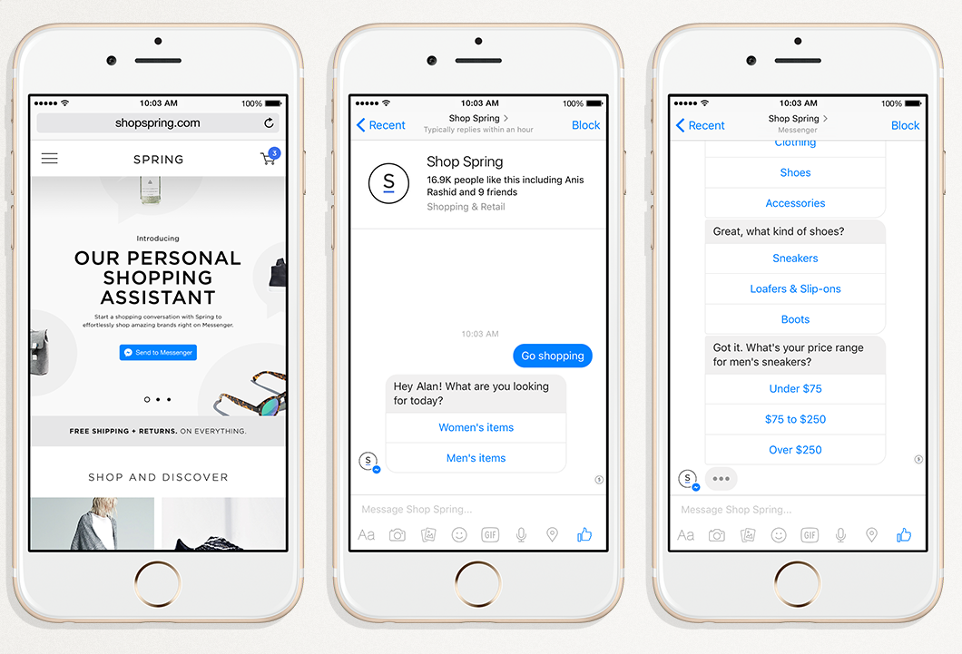

Figure 3 – Chatbot screenshot example

## 6.3 Mobile access

Mobile users primarily access social networks through smartphone apps that offer the richest experience. Some social networks also provide Java apps for feature phones and mobile browser access.

Feature phone Java apps have a significant drawback – they lack push notification capabilities. A push notification displays information on a mobile device even when the relevant application is not running (e.g., a chat message pops up even though the user is logged out of Facebook Messenger). This functionality gap reduces the social network value proposition as a communication platform for receiving calls and sending messages.

|  |  |  |
| --- | --- | --- |
| **Smartphone app** | **Feature phone Java app**  http://static.java-mobiles.com/data/programs/images/Facebook-for-Java_1_84388.jpg | **Mobile browser**  facebook_mobile |

Figure 4 – Types of apps

All major social networks provide iOS and Android smartphone apps. Support for other platforms varies.

Table 1 – Characteristics of apps

|  |  |  |  |  |  |  |
| --- | --- | --- | --- | --- | --- | --- |
|  | Smartphone apps | | | Mobile browser | Feature phone Java apps | Basic phone SMS |
| Apple iOS | Google Android | Microsoft Windows |
| **Facebook** | ✓ | ✓ | ✓ | ✓ | Any Java phone | – |
| **Facebook Messenger** | ✓ | ✓ | ✓ | \* | Certain Nokia Asha phones | – |
| **WhatsApp** | ✓ | ✓ | – | – | \*\* | – |
| **WeChat** | ✓ | ✓ | ✓ | – | Certain Nokia phones | – |
| **LINE** | ✓ | ✓ | ✓ | – | Nokia Asha | – |
| **Snapchat** | ✓ | ✓ | – | – | – | – |
| **Twitter \*\*\*** | ✓ | ✓ | ✓ | ✓ | Nokia phones | ✓ |

*\* Facebook's mobile website historically included Messenger but starting in 2016, Facebook has been requiring users to install the Facebook Messenger application. It is unclear if this policy will apply to all users and phone platforms globally.*

*\*\* WhatsApp is discontinuing support for Nokia phones in 2016.*

*\*\*\* Not technically a social network. Shown to highlight SMS support.*

## 6.4 Pursuit of revenue

Social networks have become enormously popular and are themselves bigger than the largest e-commerce companies in the world.

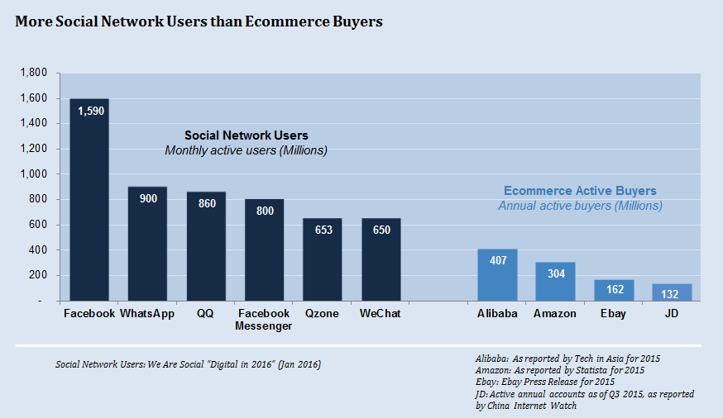

Figure 5 – Social network users v/s ecommerce buyers

Social networks have found multiple ways to monetize their user base.

Advertising is a key revenue source, but social networks generate revenue through other sources too: transaction fees, hosting fees, digital content, etc. There are examples in some marketplaces where the seller is charged a bundled fee, most of which is attributable to compensation for bringing the seller a new customer, but that also covers payments-related services.

Social networks will likely collect the most revenue from businesses but will also collect from consumers in some situations, such as P2P remittances and digital content. The revenue model ultimately depends on what makes the most sense for a particular use case. With the breadth of capabilities and users, social networks have significant flexibility to tune their revenue models.

### 6.4.1 Facebook

In 2007, Facebook aggressively pursued revenue by facilitating a deeper relationship between merchants and Facebook users, including:

**–** permitting advertising on a user's page;

**–** enabling merchants/businesses to create their own customized Facebook pages;

**–** providing highly-targeted advertising capabilities;

**–** creating a platform for third-party developers to deliver games and other applications to Facebook users.

Facebook has since added other services, like enabling advertising on third-party websites. Facebook generates revenue primarily from advertisers. Annual revenues have grown from $2B to $18B in just five years.

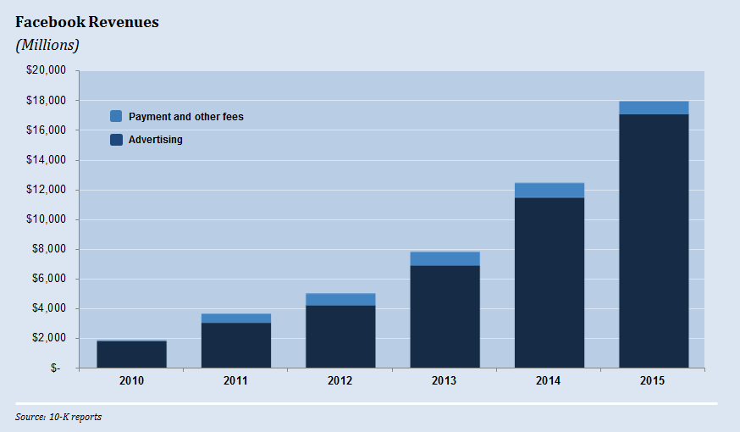

Figure 6 – Facebook revenues

### 6.4.2 WeChat

Tencent Holdings owns WeChat along with two other social networking and messaging platforms: QQZone and QQ. Tencent launched WeChat as a smartphone-focused app (which avoided PC legacy issues). Since its 2010 launch, WeChat has incorporated several revenue models into the WeChat platform, including:

**–** digital content (e.g., purchasing digital stickers to send to a friend);

**–** advertising through commercial accounts (analogous to Facebook pages) and on user feeds;

**–** transaction fees for facilitating commerce (ordering coffee, scheduling taxi rides, etc.).

Tencent does not break out WeChat revenue separately, but their total revenue has grown from $4 billion to almost $16 billion in four years.

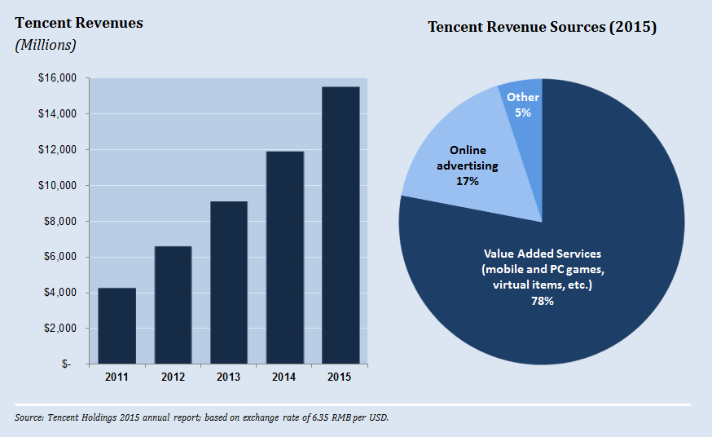

Figure 7 – Tencent revenues

### 6.1.3 LINE corporation

LINE, a popular mobile chat application in Japan, generated $1.15B in 2015 revenue. LINE generates money from advertisers but relies on consumers for up to 70 per cent of revenue.

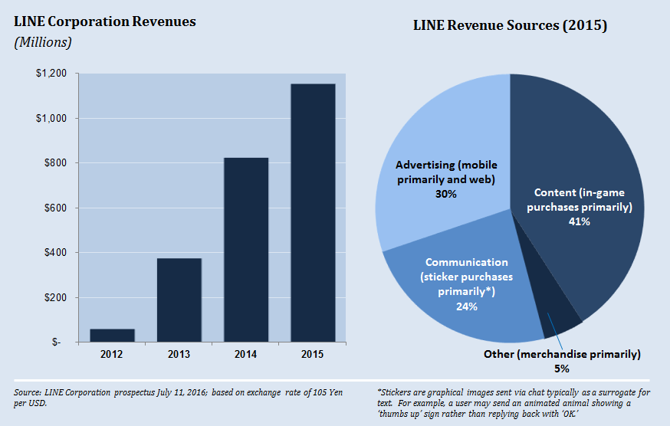

Figure 8 – LINE Corporation revenues

# 7 BoP not participating

Despite massive global adoption, social networks have largely bypassed the BoP.

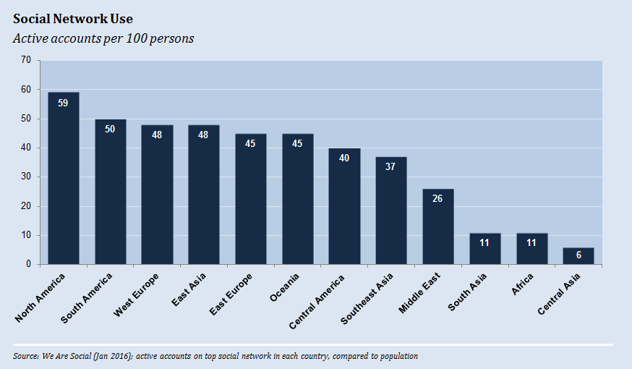

Figure 9 – Social network use

Low Internet adoption is a major contributor in the lack of BoP adoption, as are feature phone and smartphone challenges. However, even if social network adoption grows, the commercial aspects will not materialize without financial inclusion – a consumer cannot buy unless they link a payment account like M-Pesa to their social network account.

## 7.1 Low internet adoption

Low Internet adoption is at the root of low social network adoption. As highlighted in Internet.org's report, ''2015 State of Connectivity,'' Internet adoption experiences four key barriers:

**– Availability:** Proximity of the necessary infrastructure required for access. The reach of 2G data networks is relatively high, but 3G or 4G mobile broadband networks that can carry richer data are needed.

**– Affordability:** The cost of access relative to income. Cost includes the data, device and battery charging costs (including travel costs).

**– Relevance:** There needs to be a reason for users to access, such as attractive content in a user's main language.

**– Readiness:** The capacity to access, including skills, awareness and cultural acceptance.

Affordability is particularly striking. The impoverished simply cannot afford Internet access. For example, only 11 per cent of the population in Sub-Saharan Africa can afford 500MB per month (with ''affordable'' defined as consuming less than 5 per cent of income). As a point of reference, 500MB allows for 8 minutes of video per day. Average data consumption in developed countries is 3X higher, at 1400 MB per month.

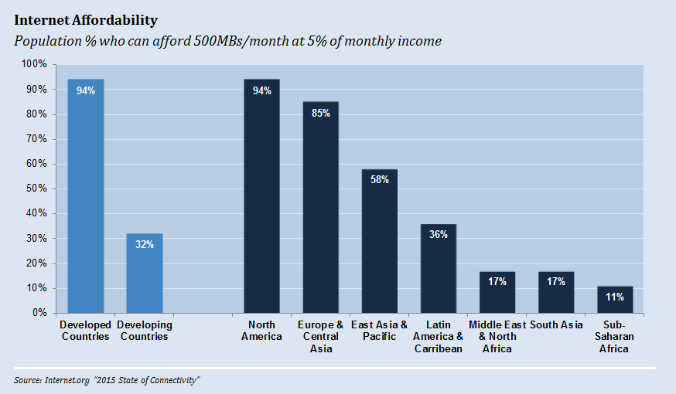

Figure 10 – Internet affordability

## 7.2 Feature phone and smartphone challenges

While some social networks can be accessed via feature phones, the experience is not optimal. For example, unless the user is currently running the social network's Java app or visiting the mobile web site, they will not receive real-time phone calls or messages. Since low-cost messaging and VoIP calls are very practical BoP use cases, feature phones severely limit social network appeal.

Smartphones address the push notification problem and offer a better overall user experience, but they create other problems:

**– Battery life:** Smartphones require frequent recharging, perhaps daily rather than one to three times per week for feature phones. This higher energy consumption creates a significant barrier for the 1.1 billion people without electrical grid access and the 1 billion with unreliable grid access. These underserved individuals must use a battery-charging vendor and therefore incur travel costs, travel time and recharge costs. Recharge costs can be $8 per month for a smartphone.[[4]](#footnote-4)

**– Device cost:** Smartphones are more expensive than feature phones. A low-cost Android smartphone can be below $50, but that still reflects a sizable investment equal to one month of BoP income. In July 2016, India-based Ringing Bells released a subsidized $4 smartphone branded ''Freedom 251'' but has been struggling to meet delivery promises and faces scepticism about their business model/economics.

**– Data cost:** Smartphones tend to use more data, driven by phone characteristics (larger screens, processing power) and user behaviour (such as downloading large applications and visiting graphics-rich websites).

## 7.3 Low financial inclusion

Unless the BoP link payment and social network accounts together, they are limited to the informational and communication features of social networks. Information can be quite powerful: pricing information, discovery of new suppliers, agro-information, etc. However, the BoP will not experience the full value of social networks without the payment component, nor will it boost penetration and usage of eMoney schemes.

WeChat is the benchmark for linking social and financial accounts. Over 300 million of its users have linked a financial account to their WeChat account.[[5]](#footnote-5) Interestingly, governmental regulations have helped increase financial account linkage. Receiving a Red Packet may be a user's first WeChat payment experience. However, before spending their digital cash, users must verify their identity. Linking a bank account or credit card is one verification method. This option enables the user to enter WeChat's vast commercial ecosystem.

# 8 Potential benefits to the BoP

The fundamental issues of Internet affordability, phone design and financial inclusion need to be solved before social networks can impact a large portion of the BoP. But, paradoxically, social networks may actually become digital on-ramps by offering simple, low-cost communication and information services. Beyond helping the BoP get online, social networks can provide a broad range of benefits, such as making agricultural value chains more efficient, providing a ubiquitous payment network, helping consumers buy more efficiently and helping the BoP earn more money.

In some cases, social networks' unique traits (size, network structure, customer insight, etc.) enable these benefits (e.g., broad payment acceptance). In other cases, traditional web sites or mobile apps can also deliver the same benefits (e.g., exposure to new customers). But, since social networks can be the way BoP users experience the web, it is important to include both sources.

## 8.2 Digital on-ramps

Social networks, and chat platforms in particular, can make establishing Internet access easier, more desirable and less expensive. Important social network capabilities include:

**• Over-the-top (OTT) services:** OTT mobile services are voice, messages, video and other content a third-party delivers without the MNO being able to control the distribution (e.g., prohibit, price differently). This capability is significant because it allows social networks to offer inexpensive messaging and voice. Since these services use an MNO's data service, messages and calls do not count toward a mobile subscriber's SMS or voice package. Users can save significantly under this arrangement by arbitraging differences between data, SMS and voice tariffs.

**• Low bandwidth options:** On traditional websites, a shopper or site visitor may wade through dozens of pages filled with data-heavy images and videos which leads to unnecessarily high data costs. Contrast that with social network approaches that could reduce data charges:

**–** Chat scenario in which a shopper reviews several product suggestions a merchant provides.

**–** Streamlined version of a social network (e.g., m.facebook.com, Free Basics by Facebook).

**• Standardized user experience:** Social networks usually present a standardized interface to their users. For example:

**–** Navigation menus are consistent from page to page and from use case to use case.

**–** Merchant information such as business name, hours, or phone number are in a similar location and format on social network-hosted merchant pages.

**–** Payment experience is the same across merchants.

**–** Universe of users and merchants can be found in a single directory.

This standardization makes the learning curve much faster. Essentially, social networks provide a 'learn once, use always' experience. Contrast this with the 'regular' web in which every website has a different look and feel, particularly on feature phones. A new visitor must pause and spend time understanding the navigational structure before gaining any real value. Additionally, chat platforms may speed up the learning curve through 'conversational commerce,' in which several back-and-forth messages between buyer and seller (chatbot, etc.) complete the transaction, much like familiar face‑to-face commerce.

**• Multiple revenue streams (subsidy potential):** Social networks are well-positioned to provide subsidies because they offer a wide range of services to a diverse group of stakeholders. Importantly, these stakeholders are mutually dependent – e.g., increasing consumer adoption creates more monetizable merchant opportunities. By contrast, MNOs have less subsidy flexibility since their offerings are narrower – e.g., lowering data prices to poor populations would not necessarily generate offsetting revenue.

### 8.1.1 BoP use cases and benefits

For a new Internet/social network user, initial use cases may involve replacing existing activities with lower cost, easier alternatives and performing basic information gathering (weather reports, etc.).

**Low-cost messaging**

Chat has been a ''killer app'' for current social network users. For example, in early 2016, Facebook Messenger's and WhatsApp's global user base was sending 60 billion daily messages, three times the global SMS volume.[[6]](#footnote-6) Chat should also appeal to the BoP given: SMS familiarity; OTT cost savings; BoP price sensitivity; and easier interface (e.g., searching for names in a directory, clicking on user pictures).

**Low-cost voice calls**

Chat applications often include VoIP calling capabilities. Voice service should appeal to the BoP given OTT cost savings, BoP price sensitivity and easier interface. Service quality may be a challenge, as data networks are not universally reliable. Calls on data networks can experience noticeable delays and dropouts. It is important to note that phone calls are not necessarily limited to other users on the same chat application, as some chat applications permit calls to landlines and mobile phones.

**Information gathering**

Chat can deliver basic information, such as weather reports, agriculture prices, or community announcements. The BoP could receive this information within a single interface without needing to leave the chat application.

**Free or subsidized data plans**

It may be economically attractive for social networks to subsidize the BoP's MNO data costs. In other words, future revenue potential or indirect revenue from advertisers, ecommerce commissions, and other sources may more than offset the data subsidy. Free Basics by Facebook provides free Internet access, however it is unclear whether Facebook or the MNOs provide the subsidy.

## 8.2 Platforms for BoP ecosystems

Besides being the digital on-ramp for consumers, social networks can also bring merchants and other entities online (e.g., Facebook Pages, WeChat Official Accounts). Additionally, social networks also allow consumers and organizations to organize themselves into communities and ecosystems, such as agricultural value chains, farmer groups, NGO group lending programs, parent/school groups and any other type of group. Each consumer and entity can participate in ecosystems relevant to them.

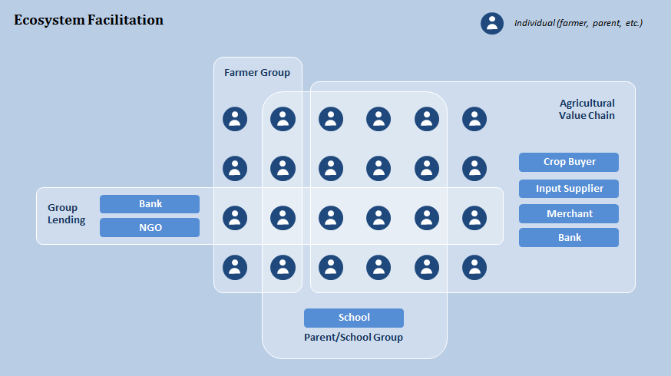

Figure 11 – Ecosystem facilitation

Social networks are well-positioned to facilitate these ecosystems.

**– Technology building blocks:** Social networks provide payment, event management, hosting, communication tools, privacy management and other reusable components that ecosystems need.

**– Large modular network:** Social networks can support many ecosystem types since a wide range of entities participate (lenders, retailers, wholesalers, governments, NGOs, consumers). Essentially, the required players are already 'in the room' and can participate in ecosystems relevant to them.

**– Fast learning curve**: The universal user experience simplifies onboarding new ecosystem members.

### 8.2.1 BoP use cases and benefits

**Agricultural value chains**

Social network platforms could be used to organize agricultural value chains and enhance how farmers interact with produce buyers, agro-dealers, banks and other stakeholders. In this scenario, third-party developers or even social networks, could develop applications related to bidding, contract management, financing, payment management, education, or product certification. Value chain administrators would then integrate these applications into their value chain's social network group. Using social network platforms would be attractive because of the pre-existing user base and universal functionality such as registration, authentication, communication and hosting, among others.

**Farmer groups**

Some smallholding farmers organize themselves into groups to share knowledge, borrow from banks, or negotiate better prices from crop buyers. Social networks can facilitate group creation and management. For example, a lead farmer or NGO could create a Facebook group. Participating farmers could send and receive group messages, review archived materials, buy and/or sell used equipment, document important agreements, etc. There is evidence that this is already happening.

**Small business websites**

Small businesses can use social networks to develop an online presence with a description of services, hours of operation, contact information, videos, photos, etc. This is already happening to some degree.

**NGO programs**

NGOs often receive 'restricted funding' for a specific project, such as ''providing financial literacy education to 200 women'', and then must measure the impact (e.g., changes in household income vs. a control group). Social networks could facilitate program management by enabling NGOs to recruit participants, disseminate training materials, conduct video training and monitor the impact through surveys.

## 8.3 Payment networks

Social networks can enable a global, interoperable, multi-channel and user-friendly eMoney payment network that connects buyers and sellers.

BoP eMoney usage has been limited to a few use cases: Receiving remote P2P payments then cashing out, and then buying airtime. Even in Kenya, where mobile money is widely used, BoP diaries revealed that only 0.7 per cent of payment transactions were electronic and 86 per cent of those were for airtime.[[7]](#footnote-7) Several factors are preventing eMoney from being more widespread. These include:

**– Cost:** Low eMoney usage makes economic sense. Most BoP transactions are for small amounts that have high transaction fees on a percentage basis. For example, 75 per cent of purchases in the Mozambique, Tanzania and Pakistan financial diaries were less than $2.[[8]](#footnote-8)

**– User experience:** The eMoney user experience is not optimal. For remote bill pay transactions, paying the correct business and ensuring payment is credited to the correct account is error-prone. For face-to-face P2P transactions, it is easier for someone to reach into their pocket than log into a phone and type the recipient's mobile number. Compelling user experiences are needed for each use case (e.g., 'bumping' phones for face-to-face P2P transactions).

**– Interoperability:** Mobile money networks are often not interoperable preventing, for example, a Tigo user from sending cash to an Airtel user. This problem is most pronounced in countries with market fragmentation (i.e., no dominant provider).

Social networks are well-positioned to solve some of these problems.

**– Large network:** Payment systems are prime examples of the network effect – as more consumers and merchants participate in a payment system, the more useful it becomes to all participants. Social networks have a significant head start, as large numbers of consumers already connect. Social networks must still convince users to link financial accounts, but WeChat proves high adoption is possible. Additionally, many merchants have a social network presence. If these merchants enable social network payment capabilities, it would reduce the need for BoP consumers to cash out.

**– Directory services:** Social networks often provide robust search capabilities to locate friends and merchants. This feature can remove the challenge of 'paying the right business' when using mobile money.

**– Ability to decouple payment methods:** Decoupling the method by which a consumer pays from the method by which a merchant gets paid increases interoperability, acceptance and flexibility (e.g., instant credit). For example, a shopper might make M-Pesa instalment payments to the social network with the social network paying the merchant in full via an Airtel account. The concept of decoupling already exists. PayPal, for example, uses this arrangement.

**– Lower POS infrastructure requirements:** Face-to-face environments, where BoP commerce typically occurs, can use the same social network infrastructure that enables e‑commerce transactions. For example, a farmer could visit a local food vendor, find that vendor's Facebook page, and make the purchase through that page. WeChat already uses this approach in China.

**– Ability to subsidize:** Because social networks target multiple revenue sources and stakeholders, they can incent adoption through subsidized pricing. Options include:

**•** Offering free payments when using balances already in social network wallets.

**•** Reimbursing MNO fees for transactions involving eMoney.

**•** Providing payment rewards (analogous to credit card 'cash back' or points to entice consumers to use their cards), thus providing additional incentives for merchants to accept those tender types.

**•** Bundling payment costs within other costs to remove payment price sensitivity (e.g., sales commission for generating revenue for a seller).

WeChat uses some of these methods. For example, P2P red envelope transactions do not incur fees.

### 8.3.1 BoP use cases and benefits

**P2P payments**

With proper licensing and MNO linkages/interoperability, social networks could provide simple and lower cost domestic and cross-border remittances. For example, a U.S. resident with linked bank and social network accounts could send money to an Indonesian relative in their 'friends' list. That recipient could store funds in their social network wallet, transfer to their bank account, or cash out by transferring funds to a social network or MNO agent.

**Face-to-face purchases**

A consumer could pay a merchant if they belonged to the same social network. For example, the merchant's phone could generate a barcode that the consumer's phone scans. The consumer would approve the transaction amount and the social network would transfer money to the merchant. Merchants would not need to invest in chip terminals or standalone barcode readers, nor would they need to belong to multiple mobile money networks.

**Remote purchases**

Similar approaches could be used for remote purchases (e-commerce or order-ahead functionality). This could mimic traditional processes with payment coming from a digital balance within the social network account or from the financial account linked to the social network account.

**Lending (digital history)**

As more and more transactions become electronic, consumers will increasingly build income and expense transaction histories. These histories can solve the challenge of proving income when qualifying for a loan.

**Instant credit**

Decoupling also opens up the possibility of social networks providing credit. For example, a social network might allow a farmer to buy equipment on credit while paying the merchant immediately.

## 8.4 Marketplaces

Social networks have the natural ability to bring buyers and sellers together. Important capabilities include:

**– Large network:** Social networks have more users than the largest e-commerce marketplaces and already serve buyers and sellers.

**– Digital onboarding:** Social networks make it easy for merchants to set up an online presence (e.g., site templates) reducing the need to build specialized websites.

**– Communication tools:** Social networks have private messaging capabilities that consumers and merchants can use for sales and customer service.

**– Deep customer insight:** Social networks have deep knowledge about their users (see the appendix for details). This can be used to help merchants reach their targets and keep advertising content relevant to users.

**– Payment facilitation:** Social networks can facilitate payments between consumers and merchants.

### 8.4.1 BoP use cases and benefits – consumers

**Product and merchant search**

Social networks can help consumers purchase from a wider array of merchants and discover new products. This may occur through marketplaces where merchants and consumers connect, or may just involve simple search functionality.

**Virtual sales and customer service**

A BoP customer and merchant could use a chat application to discuss price and availability of a harvested crop. Chatbots could also answer customer questions 24/7 (e.g., prices).

**Virtual assistance**

Chatbots could advocate for the poor. For example, a BoP shopper could inquire about a merchant's produce prices. After seeing the price quote, the shopper's personal chatbot may find better prices from other sellers.

### 8.4.2 BoP use cases and benefits – merchants / employees

**Deeper engagement with existing customers**

The BoP could use social networks to better engage their customers. For example, they could announce the arrival of fresh produce to local residents.

**Access to new customers**

The digital nature of social networks allows merchants to expose their products and services to a wider audience. These might be locals who were simply unaware of what their local merchants offered, or even new customers from neighbouring villages.

**Remote commerce/e-commerce opportunities**

With wide access to sellers and buyers, social networks can create opportunities that might not otherwise exist.

**– Marketplace access:** Rural villagers in China have become e-commerce entrepreneurs. Alibaba has created 780 Taobao villages where locals have launched over 200,000 online stores selling anything from camping gear, to auto accessories, to toys.[[9]](#footnote-9) Alibaba trains the rural residents for this entrepreneurial transition. The government also plays a role. With commerce concentrated in geographic areas, the Chinese government can target infrastructure projects like road construction to improve fulfilment capabilities.

**– Concierge commerce:** Entrepreneurial individuals can act as intermediaries to online commerce. Taobao villages in China also provide a good example. Local representatives who have developed expertise in searching Alibaba marketplaces can search on behalf of less technically savvy individuals. This concept is analogous to over-the-counter (OTC) payments in which an MNO agent makes an eMoney payment on behalf of a customer.

**Market knowledge**

BoP merchants could learn about competitors, new markets, market prices, etc.

**Access to new products and suppliers**

Social networks can help merchants purchase from a wider array of suppliers and discover new products. This may occur in online marketplaces where merchants and suppliers connect, or may just involve simple search functionality.

**Virtual entrepreneurship**

Some social media sites enable users to earn money by creating content. For example, Google shares a portion of YouTube advertising revenue with video creators. Taringa, a popular social media site in Argentina, recently announced plans to share advertising revenue with writers of articles. Taringa will pay these writers in Bitcoin. Micro-revenue sharing would not be cost-feasible using other payment methods. Social networks could adopt some of these social media business model tactics.

**On-demand marketplaces**

Networks are enabling a market for part-time employment and asset sharing. For example, Uber's user network and routing technology made it possible for an individual to transport passengers to unfamiliar locations. This concept is already materializing in developing countries (e.g., Airbnb in Cuba). Social networks could provide or distribute these services.

**Exposure to job openings**

Organizations can reach a larger pool of candidates via networks and candidates can discover a wider range of opportunities. The social nature of social networks enables a deeper understanding of the candidate and employer (e.g., reference checking).

## 8.5 Beneficial data collection

Privacy issues aside for the moment, data collection can be quite beneficial. Data can make things 'free' by enabling targeted advertising. Imagine the frustration if users had to pay even a nominal amount for each Google search they performed. While this concept may hold true across all populations, the BoP may gain unique benefits, such as greater access to credit.

Currently, relatively little is known about the lives of the BoP, since there are few paper and electronic records. This lack of data hurts the BoP. For example:

– Obtaining credit is difficult without a credit history file or electronic/accessible proof of income.

– Businesses have less insight into consumer needs.

– Medical professionals react less quickly to changing health conditions. For example, Google searches can reveal the outbreak of a virus.

Social networks are uniquely positioned to collect this data:

– **Deep insight:** Besides simple demographic information like age, gender and location, social networks collect 'softer' data, like interests, behaviours and attitudes. Social networks also capture all dimensions of a user's life: leisure, social, work and school activities.

– **Heavy user engagement:** Because users visit social networks often, the data are fresh.

MNOs have been touted as a good source of data, particularly for making credit decisions. For example, research has shown that calling behaviour (frequency, length of call, number of contacts, locations, etc.) indicates different levels of credit risk, but, social networks are likely better positioned than MNOs. As more MNO voice and messaging traffic shifts to Voice-over-Internet-Protocol (VoIP)/chat platforms, MNOs will lose their insights, with social networks picking up the difference. Social networks can then add these new insights to their already deep user profiles.

### 8.5.1 BoP use cases and benefits

**Consumer credit**

BoP consumers have trouble obtaining formal credit. One reason is lack of information (verifiable income, repayment reputation, etc.). Social networks can help solve this problem. First, wallet activity provides valuable data points about income and expenses. Second, social network data (attitudes, friendship references, etc.) create a broader view of an individual's propensity to pay.

**Commercial credit**

Social networks can also help businesses borrow. As with consumer credit analysis, data will likely include transaction histories and supplemental data. But, analyses will likely employ different metrics. For example, a downward trend in "Facebook likes'' may indicate growing credit risk.

**Targeted advertising**

While the BoP do not fit the stereotypical 'big brand micro-targeting' use case, local merchants may find targeting very valuable. Even simple attributes like location are useful. Someone selling a bicycle may target individuals within a 10km radius.

**Targeted communication**

Non-commercial communication also needs targeting. For example, a government may deliver health messages to a drought-stricken region.

**New product and program identification**

Through sentiment analysis and other techniques, commercial companies, NGOs and governments can identify new products/services and helpful community interventions.

# 9 Policy considerations

Policy makers face a tough balancing act. On one hand, social networks can bring significant value to the BoP populations, and policy makers should therefore consider policies that encourage adoption. On the other hand, social networks are tremendously powerful, and regulators should explore policies that protect consumers from potentially harmful effects.

## 9.1 Encourage adoption

### 9.1.1 Path forward

There is significant potential for social networks to benefit the underserved, but we've just scratched the surface. The BoP need a 'killer app' to jumpstart adoption. For example, a free and simple OTT communication service may spur initial usage. OTT communication can be cheaper than SMS and a photo-directory interface could be less intimidating. Once the initial usage starts, new use cases and solutions would drive further engagement.

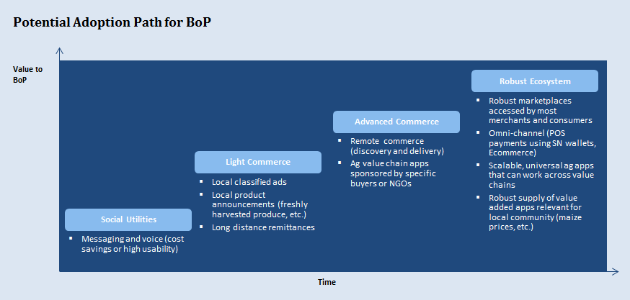

Figure 12 – Potential adoption path for BoP

### 9.1.2 Enabling layers

Achieving the potential of social networks requires progress within several enabling layers. Efforts could stall at any one of these layers grinding the potential to a halt. Policy makers may need to take action to ensure the potential is reached.

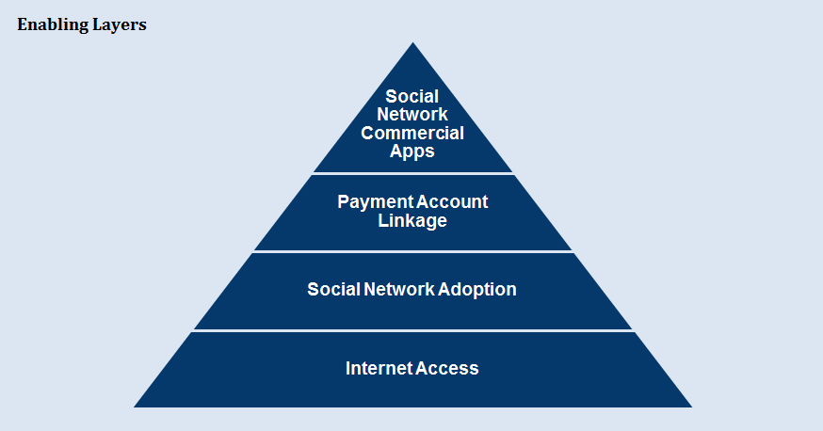

Figure 13 – Enabling layers

**Internet access**: At a foundational level, the BoP's Internet access must increase. Progress is needed in several dimensions:

– Availability: Proximity of the necessary infrastructure required for access. The reach of 2G data networks is relatively high, but more 3G or 4G mobile broadband networks that can carry richer data are needed. Traditional MNOs could provide the solution but new entrants such as SpaceX may enable attractive alternatives via micro-satellites and other technologies.

– Affordability: The cost of access relative to income. Cost includes the data, device and battery charging costs (including travel). Mobile phone decisions have a significant impact. While smartphones offer the best user experience, they have shorter battery lives, use more data and are more expensive. Technology improvements may make smartphones a more practical solution (e.g., village-based solar charging, batteries that allow rapid charging).

– Relevance: A reason for access, such as attractive content in a user's main language.

– Readiness: The capacity to access, including skills, awareness and cultural acceptance.

**Social network adoption:** The BoP need a reason to start using a social network website or mobile app. The reason need not be commercial in nature. The motivation could be something as simple as low cost, social network-enabled phone calls. The idea is to get anyone with Internet access to also create a social network account. This stage is analogous to the introduction of e-mail in developed countries. The e-mail use case drew people to the Internet. After becoming comfortable with e-mail, most eventually became e-commerce shoppers.

**Payment account linkage:** Consumers must obtain and link payment methods to their social network accounts. Without a payment account linked to a social network account, users will be limited to the informational aspects of e-commerce. They will not benefit from transactional aspects such as selling and buying products online, or sending and receiving payments to and from employers, friends and family. These payment accounts can be mobile wallets, bank accounts, or even social network accounts if a social network has the appropriate licenses. Regional characteristics will influence the type of accounts the BoP can link.

**Social network commercial apps:** Social networks must enable capabilities relevant to BoP commerce. Internet access, social network adoption, and payment account linkage make it possible for the BoP to transact, but robust commercial apps make it desirable to transact. Technology adoption typically occurs by solving specific pain points. Challenges and solutions will vary geographically. In one country, the opportunity to design, manufacture, and export furniture online may entice the BoP. In another country, farming productivity may be the triggering pain point. As specific problems like 'higher maize yields' get addressed, functionality may expand so that solutions become more general (higher horticulture yields) and appeal to larger portions of the BoP.

### 9.1.3 Metrics and accelerators

Reaching this potential requires monitoring the right metrics and finding ways to accelerate progress. The table below provides a starting point for those metrics and potential accelerators.

| **Table 2 – Social network metrics** | | |
| --- | --- | --- |
| Enabler | Metrics to monitor | Potential accelerators |
| Social network commercial apps | • Number of locally relevant apps  • Non-agriculture  • Agriculture: Problem addressed (production, transportation, etc.) and crops  • Online vs. physical relevancy  • App usage and volume of commerce  • How value is shared between the BoP, social networks, MNOs, banks and others | • Pain point research  • NGO-sponsored applications  • Public-private partnerships to create commercial applications  • Universal social network functionality (easy to use e-commerce sites, universal wallets, etc.)  • Consumer protections if the market is not evolving in a pro-consumer way (unionization, privacy, etc.) |
| Payment account linkage | • BoP adoption of eMoney  • Linking of eMoney accounts to social network accounts | • Fast-track regulatory process for social networks and mobile money operators  • Using social networks to create mobile money interoperability  • Mobile money pricing that would enable BoP digital liquidity |
| Social network adoption | • BoP enrolment, activity levels  • Types of applications used (voice, text, news, etc.) | • Implementing BoP-friendly OTT services to encourage enrolment  • Designing an identity management system with an eye toward compatibility with social network platforms |
| Internet adoption (access) | • 3G / 4G geographic coverage | • Beyond the scope of this analysis, but include strategies like ''universal service obligation'' subsidy programs |
| Internet adoption (affordability) | • Costs: phone, data, charging  • Adoption metrics  • BoP phone ownership: Smart phone, Internet-enabled, not‑enabled  • Data subscription  • Grid access to electricity | • See above |
| Internet Adoption (relevance) | • Language | • See above |
| Internet Adoption (readiness) | • Educational attainment  • Literacy | • See above |

## 9.2 Protect consumers

Imagine this potential future state:

– most of the world's population participates in social networks;

– online identities are inextricably linked to real names;

– user locations are always known;

– most communication travels through social networks;

– social networks can predict and influence an individual’s behaviour

– social networks are payment 'gatekeepers' to a significant portion of the economy.

This scenario is not farfetched. WeChat, Facebook, Uber and others demonstrate movement in all these dimensions. Social networks could become extremely powerful. The answer is not to stop social networks. Rather, the answer is to monitor and manage them judiciously so as to derive as much social benefit as possible for the BoP populations. Key topics include:

– free service vs. net neutrality;

– market power;

– data privacy;

– agency and transparency.

### 9.2.1 Free service vs. net neutrality

Social networks see an opportunity in developing countries and so are tailoring their approaches. For example, Facebook offers Free Basics by Facebook, which provides free Internet access in certain markets. Specifically, no data charge applies when users visit a predefined list of websites and have a subscriber account with a participating MNO. Any website may join if they meet certain technical requirements (i.e., offer a lightweight, mobile-friendly version that will work on both smartphones and web-enabled feature phones). Naturally, Facebook offers a lightweight version of its own site called Facebook 0. The free service is currently available from at least one MNO within 44 countries in the Africa, Middle East, Asia-Pacific and Latin American regions.[[10]](#footnote-10)

Free Basics by Facebook has been controversial. After much public debate, India's regulatory body determined the service violated net neutrality laws since free access only applied to certain websites. In theory, any website can participate in the Free Basics service but there are technical hurdles and Facebook approves the applications. Additionally, all traffic is routed through (and thus visible to) Facebook, raising privacy and competition concerns.

This controversy does not have an obvious right answer. While free access to any website is ideal and pro-consumer, the reality is that millions of poor Indians lost an opportunity to access the Internet. Given the stakes, regulators and businesses need to find common ground so that opportunities are not lost.

### 9.2.2 Market power

As prime examples of the network effect, social networks are prone to 'winner-take-all' market consolidation. This resulting ubiquity, scale and market concentration can be quite beneficial, primarily by bringing efficiency to a social network's ecosystem. For example, users can reach all of their friends via a single social network. Additionally, market fragmentation does not stall the adoption of services such as payments.

At the same time, market power creates its own set of risks. Two, in particular, are noteworthy.

**– Excessive economic power:** Social networks could become the economy's de facto gatekeeper. Social networks can charge a premium for this very defensible role. Many of the merchants using social network services will be small and do not have any negotiating leverage. Marketplaces with a similar structure can charge very high rates. For example, Google and Apple take a 30 per cent fee on applications sold through their stores. Uber takes up to 28 per cent (and perhaps more) of revenue.[[11]](#footnote-11) While an argument can be made that these fees reflect a reasonable distributor margin, these 'distributors' are not other local merchants contributing to and benefiting from the local economy. This distributor margin is exported (or at least transferred) to large foreign-owned companies.

**– Discretionary influence:** Social networks are information curators. Users do not have time to consume all of the information their friends provide. Social networks must therefore decide what to expose/promote and what to hide. Research shows this responsibility has enormous implications. For example, social networks can influence elections by increasing voter turnout of certain populations (e.g., via ''I voted'' buttons) or by influencing the attitudes through choice of what articles to display. This influence also has commercial implications. Social networks can influence a user's mood and that mood influences cosmetics purchases, particularly on Mondays.[[12]](#footnote-12)

Accordingly, we believe regulatory oversight is probably appropriate. Anti-trust laws, truth-in-advertising requirements, and disclosure rules offer a starting point for a regulatory framework. But, these risks tread new ground. For example, the evidence of 'behavioural impact' is locked away inside constantly changing databases and software rules (try asking a machine learning algorithm why it showed some user a particular article).

### 9.2.3 Data privacy

Data collection can benefit the BoP by enabling free services subsidized through advertising and new services such as lending. But, data collection poses inherent risks such as theft, accidental publication, fiduciary abuse, discrimination and persecution (political, religious, etc.). Consumer fear of these risks can create additional problems, such as:

**–** avoiding personal research of diseases/health conditions;

**–** ending friendships to maintain a good credit rating;

**–** accepting the status quo of societal norms and laws;

**–** holding back information from friends and family.

Regulators must protect consumers from these risks without perpetuating the digital divide via overly restrictive regulations. Privacy frameworks will be important tools and there is already a large body of work to draw upon. For example, the Organisation for Economic Co-operation and Development (OECD) Privacy Principles addresses data collection limits, data quality, usage limits, security safeguards, accountability for violating promises and other topics. Developing these frameworks within the context of social networks and the BoP will be critical. On one hand, social networks could be life-changing (digital on-ramps, lending, etc.). On the other hand, the breadth and depth of data collected is staggering and introduces risks that BoP markets have not previously needed to address.

### 9.2.4 Agency and transparency

Social networks could be the digital on-ramp for poor populations and transform the ways in which they do business, but there is also room for exploitation, for example:

**–** a chatbot named ''Merchant Deal Finder'' steering customers to its owner's primary business;

**–** raising prices to certain consumers whose banking activity suggests greater wealth;

**–** customer service chatbots presenting customers with higher margin but inferior solutions.

These problems already exist in physical and online commerce, but growing software sophistication makes exploitation much easier. Factor in a population with limited technology experience and there is even greater risk to the BoP. At some point a poor farmer may ask himself or herself, ''Is my chatbot lying to me?'' but until then, they are exploited. The normal deterrent, reputational risk, might not apply. A chatbot with a bad reputation is one brand change away from a clean start.

Regulators can draw upon related topics, such as agency disclosure laws, but regulatory frameworks should reflect the unique context. For example, should chatbots have to send a disclosure message that says, ''I receive a commission if you buy the product I just recommended?'' Regulations are not the only way of managing the risk. Industry self-regulation, or independent parties such as TrustE can play a role.

Appendix I

## I.1 Social network data collection

Social networks have much more knowledge about consumers than traditional marketplaces and even merchants. This deep knowledge enables robust targeting for new customer acquisition. For example, an advertiser can target ''men, aged 18-24, currently traveling within 13 miles of Atlanta, who donate to animal welfare charities, live in an apartment, like jazz music, cosmetics, tattoos, and are interested in buying an economy car in the next 365 days'', but only target them while they are ''visiting Instagram via a WiFi-connected Samsung Tablet 2 running the Android 4.0 operating system.'' This example might appear to be nonsensical, but highlights the precision that advertisers can employ. For example, Facebook advertisers can use these attributes:

Table 3 – Social network data collection

| Demographics | Interests | Behaviour | Placement |
| --- | --- | --- | --- |
| • Basics (age, gender, language, location)  • Education (level, school, fields of study, etc.)  • Ethnic affinity group (Asian, etc.)  • Financial status (income level, net worth)  • Residence (ownership, type, household composition, etc.)  • Life events (marriage, engagement, birth, etc.)  • Parent status (new parents, stay-at-home moms, etc.)  • Political views (conservative, etc.)  • Relationships (status, sexual orientation)  • Work (employer, industry, job title, etc.) | • **Business/industry** (agriculture, banking, etc.)  **• Entertainment** (board games, animated movies, etc.)  **• Family and relationships** (dating, fatherhood, etc.)  **• Fitness and wellness** (meditation, dieting, etc.)  **• Food and drink** (French food, recipes, etc.)  **• Hobbies and activities** (pets, travel, etc.)  **• Shopping and fashion** (cosmetics, toys, etc.)  **• Sports and outdoors** (camping, baseball, etc.)  **• Technology** (servers, camcorders, etc.) | **Automotive** (used motorcycle owners, in market for new BMW, etc.)  **• B2B** (employer size, industry, etc.)  **• Charitable donations** (animal welfare, arts, etc.)  **• Digital activities** (recent gamer, event creator, primary browser type, etc.)  **• Expats** (Argentinians living abroad, etc.)  **• Financial** (credit union members, real estate investors, etc.)  **• Job role** (corporate executive, farmer, etc.)  **• Media** (TV reality show watchers, etc.)  **• Mobile device** (Samsung Galaxy owners, 2G internet connections, etc.)  **• Purchase behaviour** (coupon users, beer buyers, etc.)  **• Residential profiles** (new homeowners, etc.)  **• Seasonal and events** (Summer Olympics watchers, etc.)  **• Travel** (business travellers, cruise takers, etc.) | **• Ad display location** (mobile news feed, Instagram, 3rd party sites, etc.)  **• Mobile device type** (iPad, Android smartphone, feature phone)  **• Mobile device model** (Samsung Galaxy 4, etc.)  **• OS version** (4.4 KitKat, etc.)  **• Connection method** (WiFi, any) |

This data comes from several sources:

**– User-provided:** Users often provide demographic data such as birthdate, home address, school name and relationship status. Each action further enriches the user's profile. For example, liking The House of Nanking restaurant's Facebook page may indicate an interest in ''Chinese cuisine.'' Other data sources include reading articles on certain topics, checking‑in at merchants, commenting on or liking a friend’s post, or joining a Facebook group.

**– Third-party sites:** Data collection is not limited to user behaviour within a social network. For example, sites send tracking data to Facebook if they use one of their many services: Facebook Login, Facebook Pixel (for conversion tracking), Facebook Audience Network (ads Facebook delivers to other sites) and Facebook social plug-ins (Follow, Save, Like, Share, Send, Quote, Embed, Comment). Essentially, Facebook knows what other sites and/or pages a user visits even if they’re not on the Facebook site.

**– Non-web sources:** Social networks can enrich user profiles with 'offline' data provided by data brokers such as Acxiom. This data includes retail-purchasing data, home ownership, voting registration and other data provided by retailers and government organizations. In some cases, social networks use this data to infer additional characteristics about their users (e.g., people in a certain zip code tend to be wealthy). In other cases, social networks can develop consumer-specific insights by matching/cross-referencing name, physical address, e-mail address, phone number, or some other data element. Note that these types of data are not currently available for all consumers and geographies.

Social networks can also help merchants ''remarket'' to more deeply engage with existing customers, for example, drive a consumer back to a merchant's website to complete a prior shopping session, or cross sell new products and services based on prior behaviour, behaviour of their social network friends, or behaviour of those with similar profiles. Using Facebook as an example, to use this feature, an advertiser uploads a customer list to Facebook (based on email lists, phone numbers, or simply tracking cookies/IDs). Facebook will then link those identifiers to specific Facebook users and serve them the appropriate ads. Advertisers can further refine their targets using data only Facebook possesses (age, interests, relationship status, etc.) – Facebook often knows more about a merchant's customers than the merchant. These customer lists can also be used for lookalike marketing in which Facebook targets new customers similar to existing customers, again based on traits only Facebook knows.

What's particularly impressive is the ability of advertisers to close the loop between marketing and outcomes. Through browser cookies and other technologies, advertisers can determine which viewers saw ads and returned to the merchant's website, installed an application, or took some other action. This approach also works for physical merchants. For example, a retailer may deliver an ad to a specific user and later identify the associated transaction on that customer’s loyalty card.

## I.2 Reaching users 24/7

Social networks can obviously reach users while on the social network site, but the reach also extends to other venues.

**– Social network sites:** Social network sites are very popular. For example, Facebook users spend 50 minutes per day on Facebook, Instagram and Messenger platforms (excluding the globally popular WhatsApp).[[13]](#footnote-13) Facebook's capabilities for gaining insights about and targeting users are at their peak while its users are on Facebook properties.

**– Other websites:** Facebook can reach its users and non-users while on third-party websites through the Facebook Audience Network. This ad network allows third-party websites to earn revenue by displaying ads Facebook sells to advertisers. Visitors with Facebook accounts are targeted with great precision because of Facebook profile data. But, Facebook can even target non-Facebook users with some level of precision since Facebook profiles non-users based on visits to sites using Facebook services (Like buttons, etc.).[[14]](#footnote-14)

**– Physical merchants:** Because social networks interact with many businesses and mobile phones are ubiquitous, social networks can facilitate services between consumers and physical merchants. Essentially, social networks are becoming ''virtual plumbing.''

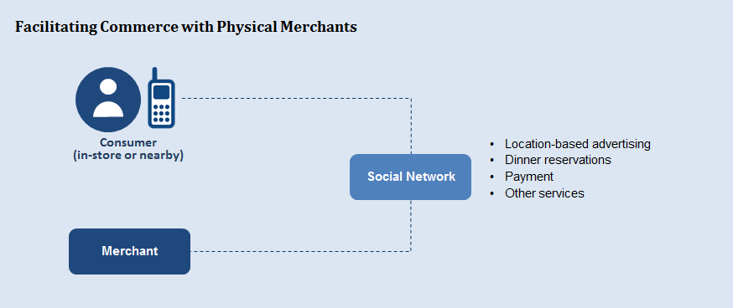

Figure 14 – Facilitating commerce with physical merchants

For example, social networks enable location-based advertising that encourages users to visit nearby merchants as shown in the following screenshot:

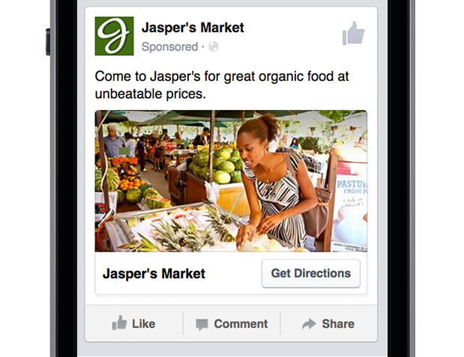

Figure 15 – Location based advertising example

Social networks can help users find restaurants and make reservations, as described in this WeChat case study.

*''The Mei Wei Bu Yong Deng official account lets users search through a directory of restaurants nearby, see how many people are currently waiting in line for a table at those restaurants, and even grab a number to wait in line without being physically present at the restaurant.''*[[15]](#footnote-15)

Social networks can also facilitate payment with physical merchants.

*''With the 7-Eleven official account, users can pay at 7-Eleven and Family Mart physical stores through a breezy, easy payment process where the cashier uses a standard handheld barcode scanner to get the customer's Quick Pay barcode at the point of sale. 7-Eleven can then also target users with custom promotions at an optimal frequency that does not flood them with unwanted marketing.''*[[16]](#footnote-16)

**– Internet of things (IoT):** The 'physical world' goes beyond traditional merchants. Social networks can be the integration path with IoT devices.

*''Take Chinese toy company Dan Dan Man, which created Mon-Mon, a Bluetooth-enabled stuffed animal toy that integrates WeChat with the offline world. Parents can use the Mon-Mon official account in WeChat to send personal voice messages and pre-recorded English courses or bedtime stories to the toy while they are at work or traveling. Kids immediately get those stories or messages, and can even press Mon-Mon's belly to reply to their parents' WeChat account in a message delivered back as a voicemail. While this is just a toy – and funnily enough, a character that started off as a popular digital sticker on WeChat! – it shows the potential of integrating messaging platforms into the physical world.''* [[17]](#footnote-17)

## I.3 Facebook games ecosystem

Social networks can seamlessly offer value throughout a merchant's value chain. An early example of this full suite of services is Facebook's launch of its casual game platform. Facebook users could play Solitaire, Words with Friends, Poker, Farmville and other games while staying on the Facebook site. Facebook brings value to all aspects of the game lifecycle, and in return receives 30 per cent of direct revenues (in-game purchases, etc.) plus ancillary advertising revenue. Facebook has since expanded to iOS and Android games so that Facebook generates advertising revenue when users install games and when game developers display in-game ads from Facebook advertisers. Almost all of Facebook's 2015 payments revenue of $849M came from games. Facebook does not separate game-related advertising revenue. By having a platform-agnostic strategy (Facebook site, iOS and Android), Facebook continued to monetize games, even as users shifted from Facebook.com to mobile platforms.[[18]](#footnote-18)

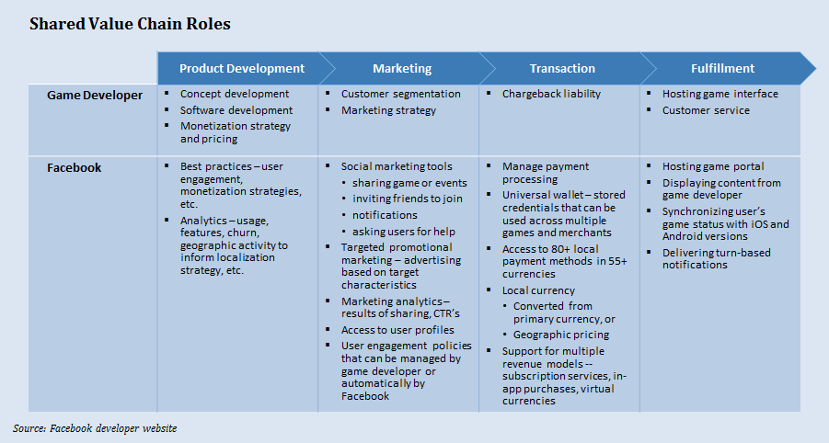

Figure 16 – Shared value chain roles

## I.4 Chat platforms

Social networks typically offer real-time messaging between users (''chat''). Because social networks are investing heavily in chat as a commerce platform, this topic deserves special attention.

### I.4.1 Chat as a feature

Chat applications facilitate real-time and asynchronous communication between two users or a small group of users – a much different method than more public communications like Tweets and Facebook posts. Chat users may send text, photos, voice recordings, videos, animations and other forms of media. Chat applications often include a VoIP service or vice versa.

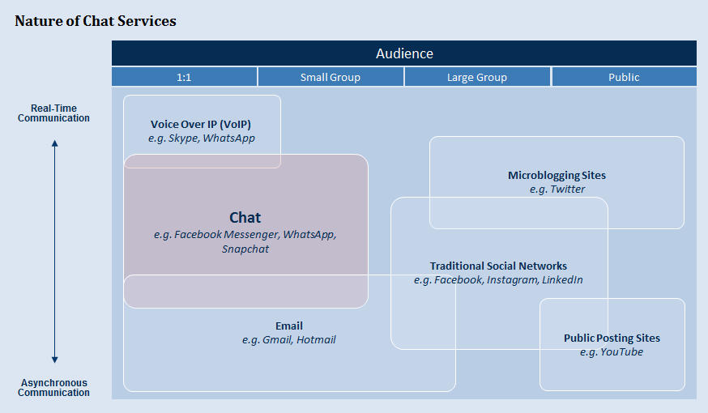

Figure 17 – Nature of chat services

Some companies began as chat or VoIP providers and have retained most of that focus so far (e.g., WhatsApp). Others have expanded significantly beyond initial chat/VoIP services (e.g., WeChat). More traditional social networks, such as Facebook, are placing more emphasis on chat (e.g., Facebook Messenger). These chat/VoIP-heritage companies and Facebook Messenger have become very popular with monthly active users rivalling those of traditional social networks.

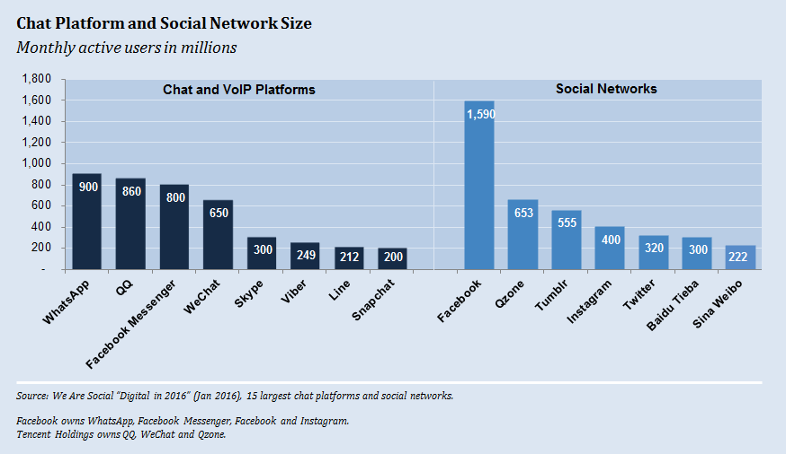

Figure 18 – Chat platform and social network size

### I.4.2 Chat as a platform

Chat is no longer just a feature that allows individuals to communicate. Chat is becoming a platform that allows businesses to provide sales, customer service, news, entertainment, or other services to new and potential customers. For example, WeChat users can ''hail a taxi, order food delivery, buy movie tickets, play casual games, check in for a flight, send money to friends, access fitness tracker data, book a doctor appointment, get banking statements, pay the water bill, find geo-targeted coupons, recognize music, search for a book at the local library, meet strangers around them, follow celebrity news, read magazine articles, and even donate to charity … all in a single, integrated app.''[[19]](#footnote-19)

Businesses are using chat platforms in several different ways:

**– Conversational style** – Human agents ('live chat'), software ('chatbot') and hybrid approaches.

**– Web style** – Traditional websites or platform-tailored applications deliver the user experience.

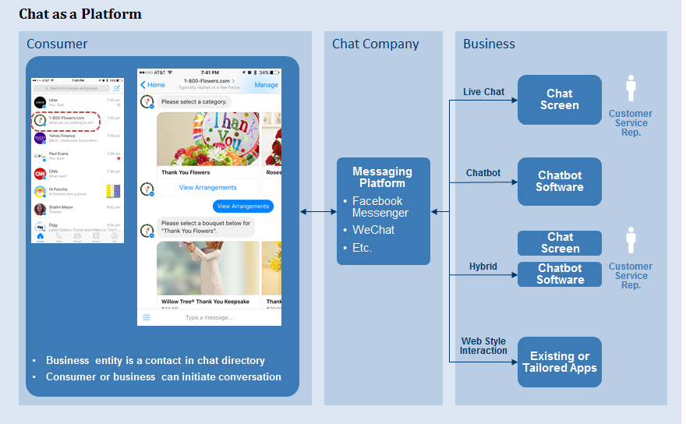

Figure 19 – Chat as a platform

As the screen shot above shows, Facebook Messenger pilots seem geared toward chatbots. Businesses on WeChat emphasize the web style interaction, as shown in the doctor appointment example below:

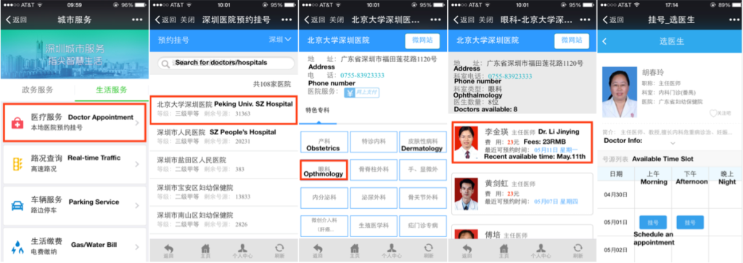

Figure 20 – Doctor appointment example

### I.4.3 Why are social networks emphasizing chat platforms?

Many social networks started as a chat service. For them, the platform approach is part of a monetization strategy. Others (primarily Facebook) gain diversification benefits. For all providers, chat platforms are an opportunity to take economic power from mobile OS providers such as Google and Apple.

**#1 – A monetization strategy for chat-heritage companies**

Many companies got started as a communication service (chat and/or voice). Examples include WhatsApp, LINE, WeChat, Viber and Skype. Monetizing the core chat feature is difficult as it is generally 'table stakes.' Accordingly, chat providers pursue other forms of revenue. For example, LINE, a popular mobile chat application in Japan, generated $1.15B[[20]](#footnote-20) in FY2015 revenue from:

– Communication (sticker[[21]](#footnote-21) purchases primarily) = 23.9 per cent

– Content (in-game purchases primarily) = 40.9 per cent

– Advertising (mobile primarily and web) = 30.2 per cent

– Other (merchandise primarily) = 5.0 per cent

Other social network revenue models include transaction fees (ordering coffee, scheduling taxi rides, etc.) and facilitating phone calls to individuals outside the social network's network.

**#2 – Diversification strategy for Facebook**

Consumers are fickle and can cause social networks to go into a ''death spiral'' – a reverse network effect in which users leaving the social network worsen the experience for users still using the social network. Facebook has this risk, particularly with the younger demographic who do not consider Facebook 'cool' and who do not want 'grandma commenting on their posts.'

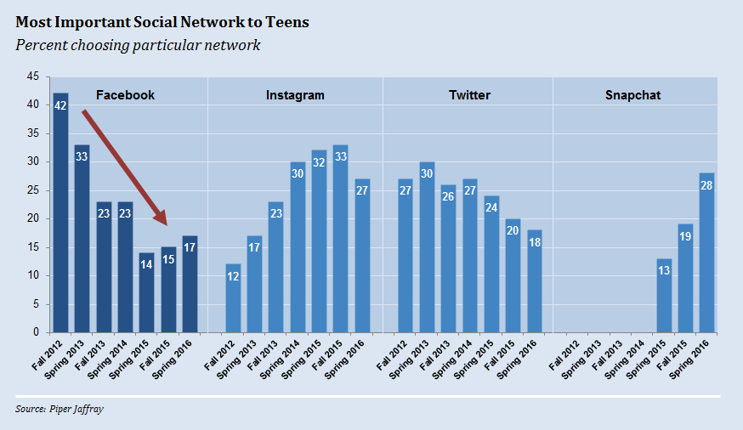

Figure 21 – Social networks' importance to teens

Teens do, however, use Facebook Messenger. In 2014, Facebook separated Messenger from the traditional Facebook application. So, a teenager can launch Messenger without experiencing Facebook’s reputational baggage.

To maintain revenue, Facebook must monetize Messenger. In April 2016, Facebook announced the beta version of Messenger platform. In Facebook's vision, communication between businesses and consumers should occur within Facebook Messenger. Consumers would be able to reach all of the businesses they need and communicate with them in a familiar way. The Messenger platform includes developer tools to facilitate this transition: Templates, user interface controls and artificial intelligence tools for application development.

**#3 – Disrupting the mobile OS and communications industry**

Chat platforms could reduce the importance of Google and Apple within mobile ecosystems. Google and Apple's control of mobile operating systems gives them great power. These giants typically receive 30 per cent of the revenue from mobile apps sold – resulting in an estimated $10B in revenue from the $30B+ in global 2015 sales. Chat providers see an opportunity to change the paradigm so that chat, not the mobile OS, is the platform. Users would no longer download and install apps on their phone, but instead access that same functionality through their chat application. If this happens, the chat platforms become the gatekeepers and monetizers that connect consumers and businesses. The mobile OS essentially becomes an invisible commodity/layer.

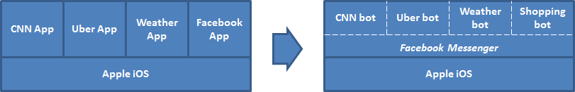

Figure 22 – Chat providers disruption to the mobile ecosystem

Chat platforms could also reduce the role of MNOs. MNOs typically charge separately for voice, SMS and data services (visiting social networks, sending email, etc.). Chat platforms also provide voice and messaging services to their users on top of the MNO's data service. This arrangement reduces the user's costs to the detriment of the MNO. MNOs may become commodity data pipes if this trend continues.

### I.4.4 Transformational benefits of artificial intelligence (AI)

Today, chatbots often operate within a structured framework. Users make requests via a menu (''Shop for shoes,'' ''Shop for shirts,'' etc.) and chatbots retrieve 'canned' responses from a database. This approach provides a predictable customer experience but does not scale well – use cases are limited since businesses must determine scenarios and appropriate responses.

Sci-fi movies depict a utopian future in which anyone can ask any question and receive a useful reply. Users have flexibility in how and what they ask, with voice recognition removing literacy requirements. Responses are not limited to pre-defined answers. For example, a consumer might ask ''Where can I find a replacement part for my water pump?'' After some back and forth clarification, a computer might return ''The replacement handle is available immediately at Paul's Irrigation Supply in Nairobi for 200 Ksh, but if you can wait until next Wednesday, it will be available at the local K&M store for only 180 Ksh.''

Two technologies provide a step toward this AI vision: natural language processing (NLP) and machine learning. NLP goals include natural language understanding (deriving meaning from human or natural language input) and natural language generation (communicating back to the user). This extremely complex field includes topics such as speech recognition, name entity recognition (identifying words that are people or places) and part-of-speech tagging (identifying whether words are nouns, verbs, etc.). In the early days, most NLP systems were based on complex sets of hand‑written rules (i.e., if you detect the phrases ''I need help'' or ''customer service'' or ''live person'' route the caller to a customer service agent.). Machine learning has made the rule development more robust – e.g., analysing historical data to find phrases that predict the need for a customer service agent.

Despite the progress and level of effort, fulfilling the AI vision is a long way off. Imagine the user frustration if a Google search returned only one sentence from one article. This scenario represents how far we are from a true AI vision. Fortunately, the AI promise is not an ‘all or nothing' proposition. The journey will likely involve incremental change, producing incremental benefits.

### I.4.5 Consumer and merchant value proposition

Chat platforms are strategically important to social networks, but do they help consumers and merchants? The AI vision has obvious appeal because it lets people communicate in a familiar and natural manner. However, utopia is a long way off. In the meantime, is the current version of chat platforms providing value?

Facebook's CEO Mark Zuckerberg argues that chat offers a superior user experience, ''No one wants to have to install a new app for every business or service that they want to interact with. We think that you should just be able to message a business in the same way that you message a friend.''[[22]](#footnote-22) This sounds good in theory, but a chat interaction may prove as frustrating as sequentially navigating a cable company's customer service phone menu. Arun Uday, Tringchat founder and former VC, offers this contrarian view, ''Think about it. Why would anybody want to replace an existing setup that is 100 per cent accurate and takes less effort to use (i.e., UI-driven menus) with something that is inaccurate and requires more effort to use (i.e., chatbots)?''[[23]](#footnote-23)

One could argue that WeChat's popularity proves consumers love interacting with businesses via chat. But, this argument has holes:

– Commercial interactions often do not fit the conversational chat stereotype. Yes, consumers can follow an 'Official Account' (e.g., Burberry clothing) and have 'conversations' through the chat interface. But, users often start with or are directed to web style pages within the WeChat application (e.g., for ordering a taxi). Essentially, WeChat's commerce expansion has relied on cross-selling more traditional commerce experiences to its chat base.

– E-commerce in China is different. Shopping is typically done through online marketplaces (analogous to WeChat's walled garden approach) rather than corporate e-commerce sites. Nonetheless, chat platforms may also prove valuable in other developing countries where e‑commerce is having a slower start.

In summary, conversational commerce is not a proven model, but importantly, it may be appropriate for some BoP applications (product inquiries, etc.) with users enjoying a simple user interface and low data costs.



Figure 22 – Chat screenshot – shopping

|  |  |
| --- | --- |
| **Structured interaction**  http://1u88jj3r4db2x4txp44yqfj1.wpengine.netdna-cdn.com/wp-content/uploads/2016/05/Pypestream_chatbot_image-300x336.png | **Natural language interaction**  chatbank_mockup |

Figure 23 – Chat screenshot – customer service

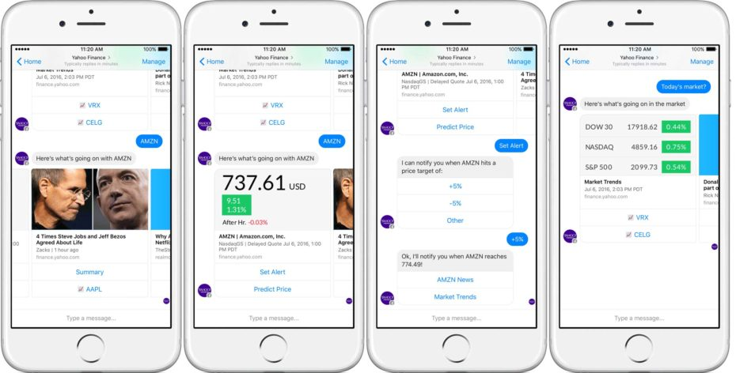

Figure 24 – Chat screenshot – news and entertainment

\_\_\_\_\_\_\_\_\_\_\_\_\_\_\_\_\_\_\_

1. New Data Revealed – Spring Festival 2016 on WeChat. Feb 24, 2016. http://blog.wechat.com/2016/02/24/new-data-revealed-spring-festival-2016-on-wechat/ (accessed August 19, 2016). Monthly active users from Tencent Holdings’ financial statements covering the quarter ending March 31, 2016. [↑](#footnote-ref-1)
2. Chan, Connie. Money as Message. How WeChat got users to adopt payments as a way to grow its network. July 24, 2016. http://a16z.com/2016/07/24/money-as-message (accessed August 19, 2016). [↑](#footnote-ref-2)
3. A chatbot is a software application designed to simulate conversation with human users. [↑](#footnote-ref-3)
4. State of Connectivity 2015: A Report on Global Internet Access. Facebook's Internet.org. [↑](#footnote-ref-4)
5. Chan, Connie. Money as Message. How WeChat got users to adopt payments as a way to grow its network. Andreessen Horowitz blog. July 24, 2016. http://a16z.com/2016/07/24/money-as-message (accessed August 19, 2016). [↑](#footnote-ref-5)
6. Goode, Lauren. Messenger and WhatsApp process 60 billion messages a day, three times more than SMS. The Verge. April 12, 2016. http://www.theverge.com/2016/4/12/11415198/facebook-messenger-whatsapp-number-messages-vs-sms-f8-2016 (accessed August 12, 2016). [↑](#footnote-ref-6)
7. Zollmann, Julie and Laura Cojocaru. Cash Lite: Are we there yet? Rethinking the evolution of electronic payments in Kenya based on evidence in the Kenyan and South African Financial Diaries. BFA and FSD Kenya. January, 2015. [↑](#footnote-ref-7)
8. World Bank. Tanzania, Mozambique and Pakistan CGAP Financial Diaries with Smallholder Households 2014-2015. Ref. TZA\_2014\_FDSH\_v01\_M, MOZ\_2014\_FDSH\_v01\_M and PAK\_2014\_FDSH\_v01\_M. All datasets downloaded on March 13, 2016. [↑](#footnote-ref-8)
9. Jing, Meng. Taobao village clusters spreading reach. China Daily. December 26, 2015. http://www.chinadaily.com.cn/business/tech/2015-12/26/content\_22813508.htm (accessed May 2016). [↑](#footnote-ref-9)
10. Internet.org website (accessed August 4, 2016) [↑](#footnote-ref-10)
11. Uber Increases Commission Fees for New York Drivers. February 10, 2016. http://uberdriverdiaries.com/ubers-pay-cut-a-one-two-punch-for-new-york-drivers/uber-increases-commission-fees-for-new-york-drivers/ (accessed August 19, 2016). [↑](#footnote-ref-11)
12. Schneier, Bruce. Data and Goliath: The Hidden Battles to Collect Your Data and Control Your World. W. W. Norton & Company. 2015. [↑](#footnote-ref-12)
13. Stewart, James B. Facebook Has 50 Minutes of Your Time Each Day. It Wants More. New York Times. May 5, 2016. http://www.nytimes.com/2016/05/06/business/facebook-bends-the-rules-of-audience-engagement-to-its-advantage.html?\_r=0 (accessed August 16, 2016). [↑](#footnote-ref-13)
14. Marshall, Jack. Facebook Wants to Help Sell Every Ad on the Web. The social network will show ads to non-Facebook users on other websites. Wall Street Journal. May 27, 2016. http://www.wsj.com/articles/facebook-wants-to-help-sell-every-ad-on-the-web-1464321603 (accessed August 23, 2016). [↑](#footnote-ref-14)
15. Chan, Connie. When One App Rules Them All: The Case of WeChat and Mobile in China. Andreessen Horowitz blog. August 6, 2015. http://a16z.com/2015/08/06/wechat-china-mobile-first/ (accessed May, 2016). [↑](#footnote-ref-15)
16. Ibid. [↑](#footnote-ref-16)
17. Ibid. [↑](#footnote-ref-17)
18. Facebook 10-K, Facebook developer website. [↑](#footnote-ref-18)
19. Chan, Connie. When One App Rules Them All: The Case of WeChat and Mobile in China. Andreessen Horowitz blog. August 6, 2015. http://a16z.com/2015/08/06/wechat-china-mobile-first/ (accessed May 2016). [↑](#footnote-ref-19)
20. LINE Corporation prospectus July 11, 2016; based on exchange rate of 105 Yen per USD. [↑](#footnote-ref-20)
21. Stickers are graphical images sent via chat typically as a surrogate for text. For example, a user may send an animated animal showing a 'thumbs up' sign rather than replying back with 'OK.' [↑](#footnote-ref-21)
22. McMillan, Robert. Facebook Hopes Chatbots Can Solve App Overload. The Wall Street Journal. Updated April 17, 2016. http://www.wsj.com/articles/facebook-hopes-chatbots-can-solve-app-overload-1460930220 (accessed August 14, 2016). [↑](#footnote-ref-22)
23. Uday, Arun. Bursting the chatbot bubble. Techcrunch website. July 16, 2016. https://techcrunch.com/2016/07/16/bursting-the-chatbot-bubble/ (accessed August 23, 2016). [↑](#footnote-ref-23)