|  |  |  |  |  |
| --- | --- | --- | --- | --- |
|  | | **International Telecommunication Union** | | |
|  | |  | | |
| **ITU-T** | **Technical Report** | |
| TELECOMMUNICATION STANDARDIZATION SECTOR OF ITU | | (6 June 2020) |
|  |  | | | |
|  | **ESTR.CLE Identify call location for emergency service** | | | |
|  |  | | | |

Summary

This technical report provides an overview of technical solution for identifying the call location for the emergency services.

Keywords

Call location, PSAP, TA.

NOTE – This is an informative ITU-T publication. Mandatory provisions, such as those found in ITU-T Recommendations, are outside the scope of this publication. This publication should only be referenced bibliographically in ITU-T Recommendations.

**Table of Contents**

1 Introduction 1

2 Scope 1

3 References 1

4 Terms and definitions 1

4.1 Terms defined here 1

5 Abbreviations and acronyms 2

6 Description of available technologies 2

6.1 Network based 2

6.1.1 For fixed network operators, all the needed information is stored in the fixed operator's database, which is mainly the address of the caller 3

6.1.2 For mobile network operators, the call location can be identified by multiple ways, either by Cell ID, or Cell ID with timing advance, or by cell ID with timing advance and received signal strength, as described below 3

6.2 Handset based 4

6.2.1 Advanced mobile location 4

6.2.2 Smartphone applications 5

6.3 Satellite systems 5

6.4 Cases used or experiences of different countries 7

6.4.1 European Union 7

6.4.2 North America 7

Technical Report ITU-T ESTR.CLE

Identify call location for emergency service

# 1 Introduction

One of the biggest challenges facing the emergency services is determining the location of mobile callers. However, cell data can help with verbal establishment of a caller's location, a more precise location will allow an even quicker response to emergencies. Emergency service measurements show that on average 30 seconds per call can be saved, and several minutes can be saved where callers are unable to verbally describe their location to stress, injury, language or simple unfamiliarity with an area. Further, each year there are many cases worldwide where the emergency services have to spend a significant amount of time searching for an incident because precise location information could not be provided.

Accordingly, it is important to identify call location for emergency services from mobile/fixed telecommunication operators with different technologies:

– To maximize the quality of service from emergency services, which depends mainly on the network architecture.

– Identify call location is an essential step to be easily linked to the emergency tracking system, to determine the most convenient way to reach the scene as soon as possible, to use alternative routes in case of traffic congestion, and to reduce the mortality rate due to the lack of timely arrival of emergency services.

– Preserve the lives of citizens by providing timely and therapeutic service to the applicant.

– Reduce counterfeits and false statements.

Effective emergency service management requires agencies from many different services to work closely together and to maintain open lines of communication. Most services do, or should, have procedures and liaisons in place to ensure this, although absence of these can be severely detrimental to good working. There can sometimes be tension between services for a number of other reasons, including professional versus voluntary crewmembers, or simply based on geographical area or division. To aid effective communications, different services may share common practices and protocol for certain large-scale emergencies.

# 2 Scope

This Technical Report provides guidance on provision of the different technologies to identify the call location for emergency services.

# 3 References

[1] European emergency number association EENA (<https://eena.org/>).

# 4 Terms and definitions

## 4.1 Terms defined here

This Technical Report defines the following terms:

**4.1.1** **Emergency services**: The public organizations that respond to and deal with emergencies when they occur, especially those that provide police, ambulance and firefighting services.

**4.1.2** **Response time**: The amount of time that it takes for emergency responders to arrive at the scene of an incident after the emergency response system was activated.

**4.1.3** **Other emergency services**: Utilities, emergency road services, disaster relief, voluntary medical services, etc.

# 5 Abbreviations and acronyms

This Technical Report uses the following abbreviations and acronyms:

ALI Advanced Location Identification

AML Advanced Mobile Location

ECID Enhanced Cell ID

EENA European Emergency Number Association

GNSS Global Navigation Satellite System

LBS Location Based Services

LPP LTE Positioning Protocol

LPPA LPP Annex

MNO Mobile Network Operator(s)

OTDOA Observed Time Difference of Arrival

PSAP Public Safety Answering Point

RRC Radio Resource Control

RRLP Radio Resource Location Protocol

SMS Short Message Service

SSID Service Set Identifier

SUPL Secure User Plan Location

TA Timing Advance

UE User Equipment

# 6 Description of available technologies

There are different protocols to identify the call location for the emergency services, such as network based, handset based and/or hybrid solutions.

## 6.1 Network based

Network based techniques use the service provider's network infrastructure (fixed/mobile) to identify the location of the handset. They can be implemented without affecting the mobile phones. Handset based technologies requires the installation of client software or special hardware on the handset to determine its location.

### 6.1.1 For fixed network operators, all the needed information is stored in the fixed operator's database, which is mainly the address of the caller

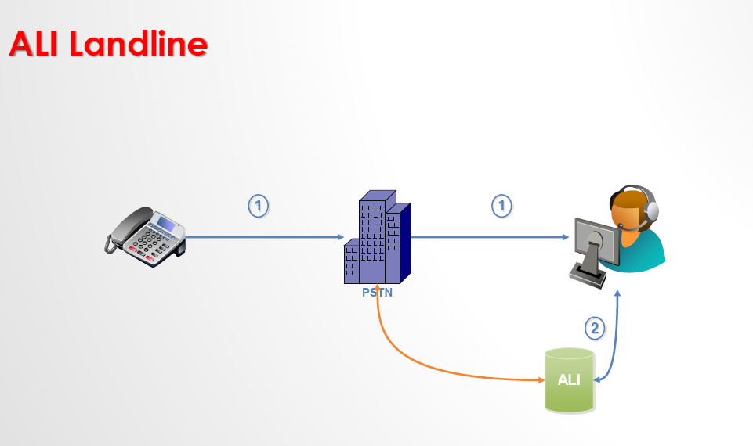

Figure 1 – Fixed network solutions

### 6.1.2 For mobile network operators, the call location can be identified by multiple ways, either by Cell ID, or Cell ID with timing advance, or by cell ID with timing advance and received signal strength, as described below

#### 6.1.2.1 Cell ID

The Cell ID is the identity number associated with a cell, which is designated by the network operator. This information is used in the network during normal operation to identify the connection point of the mobile device to the network. The operator knows the co-ordinates of each cell site and can therefore provide the approximate position of the connected mobile device.

The Cell ID positioning considers the location of the base station to be the location of the caller and communicates the sector information. The network cannot guarantee that the serving cell, which is used to estimate the handset location, is the closest to the caller. The accuracy of this method depends upon the size of the cell. It can vary from a few meters in urban locations to 10 to 30 km, especially in flat countryside and water surfaces. The underlying issue is that mobile networks are optimized for coverage, capacity and call handling with the minimum number of cells, rather than for locating phones. This method can be used regardless of the type of phone but the provided accuracy and reliability are not according to emergency service's needs.

#### 6.1.2.2 Cell ID with timing advance

The measured time between the start of a radio frame and the arrival of data to the cell of the mobile network can be added to the data of the cell identification. This period is called TA. Information derived from the wireless network can also be incorporated to the Cell ID based method. This way accuracy can be improved.

#### 6.1.2.3 Cell ID with timing advance and received signal strength

Advanced systems determine the sector in which the mobile phone resides and estimate approximately the distance to the base station. Further approximation is ensured by interpolating signals between adjacent antenna towers. Qualified services may achieve a precision of down to 50 metres in urban areas where mobile traffic and density of antenna towers (base stations) is sufficiently high. In rural and desolate areas, base stations may be kilometres apart and therefore locations are determined less precisely.



Figure 2 – Network based solutions

## 6.2 Handset based

### 6.2.1 Advanced mobile location

Advanced mobile location (AML) is a simple, cost effective solution to the mobile location problem that makes use of the built-in location capabilities of modern handsets. Once the mobile handset knows its location, it is sent to PSAPs using a simple, already available, SMS based protocol (which gives up to 160 characters of data). SMS offers the best geographic coverage, especially in remote areas, and additionally, emergency SMS messages are usually not charged. This solution offers accuracy of up to 1.1 metre resolution on the ground.

In the AML, the handset immediately attempts to determine location via all methods in parallel, so as not to delay transmission of location after the T1 timeout. If it is possible to distinguish them, cached (stale) or existing locations should not be used.

– If GNSS data becomes available before T1 seconds then that data is sent without waiting for the timeout.

– If at T1 seconds no GNSS data is available, but location is available based on Wifi SSIDs or MAC addresses of nearby access points, then the Wifi location is sent.

– If no Wifi based location is available then the cell ID based location data is sent.

– If GNSS or Wifi was switched on when the emergency call was initiated, then it should be then switched off as soon as it is no longer needed.

– If it has not been possible to get a location from any method then an SMS is sent indicating that all positioning methods have failed.

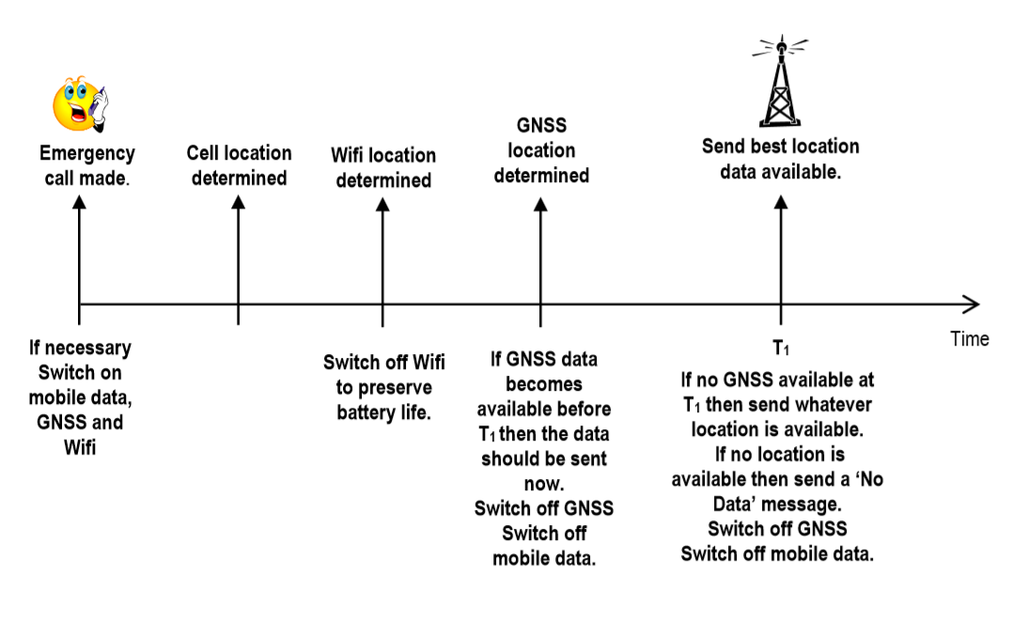

Figure 3 – Advanced Mobile location

### 6.2.2 Smartphone applications

Smartphones come with mapping apps that constantly log our position in real time. Many smart applications use this concept in order to allow civilians to provide the call taker position.

Other applications have the feature of downloading the maps in advance in order to use even without Internet connection, for example when the citizen might be abroad.

## 6.3 Satellite systems

One of the main tools to identify call locations for emergency services is GNSS, which provides positioning via satellites. Assisted GNSS (A-GNSS) connects to the nearest satellite using base stations for positioning. A-GNSS is useful for determining the location of cellular phones in an emergency and for providing LBS.

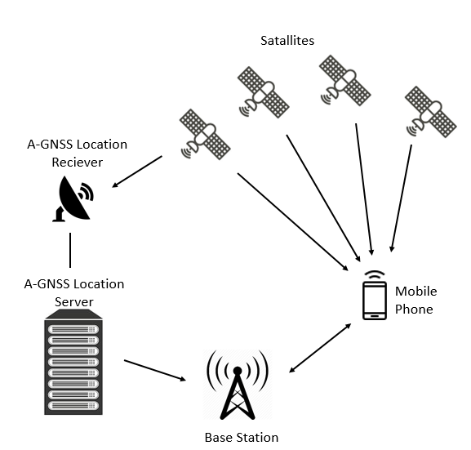

Figure 4 – A-GNSS Architecture

The UE can communicate with the location server over the user plane, using a standard data connection, or over the control plane. The server communicates directly with the UE over an IP data connection is called the ''User Plane''. Another method to transmit information directly to the handset is known as the ''Control Plane''. Positioning messages are exchanged between the network and the UE over the signalling connection. Control Plane executions are commonly used in emergency call services.

There are different types of standards for the A-GNSS messaging with the UE. As an example for GSM networks RRLP, UMTS networks RRC and LTE networks LPP. Control plane positioning protocols include RRLP, TIA 801, RRC and LPP. User plane positioning protocols include SUPL.

**RRLP**: is used in GSM and UMTS and it is provided to exchange messages between UE and an S‑MLC in order to position the device.

**RRC**: protocol is used in UMTS and LTE. It is provided to exchange messages between UE and eNB.

**LPP**: LPPa are operated from LTE via the radio network. LPP is a point-to-point protocol for communication between the location service (LCS) server and the LCS target device, and is used to provide geolocation information. LPP can be used both in the user plane and control plane.

LPPa is a communication protocol between an eNodeB and an LCS server for control-plane positioning, also it can assist user-plane positioning.

**SUPL**: SUPL works in (U-plane) to provide LBS.

LTE standards support three different UE based positioning methods:

– A-GNSS,

– Observed Time Difference of Arrival (OTDOA), and

– Enhanced Cell ID (ECID).

**ECID**: positioning is used to estimate the position of the UE quickly, but CID provides lower accuracy. Cell ID positioning performance can be improved by measuring certain network attributes. This method is called Enhanced Cell ID (ECID). ECID is able to provide better accuracy in comparison to CID.

**OTDOA**: UE-assisted method based on reference signal time difference (RSTD) measurements.

## 6.4 Cases used or experiences of different countries

### 6.4.1 European Union

Most of the European Union countries identify the call location of the customer for the emergency service by using the first generation of caller location techniques automatically or Cell ID. Recently, the AML feature has been approved by the EENA and activated in some European countries like England, Austria, Italy, etc., to be precise at call location identifier, which reaches 5 metre resolution, also the response time which occurs within 20 seconds only during communication link and uses AML features as a complementary solution to the services of locating the caller automatically [1].

### 6.4.2 North America

By studying the solutions applied in the United States of America, it was found that they apply a unified number for relief and emergency services (ambulance, rescue, and civil protection), in addition to relying on the Cell Id and TA techniques to distinguish them with the precise location of the caller [1].

______________