|  |  |  |  |  |
| --- | --- | --- | --- | --- |
|  | | **International Telecommunication Union** | | |
|  | |  | | |
| **ITU-T** | **Technical Paper** | |
| TELECOMMUNICATION STANDARDIZATION SECTOR OF ITU | | (23 October 2015) |
|  |  | | | |
|  | **HSTP-H810-XCHF Fundamentals of data exchange within ITU-T H.810 Continua Design Guideline architecture** | | | |
|  |  | | | |

Summary

The purpose of this Technical Paper is to provide a basic description of the data that is being exchanged between sensors, gateways, and end services and the value-add the Continua Design Guidelines (CDG) provide beyond the referenced standards to make implementations truly interoperable. The ITU-T Technical Paper "HSTP-H810 Introduction to the ITU-T H.810 Continua Design Guidelines" and the ITU-T H.810 CDG themselves provide a more comprehensive understanding of these interfaces.

Keywords

ITU-T H.810; Continua Design Guidelines; personal connected health; e-health.

Change Log

This document contains Version 1 of the ITU-T Technical Paper on “*Fundamentals of data exchange within ITU-T H.810 Continua Design Guideline architecture*” approved at the ITU-T Study Group 16 meeting held in Geneva, 12-23 October 2015.

|  |  |  |
| --- | --- | --- |
| **Editors:** | Michael J. Kirwan Continua and PCHA USA | Tel: +1-913-207-8226 Fax: +1-913-207-8226 Email: [mkirwan@continuaalliance.org](mailto:mkirwan@continuaalliance.org) |
|  | Daidi Zhong Chongqing University China | Tel: +86-13696454858 Email: [daidi.zhong@ieee.org](mailto:daidi.zhong@ieee.org) |

**CONTENTS**

| Page |
| --- |
| 1Purpose & Scope 1  2References 1  3Glossary 2  4Architecture in Brief 3  5Personal Health Devices Interface 4  6Services Interface 5  6.1 Device Observation 5  6.2 Questionnaires 6  6.3 Consent Management 6  6.4 Capabilities Exchange 6  6.5 Authenticated Persistent Session 6  7Health Information Services Interface 7  8Certification 7  9Foundational specifications and standards 8 |

**List of Figures**

| Page |
| --- |
| Figure 1 – High Level Architecture 3  Figure 2 – Sample IEEE 11073 Message 4  Figure 3 – Sample PCD-01 Message 5  Figure 4 – Sample PHMR Message 7 |

Technical Paper ITU-T HSTP-H810-XCHF

Fundamentals of data exchange within  
ITU-T H.810 Continua Design Guideline architecture

Introduction

National Health Ministers representing countries around the world are releasing tenders to build scalable managed healthcare services that conform to established industry standards. These standards include IEEE 11073 Personal Health Device Standards, the Integrating the Healthcare Enterprise (IHE) Patient Care Device PCD-01 Transaction, and the Health Level Seven International (HL7) personal health monitoring report (PHMR).

To enable true interoperable connectivity, ITU-T H.810-H.850 sub-series (a transposition of the Continua Design Guidelines) clearly defines the interfaces that enable the secure flow of medical data among sensors, gateways, and end services, removing ambiguity in underlying healthcare standards and ensuring consistent implementation through product certification.

# Purpose and scope

The purpose of this Technical Paper is to provide a basic description of the data that is being exchanged between sensors, gateways, and end services and the value-add the Continua Design Guidelines provide beyond the referenced standards to make implementations truly interoperable. The ITU-T Technical Paper HSTP-H810 "Introduction to the ITU-T H.810 Continua Design Guidelines" [ITU-T HSTP-H810] and the ITU-T H.810 Continua Design Guidelines [ITU-T H.810] themselves provide a more comprehensive understanding of these interfaces.

# References

[ITU-T HSTP-H810] Technical Paper ITU-T HSTP-H810 (2014), *Introduction to the ITU-T H.810 Continua Design Guidelines*.  
<<http://itu.int/pub/publications.aspx?lang=en&parent=T-TUT-EHT-2014-H810>>

[ITU-T H.810] Recommendation ITU-T H.810 (2013), *Interoperability design guidelines for personal health systems*.  
<<http://itu.int/rec/T-REC-H.810-201312-I>>

[ISO/IEEE 11073-10407] ISO/IEEE 11073-10407:2010, *Health informatics – Personal health device communication – Part 10407: Device specialization – Blood pressure monitor*.  
<<http://www.iso.org/iso/iso_catalogue/catalogue_tc/catalogue_detail.htm?csnumber=54573>>

[ITU-T H.820-H.850] Recommendation ITU-T H.820-H.850 sub-series, *Conformance of ITU-T H.810 personal health devices*.   
List at <<http://itu.int/en/ITU-T/studygroups/2013-2016/16/Pages/rm/ehealth.aspx>>

[CDG Certification] Continua certification process, <<http://continuaalliance.org/products/certification-process>> (visited 2015-10-30)

# Glossary

|  |  |
| --- | --- |
| AHD | Application Hosting Device |
| API | Application Programming Interface |
| APS | Authenticated Persistent Session |
| ATNA | Audit Trail and Node Authentication |
| BSP | Basic Security Profile |
| CDA | Clinical Document Architecture |
| DEC | Device Enterprise Communication |
| DEN | Document Encryption |
| EHR | Electronic Health Record |
| HIMSS | Healthcare Information Management Systems Society |
| HL7 | Health Level 7 International |
| HRN | Health Records Network |
| HTTP | Hypertext Transfer Protocol |
| IHE | Integrating the Healthcare Enterprise |
| IP | Internet Protocol |
| IT | Information Technology |
| ITU | International Telecommunications Union |
| JSON | JavaScript Object Notation |
| LAN | Local Area Network |
| MQTT | Message Queuing Telemetry Transport |
| NFC | Near-Friend Communication |
| NFC | Near-Field Communications |
| OMG | Object Management Group |
| ORU | Unsolicited Result Observation |
| PAN | Personal Area Network |
| PCD | Personal Connected Device |
| PCHA | Personal Connected Health Alliance |
| PHMR | Personal Health Monitoring Report |
| PIX | Patient Identifier Cross-Reference |
| QFD | Questionnaire Form Definition |
| QRD | Questionnaire Response Document |
| RLUS | Retrieval, Location and Update Service |
| S/MIME | Secure/Multipurpose Internet Mail Extensions |
| SAML | Security Assertion Markup Language |
| TAN | Touch Area Network |
| TLS | Transport Layer Security |
| USB | Universal Serial Bus |
| USB | Universal Serial Bus |
| WAN | Wide Area Network |
| WS-I | Web Services – Interoperability |
| XDM | Cross-Enterprise Document Media Interchange |
| XDR | Cross-Enterprise Document Reliable Interchange |
| XDS | Cross-Enterprise Document Sharing |
| XML | Extensible Markup Language |
| XUA | Cross-Enterprise User Assertion |

# Architecture in brief

The (personal health) devices interface (PAN/LAN/TAN Interface) standardizes around the IEEE 11073 personal health device family of standards for data format and exchange between the sensor and the gateway. The services interface (WAN Interface) standardizes around the IHE PCD‑01 Transaction to move data between a personal health gateway and health and fitness services (e.g. tele-health service).

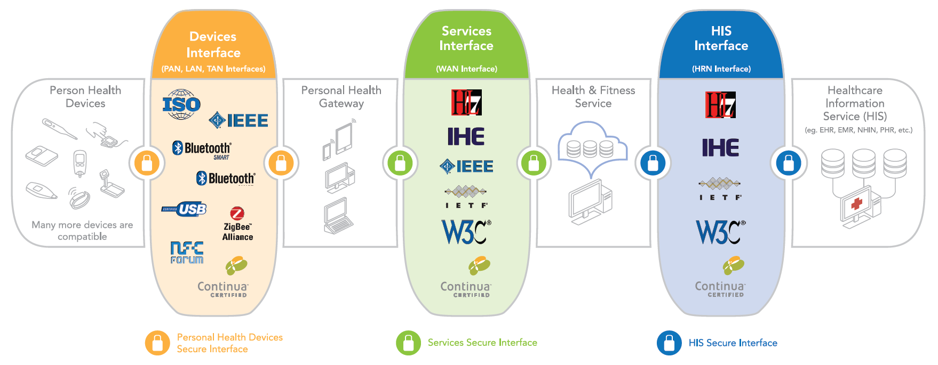

Figure 1 – High Level Architecture

The health information service interface (HRN Interface) standardizes around the HL7-based personal health monitoring report (PHMR) to move information between a health and fitness service and healthcare information service provider (e.g. EHR).

Continua addresses end-to-end security and privacy through a combination of identity management, consent management and enforcement, entity authentication, confidentiality, integrity and authentication, non-repudiation of origin, and auditing.

# Personal health devices interface

The *IEEE 11073 Personal Health Device* family of standards was developed by the IEEE to specifically address the interoperability of personal health devices (e.g. thermometer, blood pressure monitor) with an emphasis on personal use and a more simple communication model. This family of standards ensures that the user of the data knows exactly what was measured where and how, and that this critical information is not lost as it is transported from the sensor, to the gateway, and ultimately to the electronic health record system. Furthermore, one of the main reasons to use the 11073 family of standards in the Continua architecture is that it runs on top of USB, Bluetooth, NFC and ZigBee transport protocols.

There are a variety of measurement techniques, common device attributes, device specific attributes, and device events that are captured in a typical IEEE-11073 observation message. By way of example, a message from a blood pressure monitor could communicate use of the oscillometric technique, up to 18 common device attributes (e.g. model, manufacturer), 25 or more device-specific attributes (e.g. measurement units, status, time), and seven events (e.g. configuration, update). The protocol to communicate these makes sure that only changed data needs to be sent. In the example in Figure 2, the units of blood pressure are not sent as they are already known by the receiver. For more details, see [ISO/IEEE 11073-10407] on device specialization for blood pressure monitor.

Communicating such an exhaustive set of attributes may not be necessary or practical in all healthcare monitoring applications. Therefore, consultation is done within the healthcare community to agree on a subset of attributes to be included in the CDG that are sufficient for consumer-friendly healthcare monitoring solutions. In the blood pressure monitor, for example, four device-specific attributes were identified that must be communicated. Work is done closely with the Bluetooth SIG to ensure that Bluetooth Smart healthcare profiles include these attributes and that they are compatible with the IEEE 11073 data format.

Data confidentiality, integrity and authentication across the Personal Health Devices Interface is achieved via the underlying communication technology associated with each device (e.g. Bluetooth Security).

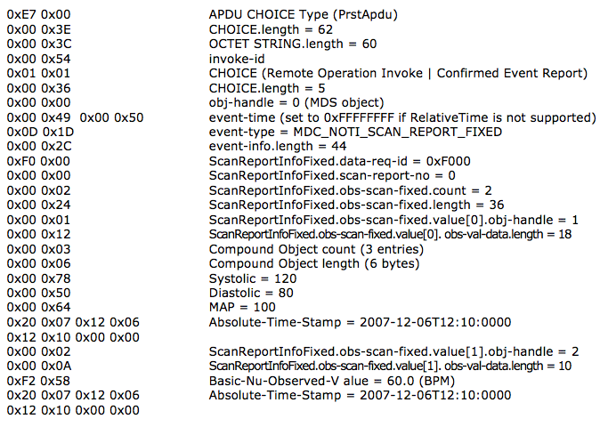

Figure 2 – Sample IEEE 11073 Message

# Services interface

The services interface provides for uploading device observations, exchange of questionnaires and responses, consent management, capabilities exchange, and authenticated persistent sessions over a wide area network. The CDG ensure interoperability by constraining IHE specifications and HL7 standards and providing implementation guidance and interface certification. For the services interface, security is achieved through consent management (HL7 CDA R2 Consent Directive), consent enforcement (XML Encryption Specification), auditing (IHE ATNA), confidentiality, integrity and service authentication (WS-I BSP, TLS v1.2), and entity authentication (WS-I BSP, WS-Security + SAML 2.0, or OAuth).

## Device observation

Device observations are one-way, point-to-point transmission of single and batch measurements between a Personal Health Gateway and a Health & Fitness Service. The *IHE PCD-01* Transaction is a profile within the HL7 Messaging Standard Version 2.6 used to communicate patient care device data from a device observation reporter (e.g. personal health gateway) to a device observation consumer (e.g. health and fitness service). *HL7 V2 Unsolicited Observation Result* (ORU^R01) message structure is used to capture and transmit sensor data. There are four key segments in this message structure: message header, patient identification, observation request, and observation result. The IEEE 11073 nomenclatures are preserved in the PCD-01 message to ensure the measurement information is clearly understood by the consumer of the observation. This PCD‑01 message is then transported over the Internet using industry standard web services as constrained in [ITU-T H.810] CDG. See example in Figure 3.

Alternatively, observations may be uploaded using the HL7 *hData framework standard* coupled with the *hData REST transport binding* (Object Management Group, OMG). hData is a RESTful application programming interface (API) specification used for lightweight, scalable information exchange that defines remote operations for accessing components of a health record and sending messages to an EHR system. hData organizes this information for web access, defines web services for consuming and producing data, standardizes metadata annotation of data, and enables popular authentication and authorization models, such as OpenID and OAuth 2.0. hData has been standardized by both HL7 and OMG.

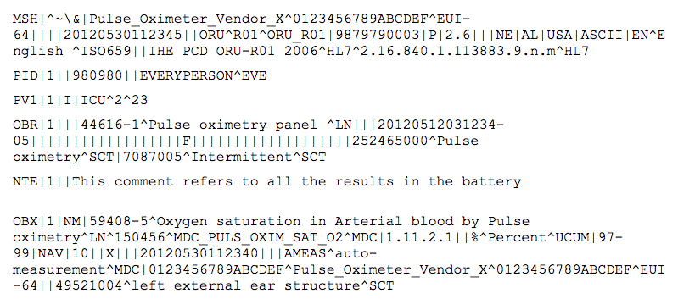

Figure 3 – Sample PCD-01 Message

## Questionnaires

Patient reported outcome measures, or *questionnaires*, are used in a clinical setting to collect information directly from the patient. The design guidelines enable the interoperable exchange of questionnaires across the services interface. Questionnaires are presented according to the *HL7 Implementation Guide for Questionnaire Form Definition* document HL7 CDA QFD. Responses to a questionnaire are then presented according to the *HL7 Implementation Guide Questionnaire* *Response* document HL7 CDA QRD. Questionnaires are transported per HL7 Version 3 Standard: hData Record Format, Release 1 and OMG hData REST Binding for RLUS Specification 1.0.1.

## Consent management

Consent management is a system, process, or set of policies that enable patients to choose what health information they are willing to permit their healthcare providers to access and share. The CDG provides for the capturing and transferring of consent policy in electronic form between the health and fitness service and the personal health gateway via the services interface. Consent representation is per *HL7 Implementation Guide for CDA Release 2.0: Consent Directive*. hData over HTTP is used as the transport protocol for the exchange of consent documents. Consent enforcement is enabled through the use of the IHE DEN profile. Alternatively, *IHE IT Infrastructure Technical Framework Supplement Cross-Enterprise Document Reliable Interchange* (XDR) can be used as transport protocol for uploading consent documents to the server. When the XDR protocol is used, consent enforcement uses XML encryption standard targeting a specific recipient.

## Capabilities exchange

Capability exchange reduces the amount of information that must be pre-configured on a device in order to obtain plug-and-play interoperability. The design guidelines enable this exchange of capability information between a personal health gateway (e.g. application hosting device, AHD) and a health and fitness service (e.g. tele-health service). Properties of a device or service and how to start the exchange of this information are defined. This information is exchanged in XML or JSON per *HL7 Version 3 Specification: hData Record Format, Release 1* over TLS v1.1 using OAuth.

## Authenticated persistent session

An authenticated persistent session (APS) enables a CDG cloud service to have a persistent secure channel to a gateway in the cellular environment where bandwidth, power, and IP resources may be limited and/or intermittent. The channel is persistent in that it stays in place even when IP connectivity is lost, continuing data delivery once IP connectivity is reestablished. Industry standard SMS messaging can be used to wake up a cellular gateway that has gone into a low power state, or lost its IP connectivity. The APS allows the cloud service to issue commands to the gateway and get timely responses without requiring continuous polling. This reduces bandwidth needs and conserves gateway power. The APS uses RESTful exchanges to establish the communications channel and MQTT, a lightweight publish-subscribe based protocol standard, to exchange messages.

# Health information services interface

The health information services (HIS) interface provides for the electronic exchange of health records employing an HL7-based PHMR. The PHMR is defined by HL7 to carry personal healthcare monitoring information to electronic medical record systems and includes representation of measurements captured by devices. The PHMR is used by Continua to communicate patient information based on a collection of one or more PCD-01 messages. See example in Figure 4.

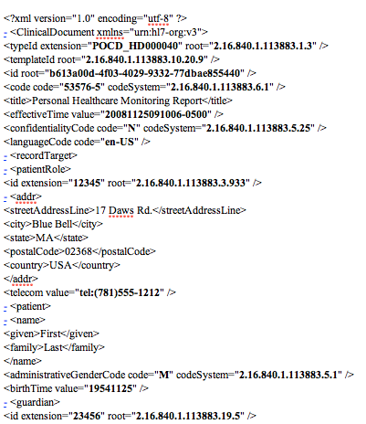

Figure 4 – Sample PHMR Message

The CDG specifies the transport of these reports using IHE XDS. XDS is a distributed collaborated approach that enables healthcare documents to be shared over a wide area network between hospitals and care providers. XDS registries store metadata used to retrieve documents, while any number of XDS repositories store documents. IHE *Patient Identifier Cross-Reference* (PIX) and *Cross-Enterprise Document Sharing* (XDS) are used by the HRN interface for cross-referencing patient identifiers and cross-enterprise document sharing.

For the HIS interface, security is achieved through confidentiality, integrity and authentication (TLS v1.1 and IHE XDM S/MIME), entity authentication (IHE XUA, IHE XUA++), identity management (IHE Patient Identity Feed HL7 V3, IHE PIXV3 Query transaction, and IHE Patient Demographics Query HL7 V3 transaction), consent management (HL7 CDA R2 Consent Directive), consent enforcement (IHE Document Encryption Profile), non-repudiation of origin (IHE Document Digital Signature), and auditing (IHE ATNA).

# Certification

Continua's Test and Certification program [CDG Certification] ensures interoperability by verifying that products conform to the Continua Design Guidelines and its underlying standards. Certification of sensor devices ensures that IEEE 11073 conformant data is securely received at the gateway. Certification of the WAN interface ensures that each field of every segment in the PCD‑01 message contains a valid value. Certification of the HRN interface ensures the syntax and semantics of the XML message.

# Foundational specifications and standards

IEEE drives the functionality, capabilities and interoperability of a wide range of products and services that transform the way people live, work and communicate. The *IEEE 11073 Personal Health Devices* family of standards enables communication between medical, health care and wellness devices and with external computer systems.

*Integrating the Healthcare Enterprise* is an initiative by care providers and vendors to improve the way information systems communicate to support patient care. Integration profiles describe clinical requirements for systems integration and well-defined and highly constrained solutions to address them. Transactions are used to specify in careful detail the roles for each component in the system and are based on standards such as IEEE 11073 and HL7.

*HL7* is a not-for-profit, ANSI-accredited standards developing organization dedicated to providing a comprehensive framework and related standards for the exchange, integration, sharing, and retrieval of electronic health information that supports clinical practice and the management, delivery and evaluation of health services.

___________________