 |  | International Telecommunication Union
 |  | ITU-T | Technical Paper
 |  | TELECOMMUNICATION  STANDARDIZATION SECTOR  OF ITU |  | (27 January 2017)
HSTP-H810-XCHF
Fundamentals of data exchange within ITU-T H.810 Continua Design Guideline architecture

Summary
The purpose of this Technical Paper is to provide a basic description of the data that is being exchanged between sensors, gateways, and end services and the value-add the Continua Design Guidelines (CDG) provide beyond the referenced standards to make implementations truly interoperable. The ITU-T Technical Paper "HSTP-H810 Introduction to the ITU-T H.810 Continua Design Guidelines" and the ITU-T H.810 CDG themselves provide a more comprehensive understanding of these interfaces.

Keywords
ITU-T H.810; Continua Design Guidelines; personal connected health; e-health.

Change Log
This document contains Version 2 of the ITU-T Technical Paper on “Fundamentals of data exchange within ITU-T H.810 Continua Design Guideline architecture” approved at the ITU-T Study Group 16 meeting held in Geneva, 16-27 January 2017.
Version 1 of this Technical Paper was approved by ITU-T Study Group 16 in its meeting in Geneva, 12-23 October 2015.

Editors: | Daidi Zhong  Chongqing University  China | Tel: +86-13696454858  Email: daidi.zhong@ieee.org
 | Michael J. Kirwan  Continua and PCHA  USA | Tel: +1-913-207-8226  Fax: +1-913-207-8226  Email: mkirwan@pchalliance.org

CONTENTS
Page
1 Purpose and scope 1
2 References 1
3 Glossary 2
4 Architecture in brief 3
5 Personal Health Devices Interface 4
6 Services Interface 5
6.1 Device Observation 5
6.2 Questionnaires 6
6.3 Consent Management 6
6.4 Capabilities Exchange 6
6.5 Authenticated Persistent Session 6
7 Healthcare Information Systems Interface 7
8 Certification 8
9 Foundational specifications and standards 8

List of Figures
Page
Figure 1: High Level Architecture 3
Figure 2: Sample IEEE 11073 Message 4
Figure 3: Sample PCD-01 Message 6
Figure 4: Sample PHMR Message 7

Technical Paper ITU-T HSTP-H810-XCHF
Fundamentals of data exchange within
ITU-T H.810 Continua Design Guideline architecture

Introduction
National Health Ministers representing countries around the world are releasing tenders to build scalable managed healthcare services that conform to established industry standards. These standards include IEEE 11073 Personal Health Device Standards, the Integrating the Healthcare Enterprise (IHE) Patient Care Device PCD-01 Transaction, and the Health Level Seven International (HL7) Personal Health Monitoring Report (PHMR).
To enable true interoperable connectivity, ITU-T H.810-H.850 sub-series (a transposition of the Continua Design Guidelines) clearly defines the interfaces that enable the secure flow of medical data among sensors, gateways, and end services, removing ambiguity in underlying healthcare standards and ensuring consistent implementation through product certification. In December 2013, Continua's Design Guidelines gained the status of an International Standard for personal health systems through ITU Telecommunications Sector (ITU-T), the standards-setting body within the United Nations.

Purpose and scope
The purpose of this Technical Paper is to provide a basic description of the data that is being exchanged between sensors, gateways, and end services and the value-add the Continua Design Guidelines provide beyond the referenced standards to make implementations truly interoperable. The ITU-T Technical Paper HSTP-H810 "Introduction to the ITU-T H.810 Continua Design Guidelines" [ITU-T HSTP-H810] and the ITU-T H.810 Continua Design Guidelines [ITU-T H.810] themselves provide a more comprehensive understanding of these interfaces.

References
[ITU-T HSTP-H810] Technical Paper ITU-T HSTP-H810 (2014), Introduction to the ITU-T H.810 Continua Design Guidelines.
<http://itu.int/pub/publications.aspx?lang=en&parent=T-TUT-EHT-2014-H810>
[ITU-T H.810] Recommendation ITU-T H.810 (2016), Interoperability design guidelines for personal health systems.
<http://itu.int/rec/T-REC-H.810-201312-I>
[ITU-T H.820-H.850] Recommendation ITU-T H.820-H.850 sub-series, Conformance of ITU-T H.810 personal health devices.
List at <http://itu.int/en/ITU-T/studygroups/2017-2020/16/Pages/rm/ehealth.aspx>
[CDG Certification] Continua certification process, <http://www.pchalliance.org/continua-product-certification> (visited 2017-04-25)
[IEEE 11073-10101] ISO/IEEE 11073-10101:2004, Health informatics – Point-of-care medical device communication -- Part 10101: Nomenclature. <https://standards.ieee.org/findstds/standard/11073-10101-2004.html> and subsequent amendments.
[IEEE 11073-10201] ISO/IEEE 11073-10201:2004, Health informatics – Point-of-care medical device communication – Domain Information Model. <https://standards.ieee.org/findstds/standard/11073-10201-2004.html>
[IEEE 11073-10407] ISO/IEEE 11073-10407:2010, Health informatics – Personal health device communication – Part 10407: Device specialization – Blood pressure monitor. <https://standards.ieee.org/findstds/standard/11073-10407-2010.html>
[IEEE 11073-20601] ISO/IEEE 11073-20601:2016, IEEE Health informatics – Personal health device communication – Part 20601: Application profile - Optimized Exchange Protocol. <https://standards.ieee.org/findstds/standard/11073-20601-2014.html> and associated corrigenda.

Glossary
API | Application Programming Interface
APS | Authenticated Persistent Session
ATNA | Audit Trail and Node Authentication
BSP | Basic Security Profile
CDA | Clinical Document Architecture
DEC | Device Enterprise Communication
DEN | Document Encryption
EHR | Electronic Health Record
HIMSS | Healthcare Information Management Systems Society
HL7 | Health Level 7 International
HIS | Healthcare Information System
HTTP | Hypertext Transfer Protocol
IHE | Integrating the Healthcare Enterprise
IP | Internet Protocol
IT | Information Technology
ITU | International Telecommunications Union
JSON | JavaScript Object Notation
MQTT | Message Queuing Telemetry Transport
NFC | Near-Field Communications
OMG | Object Management Group
ONC | Office of the National Coordinator for Health Information Technology
ORU | Unsolicited Result Observation
PCD | Personal Connected Device
PCHA | Personal Connected Health Alliance
PHMR | Personal Health Monitoring Report
PIX | Patient Identifier Cross-Reference
QFD | Questionnaire Form Definition
QRD | Questionnaire Response Document
RLUS | Retrieval, Location and Update Service
S/MIME | Secure/Multipurpose Internet Mail Extensions
SAML | Security Assertion Markup Language
TLS | Transport Layer Security
USB | Universal Serial Bus
WS-I | Web Services – Interoperability
XDM | Cross-Enterprise Document Media Interchange
XDR | Cross-Enterprise Document Reliable Interchange
XDS | Cross-Enterprise Document Sharing
XML | Extensible Markup Language
XUA | Cross-Enterprise User Assertion

Architecture in brief
The Personal Health Devices Interface standardizes around the IEEE 11073 Personal Health Device family of standards for data format and exchange between the sensor and the gateway. The Services Interface standardizes around the IHE PCD-01 Transaction to move data between a Personal Health Gateway and Health & Fitness Services (e.g. tele-health service).
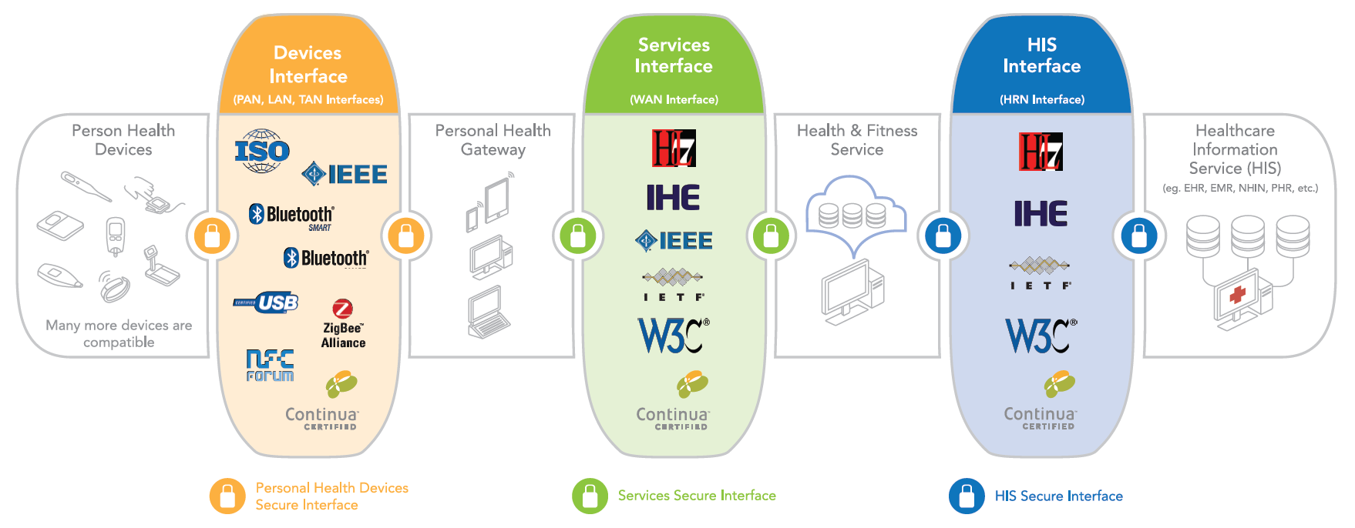
Figure 1: High Level Architecture
The Healthcare Information System Interface standardizes around the HL7-based PHMR to move information between a Health & Fitness Service and Healthcare Information System provider (e.g. electronic health record, EHR).
Continua addresses end-to-end security and privacy through a combination of identity management, consent management and enforcement, entity authentication, confidentiality, integrity and authentication, non-repudiation of origin, and auditing.

Personal Health Devices Interface
The IEEE 11073 Personal Health Device family of standards was developed by the IEEE to specifically address the interoperability of personal health devices (e.g. thermometer, blood pressure monitor) with an emphasis on personal use and a more simple communication model. This family of standards ensures that the user of the data knows exactly what was measured where and how, and that this critical information is not lost as it is transported from the sensor, to the gateway, and ultimately to the electronic health record system. Furthermore, one of the main reasons to use the 11073 family of standards in the Continua architecture is that it runs on top of USB, Bluetooth, NFC and ZigBee transport protocols.
IEEE 11073 family of standards includes the IEEE 11073-10101 Nomenclature [IEEE 11073-10101], IEEE 11073-10201 Domain Information Model [IEEE 11073-10201], IEEE 11073-20601 Optimized Exchange Protocol [IEEE 11073-20601], and the device specializations in the IEEE 11073-10400-series. The Nomenclature standard defines the overall architecture of the organization and relationships among nomenclature components along with specific semantics and syntaxes. The Domain Information Model standard addresses the definition and structuring of information that is communicated or referred to in communication between devices. The Optimized Exchange Protocol standard defines a common framework for making an abstract model of personal health data available in transport independent syntax. Device Specializations standards define communications between compute engines (e.g. personal health gateway) and specific personal health tele-health devices.
A typical 11073 observation message captures a variety of measurement techniques, common device attributes, device specific attributes, and device events. By way of example, a message from a blood pressure monitor could communicate use of the oscillometric technique, up to 18 common device attributes (e.g. model, manufacturer), 25 or more device specific attributes (e.g. measurement units, status, time), and 7 events (e.g. configuration, update). The protocol to communicate these makes sure that only changed data needs to be sent. In the example below in Figure 2 the units of blood pressure are not sent as they are already known by the receiver. See the device specialization for blood pressure monitor in [IEEE 11073-10407] for more detail.
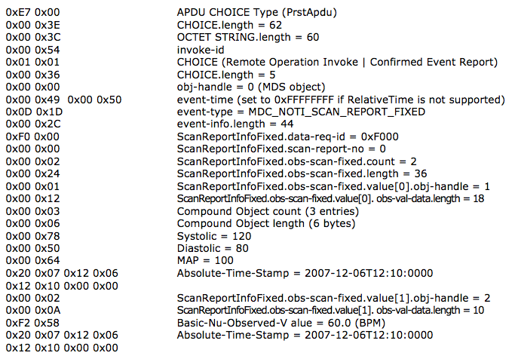
Figure 2: Sample IEEE 11073 Message
Communicating such an exhaustive set of attributes may not be necessary or practical in all healthcare monitoring applications. Therefore, Continua works within the healthcare community to agree on a subset of attributes that are sufficient for consumer-friendly healthcare monitoring solutions. In the blood pressure monitor, for example, Continua has identified four device specific attributes that must be communicated. Continua also works closely with the Bluetooth SIG to ensure that Bluetooth Smart healthcare profiles include these attributes and that they are compatible with the IEEE 11073 data format. Recently completely profiles include monitoring for sleep apnoea breathing therapy, continuous glucose and insulin pump, bringing the total number of supported profiles to 32. See the Interoperability Design Guidelines in [ITU-T H.810] for a detailed list.
Data confidentiality, integrity and authentication across the Personal Health Devices Interface is achieved via the underlying communication technology associated with each device (e.g. Bluetooth Security).

Services Interface
The Services Interface provides for uploading device observations, exchange of questionnaires and responses, consent management, capabilities exchange, and authenticated persistent sessions over a wide area network. The design guidelines ensure interoperability by constraining IHE specifications and HL7 standards and providing implementation guidance and interface certification. For the Services Interface, security is achieved through consent management (HL7 CDA R2 Consent Directive), consent enforcement (XML Encryption Specification), auditing (IHE ATNA), confidentiality, integrity and service authentication (WS-I BSP, TLS v1.2), and entity authentication (WS-I BSP, WS-Security + SAML 2.0, or OAuth).

Device Observation
Device observations are one-way, point-to-point transmission of single and batch measurements between a Personal Health Gateway and a Health & Fitness Service. The IHE PCD-01 Transaction is a profile within the HL7 Messaging Standard Version 2.6 used to communicate Patient Care Device data from a device observation reporter (e.g. Personal Health Gateway) to a device observation consumer (e.g. Health & Fitness Service). HL7 V2 Unsolicited Observation Result (ORU^R01) message structure is used to capture and transmit sensor data. There are four key segments in this message structure: message header, patient identification, observation request, and observation result. IEEE 11073 nomenclatures are preserved in the PCD-01 message to ensure the measurement information is clearly understood by the consumer of the observation. This PCD-01 message is then transported over the internet using industry standard web services as constrained in the Continua Design Guidelines.
Alternatively, observations may be uploaded using the HL7 hData framework standard coupled with the hData REST transport binding (OMG). hData is a RESTful application programming interface (API) specification used for lightweight, scalable information exchange that defines remote operations for accessing components of a health record and sending messages to an EHR system. hData organizes this information for web access, defines web services for consuming and producing data, standardizes metadata annotation of data, and enables popular authentication and authorization models, such as OpenID and OAuth 2.0. hData has been standardized by both HL7 and OMG.
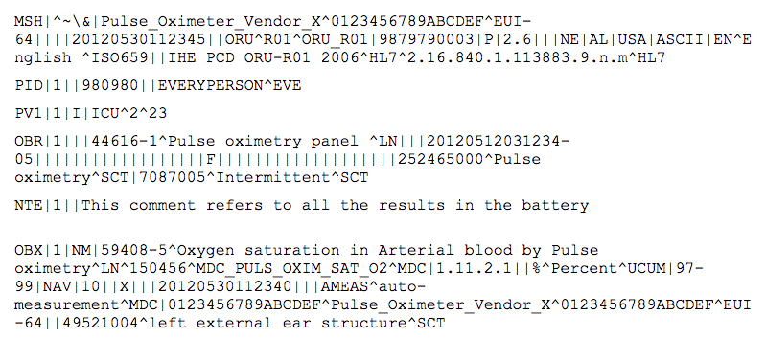
Figure 3: Sample PCD-01 Message

Questionnaires
Patient reported outcome measures, or questionnaires, are used in a clinical setting to collect information directly from the patient. The design guidelines enable the interoperable exchange of questionnaires across the Services Interface. Questionnaires are presented according to the HL7 Implementation Guide for Questionnaire Form Definition document HL7 CDA QFD. Responses to a questionnaire are then presented according to the HL7 Implementation Guide Questionnaire Response document HL7 CDA QRD. Questionnaires are transported per HL7 Version 3 Standard: hData Record Format, Release 1 and Object Management Group (OMG) hData REST Binding for RLUS Specification 1.0.1.

Consent Management
Consent management is a system, process, or set of policies that enable patients to choose what health information they are willing to permit their healthcare providers to access and share. Continua provides for the capturing and transferring of consent policy in electronic form between the Health & Fitness Service and the Personal Health Gateway via the Services Interface. Consent representation is per HL7 Implementation Guide for CDA Release 2.0: Consent Directive. hData over HTTP is used as the transport protocol for the exchange of consent documents. Consent enforcement is enabled through the use of the IHE DEN profile. Alternatively, IHE IT Infrastructure Technical Framework Supplement Cross-Enterprise Document Reliable Interchange (XDR) can be used as transport protocol for uploading consent documents to the server. When the XDR protocol is used, consent enforcement uses XML encryption standard targeting a specific recipient.

Capabilities Exchange
Capability Exchange reduces the amount of information that must be pre-configured on a device in order to obtain plug-n-play interoperability. The design guidelines enable this exchange of capability information between a Personal Health Gateway and a Health & Fitness Service (e.g. tele-health service). Properties of a device or service and how to start the exchange of this information are defined. This information is exchanged in XML or JSON per HL7 Version 3 Specification: hData Record Format, Release 1 over TLS v1.1 using OAuth.

Authenticated Persistent Session
An authenticated Persistent Session (APS) enables a Continua cloud service to have a persistent secure channel to a gateway in the cellular environment where bandwidth, power, and IP resources may be limited and/or intermittent. The channel is persistent in that it stays in place even when IP connectivity is lost, continuing data delivery once IP connectivity is re-established. Industry standard SMS messaging can be used to wake up a cellular gateway that has gone into a low power state, or lost its IP connectivity. The APS allows the cloud service to issue commands to the gateway and get timely responses without requiring continuous polling. This reduces bandwidth needs and conserves gateway power. The APS uses RESTful exchanges to establish the communications channel and MQTT, a lightweight publish-subscribe based protocol standard, to exchange messages.

Healthcare Information Systems Interface
The Healthcare Information Systems Interface provides for the electronic exchange of health records employing an HL7-based PHMR. The PHMR is defined by HL7 to carry personal healthcare monitoring information to electronic medical record systems and includes representation of measurements captured by devices. The PHMR is used by Continua to communicate patient information based on a collection of one or more PCD-01 messages.
The CDG specifies the transport of these reports using IHE XDS or ONC DIRECT. IHE XDS is a distributed collaborated approach that enables healthcare documents to be shared over a wide area network between hospitals and care providers. XDS registries store metadata used to retrieve documents, while any number of XDS repositories store documents. IHE Patient Identifier Cross-Reference (PIX) and Cross-Enterprise Document Sharing (XDS) are used by the HIS interface for cross-referencing patient identifiers and cross-enterprise document sharing. ONC DIRECT provides a simple and secure standard-based method for sending health information to the known and trusted participants via email over the Internet.
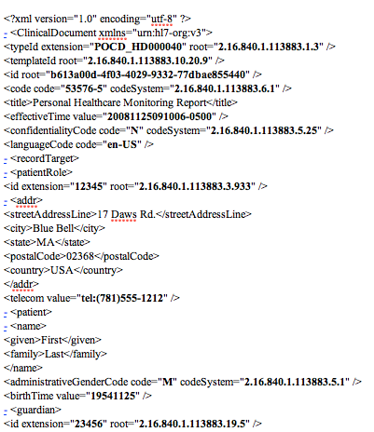
Figure 4: Sample PHMR Message
For the Healthcare Information Systems Interface, security is achieved through confidentiality, integrity and authentication (TLS v1.1 and IHE XDM S/MIME), entity authentication (IHE XUA, IHE XUA++), identity management (IHE Patient Identity Feed HL7 V3, IHE PIXV3 Query transaction, and IHE Patient Demographics Query HL7 V3 transaction), consent management (HL7 CDA R2 Consent Directive), consent enforcement (IHE Document Encryption Profile), non-repudiation of origin (IHE Document Digital Signature), and auditing (IHE ATNA).

Certification
Continua's Test and Certification program ensures interoperability by verifying that products conform to the Continua Design Guidelines and its underlying standards. Certification of sensor devices ensures that IEEE 11073 conformant data is securely received at the gateway. Certification of the WAN interface ensures that each field of every segment in the PCD-01 message contains a valid value. Certification of the HIS interface ensures the syntax and semantics of the XML message.

Foundational specifications and standards
IEEE drives the functionality, capabilities and interoperability of a wide range of products and services that transform the way people live, work and communicate. The IEEE 11073 Personal Health Devices family of standards enables communication between medical, health care and wellness devices and with external computer systems.
Integrating the Healthcare Enterprise (IHE) is an initiative by care providers and vendors to improve the way information systems communicate to support patient care. Integration profiles describe clinical requirements for systems integration and well-defined and highly constrained solutions to address them. Transactions are used to specify in careful detail the roles for each component in the system and are based on standards such as IEEE 11073 and HL7.
HL7 is a not-for-profit, ANSI-accredited standards developing organization dedicated to providing a comprehensive framework and related standards for the exchange, integration, sharing, and retrieval of electronic health information that supports clinical practice and the management, delivery and evaluation of health services.
___________________

