|  |  |  |  |  |
| --- | --- | --- | --- | --- |
|  | | **International Telecommunication Union** | | |
|  | |  | | |
| **ITU-T** | **Technical Report** | |
| TELECOMMUNICATION STANDARDIZATION SECTOR OF ITU | | (9 February 2018) |
|  |  | | | |
|  | **GSTR-TN5G**  **Transport network support of IMT-2020/5G** | | | |
|  |  | | | |

Summary

This technical report documents a reference model for the IMT 2020/5G transport network and a set of deployment scenarios. It captures requirements on transport networks in order to support IMT 2020/5G networks and provides details on the interfaces between the IMT 2020/5G entities and the transport network. The support of IMT 2020/5G network slicing (data plane and control plane) and Control/Management interfaces are also described.

Keywords

IMT-2020, 5G, network slicing

Change Log

This document contains Version 0 of the ITU-T Technical Report on “*Transport network support of IMT-2020/5G*” agreed at the ITU-T Study Group 15 meeting held in Geneva, 29 January -9 February 2018 .

|  |  |  |
| --- | --- | --- |
| **Editor:** | Stephen Shew Ciena Canada | Tel: +1 613 670 3211 E-mail: sshew@ciena.com |

**CONTENTS**

| Page |
| --- |
| 1 Scope 2  2 References 2  3 Terms and definitions 3  3.1 Terms defined elsewhere 3  3.2 Terms defined here 3  4 Abbreviations 3  5 Reference 5G Wireless Architecture 4  5.1 3GPP’s 5G Architecture 4  5.2 Evolution of wireless transport architecture from 4G to 5G 4  5.3 Functional Split in the Fronthaul Link 6  5.3.1 Channel Bandwidths 7  5.3.2 New Functional Split Options in 5G wireless network 8  5.4 RAN deployment scenarios 9  6 Synchronization 9  6.1 Synchronization distribution Architecture 9  6.1.1 Frequency synchronization architecture 9  6.1.2 Time synchronization architecture 10  6.2 Synchronization requirements 10  6.2.1 Time synchronization 10  6.2.2 Frequency synchronization 11  7 Interfaces 12  7.1 Capacity 12  7.2 Latency 13  7.3 Network Reach 13  8 Management and control 13  9 Multiservice support 15  10 Support of 5G Slicing in the transport network 15  Annex 1 Architecture of transport network for 5G 16  Annex 2 Terminology mapping 18 |

Technical Report ITU-T GSTR-TN5G

Transport network support of IMT-2020/5G

**Summary**

This technical report documents a reference model of IMT‑2020/5G network and a set of deployment scenarios. It documents requirements on transport networks in order to support IMT‑2020/5G networks, particularly at interfaces between IMT 2020/5G entities and transport networks. Aspects of transport network support include network slicing (data plane and control plane), synchronization, and Control/Management.

Technical Report ITU-T GSTR-TN5G

Transport network support of IMT-2020/5G

1. **Scope**

This TR focuses on requirements on transport networks in order to support IMT‑2020/5G networks. Aspects of how mobile traffic is directed onto transport networks are out of scope.

1. **References**
2. 3GPP TR 23.501 v1.4 (2017-09) System Architecture for the 5G System, Stage 2 Release 15
3. 3GPP TR 28.801 v15.0.0 (2017-09) Study on management and orchestration of network slicing for next generation network, Release 15
4. 3GPP TR 38.401, “Architecture description”, v0.2.0, 2017-07
5. 3GPP TR 38.801, “Technical Specification Group Radio Access Network; Study on new radio access technology: Radio access architecture and interfaces”, March 2017
6. 3GPP Release 15, TS 38.470 … 475 series (NG-RAN; F1 interface)
7. 3GPP TS 38.104, Base Station (BS) radio transmission and reception (Release 15)
8. 3GPP TS 38.133, Requirements for support of radio resource management (Release 15)
9. 3GPP TS 38.300, NR; NR and NG-RAN Overall Description; Stage 2
10. 3GPP TS 38.340, Evolved Universal Terrestrial Radio Access (E-UTRA) and NR;Multi-connectivity;Stage 2
11. 3GPP TS 36.300, Evolved Universal Terrestrial Radio Access (E-UTRA) and Evolved Universal Terrestrial Radio Access Network (E-UTRAN); Overall description
12. 3GPP TS 28.530 v0.4.0 (2018-1), Management of 5G networks and network slicing; Concepts, use cases and requirements.
13. 3GPP TS 38.913 v14.3.0 (2017-06), Study on Scenarios and Requirements for  
     Next Generation Access Technologies.
14. eCPRI Specification V1.0, "Common Public Radio Interface: eCPRI Interface Specification", August 2017
15. SCF082.09.05, Small Cell Forum (SCF) nFAPI (network functional application platform interface)
16. NGMN Alliance, “5G White Paper” 17-February 2015
17. NGMN Alliance, “5G End-to-End Architecture Framework” 04-Oct-2017
18. IEEE P1914.1/D0.1 Draft Standard for Packet-based Fronthaul Transport Networks
19. ITU-T Recommendation G.8265/Y.1365 (2010), Architecture and requirements for packet-based frequency delivery
20. ITU-T Recommendation G.8261/Y.1361 (2013), “Timing and synchronization aspects in packet networks”
21. ITU-T Recommendation G.8275/Y.1369 (2017), “Architecture and requirements for packet-based time and phase distribution”
22. ITU-T Recommendation G.8271/Y.1366 (2016), “Time and phase synchronization aspects of packet networks”
23. ITU-T Recommendation G.8271.1/Y.1366.1 (2017), ] “Network limits for time synchronization in packet networks”
24. Draft ITU-T Recommendation Y.IMT2020-MultiSL “Framework for the support of Multiple Network Slicing”
25. Draft ITU-T Recommendation Y.IMT2020-frame “Framework of IMT-2020 network”
26. MEF implementation agreement 22.2: Mobile Backhaul Phase 3 (January 2016)
27. China Mobile Research Institute et al., “Toward 5G C-RAN: Requirements, Architecture and Challenges,” V. 1.0, Nov 2016. http://labs.chinamobile.com/cran/page/7/
28. Uwe Doetsch, et al., “Quantitative analysis of split base station processing and determination of advantageous architecture for LTE,’ Bell Labs Technical Journal 18(1), 105–128 (2013)
29. **Terms and definitions**
    1. **Terms defined elsewhere**

None for this TR.

* 1. **Terms defined here**

None for this TR.

1. **Abbreviations**

|  |  |
| --- | --- |
| BBU | Baseband Unit |
| CP | Control Plane |
| CPRI | Common Public Radio Interface |
| CU | Central Unit |
| DU | Distribution Unit |
| eCPRI | Enhanced Common Public Radio Interface |
| eMBB | Enhanced Mobile Broadband |
| EPC | Evolved Packet Core |
| MAC | Media Access Control |
| MEC | Mobile Edge Compute |
| MEF | MEF Forum |
| MIMO | Multiple Input Multiple Output |
| mMTC | Massive Machine Type Communication |
| MNSSI | Managed Network Slice Subnet Instance |
| NGC | Next Generation Core |
| NR | New Radio |
| NRT | Non-Real Time |
| NSA | Non-stand Alone |
| OBSAI | Open Base Station Architecture Initiative |
| OLT | Optical Line Terminal |
| ONU | Optical Network Unit |
| PDCP | Packet Data Convergence Protocol |
| PON | Passive Optical Network |
| RAN | Radio Access Network |
| RF | Radio Frequency |
| RLC | Radio Link Control |
| RNL | Radio Network Layer |
| RRC | Radio Resource Control |
| RRH | Remote Radio Head |
| RT | Real Time |
| RU | Remote Unit |
| SA | Stand Alone |
| TNL | Transport Network Layer |
| UP | User Plane |
| URLLC | Ultra-Reliable Low Latency Communication |
| VN | Virtual Network |

1. **Reference 5G Wireless Architecture**
   1. **3GPP’s 5G Architecture**

The 3GPP’s architecture of the 5G network is shown below in Figure 5-1. It is from [9]. The NG-RAN consists of a set of gNBs connected to the 5GC (5G core network) via the NG interface. The gNBs can be interconnected through the Xn interface. A gNB may consist of a gNB-Centralized Unit (gNB-CU) and gNB-Distributed Unit (gNB-DU). The CU processes non-real time protocols and services, and the DU processes PHY level protocol and real time services A gNB-CU and the gNB-DU units are connected via F1 logical interface. One gNB-DU is connected to only one gNB-CU. For resiliency, a gNB-DU may also be able to connect to another gNB-CU (if the primary gNB-CU fails) by appropriate implementation. NG, Xn and F1 are logical interfaces.



Figure 5-1: 3GPP NG-RAN architecture [from 5]

Where fronthaul is the network between RRU (Remote Radio Unit) and DU (CPRI and eCPRI interfaces), midhaul is the network between DU and CU (F interface) and backhaul is the network between CU and 5G CN (NG interface) and between CUs (Xn interface). In some case, CU and DU are co-located and form gNB. In such scenario, RRU to gNB is fronthaul and gNB to 5G CN is backhaul. The fronthaul would typically be based on LL FS (low layer functional split) and the middlehaul would typically be based on HL FS (high layer functional split).

For redundancy, the following entity relationships may exist: gNB:5GC can be 1:2, and DU:CU can be 1:n.

* 1. **Evolution of wireless transport architecture from 4G to 5G**

Evolving from 4G/LTE to 5G New Radio (NR) transport architecture, the main change is that the original BBU function in 4G/LTE is split into three parts: Central Unit (CU), Distributed Unit (DU), and Remote Radio Unit (RRU). The motivation of this redesign is manifold [16]. For example, the new design could better facilitate radio access network (RAN) virtualization. It also allows for decreased fronthaul line rates, while meeting latency demands.

Specific functions residing in CU and DU are deployment dependent and still under discussion. Figure 2 gives one example of the evolution from 4G to a split-function architecture in 5G [26]. The RAN architecture in 4G consists of Evolved Packet Core (EPC), Baseband Unit (BBU), and Remote Radio Head (RRH). When evolving to 5G, in this example, part of the user plane (UP) functions are moved from EPC to CU and DU, Layer 2 (L2) non-real time and Layer 3 (L3) functions from BBU to CU, Layer 1 (L1)/L2 real-time functions from BBU to DU, and the rest of L1 functions from BBU to RRU. EPC functions are redistributed among the Next Generation Core (NGC), CU, and DU. The two new interfaces created are generally referred to as the high layer split point (Fronthaul-II) and the low layer split point (Fronthaul-I). Other distributions of functions between NGC, CU, DU, and RRU may also be possible. In Figure 5-2, the yellow lines indicate interfaces for transport networks and the grey or black lines with arrows illustration the migration of 3GPP functions.

Note that 3GPP considers a split base station architecture consisting of CU and DU only. In this technical report, we adopt a split architecture consisting of three elements, CU, DU and RRU.



Figure 5-2. Evolving from single-node in 4G to split function architecture in 5G.

As of Dec. 2017, 3GPP has described the evolution to 5G in two options for its Release 15: non-stand alone, and stand alone. In non-stand alone, the 4G LTE base station (eNB) and the 5G NR base station are interconnected with dual connectivity.  In the initial deployments, option 3 in Figure 5-3 below, the 4G Evolved Packet Core (EPC) remains the core and connected to the 4G LTE base station which is in turn connected to a 5G NR base station (called en-gNB in this case).  In later deployments, the 5G NG core is deployed with connection to the 4G LTE base station (now called the ng-eNB and shown in option 7) and possibly then to the 5G NR base station (option 4).   This evolution will allow the user equipment (e.g., mobile handsets) to evolve in support of the 5G radio and core functionality.

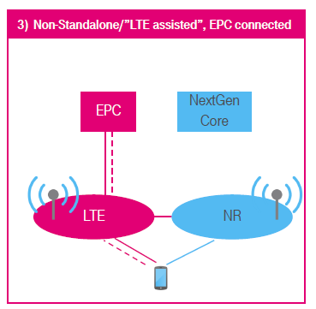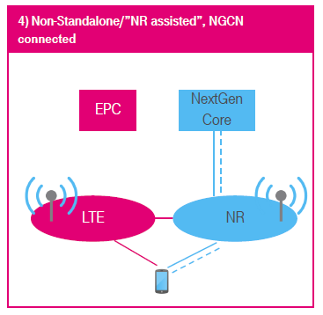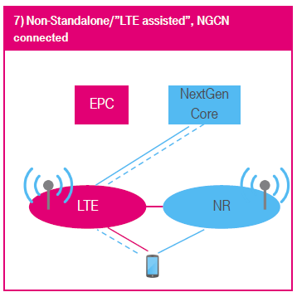

Figure 5-3 Non-stand alone configurations.

Of course, the current 4G LTE deployment is stand alone with 4G base station and core (as in option 1 in Figure 5-4)  and the final target is 5G stand alone (option 2)  with a 5G NR base station and NG core.

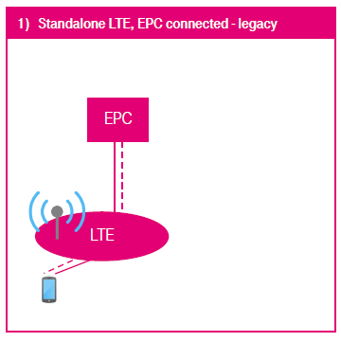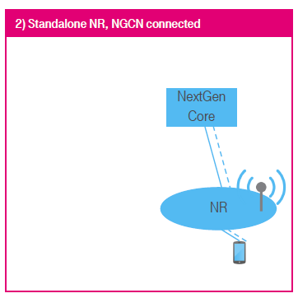

Figure 5-4 Stand alone configurations.

* 1. **Functional Split in the Fronthaul Link**

In both the upstream and downstream directions, the radio signals go through a series of signal processing blocks. Figure 5-5 shows these functional blocks and potential split points in both 4G and 5G wireless networks [4].

It is important to mention that traditional fronthaul using Option 8 (CPRI or OBSAI protocol), requires continuous bitrate transport whether user traffic is present or not. However, with the other split options (1-7), the amount of data to be transported scales with the user traffic. More detail of the requirements for different split options will be discussed in Section 7.



Figure 5-5. Signal processing chain of 4G and 5G wireless base stations and optional split points [4]

* + 1. **Channel Bandwidths**

Conventionally in 4G wireless network, the fronthaul link is between RF and the remaining L1/L2/L3 functions using CPRI/OBSAI protocol (Option 8 split point). This split point option allows the centralization of all high layer processing functions, at the expense of the most stringent fronthaul latency and bandwidth requirements.

This conventional fronthaul is based on transport of digitized time domain IQ data. For very high capacity applications, such as eMBB (enhanced mobile broadband) or for radio sites with many independent antenna elements (multi-layer MIMO), these fronthaul solutions require unreasonably high transport capacities, while allowing for transport latencies only up to a few hundred µsec.

Table 1 shows the time domain IQ data fronthaul capacities (CPRI rates without line coding) needed to support various radio frequency bandwidths and numbers of antenna ports in 5G wireless network using parameter ranges defined by 3GPP in [4]

Table 1: Required fronthaul bandwidth in 5G wireless network [4]

|  |  |  |  |  |
| --- | --- | --- | --- | --- |
| **Number of Antenna Ports** | **Radio Channel Bandwidth** | | | |
| **10 MHz** | **20 MHz** | **200 MHz** | **1GHz** |
| 2 | 1 Gbps | 2 Gbps | 20 Gbps | 100 Gbps |
| 8 | 4 Gbps | 8 Gbps | 80 Gbps | 400 Gbps |
| 64 | 32 Gbps | 64 Gbps | 640 Gbps | 3,200 Gbps |
| 256 | 128 Gbps | 256 Gbps | 2,560 Gbps | 12,800 Gbps |

The values in Table 1 are approximate net data rates (without line code) as calculated by Equation 1 below [27]. The calculation shows that transmission over the CPRI (Option 8) interface requires a net data rate of 491.52 Mbps per 10MHz radio bandwidth and per antenna port.

$B_{CPRI}=A∙f_{s}∙b_{s}∙2∙\left({16}/{15}\right)$ (1)

Here, *A* is the number of antennas per sector; $f_{s}$ represents the sample rate (15.36 MS/s per 10 MHz radio bandwidth) and $b_{s}$ the number of bits per sample (15 for LTE). The remaining factors take into account the separate processing of I and Q samples (factor 2), and the additional overhead information (factor 16/15).

* + 1. **New Functional Split Options in 5G wireless network**

The increase in data rates in 5G makes it impractical to continue with the conventional CPRI fronthaul implementation. Moving towards a higher layer split (Fig. 5-5) would relax the latency and bandwidth requirements, but then fewer processing functions can be centralized. It is thus critical that the new functional-split architecture take into account technical and cost-effective tradeoffs between throughput, latency, and functional centralization.

Several standards bodies have hence moved to identify different split points in the radio processing chain (Fig. 5-5) that allow for substantially reducing the transport capacities in C-RAN architectures compared to the current approach. The choice of optimal 5G NR split points depends on specific deployment scenarios. In April 2017, 3GPP announced the selection of Option 2 (PDCP/high RLC) as the high layer split point (called the F1 Interface), while postponing the decision of the low layer split point between two contenders (Option 6 for MAC/PHY split and Option 7 for intra-PHY split with three different variants 7-1, 7-2, 7-3) to a later time [5]. Here we use FX as the notation for the low layer split point for convenience. Cascaded split architecture is also considered to allow for additional flexibility.

In July 2017, the Small Cell Forum has extended its specification for the Functional API (FAPI) multi-vendor platform interface, which has led to accelerated deployments of small cells, to a virtualized small cell architecture, with the addition of nFAPI [14]. The nFAPI is a set of interfaces for supporting a virtualized MAC/PHY split (Option 6) to enable a smooth evolution path to 5G.

The mapping of these functional split options to CU/DU/RU is illustrated in Fig. 5-6. Here we adopt a split architecture consisting of three elements, CU, DU and RU, each of which can host any of the signal processing functions. As existing 4G deployments will continue to be supported, the terminology for BBU and RRH is renamed to CU/DU and RU in the future.

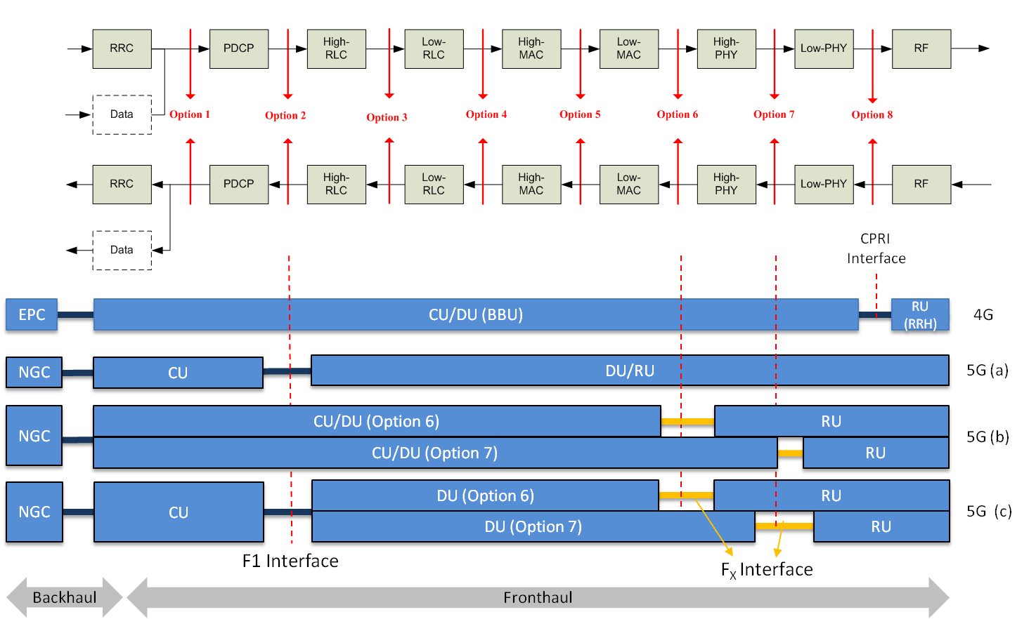

Figure 5-6. Mapping of CU and DU functions according to the split points. 5G(a) high layer split (F1); 5G(b): low layer split (FX); 5G(c) cascaded split.

Meanwhile the eCPRI group has focused its work on intra-PHY splits with data transport over packet networks, thus creating a de facto standard for the low layer split [13]. They introduced two possible splits in downlink (ID, IID) and one in uplink (IU), which allow for configurations roughly corresponding to 3GPP Options 7-2 and 7-3.

Both the 3GPP and the eCPRI specification refer to Ethernet based transport requirements as defined by Metro Ethernet Forum (MEF). MEF published its 3rd phase mobile backhaul implementation agreement in January 2016 (MEF 22.2 [25]) and is working on phase 4 MEF 22.3, which includes next generation fronthaul definitions. The IEEE P1914.1 standard[17], which will be released around or after the end of 2018, will provide specifications how to support data transport at other split points over Ethernet networks. The details of this specification are, however, not yet defined.

* 1. **RAN deployment scenarios**

Generally, a 5G transport network may contain fronthaul, midhaul and backhaul networks. However, different operators may use different deployment scenarios. Four RAN deployment scenarios have been identified.

1. **Independent RRU, CU and DU locations**

In this scenario, there are fronthaul, midhaul and backhaul networks. The distance between an RRU and DU is in the range of 0-20 kilometers while the distance between the DU and CU is up to tens of kilometers.

1. **Co-located CU and DU**

In this scenario, the CU and DU are located together, consequently there is no midhaul.

1. **RRU and DU integration**

In this scenario, an RRU and DU are deployed close to each other, maybe hundreds of meters, for example in the same building. In order to reduce cost, an RRU is connected to a DU just through straight fibre and no transport equipment is needed. In this case, there are midhaul and backhaul networks.

1. **RRU, DU and CU integration**

This network structure may be used for small cell and hot-spot scenarios. There is only backhaul in this case.

The above four application scenarios above are based on current wireless network deployments and anticipated functional splits described by wireless SDOs. However, the final application scenarios will be defined by wireless specifications, applications (i.e. eMBB vs URLLC), transport technology availability, and operators’ deployment requirements.

1. **Synchronization** 
   1. **Synchronization distribution Architecture**
      1. **Frequency synchronization architecture**

The timing reference signal of the frequency synchronization network can be transmitted over a packet network or over a TDM network (e.g., SDH transport network).

Two main methods have been defined for distributing frequency synchronization over the network: physical layer-based synchronization (e.g. Synchronous Ethernet) and packet-based synchronization (e.g. PTP). In the case of physical layer-based synchronization, the frequency reference signal is distributed through the physical layer and it can provide high-accuracy The clock quality level information (SSM code) is carried in the corresponding channel (e.g., ESMC in the case of synchronous Ethernet).

For packet-based synchronization, the packet network distributes the frequency reference signal by means of PTP packets.

Requirements on performance and management of the frequency synchronization are defined in the ITU-T G.826x series of recommendations. ITU-T G.8265 describes the architecture and requirements for packet-based frequency distribution in telecom networks and ITU-T G.8261 provides the network architecture and requirements related to physical layer-based frequency synchronization.

ITU-T G.8262.1 is being developed to define enhanced performance requirements of the physical layer clock, and this clock can be used in supporting a more accurate time synchronization.

* + 1. **Time synchronization architecture**

Requirements on performance and management of time synchronization are defined in the ITU-T G.827x series of recommendations. The general time synchronization architecture is defined in ITU-T G.8275. Time synchronization requirements and network reference models have been defined by ITU-T G.8271 and ITU-T G.8271.1. The network reference models have been defined for the purpose of analysing and deriving the time synchronization objectives in different parts of the network. One example of the network reference models is shown in Figure 6-1.



Figure 6-1: Copy of Figure II.3/G.8271.1, HRM-2 with physical layer frequency support – congruent scenario

* 1. **Synchronization requirements** 
     1. **Time synchronization**

Solutions currently defined in the ITU-T G.827x series address end-to-end time synchronization requirements of +/-1.5 microseconds. This is based on requirements that have been defined in 3GPP for the support of TDD (Time Division Duplex) operations.

For 5G, the relevant requirements are also being defined by 3GPP. As specific to fronthaul, relevant requirements as defined by the CPRI TWG can also be considered.

3GPP has preliminarily agreed that for 5G TDD operations, the cell phase synchronization accuracy measured at BS antenna connectors shall be better than 3 µs (see 3GPP TS 38 133, ref. [7]). This translates into a network-wide requirements of +/-1.5 microseconds.

Work is ongoing on synchronization requirements applicable to special radio features (Carrier Aggregation, Dual Connectivity, etc.) to be deployed in the context of 5G. Initial agreement has been reached in 3GPP on requirements applicable to MIMO or TX diversity transmissions and to intra-band contiguous carrier aggregation (see 3GPP TS 38.104). Note: in these cases the assumption is generally for co-located antennas, therefore alignment in phase is only required locally (no need to distribute synchronization over the transport network). This is an area of further study.

Concerning specific fronthaul synchronization requirements, it is possible to refer to the analysis made by the CPRI TWG. They released a document on the eCPRI transport network requirements (<http://cpri.info/downloads/Requirements_for_the_eCPRI_Transport_Network_V1_0_2017_10_24.pdf> ) where the requirements are based on 3GPP (e.g., to support MIMO or TX diversity transmissions and carrier aggregation). In the current version these are mostly based on LTE mobile generation. Also, it is important to highlight that the most stringent requirements would generally concern co-located antennas, therefore with no need to distribute time synchronization information over the transport network.

It can be noted that for some of the mobile applications (e.g., as related to fronthaul applications), the control of relative time error is generally sufficient (i.e., no need to guarantee control of time error with respect to an absolute time source such as GNSS). For further information refer to Appendix VII in G.8271.1 (see Figure 6-2).



Figure 6-2 Copy of Figure VII.1/G.8271.1 – Illustration of Relative Time Error

Note: based on request by some of the operators, studies are ongoing on the feasibility of solutions targeting end-to-end time synchronization requirements (absolute or relative) on the order of +/- 100 ns to +/- 300 ns to address specific applications or potential future requirements, therefore not necessarily related to 3GPP 5G requirements. For these applications it will also be important to select a synchronization interface that can support the relevant accuracy.

* + 1. **Frequency synchronization**

Recently also requirements for 5G frequency synchronization have been agreed by 3GPP (see ref. [7] TS 38.133), and this is aligned with the same requirements that apply to LTE (50 ppb / 100 ppb). The following is a copy of Table 6.5.1.2-1 from TS 38.133 [7], providing specification for frequency error minimum requirement that is expressed in terms of accuracy of the modulated carrier frequency of each NR carrier observed over 1 ms :

Table 2

|  |  |
| --- | --- |
| **BS class** | **Accuracy** |
| Wide Area BS | ±0.05 ppm |
| Medium Range BS | ±0.1 ppm |
| Local Area BS | ±0.1 ppm |

1. **Interfaces**

This clause provides more details on the 5G interface characteristics that would place requirements on transport networks supporting the interface.

Interfaces to the transport network from 5G/IMT2020 networks are used to request transport services. Various parameters of those requests include capacity and latency to support between interface users. These are consolidated in the following tables.

* 1. **Capacity**

Table 7-1 Capacity requirements

|  |  |
| --- | --- |
| At F1 interface | From [4], option 2  DL ***4016 Mb/s;***  ***UL 3024 Mb/s*** |
| At Fx interface | From [4], option 7a, 7b  DL:  ***10.1~22.2 Gb/s***  ***37.8~86.1 Gb/s***  ***UL:***  ***16.6~21.6 Gb/s***  ***53.8~86.1 Gb/s*** |
| At Xn interface | 25Gb/s-50Gb/s |
| At NG interface | For CU: 10Gb/s-25Gb/s  For CN: 100+Gb/s |
| Fronthaul | Dependent on number of CPRI and eCPRI interfaces. See also Table 1 in 5.3.1.  10Gb/s-825Gb/s |
| Midhaul and Backhaul | Varies with number of interfaces.  25Gb/s-800Gb/s |
| Base station (gNB) | These relate to a combination of NG and Xn interfaces, and reflects the capacity based on a gNB for 3 cells with 64T 64R antennas for low frequency and 2T 2R for high frequency.  Peak:  6.14Gb/s for 5G LF (low frequency)  19.8Gb/s for 5G HF (high frequency)  Average:  2.97Gb/s for 5G LF;  9.9Gb/s for 5G HF |

* 1. **Latency**

Figures are for one way delay, not round trip.

Table 7-2: Latency requirements

|  |  |
| --- | --- |
| At F1 interface | From [4] option 2  1.5 ~10 msec |
| At Fx interface | 100, 125, 250 and 500 µsec (a few hundred µsec) |
| Fronthaul | < 100 µsec |
| UE-CU（eMBB) | 4ms, from [12] |
| UE-CU（uRLLC) | 0.5ms, from [12] |

* 1. **Network Reach**

The ranges will vary greatly between different network operators. The follow values are based on contributions received by SG15 to date.

Table 7-3 Network reach requirements

|  |  |
| --- | --- |
| Fronthaul | 1~20km |
| Midhaul | 20~40km |
| Backhaul | 1~10km  Aggregation: 5-80km  Core: 20~300km |

1. **Management and control**

An example of the interaction between the 3GPP management system and the transport network management system is shown in Figure 8-1 below.

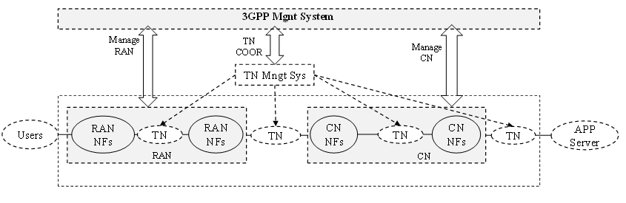

Figure 8-1 Example of the interaction between the 3GPP management system and the transport network management system [11]

The support for network slicing in the transport network is described in section 10.

For the purposes of this TR the following assumptions are made:

– The transport network management system is implemented by an SDN controller.

– To support the network shown in Figure 8-1 each of the transport networks will be presented as an independent network slice instance (that are disjoint from the other network slice instances).

– The 3GPP management system will request a transport network slice instance for each type of 3GPP service (e.g., uRLLC, eMBB, etc.).

– Each transport network slice instance will be supported by an independent virtual network (VN) each with a (logically) separate management interface.

– Transport network slices will be configured during the preparation or commissioning phase.

– The transport network will only support network slices which will not be aware of the E2E slice instances because of the differences in granularity. Therefore, each transport network slice will support zero or more E2E slice instances.

– The transport network is directly visible to the 3GPP management system (as shown in Figure 8-1) and each VN will be viewed as a Managed Network Slice Subnet Instance (MNSSI).

The following are requirements for coordination between TN management system and 3GPP management system are provided below:

1. Transport network management system should be able to receive from the E2E 5G slice management system (i.e., 3GPP management system) 3GPP E2E 5G slice instance specific requirements (e.g., performance, isolation etc.) for the connectivity to be provided by transport network, the transport network management system should, in response to the request, provide the appropriate transport network slice subnet instance. The templates for the transport network slice subnets can be designed in advance in which case the request from the 3GPP management system would include a reference to a specific template. Once the appropriate transport network slice subnet instance is set up, the association between the transport network slice subnet instance and the E2E 5G slice instance will be established and may be managed either by the transport network management system or by the E2E 5G manager.
2. The transport network management system should be able to receive a request for an inventory of the capabilities (e.g., topology, capacity, type of clients supported etc.) of transport network and provide the requested information.
3. Transport network management system should be able to modify the transport network slice subnet instance based on requests from the E2E 5G slice management system.
4. Transport network management system should be able to receive a request for the configuration and activation of performance monitoring, performance thresholds and failure supervision and provide spontaneous reports of performance threshold alarms and failure alarms and on request reports of the results of performance monitoring for the connectivity provided by transport network slice subnet.
5. **Multiservice support**

For 5G, transport networks should support multi-service capability. The following types of services can be supported:

1. Non-stand Alone (NSA) and Stand Alone (SA) deployment of 5G wireless services including eMBB (enhanced Mobile Broadband) – mMTC (massive Machine Type Communications) and URLLC (Ultra-Reliable and Low Latency Communications) defined by 3GPP
2. Legacy 2G/3G/4G wireless service
3. Fix broadband services for enterprise such as E-line, E-LAN & E-tree services defined by MEF
4. Residential broadband services, such as OLT uplink
5. Data Center interconnection
6. **Support of 5G Slicing in the transport network**

The transport network is, in general, a multi-service network and we can expect that, in some cases, the common transport network infrastructure will be shared between 5G services and other services. It is necessary to provide isolation between each of these services. Further it is necessary to provide isolation between the different 5G transport network slice instances. From a management perspective the services are placed in virtual networks (VNs) that are established as described in section 8. The forwarding plane must ensure that the traffic from one VN is not (accidentally) delivered to a different VN. It is also necessary for the forwarding plane to provide isolation that limits the interaction between the traffic in different VNs. The transport network provides two types of traffic isolation as described below:

– **Hard isolation**: The traffic loading one VN has no impact on the traffic in any other VN, including QoS effects.  
Hard isolation is implemented by providing independent circuit switched connections for the exclusive use of one VN. A circuit switched connection is provided by, for example, a dedicated wavelength or a dedicated TDM time slot.

– **Soft isolation**: The traffic loading of one VN may have an impact on the QoS provided to the traffic in other VNs.  
Soft isolation is implemented by statistically multiplexing the traffic from two or more VNs onto a common circuit switched connection using a packet technology (e.g., Ethernet VLAN, MPLS tunnel). The impact on the QoS provided by one VN caused by the traffic on other VNs may be constrained by traffic engineering including, for example, limiting the statistical multiplexing ratio, traffic policing on each VN.

As described in section 8 it is expected that the 3GPP manager will request the configuration of Managed Network Slice Subnet Instances (MNSSIs) to support the different 5G services (e.g., uRLLC, eMBB, etc.). The characteristics (e.g. bandwidth, type of isolation, latency) of each MNSSI will be defined (by the 3GPP manager) to address the needs of each 5G service. A MNSSI will be supported by a VN. In the fronthaul network only one MNSSI is required since all services are carried between the RRU and DU in a common eCPRI encapsulation.

**Annex 1  
Architecture of transport network for 5G**

In clause 5.4, the architecture in Midhaul and Backhaul of 5G network is described. According to deployment difference of CU, DU and RU, the architecture of 5G Fronthaul and Midhaul network was classified as four RAN deployments. Corresponding to different RAN deployments, the transport architecture may be different to meet specific requirements.

Figure A-1 shows the transport network architecture for independent CU and DU deployment. Fronthaul transport is between RRUs and DUs, midhaul transport is between DUs and Cus, and backhaul transport between CUs and CNs.



Figure A-1: Transport network architecture for Independent CU and DU deployment

The service of the backhaul transport is multipoint to multipoint. And for fronthaul and midhaul transport network, the service is point to point with assumption that DU only belongs to one CU at a specific time and RRU only belongs to one DU. Furthermore, both the fronthaul and midhaul transport network need provides a reasonably low latency to satisfy requirements of latency sensitive services such as uRLLC.

The network topology between fronthaul, midhaul and backhaul transport networks:

* For fronthaul transport networks, a star or ring network topology may be used.
* For midhaul transport network, a ring topology is normally used.
* For backhaul transport network, both ring and mesh topology are used.

For other RAN deployments described in clause 5.4, the transport architecture could be as follow:

* For co-located CU and DU deployment, these will be no midhaul transport network, remained fronthaul and backhaul together carry 5G traffic.
* For RRU and DU integration deployment, which means that there is no need of fronthaul transport network, remained midhaul and backhaul transport carry traffics between RRU/DU to CU and CU to CN separately.
* For RRU, DU and CU integration deployment, only backhaul transport network was left and transport network architecture is almost same with 4G scenario.

One thing should be noted is that transport network architecture should meet requirements of all or subset of four RAN deployments for specific operator and specific traffic planning. The transport network architecture should be smoothly upgraded to support more RAN deployments step by step with development of network and traffic evolution.

One example of transport network architecture for 5G C-RAN deployments is shown in following figure:

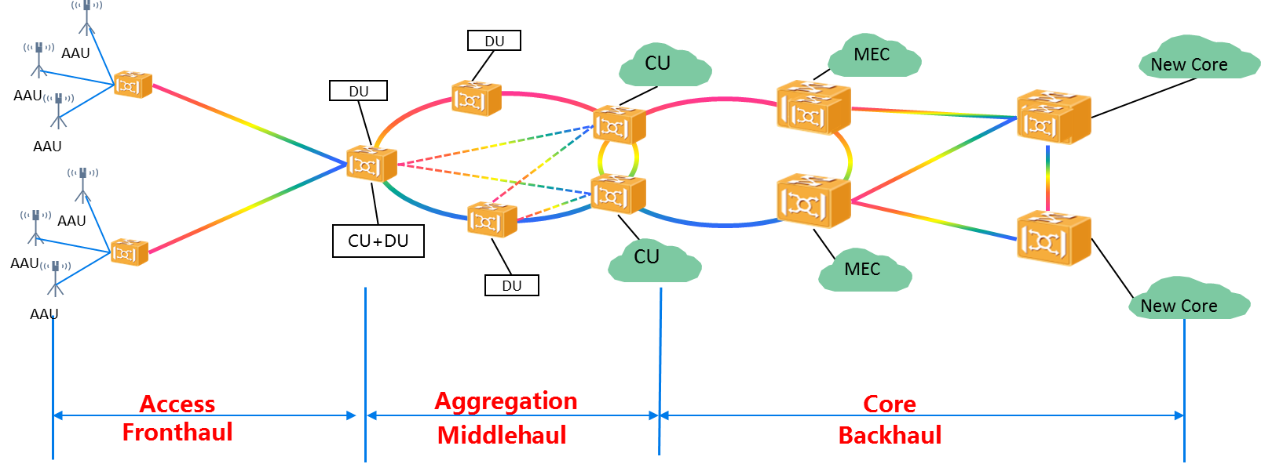

Figure A-2: An example of unified transport network architecture for 5G transport

Another example is for a D-RAN deployment as shown below in Figure A-3

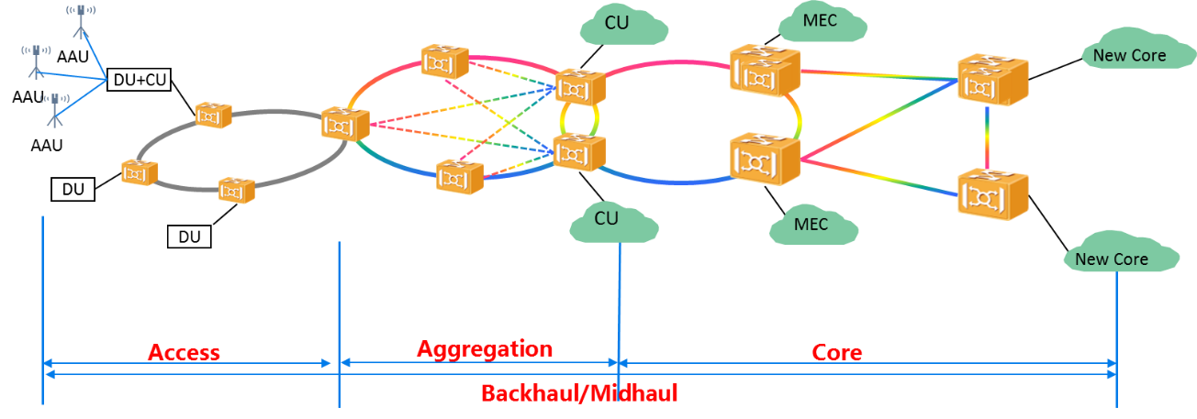

Figure A-3: A 2nd example of unified transport network architecture for 5G transport

Consider the importance of MEC in 5G, the backhaul transport network should consider MECs application and should provide flexibility and low latency for services between MECs and CU too.

The candidates of transport network technologies could be PON, OTN, SPN, Ethernet, G.Metro etc.

**Annex 2  
Terminology mapping**

**Equivalent terms**

|  |  |  |  |
| --- | --- | --- | --- |
| **Term** | **SDO** | **Term** | **SDO** |
| Fronthaul-I | 3GPP | NGFI-I | IEEE 1914.1 |
| Fronthaul-II | 3GPP | NGFI-II | IEEE 1914.1 |

___________________