 |  | International Telecommunication Union
 |  | ITU-T | Technical Paper
 |  | TELECOMMUNICATION  STANDARDIZATION SECTOR  OF ITU |  | (30 April 2021)
GSTP-FTTR
Use cases and requirements of fibre-to-the-room (FTTR)

Technical Paper ITU-T GSTP-FTTR
Use cases and requirements of fibre-to-the-room (FTTR)

Summary
Fibre-to-the-room (FTTR) is a new kind of in-premises networking technology which is based on optical fibre communication. With the benefit of optical fibre, FTTR will provide high-bandwidth and reliable transmission. It is envisaged that the topology and functionalities of FTTR technologies may be different from the current fibre-based technologies in transport and access network, and consequently it is necessary to understand the use cases of FTTR and derive the corresponding network requirements for subsequently developing specifications.
Technical Paper GSTP-FTTR ''Use case and requirements of fibre-to-the-Room (FTTR)'' collects the use cases (including in-home Wi-Fi backhauling, broadband deployment for dense apartment building, network infrastructure for smart office, Internet of things (IoT) support of smart home, low latency service in home networks, fibre deployment for FTTR for residential scenarios, network slicing, east-west data transmission in home network), where FTTR can be used. Each use case is introduced by a scenario of fibre-based network in home domain and analyses the new demand on network capability.
It is believed that FTTR technology is a promising candidate for in-premise networking.

NOTE
This is an informative ITU-T publication. Mandatory provisions, such as those found in ITU-T Recommendations, are outside the scope of this publication. This publication should only be referenced bibliographically in ITU-T Recommendations.

Keywords
Fibre-to-the-room, FTTR, network requirement, use case.

Table of Contents
Page
1 Scope 1
2 References 1
3 Abbreviations and acronyms 1
4 Introduction 2
5 Description of the use cases 3
5.1 In-home Wi-Fi backhauling 3
5.2 Broadband deployment for dense apartment building 5
5.3 Network infrastructure for smart office 5
5.4 IoT support of smart home over FTTR 6
5.5 Low latency service in home networks 7
5.6 Adapting the easy, scalable and low-cost fibre deployment for FTTR to a residential scenario 8
5.7 Network slicing 10
5.8 East-west data transmission in home network 10
5.9 Support of a multi-service transmission scheme 11
6 Summary 12
Bibliography 13

Technical Paper ITU-T GSTP-FTTR
Use cases and requirements of fibre-to-the-room (FTTR)

1 Scope
This Technical Paper summarizes a set of use cases for fibre-to-the-room (FTTR) scenarios. Each use case is discussed through the description of the scenario and the network requirements that it imposes on the FTTR technology.
This Technical Paper intends to provide guidance for developing the ITU-T FTTR specification (G.fin).

2 References
[ETSI GR F5G 001] ETSI GR F5G 001 (2020), Fifth Generation Fixed Network (F5G); F5G Generation Definition Release #1.
[IEEE 802.11ax] Standard IEEE 802.11ax (2021), IEEE Standard for Information Technology – Telecommunications and Information Exchange between Systems Local and Metropolitan Area Networks – Specific Requirements Part 11: Wireless LAN Medium Access Control (MAC) and Physical Layer (PHY) Specifications Amendment 1: Enhancements for High-Efficiency WLAN.
[IEEE 802.11be] IEEE 802.11be, IEEE Communications Magazine (2019) Lopez-Perez, D.etal, Extremely High Throughput: The Next Generation of Wi-Fi Technology Beyond 802.11ax.
[3GPP TS 23.203] 3GPP TS 23.203 (2011), 3rd Generation Partnership Project: Technical Specification Group Services and System Aspects; Policy and charging control architecture.
[Cloud VR WP] White paper, Cloud VR Network Solution White Paper – Huawei (Link: https://www-file.huawei.com/-/media/corporate/pdf/ilab/2018/cloud_vr_network_solution_white_paper_2018_en_v1.pdf)

3 Abbreviations and acronyms
This Technical Paper uses the following abbreviations and acronyms:
AP Access Point
AR Augmented Reality
BRAS Broadband Remote Access Server
BT Bluetooth
CDN Content Delivery Network
CO Central Office
DC Data Centre
DSLAM Digital Subscriber Line Access Multiplexer
E2E End-to-End
eFBB Enhanced Fixed Broadband
F5G Fifth Generation of Fixed network
FFC Full-Fibre Connection
FTTH Fibre-to-The-Home
FTTO Fibre-to-The-Office
FTTR Fibre-to-The-Room
GRE Guaranteed Reliable Experience
IoT Internet of Things
IP Internet ProtocolLAN Local Area Network
MAC Medium Access Control
MGFAST Multi-Gigabit FAST
NAS Network Attached Storage
NMS Network Management System
NT Network Terminal
ODF Optical Distribution Frame
OLT Optical Line Terminal
ONU Optical Network Unit
OTT Over The Top
PC Personal Computer
QoS Quality of Service
RGW Residential Gateway
RTT Round Trip Time
STA Station
STB Set-Top Box
TV Television
VR Virtual Reality
WFA Wi-Fi Alliance
Wi-Fi Wireless Fidelity
XG-PON 10G Passive Optical Network
5G 5th Generation

4 Introduction
FTTR is a new topology for home networks. The fibre in-home topology and functionalities of FTTR technologies may be different from the current fibre-based technologies in transport and access network. Before developing the FTTR specification (G.fin), it is necessary to understand the use cases of FTTR and derive the corresponding network requirements. Therefore, this Technical Paper collects the use case of fibre-base network in home domain and analyses the new demand on network capability.

5 Description of the use cases

5.1 In-home Wi-Fi backhauling

5.1.1 Wi-Fi data backhauling

5.1.1.1 Description
Wi-Fi technology is widely utilized in home networks for the connection of end devices, such as mobile phone, television, home appliances and so on.
To have a full home coverage of Wi-Fi signal and overcome the attenuation due to wall penetration, a Wi-Fi mesh solution called ''EasyMesh'' has been defined by Wi-Fi alliance (WFA). In this solution, multiple Wi-Fi access points (AP) are formed as a local area network (LAN). In 2021, IEEE published [IEEE 802.11ax] specification, used as a brand called "Wi-Fi 6" by WFA. With a large bandwidth up to 160 MHz and eight data streams, the maximum transmission data rate that can be achieved is up to 9.6 Gbit/s. For its next generation of wireless standard, [IEEE 802.11be], a higher data rate is expected.
To form such a mesh network with high connection data rate, a backhaul link with enough capacity is necessary. To match this desire, Figure 5-1 shows a typical application of fibre-based network as backhauling for Wi-Fi connection in a large house. To have the best signal coverage, each room is assumed to be deployed with a Wi-Fi AP, backhauled by a fibre link. The residential gateway can be the central node that group the information towards and from the internet connection.
With the evolving home network services, including high-definition video (8k), augmented reality/virtual reality (AR/VR) or hologram in the future, the backhauling network may need to support data rates up to 10 Gbit/s. The network should also support extremely low latency signal transmission to enable the best experience for cloud gaming, on-line education, etc. In addition, the access network is also evolving to the 10 Gbit/s era with the widely future deployment of XG-PON system or potential MGFAST system.
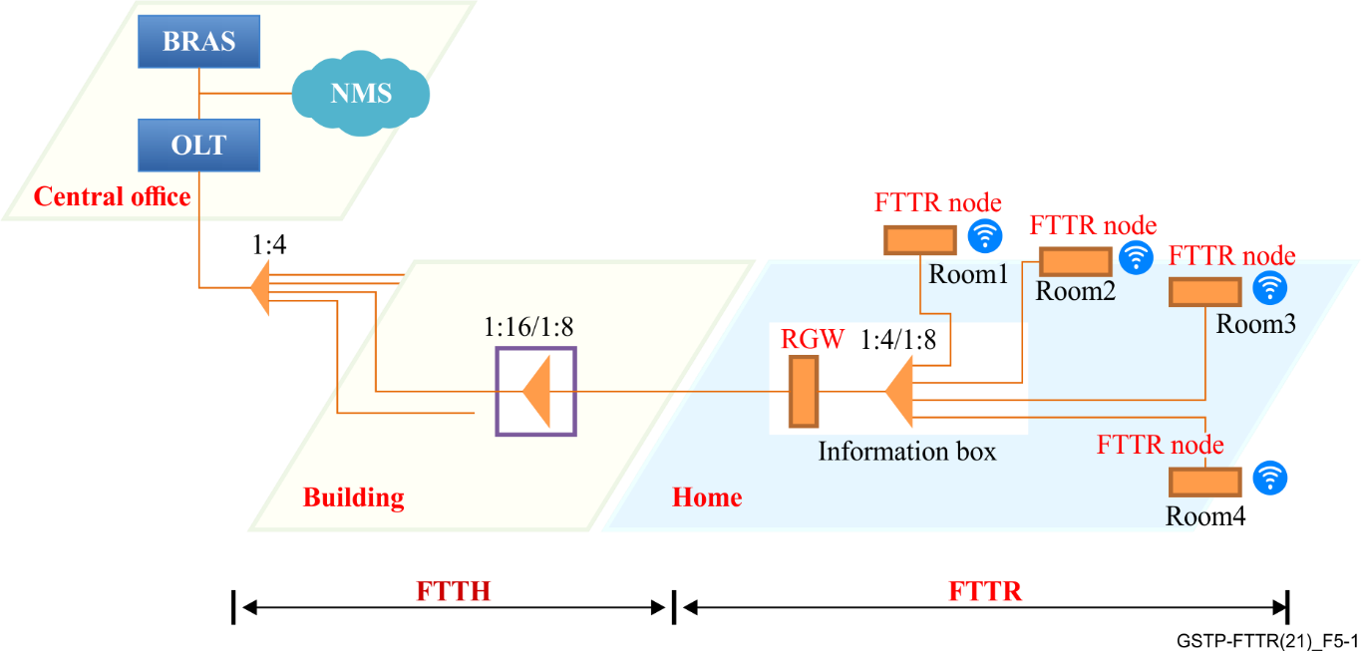
Figure 5-1 – FTTR for Wi-Fi backhauling

5.1.1.2 Requirements
The following requirements have been identified in relation to the Wi-Fi backhauling scenario:
1) Integrated network data rate of FTTR network: 10 Gbit/s;
2) To support a sufficient number (of Wi-Fi AP) for each room in this scenario, node number of G.fin optical network terminations: up to 8.

5.1.2 Seamless roaming

5.1.2.1 Description
Wi-Fi is the most pervasive technology in the home network for end user device connectivity. To overcome the attenuation due to wall penetration and blocking due to obstacles, and to achieve a full-home coverage of the Wi-Fi signal, multi-AP based Wi-Fi solutions were developed, (e.g., EasyMesh from Wi-Fi alliance).
Under the multi-AP solution, one important aspect needs to be considered: people want to move freely while they are making video calls, enjoying video conference, playing games, etc. The end device must therefore switch quickly and smoothly between multiple APs, without causing any inconveniences to end users, such as still pictures during an exchange, breaking-up of voices, etc. When using multi-AP networks, the seamless roaming capability is one of the important metrics to evaluate the performance of the home network.
Figure 5-2 shows an example of a multi-AP Wi-Fi solution in the home network.
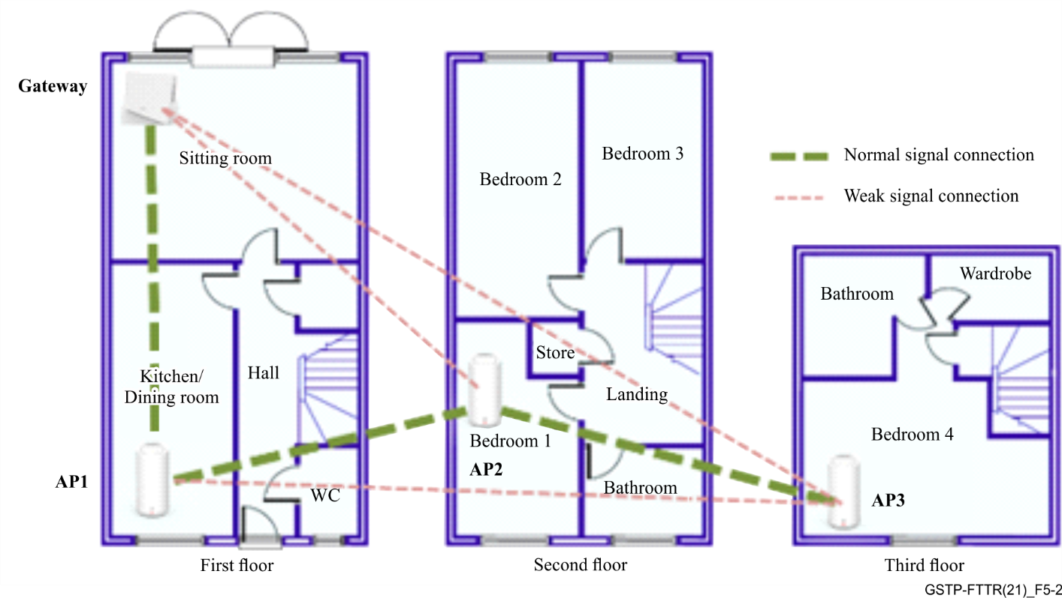
Figure 5-2 – Example of multi-AP Wi-Fi solution
Roaming between access points is actually achieved through exchanging a sequence of messages according to the roaming protocol. The loss of procedure message may cause the roaming device to stop or to retry. The usage of Wi-Fi as backhauling may cause potential loss of the roaming message due to packet collision or alien network interference in the same unlicensed frequency band. To overcome this effect, a wireline connection can provide a guaranteed channel for robust transmission of such messages between different APs or AP and station (STA).
To further boost the performance of roaming, the backhauling technology could provide a high priority channel for such roaming messages exchange. This requires a good coordination between Wi-Fi network and the FTTR network.

5.1.2.2 Requirements
The following requirements have been identified to support a seamless roaming scenario:
1) The network should define a mechanism to provide a fast message exchange for roaming messages between APs connected to different nodes of the FTTR network;
2) FTTR network should provide a good coordination with the Wi-Fi network to establish a transparent message channel for roaming.

5.2 Broadband deployment for dense apartment building

5.2.1 Description
In modern cities, dense apartment areas are popular, especially for unmarried people and the ones who temporarily live near their place of work.
In some regions, it is typical that the rooms in the apartment are individually rented. In this case, there may be no independent access network to each of the rooms but only to the apartment. Users need to share the access broadband and they expect a convenient and cost-effective solution for their high data rate network.
In this scenario, it is normal that the owner of the apartment buys a high data rate connection from the operator and constructs the network infrastructure in the building. This case is quite similar to the home area network (use case outlined in clause 5.1) with a high requirement in the network data rate. Figure 5-3 shows the usage of fibre-based network in this case. The apartment building has the network terminal installed on one of the floors. A fibre-based infrastructure can be built from there to the upper floors to convey the data service. The tenant can pay for the network on a monthly basis or even on a daily basis.
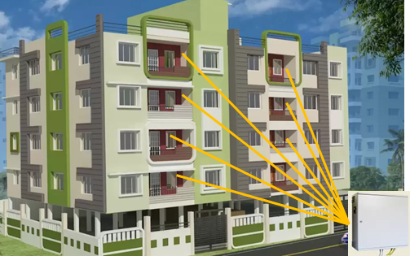
Figure 5-3 – FTTR application in a dense apartment environment

5.2.2 Requirements
The following requirements have been identified to support the broadband deployment for a dense apartment building scenario:
1) Integrated network data rate of FTTR network: 10 Gbit/s;
2) To support a sufficient number of G.fin optical network terminations: up to 64;
3) Network characteristic:
a) Nodes support authentication and identification mechanisms;
b) Nodes support encryption function to protect against snooping.

5.3 Network infrastructure for smart office

5.3.1 Description
In an industrial campus, the operator of the campus may build and maintain the private edge data centres, in which the computing resources are shared within the campus. In this scenario and especially for cloud services and video resources sharing, the data transmission within the campus is high data rate and latency sensitive.
The topology is generally a point to multipoint topology from the data centre to the offices as in the case of a home network. Various types of network services need to be supported, such as voice, Wi-Fi data backhauling, real-time camera capturing, simultaneous integration of hundreds of teleconference calls and background internet service. Due to these different network requirements, different fibre network devices may need different data rates, which requires multiple data rate level devices to be supported. For this, a chained optical distribution network could be adopted with an unbalanced power splitter shown in Figure 5-4, simplifying the fibre deployment.
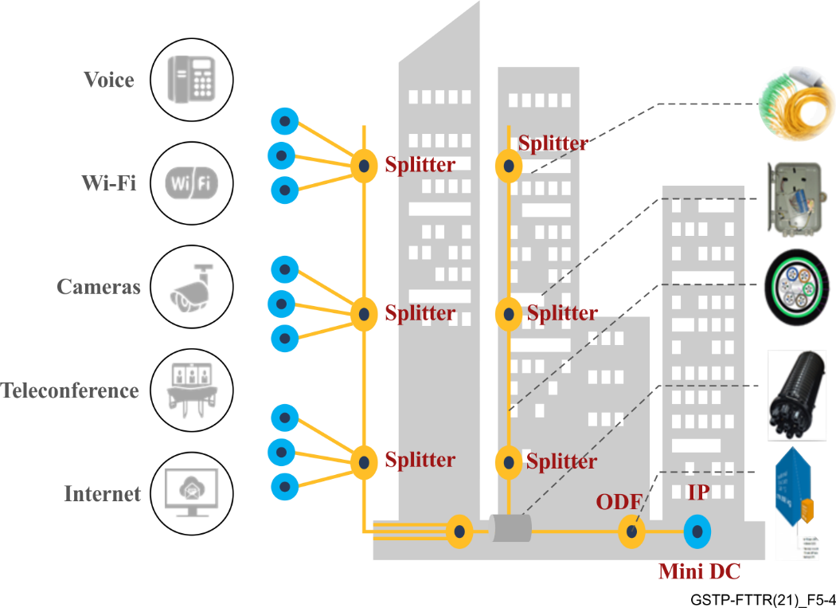
Figure 5-4 – FTTR application in smart office

5.3.2 Requirements
The following requirements have been identified to support the network infrastructure for a smart office scenario:
1) Integrated network data rate of FTTR network: 10 Gbit/s;
2) To support a sufficient number of G.fin optical terminations: up to 64;
3) Node characteristic: support different data rate profile;
4) Network characteristic:
a) Unequal power splitting, point to multi-point network topology;
b) Nodes support authentication and identification mechanisms;
c) Nodes support encryption function to protect against snooping.

5.4 IoT support of smart home over FTTR

5.4.1 Description
Residents subscribe to smart home service through interacting with various smart devices and leveraging the internet network with computing resources. All of these network elements and functions are organized together to form an automated service. To collect or configure smart devices, an Internet of things (IoT) hub is generally needed. The IoT hub, which may be integrated in the residential gateway (RGW), provides a low power communication interface with smart devices, which are normally battery powered. In some cases, the IoT hub is also battery powered, accessing the home network through different ways, such as Wi-Fi, Ethernet, or even fibre in the future. The IoT hub is configured to fulfil the requirement of a specific service. For example, the security service of smart homes may require the IoT hub to forward any sudden generated warning message (such as fire/water/temperature alarm detection) to the network server in a precise time interval. Monitoring service (such as cooking process, sleeping status, etc.) may require periodic data collecting from smart devices. Therefore, the network connecting to the IoT hub should consider not only the low power scenario but also the characteristics of the special smart home service.
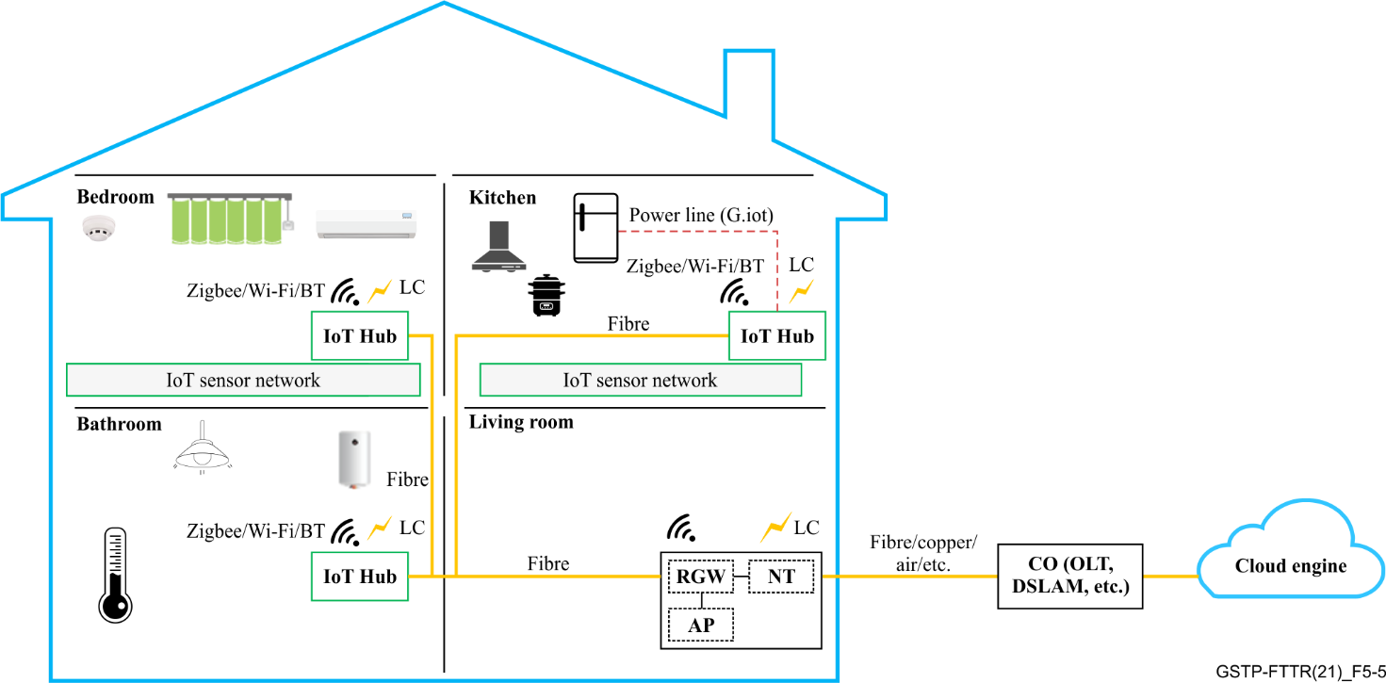
Figure 5-5 – Example of smart home over FTTR

5.4.2 Requirements
The following requirements have been identified to support the IoT support of a smart home over FTTR:
1) The FTTR network should provide low power mode for the interface to the IoT device to limit power consumption of the smart devices;
2) To facilitate the smart home service deployment, the network should provide the possibility to centrally control the low-power mode;
3) The network may support electricity charging capability to the IoT device, such as IoT hub or IoT sensors.

5.5 Low latency service in home networks

5.5.1 Description
Nowadays, video is occupying most of the in-home broadband consumption through various devices, such as high-definition televisions, smart phones, tablets, etc. On one hand, the resolution of a traditional video is 480P, 720P and 1080P, while 4K or 8K video is becoming popular due to a better experience of end users but, on the other hand, requires more bandwidth. Moreover, cloud virtual reality (VR) is emerging as a new video provision for home network. Cloud VR is based on cloud computing technology where the VR content is stored and rendered in the cloud. With fast and stable transport networks, after being coded and compressed, the video and audio outputs are transmitted to user terminals. Specifically, cloud VR service can be enjoyed by end users without purchasing expensive hosts or high-end PCs, which help to promote the popularity of VR service. The typical bandwidth and end-to-end (E2E) network round-trip time (RTT) requirements of cloud VR in different phases are shown in Table 5-1.
Table 5-1 – Bandwidth and E2E network RTT requirements of Cloud VR [Cloud VR WP]
Quality |  | Fair-experience Quality | Comfortable-experience Quality | Ideal-experience Quality
Typical strong-interaction  content resolution |  | 2K | 4K | 8K to 16K
Typical terminal resolution |  | 2K to 4K | 4K to 8K | 8K to16K
Strong-interaction VR service | Bitrate | ≥40 Mbit/s | ≥90 Mbit/s | ≥360 Mbit/s (8K)  ≥440 Mbit/s (16K)
 | Bandwidth requirement | ≥80 Mbit/s | ≥260 Mbit/s | ≥1 Gbit/s (8K)  ≥1.5 Gbit/s (16K)
 | E2E Network RTT | <20 ms | <15 ms | <8 ms
NOTE – [b-ITU-T H.266] specifies video coding that achieves compression resulting in bit rates that are approximately one half of those achieved by [b-ITU-T H.265].
Therefore, the E2E network, including Wi-Fi connection, fibre-based in-home network, access network, transport network and service processing delay, require less than 10 ms network round-trip delay in ideal-experience quality of cloud VR. It is known that Wi-Fi connection utilizes unlicensed spectrum and contention-based mechanism, which may induce relative larger latency. Fibre-based in-home network brings additional capabilities that can be leveraged to target more strict requirements.

5.5.2 Requirements
The following requirements have been identified to support the low latency service of in-home networks:
1) The FTTR network should guarantee 1ms latency for a latency sensitive service;
2) The FTTR network should use a coordinated MAC mechanism that avoids any contention of the transmitted packets.

5.6 Adapting the easy, scalable and low-cost fibre deployment for FTTR to a residential scenario

5.6.1 Description
Fibre-to-the-room is a new reference architecture of home network based on fibre-based communication technology. In most of the cases, fibre infrastructure is not available in the house and new fibre needs to be deployed. The design of FTTR specification is significantly affected by the fibre topology. For apartments or flats, the fibre network architecture is normally a star topology (from the home gateway to each of the rooms), as shown in Figure 5-6. Each room contains a dedicated fibre that communicates with an integrated optical splitter that is connected to the RGW.
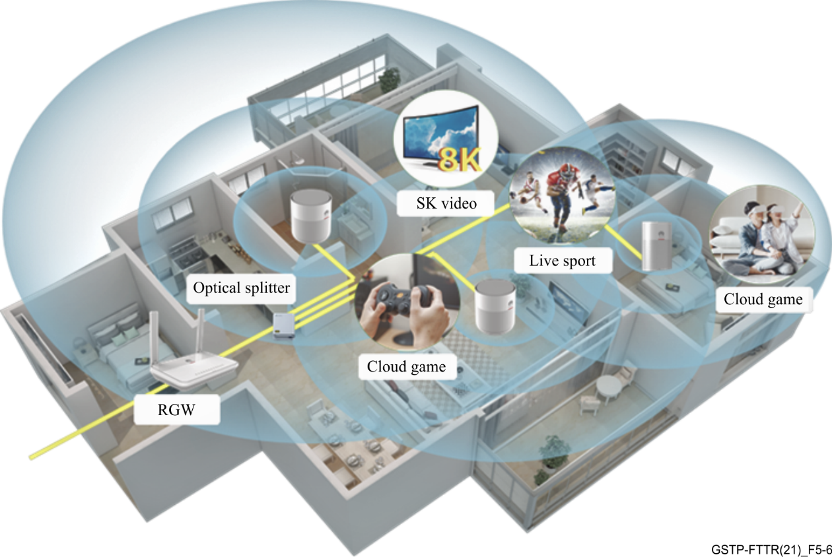
Figure 5-6 – Example of a star like fibre topology in apartment or flat
For independent multi-floor houses, itis very challenging to deploy fibre from the home gateway to each room directly since some rooms in the upper or lower floor are far away from the home gateway. A typical and simple deployment is to utilize multi-level light splitting, shown in Figure 5-7. This requires one fibre connected to the home gateway and a single fibre from the optical splitter to each floor and each room. A passive optical splitter is deployed on each floor.
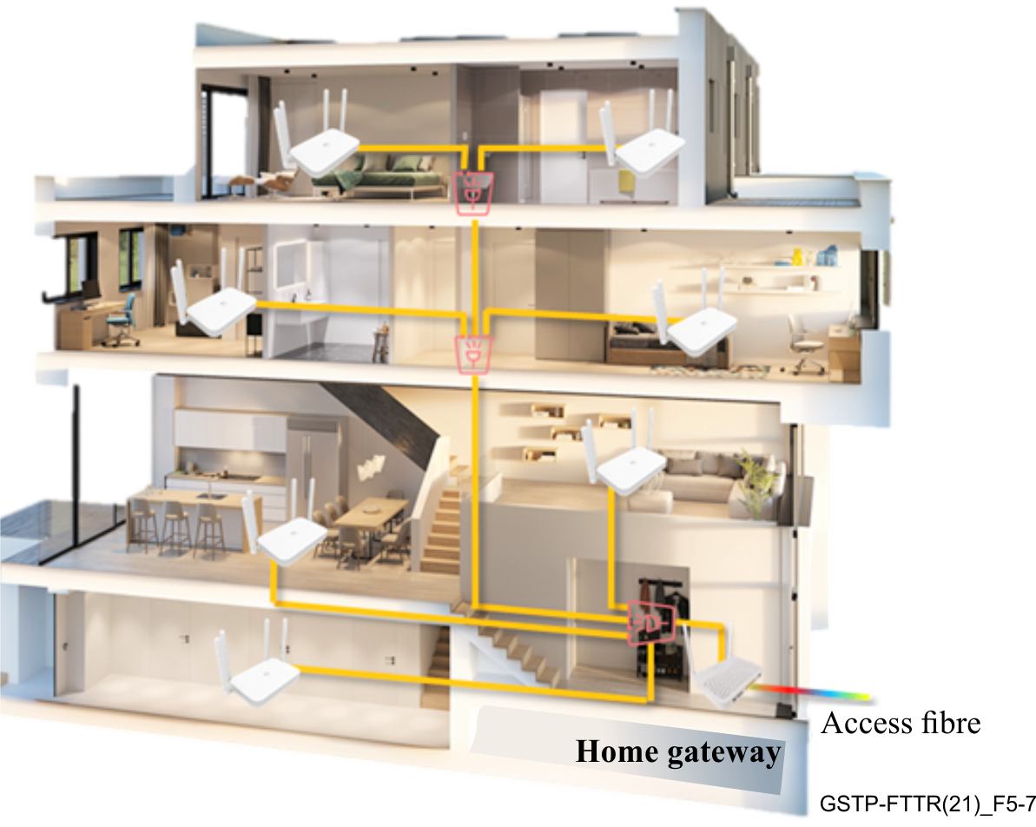
Figure 5-7 – Example of a multi-level fibre topology in an independent house

5.6.2 Requirements
The following requirements have been identified to support easy, scalable and low-cost fibre deployment for FTTR for residential scenarios:
1) The protocol of FTTR should adapt to a point to multi-point architecture and communication with a simplified fibre deployment topology in Figures 5-6 and 5-7;
2) The network should reserve enough link budget for the transceivers to achieve robust communication over multi-level fibre deployment.

5.7 Network slicing

5.7.1 Description
Nowadays, more and more novel network services (telecommuting, telemedicine, on-line education, etc.) are emerging, enriching people's lives and for convenience. By looking into different network services quality of service (QoS) requirements, some of them are sensitive to data rate, while some of them may rely on other network parameters or on a set of them. To achieve the best user experience for a specific service, the QoS requirements of such service should be met. For example, 3GPP has defined the E2E network QoS requirements of different service types in 5G standard (see Table 6.1.7-A of [3GPP TS 23.203]).
For fixed networks, F5G (see [ETSI GR F5G 001]) has defined three technology characteristics: enhanced fixed broadband (eFBB), full-fibre connection (FFC) and guaranteed reliable experience (GRE). The QoS requirement of services can be mapped to the three dimensions as shown in Figure 5-8. In fact, to satisfy E2E network QoS requirement, each segment of the network should fulfil the dedicated network QoS, forming a sliced network channel. Obviously, FTTR technology belong to the backhauling segment of home network. For example, QoS of VR service can be guaranteed by independent network slicing channel, see Figure 5-8.
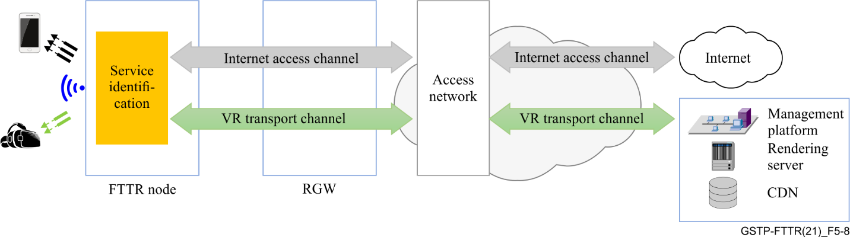
Figure 5-8 – Example of network slicing for VR service

5.7.2 Requirements
The following requirements have been identified to support the network slicing scenario:
1) FTTR network should provide a mechanism to guarantee different network QoS according to service requirement;
2) Dynamic creation and release of network slicing should be supported with the change of network service.

5.8 East-west data transmission in home network

5.8.1 Description
For traditional optical access network, the network terminal is deployed in individual houses. There is no direct data traffic between different houses. Therefore, a tree topology is suitable and adopted for optical access network.
For FTTR, there are various services, leading to East-west data transmission, including but not limited to:
1) Control of IoT devices in smart homes. For instance, command from master controller (smart phone, TV, or intelligent speaker) to IoT devices, status information of IoT devices to master controller;
2) Large volume of data transmission between network attached storage (NAS) server and end devices. For example, movies, pictures, music, and files are read (written) by (from) PC or smart phone from(to) NAS server;
3) Data transmission of security camera as shown in Figure 5-9. In security monitoring, video streaming is captured real-time, transmitted to the home data centre, which may be connected to one of the nodes of the FTTR network.
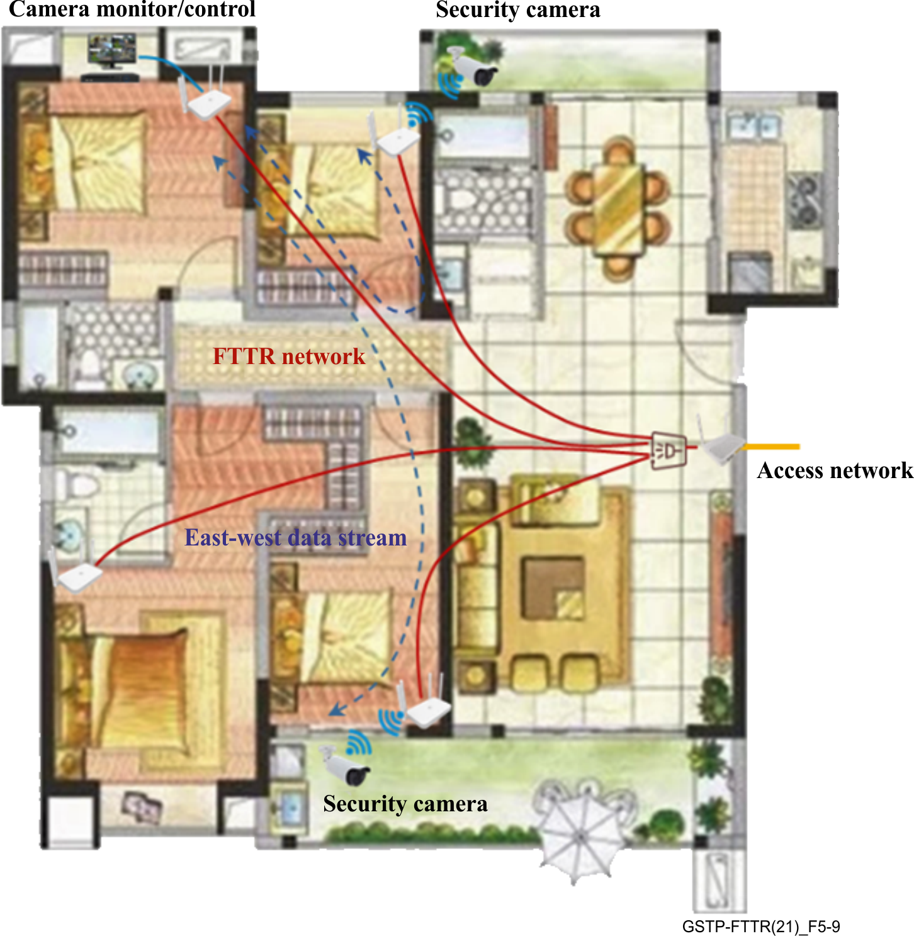
Figure 5-9 – Example of the East-west data stream (security camera)

5.8.2 Requirements
The following requirements have been identified to support east-west data transmission in home network:
1) The FTTR network should support data channel for exchanging information between any node of the network.

5.9 Support of a multi-service transmission scheme

5.9.1 Description
Technology of home network keeps evolving with the rapid increasing demand of supporting new service for end users. One of the important characteristics of home network device is service sensitive. For example, IoT sensor transmits simple data format by detecting environmental condition. Digital louder exchanges kHz frequency range voice data through low-data-rate link such as Bluetooth. Television requires stable tens of megabits per second channel for conveying video stream. AR/VR provides immersive experience based on hundreds/thousands of Mbit/s network. In the future, new service (hologram) and network device (handset, cloud mobile, etc.) will require optimal network support.
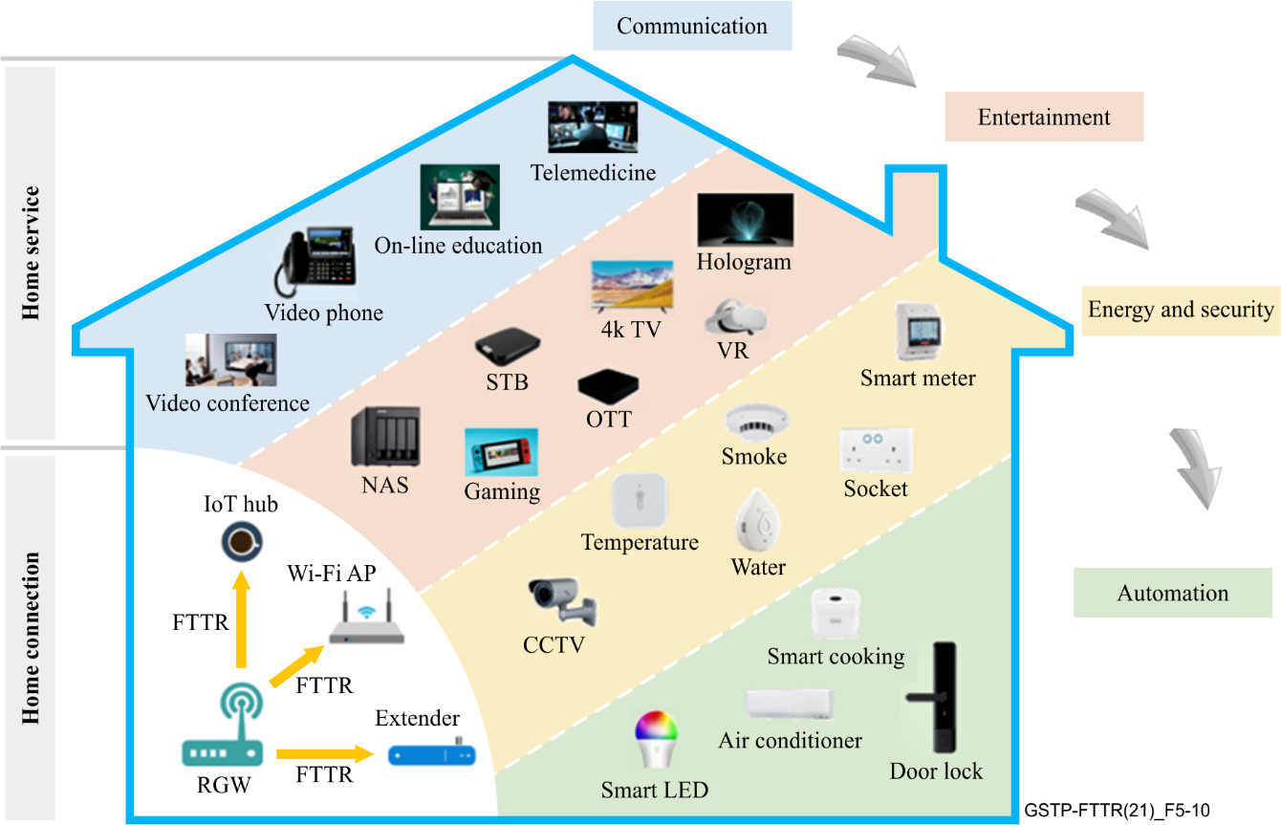
Figure 5-10 – Typical examples of network devices within home
To guarantee adaptive network support for a variety of device profiles, the FTTR technology network should support different connectivity devices, which function on diversified communication demand.

5.9.2 Requirements
1) The FTTR network should support multiple profiles (in terms of data rate) for different types of network device.

6 Summary
Fibre-to-the-room (FTTR) technology is based on the deployed fibre infrastructure. The technology intends to provide guaranteed QoS to satisfy all home service requirements. Use cases and corresponding requirements for how to evolve the technology for in-premises usage are collected and discussed in this Technical Paper. As can be seen, the FTTR technology should be developed with the satisfaction of the network requirements in terms of enough node number, network bandwidth, network architecture, device types, network QoS, intra-network switching, network data direction, etc.

Bibliography

[b-ITU-T H.265] Recommendation ITU-T H.265 (2019), High efficiency video coding.
[b-ITU-T H.266] Recommendation ITU-T H.266 (2020), Versatile video coding.

______________

