|  |  |  |  |  |
| --- | --- | --- | --- | --- |
|  | | **International Telecommunication Union** | | |
|  | |  | | |
| **ITU-T** | **Technical Paper** | |
| TELECOMMUNICATION STANDARDIZATION SECTOR OF ITU | | (04/2021) |
|  |  | | | |
|  | ITU-T GSTP-HNAFS  Architecture, functions and services of home network | | | |
|  |  | | | |

Summary

Continuously evolving and demanding applications and services in a dedicated home infrastructure require the adaptation of the support of the heterogeneous home network. With the increased penetration ratio of operator-managed home networks, it is important to have a clear understanding of the content and components of the home network. To achieve this goal, this technical paper on the architecture, functions and services of home networks provides an overview of the various in-home services, general architecture and connection technologies of such networks. By making use of this knowledge, the practical establishment of the home network could be carried out according to the customer's needs.

NOTE – This is an informative ITU-T publication. Mandatory provisions, such as those found in ITU-T Recommendations, are outside the scope of this publication. This publication should only be referenced bibliographically in ITU-T Recommendations.

Keywords

Architecture, connection technology, home network, service.

**Table of Contents**

Page

1 Scope 1

2 References 1

3 Definitions and acronyms 2

3.1 Definitions 2

3.2 Abbreviations and acronyms 3

4 Introduction 5

5 Architecture of a home network 5

5.1 General architecture of a content delivery home network 5

5.2 Deployment models for connectivity of end user devices 6

5.3 Components in a heterogeneous home network 7

5.4 Cloud engine 9

6 Services within the home 9

6.1 Background traffic service 10

6.2 Video service 10

6.3 Voice service 10

6.4 IoT service 11

7 Connection technologies 11

7.1 Wireline 11

7.2 Wireless 13

8 Summary 15

Technical Paper ITU-T GSTP-HNAFS

Architecture, functions and services of home network

# 1 Scope

This technical paper provides an overview of the status of modern home networks. This overview can be used as guidance for operators when planning their deployments.

Three key aspects of home networks are discussed:

1) The **general architecture of a home network** as an end to end (E2E) network, including both the components located within the home and the accompanying functions in the cloud.

2) The evolving **services within the home**, including but not limited to voice, video, augmented reality (AR), virtual reality (VR) and Internet of Things (IoT) (e.g., smart home).

3) General **supported functions** such as connection interfaces, management, frameworks and diagnostic features.

The detailed requirements of dedicated home networking devices are out of the scope of this Technical Paper and may be the subject of other work within ITU-T and other organizations.

# 2 References

[ITU-T G.9960] Recommendation ITU-T G.9960 (2018), *Unified high-speed wire-line based home networking transceivers – System architecture and physical layer specification.*

[ITU-T G.9961] Recommendation ITU-T G.9961 (2018), *Unified high-speed wireline-based home networking transceivers – Data link layer specification.*

[ITU-T G.9963] Recommendation ITU-T G.9963 (2018), *Unified high-speed wireline-based*

[ITU-T G.9991] Recommendation ITU-T G.9991 (2019), *High-speed indoor visible light communication transceiver* *– System architecture, physical layer and data link layer specification.*

[ITU-T H.265] Recommendation ITU-T H.265 (2019), *High efficiency video coding*.

[ITU-T H.266] Recommendation ITU-T H.266 (2020), *Versatile video coding*.

[IEEE 802.1Q] Standard IEEE 802.1Q (2012), *IEEE Standard for Local and metropolitan area networks – Media Access Control (MAC) Bridges and Virtual Bridges.*

[IEEE 802.3ab] Standard IEEE 802.3ab (1999), [*Standard for Information Technology – Telecommunications and information exchange between systems – Local and Metropolitan Area Networks – Part 3: Carrier Sense Multiple Access with Collision Detection (CSMA/CD) Access Method and Physical Layer Specifications – Physical Layer Parameters and Specifications for 1000 Mb/s Operation over 4 pair of Category 5 Balanced Copper Cabling, Type 1000BASE-T*](https://ieeexplore.ieee.org/document/798775/)*.*

[IEEE 802.3u] Standard IEEE 802.3u (1995), *IEEE Standards for Local and Metropolitan Area Networks: Supplement – Media Access Control (MAC) Parameters, Physical Layer, Medium Attachment Units, and Repeater for 100 Mb/s Operation, Type 100BASE-T*.

[IEEE 802.11ad] Standard IEEE 802.11ad (2012), *IEEE Standard for Information technology –Telecommunications and information exchange between systems – Local and metropolitan area networks - Specific requirements – Part 11: Wireless LAN Medium Access Control (MAC) and Physical Layer (PHY) Specifications Amendment 3: Enhancements for Very High Throughput in the 60 GHz Band.*

[IEEE 802.11ah] Standard IEEE 802.11ah (2016), *IEEE Standard for Information technology –Telecommunications and information exchange between systems – Local and metropolitan area networks – Specific requirements - Part 11: Wireless LAN Medium Access Control (MAC) and Physical Layer (PHY) Specifications Amendment 2: Sub 1 GHz License Exempt Operation.*

[IEEE 802.11aj] Standard IEEE 802.11aj (2018), *IEEE Standard for Information Technology –Telecommunications and information exchange between systems Local and metropolitan area networks – Specific requirements Part 11: Wireless LAN Medium Access Control (MAC) and Physical Layer (PHY) Specifications Amendment 3: Enhancements for Very High Throughput to Support Chinese Millimeter Wave Frequency Bands (60 GHz and 45 GHz).*

[IEEE 802.11ax] Standard IEEE 802.11ax (2021), *IEEE Standard for Information technology – Telecommunications and information exchange between systems Local and metropolitan area networks – Specific requirements Part 11: Wireless LAN Medium Access Control (MAC) and Physical Layer (PHY) Specifications Amendment 1: Enhancements for High Efficiency WLAN.*

[IEEE 802.11ba] Standard IEEE 802.11ba (2021), *IEEE Standard for Information Technology –Telecommunications and Information Exchange Between Systems Local and Metropolitan Area Networks – Specific Requirements Part 11: Wireless LAN Medium Access Control (MAC) and Physical Layer (PHY) Specifications Amendment 3: Wake-Up Radio Operation.*

[BBF TR-069] Technical Report 069 (2018), *CPE WAN Management Protocol.*

[BBF TR-369] Technical Report 369 (2019), *User Services Platform*.

[Cloud VR] White paper, *Cloud VR Network Solution White Paper – Huawei* (Link: <https://www.huawei.com/minisite/pdf/ilab/cloud_vr_network_solution_white_paper_en.pdf>)

# 3 Definitions and acronyms

## 3.1 Definitions

This technical paper defines the following terms:

**3.1.1 access extension network**: Segment of the network that connects the network terminal and the extended network terminal (normally the residential gateway (RGW)).

**3.1.2 access network**: Segment of the network that connects to the end user premises and is terminated by an access network terminal. It can be optionally extended by an access extension network to facilitate the deployment.

**3.1.3 cloud engine**: Network platform which is able to provide the functionalities of computing, management, control, service implementation, etc.

**3.1.4 content delivery home network**: Complete system of network devices that cooperate transparently to deliver content to end users from the service provider through the access network (and potentially through the access extension network) and through the heterogeneous home network. The content delivery home network may contain other functions, such as management and computing.

**3.1.5 end user connectivity device**: Device that provides connectivity to the network to end user devices.

**3.1.6 end user device**: Device that provides a service directly to the user (e.g., tablets, TV, mobile phones).

**3.1.7 extended network terminal**: Termination of the access extension network in the user side of the network.

**3.1.8 heterogeneous home network**: Set of network components that provide the transport of information from the residential gateway to the end user devices. This network is composed of devices of heterogeneous technologies.

**3.1.9 home connectivity network**: Subset of the heterogeneous home network that provides connectivity to the end user devices. It is also referred to as a "fronthaul network".

**3.1.10 home infrastructure network**: Subset of the heterogeneous home network that provides connectivity between end user connectivity devices. It is also referred as a "backhaul network".

**3.1.11 network terminal**: Termination of the access network format on the service provider end.

**3.1.12 personal area network**: Subset of the heterogeneous home network that provides connectivity to electronic devices centred on an individual person's workspace.

**3.1.13 sensor area network**: Subset of the heterogeneous home network that provides connectivity to spatially distributed devices communicating through wireless radio or wireline signal, cooperatively sensing physical or environmental conditions.

## 3.2 Abbreviations and acronyms

This technical paper uses the following abbreviations and acronyms:

AGV Automatic Guided Vehicles

AP Access Point

AR Augmented Reality

CDHN Content Delivery Home Network

CPE Customer Provided Equipment

DECT Digital Enhanced Cordless Telecommunications

DHCP Dynamic Host Configuration Protocol

DLNA Digital Living Network Alliance

DNS Domain Name System

DSL Digital Subscriber Line

DSLAM Digital Subscriber Line Access Multiplexer

E2E End to End

EMI Electromagnetic Interference

ENT Extended Network Terminal

EUCD End User Connectivity Device

EUD End User Device

FTTH Fibre-to-The-Home

FTTR Fibre-to-The-Room

FoV Field of View

HCN Home Connectivity Network

HDMI High Definition Multimedia Interface

HHN Heterogeneous Home Network

HIN Home Infrastructure Network

IoT Internet of Things

IP Internet Protocol

ITMS Integrated Terminal Management System

LTE Long Term Evolution

MU-MIMO Multi-user Multi-Input-Multi-Output

MIMO Multi-Input-Multi-Output

MGWS Multiple Gigabit Wireless System

NAT Network Address Translation

NMS Network Management System

NT Network Terminal

OFDMA Orthogonal Frequency Division Multiple Access

O&M Operation and Maintenance

OLT Optical Line Termination

OOK On-Off Keying

ONT Optical Network Terminal

ONU Optical Network Unit

PAN Personal Area Network

PHY Physical Layer

PON Passive Optical Network

QAM Quadrature Amplitude Modulation

QoS Quality of Service

RGW Residential Gateway

RTT Round Trip Time

SAN Sensor Area Network

TWT Target Wave Time

UHD Ultra-High-Definition

VoIP Voice over Internet Protocol

VR Virtual Reality

WFA Wi-Fi Alliance

WUR Wake-Up Radio

XGSPON 10 Gigabit Symmetrical Passive Optical Network

# 4 Introduction

A home network is the infrastructure for delivering network service to end users. In general, new home networks are composed of a mix of the most diverse access transmission technologies such as Ethernet/G.hn for broadband wireline technologies, Wi-Fi or light communication for broadband wireless technology, and Zigbee/Z-Wave/Bluetooth for IoT narrow band scenario creating what we call a heterogeneous home network (HHN).

In order to serve correctly some of the various demanding applications and services, devices within the home require not only robust connections and high throughput but also efficient management systems.

The current challenge for operators is to quickly, easily and at a low cost deploy such a high-quality home network for the delivery of demanding subscribed services to end users.

This technical paper intends to provide some insights into such HHNs to facilitate the task of understanding the specificities of enabling a service-provider-oriented home network.

# 5 Architecture of a home network

## 5.1 General architecture of a content delivery home network

The general architecture of an E2E content delivery home network (CDHN) consists mainly of three parts as shown in Figure 5-1:

1. A **cloud engine**, providing additional computing capability/resources, other management functions (such as network management, optimization and diagnostic functions) and value-added services etc. for home networks.

2. An **access network** (using digital subscriber line (DSL) / passive optical network (PON) / long term evolution (LTE), etc.), physically connected to the home network and providing broadband access to the user. The access network may be optionally extended through the use of an access extension network to reduce the cost of physical deployments by using a lower cost technology without reducing performance.

3. An **HHN**, composed of different elements:

a) **A home infrastructure network (HIN)**: Including end user connectivity devices (EUCD) that are not directly providing a service to the user and that have the role of distributing the broadband signal through the home. For instance, the HIN may be a mesh network composed of an interconnection of Wi-Fi access points. The interconnection can be wired or wireless. In general, an edge controller or cloud controller monitors, diagnoses and manages the behaviour of these HIN devices (owned by the service/cable provider or by the user) and the topology of the HIN.

b) A **home connectivity network (HCN)**: Providing connectivity to the end user devices through different technologies (e.g., Wi-Fi, light communication, Ethernet).

c) **Personal area networks (PANs)** and **sensor area networks** **(SANs)**: Subnets that provide separate connectivity for special purposes (e.g., IoT service).

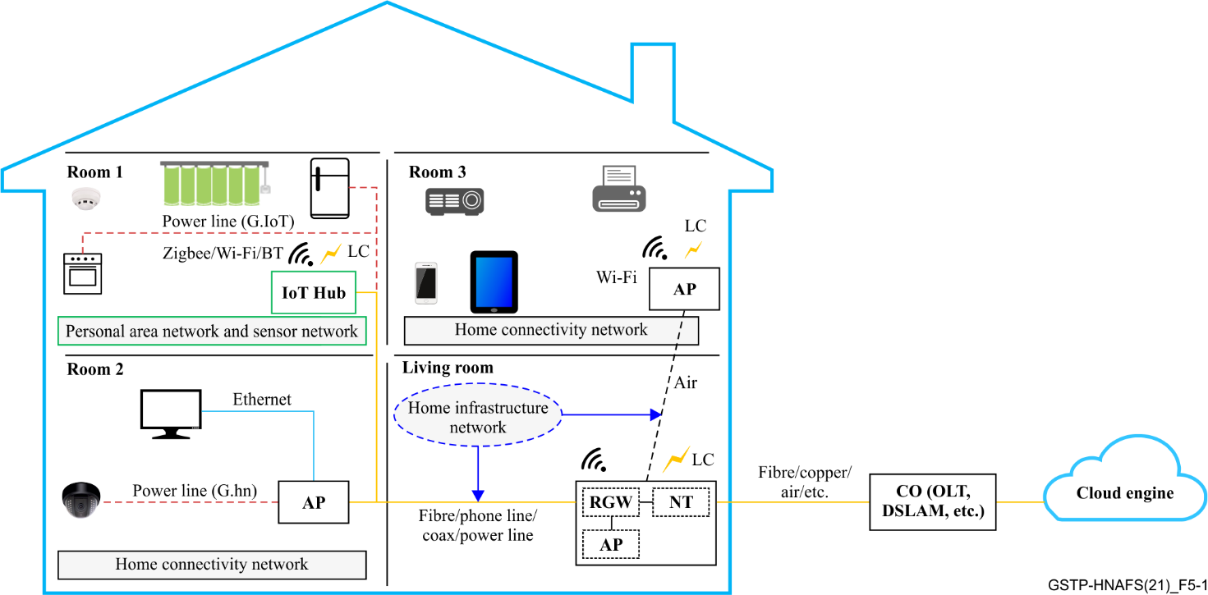

Figure 5-1 – General architecture of an E2E CDHN

## 5.2 Deployment models for connectivity of end user devices

The connection of end user devices in the HHN to the content delivery network can be established through different topologies:

1) Direct connection to a **network terminal** (e.g., optical network terminal, DSL customer premises equipment (CPE)) that includes a residential gateway (RGW) that connects end user devices through the use of a WLAN, through light communication or through other technologies (see Figure 5-2). This has been the traditional deployment model until now.

Figure 5-2 – Network Terminal providing interface for end user device connection

2) Direct connection to an **extended network terminal (ENT)** that includes an RGW that is connected to a network terminal through an access extension network. This deployment model reduces installation costs within the home and allows the location of RGW and network terminals in their optimal locations.

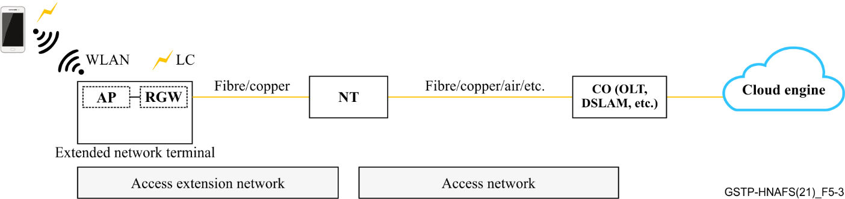

Figure 5-3 – An ENT as an independent device for   
end user devices connection

3) Connection to the **RGW** in a **network terminal** or **ENT** through an HHN (e.g., Wi-Fi mesh system) (see Figure 5-4). This deployment model is gaining more and more traction among service providers due to its robustness and manageability.

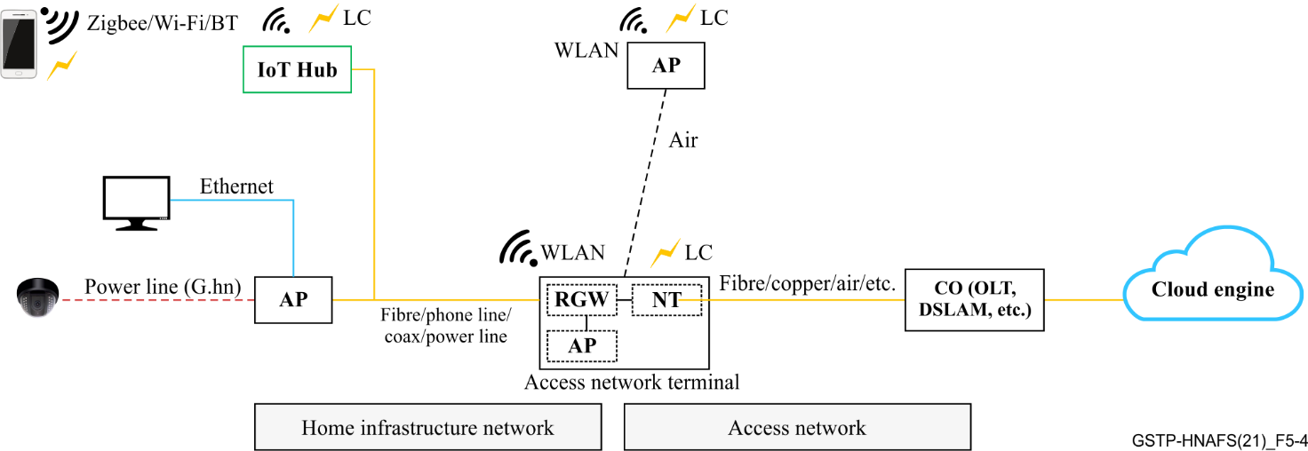

Figure 5-4 – Connection to RGW or ENT through an HHN

## 5.3 Components in a heterogeneous home network

### 5.3.1 Network terminal/extended network terminal

A network terminal is the end network device of an access network, such as the optical network terminal (ONT) of a PON network or the DSL CPE in a DSL network.

In some cases, an additional link (created using an extended access network ended by an ENT) may be needed to build up connection between the network terminal of an access network and the home network entry point. Such an extension network may be based on any available medium, including copper, fibre or even an air interface. In order to be practical and have a comprehensive solution, the function of the network terminal (or ENT) may be integrated with the RGW as a whole system.

The connection between the end user devices and the network terminal (or ENT) is established through the HHN through distinct communication methods, including wired communication (e.g., Ethernet, G.hn, MoCA, G.fin) and wireless technologies (e.g., Wi-Fi, Zigbee, Bluetooth).

### 5.3.2 Residential gateway

In general, the RGW acts as the bridge between access network and the home network. Its northbound interface connects to the network terminal (or ENT) of the access network (or extended access network), while the southbound interface may be composed of various interfaces towards the HHN through wireless (Wi-Fi, light communication) or wired (G.hn, G.fin, Ethernet, etc.) interfaces. Moreover, the RGW normally includes the function of main controller of the home heterogeneous network and carries network functions of the home networking. These functionalities may include:

1) **Enabling full house high-quality signal coverage**: The RGW (which includes the function of central controller and normally includes a wireless access point) may cooperate with other access points and wired links to guarantee an adequate Wi-Fi signal across the home. Band-steering and optimal connectivity can be obtained by correctly organizing the spectrum resources, the link topology, etc. The backhauling of the network should provide a high-quality connection with high data rate and low latency.

2) **Seamless roaming**: The RGW, as the central controller, can guide the mobile end user terminal to connect or roam to the best access points according to its traffic type or required connection quality maintaining the network service's fluent working.

3) **Providing network services**: The RGW provides network services such as domain name system (DNS), DHCP, NAT, firewall, URL filtering, DLNA server and routing.

4) **Providing management services**: The RGW is normally included in the NMS system of the service provider offering access services. The RGW therefore supports the usual network management protocol stacks (e.g., [BBF TR-069] / [BBF TR-369]). On the other hand, the customer can also access the RGW configuration through the dedicated interfaces (website or mobile app).

The maturation and wide application of cloud computing technologies are bringing economically interesting solutions to virtualize the RGW in the home network. Some network functions such as DNS cache servers, SIP gateways and content caching mechanisms are therefore considered to have been moved out of the RGW into the cloud to make it possible to transform the RGW into a low complexity device. In addition, NAT, URL filtering, firewalling and DHCP LAN servers could also be partially or totally migrated to the operator cloud infrastructure.

### 5.3.3 End user connectivity devices

EUCDs provide connectivity to the network to end user devices (e.g., wireless repeater). They may include multiple types of southbound interface to end user devices. For example, broadband links through Wi-Fi or Ethernet, low power links through Bluetooth, Z-Wave or Zigbee, service-specific links such as digital enhanced cordless telecommunications (DECT), etc. In some cases, the function of EUCD can also be integrated within RGW as a whole system.

In addition, several EUCDs may work together forming, for instance, a mesh network obeying some rules fixed by a controller. An example of such a network is the EasyMesh protocol defined by Wi‑Fi Alliance. In this network, a network controller is assigned and the rest of the EUCDs act as agents under the controller's governance.

### 5.3.4 End user device

An end user device is an electronic device that enables dedicated service for end users and is capable of connecting to the home network through at least one connection interface. Typical indoor end user devices include mobile phones, tablets and televisions. These devices enable web services, document uploads and downloads, online gaming, and so on.

Smart devices, such as various sensors (e.g., smoke detectors, temperature detectors), automatic guided vehicles (AGV) and light switches are end user devices with a low data rate in the home network since they provide a direct service to the end user. Furthermore, to provide different services to customers, new end user devices are appearing on the market, such as smart meters for smart grid application, oximeters for healthcare applications, infrared cameras for security applications and automatic feeders for pet care applications.

### 5.3.5 Management system

In general, home network management systems (NMS) run in a network server which is normally deployed in the central office of the operator's network.

The network management system provides a common framework to:

1) Monitor the status of home network devices (such as network terminals, RGW, APs, etc.) and links in the HHN.

2) Manage the link service quality.

3) Manage the communication equipment.

4) Diagnose and maintain the service terminal.

In terms of deployment, the management of the home network includes operator remote management and the user self-helped local management.

The integrated terminal management system (ITMS) is the core of the home network management system and refers to a system for managing home devices and home integrated services.

## 5.4 Cloud engine

The cloud engine is defined as the brain of cloud based HHNs. The cloud engine integrates functions in the cloud server, such as network management, service control, and network analysis to support the operation of the home network:

1) **Onsite evaluation**: To build up the home network with appropriate hardware selection, easy deployment of hardware and the best signal coverage, onsite evaluation may be necessary through multilocation signal collection, coverage measurement, analysis and evaluation. An onsite evaluation could provide evidence to help to create the best home network solution for a customer's needs.

2) **Simplified installation and fast networking**: Automatic configuration is valuable to reduce the complexity and difficulty of network establishment to the end user. The cloud engine could assist network formation through automatic access point configuration, Wi-Fi configuration and service parameter configuration.

3) **Acceptance report generation**: To continuously monitor the status of a home network, the cloud engine has the capability to conduct parameter collection or sample testing, including Wi-Fi signal quality analysis (e.g., signal heat map, latency analysis, interference analysis), roaming test, topology test and so on.

The cloud engine focuses on service automation, operation and maintenance (O&M) automation, and network autonomy to support carrier network cloudification and digital operation.

### 5.4.1 Edge engine

The increase in the number of end user devices at the edge of the home network is producing a massive amount of data to be computed at data centres, pushing home network bandwidth requirements to the limit. Data centres cannot guarantee acceptable transfer rates and response times, which could be a critical requirement for many applications. Furthermore, devices at the edge constantly consume data coming from the cloud, forcing companies to build CDHNs to decentralize data and service provisioning, leveraging physical proximity to the end user.

In a similar way, the aim of edge engines is to move the computation away from data centres in the core network towards the edge of the home network. This way, smart objects, mobile phones and network gateways may be exploited to perform tasks and provide services on behalf of the cloud. By moving services to the edge, it is possible to provide content caching, service delivery, storage and terminal device management faster, resulting in better response times and transfer rates. At the same time, distributing the logic in different network nodes introduces new issues and challenges.

# 6 Services within the home

Due to the fast development of Internet and smart home industries, the dominant services in the home network are: background service, video service, voice service and IoT service.

## 6.1 Background traffic service

Background traffic represents the bulk of the transfers and other activities that are permitted on the network but that should not impact the use of the network by other users and applications. In real networks, background service refers to the autonomous exchange of user plane data packets between the end user device and the core network, generally in the absence of a specific user interaction with the device. Background traffic services are always considered low priority in the home network.

## 6.2 Video service

We can define a video service as a type of multimedia traffic delivered by a provider that is constantly received by and presented to the end user.

The resolutions of traditional video service are normally 480P, 720P and 1080P. 4K or 8K video will be popular in the future and will require more bandwidth.

In addition, cloud VR is becoming popular in home networks. Cloud VR is a new cloud computing technology for VR services. With fast and stable transport networks, VR content is stored and rendered in the cloud, and video and audio outputs are coded, compressed and transmitted to end user devices. With cloud VR, users enjoy VR services without purchasing expensive hosts or high-end PCs, promoting VR service popularity. The bandwidth and E2E network round trip time (RTT) requirements of cloud VR in different levels of quality are shown in the following table.

Table 6-1 – Bandwidth and E2E network RTT requirements of Cloud VR [Cloud VR WP]

|  |  |  |  |  |
| --- | --- | --- | --- | --- |
| Level of quality | | Fair experience quality | Comfortable experience quality | Ideal experience quality |
| Strong interaction content resolution | | 4K | 8K | 8K/16K |
| Typical terminal resolution | | 4K | 8K | 8K/16K |
| Strong interaction VR service | Bit rate | ≥40 Mbit/s | ≥90 Mbit/s | ≥360 Mbit/s (8K)  ≥440 Mbit/s (16K) |
| Bandwidth requirement | ≥80 Mbit/s | ≥260 Mbit/s | ≥1 Gbit/s (8K)  ≥1.5 Gbit/s (16K) |
| E2E Network RTT | <20 ms | <15 ms | <8 ms |
| NOTE – [ITU-T H.266] (2020) specifies video coding that achieves compression resulting in bit rates that are approximately one half of those achieved by [ITU-T H.265] (2019). | | | | |

## 6.3 Voice service

Voice service in home network is typically implemented using voice over Internet Protocol (VoIP), which is a method composed of a group of technologies for the delivery of voice communications and multimedia sessions over Internet Protocol (IP) networks, such as the Internet. Quality of service (QoS) mechanisms are required to avoid the undesirable loss of VoIP packets by immediately transmitting them ahead of any queued bulk traffic on the same link, even when the link is congested by bulk traffic. Voice service is characterized by less than 10 ms delay and maximum jitter (see [IEEE 802.1Q] Annex I), and is considered the highest priority in the home network.

## 6.4 IoT service

IoT service can be provided by the operator through interconnecting and organizing physical objects – "things" – that are embedded with sensors, software and other technologies for the purpose of connecting and exchanging data with other devices and systems over the Internet.

The development of the smart home is significantly increasing the number of smart devices in home networks. For example, home automation is a typical use case of smart home, including the participation of various IoT devices, such as lighting, heating, air conditioning and media, as well as security and camera systems. Home energy saving is another use case that brings long-term benefits by automatically ensuring that lights and electronics are turned off or by making the residents in the home aware of consumption.

In the future, full interconnection among all devices in the home will form a local network platform for developing and operating new value-added services.

# 7 Connection technologies

## 7.1 Wireline

### 7.1.1 G.hn

G.hn is a technology composed by a family of international standards created by the ITU standardization body [ITU-T G.9960], [ITU-T G.9961], [ITU-T G.9963]. It is defined to operate over any physical wire medium within the home, including coaxial cable, telephone/CATx wires, powerline and plastic optical fibre.

An independent network is formed over the same medium, as a "domain" with inter-domain bridges used to interconnect different domains (see Figure 7-1).

G.hn systems can achieve very high transmission data rates, up to at least 10 Gbit/s over coax, 5 Gbit/s over telephone line and 2 Gbit/s over power line, respectively. Such high throughput with a very robust QoS mechanism and complete security enables G.hn networks to meet operator requirements in the home network.

Prior to G.hn, home networks were either Ethernet based, requiring new cables, or they were based on proprietary technologies that did not enjoy widespread adoption, were expensive and were known to have service or throughput issues. G.hn has consolidated the wired portion of the home network under a single technology. G.hn eliminates the need for new wires, is very cost effective, and provides the high throughput and QoS backbone necessary for today's HHN. Based on a G.hn wired backbone network, the in-home network can deliver high bandwidth content anywhere for fixed or nomadic devices, and act as wireless backhaul for multiaccess point wireless systems.

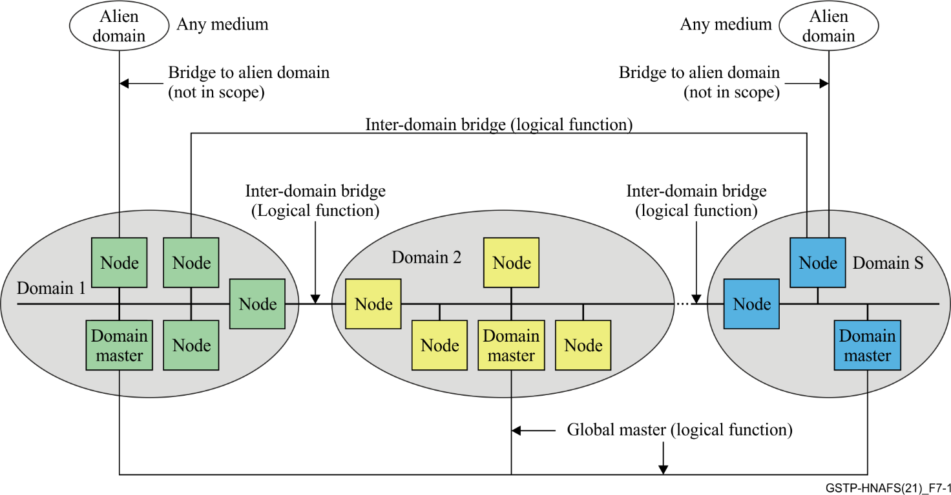

Figure 7-1 – General architecture of G.hn technology

### 7.1.2 G.fin

As the bandwidth requirement of the home network is increasing explosively, current copper based solutions may not be enough for LTE. Fibre has been widely used in metro networks and access networks for high speed communication due to its extremely good channel condition. Therefore, fibre can also be introduced to the home area for Wi-Fi backhaul.

Using fibre connection within the home brings many advantages:

1) The **bandwidth seems to be unlimited**, and it is easy to achieve more than 100 Gbit/s, supporting most of the service evolution in the near future.

2) An **extremely low** **insertion loss** (<0.3 dB/km) enables low power consumption in the transmission link and less complexity in the devices, such as laser and detector.

3) **Wavelength multiplexing** in one fibre could provide divided transmission channels for different data streams that may help to facilitate network slicing and better network QoS.

4) Compared with the base band transmission, the **optical signal in the fibre is immune to electromagnetic interference** (EMI).

5) Fibre is **lightweight and small in size**, leading to easier deployments.

Figure 7-2 – General architecture of G.fin

A typical example of home networking with fibre connection is shown in Figure 7-2. To study this topic, ITU-T SG15 Q18 recently initiated a new project on G.fin: "*High speed fibre-based in-premises transceivers – system architecture, physical layer and data link layer specification*". This new project will study the use case, architecture, technical requirements, physical layer and data link layer of fibre-based networking within premises. The project acts as a guideline for system vendors to implement the devices and for users to deploy fibre in the home.

### 7.1.3 Ethernet

Ethernet technologies are defined in IEEE 802.3 standards that describe the physical and data link layer specifications for Ethernet. Ethernet standards have a long history and experience a great success in the market. The first Ethernet standard IEEE 802.3 was published in 1983 to standardize 10 Mbit/s transmission data link for thick coax. Currently, the most popular Ethernet standards are 100 Base-T [IEEE 802.3u] and 1000 Base-T [IEEE 802.3ab], using baseband transmission over multiple well qualified twisted pairs.

## 7.2 Wireless

### 7.2.1 Wi-Fi over 2.4 GHz, 5 GHz, 5 925-7 125 GHz band

Wi-Fi is a widely deployed WLAN technology based on the [IEEE 802.11](https://en.wikipedia.org/wiki/IEEE_802.11) standard. Wi-Fi technology includes several versions (802.11a/b/d/g/n/ac/ax/be) and an unlicensed spectrum within 2.4 GHz, 5 GHz and sub-6 GHz bands is being worked on:

1) 802.11n (branded "W-Fi 4") was mainly designed for high definition video and gaming. The major advanced features were multi-input multi-output (MIMO) and 20/40 MHz channel bandwidth, achieving a maximum peak rate of 600 Mbit/s.

2) 802.11ac (branded "Wi-Fi 5") was designed for 4K video, comfortable VR, electronic schoolbag and mobile games. New features were developed, including high-order 256 quadrature amplitude modulation (QAM), 4*4 MIMO, downlink MU-MIMO and 40/80 MHz channel bandwidth, achieving a maximum peak rate of 3.5 Gbit/s.

3) [IEEE 802.11ax] (branded "Wi-Fi 6") was designed for 8K video, advanced VR games, full field of view online classroom, smart office and high definition video surveillance. It supports 1024 QAM, OFDMA that allows multi-user parallel transmission, spatial reuse and both downlink and uplink MU‑MIMO, achieving a maximum peak rate of 9.6 Gbit/s.

4) Currently, in order to fulfil the requirements of extremely high throughput applications, 802.11be (branded as "Wi-Fi 7") is under development. The scope is to support 320 MHz channel bandwidth, 4096 QAM, 6 GHz radio band, multilink operation, and multi-access-point coordination (to minimize interference and maximize network efficiency). The target peak rate is 30 Gbit/s.

In addition, to realize perfect signal coverage within the home, multiple access points may be deployed so that the multiple access point communication protocol and technology are necessary. Wi-Fi Alliance (WFA) defines the "EasyMesh" protocol to form a flexible and well-coordinated home network. To achieve a better roaming experience, 802.11k/v/r standards were specified to enable better exchange and connection among different links.

### 7.2.2 mmWave Wi-Fi

Free radio-frequency spectrum is rare in low frequency band, where the signal is capable of penetrating obstacles and travelling for long distances. To explore higher frequency bands and obtain more channel bandwidth, the IEEE 802.11 group developed the [IEEE 802.11ad] standard, which is an amendment to the IEEE 802.11 standard providing a Multiple Gigabit Wireless System (MGWS) at the 60 GHz frequency band. In this frequency band, the interference between rooms becomes extremely low compared with other conventional Wi-Fi systems in low frequency bands due to the large attenuation when traversing walls. Beamforming and larger channel bandwidths are available, enabling the transmission of data at a rate of up to around 7 Gbit/s. This will support various new applications such as uncompressed ultra-high-definition (UHD) video transmission (the replacement for HDMI), cloud VR, etc. over a wireless network. The [IEEE 802.11ad] standard defines six different channels of 2 160 MHz in the frequency of 57 to 71 GHz.

To further boost the maximum data rate, the 802.11ay amendment of [IEEE 802.11ad] introduces channel bonding technology to make use of the whole bandwidth resource, such as four channel integration to the 8.64 GHz bandwidth. MIMO is also specified with up to a maximum of four data streams. The single link rate per stream can reach up to 44 Gbit/s (up to 176 Gbit/s with four streams). Higher order QAM modulation (256 QAM) is also being considered due to the evolution of radio-frequency technology in mmWave.

China has opened the 42-48 GHz frequency band (Q-band) for WLAN usage. To adapt 802.11 systems to this new frequency band, IEEE developed a regional amendment to the 802.11 standards: [IEEE 802.11aj]. This standard implements MIMO with a maximum of a 1.08 GHz channel within the band and four data streams to support a data rate of up to 15 Gbit/s.

### 7.2.3 Low power Wi-Fi

In 2017, IEEE published [IEEE 802.11ah], also branded "Wi-Fi HaLow" to enable low power Wi-Fi. The technology utilizes 900 MHz license-exempt bands to provide extended range Wi-Fi networks. Working with a relatively narrow channel (i.e., lower than 1 MHz) and with the target wave time (TWT) power saving mechanism, [IEEE 802.11ah] provides much lower power consumption. However, [IEEE 802.11ah] operates in the sub-1 GHz band, which is not compatible with the deployed legacy networks, bringing a challenge for creating new business ecosystems.

An alternative to a low power Wi-Fi solution is [IEEE 802.11ba], called Wake-Up Radio (WUR); [IEEE 802.11ba] is not for use for data transmission but only serves as a simple "wake-up" receiver for the main radio. The receiver is active and receives the wake-up packet in the 2.4/5 GHz band while the main radio is off. The target power consumption is to be less than 100 uW in the active state with a simple modulation scheme on-off keying (OOK) and narrow bandwidth (4 MHz).

### 7.2.4 Indoor free-space light communication

Free-space light communication transmits optical signals through the air to exchange information between transceivers. In general, the optical spectrum is considered to have "unlimited bandwidth" compared with the various current radio-frequency technologies (such as Wi-Fi in C-band: 2.4/5/6 GHz or V-band: 60 GHz). Therefore, industries have developed standards for promoting free-space light communication. The first standard group was established as 802.15.7 TG in IEEE in 2009.

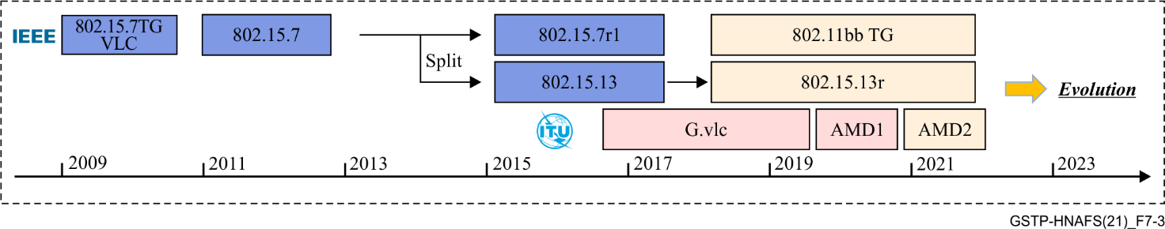

Figure 7-3 – International standard development of light communication with broadband

In 2020 (see Figure 7-3), three main broadband standards for light communications were active:

1) The **802.15.13** group will publish a revision, theoretically covering a 2 Gbit/s data rate for a single stream with a PHY similar to the ITU-T G.hn 200 MHz coax profile.

2) **802.11bb** intends to reuse Wi-Fi MAC. Additionally, 802.11a is leveraged in 802.11bb for interoperability or low speed. ITU-T G.hn PHY is also supported in 802.11bb with a MAC adaptation under development between G.hn MAC and Wi-Fi MAC.

3) **ITU**-T G.vlc in ITU-T Q18/SG15 [ITU-T G.9991] re-uses the current G.hn technology for broadband light communication. Additionally, G.hn PHY is directly reused for a DCO-OFDM scheme while a modified G.hn PHY is also specified for an ACO-OFDM scheme.

Table 7-2 summarizes the basic capability of the three standards mentioned above.

Table 7-2 – Comparison of indoor free-space optical light communication standards

|  |  |  |  |
| --- | --- | --- | --- |
|  | IEEE 802.15.13r1 | IEEE 802.11bb | ITU-T G.vlc |
| PHY | PM-PHY: PAM2 99 MHz  LB-PHY: OFDM 32MHz  HB-PHY: OFDM 200 MHz | 802.11a-PHY: OFDM 20MHz  G.hn-PHY: 200 MHz | G.hn-PHY: 200 MHz |
| Max data rate / single stream | PM-PHY: 99.42 Mbit/s  LB-PHY: 86.4 Mbit/s  HB-PHY: ~2Gbit/s | 11a-PHY: 54 Mbit/s  G.hn-PHY: ~2 Gbit/s | ACO-OFDM PHY: ~1 Gbit/s  G.hn-PHY: ~2 Gbit/s |
| MAC | 802.15.13 MAC | 802.11 MAC | G.hn MAC |
| Typical light source | LED or light bulb | LED or light bulb | LED or light bulb |

# 8 Summary

Continuously evolving demanding applications and services in a dedicated home infrastructure requires the adaptation of the support of the HHN. With the increased penetration ratio of operator-managed home networks, it is important to have a clear understanding of the content and components of the home network. To achieve this goal, this technical paper provides an overview of various in-home services and the general architecture and connection technologies of these networks. By making use of this knowledge, the practical establishment of the home network could be carried out according to the customer's needs.

___________