Standardization Sector
ITU-T Technical Paper
(09/2022)
GSTP-OPHN
Operation of G.hn technology over access and in-premises phone line medium
ITUPublications | International Telecommunication Union


Technical Paper ITU-T GSTP-OPHN
Operation of G.hn technology over access and in-premises phone line medium

Summary
Technical Paper ITU-T GSTP-OPHN describes typical network architectures, parameters, and implementation issues regarding broadband applications that use ITU-T G.9960 / G.9961 transceivers (called here "G.996x transceivers"). G.996x devices are designed to be capable of operating over different types of physical media, using different frequency ranges, and different sets of physical layers (PHY) and medium access control (MAC) parameters. Each of these applications has specific characteristics that may require optimized settings (configuration options) to be used. Additionally, implementations themselves need to consider various aspects of the applications which are described in detail in this Paper.
This Technical Paper is not an ITU-T Recommendation, but rather a tutorial that provides guidance for the user and describes how to configure ITU-T G.996x home networking systems to operate in the context of applications that require operating over various phone lines with potentially high levels of crosstalk, such as phone line cables within private apartment buildings, connecting G.hn aggregation multiplexer (GAM) equipment in the basement with the G.hn network terminal (GNT) equipment in the individual apartments.

Note
This is an informative ITU-T publication. Mandatory provisions, such as those found in ITU-T Recommendations, are outside the scope of this publication. This publication should only be referenced bibliographically in ITU-T Recommendations.

Change Log
This document contains Version 2 of the ITU-T Technical Paper on "Operation of G.hn technology over access and in-premises phone line medium" approved at the ITU-T Study Group 15 meeting held in Geneva, 19-30 September 2022.

Editor: | Taewoo Ha  KT Corporation | Tel.: +82 10 3003 1069  E-mail: taewoo.ha@kt.com
 | Marcos Martínez  MaxLinear Inc | Tel.: +34 961366004  E-mail: mmartinez@maxlinear.com

© ITU 2023
All rights reserved. No part of this publication may be reproduced, by any means whatsoever, without the prior written permission of ITU.
Table of Contents
Page
1 Scope 1
2 References 1
3 Definitions and acronyms 1
3.1 Definitions 1
3.2 Abbreviations and acronyms 2
4 Introduction 3
5 Brief introduction to G.hn 4
5.1 Generic network architecture 4
6 Use of G.hn in broadband applications over phone lines 4
6.1 G.hn-based system over phone lines 4
6.2 G.hn domains in presence of crosstalk 5
6.3 Coordinated G.hn network architecture 6
6.4 Physical layer (PHY) 9
6.5 Data link layer (DLL) 11
6.6 Interference mitigation mechanism 14
7 Network initialization 19
8 Network management 19
9 Summary 19

Technical Paper ITU-T GSTP-OPHN
Operation of G.hn technology over access and in-premises phone line medium

1 Scope
This Technical Paper focuses on the use of G.hn technology (G.996x transceivers) over phone line infrastructure for traditional gigabit access applications or Fibre-To-The extension point (FTTep) applications.
The paper is intended to provide guidance to system vendors and service providers to define, configure, deploy, and manage networks based on G.996x transceivers in this type of environment when crosstalk between lines may occur in some of the access and fibre extension topologies as described in [BBF TR-419]. For these situations, the document describes the use of an external entity to centralize the control of the transmissions on the different G.hn domains to mitigate the effect of the crosstalk.
The G.996x family of Recommendations includes [ITU-T G.9960], [ITU-T G.9961], [ITU-T G.9962], [ITU-T G.9963], [ITU-T G.9970], and [ITU-T G.9972] (optional), and is referred to herein as G.996x.

2 References
[ITU-T G.9960] Recommendation ITU-T G.9960 (2018), Unified high-speed wireline-based home networking transceivers – System architecture and physical layer specification.
[ITU-T G.9961] Recommendation ITU-T G.9961 (2018), Unified high-speed wireline-based home networking transceivers – Data link layer specification.
[ITU-T G.9962] Recommendation ITU-T G.9962 (2018), Unified high-speed wire-line based home networking transceivers – Management specification.
[ITU-T G.9963] Recommendation ITU-T G.9963 (2018), Unified high-speed wireline-based home networking transceivers – Multiple input/multiple output specification.
[ITU-T G.9970] Recommendation ITU-T G.9970 (2009), Generic home network transport architecture.
[ITU-T G.9972] Recommendation ITU-T G.9972 (2010), Coexistence mechanism for wireline home networking transceivers.
[BBF TR-069] Broadband Forum TR-069 (2007), CPE WAN Management Protocol v1.1.
[BBF TR-181] Broadband Forum TR-181 (2011), Device Data Model for TR-069.
[BBF TR-374] Broadband Forum TR-374 (2018), YANG modules for management of G.hn systems in FTTdp architectures.
[BBF TR-419] Broadband Forum TR-419 (2022), Fiber Access Extension over Existing Copper Infrastructure.
[HomeGrid Forum] HomeGrid Forum. <https://homegridforum.org/>

3 Definitions and acronyms

3.1 Definitions
This Technical Paper defines the following terms:
3.1.1 coordinated G.hn network: In the scope of this Technical Paper, a group of interconnected G.hn domains that are time-coordinated in order to minimize the crosstalk between each other.
3.1.2 device: Any type of system used for an application using a networking transceiver.
3.1.3 domain master: G.hn domain master (DM) as defined in [ITU-T G.9960] reference model.
3.1.4 end point: G.hn end point (EP) as defined in [ITU-T G.9960] reference model.
3.1.5 G.hn network: In the scope of this Technical Paper, a group of interconnected G.hn domains.
3.1.6 G.hn domain: A G.996x network comprised of a domain master and its registered nodes.
3.1.7 G.hn device: A device using a G.996x transceiver.
3.1.8 G.hn transceiver: A node in a G.996x domain that conforms with the G.996x family of Recommendations.
3.1.9 GAM (G.hn aggregation multiplexed): In this Technical Paper it represents the device that implements the DM and the GDM functionalities as defined in [ITU-T G.9960] architecture. The GAM usually includes an additional switching function to connect it to a broadband backbone.
3.1.10 GAM manager: In the scope of this Technical Paper, an entity that implements the global master functionality of a G.hn network as defined in [ITU-T G.9962].
3.1.11 GNT (G.hn network termination): In this Technical Paper it represents the device that implements EP functionalities as defined in [ITU-T G.9960] architecture.
3.1.12 node: A network element or member; specifically, in the context of this Technical Paper, a G.hn transceiver.
3.1.13 Xtalk mitigation driver: In the scope of this Technical Paper, an entity associated with a GAM manager that interfaces with the DMs depending on that GAM in order to extract information from the DM and the program constraints on its scheduling.
3.1.14 Xtalk mitigation engine: In the scope of this Technical Paper, an entity normally residing in the cloud that interacts with the xtalk mitigation drivers in order to define constraints on the different DM scheduling to optimize the interferences between the lines of the coordinated G.hn network.

3.2 Abbreviations and acronyms
This Technical Paper uses the following abbreviations and acronyms:
BAT Bit Allocation Table
BB Broadband
BLER Block Error Rate
CGN Coordinated G.hn Network
DLL Data Link Layer
DM Domain Master
DOD Domain Identifier
DS Downstream
EP End Point
FEXT Far End Crosstalk
GAM G.hn Aggregation Multiplexer
GN G.hn Network
GM Global Master
GNT G.hn Network Terminal
GW Gateway
HN Home Network
IH In-Home (regarding the location of a domain)
LAN Local Area Network
LFSR Linear Feedback Shift Register
MAC Medium Access Control
MAP Medium Access Plan
MAP-A Active Medium Access Plan
MAP-D Default Medium Access Plan
MDU Multi-Dwelling Unit
NEXT Near End Crosstalk
OFDM Orthogonal Frequency Division Multiplexing
PHY Physical Layer
PON Passive Optical Network
PSD Power Spectral Density
QoS Quality of Service
RGW Residential Gateway
SC Security controller
SNR Signal to Noise Ratio
TDD Time Division Duplexing
TDMA Time Division Multiple Access
US Upstream

4 Introduction
This Technical Paper describes how to apply coordination techniques that facilitate the establishment of broadband (BB) access and fibre extension networks over phone line cables as described in [BBF TR-419] when in presence of a high level of crosstalk (presence of neighbouring domains, using G.hn terminology). These coordination techniques are accommodated through the G.hn network (GN) architecture.
G.hn Recommendation defines a communication protocol for phone line medium that enables data rates up to 1 Gbps for in-premises networks. Based on a time division multiple access (TDMA) architecture and using a spectrum up to 100 MHz orthogonal frequency division multiplexing (OFDM), G.hn enables operation in various types of environments. This Technical Paper shows how to take advantage of the different mechanisms offered by the technology to allow multiple pairs of G.hn transceivers to operate in a time division duplexing (TDD) context over neighbour phone lines (in-premises or access) while minimizing the loss of performance due to crosstalk from other G.hn systems.

5 Brief introduction to G.hn

5.1 Generic network architecture
A G.hn domain may be established over any type of wiring (power lines, coaxial cables, phone lines and plastic optical fibre). For the distribution of broadband services in multi-dwelling units (MDUs) phone line is a convenient option because it is widely available.
Each G.hn domain may include "up to 250 G.hn nodes, one of which is designated as a domain master (DM), which coordinates the operation of all nodes in the domain. All other nodes in the domain are called "end-point nodes" (EP) or simply "nodes". The DM is responsible for assigning a schedule that meets the traffic constraints of the EPs and uses in the most efficient way the available channel resources.
A G.hn network is composed of multiple domains. The global master (GM) function provides the coordination of resources, priorities, and operational characteristics between neighbour domains of a G.hn network. The GM is a high-level management function that communicates with the management entities of the DMs and that may also convey the relevant inter-domain coordination functions.
The generic architecture of a G.hn network is presented in Figure ‎5-1.
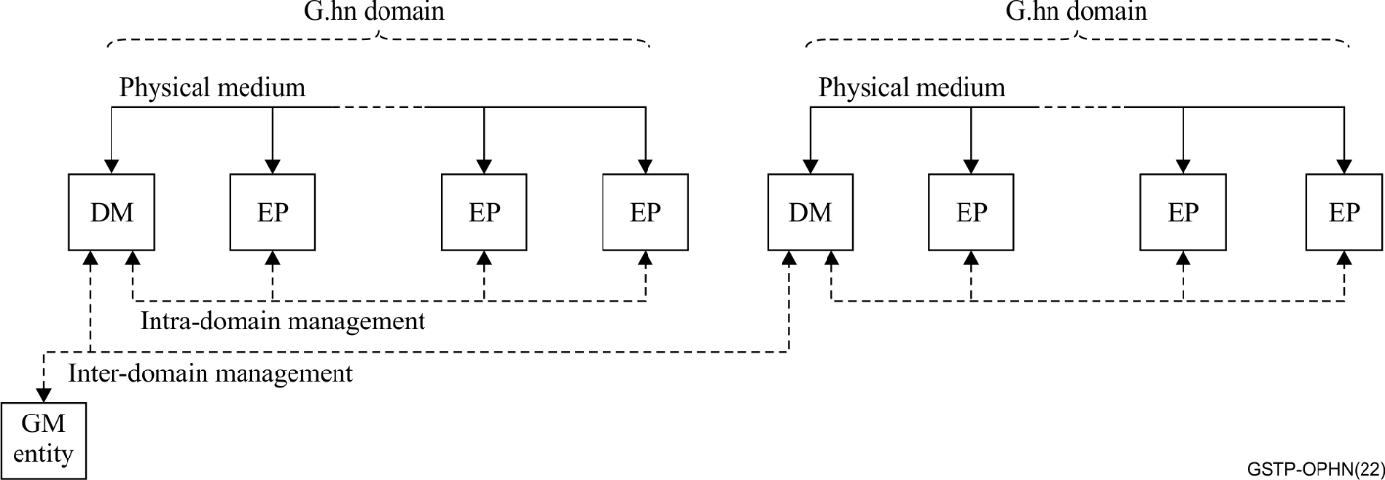
Figure ‎5-1 – Generic architecture of a G.hn network
G.hn domains can support flexible topologies. Depending on the application, G.hn domains may include many nodes (in a point-to-multipoint configuration) or just two nodes (in a point-to-point configuration). The only constraint is that one of the nodes needs to be a DM.

6 Use of G.hn in broadband applications over phone lines

6.1 G.hn-based system over phone lines
G.hn over the phone line is optimized for the deployment of an in-home (IH) network (HN) over a single phone line. However, G.hn includes techniques of crosstalk avoidance and mitigation between home networks located over different phone lines. Those techniques can be reused in order to use G.hn technology for the delivery of broadband services to individual homes or apartments. In most cases, multiple phone lines are installed near each other, often in the same bundle.
When multiple G.hn domains are operating over separate phone lines that are part of the same bundle, each domain may suffer from interference created by any other nearby domain. This Technical Paper shows how to use the different mechanisms offered by the G.hn family of Recommendations to allow multiple point-to-point systems based on the G.hn to operate simultaneously over phone line media as neighbouring domains.
NOTE – While the operation of a G.hn over phone lines has been defined in existing ITU-T G.996x Recommendations and the communication channel to allow external entities to influence the G.hn scheduling to reduce interference between lines (crosstalk), no specific guidance is provided on those Recommendations about what is the optimal configuration required to allow operation in cases in where multiple phone lines are located in close proximity to each other.

6.2 G.hn domains in presence of crosstalk
The G.hn Recommendation describes a multi-node domain with multiple devices that share a channel. A domain is controlled by a single node called a domain master (DM). The DM is in charge of coordinating the transmissions of all the nodes in the network (scheduling) to avoid collisions in the channel and guarantee a required level of quality of service (QoS) to the traffic conveyed in the domain. Each node can communicate with any of the other nodes of the domain (multi-point to multi-point communications).
Even though G.hn supports multi-point to multi-point topologies, the architecture of the broadband delivery systems over phone lines is often point-to-point: It is based on a pair of nodes that communicate with each other, with one of the nodes at the customer premises, while the other node is located at the service provider network.
This Technical Paper uses specific terminology to describe this type of architecture. In this Paper, the G.hn device installed at the user side is called a "G.hn network terminal" (GNT), while the G.hn device connected to the broadband backbone is called a G.hn aggregation multiplexer (GAM). The GAM may include multiple G.hn transceivers, each one connected to a separate phone line serving a different subscriber.
A common situation is that the phone lines run partially in parallel with each other, for example if they are part of the same bundle (e.g., distribution from a single optical termination) with the potential to interfere with each other. In G.hn, these types of domains are considered a type of neighbouring domains and are characterized by the (potentially) strong crosstalk levels between them.
Typically, this crosstalk is composed of two different contributions:
• NEXT (near end crosstalk): interference from a node located in the GAM to another node located in the same GAM (or a neighbour GAM) or from a node located at the GNT to another node located at a neighbour GNT.
• FEXT (far end crosstalk): interference from a node located in the GAM to nodes located at the GNTs of other lines, or the other way around (interference from one node located in a GNT to the nodes of other domains located in the GAM).
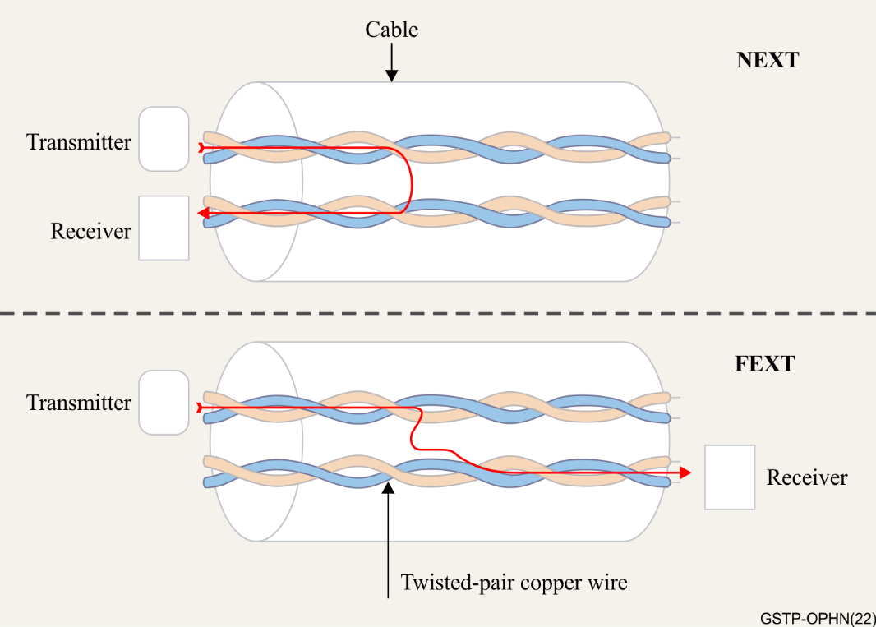
Figure ‎6-1 – FEXT / NEXT interference. Left side represents the GAM and the
right side represents the GNT
G.hn nodes can cope with these two sources of crosstalk, by imposing the following constraints on the G.hn domains in the network (see Figure 6-2):
• Each point-to-point connection between a GAM and each of the GNTs is established by creating a G.hn domain composed of two nodes.
• The combination of the individual G.hn domains forms the coordinated G.hn network (CGN).
• The nodes located in the GAM are configured as the G.hn domain master.
• Each domain has a different Domain ID.
• Each domain uses a different preamble seed to achieve near-orthogonal preamble signals. This allows nodes of a domain to decode only the frames belonging to nodes of the same domain.
• Downstream / Upstream (DS/US) transmissions within the different domains are synchronized by the alignment of the scheduling of each of the domains in the G.hn network in order to eliminate NEXT.
• Bit-loading and forward error correction are dynamically optimized to operate under the noise created by FEXT.
• Each GAM provides a management interface to the GAM manager to allow external control of the transmission characteristics in this domain (frequency, allowed time and transmission power).
The following clause describes with further details the previous points.

6.3 Coordinated G.hn network architecture
The general architecture of a coordinated G.hn network is shown in Figure 6-2:
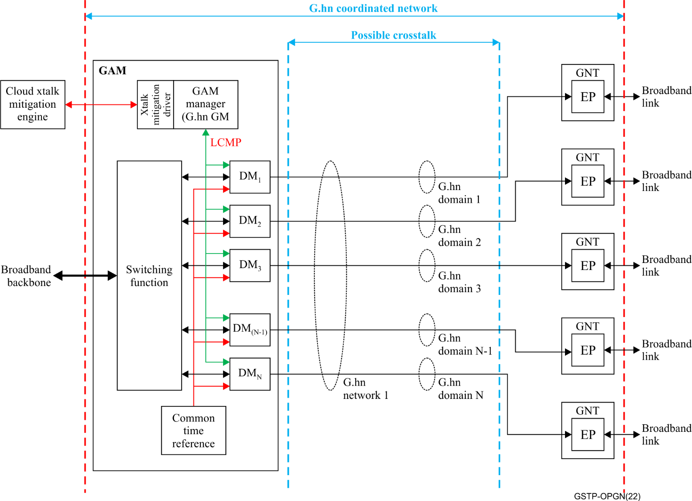
Figure ‎6-2 – Coordinated G.hn network architecture
NOTE – The terminology used in the previous diagram is defined in clause 3 of this Technical Paper.
A G.hn coordinated network is composed of N G.hn domains, each of them with its own DM and EP. These domains operate independently and define their own scheduling. However, the scheduling of these networks complies with the following requirements:
• Their medium access control (MAC) cycles are aligned, meaning that the boundaries of all the MAC cycles of all the domains in a G.hn coordinated network are the same.
• The scheduling generated by each of the domain masters in this network are subject to additional constraints defined in an external entity (xtalk mitigation engine) that can interact with the different DMs through an xtalk mitigation driver present in every GAM.
The DMs are physically located in a GAM that provides all the functions to align the MAC cycles and presents a control and data interface toward the broadband backbone. Several GAMs may be part of the same G.hn coordinated network if they align their MAC cycles.
On the user side, the EPs are located in a GNT device that offers data and control interface towards the user equipment (normally a residential gateway (RGW)).

6.3.1 Coordinated G.hn network
A coordinated G.hn network (GN) is defined as multiple G.hn domains that coordinate their transmissions in order to minimize interference between them. Figure ‎6-2 presents an example of such a network.
The coordinated G.hn network includes a G.hn aggregation multiplexer (GAM) that makes the interface between the backbone broadband link and multiple G.hn network terminal devices (GNT).
In some cases, the GAM function is physically split across multiple devices. For example, a GAM with 48 DM entities may be physically built with two physical devices that have 24 DMs each. Both physical devices need to have a common clock to ensure the 48 domains have the proper coordination.

6.3.2 G.hn domains
Each domain composing a coordinated G.hn network operates quasi-independently but is managed and/or controlled by a GAM manager that implements the G.hn global master (GM) functionality.
Each domain is composed of two G.hn nodes:
• A DM, which is always located in the GAM. The A-interface (see clause 5.2.1 of [ITU-T G.9960]) of this node is connected to the GAM switching function. The physical interface of the device is connected to the phone line port of the G.hn device.
• An EP, which is always located in the GNT. The A-interface of this node is connected to a broadband link (for example, a gigabit Ethernet port), usually connected to a local area network (LAN). The physical interface of the device is connected to the phone line port of the G.hn device.

6.3.3 Operating frequency band (OFB)
All the nodes belonging to a G.hn domain that is part of a coordinated G.hn network need to comply with one of the G.hn band plans defined for telephone baseband medium (50 MHz or 100 MHz) (see [ITU-T G.9961]).

6.3.4 GAM manager (GM)
The GAM manager ensures the global master functionality of the coordinated G.hn network (see [ITU-T G.9962]) by controlling the behaviour of the different DM management entities (DME) of each of the G.hn domains composing the network.
The GAM manager is responsible for guaranteeing the correct configuration of the different DMs in order to bring the overall G.hn coordinated network to a state where the effects of the self-crosstalk are stable.
The functions of the GAM manager are:
• Configure the appropriate seeds for PROBE frame transmission in each domain (see clause ‎6.4.2).
• Configure the appropriate seed for unloaded supported sub-carriers linear feedback shift register (LFSR) generator seeds in each domain (see clause ‎6.4.4).
• Guarantee coherence of scheduling in each of the domains (see clause ‎6.5.1.2).
• Provide the transmission characteristics allowed for each GAM to mitigate interference between domains (see clause 6.6).
The GAM manager may be either a physical entity, a function running on one of the DMs of the GAM, or a distributed entity between the DMs of the GAM.

6.3.5 Synchronization of domains
The different domains that compose a coordinated G.hn network are synchronized by using an external common clock reference. For this, each of the DMs is synchronized to the same external source (see clause 8.6.3 of [ITU-T G.9961]) generated by the GAM.
In order to guarantee that every DM chooses the same MAC cycle start time, the parameter NUM_SYNC_PERIODS of the G.hn DM is fixed to 1, and EXT_SYNC_ACCURACY of the G.hn DM is fixed to 2 μs.
The MAC cycle length is flexible within the boundaries specified by the G.hn family of Recommendations (see CYCLE_MIN and CYCLE_MAX parameters in clause 8.4 of [ITU-T G.9961]), but a value of 40 ms is typically used.
NOTE – This 40 ms value is convenient since many of the G.hn systems typically use a MAC cycle linked to the AC power line frequency (50 Hz or 60 Hz). The value of 40 ms for the MAC cycle corresponds to an AC power line frequency of 50 Hz.
If the GAM function is split across multiple physical devices, they need to include a mechanism to ensure that the same clock signal is used across all devices.

6.4 Physical layer (PHY)

6.4.1 Introduction
Several mechanisms are used within a coordinated G.hn network in order to minimize the effect of FEXT (Far end crosstalk). If these mechanisms are not used FEXT could impact each G.hn domains in a different way:
• Detection of frames from neighbour domains: The DM from a G.hn domain might detect the preamble of an upstream (US) frame coming from the EP of a different domain of the coordinated G.hn network. In order to prevent this issue, each domain uses a different seed to generate near-orthogonal preambles between frames of different domains (see clause ‎6.4.2). Through the use of this "orthogonal preambles" mechanism, the DM of each domain will only decode the frames transmitted by the EP of its domain.
• Instability of signal to noise ratio (SNR) measurements: G.hn uses a channel estimation process (see clause 8.11 of [ITU-T G.9961] to detect the changes in line conditions, measure the characteristics of the line and dynamically adapt the number of bits per sub-carrier to use (bit allocation table – BAT) to ensure that the performance is optimized. This channel estimation process depends on having relatively stable SNR measurements. Since the transmissions from another domain of the coordinate G.hn network are considered noise, the SNR results will be different depending on the transmission status of the other lines. To avoid this problem the coordinated G.hn network needs to ensure that every node transmits during the allocated time slots (see clause ‎6.5.1.2). Whenever the node has no data to transmit, probe frames are sent (see clause ‎6.4.3).
• Wrong channel estimation results: G.hn systems may use probe frames in order to estimate the channel characteristics. The coordinated G.hn network needs to ensure that the probe transmissions from each domain are different in order to avoid the coherent addition of contributions that may lead to a wrong SNR measurement. For this, per domain linear feedback shift register (LFSR) seeds are used (see clause ‎6.4.4).

6.4.2 Use of orthogonal preambles
To avoid the wrong detection of frames, the coordinated G.hn network makes use of the orthogonal preamble technique to generate the preambles of the frames, as described in [ITU-T G.9960]. The objective is that the frames from other domains that are interfering with a given G.hn domain are not decoded and are treated as noise.
To achieve this, each G.hn domain of a coordinated G.hn network uses a different orthogonal preamble. Nodes of a G.hn domain will only decode the frames with the preamble corresponding to its domain. In order to generate the preamble signal, the DM chooses a domain-specific seed taken from the pool of allowed initialization seed values for preambles for the chosen Domain ID assigned to that domain identifier (DOD) (see clause 7.2.2.2.3 of [ITU-T G.9960]).
The GAM manager of the coordinated G.hn network guarantees that the seeds used in the coordinated G.hn network generate preambles that are orthogonal to each other.

6.4.3 Probe frame transmission
G.hn systems assess the channel characteristics through the process of channel estimation (see clause 8.11 of [ITU-T G.9961]). During this process, a node (node A) may use PROBE frames transmitted by another node (node B) in order to measure the channel characteristics and calculate the bit allocation table (BAT) to be used by node B when transmitting to node A as shown in Figure 6-3.
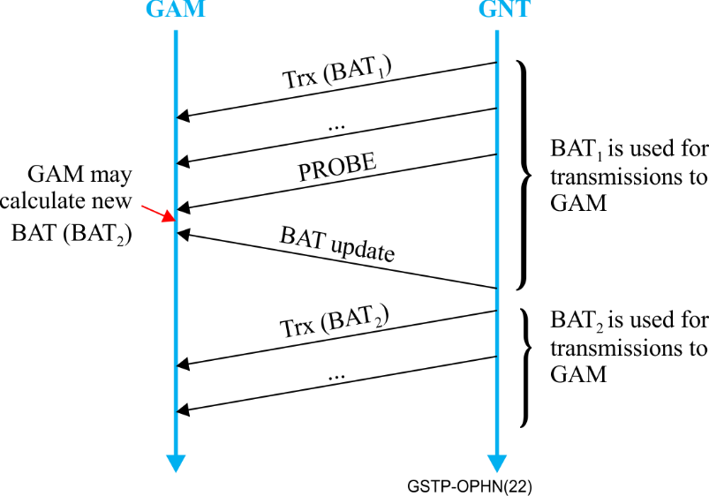
Figure ‎6-3 – Channel estimation process
NOTE – The previous figure is a simplified vision of the process. An in-depth description of the protocol may be found in clause 8.11 of [ITU-T G.9961].
G.hn systems used in an access context, need to ensure that the BAT used during transmissions has been calculated during the same crosstalk conditions as when the BAT was originally calculated; if the SNR during data transmissions is lower than the SNR during BAT estimation, the block error rate (BLER) will be too high.
To guarantee this behaviour and maintain the channel as stable as possible, the transmissions have to be continuous when a node is not in power down. Therefore, G.hn nodes transmit PHY frames even when there is no data available for transmission.
For this, G.hn transceivers need to use "PROBE PHY frames" (see clause 7.1.3.6 of [ITU-T G.9960]). When a device has a time slot assigned for transmission and it has no data to transmit, it programs a probe frame transmission so that the adjacent links suffer a stable level of interference (see Figure ‎6-4). In this way, receivers SNR estimation is more accurate (and independent of the amount of traffic on the neighbour lines), thus diminishing errors, latency and jitter.
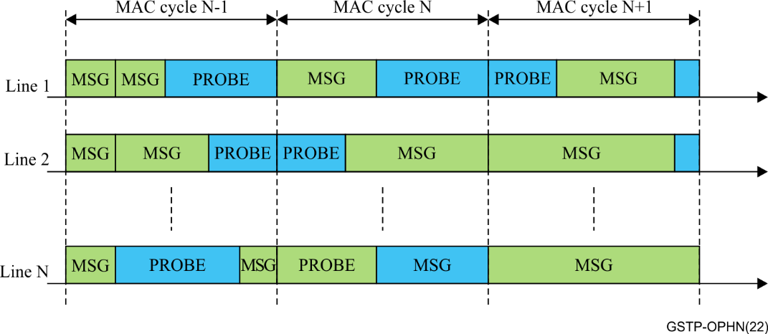
Figure ‎6-4 – Usage of PROBE frames when a node has no data to transmit
NOTE – Figure ‎6-4 represents a simplified version of the scheduling applied to the domains during several MAC cycles. This simplified version does not include the medium access plans (MAPs) that need to be transmitted in every MAC cycle.

6.4.4 Unloaded supported sub-carriers LFSR generator seeds
In a probe frame, sub-carriers are loaded with bits coming from a linear feedback shift register (LFSR) whose initial seed (for the first sub-carrier of the first symbol of the payload) is as defined in clause 7.1.4.2.6 of [ITU-T G.9960]. If all the nodes used the default seed, they would generate probe frames with the same bit sequence modulated in the sub-carriers of the same payload symbols.
This default behaviour would have a negative side effect in this application because several nodes might be transmitting synchronized probe frames with the same contents. In this case, the interference coming from other lines (domains) might add-up coherently producing a higher (or lower if the interference is destructive) level of interference compared with the case of uncorrelated transmissions (normal case when transmitting data when signals add-up non-coherently), preventing an accurate SNR estimation.
For this, each G.hn domain of a coordinated G.hn network will use different unloaded supported sub-carriers LFSR generator seed, taken from the pool of allowed seeds assigned to that domain (see clause 7.1.4.2.6 of [ITU-T G.9960].
The GAM manager ensures that the seed used for a particular domain in the network is unique.

6.5 Data link layer (DLL)

6.5.1 Introduction
Several mechanisms are used within a coordinated G.hn network in order to avoid the effect of NEXT (Near end crosstalk):
• MAC cycle synchronization: NEXT interference effect can be mitigated by synchronizing transmissions between the different domains in the coordinated G.hn network. However, this is only possible if the position of the MAC cycle start is the same in each of them. Clause ‎6.5.1.1 describes how to achieve this synchronization in a G.hn.
• Common downstream (DS) / upstream (US) scheduling: The DS/US transmissions in the coordinated G.hn network need to be synchronized in order to guarantee the isolation between lines. For this, the scheduling in the G.hn networks follows additional rules as explained in clause ‎6.5.1.2.
• Selective acknowledgements: In order to guarantee the homogeneity of the DS/US transmissions, only delayed acknowledgements are used in the coordinated G.hn network, as described in clause ‎6.5.1.3.

6.5.1.1 MAC cycle synchronization
Since the different domains share a common clock reference (see clause ‎6.3.5) from the same external source the MAC cycle duration and position are synchronized between the different domains of the coordinated G.hn network.

6.5.1.2 DS/US scheduling
In a coordinated G.hn network system, the DS/US transmission schedule are the same for all G.hn domains composing the network. For this, the schedule broadcasted in each domain's MAP (see clause 8.2 of [ITU-T G.9961]) are divided into upstream and downstream slots as shown in Figure ‎6-5.
NOTE – Default medium access plan (MAP-D) includes all the information required for registration (seeds to be used, value of some given parameters and capabilities of the network). It is sent from time to time (vendor discretionary). Active medium access plan (MAP-A) includes scheduling information for the next MAC cycle. In this way, scheduling information can vary from cycle to cycle.
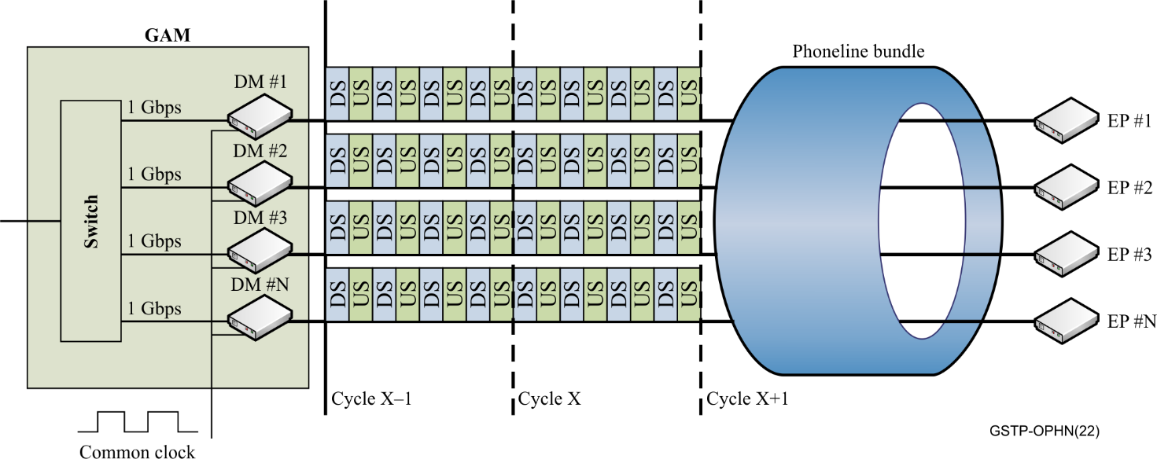
Figure ‎6-5 – DS/US scheduling
For this, the MAP-As (see clause 8.8.1 of [ITU-T G.9961]) of the different domains composing the network allocate transmission opportunities for downstream followed by the upstream transmission opportunities. The GAM manager ensures that the scheduling is common for all the G.hn domains of the coordinated G.hn network, including the exact start and stop time of each DS or US slot.
When setting up the domains, the DM of each G.hn domain of the coordinated G.hn network allocates a registration opportunity at the beginning of an upstream slot to let the GNT register with the domain.
A typical example of a possible distribution of DS/US slots is shown in Figure ‎6-6 using the following parameters:
• MAC cycle length: 40 ms;
• MAC cycle divided into 8 regions;
• 50/50 ratio: 50% of the time allocated to the downstream direction – 50% of the time allocated to the upstream direction.
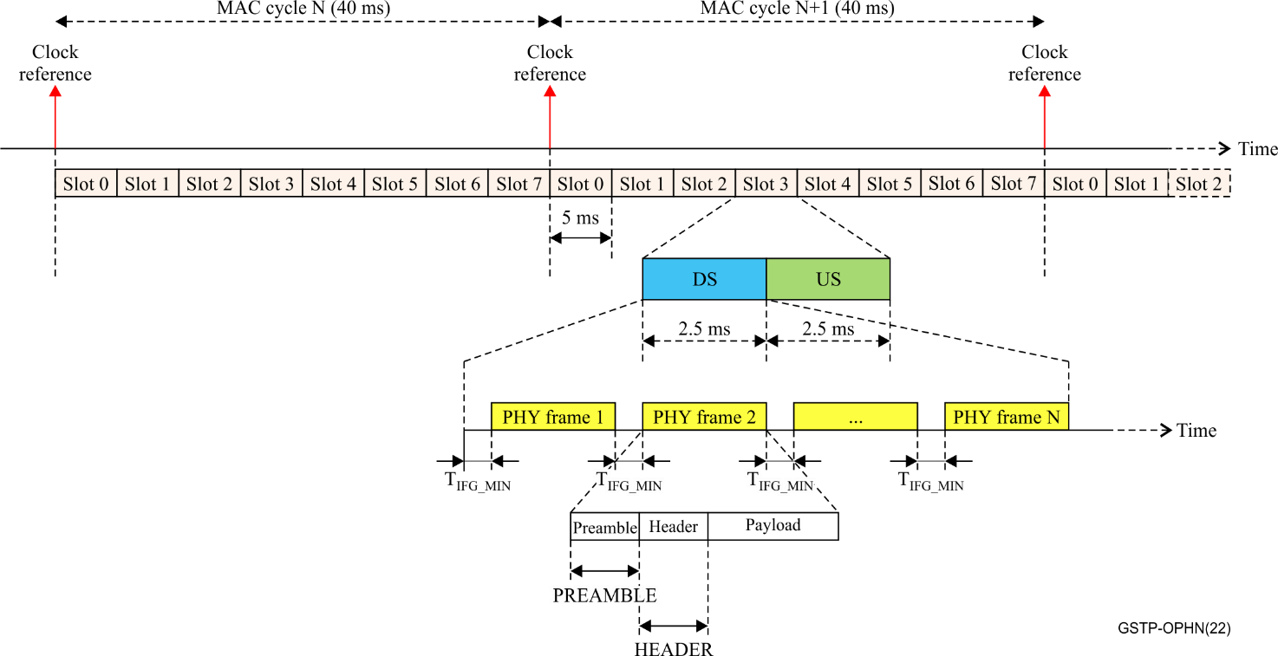
Figure ‎6-6 – Example of G.hn framing in an access system
In this example, the MAC cycle is divided into 8 slots and each of them divided are into two parts or sub-slots (DS and US). Each of the DS or US sub-slots contains one or more G.hn PHY frames with the format as specified in clause 7.1.2.1 of [ITU-T G.9960] (e.g., MAP, MSG, ACK or PROBE frames) separated by T_{IFG} (see clause 8.4 of [ITU-T G.9961]), covering the whole sub-slot allocated time.
The description of a PHY frame can be found in clause 7.1.4.5.3.3 of [ITU-T G.9960]. The following table provides a brief overview of the timings described in the G.hn Recommendations:
Table ‎6-1 – Timing information of G.hn PHY frames
Parameter | Description | Value
T_{IFG_MIN} | Duration of the inter frame gap | 55 µs
f_{OFDM} | Symbol rate | 48.828125 kHz
T_{SYMBOL} | Duration of a symbol | 20.48 µs
T_{PREAMBLE} | Duration of the preamble (1.25 symbols) | 25.6 µs
T_{HEADER} | Duration of the header (1 symbol) | 20.48 µs
In order to satisfy the G.996x Recommendations, one of the DS slots contains a MAP structure describing the schedule of the next MAC cycles.

6.5.1.3 Selective acknowledgements
G.hn provides two possible ways to acknowledge a received frame (delayed acknowledgement and immediate acknowledgement). In order to maintain DS/US synchronization of the different interfering lines, only a delayed acknowledgement mechanism is used in this kind of systems (see clause 8.9.1.2 of [ITU-T G.9961).
The delayed acknowledgement is used in both downstream and upstream directions. It is up to the nodes on both sides of the link to decide when an acknowledgement is needed and how it is sent. However, the next figure shows a possible acknowledgement scheme, using the example provided in clause ‎6.5.1.2.
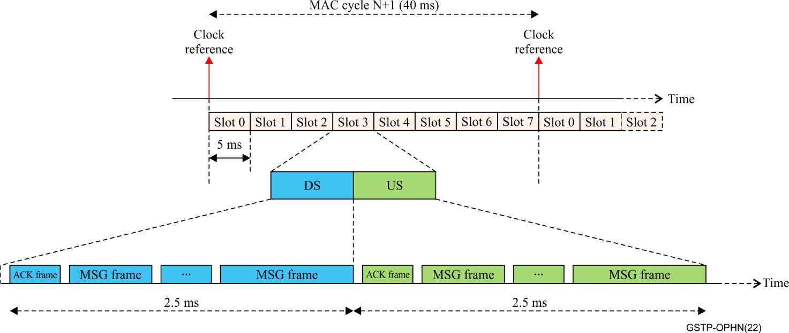
Figure‎ 6-7 – Example of acknowledgement scheme using delayed acknowledgements
In this example, every DS or US frame requests a delayed acknowledgement; the nodes on both sides of the communication link schedule an ACK PHY frame at the beginning of each sub-slot to acknowledge all the frames received during the previous sub-slot (corresponding to the opposite direction).
NOTE – The ACK frame does not need to be the first frame in the time slot.

6.6 Interference mitigation mechanism
The interference mitigation mechanism is based on the use of the C-NDIM interface provided by the G.hn network. This mechanism provides an LCMP interface to allow an external entity (crosstalk mitigation driver) to optimize the scheduling of each of the DMs to reduce the interference between the lines. The crosstalk mitigation driver may be managed by a cloud crosstalk mitigation engine that makes the necessary calculations to create the optimal scheduling for each domain.
An example of an open-source crosstalk mitigation driver and engine is the "Vector boost" framework from [HomeGrid Forum].
G.hn's family of Recommendations include mechanisms to change the configuration of the line by acting in almost real time over the following dimensions:
• Power spectral density (PSD) levels: The PSD levels used by the nodes belonging to the same G.hn domain may be dynamically changed to act over the interference between the lines.
• Frequency band: The operating frequency band (OFB) used in transmissions in the different lines may be adapted to reduce the overlap between bands, and therefore minimize the crosstalk.
• Time on wire: A centralized coordinator may add additional constraints to each domain's DM scheduler to guarantee a fair sharing of the MAC cycle between the lines of the cluster.
By modifying any of these parameters, crosstalk levels are changed to achieve different performance levels. By modifying the crosstalk levels, the instantaneous channel capacity is modified.

6.6.1 Examples of the use of centralized coordination for channel capacity improvement

6.6.1.1 Dynamic PSD levels
By modifying the PSD levels allowed in each of the domains of the G.hn cluster, we can control the instantaneous capacity of the different lines.
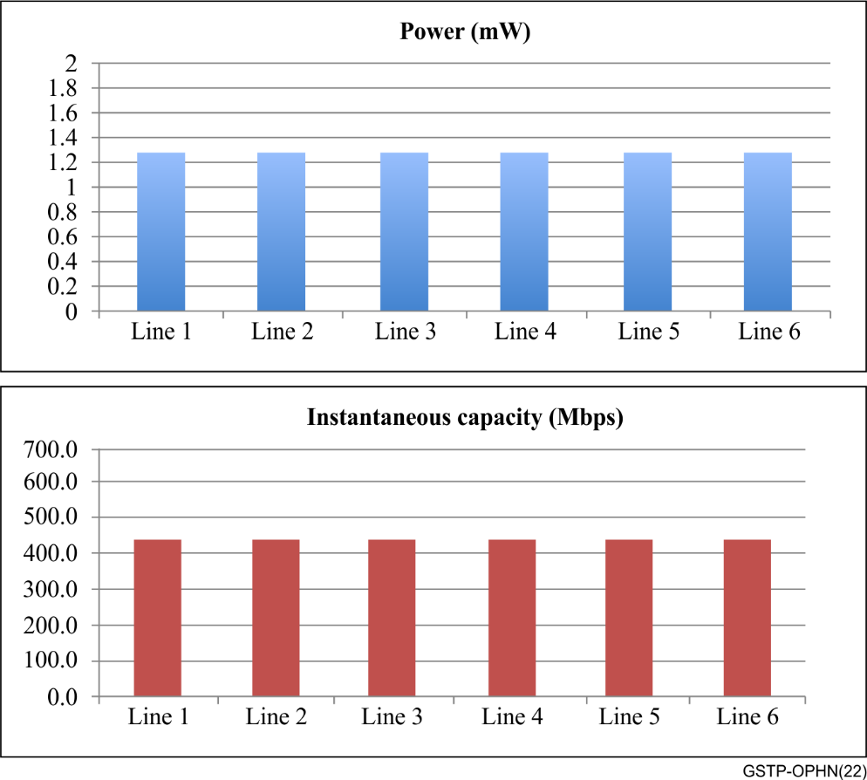
Figure ‎6-8 – All lines at full power
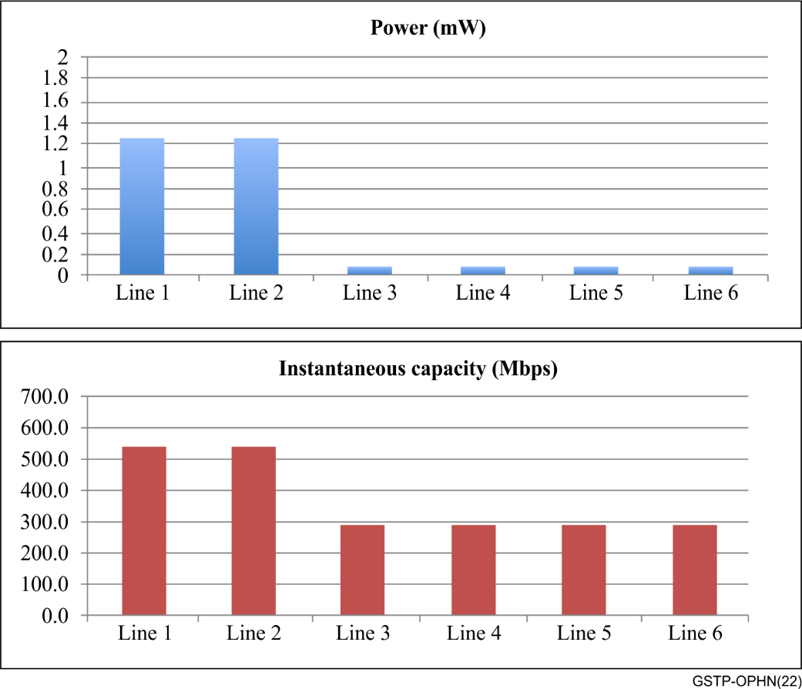
Figure ‎6-9 – Two lines at full power
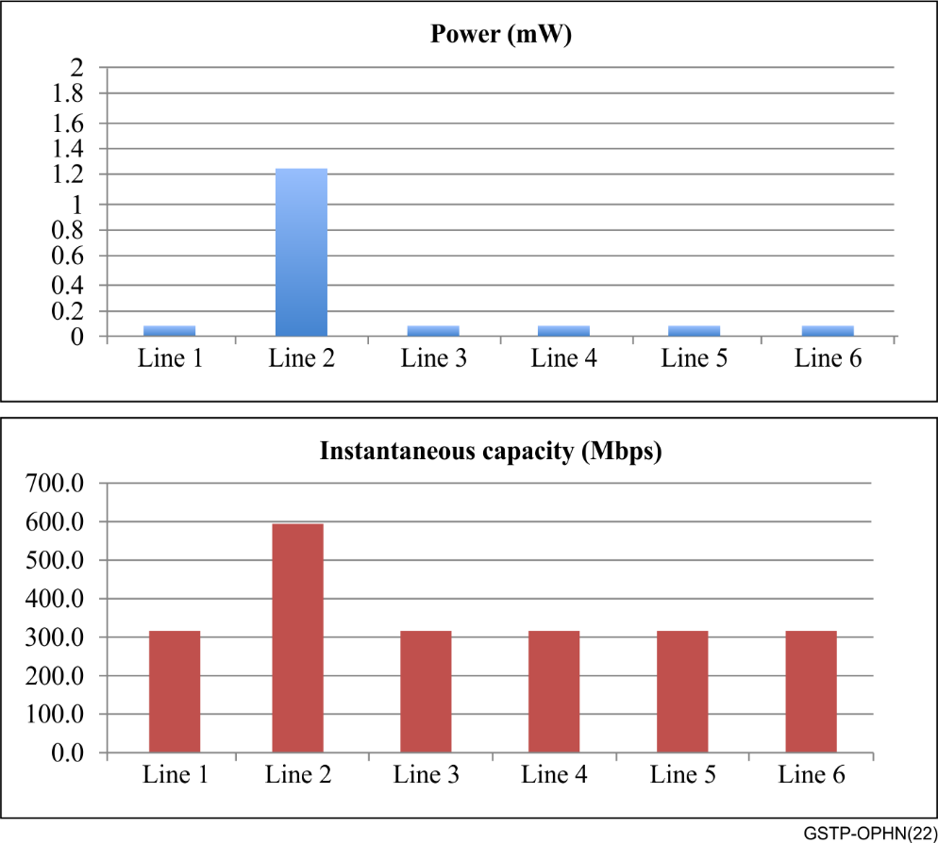
Figure ‎6-10 – One line at full power
• In Figure 6-8, All the lines in the G.hn cluster use the same power, therefore they generate the same level of crosstalk to each other. The achieved performance per line is the same.
• In Figure 6-9, If the number of lines using full power is limited, the crosstalk generated is also limited. The performance of the lines not transmitting at full power is limited, but still satisfying a minimal performance. However, with a reduced level of crosstalk with other lines, the two lines transmitting at full power benefit from an additional performance.
• In Figure 6-10, If only one line keeps transmitting at full power, the crosstalk level is minimized, and the performance of that line is maximized while satisfying a minimum performance.

6.6.1.2 Dynamic operating frequency bands
In the following example, different OFBs (chosen dynamically by the central coordinator) are used for different lines:
• Lines 1, 4 and 6 need to and are assigned to the lower part of the spectrum (more robust). Due to this, they experience crosstalk interference from all the other lines and therefore their performance is partially degraded (see Figure 6-9) but they maintain a minimum throughput.
• Line 3 needs more capacity (e.g., it may be dealing with a streaming of video) and therefore, the central coordinator allocates an additional part of the spectrum (up to 60 MHz) where the coordinator only has crosstalk with line 5.
• Finally, line 5 may be addressing a highly demanding traffic (e.g., speed tests, VR streaming, etc.) and therefore the central coordinator assigns him the full spectrum. In that case, line 5 does not suffer interference in a significant part of the spectrum and only limited interference in other parts.
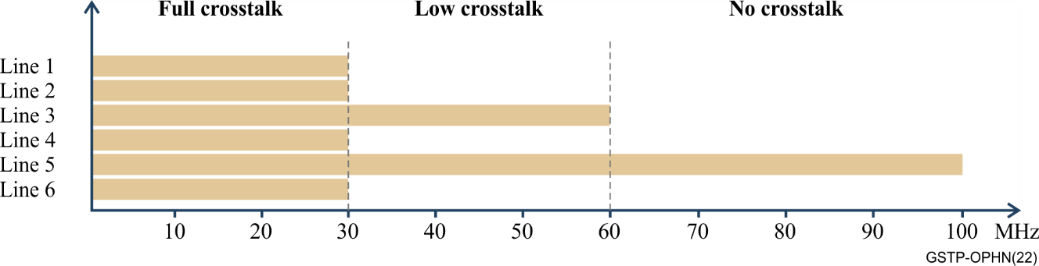
Figure ‎6-11 – Example of dynamic change of OFB
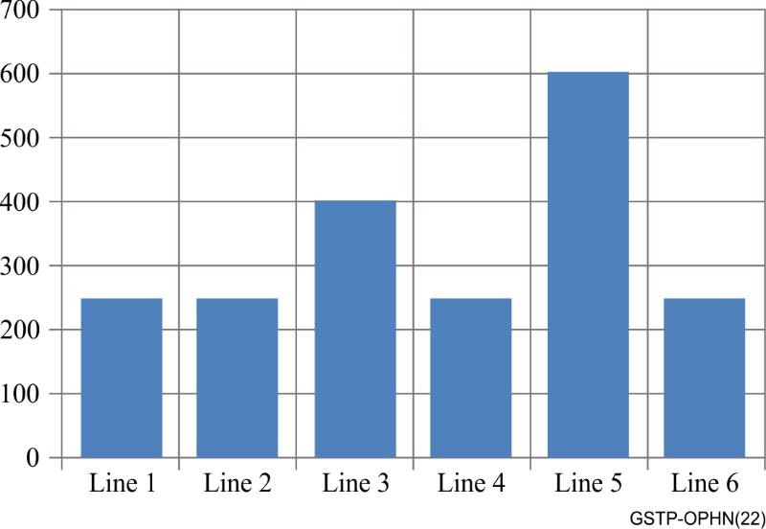
Figure ‎6-12 – Example of dynamic change of OFB – obtained performance

6.6.1.3 Dynamic allocation of time on wire
Finally, a dynamic resource allocation can be done by assigning slots of the MAC cycle to each of the lines, as shown in Figure 6-13.
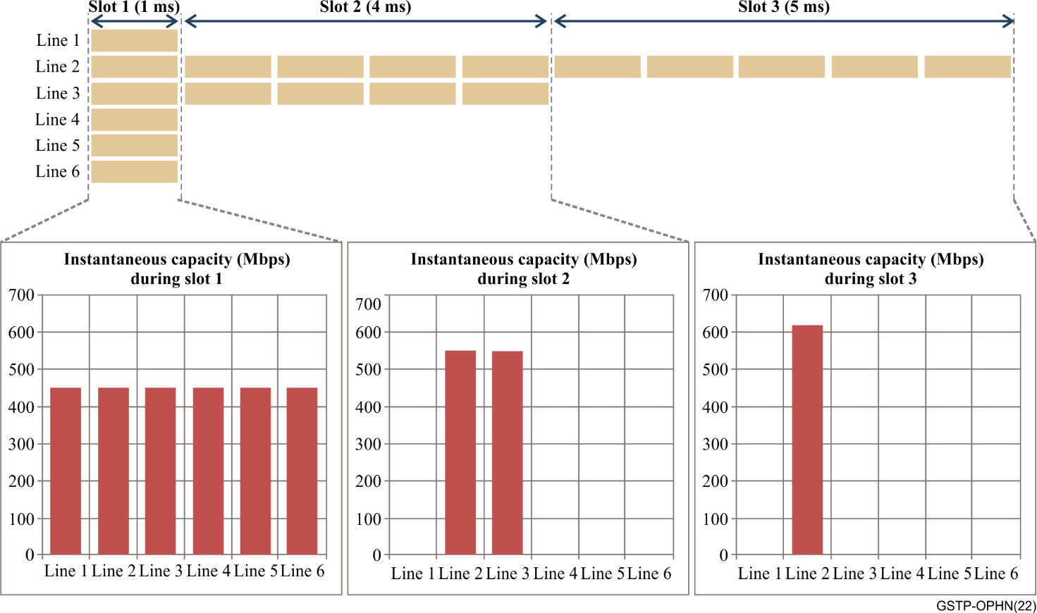
Figure ‎6-13 – Example of dynamic allocation of time on wire
• At Slot 1, all lines are active and using this slot for their transmissions. This means that they suffer crosstalk from and generate interference to other lines. In this slot, each line has an equal performance.
• At Slot 2, only 2 lines are active, therefore crosstalk between lines is reduced and these lines increase their performance.
• At Slot 3, only a single line is active, free of crosstalk, and then obtaining maximum performance.
By adding all the capacity allocated by the central coordinator to each of the lines in every slot, as shown in Figure 6-14, it can adapt the capacity of the overall cluster to the necessities of each of the subscriptions.
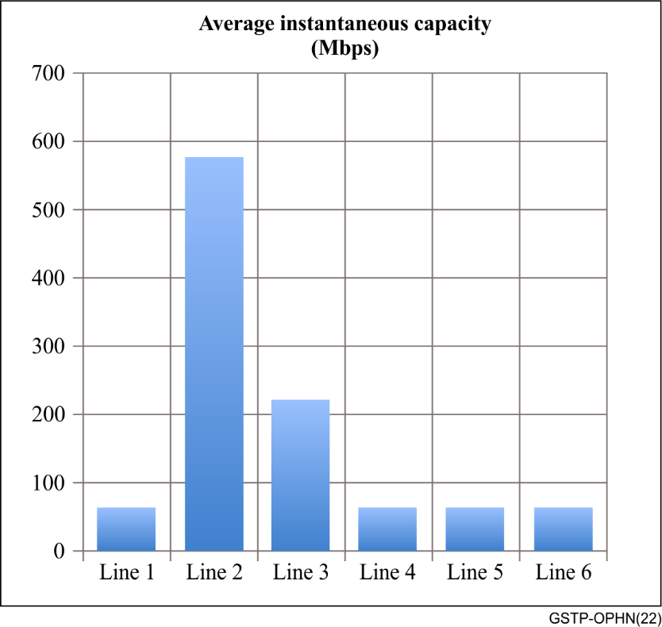
Figure ‎6-14 – Aggregated performance per line

7 Network initialization
Domain initialization of a coordinated G.hn network is the same as for any other G.hn domain (see clause 8.6.1 of [ITU-T G.9961]. The DM located in the GAM of the domain will:
• Send periodically a MAP-D (see clause 8.8.1 of [ITU-T G.9961]) frame (during a downstream time slot) in order to announce the registering parameters to the GNT. This MAP-D includes all the information for registration and all the parameters needed to establish a connection.
• Assign a registration opportunity in the upstream time slot in order to allow the EP node to register into the domain.
The MAP-D frame will, at least, contain the following auxiliary information fields:
• Domain information auxiliary information sub-field (see clause 8.8.5.2 of [ITU-T G.9961]).
• PSD-related domain Info auxiliary information field (see clause 8.8.5.5 of [ITU-T G.9961]).
• Additional domain information auxiliary information sub-subfield (see clause 8.8.5 of [ITU-T G.9961]), containing the seeds to be used in the domain.

8 Network management
The GAMs and GNTs of coordinated G.hn networks are managed through the use of standardized protocols such as [BBF TR-069] or NETCONF/YANG, using the G.hn data models defined in BBF ([BBF TR-181] and [BBF TR-374]).

9 Summary
This Technical Paper describes the use of G.996x transceivers over phone line infrastructure in the architecture of a neighbouring domain as guidance to system vendors and service providers to define, configure, deploy, and network various devices using G.996x transceivers in access deployments.
______________

