 |  | International Telecommunication Union
 |  | ITU-T | Technical Report
 |  | TELECOMMUNICATION  STANDARDIZATION SECTOR  OF ITU |  | (17 June 2022)
ESTR-KPI-RAN
Key performance indicators (KPIs) for radio access mobile networks


Technical Report ITU-T ESTR-KPI-RAN
Key performance indicators (KPIs) for radio access mobile networks
Summary
WTSA Resolution 95 (Geneva, 2022) instructs ITU-T Study Group 12 to provide references relating to minimal satisfactory key performance and key quality indicators for evaluating the quality of services, as well as to assist developing and least developed countries in elaborating and implementing actions to improve service quality and keep end users informed.
Aiming to achieve these clear directives from WTSA-22, this Technical Report presents a framework that stakeholders can use as a benchmark when defining key performance indicators (KPIs) for radio access mobile networks.
Keywords
GSM, KPI, LTE, UMTS, mobile network, targets.
Note
This is an informative ITU-T publication. Mandatory provisions, such as those found in ITU-T Recommendations, are outside the scope of this publication. This publication should only be referenced bibliographically in ITU-T Recommendations.
Change Log
This document contains Version 1 of the ITU-T Technical Report ESTR-KPI-RAN on "Key performance indicators (KPIs) for radio access mobile networks" approved at the ITU-T Study Group 12 meeting held in Geneva, 7-17 June 2022.

Editor: | Ísis de Andrade Lima  Anatel  Brazil | Tel.: +55 61 2312-2785  E-mail: isis.lima@anatel.gov.br

© ITU 2022
All rights reserved. No part of this publication may be reproduced, by any means whatsoever, without the prior written permission of ITU.

Table of Contents
Page
1 Scope 1
2 References 1
3 Terms and definitions 2
3.1 Terms defined elsewhere 2
3.2 Terms defined here 2
4 Abbreviations 2
5 Introduction 3
6 Relationship between KPIs and QoS 3
7 Considerations for KPI selection 4
7.1 Measurement approach 5
7.2 GSM KPIs 5
7.3 UMTS KPIs 8
7.4 LTE KPIs 10
8 Target setting guidance 11
9 Questionnaire results 12
9.1 KPIs and targets applied by NRAs 13
10 Conclusions 14
Appendix I – Questionnaire about Key Performance Indicators (KPIs) and targets 16
I.1 Distribution of respondents per region 16
I.2 Responses to Question 1 16
I.3 Responses to Question 2 17
I.4 Responses to Question 3 17
I.5 Responses to KPI targets 18
I.6 Other KPIs shared by NRAs 21
Bibliography 22

List of Tables
Page
Table 1 – KPIs for the GSM Network 6
Table 2 – KPIs for the UMTS Network 8
Table 3 – KPIs for the LTE Network 10

List of Figures
Page
Figure 1 – KPIs and QoS aspects for mobile networks [ITU-T E.804] 4
Figure 2 – Numbers of respondents NRAs per region 12
Figure 3 – Respondents responsible for KPIs monitoring per region 12
Figure 4 – Respondents monitoring each KPI and imposing targets on these KPIs 14
Figure I.1 – Numbers of respondents NRAs per region 16
Figure I.2 – Respondents responsible for KPIs monitoring per region 17
Figure I.3 – Kind of activities are implemented for the KPIs monitoring/assessment 17
Figure I.4 – KPIs monitored in jurisdictions 18
Figure I.5 – NRAs applying target values to KPIs 19
Figure I.6 – Minimum, median, and maximum target values applied to KPIs 20
Figure I.7 – Minimum, median, and maximum target values applied to KPIs 20

Technical Report ITU-T ESTR-KPI-RAN
Key performance indicators (KPIs) for radio access mobile networks

1 Scope
This Technical Report presents a reference for operators and regulators when selecting key performance indicators (KPIs) for radio access global standards for mobile communications (GSM), universal mobile telecommunications system (UMTS) and long term evolution (LTE) mobile networks.
NOTE – Studies considering quality of service (QoS) parameters and targets should be considered in future editions of this Technical Report, including those related to 5G networks.
The goal is to provide an overview on KPIs, mainly based on previous ITU-T Recommendations concepts, and present information gathered in 2020 from National Regulatory Authorities (NRAs), about KPIs and targets applied in a regulatory context.
The following discussions are approached:
I. Relationship between KPIs and QoS;
II. Considerations for KPI selection;
III. Target setting guidance;
IV. Lists of KPIs for GSM, UMTS and LTE;
V. Questionnaire results: KPIs applied by NRAs;
VI. Questionnaire results: targets set by NRAs.

2 References
[ITU-T E.800] Recommendation ITU-T E.800 (2008), Definitions of terms related to quality of service.
[ITU-T E.802] Recommendation ITU-T E.802 (2007), Framework and methodologies for the determination and application of QoS parameters.
[ITU-T E.804] Recommendation ITU-T E.804 (2014), Quality of service aspects for popular services in mobile networks.
[ITU-T E.806] Recommendation ITU-T E.806 (2019), Measurement campaigns, monitoring systems and sampling methodologies to monitor the quality of service in mobile networks.
[ITU-T E.807] Recommendation ITU-T E.807 (2014), Definitions, associated measurement methods and guidance targets of user-centric parameters for call handling in cellular mobile voice service.
[ITU-T G.1000] Recommendation ITU-T G.1000 (2001), Communications Quality of Service: A framework and definitions.
[ITU-T Resolution 95] Resolution 95 (2022), ITU Telecommunication Standardization Sector initiatives to raise awareness on best practices and policies related to service quality.
[ETSI TS 132 410] ETSI TS 132 410 V15.0.0 (2018), Digital Cellular Telecommunications Systems (GSM); UMTS; Telecommunications Management; Key Performance Indicators (KPI) for UMTS and GSM.
[ETSI TS 132 450] ETSI TS 132 450 V14.0.0 (2017), Universal Mobile Telecommunications System (UMTS); LTE; Telecommunications Management; Key Performance Indicators (KPIs) for Evolved Universal Terrestrial Radio Access (E-UTRAN): Definitions.

3 Terms and definitions

3.1 Terms defined elsewhere
This Technical Report uses the following terms defined elsewhere:
3.1.1 quality of service [ITU-T E.800]: Totality of characteristics of a telecommunications service that bear on its ability to satisfy stated and implied needs of the user of the service.
3.1.2 network availability [ITU-T E.804]: Probability of success of network functions performed by a network over a specified time interval.
3.1.3 network accessibility [ITU-T E.804]: Probability that the user of a service after a request (to a network) receives the proceed-to-select signal within specified conditions.
3.1.4 service accessibility [ITU-T E.804]: Probability that the user can access the desired service. A given network accessibility is a precondition for this phase.
3.1.5 service retainability [ITU-T E.804]: Service retainability describes the termination of services (in accordance with or against the will of the user).
3.1.6 service integrity [ITU-T E.804]: The degree to which a service is provided without excessive impairments, once obtained.
3.1.7 network performance [ITU-T E.804]: The network performance is assessed across a part of a network or a sub-network. Mostly, the network performance is given in a technical way by assessing technical parameters which describe the performance of this part of the network in the desired way.

3.2 Terms defined here
None.

4 Abbreviations
CS Circuit Switch
E-RAB E-UTRAN Radio Access Bearer
E-UTRAN Evolved-UMTS Terrestrial Radio Access Network
EPS Evolved Packet System
GSM Global Standards for Mobile communications
ICMP Internet Control Message Protocol
KPI Key Performance Indicator
LTE Long Term Evolution
OSS Operations Support System
PDP Packet Data Protocol
PS Packet Switch
QoS Quality of Service
RAB Radio Access Bearer
RAN Radio Access Network
RAT Radio Access Technology
RRC Radio Resource Control
SDCCH Stand-Alone Dedicated Control Channel
TCH Traffic Channel
UE User Equipment
UMTS Universal Mobile Telecommunications System

5 Introduction
Among other things, one of the main obligations of regulators is, in their actions and decisions, to lay down rules for the development of mobile communications networks, the performance of which should meet the requirements of end users. A key tool for achieving this objective is to establish a set of key performance indicators (KPIs) and the targets be met. Correspondingly, mobile network providers also set performance targets for their networks in order to attract as many customers as possible.
As introduced by [ITU-T G.1000], the level of quality offered by the service providers may not always meet what the consumer perceives. In this sense, measuring objectively the quality of service (QoS) delivered by service providers by means of setting KPIs is a useful way to monitor possible deficiencies on the network, which can affect end-users and lead to a perception of poor quality. For that purpose, besides setting KPIs, establishing targets is also important, as it indicates what is considered the desired level of QoS.
Given the complexity of selecting KPIs and related targets that reflect the most relevant aspects of mobile service; the main purpose of this Technical Report is to provide a reference to when there is the need to select KPIs and/or set targets, by presenting examples from the Questionnaire respondents. KPI targets set should be realistic by taking cognizance of the operational environment of the country, region or town/city or system.
Compulsory selection of KPIs should be made from the operating protocols of the three technologies as specified by the respective standards. Examples of these are [ETSI TS 132 410] and [ETSI TS 132 450] which state common and specific KPIs for the 2G/3G/4G technologies that can be considered relevant in the context of the network performance and the provided quality of services to the end user.
The discussed KPIs in this report cover the following mobile network technologies: GSM, UMTS and LTE and interpretations related to those KPIs and targets are also discussed in the following clauses.

6 Relationship between KPIs and QoS
According to the ITU's Quality of Service Regulations Manual [b-ITU-D Manual], KPIs are based on network counters and are essential for operation and maintenance, and for business models which can help in other actions such as reporting and auditing. KPIs can be formulated with implied or specific targets.
Figure 1 shows a model for quality of service parameters in mobile networks and their relationship with network performance. The first layer "network availability", includes key performance indicators independent of the provided services. The second layer "network accessibility", is the basic requirement for all other performance aspects and parameters from the service user point of view. The third layer contains three aspects "service access", "service integrity", and "service retainability". The performance indicators of the networks at this level, greatly influence the final quality of the services offered. The different electronic services are located in the fourth layer where there are defined the quality of service parameters from the perspective of the end user.
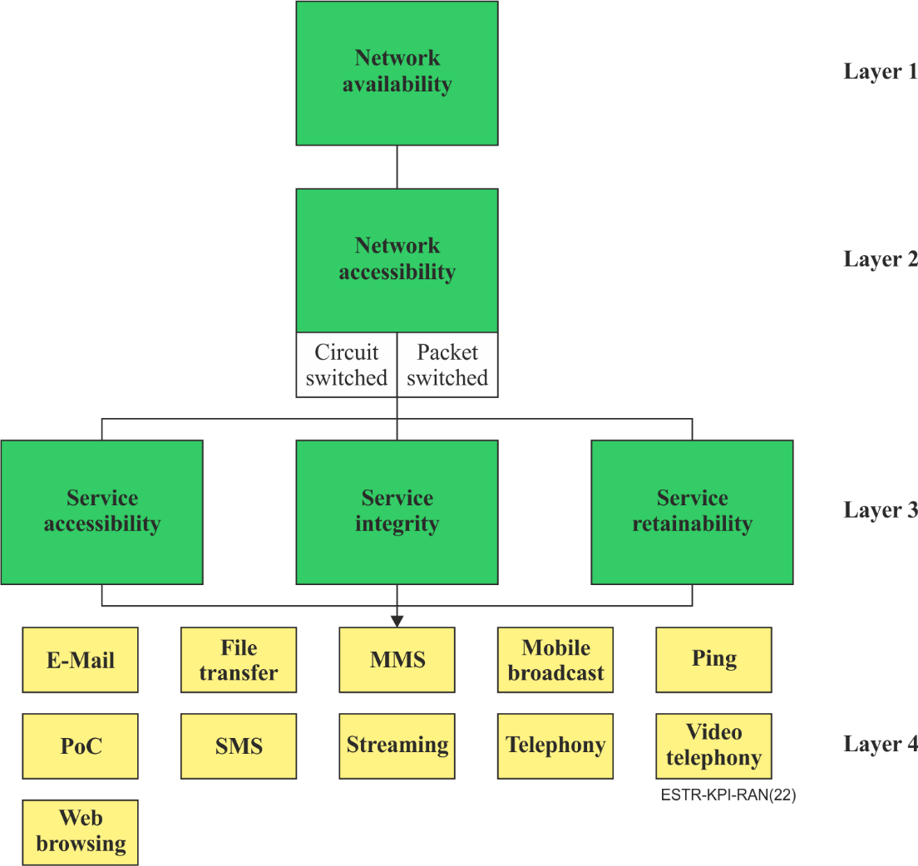
Figure 1 – KPIs and QoS aspects for mobile networks [ITU-T E.804]

7 Considerations for KPI selection
All listed KPIs in the following sections are related to the first three layers as stated in Figure 1 and their computation can be obtained from one or more raw measurements taken from specific counters or field measurements.
The KPIs selected and detailed in clauses 7.2 to 7.4 are clearly defined in ETSI reference materials specifically, [ETSI TS 132 410] and [ETSI TS 132 450] for GSM, UMTS and LTE mobile networks.
The criteria of KPI selection in the current document are:
a) the impact (enhancing or degrading) on service coverage/quality:
The quality of the provided services depends on the network performance. Due to the complexity of the architecture and design of mobile communications networks, at the level of software and hardware, there is no linear relationship between KPIs and QoS. The KPI gives some indication on the enhancement or degradation of the quality of service offered.
KPIs are meant to determine network performance which is the basis for the provided quality of electronic services at the end user and their values are triggers for identifiable problems or improvement actions.
b) how measurable/assessable they are
Not all KPIs are quantifiable or measurable. It is key in identifying the KPIs to consider ones that can be determined to ensure effective regulations and mitigation of eventual disputes.
Given that measuring performance indicators is not always an easy or feasible process, it is advisable to select an indicator (s) following some generic rules:
1) the KPI must offer the highest possible accuracy with a reasonable cost or
2) the availability and cost of the appropriate measuring tool for the KPI
c) the intended use and purpose
The usefulness and suitability of the KPI is important. The categorization of KPIs (i.e., into accessibility, retainability and integrity) give better insight into the application of KPIs. The objective for selecting a particular KPI is also largely dependent on the performance overview it offers relative to other KPIs.
Most of these KPIs which are radio access network (RAN) based, are important for different categories of applicability, such as operation, maintenance and management purposes. KPIs can be used for troubleshooting, for optimization and by network planners for dimensioning and configuration purposes. Traffic channel (TCH) congestion for example can be used by planners for dimensioning of channel resources for optimal use.
NOTE – KPIs committed to without defining the formula/approach for the KPIs have little meaning. Formulae for the KPIs are referenced in the above mentioned ETSI documents.

7.1 Measurement approach
Measurements of the KPIs can be done using real or test traffic. When using real traffic, the measurements must be made using an automatic data collection system, based on the operations support system (OSS) counters or probes which capture actual network traffic. Test traffic is an injected or created traffic for test purposes. This is usually obtained via drive test/walk test or test systems. When test traffic is used, measurements must be sampled to be representative of the situation on the ground (see Annex A of [ITU-T E.806]).
The "measurement approach" column in the tables from clauses 7.2 to 7.4 indicates the approach/methodology applicable for each KPI. For more information and guidance on the various measurement methodologies see clause 6.2 of [ITU-T E.806].

7.2 GSM KPIs
This clause provides an example of KPIs selection for the GSM technology using the criteria mentioned in clause 7. There are no rules about the number and the type of KPIs to be selected. The collection can be done according to the needs of the providers or the regulators.
The column "Considerations" of Table 1, explains justifications and factors that should be considered and the link to user experience. This is meant to offer guidance on the usefulness and applicability of each KPI. The field also distinguishes or classifies the KPIs into two categories as defined below:
– Primary: represents KPIs that have direct impact on a user or impacts that are easily perceptible by a user.
– Secondary: are KPIs that do not directly impact or are not perceptible by users.
Table 1 shows KPIs for the GSM network.
Table 1 – KPIs for the GSM network
KPI category | Key performance indicators (KPIs) | Definition | Measurement approach | Considerations
Availability | Radio coverage-RxLev | Mobile coverage essentially represents the strength/power level of signal or reception in a given area in which an end user can have successful access to both data and voice services. More information on Radio coverage measurements, refer to [ITU-T E.806] | Theoretical calculation/  Drive test | This parameter is important for the estimation of the geographic reach of  a mobile GSM network.
Accessibility | Stand-alone dedicated control channel (SDCCH) assignment success rate | The proportion of mobiles which successfully access resources, having requested an appropriate service on accessing the SDCCH.  Refer to clause 5.6 of  [b-ETSI TR 32.814] | Real traffic | Secondary  This KPI is important in indicating accessibility for several procedures like call setup, SMS delivery and location update.  It is vital for troubleshooting circuit switch (CS) access issues
 | Stand-alone dedicated control channel (SDCCH) congestion | The proportion of all SDCCH resource requests and failed due to no SDCCH resource available.  Refer to clause 5.7 of  [b-ETSI TR 32.814] | Real traffic | Secondary  This KPI is important in indicating accessibility for several procedures in circuit service. It shows the status of the SDCCH resource utilization. It is crucial for resource dimension purposes. When SDCCH gets highly congested, TCH utilization degrades
 | Traffic channel (TCH) congestion | The proportion of all requests for TCH resources (call origination and incoming handover) and fail due non available TCH resources.  Refer to clause 5.8 of  [b-ETSI TR 32.814] | Real traffic | Primary  TCH congestion often increases when traffic demand increases
 | Call setup success rate | Measures the proportion of mobiles which successfully access a TCH.  Refer to clause 5.5 of  [b-ETSI TR 32.814] | Real traffic or test traffic | Primary  The preceding KPIs on SDCCH and TCH are sub KPIs of Call Setup Success Rate.  Any of the TCH/SDCCH KPIs listed above impacts the call setup success rate. Call setup success rate gives an overview of a call, from initiation to setup
 | Packet data protocol (PDP) context activation success rate | Describes the ratio of all successful PDP context activation to PDP context activation attempts.  Refer to clause 7.5 of  [ETSI TS 132 410] | Real traffic or test traffic | Secondary  Before data is transferred to and from an MS, a PDP context must be activated. With a low or worse PDP context activation, access to data would be a challenge
Retainability | Traffic channel (TCH) drop rate | The proportion of mobiles which, having successfully accessed the TCH, subsequently suffer an abnormal release.  Refer to clause 5.3 of  [b-ETSI TR 32.814] | Real traffic or test traffic | Primary  TCH drop easily perceived by a user as it directly translates into call drop.
 | Handover success rate | The percent of handovers that were attempted from the source cell (cell for which the statistic is presented) that succeeded in making it to the destination cell.  Refer to clause 5.4 of  [b-ETSI TR 32.814] | Real traffic or test traffic | Secondary  The main purpose of handover is to guarantee call continuity. It is an important KPI because of the influencing factors that includes among other things, congestion, coverage, interference, and clocking problems. A poor /low handover success rate could influence other KPIs like TCH drop

7.3 UMTS KPIs
This clause provides an example of KPIs selection for the UMTS technology using the criteria mentioned in clause 7. Table 2 shows KPIs for the UMTS network.
Table 2 – KPIs for the UMTS network
Category | Key performance indicators (KPIs) | Definition | Measurement approach | Considerations
Availability | Radio coverage-RSCP: Received signal code power | Mobile coverage essentially represents the RSCP level of signal or reception in a given area in which an end user can have successfully access both for data and voice services.  For more information on radio coverage measurements, refer to [ITU-T E.806]. | Theoretical calculation/  Drive test | This parameter is important for the estimation of the geographic reach of a mobile UMTS network.
Accessibility | Circuit switch (CS) radio resource control (RRC) setup success rate | Describes the ratio of all successful RRC establishments to RRC establishment attempts.  Refer to clause 7.2 of [ETSI TS 132 410] | Real traffic or test traffic | Primary  This KPI indicates the signalling functions that configures the UE and control planes in order to allow other functions (like calls, handover, etc) and resource management to be implemented. An important KPI for troubleshooting and dimension purposes. It is used to determine RNC or cell admission capacity or system load
 | Radio access bearer (RAB) establishment success rate for circuit switch (CS) | The ratio of all successful conversational speech related RAB establishments to conversational speech related RAB establishment attempt.  Refer to clause 7.1.1 of [ETSI TS 132 410] |  | Primary  Used to evaluate speech service accessibility. This KPI can be used to determine a for planning and dimension purposes, speech calls redirected to gsm or calls unto the 3G network via incoming IRAT handover
 | Radio access bearer (RAB) establishment success rate for packet switch (PS) | Describes the ratio of all successful PS RAB establishments to PS related RAB establishment attempts.  Refer to clause 7.1 of [ETSI TS 132 410] | Real traffic | Primary  Used to evaluate packet-based service accessibility
Retainability | Radio access bearer (RAB) abnormal release rate | Describes the ratio of number of RAB release requests to number of the successful RAB establishments.  Refer to clause 8.1 of [ETSI TS 132 410] | Real traffic or test traffic | Primary  Any RAB abnormal release after RAB establishment and alerting is considered a drop call
 | Soft handover success rate | Describes the ratio of number of successful radio link additions to the total number of radio link addition attempts  Refer to clause 9.1 of  [ETSI TS 132 410] | Real traffic or test traffic | Secondary  Measures the simultaneous establishment of links to two base stations. It is key that this handover success is high because any issues will result in a dropped call.
 | Circuit switch (CS) inter radio access technology (RAT) handover success rate | Describes the ratio of number of successful inter RAT handover to the total number of the attempted inter RAT handover from UMTS to GSM for CS domain.  Refer to clause 9.3 of [ETSI TS 132 410] | Real traffic or test traffic | Secondary  Although this handover should appear seamless to the user, any short break in connection may be noticed by the user. This KPI can be used to evaluate whether the capacity on the cell  (i.e., on the GSM network) that the UE is trying to enter for CS may insufficient or not.
 | Packet switch (PS) inter RAT handover success rate | Describes the ratio of number of successful inter RAT handover to the total number of the attempted inter RAT handover from UMTS to GSM for PS domain.  Refer to clause 9.4 of [ETSI TS 132 410] | Real traffic or test traffic | Secondary  Although this handover should appear seamless to the user, any short break in connection may be noticed by the user. This KPI can be used to evaluate whether the capacity on the cell (i.e., on the GSM network) that the UE is trying to enter for PS may insufficient or not

7.4 LTE KPIs
This clause provides an example of KPIs selection for the LTE technology using the criteria mention in clause 7. Table 3 show KPIs for the LTE network.
Table 3 – KPIs for the LTE network
Category | Key performance indicators (KPIs) | Definition | Measurement approach | Considerations
Availability | Radio coverage-RSRP reference signal received power | Mobile coverage essentially represents the strength/power level of signal or reception in an given area in which an end user can have successfully access both for data and voice services.  For more information on radio coverage measurements, refer to [ITU-T E.806] | Theoretical calculation/  Drive test | This parameter is important for the estimation of the geographic reach of a mobile LTE network.
Accessibility | E-UTRAN radio access bearer (E-RAB) accessibility | Probability for an end-user to be provided with an E-RAB at request.  Refer to clause 6.1.1 of [ETSI TS 132 450] | Real traffic or test traffic | Primary  It is a major KPI in LTE for measuring accessibility. For the purposes of optimisation, it helps understand the common failures that usually cause E-RAB setup failures.
Retainability | Evolved-UMTS terrestrial radio access network (E-UTRAN) Radio access bearer (E-RAB) abnormal release rate | A measurement that shows how often an end-user abnormally loses an E-RAB during the time the E-RAB is used.  Refer to clause 6.2.1.2 of [ETSI TS 132 450] | Real traffic or test traffic | Primary  E-RAB is an important parameter in LTE KPI analysis. An E-RAB abnormal release means that an ongoing session is dropped requiring the user to initiate a new connection to resume the services.
Integrity | Latency | A measurement that shows how E-UTRAN impacts on the delay experienced by an end-user. Time from reception of IP packet to transmission of first packet over the air (Uu) interface.  Refer to clause 6.3.2 of [ETSI TS 132 450] | Test traffic | Primary  Latency impacts the network's throughput and thus the user's experience. The higher the latency, the higher the delays and the poorer the user's experience

8 Target setting guidance
Setting of targets should be guided by industry best practice values, operators' systems capabilities, operational environment realities and regulators.
It must be emphasized that targets set are subject to change, depending on the jurisdiction's specific circumstances.
There is no one predefined approach for setting and using targets, however an understanding of the context in which they are set and applied is important. The following outlines some of the key considerations to be made when setting targets:
– existing licence conditions or regulations and service provision capabilities;
– latent (inherent) user expectations, which stems from a general assertion belief that the progress of the telecommunications technologies can only bring better performance;
– average measured industry performance;
– benchmarking targets of countries of similar economies, sizes, or industry competitions;
– consider seasonal/milestone variations of targets.
General guidelines on targets setting can be referenced from [ITU-T E.802]. Targets are dynamic and may change as quality improves and vary for different market segments in different geographic areas as well as the level of evolution of the networks.

9 Questionnaire results
This clause presents country cases of KPIs and their targets that were solicited through a Questionnaire applied in March 2020 to participants of ITU-T Study Group 12 for consideration. In total, 57 National Regulatory Authorities (NRAs) answered the Questionnaire, from all regions, except the Commonwealth of Independent States (CIS). These numbers are depicted per region in Figure 2.
Respondent NRAs per region
(Basis: 57 NRAs)
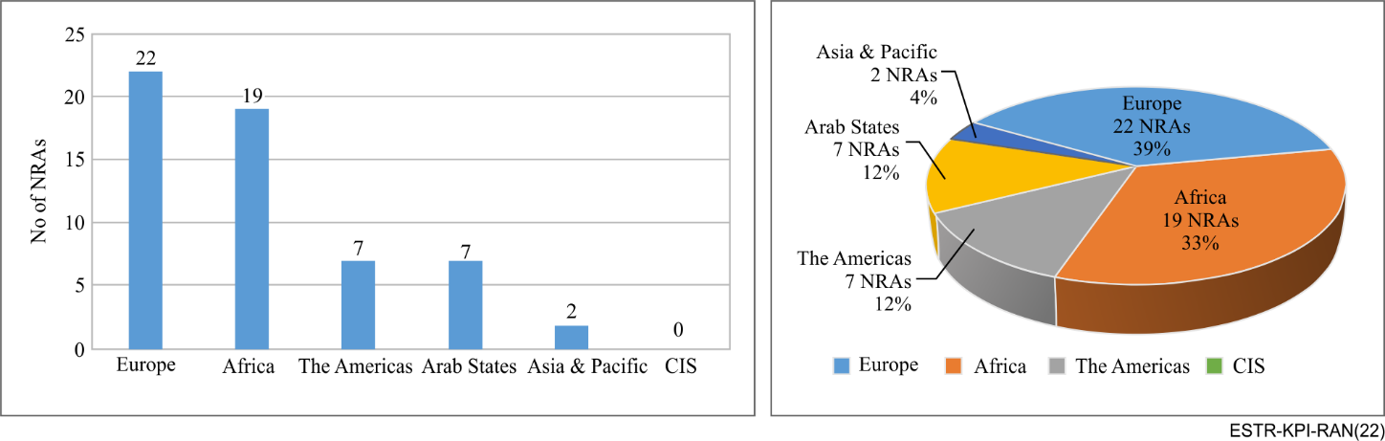
Figure 2 – Numbers of respondents NRAs per region
From 57 respondents, 47 confirmed to be responsible for mobile networks' KPIs monitoring, as shown in Figure 3.
NOTE – Conflicting information on Questionnaire items and respondents with more than one answer were not included in total numbers shown in this analysis.
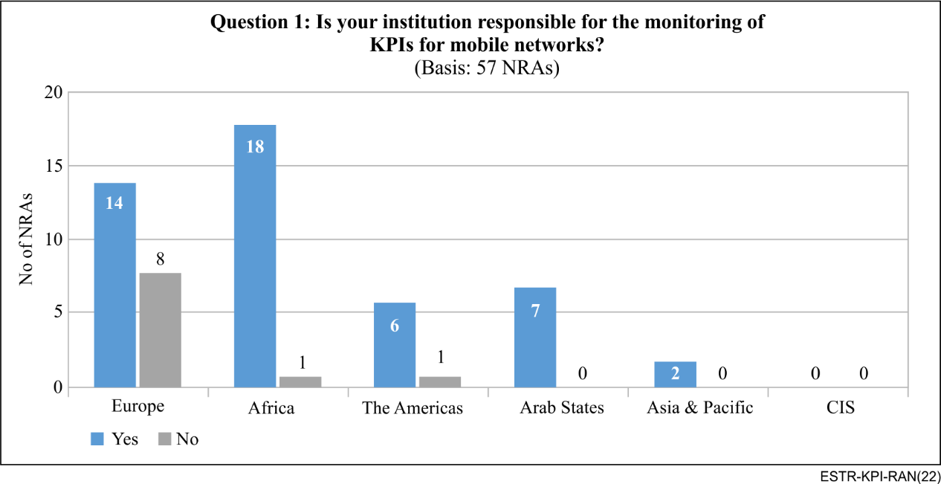
Figure 3 – Respondents responsible for KPIs monitoring per region
In this clause, the main results about which KPIs and targets are applied are shown and briefly discussed. Further details on information gathered is available in Appendix I.

9.1 KPIs and targets applied by NRAs
Figure 4 shows how many respondents monitor each KPI and how many impose targets on these KPIs. The results refer to the set of 47 regulators that affirmed to be responsible for the monitoring of KPIs for mobile networks.
The results show that most NRAs monitor call setup success rate and traffic channel drop rate, which are KPIs for GSM technologies. The number of NRAs monitoring KPIs for UMTs and LTE are considerably smaller. Also, fewer respondents set targets for LTE KPIs.
The number of NRAs monitoring LTE KPIs may suggest regulators are becoming more focused on quality of service (QoS) end-to-end indicators rather than KPIs for mobile networks. Also, there might be a large number of indicators based on applications performance and quality of experience (QoE) assessment. Although this could be an explanation for the fact that more NRAs affirmed to monitor GSM than UMTS and LTE, there were no questions applied regarding the monitoring of other QoS and QoE indicators.
The results regarding the target values (minimum, maximum and mode) applied by the respondent NRAs are shown in Appendix I. The results show that the applied targets may vary significantly. This may suggest that there are different regulatory objectives related to targets or even that KPIs are computed differently.
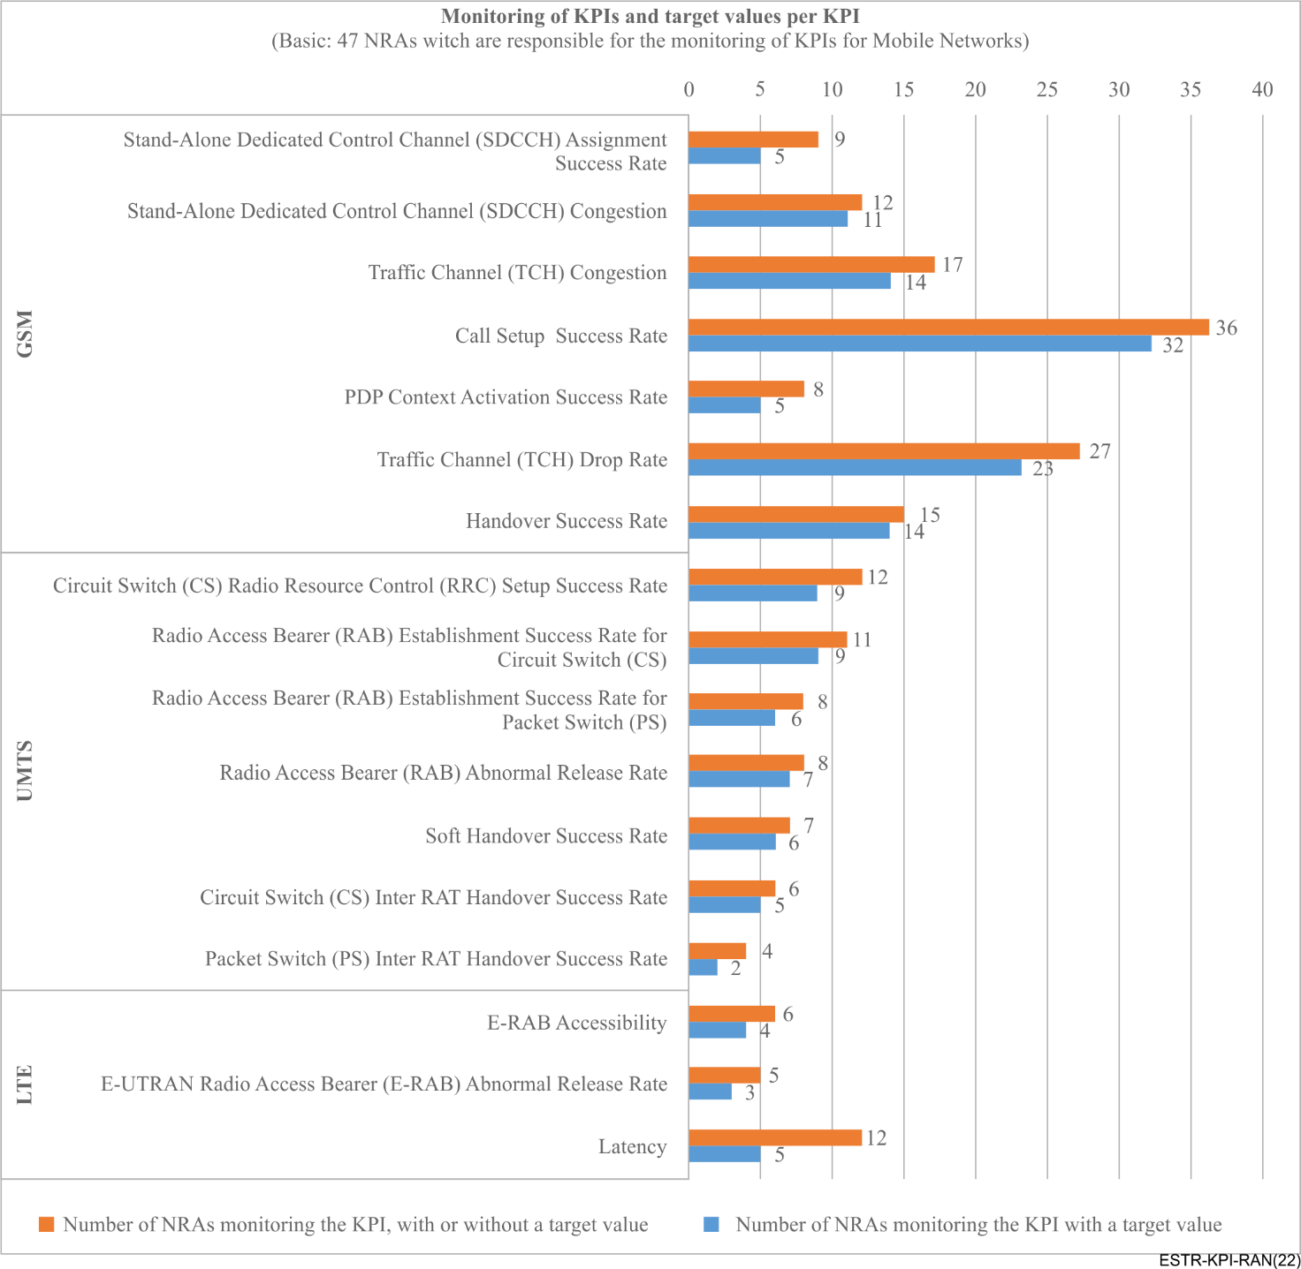
Figure 4 – Respondents monitoring each KPI and imposing targets on these KPIs

10 Conclusions
The KPIs for radio access mobile networks included in the Questionnaire, shown in Tables 1, 2 and 3, were selected based on previous Recommendations and ETSI standards. The list of KPIs consist in the most important ones for technologies GSM, UMTS and LTE.
The results gathered by 41 respondents to the Questionnaire show that most NRAs monitor call setup success rate and traffic channel drop rate, which are KPIs for GSM technologies. On the other hand, fewer NRAs monitor UMTS and LTE KPIs.
The Questionnaire applied had a restrict scope, focused only on KPIs for radio access mobile networks, and did not include questions about other indicators. Thus, it is not possible to make conclusions about the reason for observing more NRAs monitoring GSM than UMTS or LTE, but that may suggest regulators are more focused on quality of service (QoS) end-to-end indicators, indicators based on applications performance and quality of experience (QoE) assessment.
Nonetheless, 33 of the 41 respondents indicated they monitor some KPI for radio access network, showing that the results from the Questionnaire, shown in Appendix I, is an important benchmark for KPIs selection and target setting.
For future work on the matter of KPIs selections and targets setting, it might be appropriate to develop a Questionnaire with a wider scope, including the monitoring of QoS end-to-end indicators, application driven indicators and even QoE indicators. Also, it is important to start studies on 5G quality indicators.

Appendix I
Questionnaire about key performance indicators (KPIs) and targets
This appendix shows country cases of KPIs and their targets that were solicited through a questionnaire circulated in March 2020 to participants of ITU-T Study Group 12 for consideration. In total, after disregarding respondents with more than one answer, there were fifty-seven (57) respondents to the Questionnaire.
NOTE 1 – Respondents who sent more than one answer to the Questionnaire with conflicting information were not included in total numbers shown and analysis.
NOTE 2 – Considering the target values in Questionnaire were informed in free text, some answers were misplaced, containing targets that would not be applicable to the corresponding KPI. Those answers were marked with 'no target value'. I.e., they are not mentioned as 'missing target values'.
Findings and analysis of the responses are presented in clauses I.1 to I.6.

I.1 Distribution of respondents per region
NRAs in all but one region (i.e., Commonwealth of Independent States-CIS) sent responses to the questionnaire. Percentage of responses per region are 39%, 33%, 12%, 12% and 4% for Europe, Africa, the Americas, Arab States and Asia-Pacific respectively.
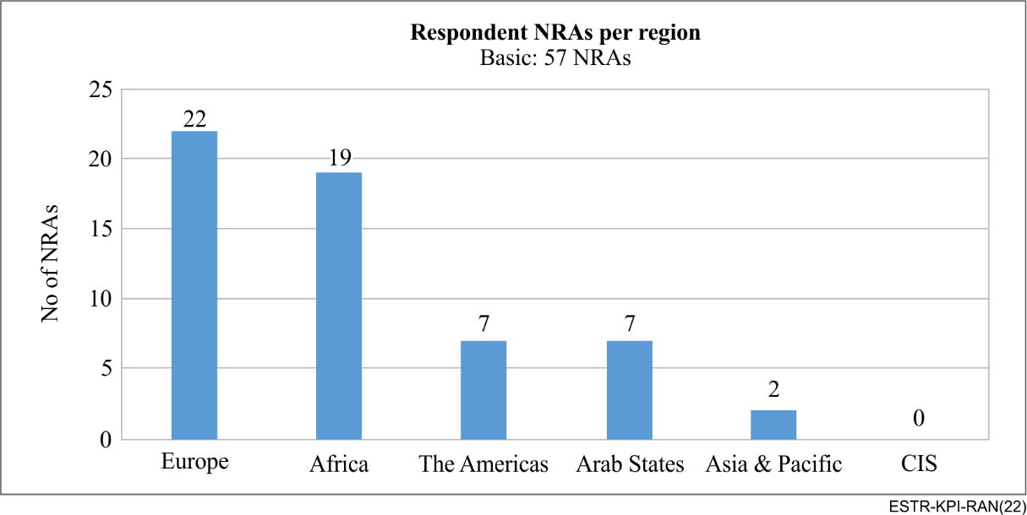
Figure I.1 – Numbers of respondents NRAs per region

I.2 Responses to Question 1
The questionnaire started by asking if the respondent's institution is responsible for the monitoring of KPIs for mobile networks. Breakdown of the responses are seen in Figure I.2 below; with the majority of respondents, 82% (i.e., 42 in number) answering 'yes'. This highlights to an extent that the right target has been solicited.
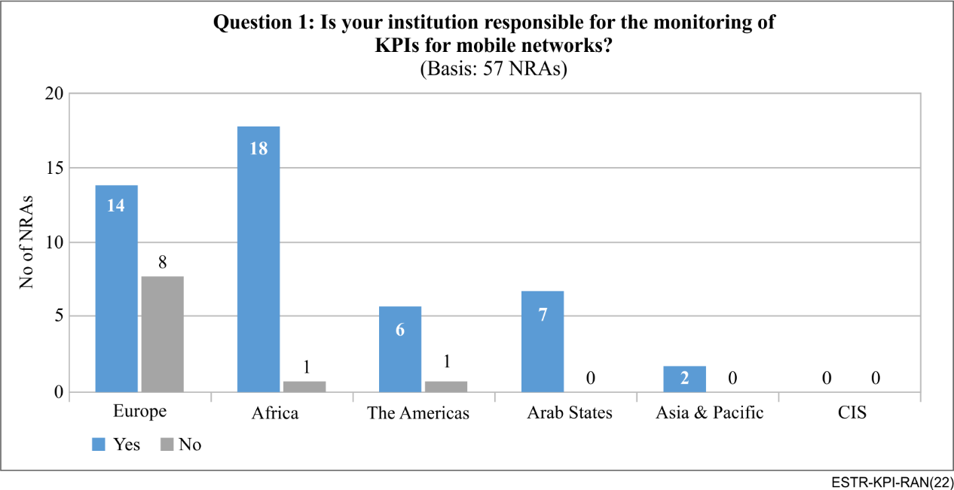
Figure I.2 – Respondents responsible for KPIs monitoring per region

I.3 Responses to Question 2
It was required of all 47 NRAs who answered 'yes' to indicate their approach for the monitoring or assessment. Multiple answers were possible to this question. Several of the answers analysed (81%) skewed to 'Measurements performed by NRA'. However, 60% implement 'Periodic reports from mobile service provider' and about 30% implement 'Measurements performed by mobile service provider'. These results appear practical as all these approaches are quite complementary. Very few indicated other approaches besides the options outlined in the questionnaire.
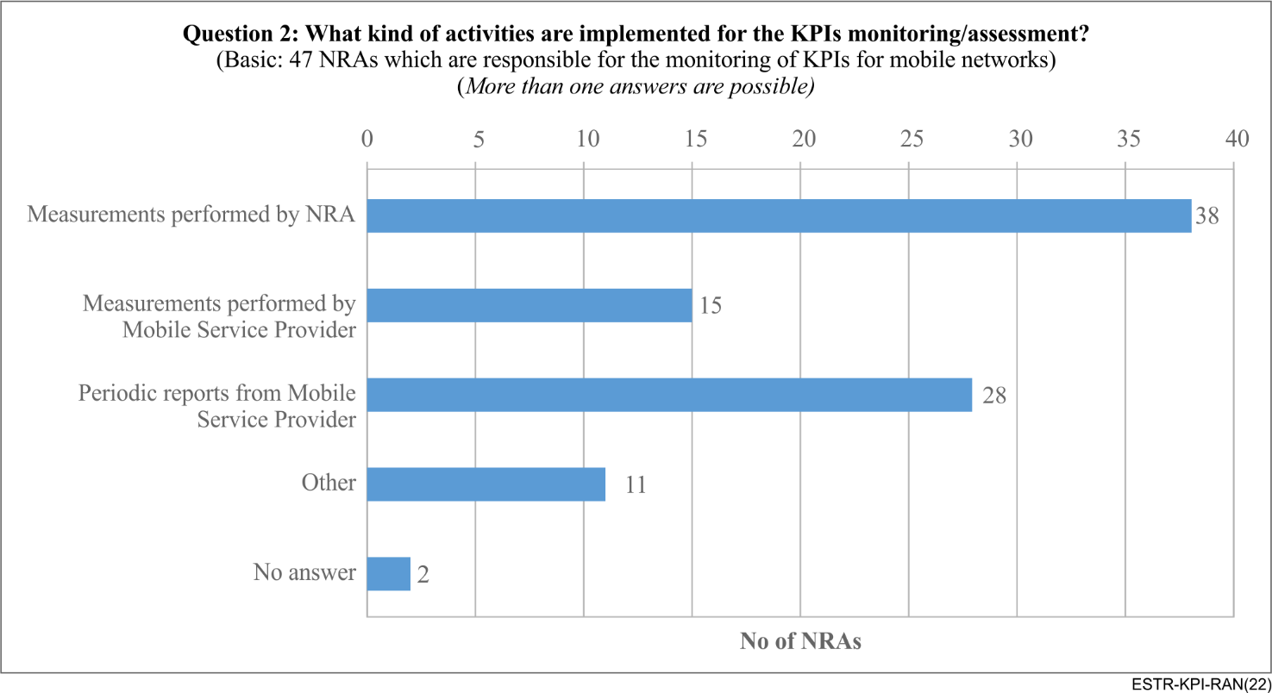
Figure I.3 – Kind of activities implemented for the KPIs monitoring/assessment

I.4 Responses to Question 3
This session asked respondents to indicate which of the KPIs in the questionnaire are they in fact monitoring in their jurisdiction.
As can be seen in Figure I.4 most of the KPIs are only monitored by a few NRAs, except for call setup success rate (monitored by 77% respondents) and TCH drop rate (monitored by 57% respondents).
This means that even though respondents may be responsible for KPIs monitoring, most do not monitor the technical parameters mentioned in the questionnaire.
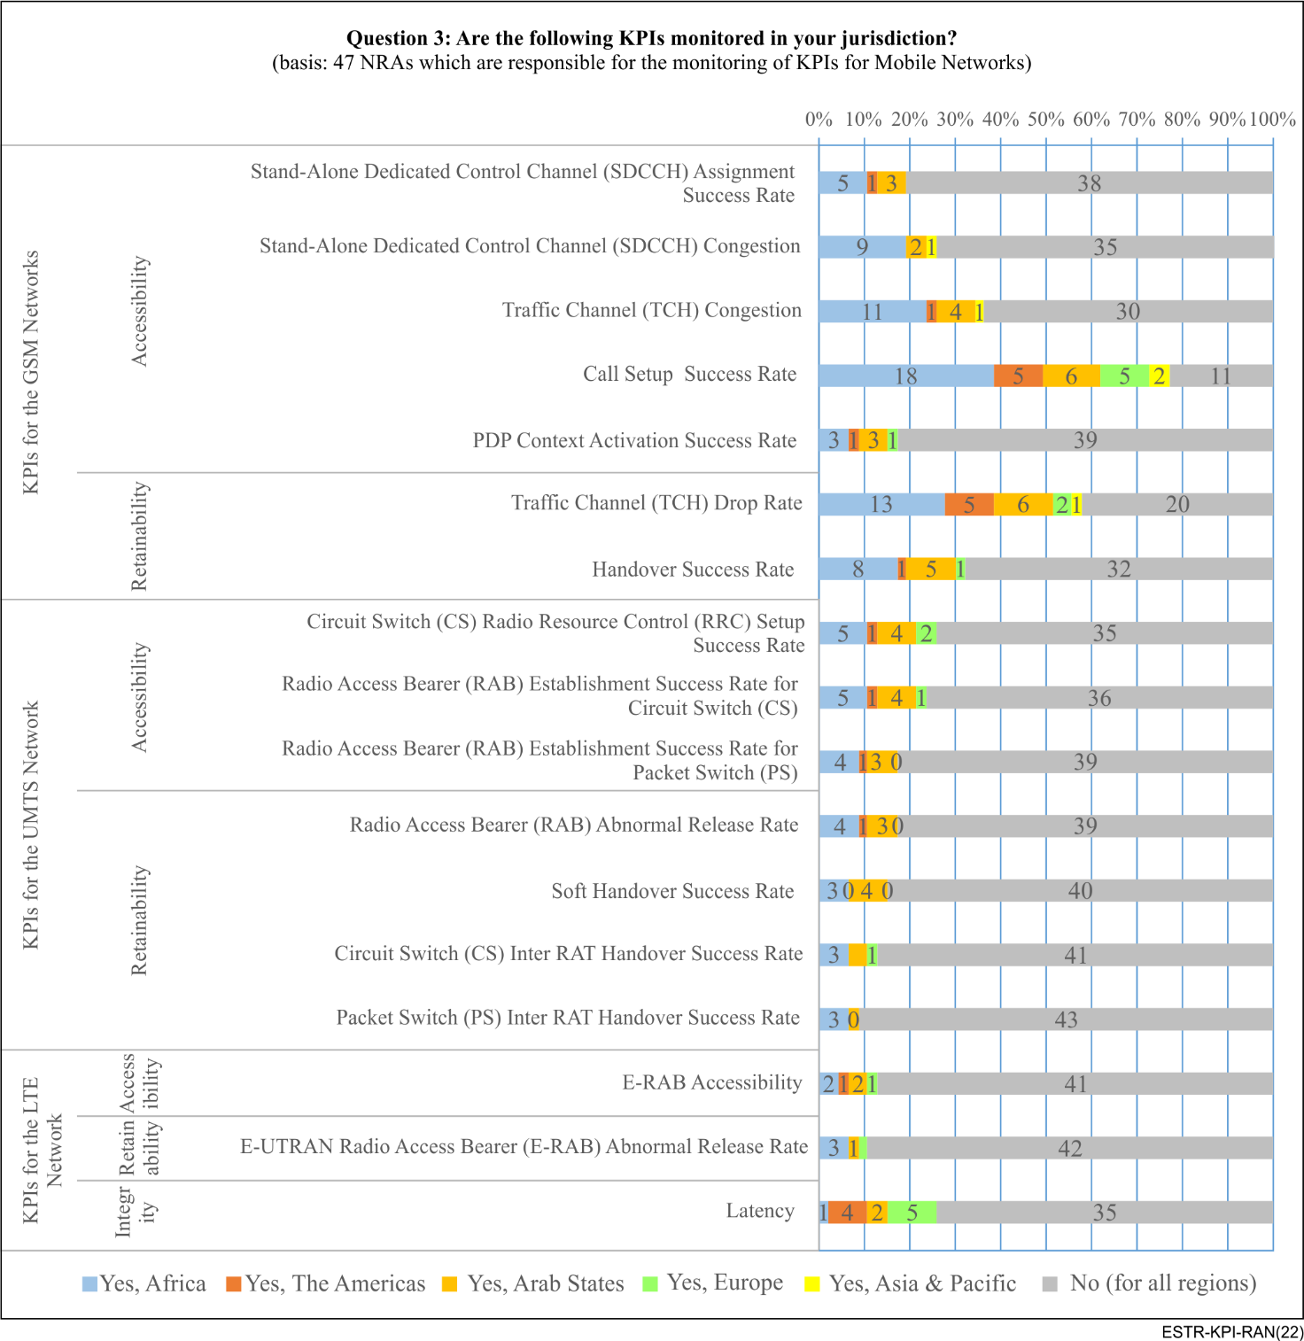
Figure I.4 – KPIs monitored in jurisdictions

I.5 Responses to KPI targets
This section of the questionnaire required NRAs who monitor a KPI to indicate their targets per KPI. As cab be seen in Figure I.5, it is obvious that in most cases the number of NRAs with target values per KPI were less than the numbers where monitoring of KPIs is under the NRA's jurisdiction. The reasons from the response were because some of the NRAs had not set targets yet or did not have targets for the KPIs. Again, the numbers point to the fact that most of the KPIs are only monitored by a few NRAs with a huge amount of heterogeneity.
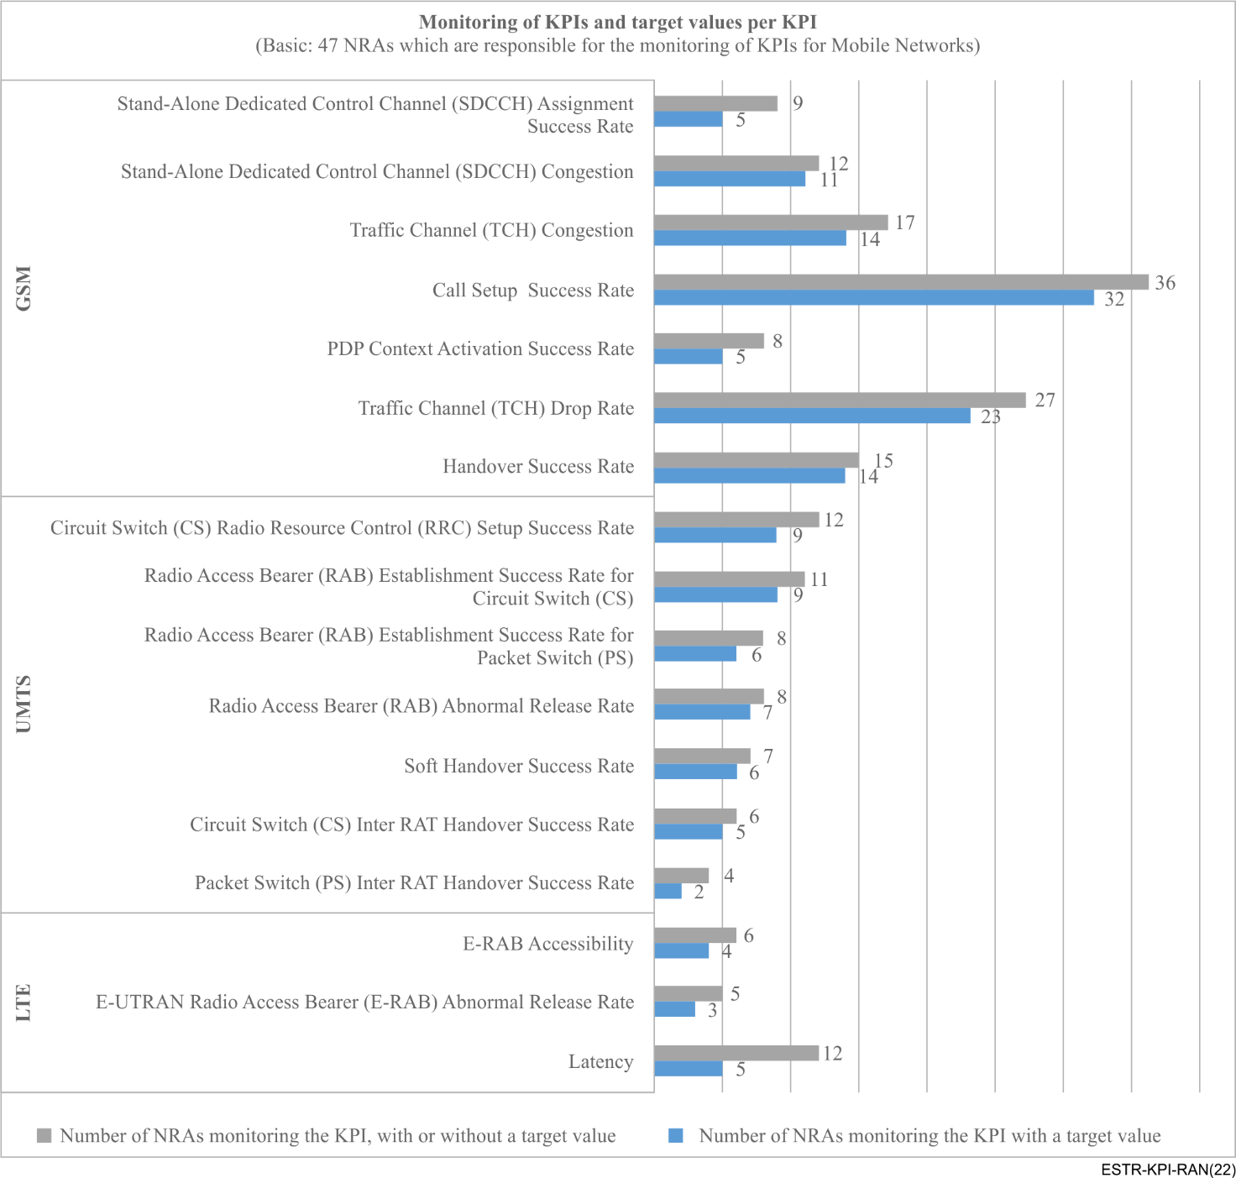
Figure I.5 – NRAs applying target values to KPIs
Figures I.6 and I.7 throw light on the most common target values, the maximum and minimum values that were received from the NRAs. A few outliers were observed in the some of the values, specifically the 0.5 and 10% for TCH drop rate, and 70% for call setup success rate.
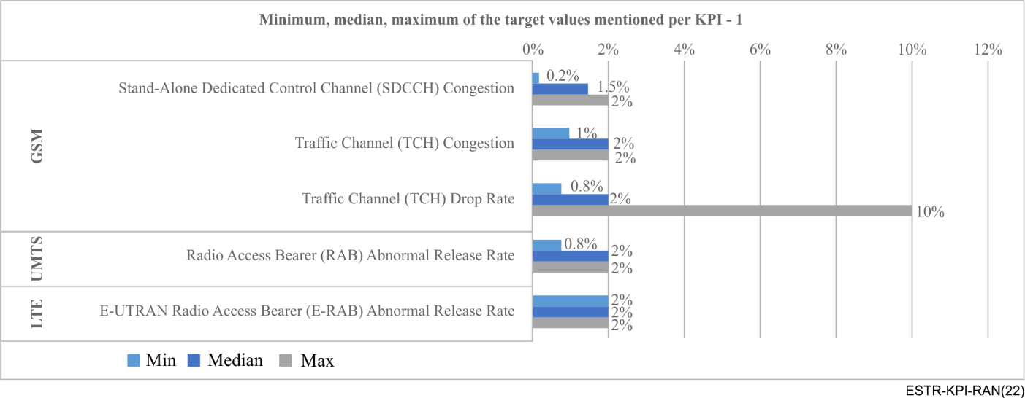
Figure I.6 – Minimum, median, and maximum target values applied to KPIs
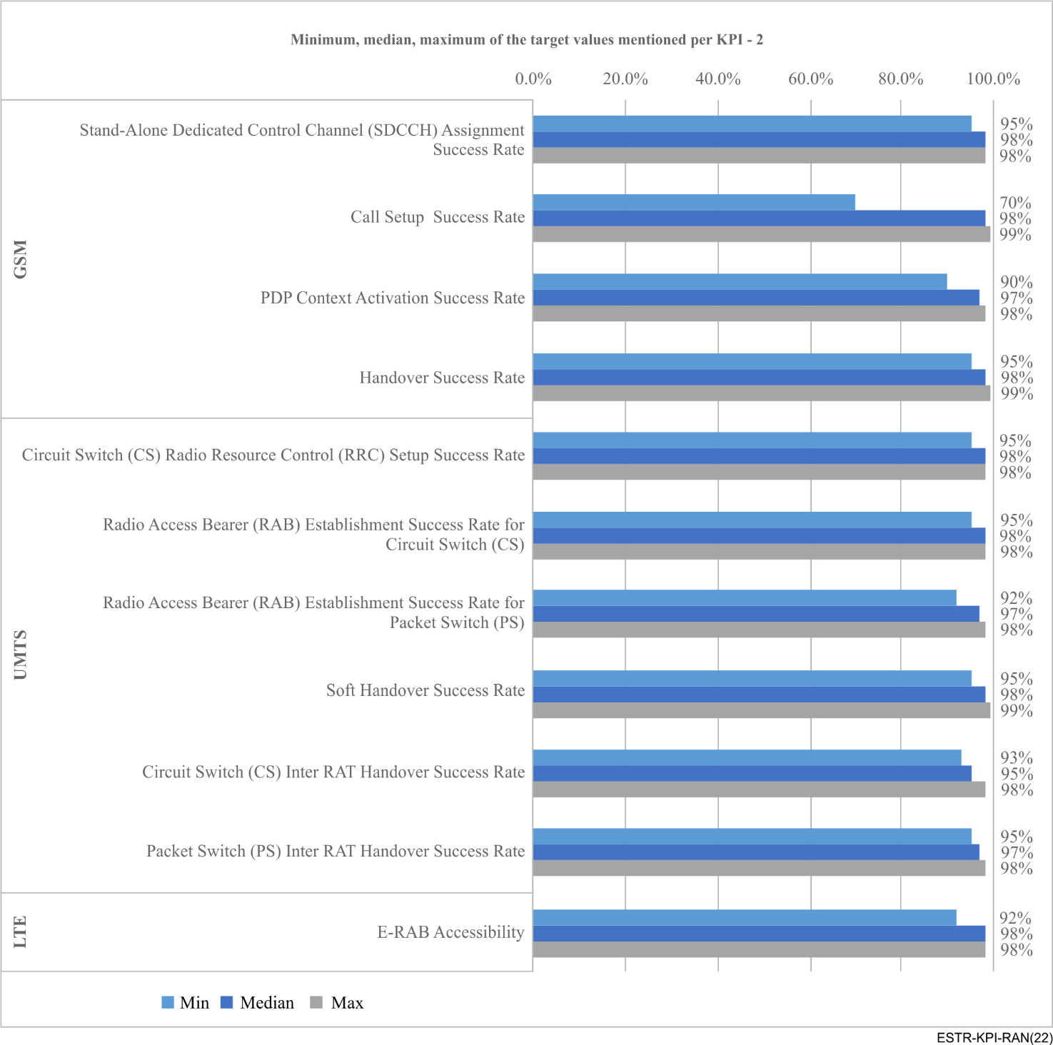
Figure I.7 – Minimum, median, and maximum target values applied to KPIs

I.6 Other KPIs shared by NRAs
The responses also offered some indication of what some NRAs will consider as relevant KPIs that they monitor besides those in the questionnaire. Most of the KPIs submitted by the NRAs are QoS user centric parameters:
List of KPIs submitted by respondent NRAs
– Credit renewal time,
– Directory services response time,
– Billing complains, billing accuracy,
– Voice service activation time,
– Voice service accessibility,
– Voice call retainability,
– HTTP and HTTPS up/down speed,
– Packet loss, navigation time,
– HTTP connection failure rate,
– Round trip time, Telephony service non-accessibility (%),
– Telephony cut-off call ratio (%),
– Speech quality
– Call setup time,
– HTTP data transfer cut-off ratio,
– HTTP mean data rate (kbit/s),
– FTP mean data rate (upload/download) (kbit/s),
– Web page download time,
– Voice call setup success rate,
– Voice call setup access time,
– Voice call drop rate,
– HTTP IP service access failure ratio,
– FTP IP service access failure ratio

Bibliography

[b-ETSI TR 32.814] ETSI TR 32.814 V7.0.0 (2007), Technical Specification Group Services and System Aspects; Telecommunication management; UTRAN and GERAN Key Performance Indicators (KPI).
[b-ITU-D Manual] Janevski, T., editor (2017), Quality of service regulation manual, Geneva: International Telecommunication Union, pp. 176, available [viewed 2021-02-18] at: https://www.itu.int/dms_pub/itu-d/opb/pref/D-PREF-BB.QOS_REG01-2017-PDF-E.pdf

