|  |  |  |  |  |
| --- | --- | --- | --- | --- |
|  | | **International Telecommunication Union** | | |
|  | |  | | |
| **ITU-T** | **Technical Paper** | |
| TELECOMMUNICATION STANDARDIZATION SECTOR OF ITU | | (25 October 2019) |
|  |  | | | |
|  | **TP-TEST-UE-MS Guideline for general test procedure and specification for measurements of the LTE, 3G/2G user equipment/mobile stations (UE/MS) for over-the-air performance testing** | | | |

**Summary**

Typical conformance tests include transmitter maximum output power, spectrum emission mask, spurious emissions, minimum output power, and adjacent channel leakage power ratio as well as receiver adjacent channel selectivity, blocking characteristics, spurious response, intermodulation characteristics, spurious emissions, and reference sensitivity level.

This Technical Paper gives an analysis of the work in relevant standards development organisations (SDOs) and a survey of the requirements, and then describes a common testing methodology for LTE, 3G/2G user equipment/mobile stations (UE/MS) for over-the air (OTA) performance testing.

**Keywords**

Antenna, over-the-air, OTA, performance testing, LTE, 3G/2G, user equipment, UE, mobile stations, MS.

Change Log

This document contains Version 1 of the ITU-T Technical Paper on “*Guideline for general test procedure and specification for measurements of the LTE, 3G/2G user equipment/mobile stations (UE/MS) for over-the-air performance testing*” approved at the ITU-T Study Group 11 meeting held in Geneva, 16-25 October 2019.

|  |  |  |
| --- | --- | --- |
| **Editor:** | Awad Ahmed Ali Hmed Mulah NTC Sudan | E-mail: [awadmulah@ntc.gov.sd](mailto:awadmulah@ntc.gov.sd) |
| **Editor:** | Uwe Baeder Rohde & Schwarz Germany | E-mail: [Uwe.Baeder@rohde-schwarz.com](mailto:Uwe.Baeder@rohde-schwarz.com) |
| **Editor:** | Alexander Nähring Rohde & Schwarz Germany | E-mail: [Alexander.Naehring@rohde-schwarz.com](mailto:Alexander.Naehring@rohde-schwarz.com) |

**Table of Contents**

**Page**

1 Scope 1

2 References 1

3 Definitions 1

4 Abbreviations and acronyms 1

5 Conventions 2

6 Survey and analysis of existing work in the relevant SDOs 2

6.1 3GPP (3rd Generation Partnership Program) 2

6.2 CTIA – The Wireless Association 3

6.3 ETSI (European Standardisation Institute) 3

6.4 CCSA (China Communications Standards Association) 3

6.5 Conclusion of the survey 3

7 General description 3

7.1 Test procedure 3

7.2 Coordinate system 3

7.3 Test site characteristics and validation 4

7.4 Test site calibration 5

8 Measurement frequencies 6

9 Transmitter performance 6

10 Receiver performance 7

11 Positioning requirements and phantoms 7

12 Measurement sites 8

Bibliography 10

Technical Paper ITU-T TP-TEST-UE-MS

ITU-T Technical Paper   
Guideline for general test procedure and specification for measurements   
of the LTE, 3G/2G user equipment/mobile stations (UE/MS)   
for over-the-air performance testing

# 1 Scope

This document describes a common testing methodology for requirements that are usually divided in two major aspects, one for the transmitter and one for the receiver as in the following examples:

– Transmitter output power (as total radiated power (TRP));

– Receiver sensitivity level (as total radiated sensitivity (TRS) or total isotropic sensitivity (TIS)).

The test procedure described in this document measures the performance of the transmitter and the receiver.

# 2 References

None.

# 3 Definitions

None.

# 4 Abbreviations and acronyms

This Technical Paper uses the following abbreviations and acronyms:

BER Bit Error Ratio

DUT Device Under Test

EIRP Equivalent Isotropically Radiated Power

EIS Effective Isotropic Sensitivity

E-UTRA Evolved UMTS Terrestrial Radio Access

E-UTRAN Evolved UMTS Terrestrial Radio Access Network

FER Frame Error Rate

FSPL Free-Space Path Loss

LTE Long Term Evolution

NR New Radio

RF Radio Frequency

TRP Total Radiated Power

TRS Total Radiated Sensitivity

TIS Total Isotropic Sensitivity

MS Mobile Station

OTA Over The Air

QZ Quiet Zone

RED Radio Equipment Directive

SDO Standards Development Organization

UE User Equipment

UTRA UMTS Terrestrial Radio Access

# 5 Conventions

None.

# 6 Survey and analysis of existing work in the relevant SDOs

This clause presents the work of major standardization organisations. However, there is no claim for completeness. In addition to the definition of test limits, all published material gives a very detailed and exact definition of the test and measurement environment. Meaningful requirements with minimized measurement uncertainty and a high guaranteed reproducibility are a basic need for making a test definition authoritative for validation and certification purpose.

## 6.1 3GPP (3rd Generation Partnership Program)

In 3GPP extensive work has been done to produce specifications for methods procedures and requirements for over the air (OTA) antenna tests [b-3GPP]. Table 1 provides a list of the specifications and their purposes.

Table 1 – 3GPP specifications for methods procedures and requirements for OTA

|  |  |  |
| --- | --- | --- |
| Specification or Report | Title | Description |
| TS 34.114 | User Equipment (UE) / Mobile Station (MS) Over The Air (OTA) antenna performance; Conformance testing | Describes the test procedure for the radiated performances measurements of the 3G/2G user equipment/mobile stations (UE/MS) in active mode in both the uplink and the downlink, total radiated power (TRP) and total radiated sensitivity (TRS). |
| TS 37.144 | User Equipment (UE) and Mobile Station (MS) GSM, UTRA and E‑UTRA over the air performance requirements | Document to establish over the air antenna minimum requirements for user equipment (UE) and mobile station (MS). |
| TS 37.544 | User Equipment (UE) Over The Air (OTA) performance;  Conformance testing | Describes the test procedure for the radiated performances measurements of the user equipment (UE) UMTS/LTE for TRS/TIS with the extension of multiple receive antennas. Definition of recommended performance values. |

Current work in 3GPP also includes the OTA measurements for new radio (NR) for cm- and mm‑wave frequencies as well as OTA MIMO testing. NR is planned as a candidate submission to IMT‑2020. The 3GPP standards define the details of the measurement procedure and the test environment.

## 6.2 CTIA – The Wireless Association

CTIA has developed a comprehensive test plan for OTA performance requirements [b‑CTIA]) that covers GSM, UMTS and LTE as well as other cellular and non-cellular standards. Test procedures for single and diversity receiver devices are described. From the requirements side only North American bands, hence ITU Region 2 are covered.

## 6.3 ETSI (European Standardisation Institute)

With the introduction of the radio equipment directive (RED) the market approval requires certification of UEs/MS to comply with OTA requirements. ETSI is now developing a harmonised standard taking care of TRP and TRS procedures and requirements as a revision of EN 301 908-2 (3G), EN 301 908-13 (LTE) and EN 301 908-25 (NR). It is very likely that procedures are following the approach as described in the 3GPP documents mentioned in clause 6.1. It is expected that requirements are also taken from 3GPP for bands and technologies that are present. Missing values are added in the process of the creation of the harmonised standard. For EN-301 908-2, the final draft is ready for the approval stage [b-ETSI], with planned approval in February 2020 and publishing in January 2021. This activity will of course focus on bands for region 1.

## 6.4 CCSA (China Communications Standards Association)

CCSA developed a series of standards for radiated performance including 2G/3G and LTE Technology YD/T 1484 "Measurement method for radiated RF power and receiver performance of wireless device" [b-CCSA]. The measurement procedures mainly follow the approach as described in the 3GPP documents.

## 6.5 Conclusion of the survey

It can be concluded that there is extensive material available in this field. The following clauses will introduce the underlying principles and common considerations. This material may therefore serve as an assistance and guideline to evaluate and introduce general test procedures and specifications for measurements of the LTE, 3G/2G user equipment/mobile stations (UE/MS) for over-the-air performance testing.

# 7 General description

## 7.1 Test procedure

The test procedure for OTA testing is separated in three steps:

1. The test chamber set-up and performance evaluation;

2. The path loss measurement of the test system for calibration;

3. The performance measurement of the device under test (DUT).

## 7.2 Coordinate system

The definition of TRP and TIS measurements are based on a spherical coordinate system as described in clause 3.4 of [b-CTIA]. The spherical coordinate system describes any point in 3D space relative to the coordinate system origin with three spherical coordinates $\left(r, θ,ϕ\right)$. A point on a sphere with radius $r$ around the origin is described with $\left(θ,ϕ\right)$, with elevation $θ∈\left(0°, 180°\right)$ and azimuth $ϕ∈\left(0°,360°\right)$. The equator is located at $θ=90°$ elevation. For OTA measurements, the convention ISO 80000-2:2009 for spherical coordinates is used. In a Cartesian coordinate system, the x-axis points towards $θ=90°, ϕ=0°$, the y-axis points towards $θ=90°, ϕ=90°$, and the z-axis towards $θ=0°$. For measurements, the DUT is located in the coordinate system origin and the measurement antenna is located in direction $\left(θ,ϕ\right)$ relative to the DUT. As the path loss caused by the distance between DUT and measurement antenna must be calibrated for the test system, the radius $r$ is not required.

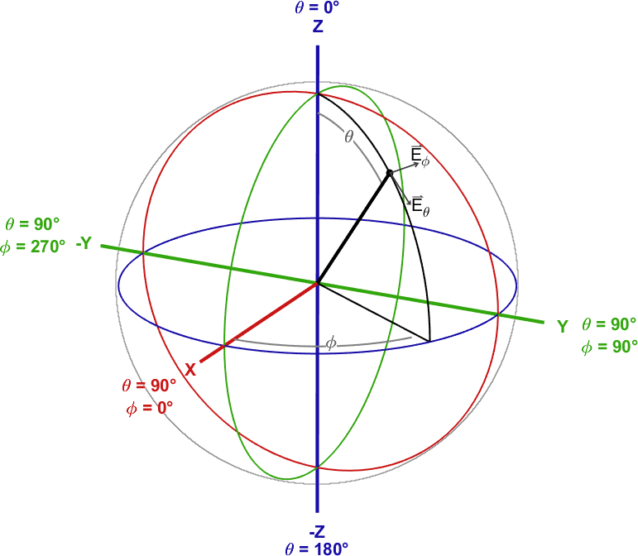

Figure 1 – Spherical coordinate system, in line with [b-IEEE]

At each measurement point, two orthogonal components of the field are measured, defined as the theta polarization ${\vec{E}}_{θ}$ and phi polarization ${\vec{E}}_{ϕ}$, pointing along the corresponding rotation vectors $θ$ and $ϕ$, respectively. The theta polarization vector points along the positive direction of increasing theta values, and the phi polarization vector points along the positive direction of increasing phi values.

## 7.3 Test site characteristics and validation

For a measurement site to qualify for performance testing of a DUT, the measurement site must provide a sufficient quiet zone (QZ) performance, effective shielding and accurate positioning.

The minimum measurement distance $R$ is determined by the far field condition. The distance between DUT and the measurement antenna must fulfil:

$$R≥\max\left(\frac{2D^{2}}{λ}, 3D, 3λ\right)$$

where $D$ is the maximum extension of the radiator (DUT).

The three inequalities represent different minimum distances to fulfil uncertainty limits. The Fraunhofer distance $R≥2D^{2}/λ$ fulfils the phase uncertainty and is the far field distance for electrically large antennas. $R>3D$ fulfils the amplitude uncertainty limit and $R>3λ$ the near field limit. In [b-CTIA], the radiator dimension is fixed to $300 mm$ for all handhelds with phantoms. Here, the largest “minimum measurement distance” required for CTIA testing of 2G, 3G and 4G frequency bands is $1.61 m$, resulting from a maximum frequency of $2690 MHz$ in the high channel of 3GPP Band 41. If a measurement system uses smaller distances other than defined by the minimum measurement distance equation, the validity of the measurement results must be demonstrated to the standardization body beforehand.

The QZ of the measurement site is qualified using a QZ ripple test. It is used to characterize variations in the field measurement caused by reflections within the anechoic chamber. Phi and theta cuts of highly symmetrical dipole or loop antennas are measured at different locations in the QZ. Deviations of the pattern cuts from a perfect circle are attributed to amplitude ripples in the quiet zone caused by imperfections of the measurement site.

## 7.4 Test site calibration

The test system losses including the free-space path loss (FSPL) must be compensated. For this, a calibration of the system is performed. A method to determine the system losses is the reference antenna method or gain transfer method. With this, a reference measurement is performed for each signal path. The reference measurement and known gain of the reference antenna determine the system loss of the current signal path. For each signal path used for UE performance measurements, up-to-date correction data must be available for correct assessment of equivalent isotropically radiated power (EIRP) and effective isotropic sensitivity (EIS) and consequently determination of TRP and TIS. The number of signal paths depends on the used system. Typically, at least two signal paths for the two polarization components ${\vec{E}}_{θ}$ and ${\vec{E}}_{ϕ}$ are required. Additional signal paths may be required for additional probe antennas, frequency ranges or test instrument set-ups.

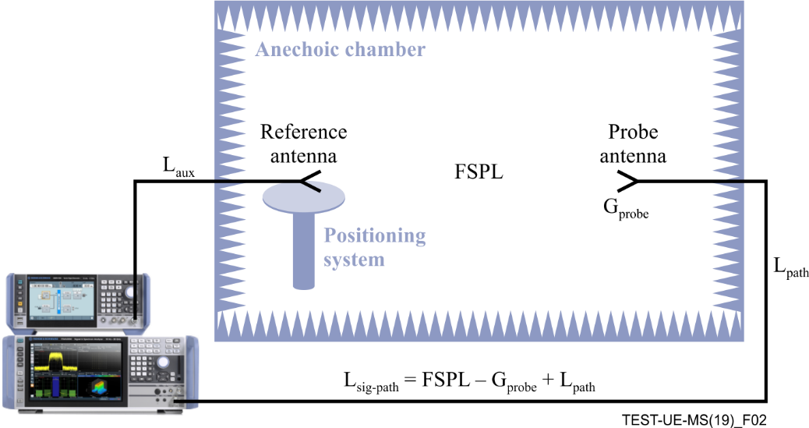

Figure 2 – Illustration of test site calibration set-up

To determine the correction value for a given signal path $L_{\text{sig-path}}$, a reference antenna with known gain $G_{ref}$ is placed in the rotation centre, polarization matched with the probe antenna and the peak gain direction aligned to the probe antenna. The signal path loss $L_{\text{sig-path}}$ is measured. This can be done with an auxiliary cable with known transmission parameters used to connect a signal generator and signal analyser to the system as shown in Figure 2. Alternatively, a reference receiver can be connected to the reference antenna and a signal with known power is fed to the signal path. Best practice for minimizing uncertainty is to use the same instrument for calibration and measurement when applicable. The auxiliary cable is not used during DUT performance testing and individual calibrations may be used for transmitter and receiver tests, using the spectrum analyser and signal generator connected to the signal path cable, respectively.

When measuring the receiver power $P_{RX}$ with known transmit power $P_{TX}$, antenna gain $G_{ref}$, and auxiliary cable loss $L_{aux}$, the signal path loss $L_{\text{sig-path}}=FSPL-G_{probe}+L_{path}$ can be straightforwardly determined:

$$L_{\text{sig-path}}=P_{TX}-P_{RX}-L_{\text{aux}}+G_{ref}$$

For every change on the measurement set-up, used connections, cables, adapter, switches, etc., the correction must be determined anew. In case of non-linearity of used components, the calibration must also be performed for various power levels and must be applied correctly during measurement.

# 8 Measurement frequencies

The radiation patterns of handset antennas can be expected to be frequency dependent. Achieved TRP and TRS values can vary over frequency and shall be measured in three channels in a frequency band (low, mid and high channel). The specified bands will be chosen to cover national or regional aspects.

Tables of the frequency bands designated for the different wireless communication standard can be found in the respective standard documents. For any DUT, frequencies are selected based on the supported frequency bands of all supported wireless communication standards of the device and the admitted frequencies in the region the DUT is to be operated.

# 9 Transmitter performance

This clause specifies the test method and test requirements for the radiated power measurement.

The radio frequency (RF) transmitter performance is qualified by sampling the radiated transmit power on a sphere around the DUT. The DUT is placed in a holding fixture on the positioning system in the QZ centre, combined with phantoms as further explained in clause 11.

The measurement site is expected to be validated and calibrated as defined in clause 7 and the power radiated by the DUT shall be measured with a calibrated measurement instrument such as spectrum analyser, power meter or other measurement receiver.

The signal power as received by the measurement receiver test instrument is corrected by the corresponding signal path correction of the currently active signal path as determined during calibration. The resulting value is the EIRP of the current polarization in the current measurement direction. To access the total radiated power of the DUT, the EIRP in all direction is spatially averaged:

$$TRP=\frac{1}{4π}\int_{0}^{2π}{\int_{0}^{2π}{EIRP\left(θ,ϕ\right)⋅\sin\left(θ\right)dθ}dϕ}$$

As the $EIRP$ is measured as vertical and horizontal component with a dual polarized probe antenna at sampled measurement locations, the TRP is approximated with:

$$TRP≈\frac{π}{2NM}\sum_{n=0}^{N-1}{\sum_{m=0}^{M-1}{\left(EIRP_{θ}\left(θ_{n},ϕ_{m}\right)+EIRP_{ϕ}\left(θ_{n},ϕ_{m}\right)\right)\sin\left(θ_{n}\right)}}$$

The measurement locations $\left(θ_{n},ϕ_{m}\right)$ are defined in a grid on a sphere around the DUT. The angular spacing of measurement points is chosen as a trade-off between measurement time and accuracy, while for low directivity antennas as used in typical UE for 2G, 3G, and 4G a low sampling of 15° is sufficient.

# 10 Receiver performance

The RF receiver performance is qualified by sampling the minimum effective isotropic sensitivity on a sphere around the DUT. The DUT is placed in a holding fixture on the positioning system in the QZ centre, combined with phantoms as further explained in clause 11.

The measurement site is expected to be validated and calibrated as defined in clause 7 and the signal received by the DUT shall be transmitted with a calibrated test instrument. To access the EIS of the receiver in a given direction, the transmitted signal is reduced in power until the error criteria (e.g., bit error ratio (BER) or frame error rate (FER)) is above a defined threshold. The lowest signal power that still enables the receiver to be within the error criteria limits, corrected by the corresponding signal path correction of the currently active signal path, is the EIS of the receiver for the given direction and polarization.

The total isotropic sensitivity (TIS) is the EIS spatially averaged over the whole sphere around the DUT:

$$TIS=\frac{4π}{\int_{0}^{2π}{\int_{0}^{π}{\left(\frac{1}{EIS_{θ}\left(θ,ϕ\right)}+\frac{1}{EIS_{ϕ}\left(θ,ϕ\right)}\right)sinθdθ}dϕ}}$$

It is important to note, that for TIS determination, it is not sufficient to rely on the conducted sensitivity of the receiver combined with the radiation pattern of the used antenna, as signal strength and noise received by the antenna will vary and is influenced by the DUT itself.

To determine the TIS from sampled measurement points, the TIS is approximated with:

$$TIS≈\frac{2NM}{π\sum_{i=1}^{N-1}{\sum_{j=0}^{M-1}{\left(\frac{1}{EIS_{θ}\left(θ_{i},ϕ_{j}\right)}+\frac{1}{EIS_{ϕ}\left(θ_{i},ϕ_{j}\right)}\right)\sin\left(θ_{i}\right)}}}$$

where $EIS_{θ}\left(θ_{i},ϕ_{j}\right)$ and $EIS_{ϕ}\left(θ_{i},ϕ_{j}\right)$ are the determined effective isotropic sensitivity in the direction $\left(θ_{i},ϕ_{j}\right)$ in the theta and phi polarization, respectively.

The measurement locations $\left(θ_{n},ϕ_{m}\right)$ are defined in a grid, e.g., 15° on a sphere around the DUT, as defined for transmitter performance in clause 9.

# 11 Positioning requirements and phantoms

The surveyed standardization bodies determine positioning requirements including the use of holding the DUT in different configurations with phantom heads and hands. Test cases describe well defined UE positioning for test comparability and the use of phantoms to mimic real life use of the UE. Typically, UEs are classified by their form factor (size, shape) and typical usage scenario (voice, data, wrist). These positions include free space (FS), head and hand phantom left and right (BHHL, BHHR), hand phantom left and right (HL, HR), and wrist-worn left and right (WL, WR) (see Figure 3). Due to the influence of the phantoms on the DUT performance, both the DUT and phantom must fit inside the QZ of the test system. The test system must be able to hold the full configuration and fix it to an accurate location while the whole fixture is rotated by the positioning system. It should be noted that [b-CTIA] currently only defined phantoms for UE up to 92 mm device width, with a fixed QZ size of 300 mm.

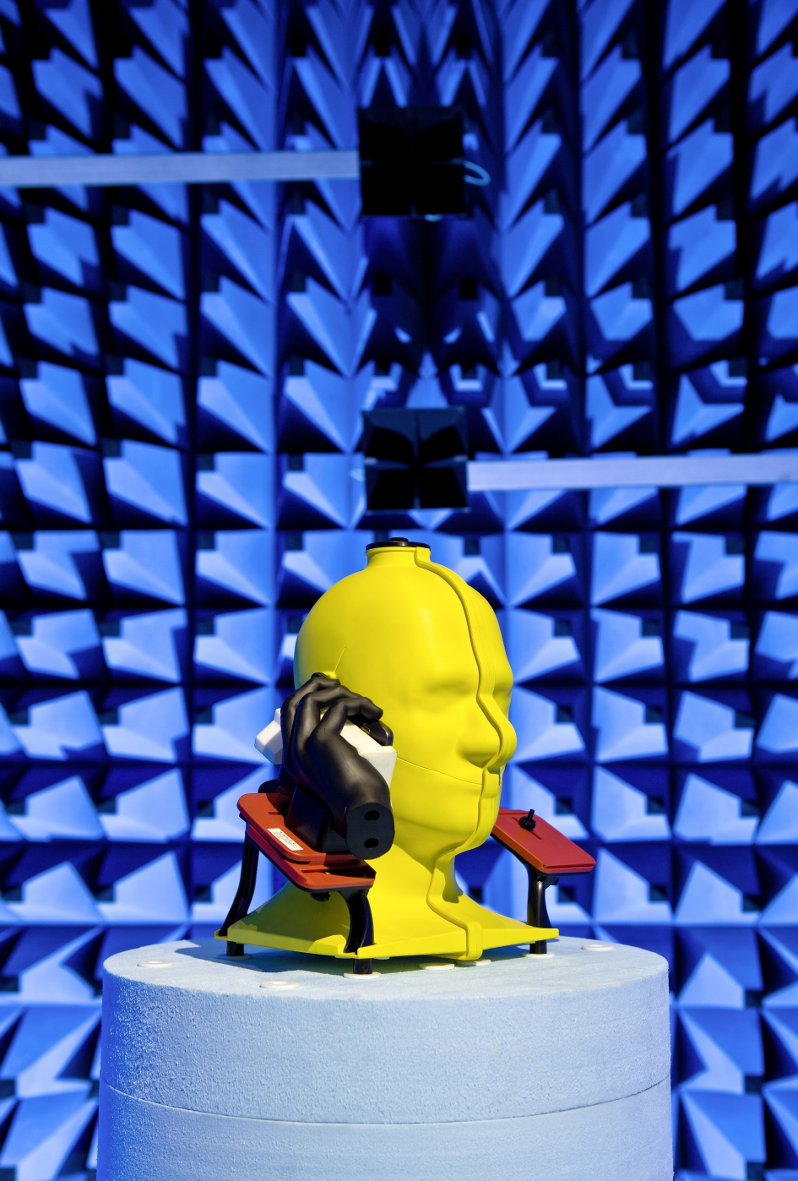

Figure 3 – Head and hand phantom in anechoic chamber

# 12 Measurement sites

Figure 4 illustrates a combined axis positioning system and a distributed axis positioning system for measurement sites.

Figure 4 – Combined axis positioning system (left) and distributed axis   
positioning system (right)

The measurement site must fulfil the positioning and QZ requirements as defined in clauses 7 and 11. The set-up must be able to position DUT and probe antenna so that the required measurement locations can be reached in 3D space. The minimum distance must be fulfilled or an alternative methodology be used that retrieves results that are equal to values obtained in far field. The default set-up is an anechoic chamber with an automated 3D positioning system. The two major positioner systems are the combined axis and distributed axis positioner systems. The coordinate systems for both set-ups differ in orientation but are physically identical and the generic spherical coordinate system defined in clause 7 applies to both. Figure 4 shows a schematic overview of the two positioning system layouts in an anechoic chamber. Figure 5 shows a real life anechoic chamber with a distributed axis positioning system.



Figure 5 – Anechoic chamber with distributed axis positioning system

Bibliography

[b-3GPP] 3GPP, *The Mobile Broadband Standard* <<https://www.3gpp.org>>

[b-CCSA] China Communications Standards Association, <[www.ccsa.org.cn](http://www.ccsa.org.cn)>

[b-CTIA] CTIA, *Test Plan for Wireless Device Over-the-Air Performance*, version 3.8.1, October 2018. <<https://api.ctia.org/wp-content/uploads/2018/10/ctia-test-plan-for-wirelesss-device-over-the-air-performance-ver-3-8-1.pdf>>

[b-ETSI] <<https://portal.etsi.org/webapp/WorkProgram/Report_WorkItem.asp?WKI_ID=50586>>

[b-IEEE] IEEE Std. 149-1979 <<https://ieeexplore.ieee.org/document/19510>>

__________________