 |  | International Telecommunication Union
 |  | ITU-T | Technical Paper
 |  | TELECOMMUNICATION  STANDARDIZATION SECTOR  OF ITU |  | (30 November 2015)
 | Future social media and knowledge society

Forward
This Technical Paper was developed by Mr. Jun Kyun Choi.

CONTENTS
Page
1 Scope 3
2 Definitions 3
3 Abbreviations 4
4 Vision and technology trends toward knowledge society 6
4.1 Vision toward knowledge society 6
4.2 New technologies for knowledge society 18
5 Vision and technology trends of social media 30
5.1 New trends of social media 30
5.2 New technologies for social media 36
6 Risks of knowledge society 43
7 New opportunity of knowledge society and social media 50
8 ICT standardization for future knowledge society 61
9 Conclusions 67
10 References and bibliography 69

List of Figures
Figure 1 – From agricultural society to knowledge society 7
Figure 2 – Expecting value of knowledge by classification of intelligences 12
Figure 3 – Key features of knowledge society 13
Figure 4 – Data-information-knowledge-wisdom (DIKW) process (ref. [14]) 16
Figure 5 – Recursive cycle of knowledge creation (ref. [15]) 17
Figure 6 – Evolution of social business [41] 51
Figure 7 – Social information infrastructure via ICTs 53
Figure 8 – ICT conceptual vision of future ICT infrastructure 54
Figure 9 – Key trends of future ICT eco-society 56
Figure 10 – Value-added services of future ICT infrastructure 57
Figure 11 – Emerging applications of future ICT infrastructure 58
Figure 12 – Strategic trends for future ICT infrastructure 59
Figure 13 – Step-wise evolution toward future ICT infrastructure 60
Figure 14 – Recursive standardization process for knowledge information infrastructure 66

ITU-T Technical Paper
Future social media and knowledge society
Introduction
Smartphone addiction
Most mothers claim "my children are dying brain" since they use smartphones the whole day. They feel that smartphones are similar to "Digital Drugs". Even when children go to bed, they have their smartphones with them. If the battery is almost worn out, most children panic easily. Many couples too often fight to use the smartphone. Most people send and receive an unlimited number of short messages by using social networking services, such as Twitter and Facebook. Smartphone addictions are due to a hyper-connected society of Internet, and they are more serious than Internet addiction or video game addiction. The average usage time per day of smartphone addiction is more than eight hours, while normal users use three hours. The main purpose of using smartphones is chatting, news searching, listening to music, and games. In the near future, mobile phone manufacturers may have to attach mandatory warning on smartphones such as "Excessive use of smartphones is harmful to your health and family reconciliation".
Data explosion
In Cisco's report on visual networking index in 2013, the volume of global Internet traffic is expected to reach 1.6 zeta bytes. (Note that 1 zettabyte = 1021 bytes = 1 billion terabytes = 1000 exabytes [1].) It has been announced that global Internet protocol (IP) traffic is expected to increase by about three-fold during the next five years. Wireless mobile traffic will exceed wired traffic, and video traffic with high definition quality will be the best. The major factor of traffic increase is the increase of Internet users and mobile devices, which are the result of the increase of broadband network bandwidth and video watching. The traffic volume of mobile devices will exceed the volume of personal computer (PC) traffic. Moreover, wireless fidelity (WiFi) traffic will exceed wired traffic for the first time. The percentage share of video traffic with high definition quality of all the traffic is expected to increase to 79% in 2018 compared to 66% in 2013. Traffic for Internet of things/machine-to-machine (IoT/M2M) applications will increase sharply in the near future.
New habit of online society
While people frequently use the Internet, they develop new habits. Currently, Internet users are increasing drastically. More than 50% of the people in the world are plugged-in at the Internet. The penetration ratio of smartphones is also steeply rising to more than 50%. Such penetration is causing change in the daily lives of people. Lately, many people may have the habit of checking their smartphones first thing in the morning; they check their schedule of the day to decide what clothes they have to wear, depending on their meeting and business schedule. On their way to work, they check their e-mails and mobile messages. For their daily lives and businesses, most people always connect to the online environment by using smartphones.
If they have a question during a meeting or a conversation, they directly check the related websites by using the smartphone so that they can obtain the facts from the Internet without a serious debate. To get the opinion of faraway experts, people call them immediately during the meeting. Sometimes, the meeting makes a vote from the all the participants including those who participated remotely. In some strange cases during face-to-face meetings, people start the meeting by using the social networking services in order to record the meeting results even though all the members are present in the same location.
In their day-to-day life, people check their personal schedule by using the Internet. They fix dates with their girlfriends, and book movie tickets by using the smartphone. When a girlfriend does not find the exact meeting place, her boyfriend directs her from her current location. Sometimes, he asks his friends to find out a nice venue to meet. He may enjoy a major event nearby like a street parade or fireworks. He can receive a discount coupon for a nearby restaurant while he is looking for a nice place.
By using the smartphone, he meets with his family and friends every day even though he could not meet them physically. Most mothers worry about their daughters when they come back home late in the evening; they can contact their daughters by using the smartphone to ensure that they return safely.
Social effects of online connectivity
At least once a day, people visit their social networking service like Twitter and Facebook, etc. When people are excluded to join as a friend or be a member of the social networking services, they are very disappointed and they think that are being bullied. People may worry about such online as well as offline exclusion from these communities. When people post the latest news and gossip on their social networking sites, they observe and wonder how to appeal or how to react to their friends. People may want to learn about new cultures of online social communities regardless of where they are or what they are working at. They may exercise new skills on how to live in an open culture of an online society. This online culture may be similar to a community culture like the Confucian civilization of Far East Asia.
Impact of technology development toward future society
The recent new technologies such as cloud computing, the web, and social networking services over the Internet are just the beginning of a wide variety of technological developments for the future. The future society is ready to invite new technologies like big data analytics, deep learning, augmented reality/virtual reality (AR/VR) as well as Internet of things (IoT), etc. In the near future, network transmission speeds will be exceeding more than 1 terabits per second and network processing power will be more than several hundred petaflops. The storage capability of individual smartphones or personal computers will be more than 1 terabytes.
IBM Watson supercomputer wins over a human at the television quiz show of Jeopardy in 2011. The thinking capability of a computer is superior to that of humans while puzzling over a particularly hard question [2]. This means that humans may focus on how to think rather than on how to remember. Humans welcome to utilize the storage and processing capability of the cloud computing system. The computer with artificial intelligence may help with how to think and remember. To overcome the language barrier, real-time language translation may be available. For example, if people are discussing some outstanding issues, the searching machine displays in advance the relevant information on the screen from the websites.
Wind of changes
In human history, there is no memory more than several billions of people are simultaneously talking and sharing contents/documents together through the Internet. The real-time voting and instant collection of opinions give an insight that technological development leads to a new cultural revolution. It offers new challenges to individual human life such as dating, chatting, shopping, listening to music, and enjoying movies, etc. There will be new business styles during the purchase, and the business transactions, etc. This leads to social, cultural, and political changes of the human life. Digital technology may be asking to change national laws and regulations. It also requests to change individual rights and responsibilities at the human and business levels.
Many people may feel ashamed in such technological developments. New ecosystems of life and business may be unstable without a guarantee of the stability and reliability of technology. If people try to drive a car without the required skill or confidence, this causes car accidents. New technologies may introduce the build-up of an unacceptable value chain (e.g. monopoly) of industries and eventually may destroy the traditional business models. The development of new technologies may be sometimes undesirable if certain levels of controllability and credibility are not guaranteed.
The online connectivity of the Internet is stronger than our expectations since it may introduce a new society and create a new culture. However, online connectivity may awake a very unstable resonance in society where collective actions, demonstrations, and public heated debates can occasionally take place. Moreover, many people receive many spam e-mails and are attacked by short message service phishing (i.e. smishing), etc.

Scope
This Technical Paper focuses on what is the expected and hopefully the knowledge society. It analyses the impacts of the development of digital technologies, the social effects of online connectivity, and the trends of the new ecosystem. It recognizes that the information and communication technology (ICT) is a centre of wind of changes. The future knowledge society will be built on the basis of the ICT infrastructure since it is totally an artificial society created by humans. The ICT infrastructure is not only for the delivery of digital data, but it also provides the eco-platform to share data, information, and knowledge. The new innovative technologies will be developed for the future open and collaborative knowledge society. Therefore, this Technical Paper explains the minimization of the unexpected risks and the maximization of the survivability of the future knowledge society.

Definitions
A number of terms in this Technical Paper with definitions are being used to describe knowledge society and social media.
2.1 data serialization: It is the process of translating data structures or an object state into a format that can be stored (for example, in a file or memory buffer, or transmitted across a network connection link) and reconstructed later in the same format or in another computer environment.
2.2 explicit knowledge: It is knowledge that can be readily articulated, codified, accessed and verbalized.
2.3 extensible markup language (XML): It is a markup language that defines a set of rules for encoding documents in a format which is both human-readable and machine-readable. It is defined by the W3C specification [17].
2.4 fintech: Financial technology, also known as FinTech, is a line of business based on using software to provide financial services.
2.5 hypertext markup language (HTML): It is the standard markup language used to create web pages. Along with cascading style sheets (CSS), and JavaScript, HTML is a technology, used by most websites to create visually engaging web pages, user interfaces for web applications, and user interfaces for mobile applications [18].
2.6 linked open data (LoD): It is the linked data that is open content. The linked data describes a method of publishing structured data so that it can be interlinked and become more useful through semantic queries. It enables data from different sources to be connected and queried.
2.7 markup language: A markup language is a system for annotating a document in a way that is syntactically distinguishable from the text. Some markup languages, such as the widely used hypertext markup language (HTML), have predefined presentation semantics with meaning that their specification prescribes how to present the structured data.
2.8 metadata: Metadata is "data about data". Two types of metadata exist: structural metadata and descriptive metadata. Structural metadata is data about the containers of data. Descriptive metadata uses individual instances of application data or data content.
2.9 resource description framework (RDF): It is originally designed as a metadata data model. It has come to be used as a general method for conceptual description or modelling of information that is implemented in web resources, using a variety of syntax notations and data serialization formats. It is defined by the W3C specification [49].
2.10 smishing: It is a compound of 'phishing' and short message service (SMS). SMiShing (SMS phishing) is a type of phishing attack where mobile phone users receive text messages containing a website hyperlink.
2.11 social graph: It is a graph that depicts personal relations of Internet users. The social graph has been referred to as "the mapping of everybody and how they are related".
2.12 tacit knowledge: It is the kind of knowledge that is difficult to transfer to another person by means of writing it down or verbalizing it.
2.13 uniform resource locator (URL): It is a reference to a web resource that specifies its location on a computer network and a mechanism for retrieving it.
2.14 extensible markup language (XML) schema: An XML schema is a description of a type of XML document, typically expressed in terms of constraints on the structure and content of documents of that type, above and beyond the basic syntactical constraints imposed by XML itself. These constraints are generally expressed using some combination of grammatical rules governing the order of elements.

Abbreviations
This Technical Paper uses the following abbreviations:
5G Fifth Generation mobile networks
API Application Programming Interface
APT Advanced Persistent Threats
AR Augmented Reality
AVC Advanced Video Coding
BEMS Building Energy Management System
CapEx Capital Expense
CCTV Closed-Circuit Television
CD-ROM Compact Disk – Read-Only Memory
CPS Cyber Physical System
CSRF Cross-Site Request Forgery
CSS Cascading Style Sheets
CSV Comma-Separated Value
DIKW Data-Information-Knowledge-Wisdom
DNA Deoxyribonucleic Acid
DTD Document Type Definition
EAV Entity-Attribute-Value
GPS Global Positioning System
HTML HyperText Markup Language
HTTP HyperText Transfer Protocol
IaaS Infrastructure as a Service
ICT Information and Communication Technology
I/O Input/Output
IoT Internet of Things
IP Internet Protocol
IPTV Internet Protocol Television
IT Information Technology
ITU International Telecommunication Union
ITU-T The ITU Telecommunication Standardization Sector
JPEG Joint Photographic Experts Group
JSON JavaScript Object Notation
LOD Linked Open Data
LTE Long Term Evolution
M2M Machine-to-Machine
MAB Multi-Author Blog
MIME Multipurpose Internet Mail Extensions
MPEG Moving Picture Experts Group
NoSQL Non-Structured Query Language
OpEx Operational Expense
PaaS Platform as a Service
PC Personal Computer
PDA Personal Digital Assistant
PHP Hypertext Preprocessor
RDF Resource Description Framework
RFID Radio Frequency Identification
SaaS Software as a Service
SDO Standards Development Organization
SMS Short Message Service
SNS Social Networking Service; Social Networking Site
SOAP Simple Object Access Protocol
SPARQL SPARQL Protocol and RDF Query Language
SQL Structured Query Language
UDDI Universal Description, Discovery and Integration
UHD Ultra-High Definition
URI Uniform Resource Identifier
URL Uniform Resource Locator
URN Uniform Resource Name
USB Universal Serial Bus
VR Virtual Reality
WiFi Wireless Fidelity
WSDL Web Service Definition Language
WSIS World Summit on the Information Society
XaaS Everything as a Service
XML eXtensible Markup Language

Vision and technology trends toward knowledge society

Vision toward knowledge society
History of knowledge
The term "knowledge society" and "knowledge worker" are used for the first time by Peter Drucker in his 1959 book "Landmarks of Tomorrow" [3]. Since then, knowledge society has become increasingly important in the business world. In addition, the idea of knowledge society is inseparable from studies on information society. The notion of information society realizes the new economy based on scientific knowledge and changes in the workplace. The information society is based on technical breakthroughs to handle massive data through the network. The information and communication technology (ICT) removes main technical obstacles to achieve the information society. For a deeper understanding of knowledge society, the history that the humankind has thought, invented, created, considered, and perfected from the beginning of civilization into the twenty-first century is highlighted by Charles Van Doren [4]. The effects of social networking and online connectivity though the ICT infrastructure are interestingly imagined to make the future knowledge society.
At the 15th ITU Plenipotentiary Conference in 1999, the World Summit on the Information Society (WSIS) was created to develop the information society. During the first phase of WSIS, the debates on the information society were mainly focused on the ICT infrastructure. The concept of knowledge societies is more all-embracing and more conducive, which simply "opens the way to humanization of the process of globalization". The notion of knowledge is central to changes of education, science, culture, and communication. Knowledge is recognized as the object of huge economic, political and cultural stakes, to the point of justifiably qualifying the societies currently emerging.
Compared with the invisible hand by Adam Smith in his 1776 book "Wealth of Nations" (regarded as the father of economics), knowledge is an invisible public good, available to each and every individual. Knowledge fosters universality, liberty, and equality as a concept of openness [5]. Nobody should be excluded from the knowledge society. Young people play a major role in using new technologies of knowledge in their daily lives. To accelerate knowledge production, information processing and communication have built a cumulative and recursive loop of innovation among people. The creativity and innovation will play a major part in knowledge societies. It leads to promoting new types of collaborative processes to achieve genuine knowledge societies.

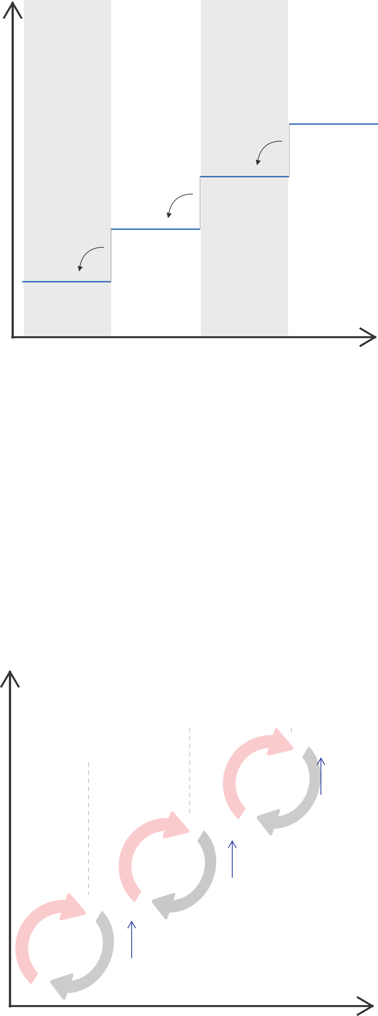
Economic
Growth
Societal Transformation
Raw Materials
Agri products
Industrial
products
Information
products
Knowledge
products
Technology
Networks
Innovation
Agricultural Society
Industrial
Society
Information
Society
Knowledge
Society
Figure 1 – From agricultural society to knowledge society

From agricultural society to knowledge society
To understand the evolution from the agricultural era to knowledge society, people interact with their environments and utilize technologies to satisfy their needs. During the agricultural revolution, people experienced a rapid improvement in agricultural production and farming technology. Farmers learned more practical and efficient farming technologies by using wheel and fertilizer. In the industrial revolution, the introduction of new power-driven machinery and other energy sources brought about a rapid and significant change of production. The steam engines, textile mills, and large scale equipment are capable of producing massive amounts of products.
Recently, in the information society, revolution is shifting from products to ideas and knowledge as shown in Figure 1 [6]. The ICT infrastructure is rooted to enable information society. The shifts are from hands-on skills to literacy skills and from industrial engineering to knowledge engineering. The decentralized and collective knowledge of the humankind will be a key factor to realize the new society. The power resides with people in charge of storing, sharing, and distributing information. New technologies and new knowledge products will be widely investigated to get new market opportunities.
What is the value of knowledge in information and communication technology?
For the value of knowledge, there are some statements: "All knowledge is of itself of some value" in Samuel Johnson in 1775, "The worth and value of knowledge is in proportion to the worth and value of its object" in Clodridge in 1825 [7]. Recently, and in relation to business, Firestone wrote "Thought, not money is the real business capital" [8]. Firestone observed that knowledge about how to produce products is more valuable than the products themselves. The value of knowledge exceeds the business values of industrial products and goods. Moreover, the shifts from tangible knowledge to intangible knowledge will be revolutionized by the way that knowledge is power in its own right.
In the information and communication world, characters, images, and symbols as well as audio/video signals can be used to indicate meaning and can be thought of as delivery of data. The transfer of data can be viewed as a process whereby knowledge can be transferred. The information and communication technology is used in all forms of recording and transfer of knowledge. The millions of books of knowledge in the libraries can be transferred in an electronic manner. The growth of information and communication technology has significantly increased the network capacity for creation and transfer of data. The evolution of the Internet and web technologies offers individuals tools to connect with each other worldwide. Innovation in mobile wireless digital technologies offers individuals a means to connect anywhere and anytime where digital technologies are accessible. ICT has the potentials to radically change education, training, employment for all members of human society.
However, the ICT infrastructure for individuals to produce and use data does not necessarily result in knowledge creation. Digital media delivers seemingly amounts of information. However, information alone does not create knowledge. For knowledge creation to take place, it is required to create awareness, meaning, and understanding of data and information. The critical analytic process of information is required to develop the knowledge that assists humankind. Information as such lacks reflection and critical thinking, and thus it can actually become "non-knowledge", which is false or inaccurate. The anticipated new technologies like big data analytics and semantic web will move both information and knowledge creations to use intelligence and create meaning.
Technology reduces the prices of telecommunication resources and enables the increase of transmission speeds and volumes of information. Technology has given birth to "networked societies". In a community, there is a set of networks within which individuals maintain special relationships whether they are family, ethnic, economic, professional, social, religious, political, or all of these simultaneously. Technological innovation helps in the emergence of new information and knowledge sharing systems that are shaped by the choices of a user or communities. The intelligence of knowledge and information sharing systems are enabled by a filtering principle that depends on the interaction of individual actions and processing of data. New information and communication technologies have created the emergence of knowledge societies. The International Telecommunication Union (ITU) as the United Nations top level standards organization relating to information and communication technologies may be concerned about future knowledge society.
Definitions of knowledge from ICT perspectives
Knowledge is a familiarity, an awareness or an understanding of someone or something such as facts, information, description or skills. Knowledge is acquired though experience or education by perceiving, discovering and learning [9]. Knowledge can refer to theoretical or practical understandings of a subject that is implicit (as with practical skills or expertise) or explicit (as with a theoretical understanding of a subject). It can be more or less formal or systematic.
Knowledge acquisition involves complex cognitive processes of perception, communication, and reasoning. From the ICT perspectives, knowledge is related to human perceptions of data streams of audio, video, image, and texts while transferring knowledge from people or organizations to others. By using e-mails or written documents for a meeting, knowledge is created and transferred by a dynamic acquisition and complex cognitive processes of the human brain like reasoning, observation, experimentation, formulation, and testing of hypotheses, etc. In scientific methods, knowledge has developed a broader view of the accumulated results of scientific experiments from discussions of communities or group of experts. For human behaviours in business, knowledge is related to a kind of decision-making process. Human behaviour is quite predictable when a certain level of experience and accumulated information are successfully collected through the network.

Types of intelligences
There is a theory of multiple intelligences rather than seeing intelligence as dominated by a single general ability which was proposed by Howard Gardner in his 1983 book "Frames of Mind: The Theory of Multiple Intelligences" [10]. He describes various types of intelligences as follows.
• Logical/mathematical intelligence: NUMBER SMART
This intelligence has to do with logic, abstractions, reasoning, numbers and critical thinking. This also has to do with having the capacity to understand the underlying principles of some kind of causal system. Scientists, engineers, computer programmers, and accountants are excellent in these kinds of intelligences. The key features of this intelligence are summarized as follows:
– Thinks conceptually;
– Skilled in reasoning, logic and problem solving;
– Explores patterns, categories, and relationships;
– Manipulates the environment to experiment in a controlled way;
– Questions and wonders about natural events.
• Interpersonal intelligence (including emotional intelligence): PEOPLE SMART
This intelligence has to do with interaction with others. Individuals who have high interpersonal intelligence are characterized by their sensitivity to others' moods, feelings, temperaments and motivations, and their ability to cooperate in order to work as part of a group. According to Gardner, inter- and intrapersonal intelligence are often misunderstood as being extroverted or liking other people. Those with high interpersonal intelligence communicate effectively and empathize easily with others, and may be either leaders or followers. They often enjoy discussion and debate. Gardner has equated this with the emotional intelligence of Goleman [11]. Emotional intelligence is the ability to recognize one's own and other people's emotions, to discriminate between different feelings, and to use emotional information to guide thinking and behaviour [12]. Counsellors, business people, politicians, and community organizers are excellent in this kind of intelligence. The key features of this intelligence are summarized as follows:
– Thinks and processes by relating, cooperating and communicating with others;
– Leaders among peers;
– Uncanny ability to sense feelings and intentions of others;
– Understands people, mediates conflict.
• Bodily-kinaesthetic intelligence: BODY SMART
The bodily-kinaesthetic intelligence is the control of one's bodily motions and the capacity to handle objects skilfully. Gardner elaborates to say that this also includes a sense of timing, a clear sense of the goal of a physical action, along with the ability to train responses. A person who has high bodily-kinaesthetic intelligence is generally good at physical activities such as sports, dancing, acting, and making things. Athletes, dancers, musicians, actors, builders, police officers, and soldiers are excellent of this intelligence. The key features of this intelligence are summarized as follows:
– Processes knowledge through bodily sensation;
– Excellent fine-motor co-ordination;
– Gut feelings about things;
– Great at mimicking your best or worst qualities and mannerisms;
• Musical/rhythmic Intelligence: MUSIC SMART
This intelligence has to do with sensitivity to sounds, rhythms, tones, and music. People with high musical intelligence normally have good pitch and may even have absolute pitch, and are able to sing, play musical instruments, and compose music. They have sensitivity to rhythm, pitch, meter, tone, melody or timbre. People for choirs, orchestra, bands, disc jockeys, and theatre are excellent in this kind of intelligence. The key features of this intelligence are summarized as follows:
– Thinks in sounds, rhythms and patterns;
– Sings, hums, whistles to themselves;
– Immediately responds to music;
– Performs and appreciates music and leads in songs;
– Sensitive to environmental sounds: crickets, bells, ambient music;
– Strong opinions of others' music.
• Intrapersonal intelligence: SELF SMART
This intelligence has to do with introspective and self-reflective capacities. This refers to having a deep understanding of the self; what one's strengths or weaknesses are, what makes one unique, being able to predict one's own reactions or emotions. Self-employed, researchers, theorists, and philosophers are excellent in this kind of intelligence. The key features of this intelligence are summarized as follows:
– Skilled in inner focusing;
– Displays a strong personality;
– Deep awareness of inner feelings, dreams and ideas;
– Reflective and analytical attitudes;
– Tends to shy away from team activities;
– Recognizes self-strength and weaknesses;
– Requires private space and time.
• Linguistic/verbal intelligence: WORD SMART
This intelligence has to do with high verbal-linguistic intelligence which displays at a facility with words and languages. People are typically good at reading, writing, telling stories and memorizing words along with dates. Verbal intelligence includes an ability of vocabulary, information, similarities, and comprehension. Teachers, journalists, writers, lawyers, and translators are excellent in this kind of intelligence. The key features of this intelligence are summarized as follows:
– Thinks in words;
– Highly developed auditory skills;
– Plays with sounds in language;
– Great storytellers, tells tales and jokes;
– Loves seeing, saying and hearing words;
– Heads are frequently stuck in a book;
– Likes to write.
• Spatial/visual intelligence: PICTURE SMART
This intelligence deals with spatial judgment and the ability to visualize with the mind's eye. Inventors, architects, engineers, and mechanics are excellent in this kind of intelligence. The key features of this intelligence are summarized as follows:
– Thinks in images and pictures;
– Clear visual images and representations;
– Knows the location of everything;
– Fascination with machines and contraptions.
Value of knowledge
The power of knowledge enables to create new add-on values to human business by combining some intelligence. All businesses have access to an extensive accumulation of knowledge since the understanding of customers' needs is combined with skills and experiences. By understanding what the customers want, combined with know-how, new chances of business may be obtained. By using knowledge in the right way and at the right time, the risks of new businesses are reduced and new opportunities are acquired.
Knowledge has not only become one of the keys to economic development, but it also contributes to human development and individual empowerment. Knowledge is a source of power because it creates a capacity for action. One of the major advantages of knowledge is that it reduces costs by achieving economies of scale and avoiding useless duplication. The notion of "knowledge societies" holds out the possibilities for sustainable development, which may be also called "information society", "knowledge-based economies", "learning societies", and "risk societies".
In science and engineering domains, knowledge is essential to make fundamental theoretical or experimental researches. Since knowledge is fundamentally a matter of cognitive capability of problem-solving, skill, training, and learning, most research in the academic world is a hybrid of new knowledge generation and subsequent exploitation. Radical innovation is rarely possible without prior knowledge. Some collaboration between the academic world and industry is necessary both for the generation of new knowledge and its applications. New scientific knowledge is essential not only for fostering innovation and development of new technology, but also for creating new processes of education and collaboration of researchers. To accelerate knowledge creation, the collaborative research model of science and engineering is crucial.
The key ingredient of knowledge is understanding. The good understanding of basic theories and practice of experimental results are required among well-trained scientists and skilful engineers. Understanding means the ability to figure out a simple set of rules that explains a particular situation. For example, a teacher gives an explanation to his students of some features of a physical object. One understands reasoning, arguments, or language if one can consciously reproduce the information contents conveyed by the network. One understands a mathematical concept if one can solve problems using it, especially problems that are not similar to what one has seen before.
For the future knowledge eco-society, there are a lot of opportunities in order to accumulate the values of knowledge as shown in Figure 2. By converging heterogeneous intelligences as indicated by Howard Gardner, the disruptive innovation of knowledge may happen: for example, emotional therapy by converging health+music, bicycle generator by converging energy+sport, and edutainment by converging game+education, etc. The innovative convergence platform of knowledge will be open for multi-dimensional thinking which enables people to create clarity out of complexity. For innovation of science and engineering, the knowledge platform extends to factual and tangible dimensions where a wide variety of scientific data are collected and analysed. However, more intangible dimension including tacit knowledge and sharing experiences, which is not well formulated, can support the emotional and spiritual drivers of culture, lifestyle and consumption behaviour, alongside the dynamics of personal well-being. The future knowledge platform will be a comprehensive and integrated set of tools and technologies which maximize accumulation and collaboration of people's knowledge.
New virtual spaces with collective intelligences may replace the existing working spaces for workshops and conferences. A lot of researchers who have not actually participated at the workshop may be encouraged to investigate new business scenarios and technological solutions at the virtual space. The virtual space provides the possibility and challenges to design new activities of collaboration and learning.

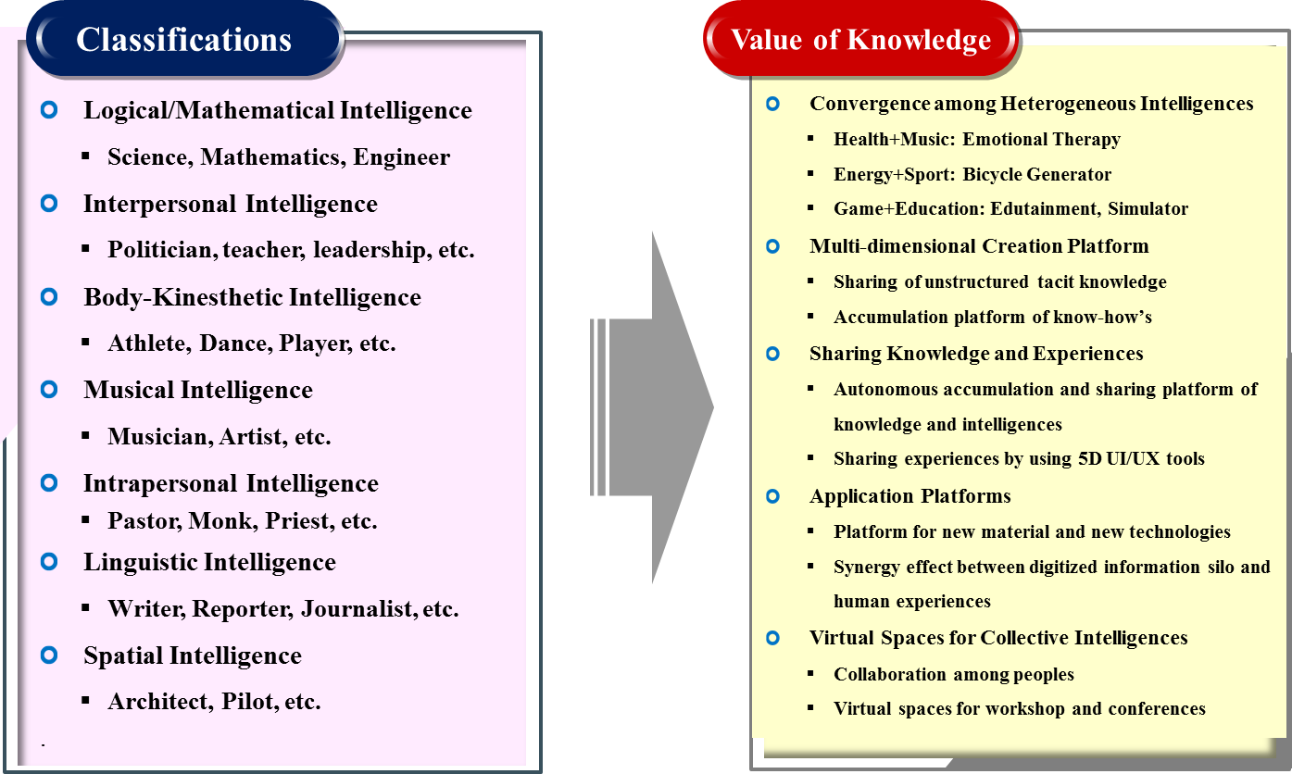
Figure 2 – Expecting value of knowledge by classification of intelligences
Sociality of knowledge
There is implicit knowledge (as with practical skill or expertise) or explicit knowledge (as with theoretical understanding of a subject). If a person has sufficient knowledge, he is thinking, making a judgement, and has an action for a subject. In order to collect sufficient information and knowledge, he searches for the related documents, discusses with colleagues, hears the opinions and shares the experiences of experts so that he can have a commonly accepted opinion on a topic. In a knowledge society, knowledge is recognized as the fundamentals of politics, economics, and culture. Individuals, communities, and organizations produce knowledge-intensive results. Peter Drucker viewed knowledge as a key economic resource in his 1969 book "The Age of Discontinuity" [13]. Knowledge is a commodity of knowledge workers to be traded for economic prosperity.
Similar to the recent social networking services, the heart of online knowledge sharing communities are the members who interact through technology and experience. The members discuss their community while constantly providing feedback that is used to shape and extend their knowledge. The social network provides best practices to ensure the synergy effects of knowledge in an area of a particular interest of each community. An interaction among people influences the development of knowledge. The collection and accumulation of knowledge drives to solve difficult problems that humans confront. For scientific matters, individual scientists are gathering ideas and opinions from communities based on some hypothesis and experimental results. The road to knowledge needs social networking environments via people, conversations, connections, and relationships. Therefore, all knowledge is socially mediated and access to it is achieved by connecting people. The social networking is to build a collection of human communities.

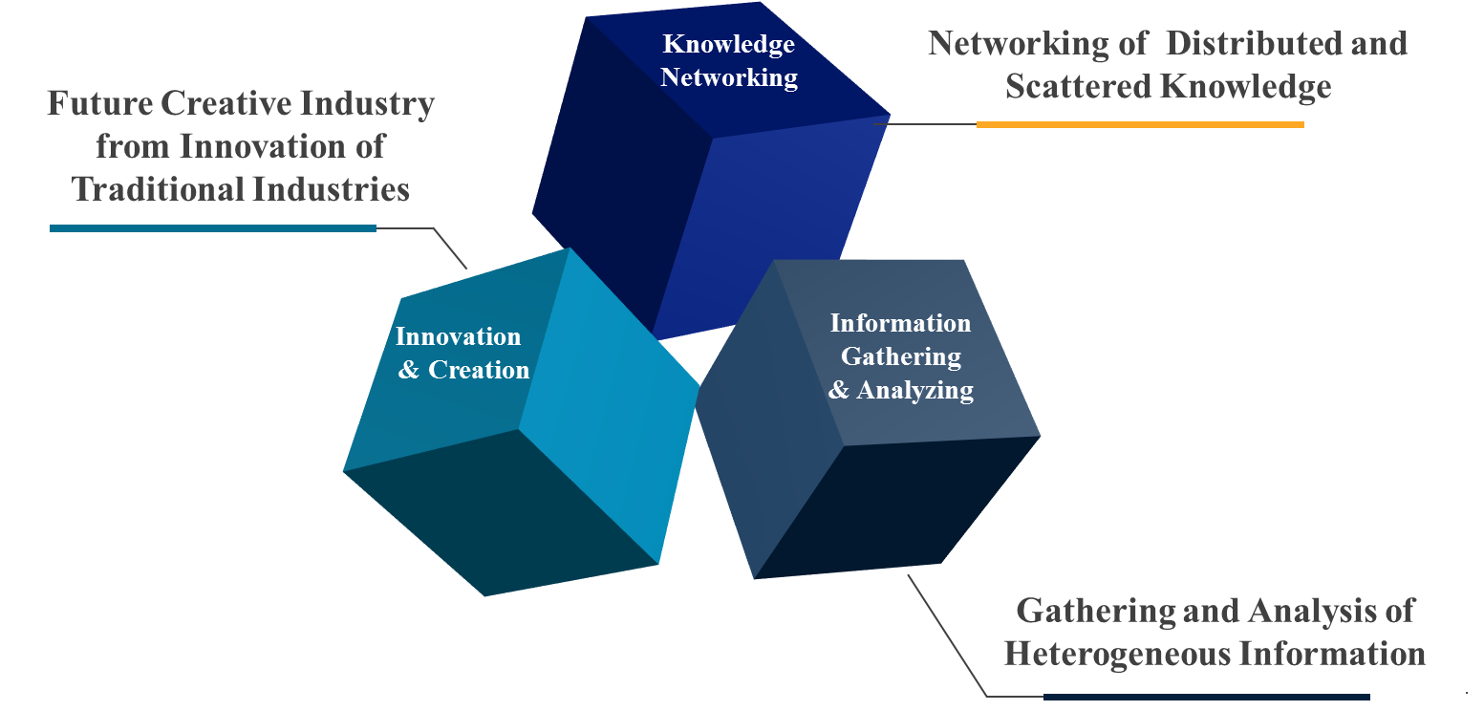
Figure 3 – Key features of knowledge society

Features of knowledge networking
From the perspectives of information and communication technology (ICT), knowledge is reusable information in a specific context. Knowledge networking is an effective way of combining individual knowledge, experiences, and skills in the pursuit of personal and community objectives. Knowledge is shared, developed, and evolved in the creation of new values. ICTs provide a new era of human thinking and knowledge processes. For knowledge workers, the use of ICTs has steadily changed from computation and communication. When people think about new concepts and patterns on real challenging issues, they can use the computing system to search in the local or external databases, use the e-mail and conference system, and discuss together with experts. The new work environments provided by ICTs attract highly motivated and knowledgeable individuals to address the detailed technical issues and engage in conceptual arguments. All the time through networking, knowledge is being continually evolved and developed. A lot of debate is invited and helpful criteria are suggested. To solve the outstanding problems, offline or one-to-one conversations can take place at the same time during the conference. Sometimes, within hours an expert solves the problems and then people make the decision with enough wisdom of the know-how.
Figure 3 shows the key features of knowledge society. First, knowledge networking is a collection of distributed and scattered knowledge. There is a rich and dynamic phenomenon of knowledge since it is more than access to information, more than the rules and inferences from theory, and more than tacit knowledge and wisdom of people's experiences. Second, from openness of communication, people gain information from experts in heterogeneous domains. They are willing to contribute their knowledge freely. The challenging problems are analysed by experts in different domains. The genuine process of cooperation is essential to share conclusions in harmony. Third, in knowledge society, a breakthrough innovation in a business matter helps to get patents. The scientific innovation leads to productive growth in related industries. The more radical and revolutionary innovations are easy to emerge from research and development through exchange of professional experiences. The information and communication technology can provide a new work environment favourable to innovation. With the help of ICTs, future new industries can be invented from creative idea generation.

Cross-disciplinary and interdisciplinary knowledge
One of the key characteristics of knowledge is seeking to synthesize broad perspectives, skill, experiences, and know-hows by crossing boundaries and thinking across traditional academic schools. Interdisciplinary knowledge is applied not only with education and training, but also with research and development. To solve the global common tasks on climate change and health, interdisciplinary studies are important to connect and integrate people with different knowledge disciplines such as physics, biochemistry, engineering, economics as well as information and communication technology.
Until now, the interdisciplinary studies are not easy if there is no agreement of soft and sufficient autonomy. Most experts with a specific knowledge in a certain domain may try to keep their own traditional methods and perspectives. Ideally, the synergy effects among people with broad dimensions and different experiences are promising. However, this contradicts the opinion that traditional disciplines are a barrier for experts who hesitate to commit themselves in interdisciplinary issues. Most organizations or scholarly journals build up their own silos of knowledge, where they store their disciplines to maintain the level of knowledge which is proudly accumulated in their own area.
The interdisciplinary activities are better suited for researchers with more than two disciplines to solve cross-domain problems. From the ICT perspectives, the research and development related to the Internet of things (IoT) and machine-to-machine (M2M) technologies are needed to collaborate with cultural and social sciences as well as in economics. In the scientific domain, the examples of interdisciplinary research areas include neuroscience, cybernetics, biochemistry and biomedical engineering. However, if the cooperative and collaborative procedures for interdisciplinary studies lack consensus, it would be difficult to carry out this interdisciplinary research.
To solve the global problems, the knowledge of eco-environments may consist of people, organizations, and processes that work together. The systematic framework would be defined with the belief that the component parts of a system can best be understood in the context of relationships with each other rather than in isolation. The ICT infrastructure can promote the interdisciplinary communication in order to avoid the silo effects of knowledge.
Knowledge accumulations
Knowledge accumulation is a step in creative thinking where information is gathered and analysed for a new idea. The societies possess huge knowledge accumulated by their own activities and experiences. Every society has its own knowledge assets. To envisage knowledge revolution of information and communication technology, the following issues are outstanding:
• How to connect the different forms of knowledge
There are many forms or types to represent knowledge or intelligences, and some forms are not represented by words. Tacit knowledge (or implicit knowledge) is difficult to transfer to other persons by means of writing it down in a document.
• New forms of development, acquisition, and spread of knowledge
The existing knowledge management relying on writing is quite restricted. New forms of capturing, developing, sharing, and effectively spreading knowledge would be needed by utilizing the ICT infrastructure as well as the computing and storage system. Texts and audiovisual forms of knowledge would be extended to the use of the five senses of human beings: sight, hearing, tasting, smelling, and touching.
• New media as useful tools of the Internet and the web
The existing file format across the Internet would be expanded to transfer various types of knowledge. The hypertext markup language (HTML) of the web technology is only designated to the text-based name of media types of software applications, audio, image, video and their mixed combinations. Digital technologies by using computer and the Internet can provide new means of communication and expression of knowledge. New media can replace the old media such as television, radio, movies, music, newspapers, magazines, books, and most printing materials.
• Cultural and linguistic diversity of knowledge
Languages, with their complex implications for identity, communication, social integration, education and development, are of strategic importance to create knowledge. Linguistic diversity plays a vital role in knowledge creation and accumulation to foster cultural diversity and intercultural dialogue. The multilingual forms of knowledge would be encouraged to preserve the existing cultural heritage.
Data → Information → Knowledge → Wisdom framework
"Knowledge Pyramid" refers to the representation of functional relationships between data, information, knowledge, and wisdom. "Typically information is defined in terms of data, knowledge in terms of information, and wisdom in terms of knowledge" [14]. From the ICT perspectives, data is simply defined as a string of bits which have no meaning or values because of lack of contexts and interpretation. When sensory signals of light, heat, sound, force, and electromagnetic are converged to digital forms, the data has a meaning with relevant description or additional explanation. Data itself cannot contain any information and it looks like noise without meaning or interpretation of empirical perception. Information is inferred from data and is defined as data that are endowed with meaning and purpose. If data to be sent is combined with interpretations from previous experiences and human cognitive intention, etc., the valuable information can be extracted. Also, when a lot of data streams are integrated or collectively analysed with other data, new information that could not be coming from individual data may be found. Knowledge is a difficult concept which is typically defined with reference to information. Humans can capture knowledge if information has been processed, organized, evaluated, or structured with combinations of experiences, insight, and intelligent cognitive decisions. Knowledge is only perceived by humans. By extending information inferred by data, knowledge is sometimes described as [14]:
– synthesis of multiple sources of information over time;
– organization and processing to convey understanding, experience and accumulated learning;
– a mix of contextual information, values, experience and rules.
One interesting issue is that knowledge has a recursive nature with data and information. When people write books and communicate with others, a set of data (i.e. texts, sounds, and images, etc.) is used to deliver information and knowledge. For voice telephony, tele-conferences or e-mails through the network, the digital bit stream can be interpreted to deliver information and knowledge together. It can be recognized depending on the level of interpretation and perception.

Context
Understanding
Data
Information
Knowledge
Wisdom
Understanding
relations
Understanding
patterns
Understanding
principles
-Who
-What
-When
-Where
-How
-Why
Feedback
Figure 2 – Data-information-knowledge-wisdom (DIKW) process (ref. [14])

Better understanding of information versus knowledge
From the ICT perspectives, there are some additional interpretations of information and knowledge as follows:
– Information is a knowledge-generating tool.
– Information is only raw data, the basic material for generating knowledge. Information is not only raw data but also the product of an operation by which it becomes a shaping or packaging to make it manageable, transmissible and consumable.
– Information is a fixed stabilized form of knowledge, while exchange knowledge is achieved by transmission.
– Information is a commodity where knowledge is shared with certain rights or restrictions (e.g. intellectual property, traditional form of knowledge, etc.).
– Information is a useful set of data to master the available information with critical judgement and thinking, analyse, sort, and incorporate the items in a knowledge base.
– Through flows of information, everyone is able to develop cognitive and critical thinking skills to distinguish between useful and useless information.
– By the reflective nature of judgement required to convert information into knowledge, knowledge processing involves more than a mere verification of facts. It implies a mastery of certain cognitive, critical and theoretical skills.
– There are different information-use strategies based on useful knowledge.
– Knowledge is precisely what enables us to "orient ourselves in thought".
– To transform information into knowledge, the distinction between knowledge and information must also take into account the process whereby knowledge is shaped as information.


Socialization
Externalization
Internalization
Combination
Empathizing
Articulating
Embodying
Connecting
Tacit
Explicit
Explicit
Tacit
Figure 5 – Recursive cycle of knowledge creation (ref. [15])

Recursive natures of knowledge
Knowledge creation has an iterative and recursive nature between tacit knowledge and explicit knowledge [15]. "Tacit knowledge represents the internalized knowledge that an individual may not be consciously aware of, such as how he or she accomplishes particular tasks" with unexplainable know-how. "Explicit knowledge represents the knowledge that the individual holds consciously in mental focus, in a form that's easily communicated to others." [15]. When tacit knowledge is extracted to become explicit knowledge, explicit knowledge is re-internalized into the tacit knowledge. Based on the iterative nature of knowledge, there can be a continual evolution of knowledge through socialization, externalization, combination, and internalization. By understanding the process of how data and information is stored, related, and integrated (data layers) and how people will want to access and utilize the information (information and knowledge layers), the steps in addressing the technology needs of a knowledge creation in the ICT environment are clarified.
Knowledge platform for complex systems
To solve the human genome and complex systems, a large number of interacting processes are needed among all the components. Moreover, the activity of individual components are non-linear. The sciences of complexity systems such as the earth's global climate, human brain, and social organization are necessarily based on interdisciplinary researches. Almost all interesting processes in nature are highly cross linked. Many systems which interact non-linearly to form compound structures or functions require more explanatory devices to explain the building blocks. This process for new, complementary, modes of description is known as hierarchical self-organizing systems that are defined as complex. The complex system is comprised of a large number of strongly interacting entities, processes, or agents, which requires understanding new scientific tools and non-linear models without equilibrium descriptions. In addition, to solve the human genome, a lot of networking environments are needed: 1) the gene networks that direct developmental processes; 2) immune networks that preserve the identity of organisms and social insect colonies; 3) neural networks in the brain that produce intelligence and consciousness; 4) ecological networks; and 5) social networks comprised of transportation, utilities, and telecommunication systems, as well as economies. The ICT infrastructure with the help of cloud computing can provide massive computer simulations for complex systems.
A stepwise approach toward future knowledge society
For the networked society, knowledge is a source of all human beings including behaviours and building society. The networking of knowledge and the speeding up of information processing open up new possibilities for work according to their use and their ultimate purpose. The current Internet as a public network gives fresh opportunities to achieve equal and universal access to knowledge. True knowledge society is evolved from sustainable development of the ICT infrastructure.
Jeremy Rifkin in his 2011 book "The Third Industrial Revolution" said that there will be new information and communication technologies associated with a change in knowledge systems and patterns [16]. With the advent of virtual world during the digital revolution, the society of the intangible always confers greater strategic advantages and power over the tangible. Jeremy Rifkin explores how Internet technology and renewable energy are merging to create a powerful "Third Industrial Revolution". He asks us to imagine hundreds of millions of people producing their own green energy in their homes, offices, and factories, and sharing it with each other in an "Energy Internet", just like we now create and share information online. The Third Industrial Revolution by using Internet technology will create thousands of businesses and millions of jobs, and usher in a fundamental reordering of human relationships. It will impact the way we conduct business, govern society, educate our children, and engage in civic life. The revolution toward knowledge society improves thermodynamic efficiencies, dramatically increases productivity, and reduces the marginal cost of producing and delivering a full range of goods and services to near zero across the entire economy.

New technologies for knowledge society
Data formats depending on applications
Through the ICT infrastructure, there are various digital data types and formats including audio/video as well as files. In telecommunication and broadcast applications, the content formats are used in recording and transmission, which include analogue and digitized contents. The contents may be delivered via transmission channels, encrypted in digital forms, recorded in storage and processing methods, and displayed on the screen. The metadata provides the descriptive information of the data such as means, purpose, time and date, creator or author, and location, etc.
For Internet applications, there are many file types and formats that are encoded for digital storage in a computer. Some file formats such as hypertext markup language (HTML), scalable vector graphics, and source codes of computer language are used with defined syntaxes and possible control characters. The chunk-based file format are used for the Internet, in which the identifiers are human-readable and classify parts of the data such as "surname", "address", "rectangle", and "font", etc. The information that identifies a particular "chunk" may be called by "field name", "identifier", "label", or "tag". The data format with multipurpose Internet mail extensions (MIME) header, comma-separated value (CSV), extensible markup language (XML), and JavaScript object notation (JSON) are used on the Internet and the web. Recently, unstructured file formats of raw data are widely used by dumping memory or collecting sensing data of Internet of things (IoT) devices. The unstructured data is difficult for reading and writing without conversion to a structured format. To identify a file format, the internal metadata is stored inside the file itself. Typical file header contains metadata about content format, size, resolution, colour, and optional authoring information. Such metadata may be used by reading, interpreting, and displaying the file.
For the location-based applications, the geographic data format is used to capture, store, edit, analyse, share, and display spatial or geographical information. The geographical data are used for location-enabled services such as transport/logistics, real estate, public safety, crime mapping, national defence, and climatology. The global positioning system (GPS)-enabled mobile devices are used to display their location in relation to fixed objects (nearest restaurant, gas station, and fire hydrant, etc.) or mobile objects (friends, children, and police cars, etc.). The geographical data represent real objects such as roads, lands, trees, houses, buildings, and waterways, etc. Moreover, abstraction references like images, vectors, points, lines, and polygons are mapped to location attributes. A new hybrid method of data is identifying the physical location which combines three-dimensional vector points of physical space. This information is becoming more realistically visually descriptive. Recently, the web access to huge amounts of geographic data enables users to create customer applications and make complex spatial information, which is called mashup application of the web. An editable map of the geographical data is used to offer street maps, aerial/satellite imageries, geocoding, search, and car navigation, etc.
For the identification-related applications, the identification can mean the process of recognizing or identifying persons, objects, or animals, etc. The bar code is increasingly being used in the industry, and the radio frequency identification (RFID) is being used as an alternative. In these applications, the identification is used to reduce running out of stock or wasted products. Credit cards and passports in the wallet are to prove who you are. Recently, biometrics, iris recognition, and voice recognition technologies are used for identification. Theft and counterfeiting of critical or costly items such as drugs, food, repair parts, or electronic components will be reduced because manufacturers will know where their products are at all times. Product wastage or spoilage will be reduced because environmental sensors will alert suppliers or consumers when sensitive products are exposed to excessive heat, cold, vibration, or other risks. Supply chains will operate far more efficiently because suppliers will ship only the products needed when and where they are needed. Consumer and supplier prices should also drop accordingly.
For data intensive applications, a large volume of data typically terabytes in size and referred to as big data are processed. Computing applications requiring large volumes of data and their processing times to I/O are deemed data intensive. The rapid growth of the Internet led to vast amounts of information available online. Parallel processing can typically involve partitioning or subdividing the data into multiple segments which can be processed independently using the same executable application program in parallel on an appropriate computing platform. The data-intensive computing are managing and processing exponentially growing data volumes, significantly reducing associated data analysis cycles to support practical and timely applications. Information extraction and indexing of web documents can derive significant performance benefits on data parallel executions since the web can be processed in parallel. The semantic query language like SPARQL protocol and RDF query language (SPARQL) may be enabled to retrieve and manipulate data stored in RDF format of the web. Massive data from millions of IoT sensors may need the non-structured query language (NoSQL) database for storage and retrieval of data, making some operations faster than the relational database. The high-speed ICT infrastructure allows the data to be partitioned among the available computing resources and processed independently to achieve performance and scalability based on the amount of data. The cloud computing system controls the scheduling, execution, load balancing, communications, and movement of programs and data across the distributed computing cluster.
For science and engineering applications, various types of signals or information such as electromagnetic signals or biometric information are converted to digital forms. The weather conditions and chemical formula are represented by digital data. The conversion of analogue symbols or signals to digital is needed to relevant mapping methods or converting rules.
The data formats described above are summarized as follows:

• Telecommunication and broadcast applications:
– Audio data encoding including analogue and digital audio;
– Visual data encoding including film, colour, graphic, 3D display, and holographic format, etc.
– Descriptive data encoding including metadata, etc.
• Internet and web applications (including semantic contexts):
– File, image, documents, computer language, etc.
– Chunk-based formats (e.g. MIME, CSV, XML, JSON, etc.).
• Location-related applications:
– Geographical information including geographical map and physical 3D spaces;
– Mainly used for transport and logistics industry (by using geolocation maps).
• Identification-related applications:
– Sensor/radio frequency identification (RFID) code, product code, bar code, etc.
– Used for trade, copyright, and ownership (e.g. shipping code, product value chain, security key, etc.).
• Data intensive applications:
– NoSQL, SPARQL, big data analytics by using MapReduce and Hadoop;
– Used for business intelligences in government and commercial solutions.
• Science and engineering applications:
– Electromagnetic spectrum, traffic signal, time, weather, temperature standards;
– Used for healthcare and medical data (e.g. deoxyribonucleic acid (DNA) sequence, biometric data including drugs, etc.).
Data models
The entity-attribute-value (EAV) model is a data model to describe entities where the numbers of attributes (properties, parameters) that can be used to describe them are potentially vast, but the number that actually applies to a given entity is relatively modest. In mathematics, this model is known as a sparse matrix. EAV is also known as object-attribute-value model, vertical database model, and open schema. This data representation is analogous to space-efficient methods of storing a sparse matrix, where only non-empty values are stored. The data type of EAV offers a limited set of data types: byte, Boolean, DateTime, double, and string, in addition to dividing numeric data into int, long, or float. It also defines custom data types such as a phone number, an e-mail address, geocode, and a medical record, etc. The cloud computing system offers data stores based on the EAV model, where an arbitrary number of attributes can be associated with a given entity. XML provides a framework on top of an EAV design and builds an application that has to manage data sets extremely complicated when using EAV models.
The data serialization model is used for computer science and communication network. The context of data serialization is the process of translating data structures or objects into a format that can be stored in a file or memory buffer, or transmitted across the network. For communication network, this process is not straightforward since data serialization is formatted by their associated protocol. In addition, a communication system running on a different hardware architecture should be able to reliably reconstruct a serialized data stream. Serializing the data structure prevents the problems of byte ordering, memory layout, or simply different ways of representing data structures.
The metadata model describes the contents and contexts of data or data files. Metadata was traditionally similar to the card catalogues of libraries. As information has become increasingly in digital form, metadata is used to describe digital data. For example, most files and documents include metadata specifying what language the page is written in, what format was used to create it, and where to find more information about the subject. There are two types of metadata: structural metadata and descriptive metadata. Structural metadata is the data about the containers of data. Descriptive metadata uses to describe individual instances of application data or the data contents. The main purpose of metadata is to facilitate in the discovery of relevant information, more often classified as resource discovery. Metadata also helps organize electronic resources and provide digital identification.
At the XML format, a set of rules to which an XML document must conform, called XML schema published as W3C, can be used to the processing of XML document [17]. Technically, a schema is an abstract collection of metadata, consisting of a set of schema components, mainly elements, attribute declarations, and complex and simple type definitions. These components are usually created by processing a collection of schema documents, which contain the source language definitions of the components. Schema documents are organized by namespace. All the named schema components belong to a target namespace which is a property of the schema document. A schema document may include other schema documents by using the same namespace and may import schema documents for a different namespace.
With the advent of web services, there are many markup languages, especially the hypertext markup language (HTML), which is the standard markup language used to create web pages [18]. It is a markup language that web browsers use to interpret and compose text, images and other materials into web pages. Web browsers can read HTML files and render them into visible or audible web pages. HTML describes the structure of a website semantically for presentation, making it a markup language, rather than a programming language. The HTML elements form the building blocks of all websites. HTML allows images and objects to be hyperlinked and can be used to create interactive forms. It provides a means to create the structured documents by denoting structural semantics for texts such as headings, paragraphs, lists, links, quotes, and other items. The language is written in the form of HTML elements consisting of tags enclosed in angle brackets like <html>. Browsers do not display the HTML tags and scripts, but use them to interpret the contents of the page. HTML can include scripts languages such as JavaScript which affect the behaviours of HTML web pages. Web browsers can also refer to cascading style sheets (CSS) to define the look and layout of texts and other materials.
If the metadata is stored in HTML format, it is very easy to share on the Internet. The files representing metadata can be grouped into three parts: structured texts from reference points to data, how the files can be accessed, and location information of files. HTML prescribes how the text will be formatted visually, which fonts will be used and on which place, where the image will be situated, and where the heading of the chapter is located, etc. However, it is typical for the descriptions of the documents that they can be classified into various categories. These categories form a certain hierarchy depending on their significance. The differences of content are not always represented visually in formatted documents, but they are very important for the mass processing of metadata.
The data models described above are summarized as follows:
• Entity-attribute-value (EAV) models
– Making statements about resources.
• (Examples) XML document type definition (DTD), tag, name, address, etc.
• Data serialization models
– File, memory buffer, packets of communication protocol, and time-varying data, etc.
• (Examples) binary/integer/real/exponent/character/string/Boolean/time, vector/matrix/array, 2D/3D graphics, recursive, audio/video stream, etc.
• Metadata/schema/markup data models
– Specify the processing to be performed or the related actions (i.e. layout, activate, trigger, and invoke, etc.).
Data storage
There was a long history of writing, recording, and storing information. Recording can be done using virtually any form of energy, spanning from manual muscle power in handwriting, to acoustic vibrations in phonographic recording, to electromagnetic energy modulating magnetic tape and optical discs. A storage device may hold information. Electronic data storage requires electrical power to store and retrieve data. Electromagnetic data may be stored in either an analogue data or digital data on a variety of media. This type of data is considered to be electronically encoded data, whether it is electronically stored in a semiconductor device. Most electronically processed data storage media (including forms of digital data) are considered permanent (non-volatile) storage, that is, the data will remain stored when power is removed from the device. In contrast, most electronically stored information is volatile memory while it vanishes if power is removed.
Except for printed data, electronic data storage is easier to revise and may be more cost effective than alternative methods due to smaller physical space requirements and the ease of replacing (rewriting) data on the same medium. However, the durability of printed data is still superior to that of most electronic storage media. The durability limitations may be overcome by the ease of duplicating (backing-up) electronic data. In this digital age, the long-term durability may be more significant since more than several zeta-bytes of the storage capacity may be needed within few years.
The information files stored on millions of servers constitute educational, cultural, and scientific resources. "Web culture" is characterized by the extreme rapidity of data-flows and rapid obsolescence. The average lifespan of an Internet page is less than one month. To preserve the accumulated information in a knowledge society, one of the possible solutions is to utilize electronic capturing devices and cloud computing storage on the web. To archive data in the cloud computing system, there is the problem of indexing files. By the uniform resource locator (URL) of the web, the successive version of the same documents should be lined up with its date of release. Digital storage is unlimited by time, geography, culture or format. It may be culture-specific but remains potentially accessible to every person in the world. The new storage technologies permit important advances regarding the accessibility and manageability of knowledge. The digital content itself has a subject to some degree of standardization without problems of incompatible formats.
Data classification and filtering
In the era of zeta-bytes, digital data would be well arranged, sorted, and prepared for searching, filtering, grouping and classification. Data classification is the process of organizing data into categories for effective and efficient use. A well-planned data classification makes essential data easy to find and retrieve. This can be of particular importance for access and search. The relevant procedures for data classification should define what categories and criteria people will use to classify data. If a data-classification scheme has been created, the appropriate handling procedures for each category should be addressed with data's life cyle requirements. It is essential that data classification is closely linked with data categories. Data classification is clustering the data sets by an iterative process of data category. New data sets can be categorized by new classification rules of knowledge and intelligence. The effectiveness of data classification is measured by predictive accuracy, speed of sorting and clustering, scalability on large amounts of data, and robustness of data quality.
In scientific and engineering fields, data classification raises the issues of identifying new observations from the existing categories of knowledge. It is considered as a kind of researching, analysing, and learning. It involves grouping data into categories based on the measure of inherent similarity. Data clustering for pattern recognition from a large amount of statistic data of images and speeches is used to identify a member of possible classes with the highest probability. Probabilistic algorithm with statistical inference is to find a best instance. In experimental and statistical analysis, data classification is done with logistic regression or a similar procedure. New observations on experimental results are referred to create new categories of possible values or outcomes.
Meaning of hyperlink, linked data, and linked open data
The outstanding difference of the web page compared with other plain documents is the hyperlink, which points to a specific web page or to a specific element within a document [19]. The hyperlink is used to link information to any other information over the Internet. It is integral to the creation of the World Wide Web. Web pages are written in the hypertext markup language (HTML). Hypertext is the text with hyperlinks. The hyperlink is a reference to data that the reader can directly follow by clicking. Users navigate or browse the web page following the hyperlinks. On the web page, most hyperlinks cause the target document to replace the document being displayed. The effect of the hyperlink may vary with the hypertext system. A link from one domain to another for a common destination anchor is a uniform resource locator (URL) used in the World Wide Web. It is achieved by means of an HTML element with a "name" or "id" attribute at the HTML document. A web browser usually displays a hyperlink in some distinguishing way, e.g. in a different colour, font or style. The behaviour and style of links can be specified using the cascading style sheets (CSS) language.
In a graphical user interface of web browsers, the hyperlinks are displayed in underlined blue texts when they have not been visited, but are displayed in underlined purple texts when they have been visited. When the user activates the hyperlink (e.g. by clicking on it with the mouse), the browser will display the target of the link. If the target is not an HTML file, depending on the file type and on the browser and its plug-ins, another program may be activated to open the file. The document containing a hyperlink is known as its source code document. For example, in an online reference work such as Wikipedia, many words and terms in the text are hyperlinked to definitions of those terms. Hyperlinks are often used to implement reference mechanisms, such as tables of contents, footnotes, bibliographies, indexes, letters, and glossaries.
The linked data builds upon standard web technologies such as hypertext transfer protocol (HTTP), resource description framework (RDF) and uniform resource identifier (URI). It describes a method of publishing structured data and enables data from different sources to be connected and queried. The linked open data (LOD) is the linked data that is open content. Tim Berners-Lee outlined four principles of the Linked Data in his "Design Issues: Linked Data note", paraphrased along the following lines [20]:
– Use URIs to name (identify) things.
– Use HTTP URIs so that these things can be looked up (interpreted, "dereferenced").
– Provide useful information about what a name identifies, when it is looked up, using open standards such as RDF, SPARQL, etc.
– Refer to other things using their HTTP URI-based names when publishing data on the web.
Metadata technology
The two groups of data are created during the digitization processing:
– digital copies of documents;
– the supporting structure, mostly textual, which enables access to the first group of data.
Let us call the first group data and the other one metadata. The data are, for example, images of the manuscript pages, while the metadata are descriptions of these pages. The distinction between these two groups is rather imprecise, because the digital copy can often be directly a component part of the description. In this case, the point of the end-user view is decisive and the metadata can be taken as the whole description including various preview images which are component parts of the texts, while the data is not a visible part of description and is referenced from it as an external file.
The metadata has two important functions to describe data and to provide access to data. Two groups of data must be decided by data formats, especially the metadata. The data format including metadata should comply with the following requirements [22]:
1 It is independent of software which will enable the user to work with metadata.
2 It should enable to classify metadata into various categories such as author, shelf-number, and page number in case of the description of a book. This classification is very useful for the mass processing of data.
3 It should enable the hierarchical classification of metadata in order to make the difference between the description of a book as a whole and the description of a page.
4 It should enable an easy transition from metadata to data.
Advantages of the web browser
With the rise of the web, the communication capacities and cognitive skills of humans are extended as active and interactive manners where individuals are not passive recipients and are capable of constituting, quite autonomously, virtual communities. The web can work to provide a gigantic pool of ideas, whether it is a matter of pieces of information or of knowledge itself. With a browser, the web is quite obvious for people to open their preferred websites multiple times a day. The web browsers are running on almost all types of computers and running on all kinds of operating systems. Many people are using the web to get the news, weather forecasts, cooking recipes, medical diagnoses, book reviews and the like. They are also using the web to book flights, plan vacations, buy and sell goods, and express opinions, etc. The major advantages that the web holds relative to the other media include [18]:
– Time: With radio and TV, the rare events that are important to a broad group of viewers could be reported live or in minutes. More typically, the delay is hours to a day. With newspapers, it takes closer to a day, sometimes more, before the news is received by the readers. With the web and smartphones, people are reporting on (e.g. through Twitter, crowd-sourcing, etc.) and reading about events about when the events occur. People get pictures and information almost instantaneously.
– Localization: The traditional media such as newspapers, radio and TV reports information relevant to a relatively large geographical region. It is more difficult to find localized information at the small community level. With the web, a village, independent of size and any community (even though it is separated geographically), can share information relevant to their members and citizens wherever web access is possible.
– Universality: Radio, TV, and newspapers usually cover a relatively large geographic area, and they are typically available only to people living in that area. It is difficult for people outside of the area to access those media. The web is universal and available anywhere in the world. It allows people today to book a hotel and prepare vacations on the other side of the world.
– Focus: There are today millions of communities specialized on specific themes (languages, hobby, nature, etc.). When there are thematic radio, newspaper, TV, and magazines, their diffusion is geographically limited. When these communities are spread over the web, the web enables people with shared interests to exchange their resources independently of their respective locations.
– Search: Mechanisms such as libraries, guides, reviews, and word-of-mouth can help people to find information that they seek in traditional media. On the web, search engines, as well as easier access to guides and reviews, facilitate the quest for information. The volume of information on the web and the ability to assess the quality of information are surprisingly remarkable.
– Linking: A person can change channels on the radio or TV, or pick up one newspaper and then move to another. On the web, links allow people to move easily from one web page to related information elsewhere on the same page, on the same site or one a different site half-way around the world. The emergence of the semantic web promises to extend this capability to linking data and ascribing greater meaning to data and relationships across the web.
Knowledge structure
Humans understand knowledge from a combination of data, information, experience, and individual interpretation. Knowledge is the sum of what is known and resides in intelligence and competence of people. There are various definitions of knowledge as "things that are held to be true in a given context and that drive us to action if there were no impediments", "capacity to act", "justified true belief that increases an entity's capacity for effective action", and "the perception of the agreement or disagreement of two ideas" [9]. There are three basic schemes of knowledge to be organized:
– Declarative knowledge: How and why the things work the way they do. It includes information about concepts and elements of particular subjects.
– Procedural knowledge: Detailed steps or activities required to perform a task or job. It allows a task to be performed into automatic (habitual) processes with repetition.
– Structural knowledge: A basis for problem solving. It is required in the creation of plans and strategies by analysing what to do, when failure occurs, or when a piece of information is missing. The conceptual elements in the knowledge structure are the key to having a "deeper understanding".
A typical example of tacit knowledge are know-how results from experience, information, knowledge, learning, and skills of humans and human communities. Knowledge creates the longest lasting competitive advantage and is an essential component of the human capital. It may consist entirely of technical information (as in science and technology area) or may reside in actual experiences or skills acquired by the individuals (as in manufacturing or medical industries).
In scientific and technological fields, the various types of knowledge are also identified as [23]:
– Conceptual knowledge, such as the concept of momentum or energy, or that the velocity of an object changes when it accelerates, or that the gravitational potential energy of an object decreases as it falls.
– Factual knowledge, such as the value of the gravitational constant g, the radius of the moon, or the density of iron.
– Representational knowledge, such as how to draw and use graphs.
– Strategic knowledge, such as the ability to recognize the applicability of a concept, for example, momentum is conserved when there are no external forces, or that energy is conserved when there are no non-conservative forces.
– Meta-cognitive knowledge, for example, the awareness of underlying assumptions, or that an answer should be checked by solving the problem a different way.
– Self-knowledge, such as knowing one's likely sources of mistakes, or knowing that one should be more procedural when solving problems.
– Operational knowledge, such as how to take the cross product or dot product of two vectors, or how to take the determinant of a matrix, or how to draw a free-body diagram.
– Procedural knowledge, such as when to use conservation of energy (i.e. when all forces are conservative), or when to specify a coordinate system (e.g. when finding potential energy), or when to draw a free-body diagram (e.g. when applying Newton's laws).
– Problem-state knowledge, which are the features of a problem used for deciding how to solve it. Examples are: knowing that there are no external forces in a particular problem, or that there are no non-conservative forces in the problem, or that an object is at rest initially, or that the object is on the incline.
Problem solving and decision-making
Recently, most problems raised by the industry or academia are not easy to solve. Problem solving and decision-making are important skills for business and life, and they are especially important to get consensus among individuals or groups of people. To improve the quality of their decisions, decision-makers need to be more decisive in acting upon the assessments.
In the problem solving and decision-making process, the creativity of individuals is essential. The brainstorming technique among people is particularly useful. Good decision-making requires a mixture of skills which includes creative development and identification of options, clarity of judgement, firmness of decision, and effective implementation. For teams and organizations, a perspective of group profiles and human resources can assist in making decisions. The decision-making may be different according to categories of people, especially in a large group of human resources, since some people may have different knowledge backgrounds and different understanding of things.
There are various techniques of problem solving from finding and defining the problems to selecting the best option. To improve the problem solving process, all the members share the current situations and the challenging issues, and seek an optimal solution. The leader encourages a group of members to develop options and select a solution. The social networking technologies may be used to get a consensus among people efficiently and effectively.
Cognitive process of knowledge creation and learning
Most knowledge is conceptual in nature. The relevant cognitive processes are required for acquisition of conceptual knowledge and construction of the useful knowledge structure. As an example, the following activities can be used by teachers to stimulate the cognitive processes needed to develop a conceptual understanding of science and technology [23]:
– Use multiple representations: A representation may be linguistic, abstract, symbolic, pictorial, or concrete. Using many different representations for the same knowledge helps people to interrelate knowledge types and relate knowledge to physical experiences. It encourages the formation of links between knowledge elements and promotes a rich clustering of knowledge.
– Make forward and backward references: Concepts require a long time to be formed. Thus, students completely learn one topic before moving on to the next. By making forward references, new materials are prepared. By making backward references, the new materials with established (or partially established) material are also linked, thus making knowledge interconnected rather than linear.
– Explore extended contexts: Concepts are extremely context dependent and do not become useful until they are well abstracted and recognized. Investigating a broad context of applicability helps people to refine and abstract concepts. It also avoids incorrect or oversimplified generalizations.
– Compare and contrast: Essence to the process of structuring (or re-structuring) knowledge is the classification and interrelation of knowledge elements. Comparisons and contrasts sensitize people to categories and relationships, and help people perceive the commonalities and distinctions needed to organize their knowledge store.
– Categorize and classify: In parallel with comparisons and contrasts, people are aware of categories and classification. People may practice creating and recognizing categorization. By classifying items, to choose names for their categories, and to explain their system, people can restructure their knowledge store.
– Predict and show (inadequacy of old model): Carefully selected demonstrations and experiments can be used to bring out inconsistencies. When experimental apparatus are being set up, people should be asked to predict what will happen when something is done. By making predictions beforehand, people may have a chance to choose alternative solutions if their own model fails.
– Explain (summarize, describe, discuss, define, etc.): The typical problems of learning are what students do not understand. Even when students get a problem right, there can still be confusion about the applicability of the equations used. When the teachers ask students how they will solve a problem, they recognize the misunderstandings and misconceptions of students, and they help the students reorganize their knowledge structure. By seeing the experts' standard demonstrations and experiments, the students can explain and discuss what they think they have seen, so that the teachers can interact with the students' views. Furthermore, the process of explaining (or summarizing, describing, discussing, etc.) helps students become aware of their own models as well as the models of other students.
– Generate multiple solutions: The students have difficulties to choose a solution when there is a set of valid solution paths. By solving problems in more than one way, students learn to prioritize elements of their knowledge.
– Plan, justify, and strategize: To avoid their impatience of solving a problem, students should be asked to plan (and then explain) how they will solve the problems. Students must learn how to determine which concepts are relevant (and which are irrelevant) for any particular problem situation and how to implement the relevant concepts to solve that problem. By generating their own strategies, students can learn how concepts are used to solve problems.
– Reflect (evaluate, integrate, extend, generalize, etc.): After completing most activities, students can get a benefit from looking back on what they have done. What experiences have they perceived? What general rules can be constructed? Other types of activities give students tips of know-hows needed to create a coherent picture of science and technology, but some sort of reflective activity is usually needed to "put the pieces together".
– Meta-communicate about the learning process: To learn science and technology (or any other complex subject), students should become self-involved. They should be exposed to other people (teachers and students) models. By communicating with each other, they must be informed of common pitfalls and misinterpretations and be ready to restructure their knowledge. Students must learn how they learn best. The collective and cooperative learning platforms between students and teachers are needed through ICT infrastructure.
Knowledge platform
The sources of knowledge may include documents, files, database, and recording of best practices or activities. A knowledge platform may need capturing, developing, sharing, and effectively using organizational knowledge. It may be a multidiscipline platform to achieving organizational objectives by making the best use of knowledge. A knowledge platform covers the fields of business strategy, information systems, management, and data and information sciences. More recently by utilizing information and communication technologies, a knowledge platform for other fields such as media, computer science, education, health, and public safety is investigated. In order to encourage the sharing of knowledge, a knowledge platform may focus on the value-added objectives such as the improved performance, competitive advantage, innovation, the sharing of lessons learned, integration and continuous improvement of human society.
Impacts of cloud computing platform
Cloud computing is to share computing resources. Cloud computing and storage provide users and enterprises to store and process their data. It relies on sharing of resources to achieve coherence and economies of scale and maximize the effectiveness of the shared resources. Cloud resources are not only shared by multiple users but are also dynamically reallocated per demand. The key technology for cloud computing is virtualization. Virtualization separates a physical device into one or more "virtual" devices, each of which can be easily used and managed to perform tasks. The key benefits of cloud computing is to increase utilization, efficiency, and productivity when multiple users can work on the same data simultaneously without suffering peak loads, rather than waiting for it to be saved, transferred, and e-mailed. With concepts of service-oriented architecture as "everything as a service" (XaaS), cloud computing providers offer their "services" which happen to form a stack: software-, platform-, and infrastructure as a service (SaaS, PaaS, and IaaS, respectively).
In the evolution of technologies and paradigms toward the knowledge society, cloud computing allows users to share data for specific applications, allows open source software, and gets new opportunities for the connected business among a large group of people, and creates deep knowledge collectively. To reshape the sharing concepts among people and communities, the cloud computing platform is very useful to extract information and knowledge from raw data.
Cloud computing has the ability to develop and design new applications through human knowledge and awareness. It provides a knowledge-based approach for end users to create new values. User's knowledge is stored in the cloud and is accessible everywhere. The essential characteristics of cloud computing are summarized as:
– On-demand self-service: Computing capabilities, such as server time, networked storage, and communication and collaboration services, are being provided automatically without requiring human interaction.
– Seamless broad network access: It can be accessed by heterogeneous mobile phones, laptops, and personal digital assistants (PDAs) anywhere and anytime. The seamless connectivity with high availability as well as high bandwidth is critical in the cloud computing environments. From the customer's point of view, users are reluctant to use cloud computing platforms if there are service disruptions or a stream of packet loss.
– Resource pooling: Physical and virtual resources are dynamically assigned according to user demands.
– Rapid elasticity: The resources of cloud computing are rapidly and elastically provisioned, quickly scaled out and scaled in.
– Measured service: Resource usages of cloud computing can be monitored, controlled, and reported.
From the viewpoint of multiple stakeholders, there are some benefits of cloud computing. From the viewpoint of network providers, the cloud computing platform provides a rich set of communication services such as voice and video calls, audio, video and web conferences, messaging, and unified communications, which may be recently implemented by mashup applications with web technologies. From the perspectives of service providers, cloud computing provides a lot of benefits as follows:
– Cost saving by virtualization of computing resources;
– Improvement of total cost of ownership and risk reduction, which is shifted from capital expense (CapEx) to operational expense (OpEx) by sharing information technology (IT) resources;
– Highly scalable and flexible infrastructure;
– Efficiency and flexibility of resource management;
– Business agility with rapid service deployment;
– Reliability of service with high availability;
– High support of third-party business.
From the user's perspectives, the cloud computing platform provides some benefits as follows:
– Optimized and rapid provisioning: Optimal application software for each business process;
– Anywhere application with any device: Connect online with any device, not only via the desktop but also via a mobile device;
– Pay-per-use pricing: Pay-as-you-go model similar to the subscription-based pricing;
– Low migration costs: Easy to switch to a competing solution by signing a new contract, transferring data, and retraining users;
– Secure important data: Easy back-up and storage of important data in multiple sites.
Impacts of Internet of things technologies
With the development of Internet of things and sensor networks, various types of data are being produced from sensors. In people's life and environments, more and more sensors are expected to detect location, measure temperature and air pressure, and record communication log. In the home, there are smart household appliances with sensors that can collect status about these appliances. They can extract status or presence information from raw data of IoT sensors. This represents some facts or context information about users and recognizes the environment which extends the ability of people's perception. This context information can be organized as the basis of effective reasoning. Users may upload a part of their perceived knowledge to the cloud environment in a certain form of rules. When Internet of things technologies are organized in the cloud computing system, the reasoning and perception processes are running and they invoke some actions for users. Moreover, the cloud provides composed web services which are connected to users and IoT sensors together.
Evolution of cyber physical systems
A cyber physical system (CPS) is a system of collaborating computational elements controlling physical entities which is bridging the physical world to the cyber world. The concept of cyber physical systems can be applied in diverse areas such as aerospace, automotive, chemical processes, civil infrastructure, energy, healthcare, manufacturing, transportation, entertainment, and consumer appliances, etc. In the CPS environments, the functions and processes of the physical elements are mapped to objects or tasks in the cyber domain. With the evolutions of Internet of things (IoT) and machine-to-machine (M2M) technologies, the sensor networks link between computational objects and physical elements. The intelligent IoT/M2M technologies can dramatically increase adaptability, autonomy, efficiency, functionality, reliability, safety, and usability of cyber physical systems. The applications of the cyber physical system, for example, include:
– the medical systems with high confidence, assistance to patients and disabled people;
– the advanced automotive systems with intelligent traffic control and safety;
– the manufacturing and robot systems with intelligent process control;
– the smart grid with energy balance of supply and demand;
– the ubiquitous city with environmental control; and
– the water resources and defence systems with infrastructure control, etc.
However, the cyber physical systems will be more deterministic, predictable, and understandable with the help of IoT/M2M technologies as well as information and communication technologies. The physical world is highly concurrent with cyber objects, which is the abstractions of software. The predictable concurrent computation is possible to satisfy performance and integrity of the system.
To realize the cyber physical system as described above, top-down solutions can complement the existing bottom-up approaches. However, there remain many challenges and opportunities in developing the immature technologies of the cyber physical system. Technically, for the first phase of the evolution of the cyber physical system, all the functions and processes of the physical system could not be mapped to the cyber system. In addition, the physical world is not entirely predictable. Within a certain reliability and predictability, the cyber physical system can be operating in a controlled environment. It should be robust to unexpected conditions and adaptable to system failures. The software in the cyber world should be predictable and reliable in the contexts of the cyber physical system since small deviations of expected operations may cause catastrophic failures. It is important to determine whether the system has performed correctly. The certain mechanism of the cyber physical system should be developed to compensate for the loss of predictability and reliability.
Second, an abstraction of objects and tasks is well defined to hide the detailed physical implementations from the cyber world. The real-time operating system in the cyber system should be hidden from the details of the concurrent operations of the physical systems. Timing in the physical implementation should be tolerant in the software operation of the cyber system. Since the cyber physical system is presumably concurrent, the physical processes coupled with the computing system are also concurrent. They have to control multiple sensors and actuators concurrently.
Third, there are security risks in the distributed applications of the cyber physical system. The proper security technologies should effectively be exploited to improve robustness in the distributed cyber physical system. For example, the distributed denial of service attacks bring about some difficulties in the realization of the cyber physical system. Therefore, the outstanding technical issues should be solved to apply the concepts of the cyber physical system to the real business market.

Vision and technology trends of social media

New trends of social media
Definition of social media
Wikipedia defines social media as the computer-mediated tools that allow people to create, share or exchange information, ideas, and pictures/videos in virtual communities [24]. Social media is defined as "Internet-based applications that allows the creation and exchange of user-generated contents." In another definition, social media has been broadly defined to refer to "the many relatively inexpensive and widely accessible electronic tools that enable anyone to publish and access information, collaborate on a common effort, or build relationships" [25]. Furthermore, social media depends on mobile and web-based technologies to create highly interactive platforms through which individuals and communities share, co-create, discuss, and modify user-generated contents.
The rise of social media has fostered an unprecedented expansion of networks along two axes: the horizontal axis is the transmission speed and the vertical axis is the number of connections. People can communicate more and more and, above all, more and more rapidly. Interactivity is another characteristics of this new digital media. Social media introduces substantial and pervasive changes of communication between organizations, communities, and individuals. Social media differs from traditional or industrial media in many ways including quality, reach, frequency, usability, immediacy and permanence. This is in contrast to traditional media that operates under a single transmission model (one source-to-many receivers).
Social networking services and new ecosystem
A social networking service (also social networking site or (SNS)) is a platform to build social networks or social relations among people who share similar interests, activities, backgrounds or real-life connections. By using the web technology, social network services provide means for users to interact over the Internet, such as e-mails, instant messaging, photo/video sharing, and blogging, etc. Social networking services allow users to share ideas, pictures, posts, activities, events, and interests with people in their network.
Social networking technologies take on many different forms including blogs, business networks, enterprise social networks, forums, microblogs, photo sharing, product/service reviews, social bookmarking, social gaming, and video sharing, etc. There are many social networking services such as Facebook, Twitter, or YouTube [24]. The purpose of the social networking service is to connect between individuals and groups of people who share something in common and are interested in learning from the lives of others. As there are many ways of connecting with people in the real world, there are also a number of social networking services in the virtual world where people communicate with each other in slightly different ways. Some of these networking services are file sharing, traditional and/or voice-video chats, messaging, e-mails, and blogging. There are categories of social networking services like former/current classmates, co-workers, and business groups, friends, dating, or suggested reading usually via some sort of customizable pages that include pictures, lifestyle information, likes/dislikes and more.
With the advent of user-generated contents and sharing features, social ecosystem platforms are very important in social media: the publishing media (with Blogs), the sharing media (with Facebook and Twitter), and the curating media (with Pinterest). The preferences in social media depend on the amount of contents. The value-added content is currently in the curating media. The interesting users' behaviour is the evolution of users' expectations: the more they use social media, the more sophisticated their needs are. As users can experience social media every day, the social media platforms like Facebook and Google are changing with a dense ecosystem of niche players. By using various social media platforms, users are involved in conversations and interactions with various device types (desktop, tablet, smartphones) as well as more sophisticated usages (publishing, sharing, playing, networking, buying, and localization). While social networking services consistently rise, new technologies are observed with the concepts of "real-time web" and "location-based". Real-time web allows users to contribute contents which are then broadcast as they are being uploaded. These concepts are analogous to live radio and television broadcasts. Twitter sets the trends as "real-time" services, wherein users can broadcast to the world what they are doing. Facebook follows suit with their "Live Feed" where users' activities are streamed as soon as they happen. Another real-time service focuses on group photo sharing wherein users can update their photo streams with photos while at an event. The image-based social media has become one of the social networking services. By merging cloud computing platforms with social networking concepts, interactive communities connect individuals based on the shared business needs or the shared experiences. The specialized networking applications can be accessed via their websites, which are closely tied to individual networking relationships based on social networking principles.
Evolution of digital book
For a very long time ago, books have been recognized as the useful material to write, print, and illustrate works of literature or human history. There is a long history of writing from papyrus to electronic books. Recently, most books are now printed in an electronic format which is fed by a continuous roll of paper and consequently more copies are printed in a short time. By adopting new digital printing technology, electronic books are widely distributed for educational, living and business purposes.
One of the problems of traditional books is the make-ready materials when the authors decide that the contents are correct. In periodicals such as magazines, journals, or newspapers, the publishing date is important, but for other types of books (for example, biographies), it is robust like carving in wood. If books are typeset for printing, any changes of contents are not possible. Only reprinting or discarding takes place.
Recent developments in book manufacturing include the development of digital printing. Digital printing has opened up the possibility of print-on-demand with relevant updates, whereas paper books are printed only until after the whole content of the book has been received from the author. It should be noted that digital books should not be modified or changed after their electronic publication. To face an ever-increasing rate of publishing, sometimes called data explosion, new contents and information are readily updated during the electronic printing of books. Since it is available online via the Internet, an online book is a digital medium for an unlimited redistribution and infinite availability in the public domain. Therefore, if digital technology is used in book design, there will be a new art of incorporating content, style, format, design, and sequence of a book. New digital books will be hyperlinked with interdisciplinary knowledge, ready for academic discussion, and collecting various opinions from social networking services. Digital books may be constantly updated and hyperlinked with the advances of contents, which is similar to publication on websites.
Electronic journals on science and technology
In academic publishing, a scientific journal is a periodical publication intended to further the progress of science, usually by reporting new researches. There are thousands of scientific journals in publication. Most journals are highly specialized and have been peer reviewed to ensure that articles meet the journal's standards of quality and scientific validity across a wide range of scientific fields. The publications of scientific research are an essential part of the scientific method. If they describe experiments or calculations, they should supply enough details that an independent researcher could repeat the experiments or calculations to verify their results. Such an article in a journal becomes part of the permanent scientific records.
Articles in scientific journals can be used in research and higher education. Scientific articles allow researchers to keep up to date with the developments of their research field. An essential part of a scientific article is the citation of earlier works. The impact of articles and journals is often assessed by counting citations. Some studies are partially devoted to the explication of classic articles. The seminar by each researcher may consist of the presentation of classic or current papers. Schoolbooks and textbooks have been written usually only on established topics while the latest researches and more obscure topics are only accessible through scientific articles. In scientific research groups or academic departments, the standards that a journal uses to determine publication can vary widely. In many fields, an informal hierarchy of scientific journals exists; the most prestigious journal in a field tends to be the most selective in terms of the articles that it will select for publication.
Electronic publishing is a new area of information dissemination. In an electronic (non-paper) form, scholarly scientific results are written or created for publication or dissemination. The electronic journal is specifically designed to be presented on the website. The electronic journal will exist alongside the paper version because the latter is not expected to disappear in the future. The output on a screen is important for browsing and searching. Many journals are electronically available in formats readable on the screen via the web browsers. Electronic publishing of scientific journals is not costly, is accessible to many people, and is doable due to the availability of supplementary materials (data, graphics, and video).
There is usually a delay of several months after an article is written before it is published in a journal. Paper journals are not an ideal format for announcing the latest researches. Many journals now publish the final papers in their electronic version as soon as they are ready, without waiting for the assembly of a complete issue, as is necessary with a paper publication. In many fields in which even greater speed is wanted, the role of the journal in disseminating the latest researches has largely been replaced by electronic databases. An increasing number of electronic journals are available as open access. Individual articles from electronic journals may be found online and stored either in personal or community archives, or posted on websites as blogs.

Meaning of social connectivity
In the ICT world, connectivity is the ability to make a connection between two or more interfaces in a telecommunication system. Many terminals including machines, appliances, and facilities are used to connect and exchange information with each other. Internet connection may be available to access from home, school, and workplace as well as public places such as libraries and Internet cafes. Coffee shops, shopping malls, and other venues increasingly offer wireless Internet connection. A whole campus or an entire city can be enabled to build a wireless community. There is a gap between people with effective connectivity and those with very limited or no connection, which is one of the digital divide.
In human life, connectivity has changed the way in which many people think, and it also allows them to take advantage of the "political, social, economic, educational, and career opportunities". A social structure composed of individuals, business partners, friends or other organizations is connected by utilizing social media technologies. Human connection is dependent on the intelligence that one brings into it. It influences thought and action, whether to do good or bad things. The needs for human connection can be perceived as physical, spiritual or emotional interactions with others. Humans are supposed to be more responsible and arguably more intelligent. José van Dijck contends in her book "The Culture of Connectivity" (2013) [26] that to understand the full weight of social media, their technological dimensions should be connected to the social domain and the cultural domain. She critically describes six social media platforms:
– three concepts of technology, users and usage, and content as platforms as techno-cultural constructs;
– ownership, governance, and business model as platforms as socio-economic structures.
Environments for crowdsourcing and collective intelligence
In theory, collective intelligence attempts to describe the phenomenon in which large, loosely organized groups of individuals come together to solve problems in highly effective ways. With the new environment of ICT connectivity, it is possible for individuals in separate locations, who may even be anonymous to each other, to work together on the same idea. Together, the concepts are attempting to understand the "wisdom of the crowd". The large network of people to solve problems can extend more broadly as an open innovation which consists of shifting the innovation process from inside the organization to generate ideas with those outside the organization. One of the benefits of collective intelligence is the diversity of ideas to be produced. When an individual tackles a problem alone, he or she may approach it with certain biases. Collective intelligence mitigates these biases by collecting a wide range of viewpoints and then aggregating them to reduce the effects of individual bias. The famous tools for collective intelligence are Wikipedia as a free encyclopaedia and Wiki as a collaborative website.
Crowdsourcing, the best-known example of technology-enabled collective intelligence, refers to the practice of an organization with a large population to solve a problem. To produce better ideas, crowdsourcing is to generate solutions, products and/or ideas that are superior in quality, quantity and effectiveness to those generated by the closed problem-solving methods. The word "crowdsourcing" is a combination of the words "crowd" and "outsourcing". Crowdsourcing is a process of getting work or funding, usually online, from a crowd of people. The idea is to take work and outsource it to a crowd of workers. By definition, crowdsourcing combines the efforts of numerous self-identified volunteers or part-time workers, where each contributor, acting on their own initiative, adds a small contribution that combines with those of others to achieve a greater result. Crowdsourcing can involve division of labour for tedious tasks split to use crowd-based outsourcing, but it can also apply to specific requests, such as crowdfunding, a broad-based competition, and a general search for answers, solutions, or a missing person.

New trends of social media
• Smartphones or social networking services replacing your wallets or credit cards
Recently, by using smartphones and/or social networking services, several millions of users send money to each other by just using their debit card information, free of charge. Meanwhile, the smartphone has also rolled out new payment features. It allows users who save their credit card information to check out with a lot of e-commerce applications across the network. As a result, many business players are battling it out in the mobile payment system, which is known in financial technology as FinTech. The smartphone or social networking services may eventually charge for their money transfer services, leverage customer purchasing data to rival traditional credit cards like Visa and Mastercard.
• Shopping plugs into social media
New buttons labelled as "buy" appear on certain tweets and posts on the social networking services. They allow users to make purchases with just a click which integrates e-commerce and social media. While happily chatting with friends, browsing the latest trends, sharing photos and videos, etc., their payment details are on file and purchases are a tap on the screen. Since most social networking services are real time, the short-term deals are with fleeting trends. With time-sensitive offers, consumers may be inclined to act quickly and make a deal. There are major benefits to advertisers. With the advent of "buy" buttons, concrete revenue figures can be attached to specific social networking messages in a way that has not been possible until now.
• Increasing advertising and privacy problems
A number of niche social networking services are built specifically with the lack of privacy, the collections of demographic and psychographic data, and the increasingly pervasive advertising. They allow users to exchange fully anonymous posts with people who are not physically nearby. The social networking service has promised to share advertisement revenues with users based on the popularity of their posts. New social platforms try to replace the existing social networking services with fewer advertisements or more privacy. The technical challenge is to provide privacy to the global community.
A number of anonymous social networking services with more privacy surge in popularity. Not everyone wants every conversation over the social media to be broadcast to the world, after all. Some users are concerned about ways the personal data is being collected, sold to advertisers, manipulated in tests, or accessed by government agencies.
A few social media fulfil their mandates on privacy issues. Some of them have been hacked with sensitive user photos posted. Real anonymity and privacy is extremely difficult to achieve. For privacy, some social media allows users to create chat rooms around shared interests with no requirement to reveal their names or locations. They allow users to conceal their identity, location, and browsing history.
• Smart devices with IoT sensors are more social
In the near future, cheap IoT sensors are included in smartphones. There is an explosion of smart devices in home appliances like thermostats, bathroom scales and refrigerators to wearables like fitness bracelets and smart watches. Many IoT devices are now collecting data and push notifications to smartphones. The challenge becomes how to more intelligently integrate the fast-growing Internet of things technologies with social media. Smart devices need to improve their social intelligence. By tapping users' social graph on their unique network of friends or listening to social media, it is easy to track users' activities and interactions with friends and followers.

Emergence of new media
By reviewing the existing types of media described above, there is some evidence of the emergence of new media with advances of information and communication technology. The rise of new media has increased communication between people all over the world. It has allowed people to express themselves through blogs, websites, videos, pictures, and other user-generated media. New media most commonly refers to contents available on-demand through the Internet, accessible on any digital device, usually containing interactive user feedbacks and creative participation [27]. New media includes the existing social media such as online newspapers, blogs, wikis, video and games. New media enables people around the world to share, comment on, and discuss a wide variety of topics. One of the key features of new media is denoted as interactivity among communities.
New media represents the digital forms with technologies that are manipulated, networkable, dense, compressible, and interactive. Wikipedia, an online encyclopaedia, combines Internet accessible digital texts, images, and video with web-links, creative participation of contributors, interactive feedback of users, and formation of a participant community of editors and donors for the benefit of non-community readers. Facebook is an example of the social media model, in which most users are also participants. As a result of the evolution of new media technologies, virtual communities are being established online by eliminating geographical boundaries and social restrictions. People in virtual communities use words on screens to exchange information for life and business. New media has the ability to connect like-minded people worldwide and feeds into the process of guiding their future development.
Although traditional social media offers a variety of opportunities for companies in a wide range of business sectors, mobile social media makes use of the location- and time-sensitivity aspects in order to engage into marketing research, communication, sales promotions/discounts, relationship development, and loyalty programs. Mobile social media offers data about offline consumer movements to online companies. Any firm with new media can know the exact time at which a customer entered one of its outlets, as well as the comments made during the visit. Mobile social media communication takes two forms, the first is a company-to-consumer relationship whereby a company may establish a connection with a consumer based in its location and provide reviews about locations nearby. The second type of communication is the result of user-generated contents. Mobile social media allows companies to tailor promotions to specific users at specific times. In order to increase long-term relationships with the customers, companies are able to create premium service programmes that allow customers who check in regularly at a location to earn discounts. Mobile social media applications are influencing an upward trend in the popularity and accessibility of e-commerce or online purchases. Almost half of smartphone owners visit social networks every day via their mobile applications. With the rapid adoption of mobile devices, social media has a symbiotic relationship with the mobile consumer.
Although there are several ways that new media may be described, Lev Manovich, in an introduction to "The New Media Reader", defines New Media by using eight propositions [28]:
1 New media versus cyberculture – Cyberculture is the various social phenomena that are associated with the Internet and network communications (blogs, online multi-player gaming), whereas new media is concerned more with cultural objects and paradigms.
2 New media as computer technology – New Media are the cultural objects which use digital computer technology for distribution and exhibition, e.g. websites, computer multimedia, and Blu-ray disks, etc.
3 New media as digital data controlled by software – New media is based on the assumption that all cultural objects rely on digital representation and computer-based delivery. New media is the digital data that can be manipulated by software. New media can create several versions of the same object. As an example, an image stored as matrix form can be manipulated and altered according to the additional algorithms implemented, such as colour inversion, grey-scaling, sharpening, and rasterizing, etc.
4 New media as the mix between existing cultural conventions and software – New media can be understood as the mix between older cultural conventions and newer conventions for data representation, access, and manipulation. Software using computer animation can help representations of visual reality and human experience.
5 New media as the aesthetics – If many aesthetic strategies may reappear, a much more comprehensive analysis on new media would correlate the history of technology with social, political, and economical histories.
6 New media as faster execution of algorithms – High performance computers can make many new forms of media art such as interactive multimedia, 3D virtual reality, and video games.
7 New media as meta-media – New media is about new ways of accessing and manipulating information (e.g. hypermedia, databases, search engines, etc.). Meta-media is an example of how quantity can change into quality as in new media technology. The manipulation techniques can recode modernist aesthetics into a very different postmodern aesthetics.
8 New media as parallel articulation of post art and modern computing – Post art or "combinatorics" involves creating images by systematically changing a single parameter. This leads to the creation of remarkably similar images and spatial structures. It means that algorithms as an essential part of new media do not depend on technology, but can be executed by humans.

New technologies for social media
Media technologies
Media is to transport information that is meant for communication like newspapers, radio, and television. It disseminates information to a large number of people, which is called mass media. However, to indicate the means of human communication such as language, reading, writing or audio/video/music, there are technologies and methods that support communication over distances in time and space. Media is physically stored content (in the case of files) or transferred content (in the case of messages), audio/video/music, film, photos or more generally of data. It is based on today's media, for example, newspapers, radio, TV, and cinema, etc. Current media technologies are described as follows:
– Mobile media: the smartphone is rapidly advancing to be the new platform of mass media;
– e-paper: certainly replaces traditional newspapers and magazines;
– wearables: tomorrows clothes are a part of the new media;
– tangible interface: a new way to use your personal computer (PC) while reading, writing, and playing games, etc.
– organic input/output (I/O): help human organs to see, hear, touch, and smell, etc.
As in science and engineering, media technology is to create cost-effective solutions to help human intelligence by applying various scientific knowledge such as electronics, telecommunication, computer science, mathematics, physics, material science, human-machine interaction, cognitive science, perception psychology, sociology, and economics, etc. However, today's media technologies are mainly built on electronic and computer systems, which are called digital media or multimedia. Digital media is stored in compact disk – read-only memory (CD-ROMs), hard disks, and flash memory. Digital cameras and video recorders are used to capture photos and record real scenes.

Online newspapers
An online newspaper is the online version of a newspaper, either as a stand-alone publication or as the online version of a printed periodical. Online newspapers such as those competing with broadcast journalism can present breaking news in a timelier manner. The credibility and strong brand recognition of well-established newspapers are also seen by the newspaper industry as strengthening their chances of survival. No printing process can help decrease costs.
Online newspapers are more or less like hard-copy newspapers and have the same legal boundaries, such as laws regarding libel, privacy and copyright. A blog or a wiki is nevertheless not clear to the public. News reporters are being taught to shoot videos and to write the Internet news pages. They attempt to write stories for both print and online publications.
Wiki (as a kind of social media)
A wiki is a website which allows collaborative modification of its content and structure directly from the web browser. "Wiki" is a Hawaiian word meaning "quick". Wikipedia is by far the most popular wiki-based website, and is in fact one of the most widely-viewed sites of the world. In a typical wiki, text is written using a simplified markup language, running on wiki software. There are at least tens of thousands of other wikis in use, both public and private, including wiki functions as knowledge management resources, notetaking tools, community websites and intranets. Some wiki engines are open source, whereas others are proprietary. Some permit control over different functions (levels of access), for example, editing rights may permit changing, adding or removing materials. Others may permit access without enforcing access control. Other rules may also be imposed to organize contents. Ward Cunningham, the developer of the first wiki software, WikiWikiWeb, originally described it as "the simplest online database that could possibly work." [29]
The essence of the wiki concept is as follows:
– "A wiki invites all users to edit any page or to create new pages within the wiki Web site, using only a plain-vanilla Web browser without any extra add-ons.
– "Wiki promotes meaningful topic associations between different pages by making page link creation almost intuitively easy and showing whether an intended target page exists or not.
– A wiki is not a carefully crafted site for casual visitors. Instead, it seeks to involve the visitor in an ongoing process of creation and collaboration that constantly changes the website landscape."
"A wiki enables communities to write documents collaboratively, using a simple markup language and a web browser." A single page in a wiki website is referred to as a "wiki page" which is usually well interconnected by hyperlinks. "A wiki is essentially a database for creating, browsing, and searching through information." A wiki allows evolving, complex, and networked texts with argument and interaction. A characteristic of wiki technology is the ease to find which pages can be created and updated. Generally, there is no review before modifications are accepted. "Many wikis are open to alteration by the public without requiring registration of user accounts. Many edits can be made in real-time and appear almost instantly online. However, this feature facilitates abuse of the system. Private wiki servers require user authentication to edit pages, and sometimes even to read them."
Blog (as a kind of social media)
A blog is a personal online journal that is frequently updated and intended to the open public, which is a discussion or an informational site published on the World Wide Web [30]. Blogging can be seen as a form of a social networking service. A key characteristic of blogs is interactive, allowing visitors to leave comments and even messages to each other on the blogs. The interactivity of blogs distinguishes them from other static websites. "Bloggers do not only produce contents to post on their blogs, but also build social relations with their readers and other bloggers." The one is more personal online diaries and the other is more of an online brand advertising of a particular individual or company. Many blogs provide commentary on a particular subject. "A typical blog combines text, images, and links to other blogs, Web pages, and other media related to its topic. The ability of readers to leave comments in an interactive form is an important contribution to the popularity of many blogs. Most blogs are primarily textual, although some focus on art (art blogs), photographs (photoblogs), videos (video blogs or "vlogs"), music (MP3 blogs), and audio (podcasts). Microblogging is another type of blogging, featuring very short posts."
Recently with the rise of Twitter and other "microblogging" systems, "multi-author blogs" (MABs) have been developed, in which the posts written by large numbers of authors are professionally edited. "MABs from newspapers, other media outlets, universities, think tanks, advocacy groups, and similar institutions account for an increasing quantity of blog traffic." There are many different types of blogs: personal blogs, collaborative blogs, group blogs, microblogging (the practice of posting small pieces of digital content which could be texts, pictures, links, short videos, or other media on the Internet), corporate and organizational blogs. It is noteworthy to mention that the future direction of the news is all blogosphere, all opinions with no serious fact-checking, no serious attempts to put stories in contexts, but not a lot of mutual understanding.
Wikipedia (as a kind of social media)
Wikipedia is a free, open content online encyclopaedia created through the collaborative efforts of a community of users. It is a special type of website designed to make collaboration easy, called a wiki. Jimmy Wales and Larry Sanger co-founded Wikipedia [42]. As of January 2008, the encyclopaedia offered over four million articles. At that same time, Wikipedia is ranked as the eighth-most popular site on the Internet. Wikipedia was the only non-commercial site of the top ten. Criticisms of Wikipedia include assertions that its openness makes it unreliable and unauthoritative. Because articles do not include by-lines, authors are not publicly accountable for what they write. Similarly, because anyone can edit any article, the site's entries are vulnerable to unscrupulous edits.
Facebook (as a kind of social media)
Facebook is a popular free social networking website that allows registered users to create profiles, upload photos and video, send messages, and keep in touch with friends, family, and colleagues. This site includes public features such as:
– Marketplace – allows members to post, read, and respond to the classified advertisements;
– Groups – allows members who have common interests to find and interact with each other;
– Events – allows members to publicize an event, invite guests, and track who plans to attend;
– Pages – allows members to create and promote a public page built around a specific topic;
– Presence technology – allows members to see which contacts are online and chat.
Within each member's personal profile, there are several key networking components. The most popular feature is arguably the Wall which is essentially a virtual bulletin board. Messages left on a member's Wall can be texts, videos or photos. Another popular component is the virtual photo album. Photos can be uploaded from a desktop or directly from a smartphone camera. An interactive album allows the member's contacts (who are generically called "friends") to comment on each other's photos and identify (tag) people in the photos. Another popular profile component is status updates. A microblogging feature allows members to broadcast short announcements to their friends. All interactions are published in a news feed, which is distributed in real time to the member's friends.
Facebook offers a range of privacy options to its members. A member can make all his communications visible to everyone. He can block specific connections and keep all his communications private. Members can choose whether or not to be searchable, decide which parts of their profile are open to the public, decide what not to put in their news feed, and determine exactly who can see their posts. For those members who wish to use Facebook to communicate privately, the messages closely resemble e-mails.
Facebook represents a potentially useful tool in educational contexts. It allows for both asynchronous and synchronous dialogues and supports the integration of multimodal contents such as user-created photographs, video, and URLs to other texts. Furthermore, it allows students to ask minor questions when they might not feel like visiting a professor during office hours. Facebook is one alternative means for shyer students to be able to voice their thoughts in and outside of the classroom. It allows students to collect their thoughts and articulate them in writing. In addition, it can encourage more frequent student-instructor and student-student communications.
Twitter (as a kind of social media)
Twitter is a free social networking microblogging service that allows the registered members to broadcast short posts called tweets. Twitter has been called "the SMS of the Internet". Twitter members can broadcast tweets and follow other users' tweets by using multiple platforms and devices. Tweets can be sent by cell phone text messages. Twitter was created in March 2006 by Jack Dorsey, Evan Williams, Biz Stone and Noah Glass and launched in July 2006 [31].
The default settings for Twitter are public. To weave tweets into a conversation thread or connect them to a general topic, members can add hashtags to a keyword in their post. Tweets, which may include hyperlinks, are limited to 140 characters due to the constraints of Twitter's short message service (SMS) delivery system. Because tweets can be delivered to followers in real time, they might seem like instant messages to the novice user.
YouTube (as a kind of social media)
YouTube is a video-sharing website headquartered in San Bruno, California, United States [32]. The site allows users to upload, view, and share videos. It makes use of WebM, ITU-T H.264/MPEG-4 advanced video coding (AVC) [50] to display a wide variety of user-generated and corporate videos. Available contents include video clips, TV clips, music videos, and other contents such as video blogging, short videos, and educational videos.
Most of the contents on YouTube have been uploaded by individuals, but some media corporations offer their materials via YouTube. The unregistered users can watch videos and the registered users can upload videos to their channels. YouTube is the most frequently used social media tool in the classroom. Students can watch videos, answer questions, and discuss contents. Additionally, students can create videos to share with others. YouTube also provides an opportunity for peer learning and problem solving since videos keep students' attention, generate interests in the subject, and clarify course contents. Additionally, the videos help students recall information and visualize real world applications to understand course concepts.
Both individuals and large production companies have used YouTube to grow audiences. Old media move into the websites that witness early content creators and perceive audience volumes larger than that attainable by television. Online video will dramatically accelerate scientific advances. It can do for face-to-face communication which has been "fine-tuned by millions of years of evolution". However, at the time of uploading a video on YouTube, the copyright issues are controversial since there are still many unauthorized clips of copyrighted materials.
Key features of social media
In comparison with other media, social media has a variety of business opportunities to engage into marketing, research, communication, sales promotions/discounts, and relationship development. Social media are a blending of technology and social interaction for the co-creation of values. People obtain information, news, and other data from electronic media. They enable anyone to publish information as a type of user-generated contents. Social media have provided an open environment where people are free to exchange ideas on technologies, applications, brands, and products.
One characteristic shared by social media is the capability to reach small or large audiences, for example, either a blog post or a television show may reach some people or millions of people. The differences of social media from traditional media is described as follows [24]:
1 Quality: The main challenge posed by contents in social media sites is the fact that the distribution of quality varies from very high quality to low quality, to sometimes abusive contents.
2 Reach: Social media are more decentralized, less hierarchical, and distinguished by multiple points of production and utility.
3 Frequency: The number of advertisements is immediately displayed on social media platforms.
4 Accessibility: The social media tools are generally available to the public.
5 Usability: Most social media production requires skills or tools to be open, and anyone can commonly operate the means of social media production.
6 Immediacy: Social media can be capable of virtually instantaneous responses.
7 Permanence: The contents of social media can be altered almost instantaneously by comments or editing.
In addition, the features of social media can be classified with the following functional blocks [24]:
– Identity: This block represents the extent to which users reveal their identities in a social media setting. It includes metadata information such as name, age, gender, profession, location, and also additional information that portrays users in certain ways.
– Conversations: This block represents the extent to which users communicate with other users. Many social media sites are designed primarily to facilitate conversations among individuals and groups. People tweet and blog to meet new like-minded people, to ﬁnd true love, to build their self-esteem, or to be on the cutting edge of new ideas or trending topics.
– Sharing: This block represents the extent to which users exchange, distribute, and receive contents. The term 'social' often implies that exchanges between people are crucial. In many cases, however, sociality is about the objects that mediate these ties between people.
– Presence: This block represents the extent to which users can know whether other users are accessible or not. It includes knowing where others are, in the virtual world and/or in the real world, and whether they are available.
– Relationships: This block represents the extent to which users can be related to other users. Two or more users have some form of associations that lead them to converse, share objects of sociality, meet up, or simply just list each other as a friend or fan.
– Reputation: This block represents the extent to which users can identify the standing of others, including themselves. Reputation can have different meanings on social media platforms. In most cases, reputation is a matter of trust. Since the current information technologies are not yet good at determining such highly qualitative criteria, social media sites rely on automatic aggregation of user-generated information to determine trustworthiness.
– Groups: This block represents the extent to which users can form communities and sub communities. The more 'social' a network becomes, the bigger the group of friends, followers, and contacts.
Recently, the new add-on features of social media technologies are investigated as follows:
– (Secret) The users share their feeling and thoughts only inside their own contacts. They do not want to share without knowing who they are.
– (Snap shot) By using smartphones, mobile social networking services can share photos or videos with private messages. A series of photos and videos can be composed of a variety of storytelling. A nice collection of photos can be tagged from others.
– (Voice message) The smartphone is useful to send voice messages as well as texts. Through voice calls, photos and videos can be shared with others.
– (Dating) People can chat about their mutual feelings on photos and basic information of others.
– (Microblogging) If someone wants to publish stories or ideas, others can recommend the related stories and give a view of their favourites.
– (Like) Users can click the "like" button with a comment. Some symbols like a heart and bubble can be posted on photos and messages.
– (Direct message) A direct message can be sent to an anonymous person for advice or just for a chat. It allows people to anonymously share secrets.
Web technologies for social media
Many people recognize that web technology is a web page by using the web browser. A web browser displays a web page on a monitor or mobile device. With graphic user interface, the web page is what is displayed, usually written in HTML or comparable markup language. Web browsers coordinate the various web resource elements for the web page such as style sheets, scripts, and images [33]. Typical web pages provide hypertexts which include the navigation menu to other web pages via hyperlinks. A web browser can retrieve a web page from a remote web server. The web browser uses the hypertext transfer protocol (HTTP) to make requests to the web server. The web server may restrict access to only a corporate network. A static web page is delivered exactly as stored in the web servers, while a dynamic web page is generated by a web application that is driven by server-side software or client-side scripting. Today, web pages are becoming more dynamic as in many popular forums, online shopping, and even on Wikipedia. A dynamic web page is created at the server side when it is requested and served to the end users. These types of web pages typically do not have a permanent link, or a static URL, associated with them. The design of a web page is personal according to one's own preferences. Many people edit the contents of a web page by using web templates. They rely on web hosting services for a quick and easy creation of a web page.
A web document is similar in concept to a web page, but a web document has its own uniform resource identifiers (URIs). It should be noted that a web document is not the same as a file. A single web document can be available in many different formats and languages. A single file, for example a hypertext preprocessor (PHP) script, may be responsible for generating a large number of web documents with different URIs. A web document is defined as HTML, Joint Photographic Experts Group (JPEG), or resource description framework (RDF) in response to HTTP requests. As for the resources identified by URI, the user gets a readable representation of the web, in which the resources are not only web documents, but also real world objects such as cars, buildings, sensors, and non-existing things.
There are various definitions of the web: web service, web applications, web page, web protocol, web operating systems, and web data, etc. First, W3C defines a web service as a software system designed to support interoperable machine-to-machine interaction over a network. Technically, a web service describes a standardized way of integrating the web-based applications using the XML, simple object access protocol (SOAP), web service definition language (WSDL) and universal description, discovery and integration (UDDI) open standards, which is defined as [34]:
– A web service has an interface described in a machine-processable format (specifically WSDL). Other systems interact with the web service prescribed by its description using SOAP messages, typically conveyed using HTTP with an XML serialization in conjunction with other web-related standards.
• Social graph for knowledge representation
The social graph is a graph that depicts personal relations of users. In the relational representation of social networking services, the social graph has been referred to as "the global mapping of everybody and how they're related." [35] The graphic model of knowledge has structured the relationships with lines connecting objects to indicate knowledge. To solve problems of very complex systems, social graphs are used to find rules and relations of sets and subsets of problems. Various kinds of reasoning from individual views or opinions automate their logics into a graphical form. Knowledge representation by using social graph incorporates the findings about how humans solve problems and represent knowledge that will make complex systems easier to design and build. In a graphic form, knowledge representation goes hand in hand with automated reasoning because representing knowledge explicitly by graphic form is to be able to reason about that knowledge, to make inferences, and assert new knowledge, etc. All knowledge representation methods like social graphs have a reasoning or inference engine.
Similar to a social graph, a mind map is also used to visually organize information based on hierarchies and tree structures denoting relationships with a concept. A mind map is created and drawn as an image to which representations of ideas are added. The concept maps connect multiple words or ideas which has text labels on their connecting lines.
• Emerging technologies for structured media
For the future of media structure, the documents with website usability are very important to enable content sharing, creating ideas collectively, and accumulating business intelligence. The web technology with a cloud-based platform provides the controlled way to share and store documents with the collaboration of users. The emerging features of future structured media will be based on web technologies as follows:
– (Voice) For voice interaction, document formats representing speech dialogue and specific markup language for speech recognition are defined in a form of XML. With voice interface at the web document, it is possible to create new interactive voice applications like a voice browser.
– (Image) For image representation, the colour format of images and the animated format of objects can be defined as an emerging document, which are natural for interpretation and suitable for user interaction. To search for image library, the techniques for tagging and indexing images are needed in the web documents. The images or symbols with textual contents are indexed by the search engines. In addition, the extraction of text strings from images and symbols of the web documents is used to represent colour code and indicate real physical components connected to animated symbols. A fraction of images may contain texts for a specific query.
– (Table) To lay out the contents with table format, the techniques for indexing and analysing tables are investigated at the web format. The sequence of strings of columns and rows in the table structure can appear in a graphical form.
– (Graph) The graph representation in the web documents is used to deliver the logical structure of tasks, algorithms, functionalities, or heuristics, etc. The graph model for HTML documents includes the tree-structured hierarchy when parsing the tags. To connect nodes in the hierarchy of a graph model, there are the incoming/outgoing links for query and process. The hyperlink in a graph model is used to distinguish nodes of external references.
– (Index) The documents in the database or the directory would be well formatted and indexed. The string of texts in the documents is hyperlinked to the specific URIs of the web. Some images may be linked with real geographical locations.
– (Semantics) Technically, the semantic web with tags will be coming to mark up semantics on HTML and XML as well as traditional word-like documents. Most contents have various ontology/XML standard formats, which are stored in databases with label.
– (Multimodal) The multimodal interface of future web documents is one of the outstanding issues to be solved in the near future.
– (Language) For exploiting knowledge from documents on the web, the integration of XML technologies is used for natural language processing. With syntactic and semantic analysis of language, the self-explaining XML tags can be used to recognize concepts and extract knowledge from the document.
To cultivate new emerging media, the content authoring tools are also needed to develop. Until now, there are many ways for authoring multimedia documents. A video description with the structured model is used for the composition of video elements (character, shot, scene, etc.) with other media objects (text, sound, image, etc.). The multimedia documents have more complex and sophisticated presentation. For example, a character in a video is introduced by displaying a textual description when that character occurs. A word in a text sentence is highlighted when an audio plays out. A hyperlink is set on a video object or on a particular region of an image. A start time of the video object in the video sequence coordinates the word in the texts and time location of word pronunciation in the audio or coordinates the video objects and the image regions. The structured media whose information content is described will make the content information available for composition process. A structured media contains not only raw data, but also a hierarchical description of this media content information. Multimedia documents have more complex presentation scenarios and require more flexible presentation services including interactions. For the multimedia documents with XML description, the web browsers can implement the temporal and spatial models to present the documents.

Risks of knowledge society
Negative effects of social media
Social media relies on trustworthiness and reliability of information presented. The impacts of social media include an individual's concentration, ownership of media content, and the meaning of interactions. Although some social media offers users the opportunity to cross-post simultaneously, some social media platforms have been criticized for poor interoperability or disparity of information, which leads to the creation of information silos-isolated collections of data contained in a social media platform. Sometimes, it is argued that social media have negative effects while allowing individuals to advertise themselves and form friendships. The term "social" cannot account for positive features and hence the level of sociability should be determined by the actual performances of users.
Since the dramatic decrease of face-to-face interactions, more social media platforms have been introduced with the threat of cyber-bullying and online sexual predators being more prevalent. Social media may expose children to images of alcohol, tobacco, and sexual behaviours. In regards to cyber-bullying, it has been proven that individuals who have no experiences with cyber-bullying often have a better well-being than individuals who have been bullied online.
Twitter is increasingly a target of heavy activity of marketers. Their actions, focused on gaining massive numbers of followers, include use of advanced scripts and manipulation techniques that distort the prime idea of social media by abusing human trustfulness.
British-American entrepreneur and author Andrew Keen criticizes social media in his book "The Cult of the Amateur" [36] writing: "Out of this anarchy, it suddenly became clear that what was governing the infinite monkeys now inputting away on the Internet was the law of digital Darwinism, the survival of the loudest and most opinionated. Under these rules, the only way to intellectually prevail is by infinite filibustering." This is also relative to the issue of "justice" in the social network.

Social networking threats
Social networking tools have changed the way people interact in their personal life and business. Increasingly, these tools play a significant role in how business gets done; however, they are also a high risk. Below are top 10 social networking threats/risks that enterprises must consider when developing their policies [37]:
1 Social networking worms: While a multi-faceted threat challenges the definition of "worm", it is specifically designed to propagate across social networks, enlist more machines into its botnet, and hijack more accounts to send more spam to enlist more machines.
2 Phishing bait: Many users of the social networking services had their accounts compromised. Although this was only a "tiny fraction of a percent," it is still a significant number considering that famous social networking services have over several million users. To their credit, the social networking services acted quickly, working to blacklist that domain, but many copycat efforts ensued.
3 Trojans: Social networks have become a great vector for Trojans: Zeus – a potential and popular banking Trojan that has been given new life by social networks. There have been several recent high-profile thefts blamed on Zeus. URL zone can calculate the value of the victim's accounts to help decide the priority of the thief.
4 Data leaks: Social networks are all about sharing. Unfortunately, many users may share too much sensitive information about their organizations such as projects, products, financial, organizational changes, and/or scandals, etc.
5 Shortened links: People use URL shortening services (e.g. bit.ly and tinyurl) to fit long URLs into tight spaces. They may be clicking on a malware since the shortened links are easy to use and are also ubiquitous.
6 Botnets: Recently, the accounts of a social networking service are used as the command and control channel for a few botnets. It is shutting these accounts down given the ease of access of infected machines via the social networking service.
7 Advanced persistent threats: One of the key elements of advanced persistent threats (APT) is the gathering of intelligences of persons of interest, for which social networks are a data source. Perpetrators of APTs use this information to further their threats by placing more intelligence gathering (e.g. malware, Trojans), and then gaining access to sensitive systems.
8 Cross-site request forgery (CSRF): CSRF attacks exploit the trust that a social networking application has in a logged-in user's browser. Consequently, as long as the social network application is not checking the referrer header, it is easy for an attack to "share" an image in a user's event stream that other users might click on to catch and spread the attacks.
9 Impersonation: The social network accounts of several prominent individuals with thousands of followers have been hacked. Furthermore, several impersonators have gathered hundreds and thousands of followers.
10 Trust: The common thread across almost all of the threats is the tremendous amount of trust that users have in social applications. Like e-mail or instant messaging, people trust links, pictures, videos and executables when they come from "friends".
Political dangers and personal safety of blogs
Blogging can sometimes have unforeseen consequences in politically sensitive areas. Blogs are much harder to control than broadcast or even print media. As a result, some authorities and communities often seek to suppress blogs and/or to punish those who maintain them. For example, a blogger was found guilty and sentenced for a three-year prison term for insulting Islam and inciting sedition.
One consequence of blogging is the possibility of attacks or threats against the blogger, sometimes without apparent reason. While a blogger's anonymity is often tenuous, Internet trolls who would attack a blogger with threats or insults can be emboldened by anonymity. Therefore, the Blogger's Code of Conduct which is proposed by Tim O'Reilly for bloggers enforces civility on their blogs by being civil themselves and moderating comments on their blog. A proposed list for blogging behaviours is as follows [30]:
1 Take responsibility not just for your own words, but for the comments you allow on your blog;
2 Label your tolerance level for abusive comments;
3 Consider eliminating anonymous comments;
4 Ignore the trolls;
5 Take the conversation offline, and talk directly, or find an intermediary of who can do so;
6 If you know someone who is behaving badly, tell them so;
7 Do not say anything online that you would not say in person.
Human right in knowledge society
Human right and inclusive participation are characteristics of knowledge society. Freedom of expression implies freedom of opinion, freedom of speech and of the written word, freedom of the press, free access to information, and the free flow of data and information. Human right is summarized as [38]:
– Freedom of opinion and expression as well as freedom of information, media pluralism and academic freedom.
– Freedom of expression is a fundamental human right. Everyone has the right to freedom of opinion and expression.
– Closely linked with the essential freedom of scientific research and artistic creation.
– The right to education towards free access to other levels of education.
– The right to "freely to participate in the cultural life of the community, to enjoy and share in scientific advancement and its benefits."
– The freedoms described in the Universal Declaration of Human Rights and the International Covenant on Civil and Political Rights also guarantee that individuals throughout the world will not allow themselves to be submerged by the mass of confused data. It is for relevant information, exchange, sharing, discussion and scientific or free creative activity that such information can become knowledge.
– Freedom of expression is moreover the guarantee of access for all to contents that are as diversified and reliable as possible.
– From the point of view of fundamental rights, the political safeguarding of those rights and the diversity of contents that circulate in the global information society.
Knowledge societies is risk societies
Knowledge resources have become strategic, but if exploited for ill-intentioned purposes they could inflict irreparable damage. By making such resources accessible to the world at large, unknown dangers will be opened up. On the contrary, the accelerated spread of knowledge is to confront risks and to boost the self-regulating capacity of human societies. The risks that threaten people arise from the complexity of their interaction and the mechanisms required to cope with those risks. Knowledge societies may precisely constitute the most effective means of dealing with the new complexity of technological developments. Eventually, some mechanisms are needed to cure the ills of ignorance and error, to free the individual from fears and constraints represented by nature, to lessen uncertainty and to control risks.
Knowledge societies will have to meet instability and insecurity that are often social and political consequences of scientific progress and technological innovation. In nature, any technological innovation and any technical system generates risks. However, not all risks are equal and some are unacceptable. The distinction between risks taken intentionally and risks incurred passively is an ethical debate on inequalities with regard to risk.
Risks on data integrity
Data integrity refers to maintaining and assuring the accuracy and consistency of data. It is critical to design, implementation, and usage of any system which stores, processes, or retrieves data. Data integrity is the opposite of data corruption, which is a form of data loss. Data integrity as protecting data from unauthorized parties is not to be confused with data security. It aims to prevent unintentional changes to information. The failure of data integrity results from any unintended changes to data as the results of storage, retrieval, processing operation, including malicious intent, unexpected hardware failure, and human error, etc. If the changes are the results of unauthorized access, it may also be a failure of data security. Data integrity can be lost because of programming errors (e.g. good data is processed by incorrect programs), processing errors (e.g. transactions are processed more than once against the same master file), or management/process errors (e.g. poor management of the systems maintenance process).
The risks of data integrity pervasively apply to an application system used to support a work process in multiple places and at multiple times throughout the network. However, they are principally manifest in the following components of risks:
– User interface: Risks in this area relate to whether there are adequate restrictions of user interfaces to be authorized to perform system functions. Other risks relate to the adequacy of preventive or detective controls of user interfaces to ensure that only valid data can be entered into a system.
– Processing: Risks relate to whether there are adequate preventive or detective balancing and reconciliation controls to ensure that data processing has been timely completed. It includes risks associated with the accuracy and integrity of decisions-making.
– Error processing: Risks in this area relate to whether or not there are adequate processes and other system methods to ensure that any data entry or processing exceptions that are captured are adequately corrected, and reprocessed accurately, completely and on a timely basis.
– Data interface: Risks relate to whether there are adequate preventive or detective controls to ensure data that is adequately and completely transmitted to be processed by another system.
– Change management: This risk is associated with inadequate change management that includes user involvement and training. It includes the process changes of a system that are both communicated and implemented.
– Data: This risk is associated with inadequate data management controls which include both the security/integrity of processed data and the effective management of databases and data structures.
Focusing on data integrity, attacks result from intentional, and unauthorized modification of data. There are several attacks on data integrity such as abuse of trust, forgery, and unauthorized use, etc. The loss of data integrity is triggered by the following situations [39]:
– Changes to access permissions and privileges;
– Inability to track the use of privileged passwords, particularly when passwords are shared;
– End-user errors that impact production and manipulation of data;
– Vulnerable code-in applications (e.g. backdoors);
– Weak or immature change control and accreditation processes;
– Misconfiguration of security devices and software;
– Incorrectly or incompletely applied patches;
– Unauthorized devices connected to the private network;
– Unauthorized applications on devices connected to the private network.
In order to improve data integrity, the adoption of best practices needs to be complemented by formalizing accountabilities for data processes that support and enhance data security. For the ICT service environments, the good practices for data integrity include [39]:
– Taking ownership of data and accountability for data integrity: When IT services and operations are outsourced, and when these are provided in-house, it is easy to believe that the data are owned by the IT service providers. In this situation, the IT service provider is responsible for maintaining confidentiality and integrity. Ownership requires a value assessment in an estimation of the potential cost of lost data integrity, including direct financial losses (as is the case in fraud or major operational disruption), legal costs, and reputational damage.
– Access rights and privileges: The principles of "need to know" and "least privileged" are good practice and, in theory, are not difficult to apply. The social networking concept that everyone is an information producer allows greater openness and sharing. It forces to resist and challenge the implementation of these principles. The processes for requesting, changing, and removing access rights should be formalized, documented, regularly reviewed, and audited. It is common for organizations not to have a complete and updated inventory of who has access and what is a complete list of user privileges.
Against transparency: Risks of open data
Open data is a growing class of available information assets that increasingly provides additional big data analytics. It offers a lot of business benefits including strategy insights, market and trend awareness, and even direct monetization. By consuming open data, people expose themselves to a variety of risks during the purchase of syndicated data from information brokers and the use of internal enterprise data.
There are many potential gains for a wide range of data to be used from financial transactions with business partners to high-level information such as tacit knowledge or know-hows, for example, on how bumblebees respond to different flowers. Open data enables accountability if the facts are there for all to see. Open data empowers communities from inputs of the truth about crime rates, educational achievement, and social services, etc. Open data even drives economic growth while more small companies are springing up that extract useful information from data. Open data may even lead to more accurate and better decisions since a wider variety of interested parties have the opportunity to examine the facts.
However, open data also raises some concerns. The potential threat to privacy is probably the foremost risk. There is no personal data to be shared with any third party. However, it is questionable whether this can be achieved by the use of multiple sources of data which can be combined to yield information about individuals.
Risks on Internet and digital technologies
Digital communication has a number of specific characteristics that make it so popular. Digital media are primarily characterized by an exceptional ease of receiving and sending messages. A message sent by e-mail or in the form of short message service (SMS) is received almost instantaneously regardless of geographic distance. Experts warn that specific characteristics of digital communication entail risks that may easily be overlooked or be underestimated and that affect young people in particular. The Internet and digital technologies can enable some authorities to monitor telephone conversations, to close down a website, to ban the illegal use of a radio frequency or even to filter out specific flows of spams or advertisement messages. The access of a large number of users to information resources is full of promise, but it can also cause irreparable damage and create unpredictable dangers. The growth of knowledge societies might precisely be one of the most effective means to reduce risks.
As far as technological hazards are concerned, the man-machine system has always proved unpredictable and fallible, whereas the nature of the system is to function normally. The drawbacks and risks in the system may be passed off while the inescapable failure down takes place. The network development gives increasing importance to knowledge. It relies on technological dependency which accentuates risks and threats. Misuse of knowledge can be utilized by terrorists. The potential consequences of misuse of knowledge may accelerate terrorist activities. Scientists and engineers have a duty to protect the public safety from those hazards.
Greater openness, combined with hiding one's real identity and impersonating a false one, increases the risks of people making contacts with malicious individuals and becoming victims of deception. In more extreme cases, young people may fall prey to "sexual predators", become members of cults, be exposed to dangerous ideologies, and start gambling or carrying out illegal activities, etc. With all emerging technologies, there are potentials for misuse. Risks associated with user interactive actions include cyberbullying and abuse by online predators. They also include identity theft and exposure to inappropriate contents including self-harm, racism, and adult pornography, etc. The risks to children and young people watching video games may be subject to be reviewed by governments. In order to understand the potential risks and encourage safe and responsible use of the Internet, there are crucial steps of risk management to be taken to keep children and young people safe online. The ICT experts may develop the safeguarding processes and relevant technologies to protect children and young people.
Security and privacy on cloud computing
Cloud computing poses privacy concerns because the service providers can access the data that is on the cloud at any time. It could accidentally or deliberately alter or even delete some portions of the data. Many cloud providers can share data and information with third parties while a requisite for the purposes of law and order should be needed. This should be permitted in privacy policies that users have to agree to before they start using the cloud services. Solutions to privacy include policy and legislation as well as end users' choices for how the data is stored. Users can encrypt data that is processed or stored within the cloud to prevent unauthorized access. There is the risk that end users do not understand the issues involved when signing on to a cloud service (for example, persons sometimes do not read the many pages of the terms of service agreement, and just click "Accept" without reading).
In a cloud computing platform being shared by different users, there may be a possibility that information belonging to different copyright owners resides on the same data server. Therefore, information leakage may arise by mistake when information belonging to one customer is given to others. Additionally, hackers are spending substantial times and efforts looking for ways to penetrate the cloud. There are some real Achilles' heels in the cloud computing infrastructure that are making big holes for bad guys to get into. Because data from hundreds or thousands of companies can be stored on large cloud servers, hackers can theoretically gain control of a huge database of information through a single attack.
There is also the problem of legal ownership of the data. Many terms of service agreements are silent on the question of ownership. Physical control of the personal computer equipment (that is private cloud) is more secure than having the equipment offsite and under someone else's control (that is public cloud). Fundamentally, the private cloud is being seen as more secure with a higher level of control; however, the public cloud is being considered to be more flexible and requires less time and money investments from users. Public cloud computing service providers have great incentive to prioritize building and maintain a strong management of secure data. Some small businesses that do not have expertise in IT security could find it more secure to use a public cloud.
Risk identification, protection, and management
It is very difficult to prevent risks that people have not identified beforehand. Knowledge societies seem well protected than ever to undertake such a task. The information and technological revolution are indisputably a great advantage for researchers who have access to a vast amount of resources. Such proliferation may make it difficult to identify and manage risks. The knowledge-based process like big data analytics may be emerging to expose risks from the undifferentiated flows of available data.
As a matter of fact, risk identification is a matter of good governance. Information is of no value if people are unable to gather and use it. Risk identification requires the efficient activity of data analytics whose technical and scientific abilities must be recognized by the public and private decision-making entities. Risk identification has the priority to ensure that key information is passed up to the highest decision-making levels, in particular in cases of hacking or natural disasters. In order to handle risks, the relevant risk management system should report the incident quickly to the decision-makers. The precautionary principle on risk is to recommend a proactive approach.
The monitoring of the predefined risks can also be set up both at the domestic and international levels. In the war against terrorism, knowledge on risks becomes a strategic resource. Governments may monitor contents, identify access points, and block websites to avoid potential risks. To restrict illegal contents, the sophisticated surveillance techniques can be developed.
Risk management takes information feeds from one or more sources that detect deviations, defects, or other patterns from security or business applications. This can include active sensor technologies to protect, monitor, and manage information networks and systems. For risk management, it is important to bear in mind the prevention of risks. Sufficient countermeasures are required rather than excessive, unnecessary, and pointless measures. Sometimes, the good intentions of risk management become wasteful expenditure or impediments to growth, innovation, and opportunity for ICT markets. By combining information and communication technologies such as web-based information security management systems, the defences against cyberattacks are enhanced in real time. The information and communication technologies for risk protection and management include [40]:
– host-based intrusion detection, vulnerability assessment, configuration and policy compliance, database logs, website logs, and file accesses;
– hosts for penetration testing, e-mail scanning, and spam filters;
– network intrusion detection and prevention, netflow, and firewall/router/other network devices logs;
– access and identity for successful or failed logins, new users, deleted users, privilege escalation, and biometric identities;
– website vulnerability detection (cross-site scripting, structured query language (SQL) injection, etc.), pages visited, and referred from;
– end-point monitoring such as permitted user activity, not permitted user activity, data leakage monitoring, universal serial bus (USB) usage monitoring and reporting;
– anti-virus, anti-phishing, and malware detection;
– audit logs of activity, and audit log collection for operating systems, etc.

Governance of knowledge society
If everyone is able to find their place and their presence, without distinction of any kind – race, sex, language, religion, political or philosophical convictions, income or class, knowledge as a most valuable resource will increasingly determine who has access to profit from it. Knowledge sharing requires an effort of thinking and understanding, an ability to question one's own certainties, openness to the unknown, a desire to cooperate, and a sense of solidarity. In knowledge-based economies, the human capital is the main source of profit.
The emergence of a knowledge society may bring about new forms of relationships between its citizens, on the one hand, and between its citizens and institutions, on the other hand. With the progress of information and communication technology, some members directly control entire organizations and communities by managing information flows over their own hierarchical structure of management. Governance activities ensure that critical management information is sufficiently complete, accurate and timely to enable appropriate management decision-making, and provide the control mechanisms to ensure that strategies, directions, and instructions are carried out systematically and effectively.
In addition, data governance addresses specifically the information resources that are processed and disseminated. Data governance has an important function for public data of government and private data of business, which is setting the parameters for data management and usage, creating processes for resolving data issues, and enabling users to make decisions based on high-quality data and well-managed information assets. The key elements of data governance can be categorized into major areas of data accessibility, data availability, data quality, data consistency, data security, and data auditability.
New policies on privacy and copyright
The right to think and to say what one thinks is not the right to disclose what one knows. Thus, some information, for example, from the cartography of strategic sites to the publication of certain scientific discoveries can be seen as sensitive. It may be excluded from the information that may be freely circulated. The protection of privacy of personal data has arisen as a new fundamental right of the individual [38]. In the name of openness and free circulation of information and knowledge, there is a growing confusion between private knowledge and public knowledge. The separation between the public and private domain protects people against too intrusive an interest by others. Too much knowledge may be harmful. Secrecy is an important mode of social regulation because it protects privacy. In relation to private life, the counterpart of the right not to know is a right that the others shall not know. "Expression" and "commoditization" obey logics that can be contradictory.
Trademark protection can also entail a restriction on freedom of expression. It requires a balanced approach combining protection of intellectual property and promotion of the public domain. Paying process royalties to the copyright holder may lead to a violation of the copyright.

New opportunity of knowledge society and social media
Evolution of social media markets
Social media has become a ubiquitous part of daily life. From primitive days of traditional news and chat rooms, social media has changed the way we communicate, gather and share information, and has given rise to a connected global society. There was the social innovation that started with the first crowdsourced encyclopaedia, Wikipedia. While Facebook and Twitter are the two top social media platforms today, there will be other great steps of social media with combinations of IoT/M2M and cloud computing technologies. The mobile smartphone will open the additional playground of social media.
For interaction behaviours of social media, the users read blogs, Facebook and Twitter, listen to podcasts, visit social websites, watch and upload audio, music, and video, publish blogs and web pages, and comment on someone else's blog, etc. However, there will be new markets of social business as shown in Figure 6. While the current social media are mainly for information and entertainment, the new social media will shift their capabilities to drive business including mission critical applications. There will be new types of engagements of customer relationship to bridge the gap among human knowledge and experiences, and obtain new revenues from customers. By connecting people including customers, employees, and partners, new productive and efficient ways of business will be launched. By collectively sharing information among people, more exact actions to drive better business results will be aligned.

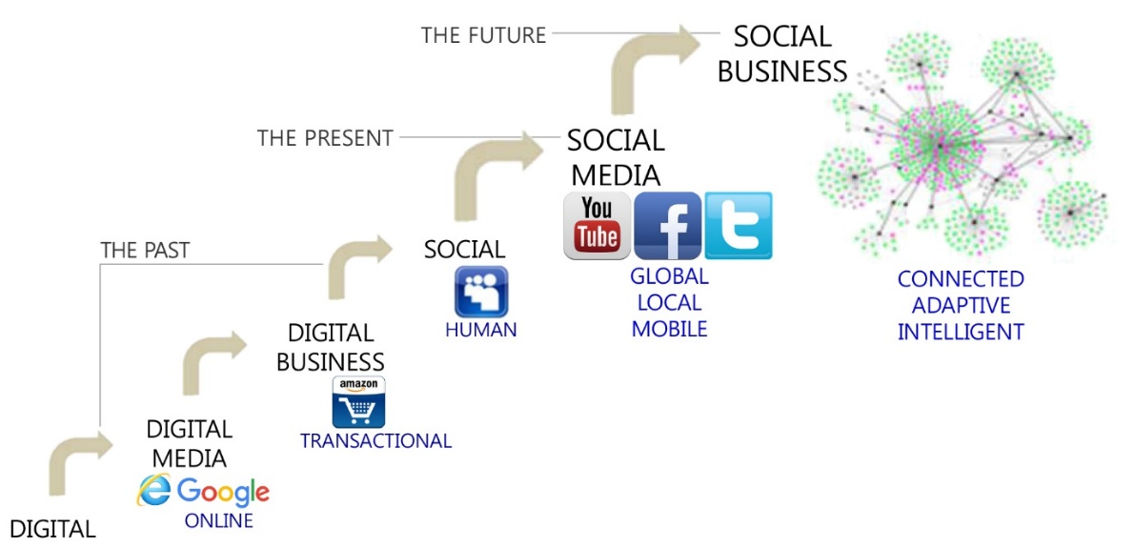
Figure 6 – Evolution of social business [41]

When the IoT/M2M technologies are combined with social media, there is an amazing opportunity to create better, more useful experiences. There are new ways of human life and business by utilizing sensor technologies such as smoke detectors, motion detectors, thermostats, and closed-circuit television (CCTV) cameras, etc. The situations captured by many sensors are visualized in the smartphones of individuals and/or groups of communities, which invoke reactions and feedback from people. The evolutions of the Internet of things (IoT) applications will take the same path as those of social media applications. The open application programming interface (API) technologies allow the IoT devices to become a member of social communities. For example, the building energy management system (BEMS) can be implemented and operated by collaborations of humans and a lot of sensors. It seems that the IoT sensors are a member of the social community to manage the building energy consumption. If IoT devices are open to invite new technologies, social IoT applications will be created, which is similar to those of social media applications.
Emergence of knowledge society
The creation and dissemination of knowledge is increasingly the key to success, and thus to sustainable economic and social development. Creative knowledge is a key factor in global competitiveness, which fuels new job creation and economic growth. The most important property of knowledge is now intellectual property. It is essential to growth and prosperity rather than traditional labour. Moreover, knowledge has been a driver of economic and social development as well as productivity of manufacturing industry. Knowledge innovation fundamentally means coming up with new ideas about how to do things better or faster.
By utilizing information and communication technologies, the emergence of the knowledge society is bringing about a fundamental reshaping of the existing industrial society. It introduces a transformation of global economy. The information and communication technologies are facilitating a new intensity in the application of knowledge to economic activity, to the extent that it has become the predominant factors in the creation of wealth.
To cope with the upcoming zeta-byte era toward knowledge society, the market potential of telecommunication and broadcast is gradually declining even though smartphones, TVs, and PCs are the major source of traffic [1]. The fastest growing traffic is coming from Internet of things/machine-to-machine (IoT/M2M) applications. The high traffic growth is due to more video applications combined with IoT/M2M applications such as e-health and self-driving cars. With the increasing usage of WiFi and long term evolution (LTE) technologies, video applications are becoming the largest portions of upstream traffic, which is mainly coming from user-created contents as the user has a role of content producer. The following are the tangible lists of sharing information and knowledge via the ICT infrastructure:
– Information of science and technologies;
– Bio and medical information;
– Energy, automobile related information;
– Nano, semiconductor, and component information;
– Education, culture, and art information;
– Public information of government;
– Society and life related information.
Social information infrastructure via ICTs
A large volume of data among human-to-human, human-to-machine, and machine-to-machine is delivered, shared, processed, and consumed through the ICT infrastructure. The concept of social information infrastructure is shown in Figure 7. To explain the left-hand side of this figure, more than seven billion people may connect to build up their own human relationships and communities through the ICT infrastructure. The traditional telecommunication services and the recent social networking services are connecting people. The right-hand side of the figure illustrates the concept of the cyber physical system consisting of building, transport, energy, water, manufacture, health, surveillance, and environment through the ICT infrastructure. All the physical entities are mapped to the corresponding objects in the cyber world through the ICT infrastructure. The actual behaviours and presence of the physical world are connected to the equivalent objects in the cyber world. Human intelligences accumulated by social communities are reflected on the objects in the cyber world. Therefore, the future social information infrastructure can consist of both the human platform among people and the platform for the cyber-physical system.

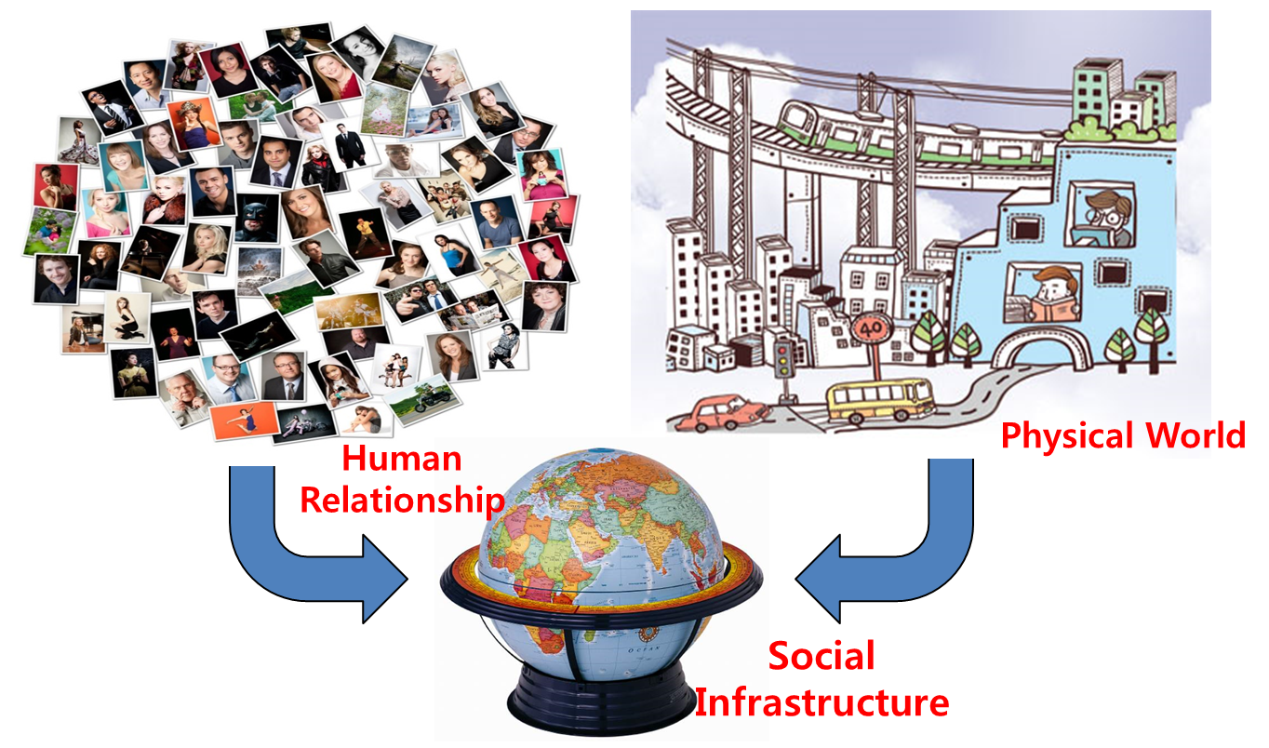
Figure 7 – Social information infrastructure via ICTs

Conceptual visions of future ICT infrastructure
With layering concepts, the future ICT world consists of the physical world and the cyber world as well as of the data world and knowledge world, as shown in Figure 8. The integration of the physical world and cyber world is done by ICT convergence which is interlinking the information and communication technology and other industrial technologies for energy, transportation, health, and public safety, etc. System information and physical operations are logged at software entities in the cyber world. The parameters of software entities in the cyber world are tuned with the corresponding parameters of the physical system, for example, for testing or manufacturing process. The software function in the cyber world has a mirror image of the real physical system which is able to continuously record and track the physical operation. Therefore, the integrated intelligent functions in the cyber world are applied to the physical world.
If the operation and maintenance of the cyber world are inconsistent with those of the physical world, there are some challenging issues to be solved by the creative innovation of the cyber physical system. For the design of the cyber physical system, the physical systems can be collaboratively and interdisciplinary implemented by using intelligent software engineering. The physical system should be robust and stable while there are the interruption of controllability and the failures of software functions. Also, the unexpected results and harmful failures of the physical system can be simulated by software engineering. For stable operations of the physical system, the proactive algorithms running in the cyber world can be applied to avoid unpredictable risks or deadlocks.

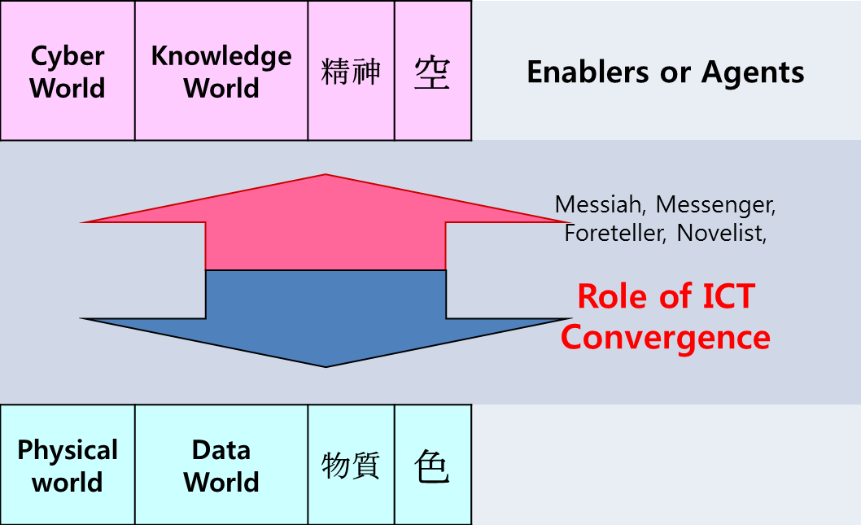
Figure 8 – ICT conceptual vision of future ICT infrastructure

Key trends of the future ICT eco-society
The key trends of the future ICT infrastructure are to build creative, trustworthy, and a knowledge eco-society. All people invent their own ideas for improvement of their life and business. If someone creates new ideas that wants to share with his/her friends, the communication channel should be secure and reliable. By accumulating the existing activities for a future knowledge society, the key trends are identified as "hyper connected society", "mobile native", "free economy", and "the third industrial revolution". The essence of the key trends for the future knowledge society is summarized as follows:
– "Hyper connected society" for coexistence, consensus, and sharing:
• Technology breakthroughs by using smartphones and IoT/M2M technologies;
• Information resonance effects of smart networking and social media;
• New opportunities of explosion of digital information and big data analytics.
– "Mobile native" for global digital nomads:
• Global citizenship/community and digital native/immigrants/nomad;
• Smart seniors in an aging society;
• Cultural convergence by utilizing information and communication technologies;
• Accumulation of people's knowledge: expecting new democracy and virtual space for new agora world.
– "Free economy" on collaborative consumption:
• Sharing culture and economy by utilizing social networking services;
• Privacy collapse and new opportunity of statistics information from community interests.
– "The third industrial revolution" for sharing information (by Jeremy Rifkin [16]):
• Energy Internet and industrial Internet, great escapes from telecommunication and broadcast business;
• Global integration of online/offline markets and e-commerce;
• Global reorganization of job/labour markets and human resources.
For the establishment of a creative, trustworthy, and knowledge eco-society, first the information and communication technology can help enormously increase the overall productivity of other industries such as energy, transportation, education, health, safety, and environment, etc., as shown in Figure 9. Second, the new paradigm toward the connected world will be open to realize communication among human-to-human, human-to-machine, and machine-to-machine. In addition, virtual reality technologies may be used to bridge between the physical world and the cyber world. Interdisciplinary activities among people are expected to search for new discoveries of knowledge and intelligence. The ICT infrastructure should be well structured to open new windows of discovery relying on human intelligence. It should also enable new innovations on education, energy, transportation, nano-, and bio-technologies, etc.
From the perspective of productivity, the information and communication technologies enable to improve the productivity of traditional industries. During the last ten years, the growth of the global economy is primarily due to utilizing ICTs. ICTs can provide significant benefits on convergence industries which are abbreviated by energy+ICT, health+ICT, and transport+ICT, etc. Until now, the lack of investments in the ICT infrastructure might have been the cause in the slow process of the economy. This is why ICT is an important enabler to drive the add-on values on productivity.
Second, from the perspective of communication, there is a wide range of ICT applications such as telephony and television as well as e-mail, etc. Recently, with the progress of IoT/M2M technologies, the human-to-machine and machine-to-machine communication are widely under development. Some software and devices help people record, store, process, retrieve, transfer, and receive information. To help public safety in metropolitan regions, some IoT devices enable new peer-to-peer services and location-based applications. Humans can communicate with sensors by abstraction or artefact of objects. Data visualization can help communication between humans and objects.
Third, from the perspective of new discovery based on human intelligence, ICTs can provide a more efficient and effective platform to explore new science and technology areas. In some specific areas, people find it difficult to learn a certain knowledge. By an optimum utilization of the computing and storage systems, people can get great help to find, compare, and analyse the facts and experimental results. A group of people among different communities can make a discussion and collect their opinions from various principles and theories. ICTs provide a collaborative platform for billions of people with unlimited storage and processing capacity, which can open new windows to discover knowledge for education, energy, transportation, nano- and bio-technology, etc. The complex system which has been almost impossible to handle by analytical and statistical methods of the existing science and technology can be solved, for example, to forecast the weather and analyse the human genome.

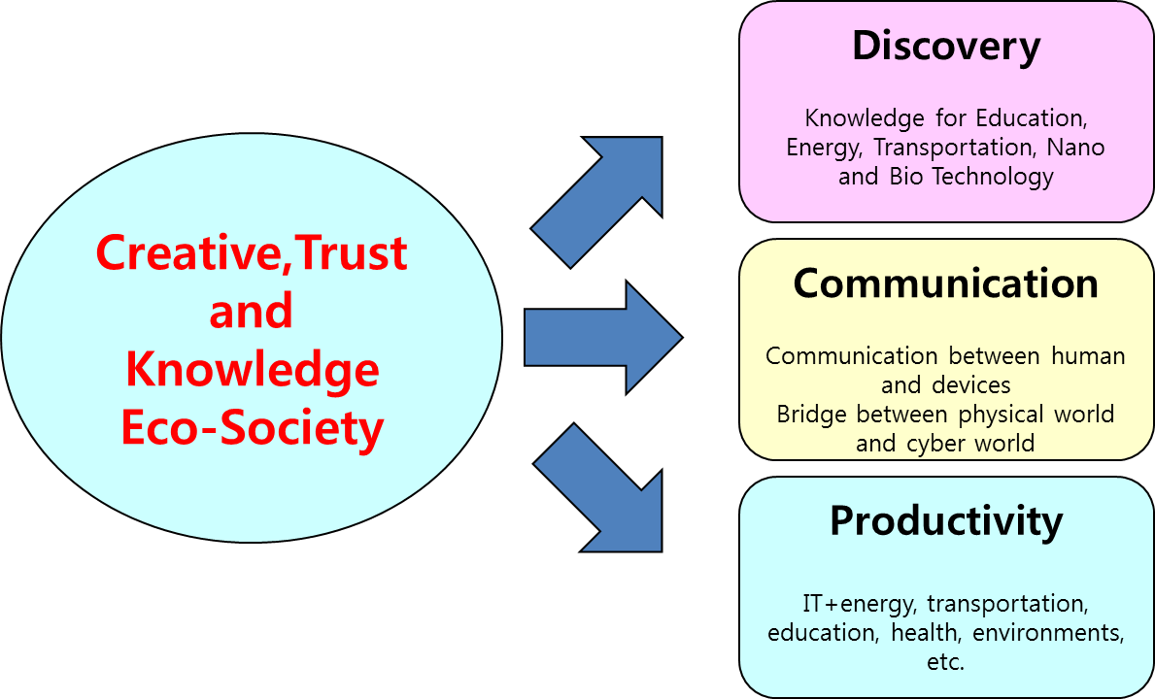
Figure 9 – Key trends of future ICT eco-society

Value-added services of future ICT infrastructure
From a narrow perspective of ICTs, the expected market potentials of telecommunication and broadcast services are not so great even though 5G technology and ultra-high definition TV technology may appear in the market. The high speed and high quality of ICTs may be not significantly interesting since network performance is counting on the law of marginal utility. However, there are more productive, competitive, and innovative ICT markets if the value-added services and the discovery of new technology can be cultivated, as shown in Figure 10. The web- and app-services on cloud environments will be continuously upgraded and added to deliver new values. The wide variety of social media services can create a new life style and a new business model (we call this trend 2nd class of ICT industries). Finally, if future knowledge platforms are well organized to invoke collective intelligence and crowdsourcing among people, this will be very useful also for other industries such as education, energy, health, and transportation, etc., (we call this trend 3rd class of ICT industries). Therefore, new market volumes of future ICT services will be greater than those of traditional telecommunication and broadcast services.
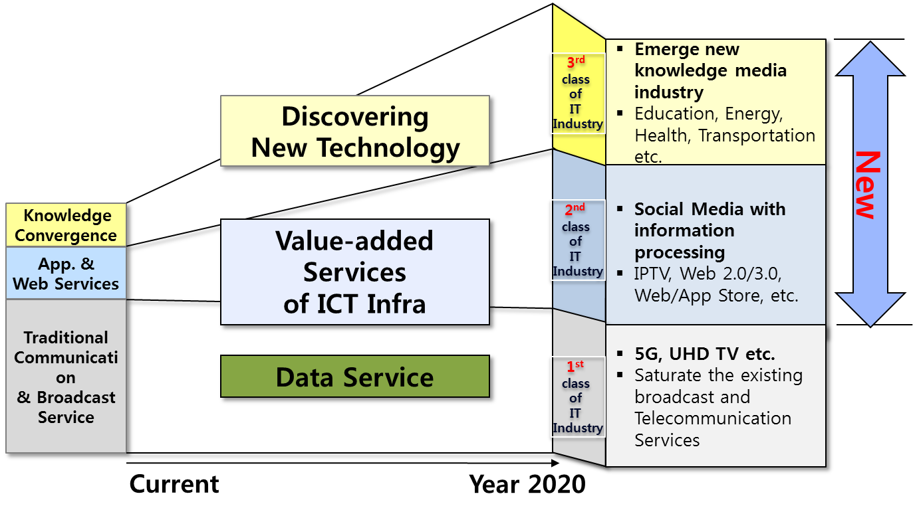
Figure 10 – Value-added services of future ICT infrastructure

Emerging applications of future ICT infrastructure
If the ICT infrastructure is well designed and deployed, many applications will be accelerated. The new possibility will appear in the outstanding application areas in the environment, ageing, knowledge media, and information prediction, as shown in Figure 11. First, to cope with climate change, CO₂ emissions should be reduced by a global consensus. ICTs are a source of as much carbon dioxide in the atmosphere, while at the same time, they provide the solutions that save energy both in the industry and in-house applications. The energy-efficient data centres and software virtualization for dynamic capacity management are essential for green ICTs. When the green ICT is combined with relevant communication solutions, such as video conferences, this reduces carbon emissions by avoiding unnecessary travelling. The benefits of green ICTs can reduce energy consumption by installing more efficient hardware systems.
For better ageing and e-health, the information and communication technologies can improve the quality of life of the elderly and help people remain healthy. From e-health to intelligent care system, ICT promotes the well-being of the aged in their whole lifetime.
The multimedia applications and web-based contents are used for future education including training, presentation, and exercise, etc. The computer-based training and three dimensional simulation programs can help students get indirect experiences. The collective platform for teaching and learning is needed to support the creation of ideas among students. Teachers can be encouraged to use new education platforms equipped with multimedia sharing tools.
As a part of big data analytics, information prediction will be one of the emerging markets. By collecting statistics and analysing user behaviours, some events can be predictive to happen with certain probability. With risks of uncertainty, the probability of an event is closer than the average before. With the progress of IoT/M2M technologies, information prediction will be a steadily emerging market to predict natural disasters, protect public safety, and reduce traffic accidents and air pollution.

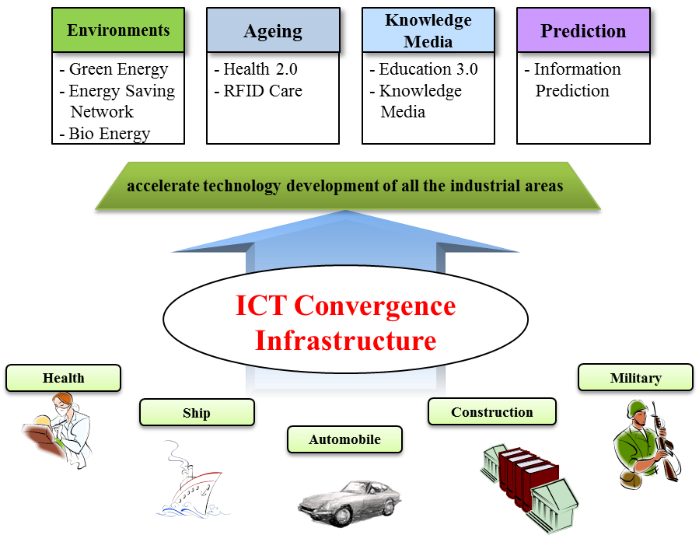
Figure 11 – Emerging applications of future ICT infrastructure

Convergence markets with energy, transportation, and healthcare, etc.
When information and communication technologies are applied to other industries like energy, transportation, health, education, and public safety, new behaviours and benefits will appear for individuals and communities in their own work environments. People working in other industries may have a chance to get new practices and experiences by using ICT and social media. When IoT/M2M devices plug-in at the network, these physical entities will become a partner of people in the same business domain, and they will be ready to connect people, activate systems, and process tasks.
For example, when the smart grid adopts social media technologies, overall energy consumptions are collaboratively controlled with the help of communities by being aware of energy generation and delivery status. To reflect the status of power generations including solar cells and wind turbines, the collaborative behaviours among people can make a shift of energy consumption to reduce peak energy consumption. The social network can measure the status of energy generation and consumption in real time. It acts properly to reduce peak energy consumption with the help of social communities.
For intelligent transportation management in a smart city, traffic signals at the crossroad are adaptively controlled according to the numbers of vehicles and driving behaviours of people. People may call a taxi or ride a bus at the nearest location with the help of social media. The new functionality of social media, combined with IoT/M2M technologies, makes transport easier and safer to people. To allow for seamless usage and on-time availability of transport means, an ideal solution may be a mix of individual vehicles, vehicle sharing, and railway.
For health applications with social media, smart monitoring equipment reports health conditions of patients and individuals periodically. The healthcare systems are equipped with the identification systems for tracking patients and individuals. The social media platform can gather health data of individuals and report to doctors. When a medical emergency happens, the social network can help call the 911 centre, drive an ambulance, assist patients, advice doctors, and notify the hospital simultaneously.
Strategic trends for deployment of future ICT infrastructure
In order to deploy future ICT infrastructure successfully, there are three strategic issues as shown in Figure 12. First, the well-organized wireline/wireless network will be a good basis to construct the future ICT infrastructure. From traffic demands and application types, user equipment and sensor devices will be plug-in the network mostly by using 5G or WiFi wireless technologies. At the edge and core network, optical systems with more than 100 Gigabits/s per wavelength will be available in the near future. The passive optical network system of more than 10 Gigabits/s will replace the existing copper cable and unshielded twisted pairs at the access network. Second, from the viewpoint of information sharing platform, all the data created by users and collected by machines are efficiently and effectively stored at certain servers. From this platform, the public information for human life and business may be easily accessed within a few seconds. Moreover, some of the government-owned information may be freely and easily obtained. The design guideline of the information sharing platform is how to access data with acceptable scalability and confidentiality. The cloud computing platform will be a good candidate to be a future information sharing platform.

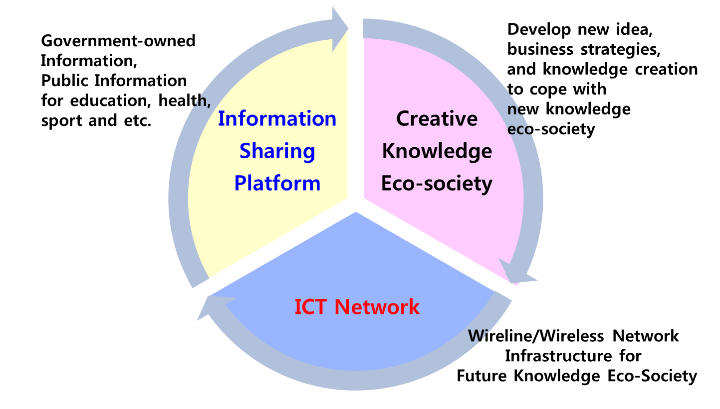
Figure 12 – Strategic trends for future ICT infrastructure

Third, from the viewpoint of knowledge creation, the most outstanding issues are how to support a creative knowledge eco-society with innovative ideas. Here, it is noted that all the relevant information and knowledge are created, shared, processed, and utilized originally by human beings. If some people raise questions, interests, and/or curiosity, they can share the relevant information and knowledge easily at that instance. However, unfortunately, the current cloud computing system is mainly designed only for efficiency of storage and processing. This means that the cloud computing platform will be evolved to help people's curiosity. In addition, the digital data format which is used to display video screening and deliver audio/sound/voice signals should be evolutionally tuned with the human organ and human perception mechanism. Until now, the data structure and formats are defined and classified according to the spectrum of long-lived knowledge silo as in education, transportation, energy, health, science, and engineering, etc. New integrated data formats based on semantic ontology may be challenging, which are easily interpreted and perceived by users.

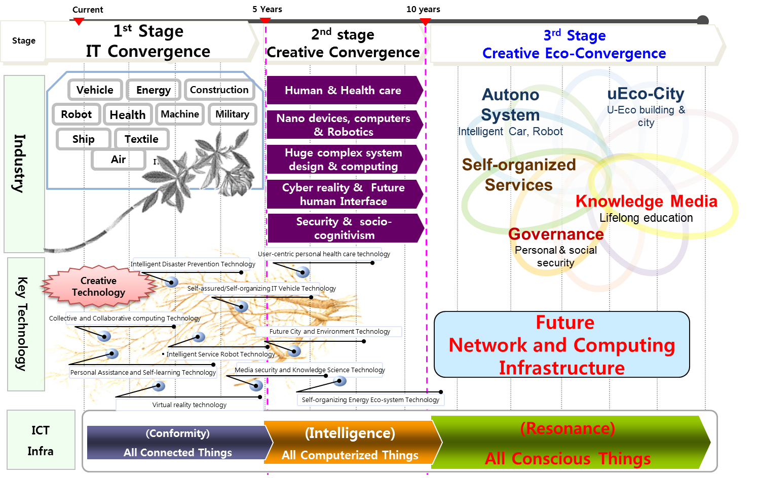
Figure 13 – Step-wise evolution toward future ICT infrastructure

Figure 13 shows the overall roadmap of evolution toward the future convergence era relying on ICT infrastructure. In the first stage, the evolution of traditional industries such as energy, health, robots, machines, and vehicles simply utilize the data delivery capability of the existing network and computing infrastructure. The new technologies like IoT/M2M are applied to increase the productivity of traditional industries. The collaborative and interdisciplinary methods among various fields of knowledge are triggered to open a new convergence era in the second stage of evolution. Many key technologies are integrated with a certain level of intelligence. In the third stage of evolution, a new industrial structure is organized and constituted toward a future knowledge convergence society, which is quite different from the existing classification of industries. Conceptually, the future industrial structure toward a new creative eco-convergence era may be classified into five types: autono system, uEco-city, self-organized services, knowledge media, and governance:
1 Autono system: It is realized that autonomy is applied to all the eco-systems as well as individual systems like intelligent robots. It is used to refer to the self-governing system.
2 uEco-city: The uEco-city means the evolution of an eco-friendly ubiquitous city. The current metropolitan environments may be transformed to eco-cities in which the information and communication technologies enhance quality and performance of urban life and reduce costs and resource consumptions on transport, energy, healthcare, water, and waste.
3 Self-organized services: The self-organized services mean that all the operations of the physical system and software platform have the characteristics of a self-organized and self-sufficient systems. The software running at a specific system has a capability of self-organization and self-correction in cases of faults and abnormal situations. In the cloud computing environments, a self-organized service is crucial to discover and consume the service autonomously. Precise and robust service discovery algorithms are desirable.
4 Knowledge media: Future lifelong education needs a self-motivated pursuit of knowledge for either personal or professional reasons. Knowledge media is incorporated over the existing education and media with cognitive and learning sciences. Knowledge media is about the processes of generating, understanding and sharing knowledge using several different media.
5 Governance: Toward a future safe and sustainable knowledge society, governance is essential to reduce global risks and increase human sustainability. New forms of governance are inevitable to continue economic growth and regulate markets and technologies.
The future network and computing infrastructure will provide the fundamental facilities and environments to realize the concepts of all conscious things. Key concepts toward a new knowledge society are coming from understandings on how information and knowledge/intelligence via the ICT infrastructure are used to change human life and business behaviours.

ICT standardization for future knowledge society
Principles for knowledge eco-society
Knowledge society is based on the needs of knowledge distribution, access to information and capability to transfer information into knowledge. Knowledge distribution is one of the key requirements of the knowledge society. All the members have to understand the role of the knowledge society in the future development of human society. A knowledge society promotes human rights and offers equal, inclusive, universal access to all knowledge creation. There are basic principles that are essential for the development of knowledge society:
– (Equal access and open interface): A public and an open accessible knowledge has uncountable values in various areas of science and technology as well as in the business domain. It provides an opportunity for all to access local and global information in a more equitable manner. From the viewpoint of standardization, "open" means that the public information including ITU-T documents is available and is within the reach of the public (online), with low to no barriers for its reuse and consumption. Anonymous access to knowledge must be allowed for the public. Public data should not be hidden behind "walled gardens". Therefore, the knowledge society provides open and equal access, and universal access to ITU-T documents though better networking.
– (Trust): Trust including security and privacy is a prerequisite for the development of the future knowledge society. Published documents should be digitally signed or should include publication/creation date, authenticity, and integrity. Digital signatures help the public validate the source of the data they find so that they can trust that the data has not been modified since it was published. Trust needs to share the environmental knowledge for sustainable development to reduce all kinds of risks. The certification or trust to ensure user access of reliable and relevant ITU-T documents is inevitable.
– (No privileges and universal access): The benefits of the information and communication technologies are evenly distributed and widely open to a new digital opportunity to realize the future knowledge society. All knowledge extracted by data is made available to the public since knowledge is an invisible public good. Public data including ITU-T documents is not subject to valid privacy, security or privilege limitations. Public data is not subject to any copyright, patent, trademark or trade secret regulation. Reasonable privacy, security and privilege restrictions may be allowed with certain consensus or agreement. Therefore, the knowledge society provides a collaborative and an equal opportunity of knowledge in the public domain. Some harmony may be needed between the private sector and the public/social/government organizations to achieve a future knowledge society.
– (Lifelong learning): Pursuit of knowledge for either personal or professional reasons is ongoing, voluntary, and self-motivated. Lifelong learning recognizes that learning is not confined to childhood or to a classroom but that it takes place throughout life and in a range of situations. Learning can no longer be divided into a place and time to acquire knowledge (school) and a place and time to apply the knowledge acquired (workplace). Learning can take place on an ongoing basis from our daily interactions with others. There are several forms of learning: formal learning, informal learning, or self-directed learning.
– (Diversity): There are cultural and linguistic diversities that play a role in the supply of creative work. The promotion, affirmation and preservation of diverse cultural identities and languages will further enrich the future knowledge society.
– (Social connectivity): Everyone has the freedom of opinion and expression without interference. Communication is a fundamental social process. The information and communication technology can accelerate the social nature of individuals and communities.
– (Linked chain): Data consists of a set of data records linked together and organized by links or references. The linked data structure with linked lists or search trees is very useful to retrieve and identify their properties. Metadata includes the descriptive or related information of links. With the help of links and metadata information, the relationships among data, information, and knowledge will be defined.
– (Technology): The development of ICT technologies ensures free and common benefits of knowledge. It encourages innovation with collaboration, and research and developments with better scientific knowledge sharing. It is important to promote thinking about technical and legal feasibilities of knowledge certification and standards by ensuring users' access to reliable and relevant contents. In order to promote the spread and sharing of knowledge by developing ICT technologies (e.g. tools, freeware, common hardware, etc.), the step-wise plans of standardization with priority are essential.
Types of standards and open standards
There is a distinction between formal, de facto, and de jure standards. Formal standards are elaborated by standardization bodies. Both ITU and ISO/IEC are formal standardization bodies according to such a classification. De facto standards are technologies standardized through market mechanisms, and de jure standards are imposed by law. In addition, there are three levels of standards: reference, minimum quality and compatibility/interoperability standards. The compatibility/interoperability standards ensure that one component may successfully be incorporated into a larger system given an adherence to the interface specification of the standard.
De facto standards are often developed by industrial consortia or vendors. Examples of such standards are the World Wide Web (W3) consortium currently developing a new version of the HTML format for the web. The W3 consortium is independent of, but closely linked to, the standardization process of IETF. Some of the consortia operate independently of the international standardization bodies. Therefore, there may be some conflicts in governmental regulations or industry-specific requirements caused by fundamental climatic, geographical, technological, or infrastructural factors, or the stringency of safety requirements that a given standard authority considers appropriate.
An open standard is publicly available and has various rights to use associated with it, and may also has various properties of how it was designed (e.g. open process). The different meanings of openness are associated with their usage including the openness of the resulting specification, the openness of the drafting process, and the ownership of rights in the standard. If some standards are sometimes proprietary and only available under restrictive contract terms from the organization that owns the copyright on the specification, such specifications are not considered to be fully open; therefore, they cannot be called open standards. They may satisfy "reasonable and non-discriminatory" patent licensing fee requirements in order to be accepted by ITU-T standards.
Conceptual framework for standardization of knowledge information infrastructure
Standardization is a simple and straightforward process with a necessary basis for far-reaching technical consensus. The development of the ICT infrastructure including the standards should be recognized as a highly complex socio-technical negotiation process. The understanding of how to build the ICT infrastructure with social, economic, political and technical considerations is interacted with the overall design of the knowledge society which classifies and conceptualizes to grasp the role of standards in the development of future information infrastructures.
Before making a clear consensus of the future information infrastructure, discussion among people may be used to make conceptual distinctions and organize ideas. The conceptual framework identifies their priority and chooses initial action items. The conceptual framework is abstract representations, connected to the research that directs the collection and analysis of data. By collecting data and assessing the evidence, formal hypotheses take place with possible explanations. Finally, the conceptual model of the ICT infrastructure for the knowledge society is characterized without regard to their underlying assumptions and technologies. The abstract model may partition a set of functions or layers with certain classifications of the knowledge information infrastructure. An open, voluntary, and consensus-based standardization process will be critical to build the ICT infrastructure toward a future knowledge society.
When the ICT infrastructure may extend to other convergence industries, it may provide computing, storage, and networking resources for energy, transport, health, education, and environments, etc. Since people relating to other industries have their own data formats to share and distribute their idea, the data sharing platform is very important to access data with confidence. For the future ICT industry, the collective intelligence framework is essential to accumulate data from various sensors, networking systems, and cloud servers, etc. The location and presence information of the IoT systems are used to extract the context-aware information from raw data. However, there are some limitations in these types of data. All the data sources have their own output format by given types. In the current Internet and web, for example, only URL/URI/uniform source name (URN) are available to identify data types for certain Internet protocol (IP) domains of the Internet. There are only available for the telephone numbering and addressing structure for fixed and mobile telephony. Toward future convergence services, the data types including identification, numbering, and addressing should be extended to support IoT/M2M devices and equipment of other convergence industries.
Moreover, data sources are mainly classified into private data and public data. For private data, malicious threats may attack to obtain user sensitive information for identification, detection, and tracking, etc. The malicious activity may be based on IP addresses, numbering, and URLs. Some data may be discovered through an incident monitoring process which is shared with private communities. Therefore, the trust framework for the future knowledge society should be built to observe data from any source and protect against malicious activities.
Technically, in order to get a common understanding of the future knowledge society, the following outstanding issues for standardization can be investigated as follows:
– How to connect the forms of knowledge in relationship to data:
• Writing books and documents is not enough. The recursive mechanism to accumulate individual knowledge and opinions including tacit knowledge are needed to create new forms of knowledge.
– Metadata is like a glue to connecting data, information, and knowledge:
• Various types of metadata may be defined when data is created, delivered, processed, shared, and consumed by users and communities. It may be called source metadata, content metadata, service metadata, user metadata, and application-specific context metadata, etc.
• Metadata may be parsed to extract the useful meanings of data, a capability which is part of the intelligent processing of data.
• Metadata may be created after pre-processing or post-processing of data with related context-aware information such as condition, situation, and environment.
• The discrimination between information and knowledge from raw data is the understanding and interpretation of their contents, which may be described as metadata.
– New forms of development, acquisition, and spread of knowledge:
• The new tools to create, collect, accumulate, share and distribute data, information, and knowledge are needed to invent new forms of knowledge. This may evolve from social media with the progress of user interface and human perception technologies.
– New web as a useful tool for knowledge society:
• The existing web technology based on HTML has some limitations to help convergence service environments including IoT/M2M applications. New markup languages to communicate and share data, information, and knowledge may be needed.
• The concepts of the web application programming interface (API) for binding and sharing contents/documents/files with their corresponding software may be enhanced. Also, new sharing and communication mechanisms between human-to-machine and machine-to-machine are needed to support IoT/M2M applications in the environment of the web services and web applications.
Pre-standardization approaches toward knowledge information infrastructure
In spite the fact that there are many definitions on knowledge and knowledge society, the two terms are still ambiguous. From the perspective of information and communication technologies, the knowledge information infrastructure is difficult to realize as the famous philosopher Plato defined knowledge as: "justified true belief". Designing an accurate and efficient knowledge and trust model are a key research challenge. Various types of knowledge and trust models may be suggested as a pre-standardization process. The collective and crowdsourcing behaviours among people are supposed to collect knowledge from human reasoning and will be a basis to develop the relevant standards. The process of developing a standard is based on a fair and equitable way that typically ensures the high quality output and market relevance.
Standardization can be achieved on many different levels expanding from a uniform and integrated system over similar and harmonized process flows. As a result, harmonization is a preliminary stage of standardization which allows the exchange of information between different organizations without additional training. The right level of standardization varies depending on the individual member's conditions, working structure, management maturity, and the objectives of technical standardization. The formal working methods of ITU-T standardization may be not efficient if there are many views, opinions, and technical solutions. Brainstorming of ideas may be needed to get rough and common consensus.
In addition, the other standards development organizations (SDOs) may have their own working methods to produce documents, reports, and implementation agreements. The harmony between the working methods of formal standard bodies and the mission-oriented working methods of other SDOs may be needed. If the action items are well specified and the working methods including collaborations with other SDOs are clearly agreed, the formal working process of ITU-T can be initiated. Therefore, before standardization in ITU-T, a common understanding and consensus for knowledge are needed.
The following items are recommended for pre-standardization activities in ITU-T, which may be intended to initiate a joint research or coordination group for collaboration with other SDOs:
– Concept and basic principles of data, information, and knowledge in terms of the ICT world:
• Review the concepts and understanding of data, information, and knowledge;
• Identify the definition, property, and functional capability of data, information, and knowledge;
• Analyse the relationship and the linked mechanism among data, information, and knowledge;
• Investigate the use cases and examples of data, information, and knowledge.
– Data classification, types, and formats in terms of the ICT world:
• Review the existing data types and formats both in digital and analogue forms, which are available in the real world;
• Investigate the definition, property, and classification of data types and formats;
• Investigate the data description methods according to common and specific applications;
• Identify the definition, property, and description methods of metadata;
• Investigate the relationship between data and metadata;
• Investigate the linked types and formats of data (e.g. linked data and linked open data);
• Investigate the data formats for specific applications (e.g. web application, file, database, 2D/3D geographical information, anatomy information of human body, composition of texts, image, symbol, and audio/visual information, etc.);
• Investigate description format and processing methods of data, information, and knowledge (e.g. pre-processing and post-processing of data with the help of metadata).
– Functional architecture of knowledge information infrastructure:
• Review the existing ICT architecture to handle data, information, and knowledge;
• Investigate the service concepts and principles of the knowledge information infrastructure;
• Investigate the requirements and functional architecture of the knowledge information infrastructure;
• Identify the use cases and application models of the knowledge information infrastructure;
• Investigate the step-wise deployment scenarios of the knowledge information infrastructure.
– Social media services and technologies for the knowledge information infrastructure:
• Review the existing social media services and technologies;
• Investigate service concepts and principles of social media toward the knowledge society;
• Investigate the definition, requirements, and functional architecture of social media for the knowledge information infrastructure;
• Investigate the web technologies and web services as a part of social media;
• Investigate how to integrate web services and application software for the knowledge information infrastructure;
• Investigate the step-wise deployment scenario and roadmap of social media.
– Trust provisioning for knowledge information infrastructure:
• Review the existing security and privacy solutions;
• Investigate service concepts and principles for trust provisioning;
• Investigate the requirements and functional architecture for trust provisioning;
• Investigate the relationship between trust, security, and privacy;
• Investigate the step-wise scenarios of trust provisioning for knowledge information infrastructure.
Recursive standardization process for knowledge information infrastructure
In summary, Figure 14 may propose the conceptual model for a new standardization process toward the knowledge information infrastructure. In order to configure a conceptual framework of the knowledge information infrastructure, three key issues are well identified and analysed: knowledge definition, social media and the web, and trust provisioning. In the definition of knowledge, the basic concepts of data, information, and knowledge are specified. The data model and format including metadata are also critical to make progress. Standardization will take place with a common understanding and a certain consensus of knowledge, social media, and trust provisioning. However, the recursive process of standardization may be applicable to reflect some feedbacks from human understanding and the related markets after publishing standard documents, since knowledge, in nature, has a recursive form of human perception and intelligence.

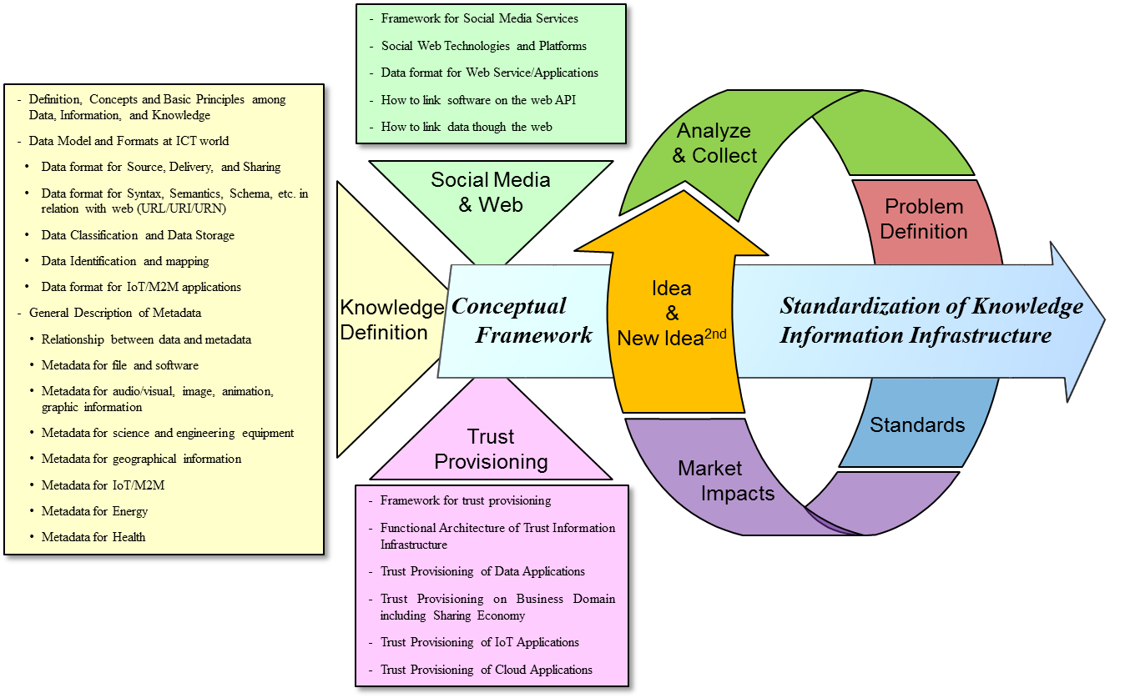
Figure 14 – Recursive standardization process for knowledge information infrastructure

Collaborations with outside ITU-T
For acceleration and collaboration with outside of ITU-T, the following new working methods for the knowledge information infrastructure are recommended:
– Harmony between the public sector (ITU-T) and the private sector (implementation and market deployment):
• (Public) Open, common, mutual benefits for all mankind;
• (Private) maximize the revenues and help the public sectors;
• Create new value-added markets without any harm and unhappiness;
• Protect the negative effects of new technologies and the new ecosystem.
– Collaborations with academia for new ideas and technical breakthroughs:
• Pre-standard collaborative processes are essential such as forums, workshops, and hackathon events of idea collection, etc.
• Build open common collaborative platform and interoperability tests among people and communities;
• Accumulate and share documents, opinions, and tacit know-hows, etc.
– Recursive standardization process with collective intelligence and crowdsourcing:
• Idea → analyse, collect → problem definition → standards → market impacts → new ideas.
– Review the technical classifications of the current ITU-T study groups:
• Functional decompositions (including pros and cons);
• Identify the changing or evolving value-chains of technology and markets;
• Establish a task force for special missions.

Conclusions
The year 2015 was ITU's 150th anniversary starting from the first international Telegraph Convention and the creation of the International Telecommunication Union. During the last 150 years, the information and communication technology (ICT) is one of the key drivers of innovation and technological breakthroughs in the world. Recently, the surprising news is that the penetration ratio of Internet access in the world was more than 40 % in 2014. Moreover, the number of mobile subscribers has already exceeded more than 3.6 billion in 2014. To cope with the future knowledge information infrastructure, this Technical Paper will be summarized as follows:
– Knowledge society will be realized by the developments of information and communication technologies:
• Information and communication technology is a key enabler to open a future knowledge society since knowledge society is a kind of artificial world created by human minds.
– Online connectivity introduces new cultural experiences of human life and business:
• Online connectivity has changed the way in which many people think and allows them to take advantage of the "political, social, economic, educational, and career opportunities";
• Reflecting on human history, a totally new ICT culture relying on massive connectivity between human-to-human and human-to-machine may take place.
– New habits of human life and business via smartphones and social media:
• Smartphones play the role of the personal assistant or guidance to help schedule meetings, ticket reservations, and information search, etc.
• Social media may create a new window of cyber industry and open new social markets.
– Accumulation of human intelligence including tacit know-hows:
• With the help of data and knowledge engineering, all human intelligence and experiences will be accumulated and shared with others;
• Since all the experiences and experimental results are collectively and interdisciplinary accumulated, problems of a complex nature like climate change and human genome may be solved.
– New knowledge products and new social media markets relying on human intelligence:
• Simulator or virtual space to experience the real physical world;
• Virtual reality for practices and new experiences of tacit knowledge;
• New markets for the cyber physical system by combining with the IoT/M2M technologies.
– ITU-T has a responsibility to get a consensus for the knowledge information infrastructure:
• ITU may have a leadership role to introduce the future knowledge society by getting a global consensus for the future ICT infrastructure;
• Standards for future knowledge-aware industries are critical to realize a knowledge eco-society.
– On the other hand, the future knowledge society should be a safe and sustainable society:
• It encourages the positive effects of online connectivity and social media.
• It protects user privacy and unexpected dangers to minimize the unexpected risks.
• It maximizes human survivability in the future.
Finally, ITU-T may get a chance to lead the future knowledge society in terms of standardization. As a top level of formal standards body, ITU-T may try to initiate new working methods for the standardization of the future knowledge information infrastructure. In addition, ITU-T may have a leadership role to collaborate with the private sectors and academia which are outside of ITU-T. The pre-standardization and conceptual framework activities may be encouraged with collective intelligence and crowdsourcing.

References and bibliography
[1] Cisco® Visual Networking Index™ Global Forecast and Service Adoption for 2013 to 2018.
[2] http://www.techrepublic.com/article/ibm-watson-the-inside-story-of-how-the-jeopardy-winning-supercomputer-was-born-and-what-it-wants-to-do-next/, 2015 CBS Interactive.
[3] Drucker, Peter (1957), Landmarks of Tomorrow, Harper & Row, New York, ISBN 978-1-56000-622-0.
[4] Van Doren, Charles (1991), A History of Knowledge: Past, Present, and Future, Ballantine Book, ISBN:978-0-345-37316-8.
[5] Smith, Adam (1776), An Inquiry into the Nature and Causes of the Wealth of Nations, (1 ed.), W. Strahan, London.
[6] http://www.slideshare.net/SD_Paul/science-and-technology-capacity-and-the-knowledge-society, LinkedIn Corporation © 2015.
[7] https://en.wikipedia.org/wiki/Knowledge_value, last modified on 5 November 2015.
[8] Firestone, Harvey (1868-1938), Thoughts on Wisdom, Forbes (1997) p. 108.
[9] http://www.businessdictionary.com/definition/knowledge.html, 2015 WebFinance, Inc.
[10] Gardner, Howard (1983), Frames of Mind: The Theory of Multiple Intelligences.
[11] Goleman, Daniel (1998), What Makes a Leader? Harvard Business Review.
[12] Coleman, Andrew (2008), A Dictionary of Psychology (3rd), Oxford University Press, ISBN 9780199534067.
[13] Drucker, Peter (1969), The Age of Discontinuity, Harper & Row, New York, ISBN 978-1-56000-618-3.
[14] Rowley, Jennifer (2007), The wisdom hierarchy: representations of the DIKW hierarchy, Journal of Information and Communication Science 33 (2): 163-180.
[15] http://www.cioupdate.com/cio-insights/implementing-knowledge-management-part-i-concepts-approach-1.html, 2015 QuinStreet Inc.
[16] Rifkin, Jeremy (2011), The third industrial revolution.
[17] XML and Semantic Web W3C Standards Timeline, W3C, 2012-02-04.
[18] https://en.wikipedia.org/wiki/HTML, last modified on 30 November 2015.
[19] http://www.merriam-webster.com/dictionary/hyperlink, 2015 Merriam-Webster, Incorporated.
[20] Berners-Lee, Tim (2006), Linked Data – Design Issues, W3C, Retrieved on 18 Dec. 2010.
[21] https://en.wikipedia.org/wiki/Linked_data, last modified on 30 November 2015.
[22] http://www.unesco.org/webworld/mdm/czech_digitization/doc/digitiz.htm, 2015.
[23] https://www.srri.umass.edu/topics/knowledge-structure, 2015 University of Massachusetts Amherst.
[24] https://en.wikipedia.org/wiki/Social_media, last modified on 2 December 2015.
[25] Murthy, Dhiraj (2013), Twitter: Social Communication in the Twitter Age, Polity, Cambridge, ISBN 978-0-7456-6510-8.
[26] van Dijck, José (2013), The Culture of Connectivity: A Critical History of Social Media, Oxford University Press.
[27] https://en.wikipedia.org/wiki/New_media, last modified on 28 November 2015.
[28] Manovich, Lev, New Media From Borges to HTML, The New Media Reader, Ed. Noah Wardrip-Fruin & Nick Montfort, Cambridge, Massachusetts, 2003, 13-25. ISBN 0-262-23227-8.
[29] Cunningham, Ward (2002), What is a Wiki, WikiWikiWeb, retrieved on 10 April 2008.
[30] https://en.wikipedia.org/wiki/Blog, last modified on 2 December 2015.
[31] https://blog.twitter.com/2012/twitter-turns-six, 2015 Twitter, Inc.
[32] https://en.wikipedia.org/wiki/YouTube, last modified on 3 December 2015.
[33] https://en.wikipedia.org/wiki/Web_page, last modified on 2 December 2015.
[34] Web Services Glossary, W3C, Retrieved on 22 April 2011.
[35] https://en.wikipedia.org/wiki/Social_graph, last modified on 23 October 2015.
[36] Keen, Andrew, The Cult of the Amateur, Random House, ISBN 978-0-385-52081-2.
[37] http://www.networkworld.com/article/2213704/collaboration-social/top-10-social-networking-threats.html
[38] Towards Knowledge Societies, UNESCO Publishing, ©UNESCO 2005, ISBN 92-3-204000-X.
[39] https://www.isaca.org/Journal/archives/2011/Volume-6/Pages/Data-Integrity-Information-Securitys-Poor-Relation.aspx, 2015 ISACA.
[40] https://en.wikipedia.org/wiki/Governance,_risk_management,_and_compliance, last modified on 9 July 2015.
[41] http://www.dr4ward.com/dr4ward/2012/05/how-has-digital-and-social-media-evolved-into-social-business-and-what-is-next-infographic.html, Posted on 7 May 2012.
[42] https://en.wikipedia.org/wiki/History_of_Wikipedia, last modified on 2 December 2015.
[43] Hilbert, M., and Lopez, P. (2011), The world’s technology capacity to store, communicate, and compute information, Science, 332 (6025) 60-65.http://www.martinhilbert.net/WorldInfoCapacity.html
[44] Weinberger, David (2011), Too Big To Know, Basic Books, Leader's Books Publisher.
[45] Schmidt, Eric, and Cohen, Jared (2013), The New Digital Age, Google Inc.
[46] Drucker, P.F. (1969), The age of discontinuity: Guidelines to our changing society, New York, NY: Harper & Row.
[47] Sanou, B. (2013), The world in 2013: ICT fact and figures, Retrieved from http://www.itu.int/en/ITU-D/Statistics/Documents/facts/ICTFactsFigures2013.pdf
[48] Gross, M. (2010), Ignorance and Surprise: Science, Society, and Ecological Design, Cambridge, MA, MIT Press.
[49] https://en.wikipedia.org/wiki/Resource_Description_Framework, last modified on 26 May 2016.
[50] Recommendation ITU-T H.264 (2016), Advanced video coding for generic audiovisual services.
___________________

