Standardization Sector
ITU-T Technical Report
(09/2023)
YSTR.HTSA-overview
Overview of ICT based highway traffic safety assessment
ITUPublications | International Telecommunication Union


Technical Report YSTR.HTSA-overview
Overview of ICT based highway traffic safety assessment

Summary
This Technical Report presents an overview and covers the process of information and communication technology (ICT) based highway traffic safety assessment since a lot of information and communication technologies have been widely used in the traffic field, especially in the highway industry and have made remarkable achievements. There is no scientific and effective index system for evaluating ICT-based highway traffic safety. In other words, there is a lack of uniform capability methodologies for ICT based highway traffic safety assessment.
Keywords
Highway, highway traffic safety assessment (HTSA), key performance indicator (KPI).

Note
This is an informative ITU-T publication. Mandatory provisions, such as those found in ITU-T Recommendations, are outside the scope of this publication. This publication should only be referenced bibliographically in ITU-T Recommendations.

© ITU 2024
All rights reserved. No part of this publication may be reproduced, by any means whatsoever, without the prior written permission of ITU.

Table of Contents
Page
1 Scope 1
2 References 1
3 Definitions 1
3.1 Terms defined elsewhere 1
3.2 Terms defined in this Technical Report 1
4 Abbreviations and acronyms 1
5 Introduction 2
5.1 Overview of highway traffic safety 2
5.2 Risk management 4
5.3 Process of ICT based highway traffic risk management 4
6 Pre-assessment 5
7 ICT based HTSA 6
8 Risk treatment 7
Appendix I – Types of uncertainty in highway scenarios 9
Appendix II – Dimension of key performance indicators 11
Appendix III – Examples of KPIs 12
Bibliography 13

Technical Report YSTR.HTSA-overview
Overview of ICT based highway traffic safety assessment

1 Scope
This Technical Report presents an overview of information and communication technology (ICT) based highway traffic safety assessment (HTSA). It covers an introduction to traffic safety, risk management, and ICT based HTSA. The process of ICT based highway traffic risk management includes:
– Pre-assessment;
– ICT based HTSA; and
– Risk treatment.

2 References
[IEC 31010] IEC 31010:2019, Risk management – Risk assessment techniques.
[ISO/IEC 20547] ISO/IEC 20547-4:2020, Information technology – Big data reference architecture – Part 4: Security and privacy.
[ISO 26262-1] ISO 26262-1:2018, Road vehicles – Functional safety – Part 1: Vocabulary.
[ISO 31000] ISO 31000:2018, Risk management – Guidelines.

3 Definitions

3.1 Terms defined elsewhere
This Technical Report uses the following terms defined elsewhere:
3.1.1 risk [ISO 31000]: Effect of uncertainty on objectives.
3.1.2 risk management [ISO 31000]: Coordinated activities to direct and control an organization with regard to risk.

3.2 Terms defined in this Technical Report
This Technical Report defines the following terms:
3.2.1 highway: A main road, especially one connecting major towns or cities.
3.2.2 highway user: Any person on the highway.
3.2.3 highway traffic safety: Conditions and factors to highway traffic crashes and other traffic incidents that have an impact on or have the potential to have an impact on death or serious injury of highway users.
3.2.4 highway traffic safety assessment: The highway traffic safety assessment is an overall process to monitor, identify, analyse and evaluate the risks related to highway traffic safety in order to improve risk management capabilities.
3.2.5 risk evaluation: A process of comparing the results of the risk analysis with established risk criteria.

4 Abbreviations and acronyms
This Technical Report uses the following abbreviations and acronyms:
HTSA Highway Traffic Safety Assessment
ICT Information and Communication Technology
KPI Key Performance Indicator

5 Introduction

5.1 Overview of highway traffic safety
Deaths and injuries resulting from highway traffic crashes remain a serious problem globally and current trends suggest that this will continue to be the case in the foreseeable future. Based on [b-WHO Global], the number of traffic deaths continues to climb, reaching 1.35 million in 2016. However, the rate of deaths relative to the size of the world's population has stabilized in recent years, as shown in Figure 1. The impact of highway safety on human societies has resulted in massive expenditures on safety-related countermeasures, therefore any success of efforts in reducing the likelihood of highway crashes and mitigating their impact cannot be denied. This Technical Report aims to offer a brief overview of highway traffic safety and then introduce a methodology for ICT based highway traffic safety assessment.
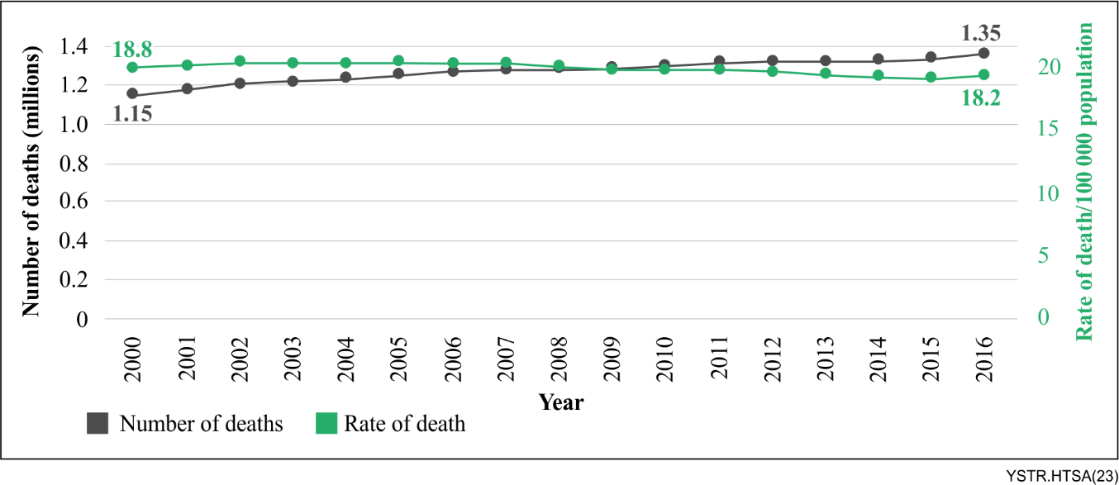
Figure 1 – Number and rate of road traffic deaths per 100 000 population:
2000-2016 [b-WHO Global]
Highway traffic safety is a huge topic. There are many organizations, research, projects, standards, methods, and systems from different perspectives contributing to this topic. The international road assessment programme (iRAP) aims to offer and execute a set of methodologies to investigate and rate highway infrastructure, with the aim of saving lives by eliminating high risk roads, especially highways. The ISO provides several standards to ensure highway traffic safety from the aspect of vehicles' functionality. In addition, with developments in ICT, studies of intelligent traffic safety systems have become more prevalent. The related studies contain both unilateral studies including collision, speed, and severe weather as well as comprehensive research on traffic safety management. At the same time, there is academic research to study the relationships between key factors and highway traffic safety, including aspects of highway traffic safety such as legislation and post-crash response.
According to [b-iRAP Global], safe highway infrastructure is essential to reduce road trauma. Highway infrastructure must be planned, designed, built, and operated to enable multimodal mobility, including shared public transport. It must eliminate or minimize risks for all highway users. The international road assessment programme and its partners have developed a suite of tools to support infrastructure safety management globally and locally. The tools can be used at all the following stages of a road's lifecycle:
– Planning: includes strategy, policy, and project concepts.
– Early design: includes feasibility and concept designs.
– Detailed design: includes final designs.
– Build (during construction): when traffic uses a road under construction.
– Open to traffic: after the construction is complete.
– Maintaining and operating: normal operation of the road.
As an important highway participant, vehicles should be designed to ensure the safety of those inside and those outside them. The [ISO 26262-1] series of standards provide a reference for the automotive safety life-cycle, an automotive-specific risk-based approach to determine integrity levels, and other related requirements for functional safety management.
From the ICT perspective, there are various systems related to highway traffic safety, including some sub-systems focusing on specific fields as well as comprehensive traffic safety management systems.
Collision mitigation systems represent the systems or algorithms to reduce the probability of vehicle collision, especially in automatic or auxiliary driving. [b-Bence] offers an algorithm for autonomous driving, making use of neural networks for real time risk estimation of collisions in highway traffic situations. Adaptive cruise control systems can also help to avoid collisions. [b-ISO 15622] and [b-ISO 15623] provide the related performance requirements and test procedures to enable such collision warnings. [b-ISO 19237] also offers a system considering the situation of collision with pedestrians.
The speed warning systems to some extent also help to reduce the probability of collisions [b-ISO 11067] provides the related performance requirements and test procedures to warn the driver of the danger caused by maintaining excessive speed while approaching an upcoming curved road.
[b-ISO 18682] provides systems to recognize vehicle conditions and their ambient environment using on-board remote sensing, or cooperatively through communication between infrastructure and vehicle (I-V), or among vehicles (V-V), so that the systems enable warnings or inform the driver of external hazards. [b-ITU-T Y.4116] specifies the requirements of safety management in larger transportation aspects, including road transportation, railway transportation, maritime transportation, and air transportation. Based on that, [b-ITU-T Y.4457] offers an architectural framework for transportation safety services, as well as a traffic safety management model. The model contains the basic steps of a traffic safety management life-cycle:
– Monitoring early warnings of disaster;
– Disaster detection;
– Disaster simulation;
– Disaster countermeasures;
– Disaster prevention.
[b-Mannering] compares many statistical methodologies applied in highway-accident research and presents the evolution of methodological approaches in accident research in recent years. The paper offers a list of methodologies when studying highway-accident issues. Speed is always an important factor. Most research shows that raising speed limits results in more injuries. In [b-Brubacher], the study used an interrupted time series approach to evaluate the impact of these speed limit increases on fatal crashes. The impact of phone distractions when driving is studied in [b-Stavrinos]. It is established that cell phone use (talking and text messaging) while driving compromises a motor vehicle driver's performance which may result in safety issues. [b-Uddin] is focused on investigating the relationship between crash factors and crash injury severity based on weather conditions, by examining the impact of weather conditions via separate models for different weather conditions.
Above all, there is much research concerning the pre-crash and crash issues mentioned above, but the post-crash situation is easily neglected. That is why [b-WHO Post] appeals to strengthen the capability of post-crash response. Meanwhile, [b-GRSF Post] offers a toolkit listing out the key elements of effective post-crash emergency response.
This Technical Report aims to investigate highway traffic safety from an assessment perspective, helping to mitigate the risk of traffic incidents resulting in deaths or injuries in the highway scenario.

5.2 Risk management
Through a risk management methodology, the risks related to highway traffic safety can be monitored, identified, analysed and evaluated. Furthermore, decisions can be made to cut down the fatalities or serious injuries involving highway traffic with the assistance of the assessment results.
A general risk management methodology is given in [ISO 31000]. The methodology comprises principles, framework and process. According to [ISO 31000], the principles are the foundation for managing risk and the framework is to assist the organization in integrating risk management into significant activities and functions. Meanwhile, the process can be customized and applied to achieve objectives and to suit the external and internal context.
Guidance on the selection and application of risk assessment techniques is provided in [IEC 31010]. The techniques are used within the risk assessment steps of identifying, analysing, and evaluating risk as described in [ISO 31000].

5.3 Process of ICT based highway traffic risk management
This Technical Report proposes a process of highway traffic risk management from the perspective of ICT. The process, tailored and extended based on [ISO 31000], is shown in Figure 2.
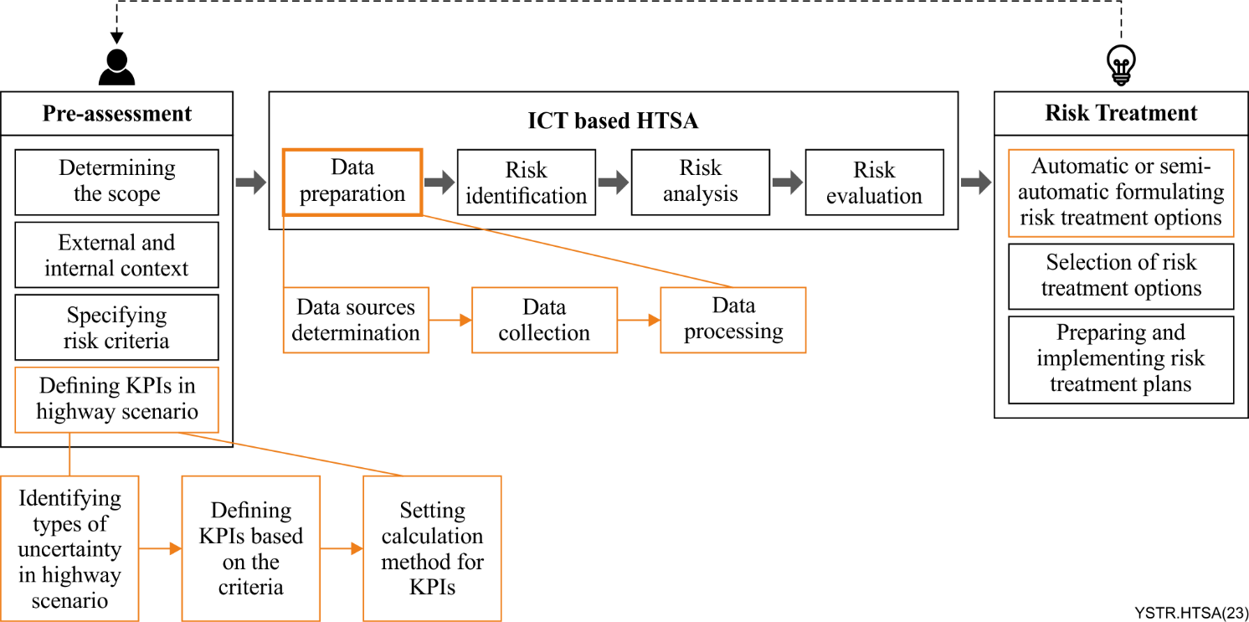
Figure 2 – Process of ICT based highway traffic risk management

6 Pre-assessment
The theoretical basis of risk management in highway scenarios is risk engineering or safety engineering, including many methods and models such as preliminary hazard analysis and risk analysis.
Hazard analysis involves the identification of possible risks and the estimation of their possible consequences. [b-Simmons] defines a hazard as an activity or circumstance posing potential loss or harm to a target and is a condition required for an undesired loss event. A preliminary hazard analysis process flow is introduced in [b-Simmons]:
– Identify targets to be protected such as personnel, environment, and infrastructure;
– Recognize risk tolerance limits, which will be given in specifying risk criteria;
– Ensure the scope including physical boundaries, operating phases, etc. which will be ensured in determining the scope;
– Identify hazards and the target.
Then the process will continue with some steps in other stages including evaluated probability, evaluated worst-case severity, assess risk, and provide countermeasures.
A risk governance framework is offered in [b-IRGC Risk], and the first concern in the risk assessment process is that the hazard, as a source of risk, needs to be distinguished from its impact. Meanwhile, some questions need to be considered, such as:
What accident scenarios can occur?
What about their severity and probability of occurrence?
However, in some systems it is not uncommon to find hazards that are declared only after the potential for undesired consequences is uncovered. [b-NASA Dezfuli] also recommends non-hazard-centric methods and introduces a scenario-based understanding of the system's safety performance, such as identifying the most critical scenarios that can lead to undesired consequences. Also [b-NASA Dezfuli] offers an integrated safety analysis (ISA), which has a series of characteristics, including uncertainties that should be explicitly considered. In addition, besides identifying scenarios, it is necessary to quantify scenario likelihoods and to address uncertainty.
There are many models when analysing risk. In hazard analysis, a bow-tie method has gained popularity as an intuitive graphical manner of presenting accident scenarios and explaining the importance of barriers, which probably originated in ICI (a United Kingdom chemical company) in the late 1970s. [b-Sotiralis] and [b-Liang] use the bow-tie method to analyse traffic and maritime accidents. In addition, more and more statistical models and artificial intelligence models are now available to be used. [b-Mannering] compares several statistical methodologies applied in highway-accident research and presents the evolution of methodological approaches in accident research in recent years.
Above all, those models need input parameters or quantitative factors. Therefore, this Technical Report proposes the process of defining key performance indicator(s) (KPIs) in highway scenarios in the pre-assessment phase, aiming to offer KPIs when using analysis models. In this way, the KPIs enable the reduction of concerns about hazards, targets, scenarios, and uncertainty of their potential harm in highway traffic safety issues.
To recap, the pre-assessment phase includes:
– Determining the scope: the highway authority should define the scope of its ICT based HTSA. It is important to be clear about the scope under consideration including objectives, outcomes, resources, etc.
– External and internal context: it is the environment in which the highway authority seeks to define and achieve its objectives. The external context includes, but is not limited to, the social, cultural, political, legal, regulatory, financial, and technological factors. The internal context includes but is not limited to, the vision, mission, organizational structure, roles, and strategy.
– Specifying risk criteria: the highway authority should specify the amount and type of risk that it may or may not find acceptable, relative to the objectives. It should also define criteria to evaluate the significance of the various risks to support decision-making processes. These should be established at the beginning of the HTSA and should be continually reviewed and improved, if necessary. To set risk criteria, the following should be considered:
– nature and type of uncertainties that can affect outcomes and objectives;
– consequences and the likelihood of the risks;
– time-related factors;
– consistency in the use of measurements;
– level of risks;
– combinations and sequences of multiple risks that should be taken into account;
– the organization's capacity.
– Defining KPIs in highway scenario: it includes
– Identifying types of uncertainty in highway scenarios: this is detailed in Appendix I;
– Defining KPIs based on the criteria: an example of KPIs is provided in Appendix III;
– Setting calculation methods for KPIs: some techniques can be referred to in [IEC 31010].

7 ICT based HTSA
The ICT based HTSA is the overall process of data preparation, risk identification, risk analysis, and risk evaluation.
– Data preparation: it is an important component of the HTSA process from an ICT perspective, it includes:
– Data sources determination: the data sources can be collected from transportation agencies serving the city or open source databases;
– Data collection: it supports many ways to collect data, such as system automatic access or manual input;
– Data processing: it involves many methodologies including statistical knowledge, database knowledge, etc. When a large volume of data processing is needed, the big data reference architecture in [ISO/IEC 20547] can be referred to.
– Risk identification: the purpose of risk identification is to find, recognize, and describe risks that might help or prevent an organization from achieving its objectives. Relevant, appropriate, and up-to-date information is important in identifying risks.
Before risk identification, it is necessary to clarify the relevant concepts. However, there is currently no unified understanding of risk related concepts. Figure 3 shows an understanding of the risk related concepts.
[b-IRGC Risk] proposes that risk is a composition of the potential to cause harm by the risk agent, the possibilities of being exposed to this agent and the vulnerability of the risk absorbing system (amount of stress that the system can tolerate). So, the premise of the hazard caused by the risk should include the exposure of risk-related objects, sensitivity of risk, and the vulnerability of the risk-related objects. And also, the risk effect is uncertain, as the opportunities and threats coexist. Finally, the threat causes the hazard with a certain probability.
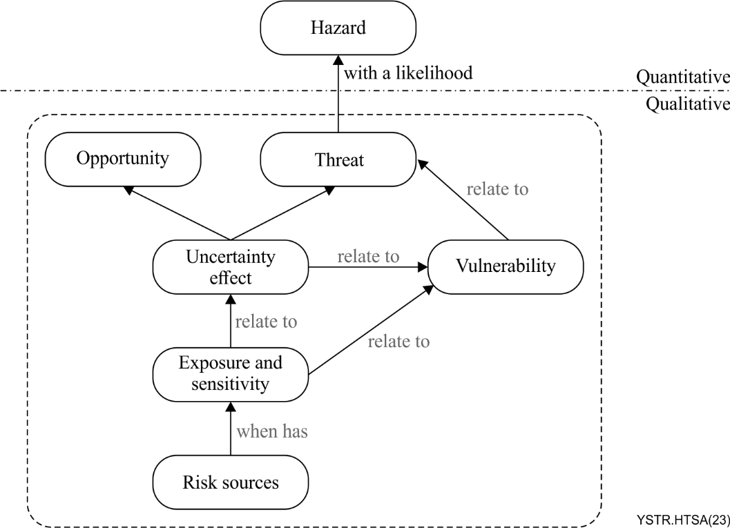
Figure 3 – An understanding of risk related concepts
There are too many implicit things so most ways of identifying risk are qualitative. As discussed in clause 6, [b-NASA Dezfuli] recommends non-hazard-centric methods and introduces a scenario-based understanding of the system's safety performance, such as identifying the most critical scenarios that can lead to the undesired consequences.
Therefore, this Technical Report recommends using a scenario-based understanding method to identify risks, that is, using the types of uncertainty in the highway scenarios in Appendix I to simplify the identification process.
– Risk analysis: the purpose of risk analysis is to comprehend the nature of risk and its characteristics including, where appropriate, the level of risk. Risk analysis involves a detailed consideration of uncertainties, risk sources, consequences, likelihood, events, scenarios, controls, and their effectiveness.
Based on [b-NASA Dezfuli], the analysis steps are to estimate the likelihood of the departure and the magnitudes of the consequence for each individual risk, to evaluate the time frame available for preventive or mitigative action, and to characterize the uncertainties. [b-IRGC Risk] specifies something almost similar, meaning that these steps aim to identify and describe the possibility of occurrence or a probability distribution over a range of negative consequences.
There are many methods that can be used to estimate the likelihood of the risk, and some useful techniques can be referred to in [IEC 31010].
– Risk evaluation: the purpose of risk evaluation is to support decisions. Risk evaluation involves comparing the results of the risk analysis with the established risk criteria to determine where additional action is required.

8 Risk treatment
Risk treatment is the process of selecting and implementing measures to reduce risk. Methods include risk avoidance, risk modification (reducing the probability of the unwanted event or mitigating its consequences) and risk transfer (insurance). An organization's decisions on which levels of risk are acceptable, and how to allocate investments between risk reduction and risk transfer depend on the organizations' risk attitude. However, no matter what the attitudes and methods are, countermeasures are needed. [b-IRGC Risk] and [b-NASA Dezfuli] underline the decision-making process with similar approaches. They note that the generation of countermeasures involves internal or external experts and relies on scientific models. Complex risks can be addressed by acting on the best available scientific expertise and knowledge.
From an ICT perspective, some technologies enable automatic or semi-automatic decision-making processes. [b-Parnell] discusses different kinds of decision support systems, including their ideal characteristics and background history. [b-Driscoll] gives a thoroughly updated overview of systems engineering management and decision making. In addition, it delivers a comprehensive and authoritative overview of the systems decision process, systems thinking, and qualitative and quantitative multi-criteria value modelling, thus directly supporting decision making throughout the system life cycle. All of the above constitute the theoretical basis for formulating automatic or semi-automatic risk treatment options.
In this clause, the risk treatment approach contains three steps, that is, to formulate, select, and implement options for addressing risk.
– Formulating automatic or semi-automatic risk treatment options: it is a typical feature in the HTSA process from an ICT perspective. After risk assessment, decisions can be made in an automatic or semi-automatic way to treat risk. ICT based systems or other tools may enable the generation of treatment options to serve the decision maker.
– Selection of risk treatment options: selecting the most appropriate risk treatment option(s) involves balancing the potential benefits derived in relation to the achievement of the objectives against costs, effort, or disadvantages of the implementation.
– Preparing and implementing risk treatment plans: this specifies how the chosen treatment options will be implemented.

Appendix I
Types of uncertainty in highway scenarios
There have been many studies detailing various risk factors and their effects on accident rates, which help to summarize the different types of uncertainty in highway scenarios.
Human factors are almost primary. In [b-Vogel], human factors account for 75.4% of accidents. These factors include the characteristics of speeding, traffic violations, alcohol and age. Other factors such as driver fatigue which is studied in [b-Eriksson], and mobile phone use studied in [b-Rodríguez] matter too.
Highway environment factors are also important. In [b-Vogel], the environmental factors include the characteristics of road design, maintenance, and weather conditions. Curved roads contribute to collisions as well, based on [b-Dabbour].
Next are vehicle factors. As [b-Vogel] points out, vehicle factors include the characteristics of faulty lights and other vehicle problems. [b-Fitzgerald] studies the number of occupants, and vehicle year of manufacture, which also affect traffic risk.
Other factors impacting traffic risk including animals or pedestrians on the highway are studied in [b-Vogel].
In addition, the capabilities of traffic management systems should not be neglected. Both the use of information systems and the conduct of emergency response programmes reduce the injury severity resulting from highway traffic risk. [b-Goodwin] and [b-DTFHA Road] present the Road Weather Information Systems and the relevant best practices to demonstrate efforts to reduce losses caused by highway traffic risks. [b-WHO Post] appeals to strengthen the post-crash response capability, and [b-GRSF Post] offers a toolkit listing out the key elements of effective post-crash emergency response. The practice of these capabilities should be described as a factor as well.
In conclusion, considering all the studies, this Technical Report provides the types of uncertainty in highway scenarios for the following: highway user, vehicle, highway infrastructure, environment, and management as shown in Table I.1.
Table I.1 – Types of uncertainty in highway scenarios
Number | Types | Uncertainty to be considered
1 | Highway user | Highway users include not only the person inside the vehicle but also persons outside the vehicle.  The uncertainty of highway user behaviour such as the driver's fatigue, driving state, the irregular operations of highway maintenance workers, etc., will directly impact the response of the vehicle, leading to the occurrence of traffic accidents.
2 | Vehicle | Vehicles are essential elements in the occurrence of uncertain traffic events on highways.  Certain characteristics of vehicles during driving may lead to the occurrence of traffic accidents, such as over-speeding, overload, tyre conditions, traffic flow and so on.
3 | Highway infrastructure | The condition of the highway infrastructure, such as the condition of the road surface, the deficiency of highway hazard signs, and the road alignment, etc., may indirectly impact driving, leading to the occurrence of traffic accidents.
4 | Environment | Extreme weather such as crosswind, low visibility due to heavy rain and fog, slippery surfaces due to road ice, etc., has a great impact on traffic conditions, thus affecting traffic safety.
5 | Management | The management type here refers to the capabilities of the highway authority. The capabilities include the early-warning of highway traffic risks, the in-time risk treatment, the efficiency of rescue, etc. These capabilities can reduce the occurrence of traffic accidents and losses caused by uncertainty.

Appendix II
Dimension of key performance indicators
The dimensions of KPIs refer to the types in Table I1. In addition, there are sub-dimensions for each dimension.
In Table II.1, each dimension is identified by the letter Dx. The sub-dimensions are then classified by the label Dx.y where x denotes the dimension and y maps to the sub-dimension.
Table II.1 – Sub-dimension of KPIs
Dimension label | Dimension | Sub-dimension label | Sub-dimension
D1 | Highway user | D1.1 | Driver
 |  | D1.2 | Other users
D2 | Vehicle | D2.1 | Vehicle condition
 |  | D2.2 | Vehicle mobility
D3 | Highway infrastructure | D3.1 | Condition of road surface
 |  | D3.2 | Road alignment
 |  | D3.3 | Guardrail and signboard
D4 | Environment | D4.1 | Weather
 |  | D4.2 | Visibility
 |  | D4.3 | Traffic capacity
 |  | D4.4 | Wildlife infestation
D5 | Management | D5.1 | Capabilities of monitoring risk
 |  | D5.2 | Capabilities of risk treatment and rescue

Appendix III
Examples of KPIs
Table III.1 lists the examples of KPIs defined for the highway user dimension.
Table III.1 – Example of KPIs for a highway user
Sub-dimension | Indicator | Description
D1.1 Driver | I1.1.1 Age | Age group of the driver.  NOTE – According to [b-Cox], drivers aged 70+ have higher crash death rates per 1 000 crashes than middle-aged drivers (aged 35-54).
 | I1.1.2 Driving experience | Years since obtaining the driving license.  NOTE – According to [b-Tao], personality traits and driving experience play a role in predicting the risk of traffic crashes.
 | I1.1.3 Duration of driving | Duration of continuous driving.  NOTE – According to [b-Elshamly], fatigue due to long driving hours and lack of sleep is the likeliest cause of truck crashes.
 | I1.1.4 Existence of tailgating behaviour | Existence of behaviour without a sufficient safe distance between the car and the car in front.  NOTE – According to [b-Sayed], many crashes are caused primarily by tailgating.
 | I1.1.5 Existence of phone call behaviour | Existence of the behaviour to make a phone call.  NOTE – According to [b-Sayed], the third most likely cause of crashes was distracted driving, caused by mobile phones or eating.
D1.2 Other users | I1.2.1 Existence of illegal crossing behaviour | Existence of pedestrian behaviour to cross the highway illegally.  NOTE – According to the driver behaviour questionnaire (DBQ) in the research of [b-Sayed], truck drivers rated a pedestrian illegally crossing a road with high-speed traffic as the most dangerous situation.
 | I1.2.2 Existence of irregular highway maintenance behaviour | Existence of irregular operation of highway maintenance, such as not placing any signboard, the workers crossing the highway illegally, etc.

Bibliography

[b-ITU-T Y.4116] Recommendation ITU-T Y.4116 (2017), Requirements of transportation safety services including use cases and service scenarios.
[b-ITU-T Y.4457] Recommendation ITU-T Y.4457 (2018), Architectural framework for transportation safety services.
[b-ISO 11067] ISO 11067:2015, Intelligent transport systems – Curve speed warning systems (CSWS) – Performance requirements and test procedures.
<https://www.iso.org/standard/50091.html#:~:text=ISO%2011067%3A2015%20contains%20the,Speed%20Warning%20Systems%20(CSWS).>
[b-ISO 15622] ISO 15622:2018, Intelligent transport systems – Adaptive cruise control systems – Performance requirements and test procedures.
<https://www.iso.org/standard/71515.html>
[b-ISO 15623] ISO 15623:2013, Intelligent transport systems – Forward vehicle collision warning systems – Performance requirements and test procedures.
<https://www.iso.org/standard/56655.html#:~:text=ISO%2015623%3A2013%20specifies%20performance,is%20operating%20at%20ordinary%20speed.>
[b-ISO 18682] ISO 18682:2016, Intelligent transport systems – External hazard detection and notification systems – Basic requirements.
<https://www.iso.org/standard/63250.html#:~:text=ISO%2018682%3A2016%20specifies%20basic,should%20be%20included%20in%20messages.>
[b-ISO 19237] ISO 19237:2017, Intelligent transport systems – Pedestrian detection and collision mitigation systems (PDCMS) – Performance requirements and test procedures.
<https://www.iso.org/standard/64111.html#:~:text=PDCMS%20require%20information%20about%20range,driver%20if%20a%20hazard%20exists.>
[b-Bence] Bence, D., Láncz, G., and Hunyady, G. (2019), Highway Situation Analysis with Scenario Classification and Neural Network based Risk Estimation for Autonomous Vehicles. <https://www.semanticscholar.org/paper/Highway-Situation-Analysis-with-Scenario-and-Neural-Dávid-Láncz/373f97a7f324781f63e6ed437032996f73f9aebd>
[b-Brubacher] Brubacher, J.R., Chan, H., Erdelyi, S., Lovegrove, G., and Faghihi, F. (2018), Road Safety Impact of Increased Rural Highway Speed Limits In British Columbia, Canada., Sustainability.
<https://www.mdpi.com/2071-1050/10/10/3555>
[b-Cox] Cox, A.E., and Cicchino, J.B. (2021), Continued trends in older driver crash involvement rates in the United States: Data through 2017-2018. Journal of Safety Research. Volume 77, pp. 288-295. <https://doi.org/10.1016/j.jsr.2021.03.013>
[b-Dabbour] Dabbour, E. (2012), Using Logistic Regression to Identify Risk Factors Causing Rollover Collisions. International Journal for Traffic and Transport Engineering. Volume 2 (4). pp. 372-379.
<http://ijtte.com/study/87/USING_LOGISTIC_REGRESSION_TO_IDENTIFY_RISK_FACTORS_CAUSING_ROLLOVER_COLLISIONS.html>
[b-Driscoll] Driscoll, P.J., Parnell, G.S., and Henderson, D.L. (2022), Decision Making in Systems Engineering and Management 3rd Edition, John Wiley & Sons.
<https://www.wiley.com/en-us/Decision+Making+in+Systems+Engineering+and+Management%2C+3rd+Edition-p-9781119901402>
[b-DTFHA Road] U.S. Department of Transportation, Federal Highway Administration, An Introduction to Standards for Road Weather Information Systems, July 2002.
https://ops.fhwa.dot.gov/weather/publications/rwis_brochure.pdf
[b-Elshamly] Elshamly, A.F., El-Hakim, R.A., and Afify, H.A. (2017), Factors affecting accidents risks among truck drivers in Egypt. MATEC Web of Conferences, 124(4):04009.
<https://www.researchgate.net/publication/320105702_Factors_Affecting_Accidents_Risks_among_Truck_Drivers_In_Egypt>
[b-Eriksson] Eriksson, M., and Papanikolopoulos, N. (2001), Driver Fatigue: A Vision-Based Approach to Automatic Diagnosis. Transportation Research Part C: Emerging Technologies, Volume 9, pp. 399-413.
<https://doi.org/10.1016/S0968-090X(00)00045-0>
[b-Fitzgerald] Fitzgerald, E., and Landfeldt, B.G. (2015). Increasing Road Traffic Throughput through Dynamic Traffic Accident Risk Mitigation. Journal of Transportation Technologies. 05(04):223-239.
<https://www.researchgate.net/publication/283620521_Increasing_Road_Traffic_Throughput_through_Dynamic_Traffic_Accident_Risk_Mitigation>
[b-Goodwin] Goodwin, L.C. (2003), Best Practices for Road Weather Management U.S. Department of Transportation.
<https://rosap.ntl.bts.gov/view/dot/37324>
[b-GRSF Post] The Global Road Safety Facility (GRSF) (2021), Post-crash Emergency Response Toolkit.
<https://www.roadsafetyfacility.org/publications/post-crash-emergency-response-toolkit>
[b-iRAP Global] International Road Assessment Programme (iRAP) (2021), Global Plan – Decade of Action for Road Safety 2021-2030.
<https://cdn.who.int/media/docs/default-source/documents/health-topics/road-traffic-injuries/global-plan-for-road-safety.pdf>
[b-IRGC Risk] International Risk Governance Council (IRGC) (2017), Introduction to the IRGC Risk Governance Framework. Revised version.
<https://infoscience.epfl.ch/record/233739>
[b-Liang] Liang, J., Ma, B., Sun, G., Suo, C. (2022), Traffic Accident Analysis Based on Bow-Tie Model. Beijing Institute of Petrochemical Technology.
<https://pdf.hanspub.org/MOS20220400000_80779939.pdf>
[b-Mannering] Mannering, F.L., and Bhat, C.R. (2014), Analytic methods in accident research: Methodological frontier and future directions, Analytic Methods in Accident Research, Volume 1, pp. 1-22.
<https://www.sciencedirect.com/science/article/abs/pii/S2213665713000031>
[b-NASA Dezfuli] Dezfuli, H., Benjamin, A., Everett, C., Smith, C., Stamatelatos, M., Youngblood, R., Blythe, M., Boyer, R., Bream, B., Everline, C., Feather, M., Fuller, R., Groen, F., Jambulingam, N., Johnson, K.C., Kowaleski, M., Layne, A., Leitner, J., Long, R., Mathias, D., Schoren, W., Colon, A., Day, J., Diventi, A., Denney, E., Fesq, L., Lewis, B., McMillian, S., Rutledge, P., Safie, F., and Smith, D. (2011), NASA System Safety Handbook – Volume 1, System Safety Framework and Concepts for Implementation.
<https://ntrs.nasa.gov/api/citations/20120003291/downloads/20120003291.pdf>
[b-Parnell] Parnell, G.S., Driscoll, P.J., and Henderson, D.L. (2010), Decision Making in Systems Engineering and Management.
<https://onlinelibrary.wiley.com/doi/book/10.1002/9780470926963>
[b-Rodríguez] Rodríguez-Ascariz, J.M., Boquete, L., Cantos, J., and Ortega, S. (2011) Automatic System for Detecting Driver Use of Mobile Phones. Transportation Research Part C: Emerging Technologies, 19 (4):673-681.
<https://www.researchgate.net/publication/251630798_Automatic_system_for_detecting_driver_use_of_mobile_phones>
[b-Sayed] Sayed, I., Abdelgawad, H., and Said, D. (2022), Studying driving behavior and risk perception: a road safety perspective in Egypt. Journal of Engineering and Applied Science. 69, 22.
<https://doi.org/10.1186/s44147-021-00059-z>
[b-Simmons] Simmons, R., and Clemens, P.L. (1998), System Safety and Risk Management.
<https://www.researchgate.net/publication/344044305_System_Safety_and_Risk_Management>
[b-Sotiralis] Sotiralis, P., Louzis, K., and Ventikos, N.P. (2018), The role of ship inspections in maritime accidents: An analysis of risk using the bow-tie approach. Proceedings of the Institution of Mechanical Engineers Part O – Journal of Risk and Reliability.
<https://www.researchgate.net/publication/325839618_The_role_of_ship_inspections_in_maritime_accidents_An_analysis_of_risk_using_the_bow-tie_approach>
[b-Stavrinos] Stavrinos, D., Jones, J.L., Garner, A.A., Griffin, R., Franklin, C.A., Ball, D., Welburn, S.C., Ball, K.K., Sisiopiku, V.P., and Fine, P.R. (2013), Impact of distracted driving on safety and traffic flow, Accident Analysis & Prevention, Volume 61.
<https://www.sciencedirect.com/science/article/abs/pii/S0001457513000328?via%3Dihub>
[b-Tao] Tao, D., Zhang, R., and Qu, X. (2017), The role of personality traits and driving experience in self-reported risky driving behaviors and accident risk among Chinese drivers. Accident Analysis & Prevention Volume 99, Part A.
<https://doi.org/10.1016/j.aap.2016.12.009>
[b-Uddin] Uddin, M., and Huynh, N. (2020), Injury severity analysis of truck-involved crashes under different weather conditions. Accident Analysis & Prevention.
<https://www.sciencedirect.com/science/article/abs/pii/S0001457519311005>
[b-Vogel] Vogel, L., and Bester, C.J. (2005), A Relationship between Accident Types and Causes.
<https://repository.up.ac.za/bitstream/handle/2263/6327/025.pdf;sequence=1>
[b-WHO Global] World Health Organization (WHO) (2018), Global status report on road safety 2018.
<https://www.who.int/publications/i/item/9789241565684#:~:text=The%20Global%20status%20report%20on,people%20aged%205%2D29%20years.>
[b-WHO Post] World Health Organization (WHO) (2016), Post-crash response: supporting those affected by road traffic crashes.
<https://www.who.int/publications/i/item/post-crash-response-supporting-those-affected-by-road-traffic-crashes>

______________

International road assessment programme (iRAP). Available from URL: https://irap.org/.
The RAP infrastructure safety management tools. Available from URL: https://irap.org/rap-tools/.

