Syrian Arab Republic (country code +963)

Communication of 11.VIII.2022:
The Syrian Telecommunications and Post Regulatory Authority, Damascus, announces the following national numbering plan.

National numbering Plan in fixed & Mobile networks Scheme:

Use | Range |  | # of digits | Comments
International & Country Code | +963 |  | 5 digits
Mobile Operators | 093/098/099 (Syriatel) + 7 digits |  | 10 digits
 | 094/095/096 (MTN Syria) + 7 digits
 | 091/092 (WAFA Telecom) + 7 digits
 | 090/097 |  | Reserved
Fixed Operator  Syrian Telecom | Damascus & Rural | (0)11 + 7 digits | 9/10 digits  for POTS  (10/11 digits for ISDN) | NDC +SN
 | Al Quneitra | (0)14 + 7 digits
 | Daraa | (0)15 + 7 digits
 | Al Sweda | (0)16 + 6 digits
 | Aleppo | (0)21 + 7 digits
 | Al Rakkah | (0)22 + 6 digits
 | Edleb | (0)23 + 6 digits
 | Homs | (0)31 + 7 digits
 | Hama | (0)33 + 7 digits
 | Latakia | (0)41 + 7 digits
 | Tartous | (0)43 + 7 digits
 | Deir Elzzour | (0)51 + 6 digits
 | Al Hasakeh | (0)52 + 6 digits
 | 048 - 047 |  |  | Used
 | 06 - 07 |  |  | Not used
 | 1xx |  | 3 digits | Short numbers
 | 50xx - 20xx - 30xx  92xx - 93xx - 94xx - 95xx  97xx - 98xx - 99xx |  | 4 digits | Ranges used for private numbering in all governorates
 | 40xx - 60xx - 70xx - 80xx - 90xx  - 91xx - 96xx |  |  | In Damascus

National Numbering Plan Diagram:

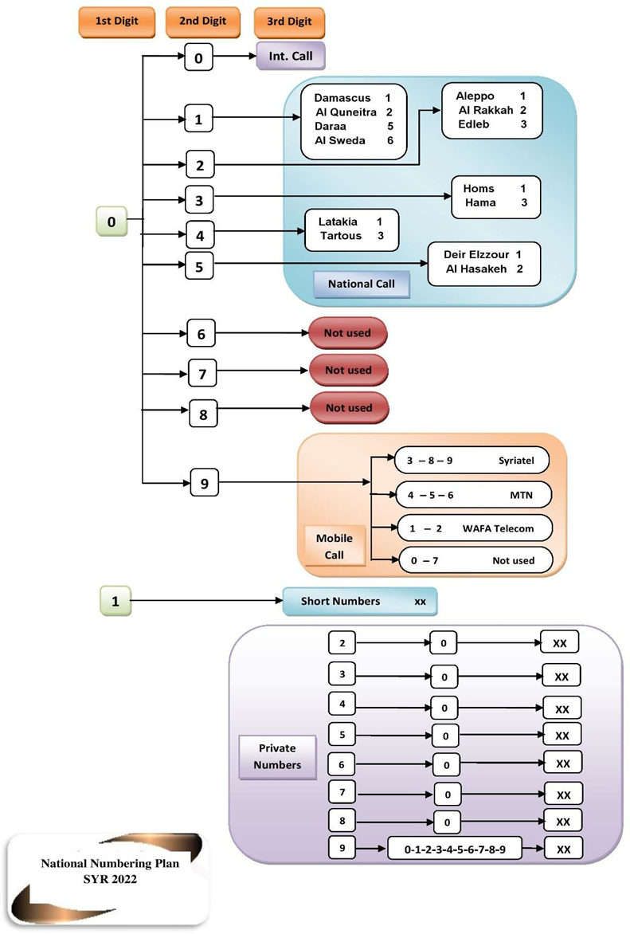
Contact:
Eng. Wael Saba
Technical Affairs Director
Syrian Telecommunications and Post Regulatory Authority
DAMASCUS
Syrian Arab Republic
Tel: +963 11 613 6210
Fax: +963 11 613 6211
E-mail: technical.affairs@sytra.gov.sy
URL: www.sytra.gov.sy

Communication of 27.II.2022:
The Syrian Telecommunications and Post Regulatory Authority, Damascus, announces the following assignment of mobile number series in the national numbering plan.
Mobile Operator Code MOC:
CC | MC | MOC | SN | Entry date | Assigned to
963 | 9 | 1 | 7 Digits | 21-02-2022 | WAFA Telecom
 |  | 2
International dialling format: +963 91 XXXX XXX
+963 92 XXXX XXX
Contact:
Eng. Wael Saba
Technical Affairs Director
Syrian Telecommunications and Post Regulatory Authority
DAMASCUS
Syrian Arab Republic
Tel.: +963 11 613 6 210
Fax: +963 11 613 6 211
E-mail: technical.affairs@sytra.gov.sy

