Facilitator’s Report

ITU Green Standards Week World Café
Workshop on Submarine Cables for Ocean/Climate Monitoring and Disaster Warning:
Science, Engineering, Business and Law

9 September 2011, Rome, Italy

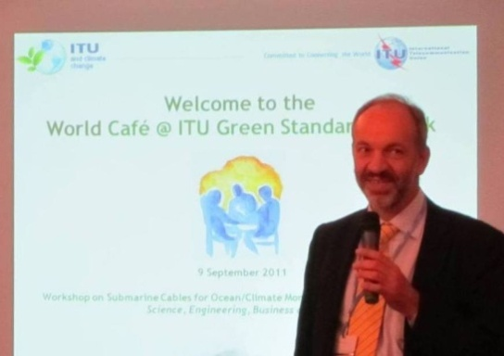

On 9 September 2011, a World Café collaborative meeting was held as last session of the Workshop on Submarine Cables for Ocean/Climate Monitoring and Disaster Warning: Science, Engineering, Business and Law, within the ITU Green Standards Week in Rome, Italy at the Telecom Italia Auditorium.

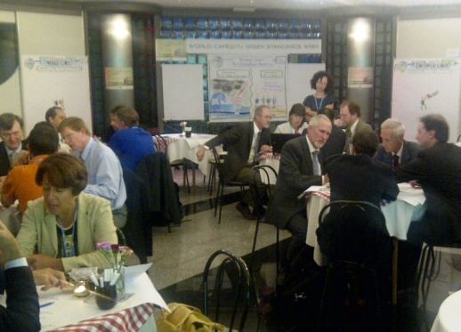

Participants had the opportunity to contribute their individual input, producing rich results and a significant number of actionable items which were formalized in the workshop output document, the “Call to Action”.

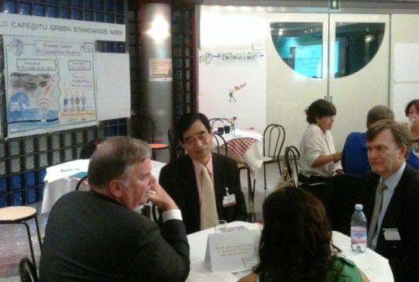

The World Café equally served as an excellent means to foster communication and exchanges amongst peers, in an informal and welcoming atmosphere.

This document reports on the activity with a brief introduction on the purpose and methodology, followed by a description of the café, the results and emerging trends, the next steps and an overview of the feedback received from the participants.

For additional information, including photographs of the café, please contact tsbadmin@itu.int .

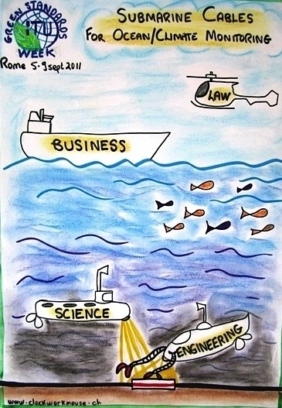

Contents

1. Introduction 3
2. World Café Organizers 3
3. Methodology 4
4. Programme and functioning 4
5. Results of Conversation 1 6
6. Results of Conversation 2 7
7. Results of the midway Town Hall discussion 8
8. Results of Conversation 3 9
9. Results of the final Town Hall discussion 10
10. Experiences and impressions 11

Introduction

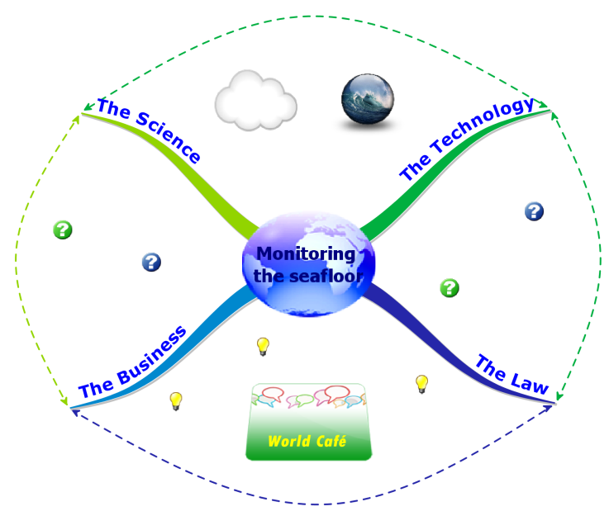
The World Café is an effective way to host vibrant collaborative conversations. The café held on 9 September 2011, as the last session of the Workshop on Submarine Cables for Ocean/Climate Monitoring and Disaster Warning: Science, Engineering, Business and Law was designed to ensure the active involvement of each and every participant in a generative discussion around the key questions and issues emerging from the workshop.

An opportunity was offered to

- Stimulate new perspectives
- Trigger initiatives
- Generate input for output document
- Facilitate networking, connection and exchanges
- Consolidate a community of interests

Participants were invited to

- Explore the different viewpoints the workshop’s for dimensions: the science, the technology, the business and the law
- Bridge the knowledge silos between the dimensions
- Identify divergences and investigate opportunities to transcend them by viewing the challenge as an interconnected system

Participants appreciated the World Café and its unique format which provided a means to engage in a truly collaborative conversation that yielded constructive results.

World Café Organizers

This was the first World Café organized for ITU delegates, a community known for its history-making potential.

Given the pioneering topic of the workshop, ITU/TSB decided to offer the World Café as a platform for shared dialogue, intensive peer exchanges and an effective means to consolidate an open network of world-class experts in the field.

Hosts | Reinhard Scholl, ITU TSB  Cristina Bueti, ITU TSB
Host and Organizer in Italy | Flavio Cucchietti, Telecom Italia
Design and Facilitation | Saba Imru, ITU TSB
Content harvest and consolidation, reporting | Martin Adolph, ITU TSB  Erica Campilongo, ITU TSB
Graphic records | Elizabeth Auzan, Consultant for ITU
World Café support in Italy | Beatriz de Meirelles, Telecom Italia

Methodology

The world café is a collaborative conversation methodology originated in the early 90s by scholars Juanita Brown PhD and David Isaacs in the United States and now widely used at a global level in industry, government, civil society and academia. It is based on systems thinking as applied to organizations and on collective intelligence studies.

Amongst the key design principles of the world café are the creation of hospitable space, exploring questions that matter, encouraging everyone’s contribution, connecting diverse perspectives and sharing collective discoveries.

Participants are invited to explore strategic questions together in an informal setting. At the issue of a world café, results are shared and analyzed for further follow-up actions and implementation.

Real-time graphic records were created as a means to capture the essence of the on-going conversations in pleasant visual format.

Programme and functioning

The World Café at ITU Green Standards week was held from 15:30-17:30 hrs, with the following structure:
- Introduction
- Conversation 1 – to make connections amongst participants and between the four workshop dimensions: the science, the technology, the business, the law
- Conversation 2 – to explore possibilities and open up new horizons
- Midway Town Hall plenary conversation – to share individual ideas in the larger group
- Conversation 3 – to identify ways to move forward and establish actions
- Final Town Hall plenary conversation – to converge all ideas and focus on outcome actions

Each conversation was stimulated by a strategic question:
- Conversation 1, Question 1:
What role can my organization/company play to facilitate the use of submarine communications cables for ocean and climate monitoring and disaster warning?
- Conversation 2, Question 2:
What new possibilities on this topic have we not yet explored?
- Conversation 3, Question 3:
What do you propose as the most important next steps?

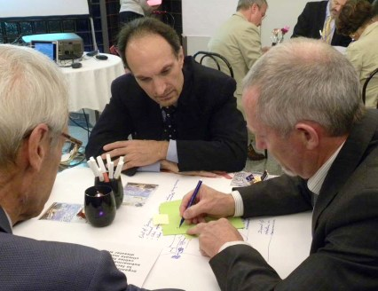 | Participants were assembled around tables in small groups for the three conversation rounds. At the end of each round, the main ideas of each table were collected on post-it notes and participants changed tables for the next round, to meet new people and to carry ideas into the new group.
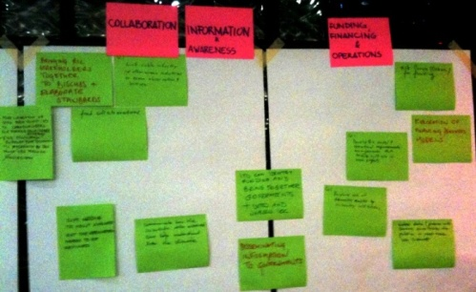 | The multiple exchanges of ideas amongst participants stimulated new thoughts and connections and the conclusions of each conversation were more than simply a catalogue of individual ideas but rather a combination of common and diverse views.  The co-created event produced a rich content and invited engagement.
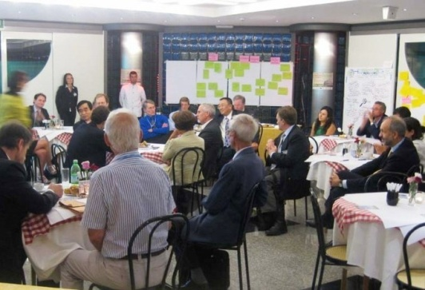 | Two plenary Town Hall conversations were held to connect the various ideas that emerged at the various tables, identify common trends and determine the new initiatives and commitments.
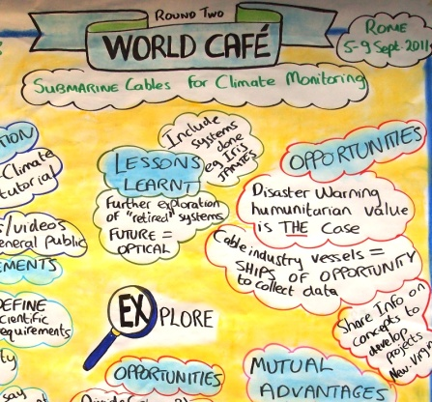 | Visual records gave a real-time synthesis of the highlights of the conversations and added a playful tone to the event, underlying the serious but fun approach to creative thinking.

Results of Conversation 1
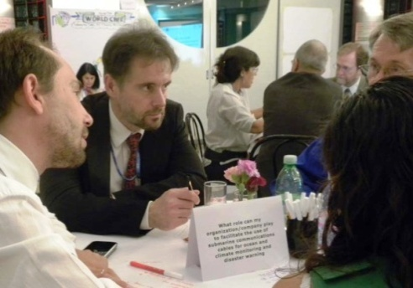
During the first conversation, participants were invited to start making connections between the four workshop dimensions: the science, the technology, the business, the law by exploring the question:

What role can my organization/company play to facilitate the use of submarine communications cables for ocean and climate monitoring and disaster warning?

The ideas emerging from the conversation are clustered by topic as follows:

Collaboration
- Bringing the stakeholders together to discuss and elaborate standards
- Find collaborators
- Link cable industry with other ocean industries on ocean observation science
- ICPC can bring experience and know how on cables. The scientists can bring info on technical requirements
- ICPC to help evaluate but the requirement needs to be defined
Information & awareness
- Disseminating information to governments
- Make data (pictures with camera) available to public in real-time via Internet
- Communicate how the scientific data measured can help understand the climate better
- More circulation of info from scientists to cable engineers for starting profitable synergy
Possibilities and solutions
- Infrastructure (submarine cables)
- Engineering solutions
- Two different levels:
  - Deep scientific studies - few dedicated points
  - Simple measurements - all repeaters
- Similar precedent by WMO project - AMDAR Aircraft Meteorological Data Rely
- Explore use of domestic cables by in-country institutions
- Develop Bi2 model and operational arrangements that enable multi use in new projects
Pilot projects
- Pilot projects, select instruments, select optical transport, long life (25 years) and seabed trials on existing observatory
- Pilot projects to demonstrate the technology, benefits, build confidence
- Based on the implementation of the pilot project it could lead to standards
Funding
- Exploration of financing/business models
- Ask Google (Ocean) for funding
- ITU can identify funding and bring together governments, WTO and UNESCO IOC

Results of Conversation 2

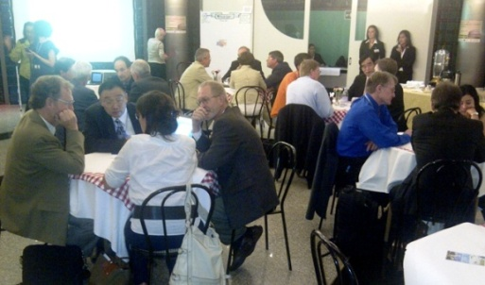
During the second conversation, participants explored novel possibilities and opened up new horizons by exploring the question:

What new possibilities on this topic have we not yet explored?

Several ideas emerged revolving around the following topic areas:

Collaboration and mutual advantage
- Science without information (data) transfer is nothing; TC cable industries can make "connection"
- Science & industry communities can have reciprocal advantages in putting sensors for climate change studies and cable protection
- More collaboration between science + telecoms world
- Standardization, involve manufacturers
Information & awareness
- Use disaster warning/humanitarian value as the case for using cables to collect ocean data
- Promote the importance of deep sea data through movies, videos for general public
- UN FCCC & climate change tutorial
Areas for study and requirements
- Explore and define system and scientific requirements
- Scientists requirements match with engineering
- Scientists saying what they want to measure? - How do we see new?
- Information on concepts and opportunities to develop pilots (new - virgin)
- Longevity & QA
- Environmental impact
- Pilot project to understand tech. requirements apply for euro. research project
- Include systems to see and learn projects already done
Possibilities and Solutions
- Collect data during operations and maintenance
- Use cable industry vessels as ships of opportunity to collect data during installation, maintenance and repair voyages
- Further exploration of use of retired systems:
- Co-Axial
- Optical with regenerators
- Optical with amplifiers
- Future optical systems
- Possibility of dividing information on a coastal state basis and gathering all information by independent agency
- Projects within limits of domestic jurisdiction (avoid delimitation issues)
- Drop “scientific boxes” (no connection to teleco cables) and devise ways of collecting data in real-time.
Funding
- As for funding:
  - Bill Gates Foundation; The public; Al Gore; Carlos Slim

Results of the midway Town Hall discussion

The purpose of this first plenary Town Hall discussion was to share individual ideas, experiences and insights after the first two conversations. It gave an indication of emerging trends in the group as a whole.

The main ideas that emerged were:

- The World Café helped distill ideas.
- Through face to face conversation the exchange of ideas and points of view were facilitated. People felt at ease in answering questions.
- The World Café helped explore new possibilities.
- The face to face discussion facilitated a better understanding of the issue. It was of fundamental importance to define what the problem requires in order to identify possible solutions.
- We are making history. We should be aware of the importance of using submarine cables to monitor the climate and to prevent natural disasters.
- The need of continuous observation has been raised.
- The need to create a pilot emerged in order to better understand technical possibilities and to confront with legal issues.
- The issue of clearly defining the requirements needed was raised. The requirements should be identified by the different communities involved in this activity. The common and open discussion led during the World Café underlined the need of a broader point of view on the issue, bringing together scientific community and ICT industry.
- The World Café was challenging because it brought together people from different cultures, communities and backgrounds. The World Café raised the challenge of how to bridge the gap between the scientific community and the ICT industry. The World Café also showed the willingness of people from different backgrounds to communicate and collaborate.

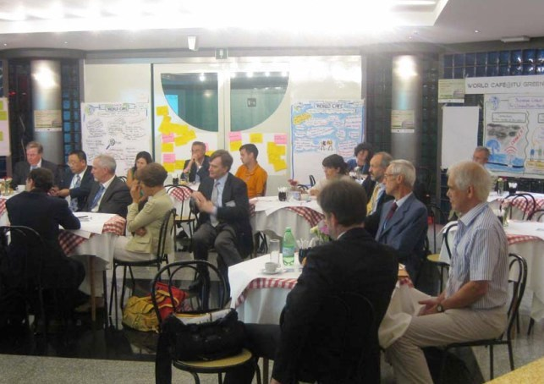

Results of Conversation 3
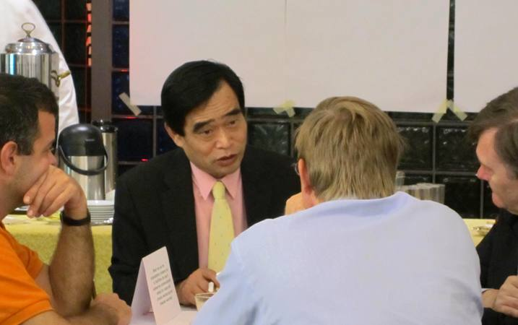
In the third conversation, participants identified ways to move forward and determined a number of concrete actions to be taken.

What do you propose as the most important next steps?

Collaboration for Action
- Call to action
- Joint task force
- ITU to convene small, enthusiastic project team
- Create a group of experts
  - Science & Business (S&B)
  - Regional, local international scale
  - Create database (S&B)
  - Include manufactures
- Don't lose momentum (but sleep on it ...)
Information & awareness
- Scientist to make clear(er) what the data they would collect would be useful for
- Get (eminent) author(s) to write article in Scientific American
Areas for study
- Further discussion on definition of issues in an Asia-Pacific venue
- Identification of the issue - specifics
- Inventory of ocean abbreviations
- Define what outcomes are desired, how to get there, undertake cost/benefit analysis
- Perform:
  - Cost analysis
  - Environmental impact
  - Legal analysis
- Examine what data is actually required and who actually requires it
- Fund engineering study on optical transport
- Identify clients:
  - End users
  - Funders
  - UN Agencies
- Data dissemination:
  - Who gets the data?
  - Who needs the data? – misuse
- ABE-LOS/IOC: Discuss legal parameters - possible feasibility study
- Atlas - Map of submarine cables that would be priority
- Areas that will suffer most from climate change, i.e. inundation (area of focus)
Pilot projects
- Develop pilot projects:
  - Easy (e.g. short distance)
  - Reliable to Telecos (demonstrate)
  - Clear scientific object
- Pilot project scale (of MSR only?) to test science, instruments, technology, etc.
- Do pilot in area of greatest interest, least variables/barriers (e.g. domestic waters on high seas)
- Pilot project multi-community design and implement
- Sketch of project plans(s)
- Organize next workshop in:
  - A direct pacific
  - Those affect most by climate change or tsunami
Funding
- Explore financing opportunities, including financial mechanisms

Results of the final Town Hall discussion
This last session served to converge the content of all the previous conversations, clarify positions and focus intentions towards the drafting and approval of the outcome document “Call for Action”.

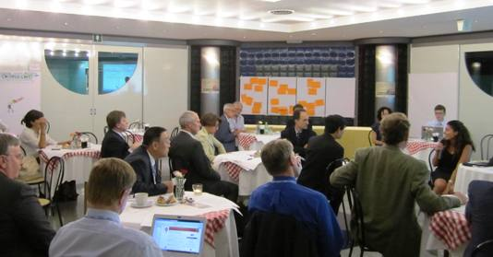

- The World Café contributed to build confidence among the participants.
- The World Café facilitated exchange of ideas and stimulated new considerations.
- Focusing the discussion on what is achievable is better than doing nothing.
- The issue of climate change put together experts from different backgrounds. That helped gain a better and broader understanding and identify ways forward.
- A participant conveyed the message: “Sleep on it!”. He clarified that even though the discussion does not end with a solution, new ideas will take shape in the future thanks to the vibrant face to face exchange.
- According to one of the participant if policy makers understand what the stakes are and promote the issue, law will find a way to adjust and support their commitments.
- Some people observed that they came at the World Café with their own views of the issue and they left with a different perception of the issue.
- A participant affirmed that he felt important during the discussions. He argued that everyone can make the difference.
- With reference to technical capability, a participant wanted to clarify that it is difficult to work in deep ocean. He asserted that the first step is to recognize and accept it. If we are not aware of the challenges we will meet, we will fail.
- If human beings achieved in exploring the outer space, they would succeed with oceans as well.
- A participant raised the need of setting our priorities. We could not live without telecommunications on one side and the future of the earth should be a priority for all human beings on the other side.
- Some people wished that the friendly environment of the World Café could be recreated in the future and that all participants could come together again in the future to move forward the agenda of submarine cables and climate monitoring.
- The opportunity to take the momentum and remain committed on the issue was welcome.

Experiences and impressions
In terms of how the World Café was experienced, participants’ comments revealed that overall it was felt to be a positive experience resulting in new perspectives. The informal atmosphere was appreciated as conducive to constructive exchanges and there were requests to repeat the world café methodology as a collaborative meeting tool.

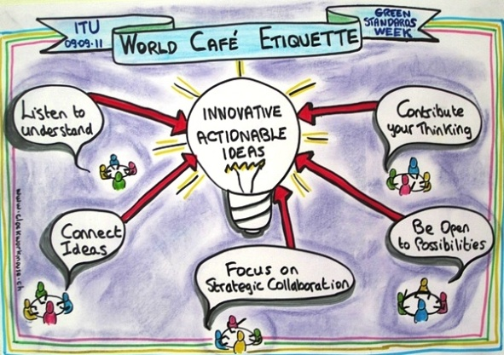

The results of the feedback form are listed below:

How did you like the World Café?

1 NOT satisfied: 0%
2 0%
3 Neutral: 5%
4 16%
5 VERY satisfied: 79%

Comments:

- Everybody gave his/her contribution to the conversation
- Excellent, continue the exercise!
- It is a good idea for such a successful World Café. I enjoyed it. John You
- Great explicit directions from organizer
- Excellent way to overcome barriers
- It was interesting and stimulating
- Well organized
- The interaction
- Great concept & process
- Good facilitation
- Would be good to get results from walls synthesised/summarized verbally a bit more
- Well organized and managed
- Very useful for future activities
- First experience of World Café and something I will use

What did you like the best?

- Meeting a small number of people at a time
- Speaking about important problems that concern mankind
- Everybody said his/her opinion
- The possibility to talk in small groups
- The interactive nature
- World Café (as a whole)
- The collaborative spirit, the collective efforts and innovative ideas. The World Café is a successful one!
- This provides opportunity to talk face to face with participants from different backgrounds. The conferences I attended before were usually giving me no impression and not making friends and exchanging ideas, etc. John You
- The interaction between people of different disciplines, get varied and valuable input
- How apparent "opposites" managed to focus on common achievable theme
- Diversity of discussion in a positive and engaging environment
- The graphics and results
- The "environment" was friendly
- The way in which ideas were got from people
- The interaction and thought-provoking conversation
- The possibility to talk in small groups
- Round table discussions
- Dialogue, meeting new people
- Possibility to discuss with people coming from "different" worlds
- Rotating of participants
- Good questions to focus on
- To have the possibility to exchange views with persons of different cultures
- Interactive nature
- Sharing and development of ideas
- Constructive and open
- Enabling/pushing different mind sets to talk and understand each other

What are your suggestions for improvements?

- A little more time to ask at the end a short opinion/statement from each participant
- Bigger table for 6-8 persons
- Longer discussion time for each round
- It will be more exciting together with an evening session (group dinner) if feasible
- Social activity after the World Café
- Keep using this tool
- Include a "situation" for participants to solve
- Suggest that participants introduce each other at the table
- Allow us to paint on walls
- Make sure the table has people from different fields
- Ensure location acoustics make it easy to converse (too hard to hear over all the talk)
- First question was less conducive to collaborative ideas
- More time for discussion
- A bit more time for discussion would be ok
- Let's continue to explore the possibility to use submarine cables.




