International Telecommunication Union

Open Communication Architecture Forum

OCAF Focus Group

CGOE Components

HTTP Client

Version 1.0

July 2006

Y.cgoe-cmpts-Annex http.clnt
Carrier grade open environment components
ANNEX http.clnt
The HTTP client CGOE component
Summary
This Annex specifies the HTTP client CGOE component.
Keywords
<Optional>

1 Scope
This Annex specifies the HTTP client CGOE component.

2 References
The following ITU-T Recommendations and other references contain provisions, which, through reference in this text, constitute provisions of this Recommendation. At the time of publication, the editions indicated were valid. All Recommendations and other references are subject to revision; users of this Recommendation are therefore encouraged to investigate the possibility of applying the most recent edition of the Recommendations and other references listed below. A list of the currently valid ITU-T Recommendations is regularly published.
The reference to a document within this Recommendation does not give it, as a stand-alone document, the status of a Recommendation
Editor’s note: To be completed

3 Definitions
Editor’s note: To be completed
This Recommendation defines the following terms:
3.1 Application: (See Recommendation Y.CGOE)
3.2 Carrier grade: (See Recommendation Y.CGOE)
3.3 CGOE component: (See Recommendation Y.CGOE)
3.4 End-to-End Security: End-to-end security refers to security between two Diameter nodes, possibly communicating through Diameter Agents.
3.5 Functional requirements: (See Recommendation Y.CGOE)
3.6 Middleware: (See Recommendation Y.CGOE)
3.7 Non-functional requirements: (See Recommendation Y.CGOE)

4 Abbreviations
Editor’s note: To be completed
AAA | Authentication, Authorization and Accounting
CGOE | Carrier Grade Open Environment

5 Conventions
This Recommendation uses the CGOE component diagram conventions detailed in clause 5 of the main body of this Recommendation.

6 The HTTP client CGOE component

6.1 General

Brief description
The Hypertext Transfer Protocol (HTTP) is a component that operates as an interface and is an application-level protocol for distributed, collaborative, hypermedia information systems. It is a generic, stateless, object-oriented protocol which can be used for many tasks, such as name servers and distributed object management systems, through extension of its request methods. If HTTP is operated over Transport Layer Security Protocol (TLS Protocol) it is called HTTPS.
The component HTTP acts as a server, which provides a concrete communication facility.
A technology independent description is in Figure http.clnt.1/Y.cgoe.cmpts.
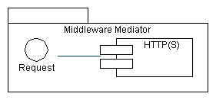
Figure http.clnt.1/Y.cgoe.cmpts Technology Independent View
This shows that HTTP offers the capability for communication based on requests. This is the primary interface for HTTP.
The HTTP has Client-Server-Architecture. A principle description is in Figure http.clnt.2/Y.cgoe.cmpts.
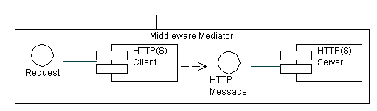
Figure http.clnt.2/Y.cgoe.cmpts - HTTP Client-Server-Architecture
This document focuses on the Client part of the HTTP(S) component. However most of the description holds also for the Server part of the HTTP(S) component.

6.2 Relationship with other CGOE components
A CGOE compliant HTTP Client component makes use of other interfaces as shown in Figure http.clnt.3/Y.cgoe.cmpts. These are secondary interfaces which are described in the CGOE documentation for each component. Each of these secondary interfaces will have one or more technology-specific instances.
The CGOE component HTTP Client is used by the CGOE component OAM&P Middleware. HTTP is an optional interface which may be present or not to the OAM&P Middleware.
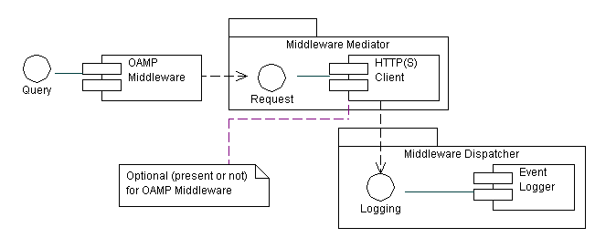
Figure http.clnt.3/Y.cgoe.cmpts secondary Interfaces

6.3 Internal functional properties

6.3.1 Cache
Caching is used to improve the performance of HTTP. The goal of caching is to eliminate the need to send requests in many cases, and to eliminate the need to send full responses in many other cases.
Standard
IETF RFC 2616

6.3.2 Tracing
Tracing deals with monitoring communication traffic for the purpose of error finding
None

6.4 Non-functional properties

6.4.1 Transaction Performance
This property measures how many requests can be handled per second.
Unit of measure: Request/second

6.4.2 Modification of multitude Data Records
This property measures if a command of the interface operation supports modifying more than one data record.
Unit of measure: Yes/No

6.4.3 Recovery
This property measures the behavior of the components if there is no response or confirmation e.g. due to a temporary outage.
Unit of measure: yes / partly / no

6.5 Interfaces

6.5.1 HTTP client-IF-01 <Request>
Provides the capability to communicate using HTTP.
Standard
IETF RFC 2616

6.5.2 HTTP client-IF-02 <HTTP Message>
Provides the capability to communicate between HTTP Client and HTTP Server.
Standard
IETF RFC 2616

6.5.3 HTTP client-IF-03 <Logging>
Provides the capability to log any transaction in relation to the component HTTP.
Standard
GAP (Possible Solution the logging component of the specific Middleware can be used)

6.5.4 HTTP client-IF-04 Transmission <Control Protocol>
Provides mechanisms used to transfer any HTTP request/response over the internet protocol. If no port is given the default port is 80.
Standards
IETF RFC 3588
STD7 IETF RFC 793

6.5.5 HTTP Client-IF-05 <Transport Layer Security Protocol>
Provides mechanisms used to transfer any HTTP request/response over the internet protocol in a secure manner. If no port is given the default port is 443.
Standard
IETF RFC 3546

7 Security
Editor’s note: To be added
________________________________________
Bibliography
Editor’s note: To be added
___________________

