|  |  |
| --- | --- |
|  | الا تحــاد الــدولي للاتصــالات  *مكتب تقييس الاتصالات* |

|  |  |  |
| --- | --- | --- |
|  |  | جنيف، 1 نوفمبر 2014 |
| المرجع:    الهاتف:  الفاكس:  البريد الإلكتروني: | **TSB AAP-45**  AAP/MJ  +41 22 730 5860  +41 22 730 5853  tsbdir@itu.int | - إلى إدارات الدول الأعضاء في الاتحاد؛  - إلى أعضاء قطاع تقييس الاتصالات؛  - إلى المنتسبين إلى قطاع تقييس الاتصالات  **نسخة إلى:**  - رؤساء لجان الدراسات في قطاع تقييس الاتصالات ونوابهم؛  - مدير مكتب تنمية الاتصالات؛  - مدير مكتب الاتصالات الراديوية |

الموضوع: **حالة التوصيات الخاضعة لعملية الموافقة البديلة (AAP)**

حضرات السادة والسيدات،

تحية طيبة وبعد،

تنطبق عملية الموافقة البديلة (AAP) المعرفة في التوصية ITU‑T A.8 على التوصيات التي لا تنطوي على بعد سياسي أوتنظيمي ولا تتطلب بالتالي استشارة الدول الأعضاء رسمياً (انظر الرقم 246B من اتفاقية الاتحاد).

ويتضمن **الملحق 1** لائحة بالنصوص التي تغيرت حالتها مقارنة بما جاء في إعلانات عملية الموافقة البديلة السابقة.

إذا رغبتم في تقديم تعليق بشأن توصية ما خاضعة لعملية الموافقة البديلة، فنرجو منكم استعمال استمارة التعليق على الخط المتوفّرة على موقع قطاع تقييس الاتصالات على صفحة عملية الموافقة البديلة [http://www.itu.int/ITU-T/aap](http://www.itu.int/ITU-T/aap/) على المدخل الخاص بالتوصية المعنية (انظر **الملحق** (**2**. وبديلاً من ذلك، يمكنكم تقديم التعليقات باستكمال الاستمارة الواردة في **الملحق 3** وإرسالها إلى أمانة لجنة الدراسات المعنية بالأمر.

وتجدر الإشارة إلى أنه يفضّل عدم إرسال تعليقات تقتصر على تأييد اعتماد النص قيد النظر.

وتفضلوا بقبول فائق الاحترام والتقدير.

مالكولم جونسون  
مدير مكتب تقييس الاتصالات

**الملحقات:** 3

Annex 1

(to TSB AAP-45)

Status codes used in the AAP announcements:

LC = Last Call

LJ = Last Call Judgment (includes comment resolution)

AR = Additional Review

AJ = Additional Review Judgment (includes comment resolution)

SG = For Study Group approval

A = Approved

AT = Approved with typographic corrections

AC = Approved after Additional Review of Comments

NA = Not approved

TAP = Moved to TAP (ITU-T A.8 / § 5.2)

ITU-T website entry page:

[http://www.itu.int/ITU-T](http://www.itu.int/ITU-T/)

Alternative approval process (AAP) welcome page:

[http://www.itu.int/ITU-T/aapinfo](http://www.itu.int/ITU-T/aapinfo/)

Note – A tutorial on the ITU-T AAP application is available under the AAP welcome page

ITU-T website AAP Recommendation search page:

<http://www.itu.int/ITU-T/aap/>

Study Group web pages and contacts:

|  |  |  |
| --- | --- | --- |
| SG 2 | <http://www.itu.int/ITU-T/studygroups/com02> | [tsbsg2@itu.int](mailto:tsbsg2@itu.int) |
| SG 3 | <http://www.itu.int/ITU-T/studygroups/com03> | [tsbsg3@itu.int](mailto:tsbsg3@itu.int) |
| SG 5 | <http://www.itu.int/ITU-T/studygroups/com05> | [tsbsg5@itu.int](mailto:tsbsg5@itu.int) |
| SG 9 | <http://www.itu.int/ITU-T/studygroups/com09> | [tsbsg9@itu.int](mailto:tsbsg9@itu.int) |
| SG 11 | <http://www.itu.int/ITU-T/studygroups/com11> | [tsbsg11@itu.int](mailto:tsbsg11@itu.int) |
| SG 12 | <http://www.itu.int/ITU-T/studygroups/com12> | [tsbsg12@itu.int](mailto:tsbsg12@itu.int) |
| SG 13 | <http://www.itu.int/ITU-T/studygroups/com13> | [tsbsg13@itu.int](mailto:tsbsg13@itu.int) |
| SG 15 | <http://www.itu.int/ITU-T/studygroups/com15> | [tsbsg15@itu.int](mailto:tsbsg15@itu.int) |
| SG 16 | <http://www.itu.int/ITU-T/studygroups/com16> | [tsbsg16@itu.int](mailto:tsbsg16@itu.int) |
| SG 17 | <http://www.itu.int/ITU-T/studygroups/com17> | [tsbsg17@itu.int](mailto:tsbsg17@itu.int) |

Situation concerning Study Group 9 Recommendations under AAP

| **Rec #** | **Title** | **Last Call (LC) Period** | | | | **Additional Review (AR) Period** | | | | Status |
| --- | --- | --- | --- | --- | --- | --- | --- | --- | --- | --- |
| **LC Start** | **LC End** | **LC Result** | **LJ Result** | **AR Start** | **AR End** | **AR Result** | **AJ Result** |
| [J.195.2 (J.HiNoC-phy)](http://www.itu.int/itu-t/aap/AAPRecDetails.aspx?AAPSeqNo=3100) | Physical layer specification for high speed transmission over coaxial networks ([Summary](https://www.itu.int/ITU-T/aap/dologin_aap.asp?id=T0102000C1C0801MSWE.docx&group=9)) | 2014-10-01 | 2014-10-28 | A |  |  |  |  |  | A |
| [J.195.3 (J.HiNoC-mac)](http://www.itu.int/itu-t/aap/AAPRecDetails.aspx?AAPSeqNo=3108) | Medium Access Control layer specification for high speed transmission over coaxial networks ([Summary](https://www.itu.int/ITU-T/aap/dologin_aap.asp?id=T0102000C240801MSWE.docx&group=9)) | 2014-10-01 | 2014-10-28 | A |  |  |  |  |  | A |
| [J.201](http://www.itu.int/itu-t/aap/AAPRecDetails.aspx?AAPSeqNo=3106) | Harmonization of declarative content format for interactive television applications ([Summary](https://www.itu.int/ITU-T/aap/dologin_aap.asp?id=T0102000C220801MSWE.docx&group=9)) | 2014-10-01 | 2014-10-28 | LJ |  |  |  |  |  | LJ |
| [J.205 Corrigendum 2](http://www.itu.int/itu-t/aap/AAPRecDetails.aspx?AAPSeqNo=3123) | Requirements for an application control framework using integrated broadcast and broadband digital television ([Summary](https://www.itu.int/ITU-T/aap/dologin_aap.asp?id=T0102000C330801MSWE.docx&group=9)) | 2014-10-01 | 2014-10-28 | LJ |  |  |  |  |  | LJ |
| [J.301 (J.arstv-req)](http://www.itu.int/itu-t/aap/AAPRecDetails.aspx?AAPSeqNo=3109) | Requirements of Augmented Reality Smart Television System ([Summary](https://www.itu.int/ITU-T/aap/dologin_aap.asp?id=T0102000C250801MSWE.docx&group=9)) | 2014-10-01 | 2014-10-28 | A |  |  |  |  |  | A |
| [J.343 (J.bitvqm)](http://www.itu.int/itu-t/aap/AAPRecDetails.aspx?AAPSeqNo=3110) | Hybrid perceptual bitstream video quality assessment ([Summary](https://www.itu.int/ITU-T/aap/dologin_aap.asp?id=T0102000C260801MSWE.docx&group=9)) | 2014-11-01 | 2014-11-28 |  |  |  |  |  |  | LC |
| [J.343.1 (J.bitvqm1)](http://www.itu.int/itu-t/aap/AAPRecDetails.aspx?AAPSeqNo=3111) | Hybrid-NRe objective perceptual video quality measurement for HDTV and multimedia IP-based video services in the presence of encrypted bitstream data ([Summary](https://www.itu.int/ITU-T/aap/dologin_aap.asp?id=T0102000C270801MSWE.docx&group=9)) | 2014-11-01 | 2014-11-28 |  |  |  |  |  |  | LC |
| [J.343.2 (J.bitvqm2)](http://www.itu.int/itu-t/aap/AAPRecDetails.aspx?AAPSeqNo=3112) | Hybrid-NR objective perceptual video quality measurement for HDTV and multimedia IP-based video services in the presence of non-encrypted bitstream data ([Summary](https://www.itu.int/ITU-T/aap/dologin_aap.asp?id=T0102000C280801MSWE.docx&group=9)) | 2014-11-01 | 2014-11-28 |  |  |  |  |  |  | LC |
| [J.343.3 (J.bitvqm3)](http://www.itu.int/itu-t/aap/AAPRecDetails.aspx?AAPSeqNo=3113) | Hybrid-RRe objective perceptual video quality measurement for HDTV and multimedia IP-based video services in the presence of a reduced reference signal and encrypted bitstream data ([Summary](https://www.itu.int/ITU-T/aap/dologin_aap.asp?id=T0102000C290801MSWE.docx&group=9)) | 2014-11-01 | 2014-11-28 |  |  |  |  |  |  | LC |
| [J.343.4 (J.bitvqm4)](http://www.itu.int/itu-t/aap/AAPRecDetails.aspx?AAPSeqNo=3114) | Hybrid-RR objective perceptual video quality measurement for HDTV and multimedia IP-based video services in the presence of a reduced reference signal and non-encrypted bitstream data ([Summary](https://www.itu.int/ITU-T/aap/dologin_aap.asp?id=T0102000C2A0801MSWE.docx&group=9)) | 2014-11-01 | 2014-11-28 |  |  |  |  |  |  | LC |
| [J.343.5 (J.bitvqm5)](http://www.itu.int/itu-t/aap/AAPRecDetails.aspx?AAPSeqNo=3115) | Hybrid-FRe objective perceptual video quality measurement for HDTV and multimedia IP-based video services in the presence of a full reference signal and encrypted bitstream data ([Summary](https://www.itu.int/ITU-T/aap/dologin_aap.asp?id=T0102000C2B0801MSWE.docx&group=9)) | 2014-11-01 | 2014-11-28 |  |  |  |  |  |  | LC |
| [J.343.6 (J.bitvqm6)](http://www.itu.int/itu-t/aap/AAPRecDetails.aspx?AAPSeqNo=3116) | Hybrid-FR objective perceptual video quality measurement for HDTV and multimedia IP-based video services in the presence of a full reference signal and non-encrypted bitstream data ([Summary](https://www.itu.int/ITU-T/aap/dologin_aap.asp?id=T0102000C2C0801MSWE.docx&group=9)) | 2014-11-01 | 2014-11-28 |  |  |  |  |  |  | LC |
| [J.900 (J.Cable3DTV-Req)](http://www.itu.int/itu-t/aap/AAPRecDetails.aspx?AAPSeqNo=3107) | Requirements for Stereoscopic Three Dimensional Television Service over Hybrid Fiber and Coaxial based networks ([Summary](https://www.itu.int/ITU-T/aap/dologin_aap.asp?id=T0102000C230801MSWE.docx&group=9)) | 2014-10-01 | 2014-10-28 | A |  |  |  |  |  | A |
| [J.1003 (J.rcas-net)](http://www.itu.int/itu-t/aap/AAPRecDetails.aspx?AAPSeqNo=3101) | Specifications of network protocol for renewable conditional access system ([Summary](https://www.itu.int/ITU-T/aap/dologin_aap.asp?id=T0102000C1D0801MSWE.docx&group=9)) | 2014-10-01 | 2014-10-28 | A |  |  |  |  |  | A |

Situation concerning Study Group 12 Recommendations under AAP

| **Rec #** | **Title** | **Last Call (LC) Period** | | | | **Additional Review (AR) Period** | | | | Status |
| --- | --- | --- | --- | --- | --- | --- | --- | --- | --- | --- |
| **LC Start** | **LC End** | **LC Result** | **LJ Result** | **AR Start** | **AR End** | **AR Result** | **AJ Result** |
| [G.1091 (G.QRTP)](http://www.itu.int/itu-t/aap/AAPRecDetails.aspx?AAPSeqNo=3121) | QoE requirements for telepresence services ([Summary](https://www.itu.int/ITU-T/aap/dologin_aap.asp?id=T0102000C310801MSWE.doc&group=12)) | 2014-10-01 | 2014-10-28 | A |  |  |  |  |  | A |
| [P.340 Amd.1 (2014)](http://www.itu.int/itu-t/aap/AAPRecDetails.aspx?AAPSeqNo=3117) | Transmission characteristics and speech quality parameters of hands-free terminals: Amendment 1- Annex B: Objective test methods for multi-talker scenarios ([Summary](https://www.itu.int/ITU-T/aap/dologin_aap.asp?id=T0102000C2D0801MSWE.docx&group=12)) | 2014-10-01 | 2014-10-28 | A |  |  |  |  |  | A |
| [P.501 Amd.2 (2014)](http://www.itu.int/itu-t/aap/AAPRecDetails.aspx?AAPSeqNo=3124) | Test signals for use in telephonometry: Amendment 2 - Annex C -Speech files prepared for use with P.800 conformant applications and perceptual based objective speech quality prediction ([Summary](https://www.itu.int/ITU-T/aap/dologin_aap.asp?id=T0102000C340801MSWE.doc&group=12)) | 2014-10-01 | 2014-10-28 | A |  |  |  |  |  | A |
| [P.1302 (P.ACQ)](http://www.itu.int/itu-t/aap/AAPRecDetails.aspx?AAPSeqNo=3118) | Subjective method for simulated conversation tests addressing speech and audiovisual call quality ([Summary](https://www.itu.int/ITU-T/aap/dologin_aap.asp?id=T0102000C2E0810MSWE.docx&group=12)) | 2014-10-01 | 2014-10-28 | A |  |  |  |  |  | A |
| [P.1311 (P.SAM-Part 1)](http://www.itu.int/itu-t/aap/AAPRecDetails.aspx?AAPSeqNo=3119) | Method for determining the intelligibility of multiple concurrent talkers ([Summary](https://www.itu.int/ITU-T/aap/dologin_aap.asp?id=T0102000C2F0801MSWE.docx&group=12)) | 2014-10-01 | 2014-10-28 | LJ |  |  |  |  |  | LJ |
| [P.1401 Cor.1 (2014)](http://www.itu.int/itu-t/aap/AAPRecDetails.aspx?AAPSeqNo=3120) | Methods, metrics and procedures for statistical evaluation, qualification and comparison of objective quality prediction models: Corrigendum 1 ([Summary](https://www.itu.int/ITU-T/aap/dologin_aap.asp?id=T0102000C300801MSWE.doc&group=12)) | 2014-10-01 | 2014-10-28 | A |  |  |  |  |  | A |
| [Y.1546 (Y.15HO)](http://www.itu.int/itu-t/aap/AAPRecDetails.aspx?AAPSeqNo=3122) | Hand-over performance among multiple access networks ([Summary](https://www.itu.int/ITU-T/aap/dologin_aap.asp?id=T0102000C320801MSWE.docx&group=12)) | 2014-10-01 | 2014-10-28 | A |  |  |  |  |  | A |

Situation concerning Study Group 15 Recommendations under AAP

| **Rec #** | **Title** | **Last Call (LC) Period** | | | | **Additional Review (AR) Period** | | | | Status |
| --- | --- | --- | --- | --- | --- | --- | --- | --- | --- | --- |
| **LC Start** | **LC End** | **LC Result** | **LJ Result** | **AR Start** | **AR End** | **AR Result** | **AJ Result** |
| [G.9979 (G.99xx, 1905.1 Ext)](http://www.itu.int/itu-t/aap/AAPRecDetails.aspx?AAPSeqNo=2907) | ITU-T Extension to the IEEE 1905.1 2013 Standard ([Summary](https://www.itu.int/ITU-T/aap/dologin_aap.asp?id=T0102000B5B0810MSWE.doc&group=15)) | 2014-10-01 | 2014-10-28 | SG |  |  |  |  |  | SG |

Situation concerning Study Group 16 Recommendations under AAP

| **Rec #** | **Title** | **Last Call (LC) Period** | | | | **Additional Review (AR) Period** | | | | Status |
| --- | --- | --- | --- | --- | --- | --- | --- | --- | --- | --- |
| **LC Start** | **LC End** | **LC Result** | **LJ Result** | **AR Start** | **AR End** | **AR Result** | **AJ Result** |
| [H.264.2](http://www.itu.int/itu-t/aap/AAPRecDetails.aspx?AAPSeqNo=3032) | Reference software for ITU-T H.264 advanced video coding ([Summary](https://www.itu.int/ITU-T/aap/dologin_aap.asp?id=T0102000BD80801MSWE.doc&group=16)) | 2014-10-01 | 2014-10-28 | LJ |  |  |  |  |  | LJ |
| [H.265 (V2) (H.HEVC Amd.1)](http://www.itu.int/itu-t/aap/AAPRecDetails.aspx?AAPSeqNo=3035) | High efficiency video coding ([Summary](https://www.itu.int/ITU-T/aap/dologin_aap.asp?id=T0102000BDB0801MSWE.doc&group=16)) | 2014-10-01 | 2014-10-28 | A |  |  |  |  |  | A |
| [H.761](http://www.itu.int/itu-t/aap/AAPRecDetails.aspx?AAPSeqNo=3038) | Nested Context Language (NCL) and Ginga-NCL ([Summary](https://www.itu.int/ITU-T/aap/dologin_aap.asp?id=T0102000BDE0801MSWE.docx&group=16)) | 2014-11-01 | 2014-11-28 |  |  |  |  |  |  | LC |
| [H.821 (H.EH-HRN-01)](http://www.itu.int/itu-t/aap/AAPRecDetails.aspx?AAPSeqNo=3040) | Conformance testing: Health record network (HRN) interface ([Summary](https://www.itu.int/ITU-T/aap/dologin_aap.asp?id=T0102000BE00801MSWE.docx&group=16)) | 2014-10-01 | 2014-10-28 | A |  |  |  |  |  | A |

Situation concerning Study Group 17 Recommendations under AAP

| **Rec #** | **Title** | **Last Call (LC) Period** | | | | **Additional Review (AR) Period** | | | | Status |
| --- | --- | --- | --- | --- | --- | --- | --- | --- | --- | --- |
| **LC Start** | **LC End** | **LC Result** | **LJ Result** | **AR Start** | **AR End** | **AR Result** | **AJ Result** |
| [X.1311 Cor.1](http://www.itu.int/itu-t/aap/AAPRecDetails.aspx?AAPSeqNo=3130) | Information Technology - Security framework for ubiquitous sensor networks - Technical Corrigendum 1 ([Summary](https://www.itu.int/ITU-T/aap/dologin_aap.asp?id=T0102000C3A0820MSWE.docx&group=17)) | 2014-11-01 | 2014-11-28 |  |  |  |  |  |  | LC |
| [X.1341 (X.cmail)](http://www.itu.int/itu-t/aap/AAPRecDetails.aspx?AAPSeqNo=3141) | Certified mail transport and certified post office protocols ([Summary](https://www.itu.int/ITU-T/aap/dologin_aap.asp?id=T0102000C450801MSWE.docx&group=17)) | 2014-11-01 | 2014-11-28 |  |  |  |  |  |  | LC |

Annex 2

(to TSB AAP-45)

Using the on-line comment submission form

Comment submission

1) Go to AAP search Web page at <http://www.itu.int/ITU-T/aap/>

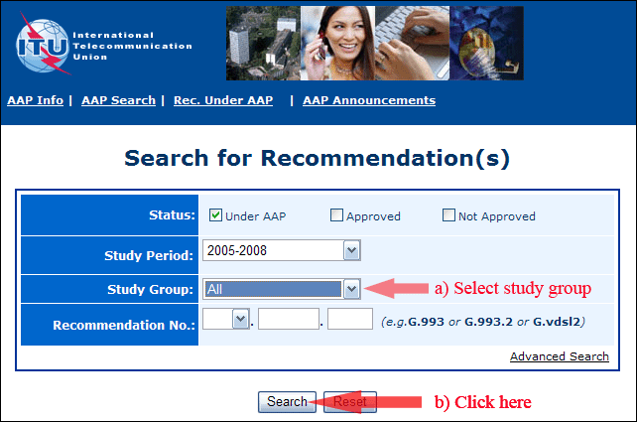

2) Select your Recommendation

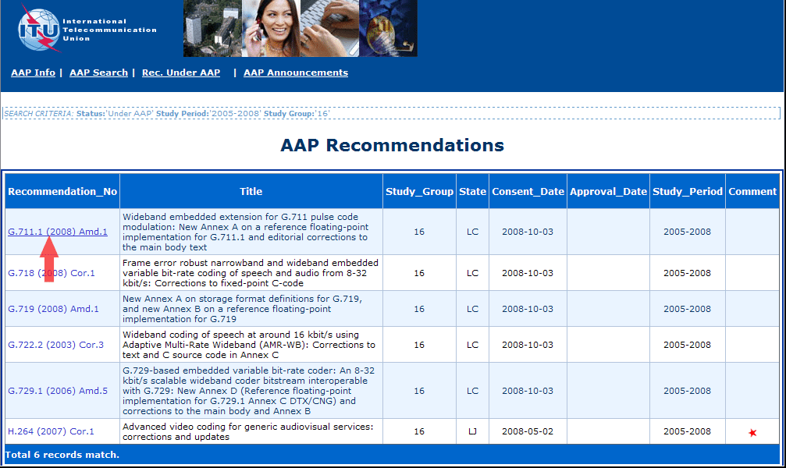

3) Click the "Submit Comment" button

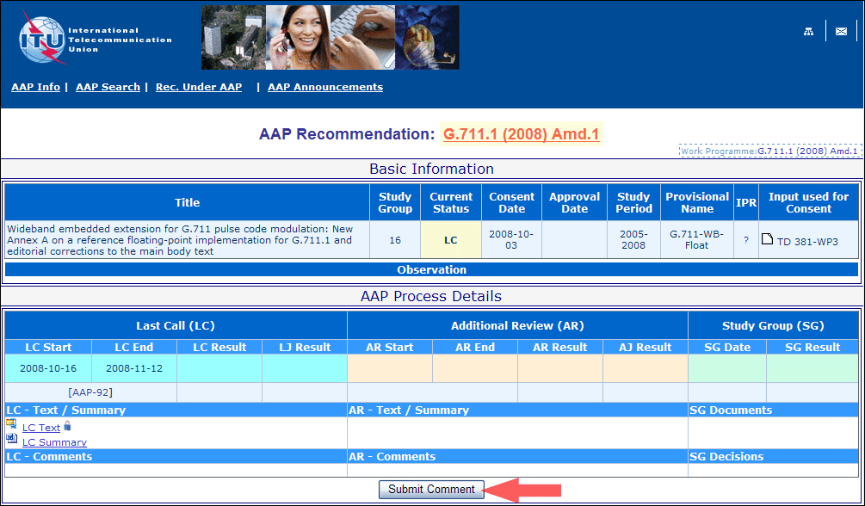

4) Complete the on-line form and click on "Submit"

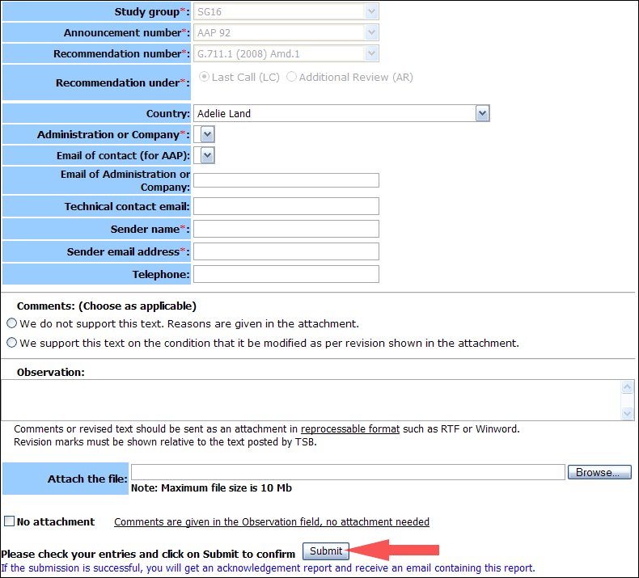

For more information, read the AAP tutorial on:   
<http://www.itu.int/ITU-T/aapinfo/files/AAPTutorial.pdf>

Annex 3

(to TSB AAP-45)

Recommendations under LC/AR – Comment submission form

*(Separate form for each Recommendation being commented upon)*

|  |  |
| --- | --- |
| ITU-T AAP comment submission form for the period 2009-2012 | |
| **Study Group:** |  |
| **Announcement number:** |  |
| **Recommendation number:** |  |
| **Recommendation under:** | Last call (LC)   Additional Review (AR) |
| **Country:** |  |
| **Administration/Company:** |  |
| **Name of AAP Contact Person:** |  |
| **Email of AAP Contact Person:** |  |
| **Sender name: (if different from AAP Contact Person)** |  |
| **Sender email address:** |  |
| **Telephone:** |  |
| **Comments: (Choose as applicable)** | We do not support this text. Reasons are given in the attachment.   We support this text on the condition that it be modified as per revision shown in the attachment. |
| **Observations:** |  |

**No attachment:** Comments are given in the Observation field, no attachment needed

*To be returned to: email:* [*tsbsg....@itu.int*](mailto:tsbsg....@itu.int) *[or fax +41 22 730 5853]  
Comments or revised text should be sent as an attachment in RTF or WinWord format.  
Revision marks must be shown relative to the text posted by TSB.*