Union Internationale des Telecommunications
Bureau de la normalisation des télécommunications

Genève, le 1 mai 2015

Réf:  Tél:  Fax:  E-mail: | TSB AAP-56  AAP/CL  +41 22 730 5860  +41 22 730 5853  tsbdir@itu.int | – Aux administrations des Etats Membres de l'Union;  – Aux Membres du Secteur UIT-T;  – Aux Associés de l'UIT-T  Copie:  – Aux Présidents et Vice-Présidents des Commissions d'études de l'UIT-T;  – Au Directeur du Bureau de développement des télécommunications;  – Au Directeur du Bureau des radiocommunications

Objet: | Etat des Recommandations auxquelles s'applique la variante de la procédure d'approbation (AAP)

Madame, Monsieur,

La variante de la procédure d'approbation (AAP), définie dans la Recommandation UIT-T A.8, s'applique aux Recommandations qui n'ont pas d'incidence politique ou réglementaire et ne nécessitent donc pas une consultation formelle des Etats Membres (voir le numéro 246B de la Convention de l'UIT).
L'Annexe 1 énumère les textes dont le statut a changé par rapport aux annonces TSB AAP antérieures.
Si vous souhaitez soumettre des observations sur une Recommandation ayant fait l'objet de la procédure AAP, vous êtes encouragés à utiliser le formulaire en ligne de soumission des observations AAP, disponible dans l'espace AAP du site web de l'UIT-T à l'adresse http://www.itu.int/ITU-T/aap/, à la page de la Recommandation concernée (voir l'Annexe 2). Vous pouvez aussi soumettre vos observations en remplissant le formulaire figurant à l'Annexe 3 et en l'envoyant au secrétariat de la Commission d'études concernée.
Veuillez noter que les observations ayant simplement pour objet d'appuyer l'adoption du texte en question ne sont pas encouragées.
Veuillez agréer, Madame, Monsieur, l'assurance de ma considération distinguée.
Chaesub Lee
Directeur du Bureau de la normalisation des télécommunications

Annexes: 3

Annex 1
(to TSB AAP-56)

Status codes used in the AAP announcements:
LC = Last Call
LJ = Last Call Judgment (includes comment resolution)
AR = Additional Review
AJ = Additional Review Judgment (includes comment resolution)
SG = For Study Group approval
A = Approved
AT = Approved with typographic corrections
AC = Approved after Additional Review of Comments
NA = Not approved
TAP = Moved to TAP (ITU-T A.8 / § 5.2)
ITU-T website entry page:
http://www.itu.int/ITU-T
Alternative approval process (AAP) welcome page:
http://www.itu.int/ITU-T/aapinfo
Note – A tutorial on the ITU-T AAP application is available under the AAP welcome page
ITU-T website AAP Recommendation search page:
http://www.itu.int/ITU-T/aap/
Study Group web pages and contacts:
SG 2 | http://www.itu.int/ITU-T/studygroups/com02 | tsbsg2@itu.int
SG 3 | http://www.itu.int/ITU-T/studygroups/com03 | tsbsg3@itu.int
SG 5 | http://www.itu.int/ITU-T/studygroups/com05 | tsbsg5@itu.int
SG 9 | http://www.itu.int/ITU-T/studygroups/com09 | tsbsg9@itu.int
SG 11 | http://www.itu.int/ITU-T/studygroups/com11 | tsbsg11@itu.int
SG 12 | http://www.itu.int/ITU-T/studygroups/com12 | tsbsg12@itu.int
SG 13 | http://www.itu.int/ITU-T/studygroups/com13 | tsbsg13@itu.int
SG 15 | http://www.itu.int/ITU-T/studygroups/com15 | tsbsg15@itu.int
SG 16 | http://www.itu.int/ITU-T/studygroups/com16 | tsbsg16@itu.int
SG 17 | http://www.itu.int/ITU-T/studygroups/com17 | tsbsg17@itu.int

Situation concerning Study Group 2 Recommendations under AAP
Rec # | Title | Last Call (LC) Period |  |  |  | Additional Review (AR) Period |  |  |  | Status
 |  | LC Start | LC End | LC  Result | LJ  Result | AR Start | AR End | AR  Result | AJ  Result
M.1400 | Designations for interconnections among operators' networks (Summary) | 2015-04-01 | 2015-04-28 | A |  |  |  |  |  | A
M.3170.0 (2007) Amd.1 | Multi-technology network management - Introduction and supporting documentation: Amendment 1 - Upgrade to MTNM Release 3.5 (Summary) | 2015-04-01 | 2015-04-28 | A |  |  |  |  |  | A
M.3170.1 (2007) Amd.1 | Multi-technology network management: Business agreement (TMF513): Amendment 1 - Upgrade to MTNM Release 3.5 (Summary) | 2015-04-01 | 2015-04-28 | A |  |  |  |  |  | A
M.3170.2 (2007) Amd.1 | Multi-technology network management: Information agreement (TMF608): Amendment 1 - Upgrade to MTNM Release 3.5 (Summary) | 2015-04-01 | 2015-04-28 | A |  |  |  |  |  | A
M.3170.3 (2007) Amd.1 | Multi-technology network management: CORBA IDL Solution Set (TMF814) with Implementation Statement Templates and Guidelines (TMF814A): Amendment 1 - Upgrade to MTNM Release 3.5 (Summary) | 2015-04-01 | 2015-04-28 | A |  |  |  |  |  | A
M.3170.4 (M.3170-cts) | Multi-technology network management: Conformance testing specification (Summary) | 2015-04-01 | 2015-04-28 | A |  |  |  |  |  | A
Situation concerning Study Group 5 Recommendations under AAP
Rec # | Title | Last Call (LC) Period |  |  |  | Additional Review (AR) Period |  |  |  | Status
 |  | LC Start | LC End | LC  Result | LJ  Result | AR Start | AR End | AR  Result | AJ  Result
K.20 | Resistibility of telecommunication equipment installed in a telecommunications centre to overvoltages and overcurrents (Summary) | 2015-02-01 | 2015-02-28 | LJ | AR | 2015-04-01 | 2015-04-21 | AC |  | AC
K.21 | Resistibility of telecommunication equipment installed in customer premises to overvoltages and overcurrents (Summary) | 2015-02-01 | 2015-02-28 | LJ | AR | 2015-04-01 | 2015-04-21 | AC |  | AC
K.44 (2012) Amd.1 | Resistibility tests for telecommunication equipment exposed to overvoltages and overcurrents - Amendment 1 (Summary) | 2015-02-16 | 2015-03-15 | AR |  | 2015-04-01 | 2015-04-21 | AC |  | AC
K.45 | Resistibility of telecommunication equipment installed in the access and trunk networks to overvoltages and overcurrents (Summary) | 2015-02-01 | 2015-02-28 | LJ | AR | 2015-04-01 | 2015-04-21 | AC |  | AC
L.1202 (L.performance) | Methodologies for evaluating the performance of up to 400VDC power feeding system and its environmental impact (Summary) | 2015-02-01 | 2015-02-28 | LJ | AR | 2015-04-01 | 2015-04-21 | AC |  | AC
Situation concerning Study Group 11 Recommendations under AAP
Rec # | Title | Last Call (LC) Period |  |  |  | Additional Review (AR) Period |  |  |  | Status
 |  | LC Start | LC End | LC  Result | LJ  Result | AR Start | AR End | AR  Result | AJ  Result
Q.3615 (Q.ProGeoSMS) | Protocol for GeoSMS (Summary) | 2014-08-01 | 2014-08-28 | LJ | SG |  |  |  |  | AC
Situation concerning Study Group 15 Recommendations under AAP
Rec # | Title | Last Call (LC) Period |  |  |  | Additional Review (AR) Period |  |  |  | Status
 |  | LC Start | LC End | LC  Result | LJ  Result | AR Start | AR End | AR  Result | AJ  Result
G.993.2 (2011) Amd.6 | Very high speed digital subscriber line transceivers 2 (VDSL2): Amendment 6 (Summary) | 2015-01-16 | 2015-02-12 | LJ | AR | 2015-05-01 | 2015-05-21 |  |  | AR
G.997.2 | Physical layer management for FAST transceivers (Summary) | 2015-01-16 | 2015-02-12 | LJ | AR | 2015-05-01 | 2015-05-21 |  |  | AR
G.998.4 (2010) Amd.4 | Improved impulse noise protection for DSL transceivers: Amendment 4 (Summary) | 2015-01-16 | 2015-02-12 | LJ | AR | 2015-05-01 | 2015-05-21 |  |  | AR
Situation concerning Study Group 16 Recommendations under AAP
Rec # | Title | Last Call (LC) Period |  |  |  | Additional Review (AR) Period |  |  |  | Status
 |  | LC Start | LC End | LC  Result | LJ  Result | AR Start | AR End | AR  Result | AJ  Result
F.743.1 (H.IVSReqs) | Requirements for intelligent visual surveillance (Summary) | 2015-04-01 | 2015-04-28 | A |  |  |  |  |  | A
G.168 (V8) | Digital network echo cancellers (Summary) | 2015-04-01 | 2015-04-28 | A |  |  |  |  |  | A
H.222.0 (2014) Amd.1 | Information technology - Generic coding of moving pictures and associated audio information: Systems: Delivery of timeline for external data (Summary) | 2015-04-01 | 2015-04-28 | A |  |  |  |  |  | A
H.248.78 | Gateway control protocol: Bearer-level message backhauling and application level gateway (Summary) | 2015-04-01 | 2015-04-28 | A |  |  |  |  |  | A
H.248.81 (2011) Amd.2 | Gateway control protocol: Guidelines on the use of the international emergency preference scheme (IEPS) call indicator and priority indicator in ITU-T H.248 profiles: DiffServ signaling approach (Summary) | 2015-04-01 | 2015-04-28 | A |  |  |  |  |  | A
H.265 (V3) | H.265 high efficiency video coding (Summary) | 2015-04-01 | 2015-04-28 | A |  |  |  |  |  | A
H.460.22 (H.460.22) | Negotiation of security protocols to protect H.225.0 call signaling messages (Summary) | 2015-04-01 | 2015-04-28 | A |  |  |  |  |  | A
H.721 (V2) | IPTV terminal devices: Basic model (Summary) | 2015-04-01 | 2015-04-28 | A |  |  |  |  |  | A
H.741.4 (2012) Amd.1 | IPTV application event handling: Transport mechanisms for audience measurement: XML schema on the data structures for message delivery (Summary) | 2015-04-01 | 2015-04-28 | A |  |  |  |  |  | A
H.765 (H.IPTV-Widget, ex HSTP.IPTV-Widget) | Packaged IPTV application (widget) service (Summary) | 2015-04-01 | 2015-04-28 | A |  |  |  |  |  | A
H.770 | Mechanisms for service discovery and selection for IPTV services (Summary) | 2015-04-01 | 2015-04-28 | A |  |  |  |  |  | A
H.781 (H.DS-ARCH) | Digital signage: Functional architecture (Summary) | 2015-04-01 | 2015-04-28 | A |  |  |  |  |  | A
T.804 Amd.2 | Information technology - JPEG 2000 image coding system: Reference software: Additional reference software (Summary) | 2015-04-01 | 2015-04-28 | A |  |  |  |  |  | A
Situation concerning Study Group 17 Recommendations under AAP
Rec # | Title | Last Call (LC) Period |  |  |  | Additional Review (AR) Period |  |  |  | Status
 |  | LC Start | LC End | LC  Result | LJ  Result | AR Start | AR End | AR  Result | AJ  Result
X.509 Cor.1 (X.509 Cor.1) | Information technology - Open Systems Interconnection - The Directory - Public-key and attribute certificate frameworks - Technical Corrigendum 1 (Summary) | 2015-05-01 | 2015-05-28 |  |  |  |  |  |  | LC
X.675 (X.orf) | OID-based resolution framework for heterogeneous identifiers and locators (Summary) | 2015-05-01 | 2015-05-28 |  |  |  |  |  |  | LC
X.1157 (X.sap-7) | Technical capabilities of fraud detection and response for services with high assurance level requirements (Summary) | 2014-10-16 | 2014-11-12 | LJ | SG |  |  |  |  | TAP
X.1163 (X.p2p-3) | Security requirements and mechanisms of peer-to-peer-based telecommunication networks (Summary) | 2015-05-01 | 2015-05-28 |  |  |  |  |  |  | LC
X.1341 (X.cmail) | Certified mail transport and certified post office protocols (Summary) | 2014-11-01 | 2014-11-28 | LJ | SG |  |  |  |  | TAP

Annex 2
(to TSB AAP-56)
Using the on-line comment submission form
Comment submission
1) Go to AAP search Web page at http://www.itu.int/ITU-T/aap/
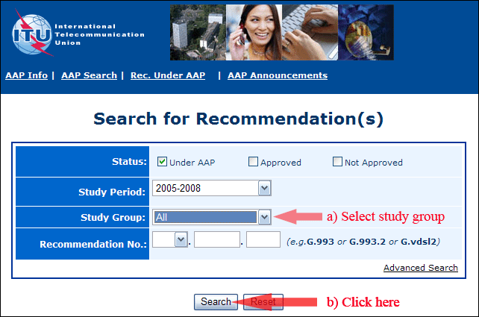
2) Select your Recommendation
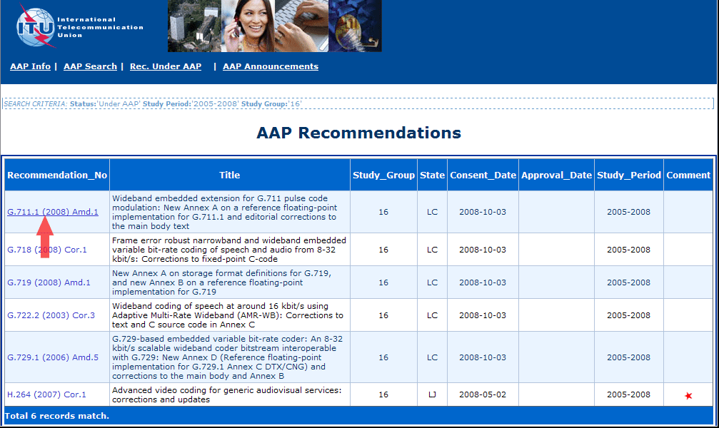
3) Click the "Submit Comment" button
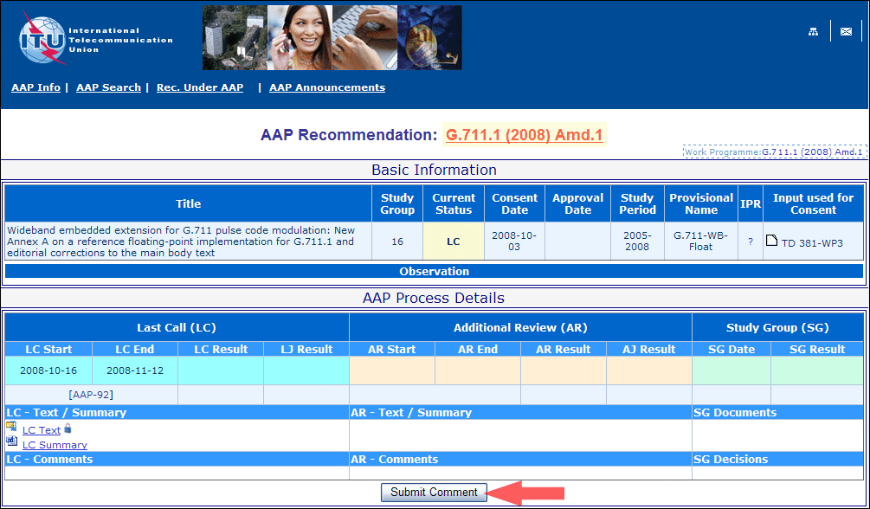
4) Complete the on-line form and click on "Submit"
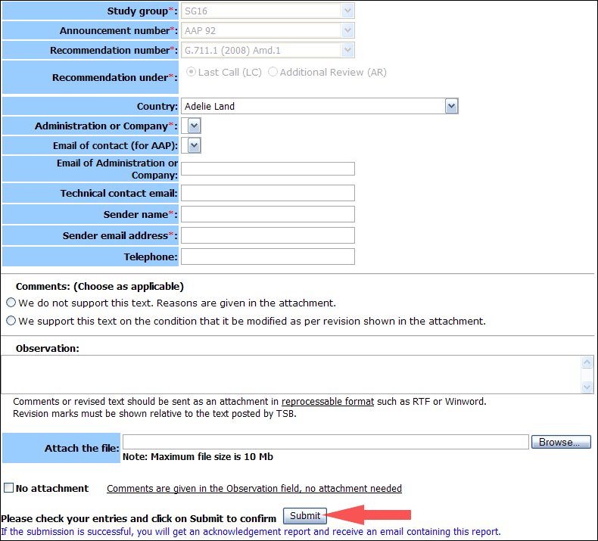
For more information, read the AAP tutorial on:
http://www.itu.int/ITU-T/aapinfo/files/AAPTutorial.pdf
Annex 3
(to TSB AAP-56)
Recommendations under LC/AR – Comment submission form
(Separate form for each Recommendation being commented upon)
ITU-T AAP comment submission form for the period 2009-2012
Study Group:
Announcement number:
Recommendation number:
Recommendation under: | Last call (LC)  Additional Review (AR)
Country:
Administration/Company:
Name of AAP Contact Person:
Email of AAP Contact Person:
Sender name:
(if different from AAP Contact Person)
Sender email address:
Telephone:
Comments:  (Choose as applicable) | We do not support this text. Reasons are given in the attachment.  We support this text on the condition that it be modified as per revision shown in the attachment.
Observations:
No attachment: Comments are given in the Observation field, no attachment needed
To be returned to: email: tsbsg....@itu.int
[or fax +41 22 730 5853]
Comments or revised text should be sent as an attachment in RTF or WinWord format.
Revision marks must be shown relative to the text posted by TSB.

