Unión Internacional de Telecomunicaciones
Oficina de Normalización de las Telecomunicaciones

Ginebra, 01 de mayo de 2015

Ref:  Tel:  Fax:  Correo-e: | TSB AAP-56  AAP/CL  +41 22 730 5860  +41 22 730 5853  tsbdir@itu.int | – A las Administraciones de los Estados Miembros de la Unión;  – A los Miembros del Sector UIT-T;  – A los Asociados del UIT-T  Copia:  – A los Presidentes y a los Vicepresidentes de las Comisiones de Estudio del UIT-T;  – Al Director de la Oficina de Desarrollo de las Telecomunicaciones;  – Al Director de la Oficina de Radiocomunicaciones

Asunto: | Situación de las Recomendaciones sometidas al proceso de aprobación alternativo (AAP)

Muy señora mía/Muy señor mío:

El proceso de aprobación alternativo (AAP) definido en la Recomendación A.8 del UIT-T se aplica a las Recomendaciones que no tienen consecuencias en materia de política o reglamentación y que no requieren, por lo tanto, la consulta formal de los Estados Miembros (véase el número 246B del Convenio de la UIT).
En el anexo 1 se enumera la lista de los textos cuyo estado ha cambiado con respecto a los anuncios TSB AAP precedentes.
Si desea formular un comentario en relación con una Recomendación sometida al AAP, le alentamos a utilizar el formulario de presentación de comentarios disponible en la página de la Recomendación que figura en el área AAP del sitio web del UIT-T, en la dirección http://www.itu.int/ITU-T/aap/ (véase también el anexo 2). Alternativamente, pueden presentarse comentarios completando el formulario del anexo 3 y remitiéndolo a la secretaría de la Comisión de Estudio correspondiente.
Le rogamos tenga en cuenta que no se alientan comentarios que se limiten a apoyar la adopción del texto en cuestión.
Le saluda atentamente,

Chaesub Lee
Director de la Oficina de
Normalización de las Telecomunicaciones
Anexos: 3

Annex 1
(to TSB AAP-56)

Status codes used in the AAP announcements:
LC = Last Call
LJ = Last Call Judgment (includes comment resolution)
AR = Additional Review
AJ = Additional Review Judgment (includes comment resolution)
SG = For Study Group approval
A = Approved
AT = Approved with typographic corrections
AC = Approved after Additional Review of Comments
NA = Not approved
TAP = Moved to TAP (ITU-T A.8 / § 5.2)
ITU-T website entry page:
http://www.itu.int/ITU-T
Alternative approval process (AAP) welcome page:
http://www.itu.int/ITU-T/aapinfo
Note – A tutorial on the ITU-T AAP application is available under the AAP welcome page
ITU-T website AAP Recommendation search page:
http://www.itu.int/ITU-T/aap/
Study Group web pages and contacts:
SG 2 | http://www.itu.int/ITU-T/studygroups/com02 | tsbsg2@itu.int
SG 3 | http://www.itu.int/ITU-T/studygroups/com03 | tsbsg3@itu.int
SG 5 | http://www.itu.int/ITU-T/studygroups/com05 | tsbsg5@itu.int
SG 9 | http://www.itu.int/ITU-T/studygroups/com09 | tsbsg9@itu.int
SG 11 | http://www.itu.int/ITU-T/studygroups/com11 | tsbsg11@itu.int
SG 12 | http://www.itu.int/ITU-T/studygroups/com12 | tsbsg12@itu.int
SG 13 | http://www.itu.int/ITU-T/studygroups/com13 | tsbsg13@itu.int
SG 15 | http://www.itu.int/ITU-T/studygroups/com15 | tsbsg15@itu.int
SG 16 | http://www.itu.int/ITU-T/studygroups/com16 | tsbsg16@itu.int
SG 17 | http://www.itu.int/ITU-T/studygroups/com17 | tsbsg17@itu.int

Situation concerning Study Group 2 Recommendations under AAP
Rec # | Title | Last Call (LC) Period |  |  |  | Additional Review (AR) Period |  |  |  | Status
 |  | LC Start | LC End | LC  Result | LJ  Result | AR Start | AR End | AR  Result | AJ  Result
M.1400 | Designations for interconnections among operators' networks (Summary) | 2015-04-01 | 2015-04-28 | A |  |  |  |  |  | A
M.3170.0 (2007) Amd.1 | Multi-technology network management - Introduction and supporting documentation: Amendment 1 - Upgrade to MTNM Release 3.5 (Summary) | 2015-04-01 | 2015-04-28 | A |  |  |  |  |  | A
M.3170.1 (2007) Amd.1 | Multi-technology network management: Business agreement (TMF513): Amendment 1 - Upgrade to MTNM Release 3.5 (Summary) | 2015-04-01 | 2015-04-28 | A |  |  |  |  |  | A
M.3170.2 (2007) Amd.1 | Multi-technology network management: Information agreement (TMF608): Amendment 1 - Upgrade to MTNM Release 3.5 (Summary) | 2015-04-01 | 2015-04-28 | A |  |  |  |  |  | A
M.3170.3 (2007) Amd.1 | Multi-technology network management: CORBA IDL Solution Set (TMF814) with Implementation Statement Templates and Guidelines (TMF814A): Amendment 1 - Upgrade to MTNM Release 3.5 (Summary) | 2015-04-01 | 2015-04-28 | A |  |  |  |  |  | A
M.3170.4 (M.3170-cts) | Multi-technology network management: Conformance testing specification (Summary) | 2015-04-01 | 2015-04-28 | A |  |  |  |  |  | A
Situation concerning Study Group 5 Recommendations under AAP
Rec # | Title | Last Call (LC) Period |  |  |  | Additional Review (AR) Period |  |  |  | Status
 |  | LC Start | LC End | LC  Result | LJ  Result | AR Start | AR End | AR  Result | AJ  Result
K.20 | Resistibility of telecommunication equipment installed in a telecommunications centre to overvoltages and overcurrents (Summary) | 2015-02-01 | 2015-02-28 | LJ | AR | 2015-04-01 | 2015-04-21 | AC |  | AC
K.21 | Resistibility of telecommunication equipment installed in customer premises to overvoltages and overcurrents (Summary) | 2015-02-01 | 2015-02-28 | LJ | AR | 2015-04-01 | 2015-04-21 | AC |  | AC
K.44 (2012) Amd.1 | Resistibility tests for telecommunication equipment exposed to overvoltages and overcurrents - Amendment 1 (Summary) | 2015-02-16 | 2015-03-15 | AR |  | 2015-04-01 | 2015-04-21 | AC |  | AC
K.45 | Resistibility of telecommunication equipment installed in the access and trunk networks to overvoltages and overcurrents (Summary) | 2015-02-01 | 2015-02-28 | LJ | AR | 2015-04-01 | 2015-04-21 | AC |  | AC
L.1202 (L.performance) | Methodologies for evaluating the performance of up to 400VDC power feeding system and its environmental impact (Summary) | 2015-02-01 | 2015-02-28 | LJ | AR | 2015-04-01 | 2015-04-21 | AC |  | AC
Situation concerning Study Group 11 Recommendations under AAP
Rec # | Title | Last Call (LC) Period |  |  |  | Additional Review (AR) Period |  |  |  | Status
 |  | LC Start | LC End | LC  Result | LJ  Result | AR Start | AR End | AR  Result | AJ  Result
Q.3615 (Q.ProGeoSMS) | Protocol for GeoSMS (Summary) | 2014-08-01 | 2014-08-28 | LJ | SG |  |  |  |  | AC
Situation concerning Study Group 15 Recommendations under AAP
Rec # | Title | Last Call (LC) Period |  |  |  | Additional Review (AR) Period |  |  |  | Status
 |  | LC Start | LC End | LC  Result | LJ  Result | AR Start | AR End | AR  Result | AJ  Result
G.993.2 (2011) Amd.6 | Very high speed digital subscriber line transceivers 2 (VDSL2): Amendment 6 (Summary) | 2015-01-16 | 2015-02-12 | LJ | AR | 2015-05-01 | 2015-05-21 |  |  | AR
G.997.2 | Physical layer management for FAST transceivers (Summary) | 2015-01-16 | 2015-02-12 | LJ | AR | 2015-05-01 | 2015-05-21 |  |  | AR
G.998.4 (2010) Amd.4 | Improved impulse noise protection for DSL transceivers: Amendment 4 (Summary) | 2015-01-16 | 2015-02-12 | LJ | AR | 2015-05-01 | 2015-05-21 |  |  | AR
Situation concerning Study Group 16 Recommendations under AAP
Rec # | Title | Last Call (LC) Period |  |  |  | Additional Review (AR) Period |  |  |  | Status
 |  | LC Start | LC End | LC  Result | LJ  Result | AR Start | AR End | AR  Result | AJ  Result
F.743.1 (H.IVSReqs) | Requirements for intelligent visual surveillance (Summary) | 2015-04-01 | 2015-04-28 | A |  |  |  |  |  | A
G.168 (V8) | Digital network echo cancellers (Summary) | 2015-04-01 | 2015-04-28 | A |  |  |  |  |  | A
H.222.0 (2014) Amd.1 | Information technology - Generic coding of moving pictures and associated audio information: Systems: Delivery of timeline for external data (Summary) | 2015-04-01 | 2015-04-28 | A |  |  |  |  |  | A
H.248.78 | Gateway control protocol: Bearer-level message backhauling and application level gateway (Summary) | 2015-04-01 | 2015-04-28 | A |  |  |  |  |  | A
H.248.81 (2011) Amd.2 | Gateway control protocol: Guidelines on the use of the international emergency preference scheme (IEPS) call indicator and priority indicator in ITU-T H.248 profiles: DiffServ signaling approach (Summary) | 2015-04-01 | 2015-04-28 | A |  |  |  |  |  | A
H.265 (V3) | H.265 high efficiency video coding (Summary) | 2015-04-01 | 2015-04-28 | A |  |  |  |  |  | A
H.460.22 (H.460.22) | Negotiation of security protocols to protect H.225.0 call signaling messages (Summary) | 2015-04-01 | 2015-04-28 | A |  |  |  |  |  | A
H.721 (V2) | IPTV terminal devices: Basic model (Summary) | 2015-04-01 | 2015-04-28 | A |  |  |  |  |  | A
H.741.4 (2012) Amd.1 | IPTV application event handling: Transport mechanisms for audience measurement: XML schema on the data structures for message delivery (Summary) | 2015-04-01 | 2015-04-28 | A |  |  |  |  |  | A
H.765 (H.IPTV-Widget, ex HSTP.IPTV-Widget) | Packaged IPTV application (widget) service (Summary) | 2015-04-01 | 2015-04-28 | A |  |  |  |  |  | A
H.770 | Mechanisms for service discovery and selection for IPTV services (Summary) | 2015-04-01 | 2015-04-28 | A |  |  |  |  |  | A
H.781 (H.DS-ARCH) | Digital signage: Functional architecture (Summary) | 2015-04-01 | 2015-04-28 | A |  |  |  |  |  | A
T.804 Amd.2 | Information technology - JPEG 2000 image coding system: Reference software: Additional reference software (Summary) | 2015-04-01 | 2015-04-28 | A |  |  |  |  |  | A
Situation concerning Study Group 17 Recommendations under AAP
Rec # | Title | Last Call (LC) Period |  |  |  | Additional Review (AR) Period |  |  |  | Status
 |  | LC Start | LC End | LC  Result | LJ  Result | AR Start | AR End | AR  Result | AJ  Result
X.509 Cor.1 (X.509 Cor.1) | Information technology - Open Systems Interconnection - The Directory - Public-key and attribute certificate frameworks - Technical Corrigendum 1 (Summary) | 2015-05-01 | 2015-05-28 |  |  |  |  |  |  | LC
X.675 (X.orf) | OID-based resolution framework for heterogeneous identifiers and locators (Summary) | 2015-05-01 | 2015-05-28 |  |  |  |  |  |  | LC
X.1157 (X.sap-7) | Technical capabilities of fraud detection and response for services with high assurance level requirements (Summary) | 2014-10-16 | 2014-11-12 | LJ | SG |  |  |  |  | TAP
X.1163 (X.p2p-3) | Security requirements and mechanisms of peer-to-peer-based telecommunication networks (Summary) | 2015-05-01 | 2015-05-28 |  |  |  |  |  |  | LC
X.1341 (X.cmail) | Certified mail transport and certified post office protocols (Summary) | 2014-11-01 | 2014-11-28 | LJ | SG |  |  |  |  | TAP

Annex 2
(to TSB AAP-56)
Using the on-line comment submission form
Comment submission
1) Go to AAP search Web page at http://www.itu.int/ITU-T/aap/
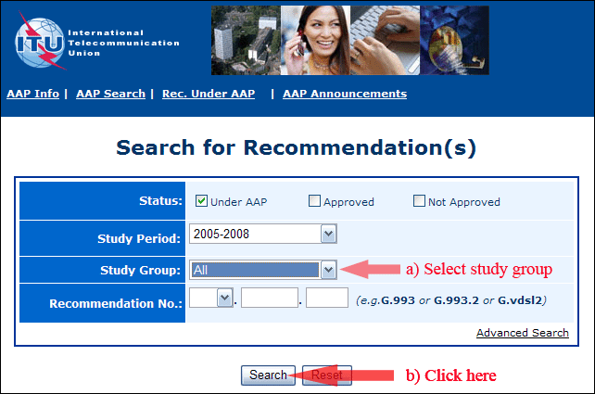
2) Select your Recommendation
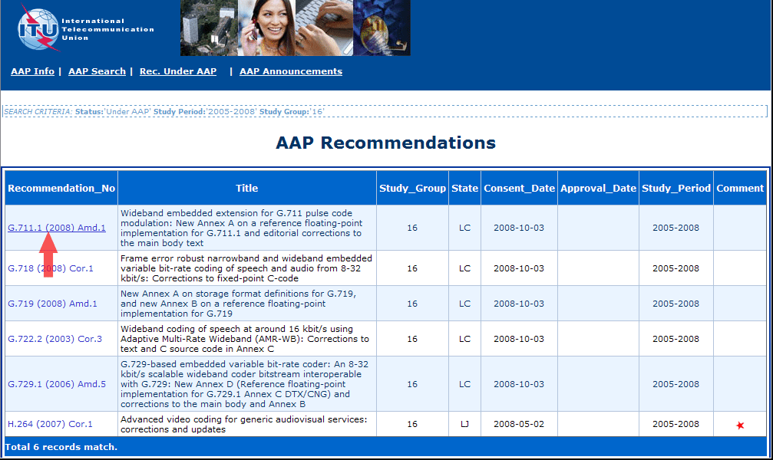
3) Click the "Submit Comment" button
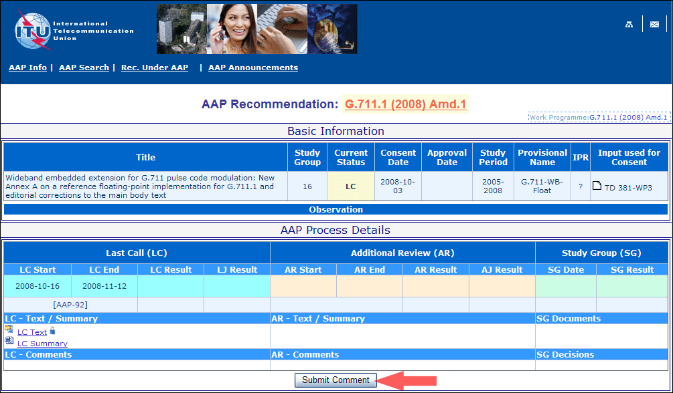
4) Complete the on-line form and click on "Submit"
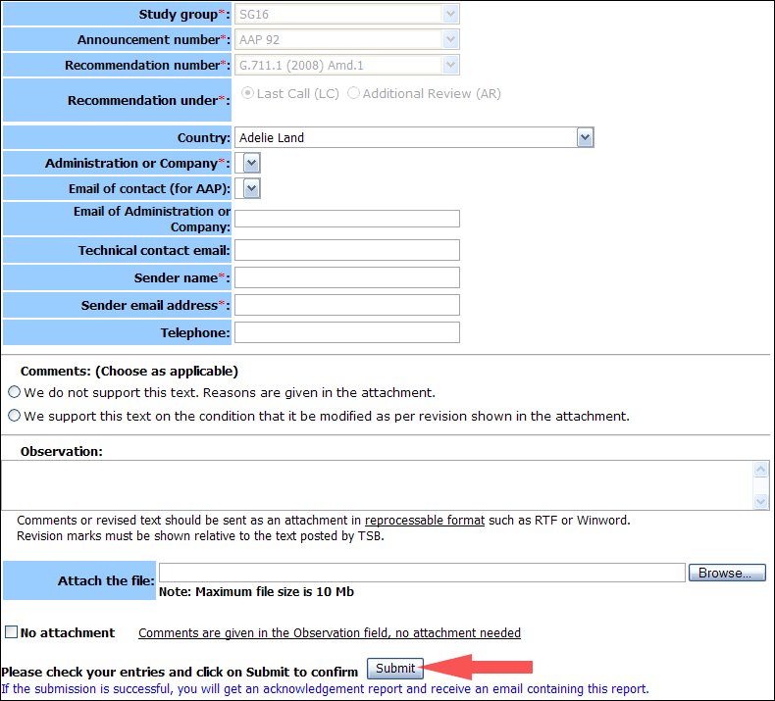
For more information, read the AAP tutorial on:
http://www.itu.int/ITU-T/aapinfo/files/AAPTutorial.pdf
Annex 3
(to TSB AAP-56)
Recommendations under LC/AR – Comment submission form
(Separate form for each Recommendation being commented upon)
ITU-T AAP comment submission form for the period 2009-2012
Study Group:
Announcement number:
Recommendation number:
Recommendation under: | Last call (LC)  Additional Review (AR)
Country:
Administration/Company:
Name of AAP Contact Person:
Email of AAP Contact Person:
Sender name:
(if different from AAP Contact Person)
Sender email address:
Telephone:
Comments:  (Choose as applicable) | We do not support this text. Reasons are given in the attachment.  We support this text on the condition that it be modified as per revision shown in the attachment.
Observations:
No attachment: Comments are given in the Observation field, no attachment needed
To be returned to: email: tsbsg....@itu.int
[or fax +41 22 730 5853]
Comments or revised text should be sent as an attachment in RTF or WinWord format.
Revision marks must be shown relative to the text posted by TSB.

